NXT SCHOOL · META LAUNCH PLAN · CORE 1-PAGER
Meta launch: campaigns, ad sets, angles & creatives
Live Tue 6 / Wed 7 Oct → 8 Nov · Novi Sad · 150,000 RSD (floor 120k) · program starts Mon 9 Nov · goal: 30–40 enrolled in the November cohort; first 20–30 leads = validation.
OPTIMIZE FOR  Lead = application_submit | NOVEMBER TARGET  30–40 enrolled ← 150–200 leads | TARGET CPL  ≤ 1,000 RSD (aim ~750) | TRACK FROM DAY 1  CPL · qualified · contacted · lead→enrol · CAC
1 Campaigns → ad sets
Campaign (objective · conversion) | Ad set · audience | Ads | Budget | Live
1 · PROSPECTING · Leads (application_submit)  NXT_META_LEADS_PROSP_Launch_2610 | 1.1 Broad_NS15km_25-55 · Novi Sad +15 km · 25–55 · Advantage+ audience · excl. applicants · no Audience Network | P1–P6 | 112,000 (75%) · 3,000→3,700/day | 6/7 Oct → 8 Nov
2 · OPEN DAY · Leads (Open Day registration)  NXT_META_LEADS_OPENDAY_2610 | 2.1 BroadWarm_NS12km · Novi Sad +12 km · 25–55 + all warm audiences · excl. registrants | O1–O3 | 23,000 (15%) · ~1,550/day | 12 → 26 Oct
3 · RETARGETING · Leads (application_submit)  NXT_META_LEADS_RT_2610 | 3.1 Warm_30d · visitors 30d · started form 14d · IG/FB engagers 60d · excl. applicants · max 4 ads live | R1–R7 | 15,000 (10%) · ~580/day | 13 Oct → 8 Nov
Total | 3 campaigns · 3 ad sets · 16 ads over 5 weeks |  | 150,000 RSD
2 Angles — 1–4 + Offer run side by side from day 1; Open Day on dates
Angle | Who × pain / desire | Proof we own | Creatives
1 · Hero | Future-minded parents × "will school prepare my kid?" | Projects, not tools · 4 levels · My NXT Portfolio | C1, C2
2 · Less scrolling | Parents of 1st–6th graders × "stalno je na telefonu" | Each class ends with something made · "Ekran je alat" | C3
3 · English | English-aware parents × "zna reči, ali ne priča" | Speaks through projects, grows with the group’s confidence · Serbian if needed | C4
4 · AI + digital | AI-worried parents × "koristi AI — a razmišlja li?" | Ask → Check → Improve → Decide · safety in every project | C7, Reel
Offer · Founding | Warm, price-aware × "is it worth it, why now?" | 5,900 vs 7,200 · start 9 Nov · Showcase · no entrance test | C5, FAQ, R6
D · Open Day | Undecided × "want to see it first" | Mon 26 Oct, 18–20 h: kids’ mini challenge, parents meet the program | C6
3 Ads — creative × angle × when
Ad (P = 1.1 · O = 2.1 · R = 3.1) | Creative · on-image hook | Angle | Copy opener (SR) | When · format
P1 | C1 Hero · "Veštine za svet u kojem će odrastati." | 1 | Deca koja danas kreću u školu odrastaće u svetu… | W1 · static → photo W2
P2 | C3 Less scrolling · screen time vs "NXT ova nedelja ✓" | 2 | Vaše dete već zna da skroluje. Kod nas uči da stvara. | From W1 · static
P3 | C4 English · "Engleski bez straha." + kids’ chat | 3 | Zna reči, ali ne priča? Engleski bez straha — kroz projekte. | From W1 · static
P4 | C7 AI literacy · "…nije AI literacy" + Ask → Decide | 4 | Znati da pitaš ChatGPT nešto nije AI literacy. | From W1 · static
P5 / R1 | C5 Founding · 5.900 RSD · "početak 9. novembra" | Offer | Upisujemo prvu, founding generaciju. Početak: 9. novembar. | W1 (R1 W2) · static
P6 | Reel "Pitali smo decu…" · AI: pametniji ili lenjiji? | 4 · 1 | Pitali smo decu: AI — pametniji ili lenjiji? | W3 → · video
O1 / R3 | C6 Open Day · "Neka dete isproba. Vi upoznajte program." | D | Dođite na NXT Open Day — ponedeljak, 26. oktobar, 18–20 h. | W2–W3 · static
O2 · O3 | O2 Open Day invite on the winning P-ad hook · O3 countdown (21 Oct) | D | Open Day copy, first line adapted to the angle | W2–W3 · static
R2 | FAQ · coding, English, portfolio, entrance test | Offer | Da li je ovo škola programiranja? Nije… | From W2 · static
R4 | C2 Levels · Explore · Create · Build · Lead | 1 | Isti NXT pristup, prilagođen uzrastu. | From W2 · static
R5 | Team · "Ko stoji iza NXT-a?" (real portraits) | Offer | Obrazovanje, tehnologija i kreativne industrije. | W3 → · photos
R6 · R7 | "Počinjemo 9. novembra" · Open Day recap | Offer · D | Prva generacija počinje u ponedeljak, 9. novembra. | W4 · static + photos
Launch statics (direction mocks — real photos replace them from W2–W3) · every creative in 4:5 feed + 9:16 · blue = static, green = real photo / video
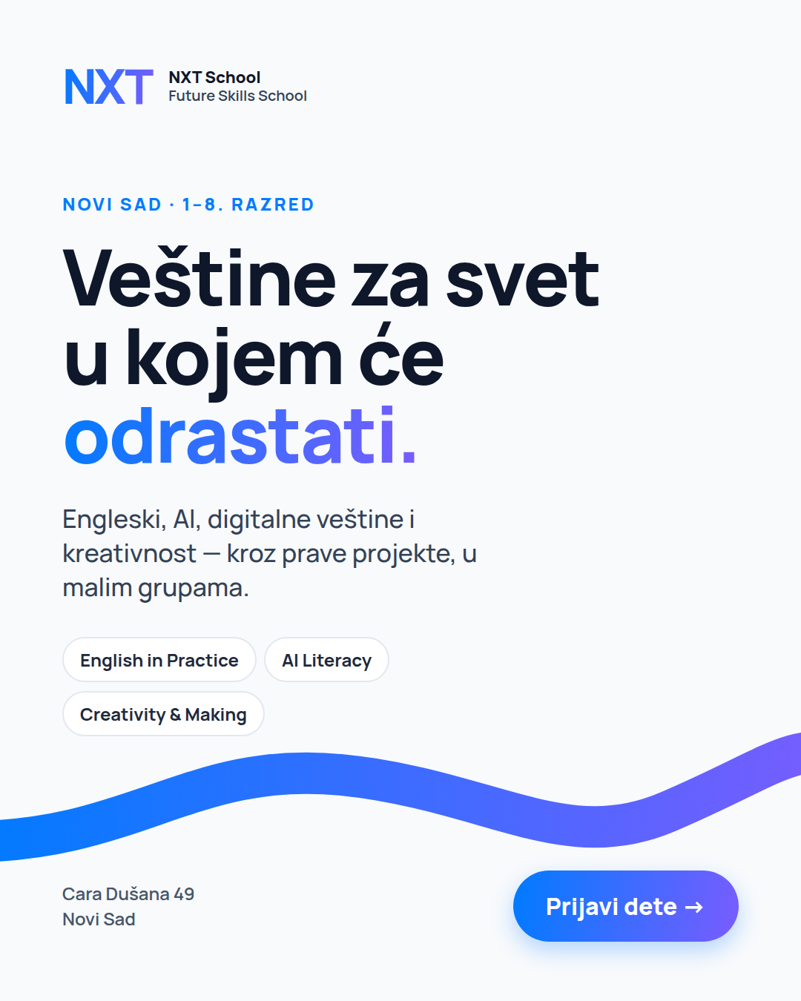  C1 Hero | 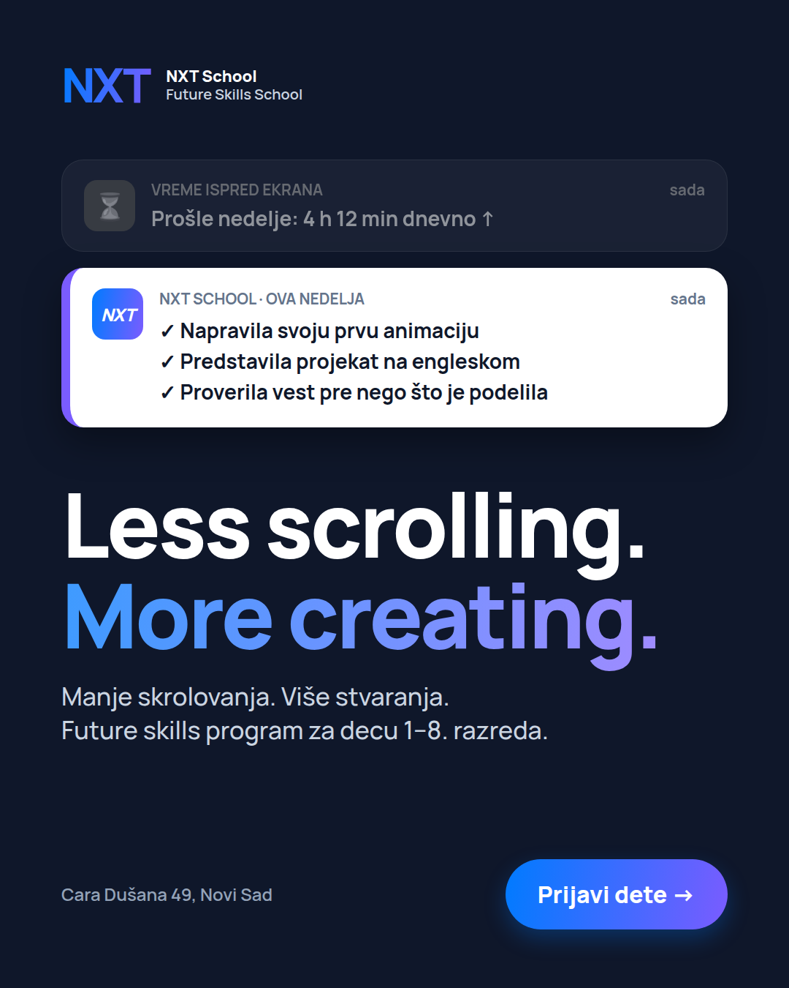  C3 Less scrolling | 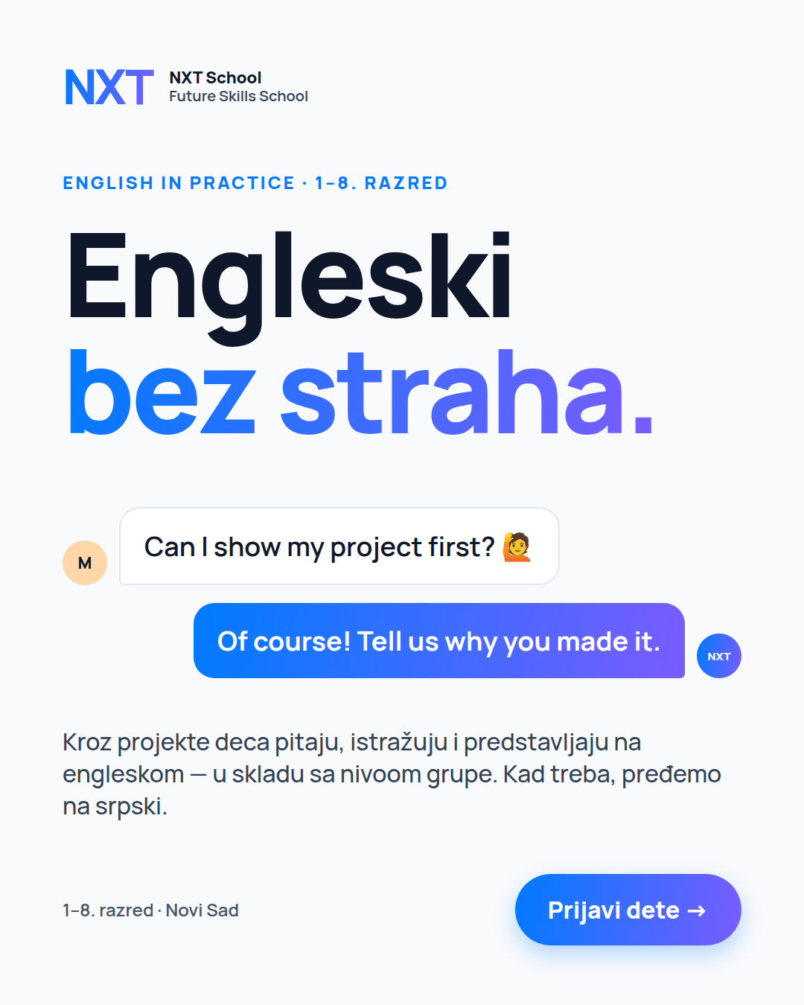  C4 English | 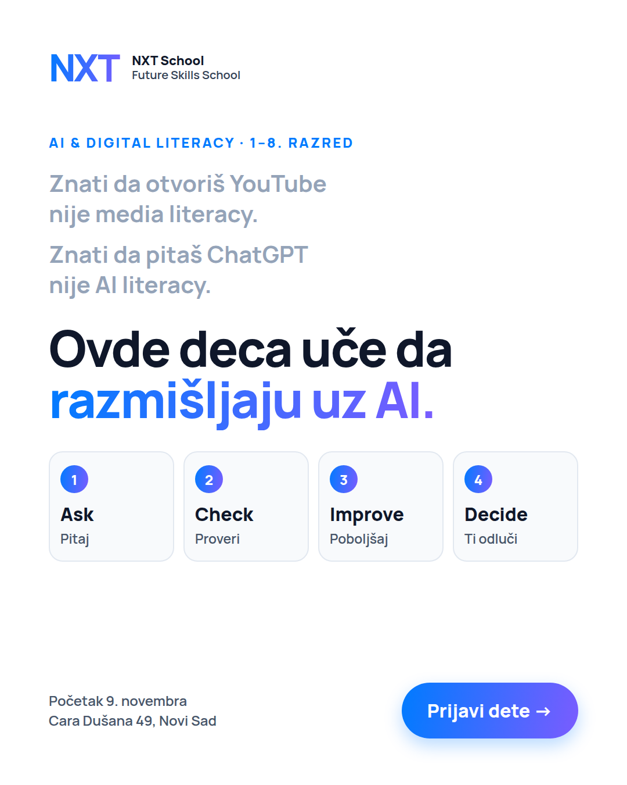  C7 AI literacy | 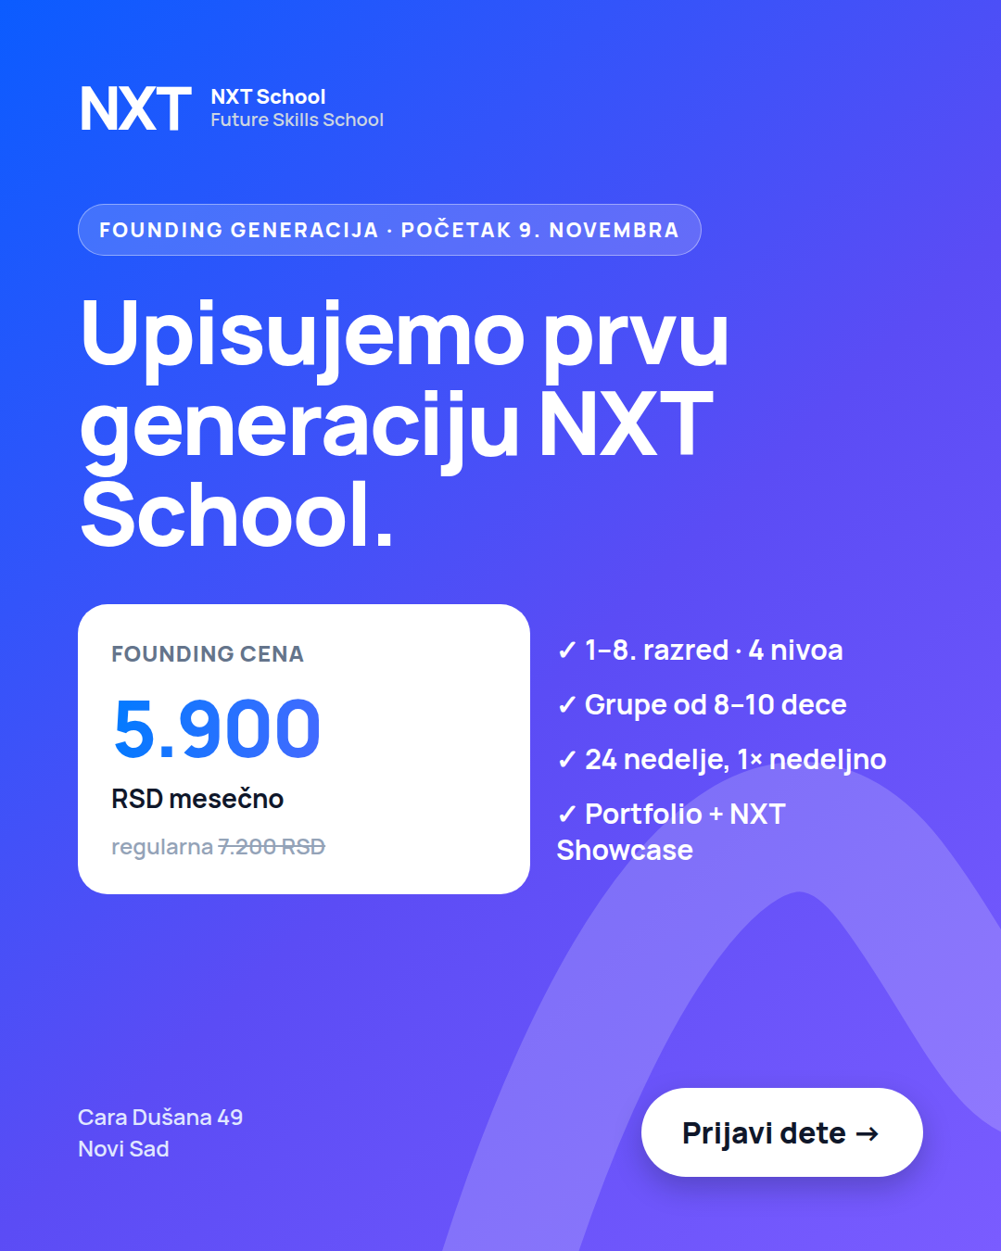  C5 Founding | 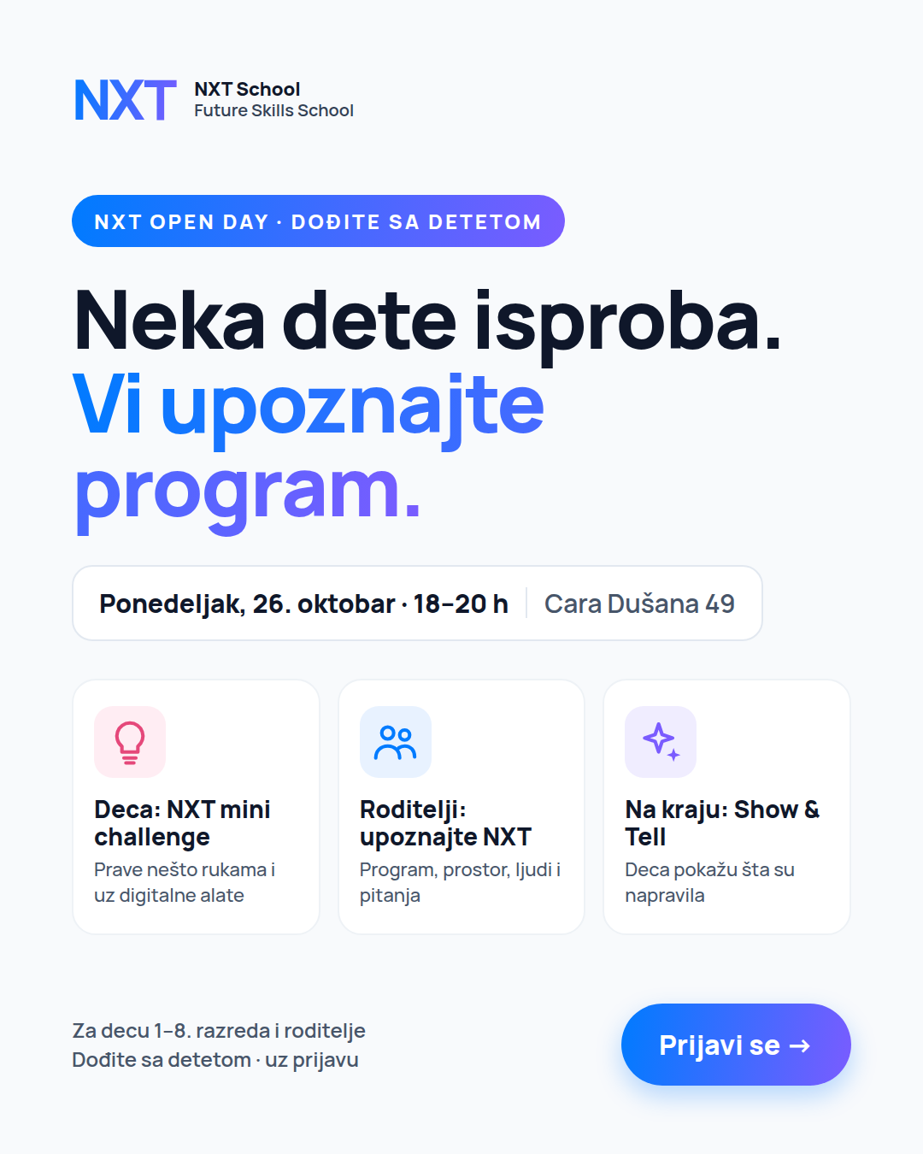  C6 Open Day
4 Rules until 8 Nov
- First 72 h hands off; first 20–30 leads = validation — QA only: lead lands in Fast Lane with phone/email, Lead event fires, UTMs stored.
- Cut at ≥ 1,500 impressions with link CTR < 0.6%, or 2,000 RSD spent with 0 leads. Winner (CPL ≤ 800, ≥ 5 qualified leads) → variants in W3, then 60/30/10.
- Content: static W1 → real space photos W2 → Šmiranti shoot + first Reels W3 → Open Day content + last call W4. Cast kids are never captioned as NXT students.
- Budget: 150k is what 30–40 enrolled needs (~150–200 leads at ~20%). If CPL > 1,000 after day 10, hold at 120k (≈ 20–25 enrolled) and roll the rest into January.
- Confirmed by the live site: Open Day Mon 26 Oct, 18–20 h · founding 5.900 RSD for the whole program (6 payments), regular 7.200 · no joining mid-program. Still to confirm: is the Open Day free? · team roles for R5 · Mladen signs off all messaging.

