NXT SCHOOL · WEEKLY CREATIVE PLAN · META
Week 1 · 6–11 Oct — Launch: 5 statics side by side
Goal: let the first 20–30 leads show which angle wins. Everything is a designed static (feed 4:5 + story 9:16) — no photos needed yet.
W1 · 6–11 Oct  Launch | W2 · 12–18 Oct  First read + Open Day + RT | W3 · 19–25 Oct  Winner + first real content | W4–5 · 26 Oct–8 Nov  Real content + last call

1 · PROSPECTING ad set 1.1 Broad_NS15km_25-55 · 3,000 RSD/day
 | Ad · creative | Status | Format | What to do / note
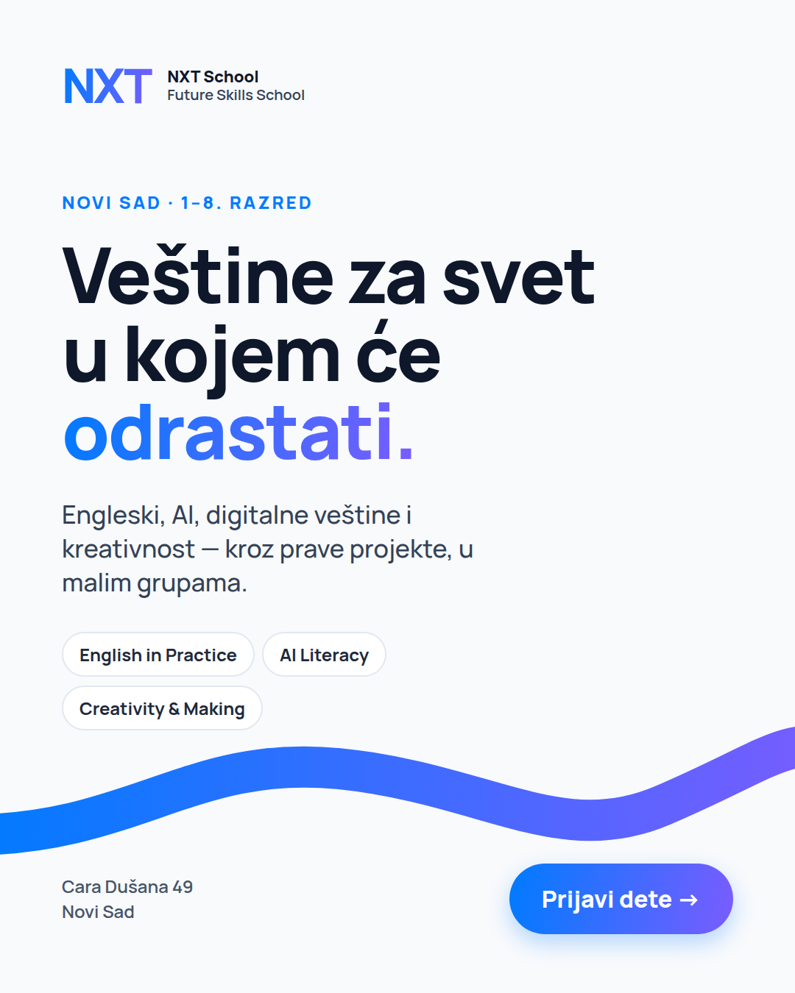 | P1 · C1 Hero  Angle 1 · "Veštine za svet u kojem će odrastati" | NEW | STATIC · 4:5 + 9:16 | Live day 1. Copy: Angle 1 long + short.
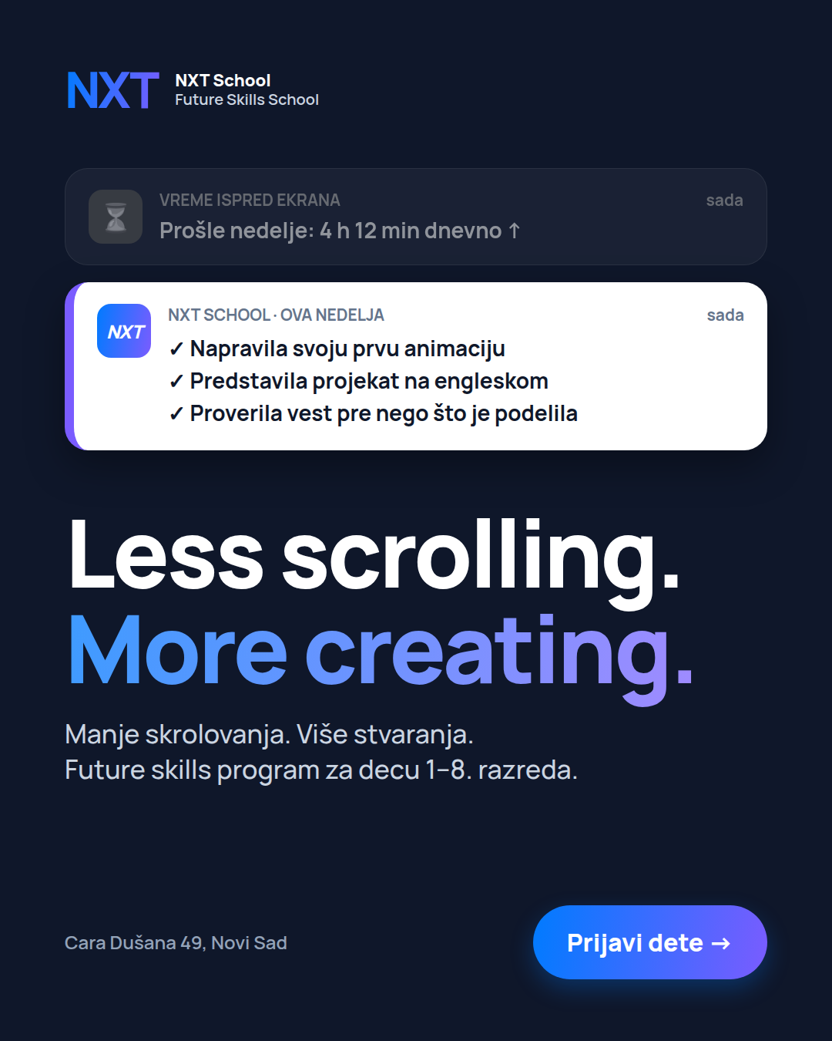 | P2 · C3 Less scrolling  Angle 2 · "Manje skrolovanja. Više stvaranja." | NEW | STATIC · 4:5 + 9:16 | Live day 1. Copy: Angle 2.
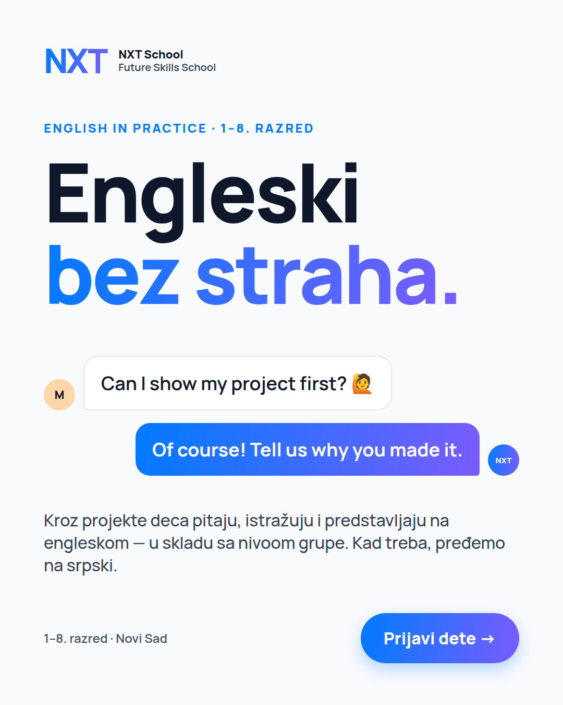 | P3 · C4 English  Angle 3 · "Engleski bez straha." | NEW | STATIC · 4:5 + 9:16 | Live day 1. Copy: Angle 3.
 | P4 · C7 AI literacy  Angle 4 · "Pitaj. Proveri. Poboljšaj. Ti odluči." | NEW | STATIC · 4:5 + 9:16 | Live day 1. Copy: Angle 4.
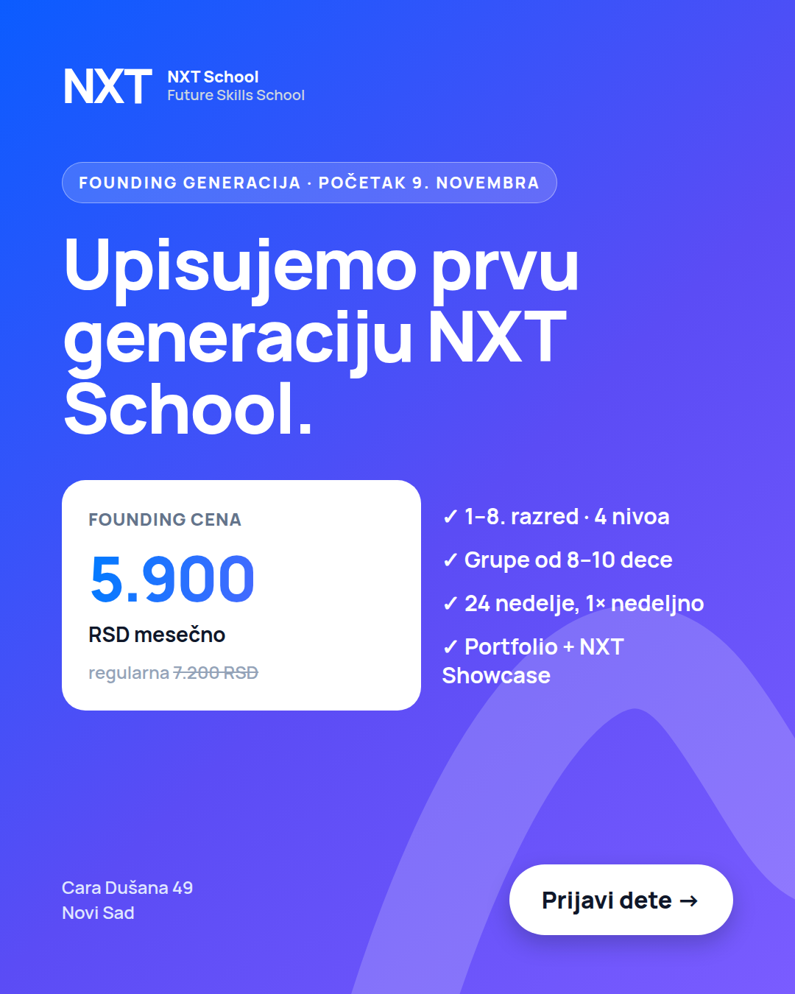 | P5 · C5 Founding  Offer · "Founding cena: 5.900 RSD mesečno" | NEW | STATIC · 4:5 + 9:16 | Live day 1. Copy: Offer.

2 · OPEN DAY ad set 2.1 · starts 12 Oct
 | Ad · creative | Status | Format | What to do / note
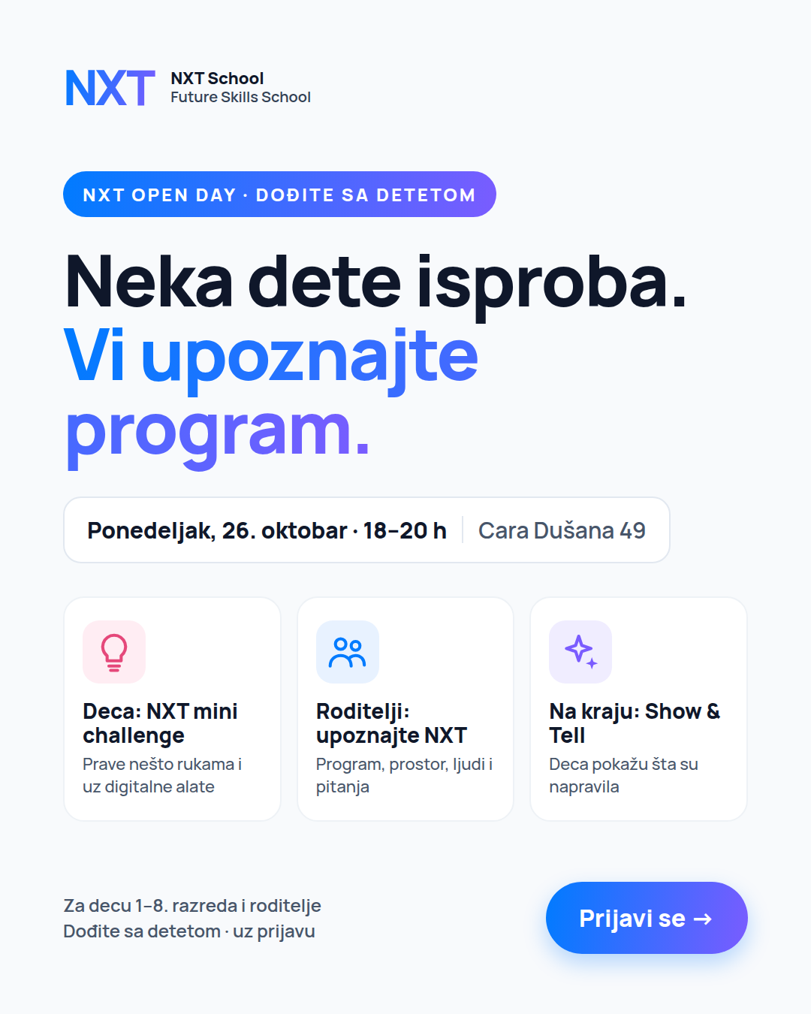 | O1 · C6 Open Day  Angle D | OFF | — | Not live yet — Nikola finishes feed + story by Fri 9 Oct.

3 · RETARGETING ad set 3.1 · starts 13 Oct
 | Ad · creative | Status | Format | What to do / note
 | Audience building  site visitors · form starters · IG/FB engagers | OFF | — | Nothing live — the warm audience is still too small (< 1k).

TEST THIS PERIOD  • The 5 angles against each other — same audience, same budget (Round 1).  • Hands off for 72 h: no edits, no budget changes.  • First read day 6–8: each ad ≥ 1,500 impressions, CPL, link CTR, landing-page conversion. | TO DO THIS PERIOD  • Paid: daily QA — lead lands in Fast Lane with phone/email, Lead event fires, UTMs stored.  • Nikola: C6 Open Day (4:5 + 9:16) by Fri 9 Oct · R2 FAQ + C2 Levels by Mon 12 Oct.  • Igor: photos of the empty space + team portraits by Fri (phone is fine).  • Mladen: confirm the Šmiranti shoot date (Open Day = Mon 26 Oct, 18–20 h, per site).

NEW | KEEP | TEST | PAUSE / ENDS | OFF | STATIC · 4:5 + 9:16 | PHOTO · 4:5 + 9:16 | VIDEO · 9:16 Reel | MOTION 6 s / CAROUSEL
NXT SCHOOL · WEEKLY CREATIVE PLAN · META
Week 2 · 12–18 Oct — First read, Open Day and retargeting go live
Goal: pick the winning angle, fill the Open Day, start retargeting. Still mostly static; the first real photo (the space) arrives in P1.
W1 · 6–11 Oct  Launch | W2 · 12–18 Oct  First read + Open Day + RT | W3 · 19–25 Oct  Winner + first real content | W4–5 · 26 Oct–8 Nov  Real content + last call

1 · PROSPECTING ad set 1.1 · ~3,700 RSD/day
 | Ad · creative | Status | Format | What to do / note
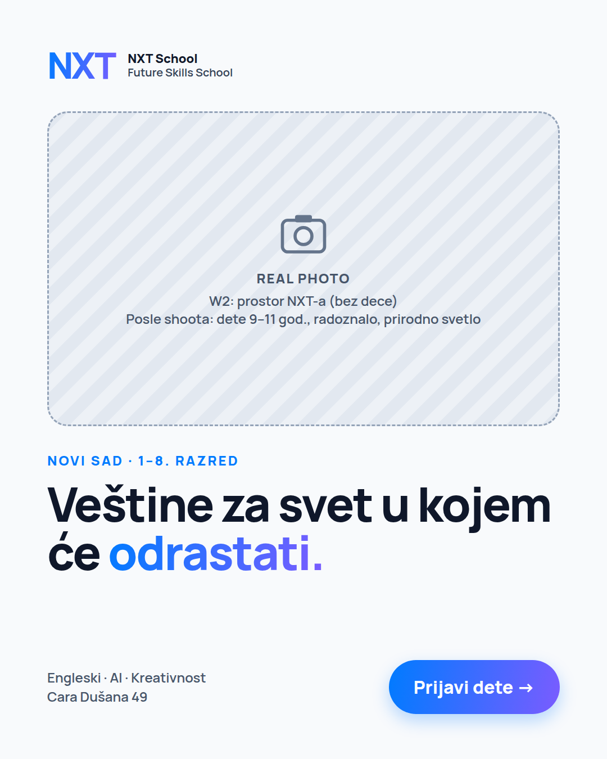 | P1 · C1 Hero — real space-photo version  Angle 1 | TEST | PHOTO · 4:5 + 9:16 | Run next to the graphic P1 (one change: the background). Only if the space photos look decent.
 | P2 · C3 Less scrolling | KEEP or PAUSE | STATIC · 4:5 + 9:16 | After the day 6–8 read: keep the top 3 ads,
 | P3 · C4 English | KEEP or PAUSE | STATIC · 4:5 + 9:16 | pause the bottom 1–2 (link CTR < 0.6% at 1,500 impressions,
 | P4 · C7 AI literacy | KEEP or PAUSE | STATIC · 4:5 + 9:16 | or 2,000 RSD spent with 0 leads).
 | P5 · C5 Founding | KEEP or PAUSE | STATIC · 4:5 + 9:16 | Write down the winning angle → it gets the W3 variants.

2 · OPEN DAY ad set 2.1 · ~1,550 RSD/day · 12 → 26 Oct
 | Ad · creative | Status | Format | What to do / note
 | O1 · C6 Open Day  "Neka dete isproba. Vi upoznajte program." | NEW | STATIC · 4:5 + 9:16 | Live Mon 12 Oct. Feed + story version.
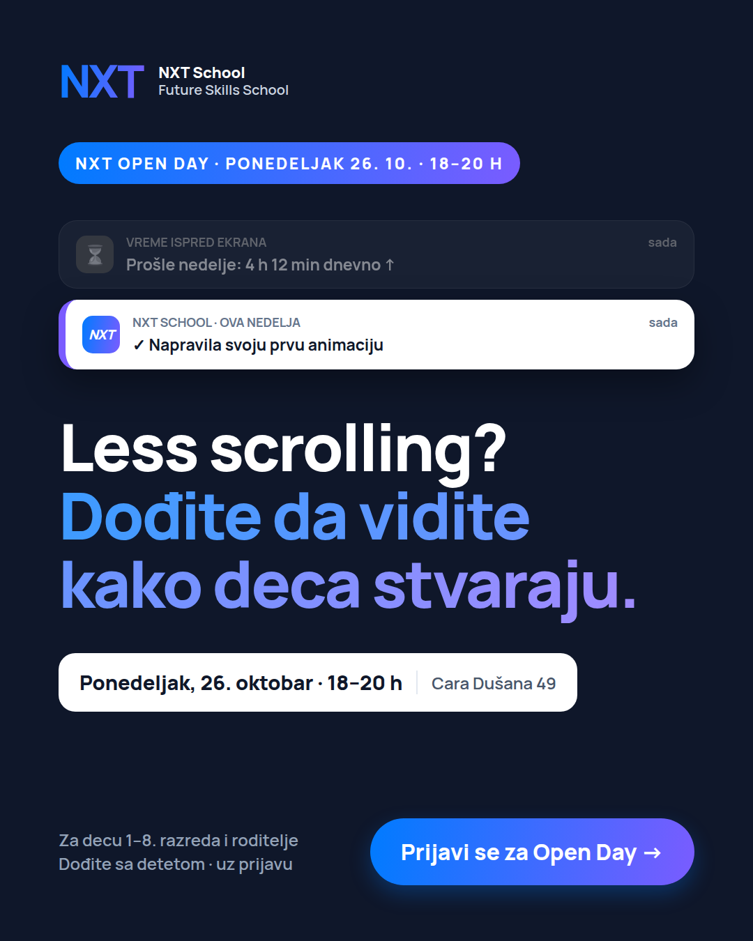 | O2 · Open Day + winning P-ad hook | NEW | STATIC · 4:5 + 9:16 | Live Tue 13 Oct — Open Day kicker + date on top; hook from whichever P-ad leads.

3 · RETARGETING ad set 3.1 · ~580 RSD/day · max 4 ads
 | Ad · creative | Status | Format | What to do / note
 | R1 · C5 Founding (price + start date) | NEW | STATIC · 4:5 + 9:16 | Live Tue 13 Oct.
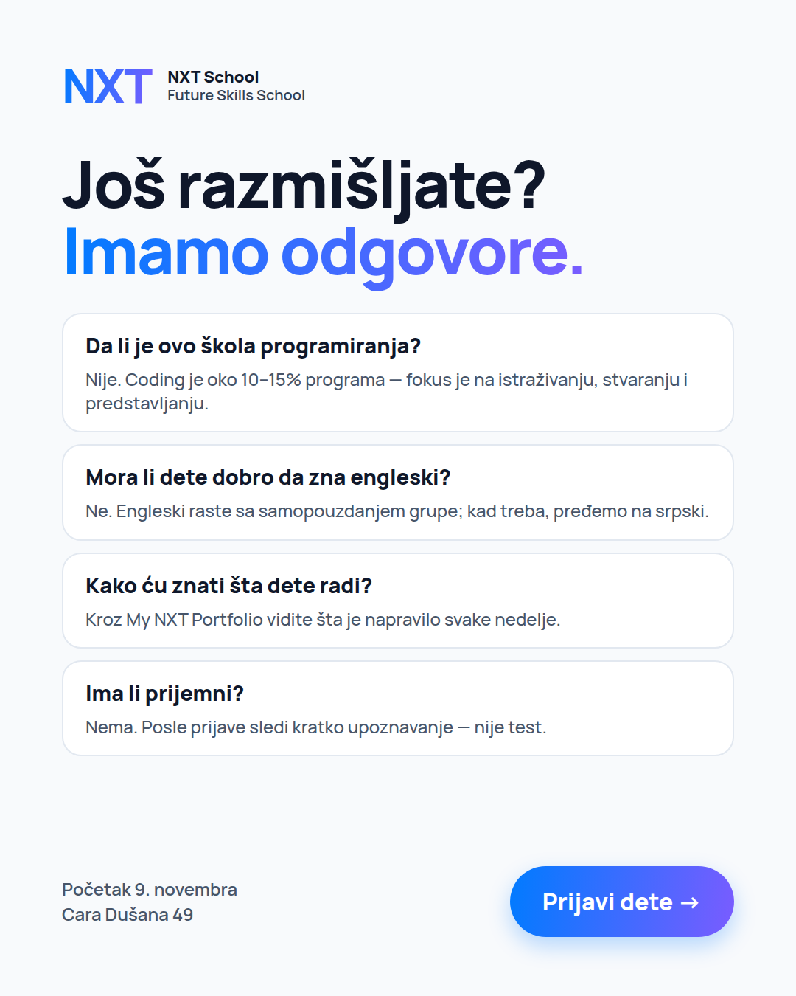 | R2 · FAQ "Još razmišljate?" | NEW | STATIC · 4:5 + 9:16 | Live Tue 13 Oct.
 | R3 · C6 Open Day | NEW | STATIC · 4:5 + 9:16 | Live Tue 13 Oct → ends Mon 26 Oct, 17 h.
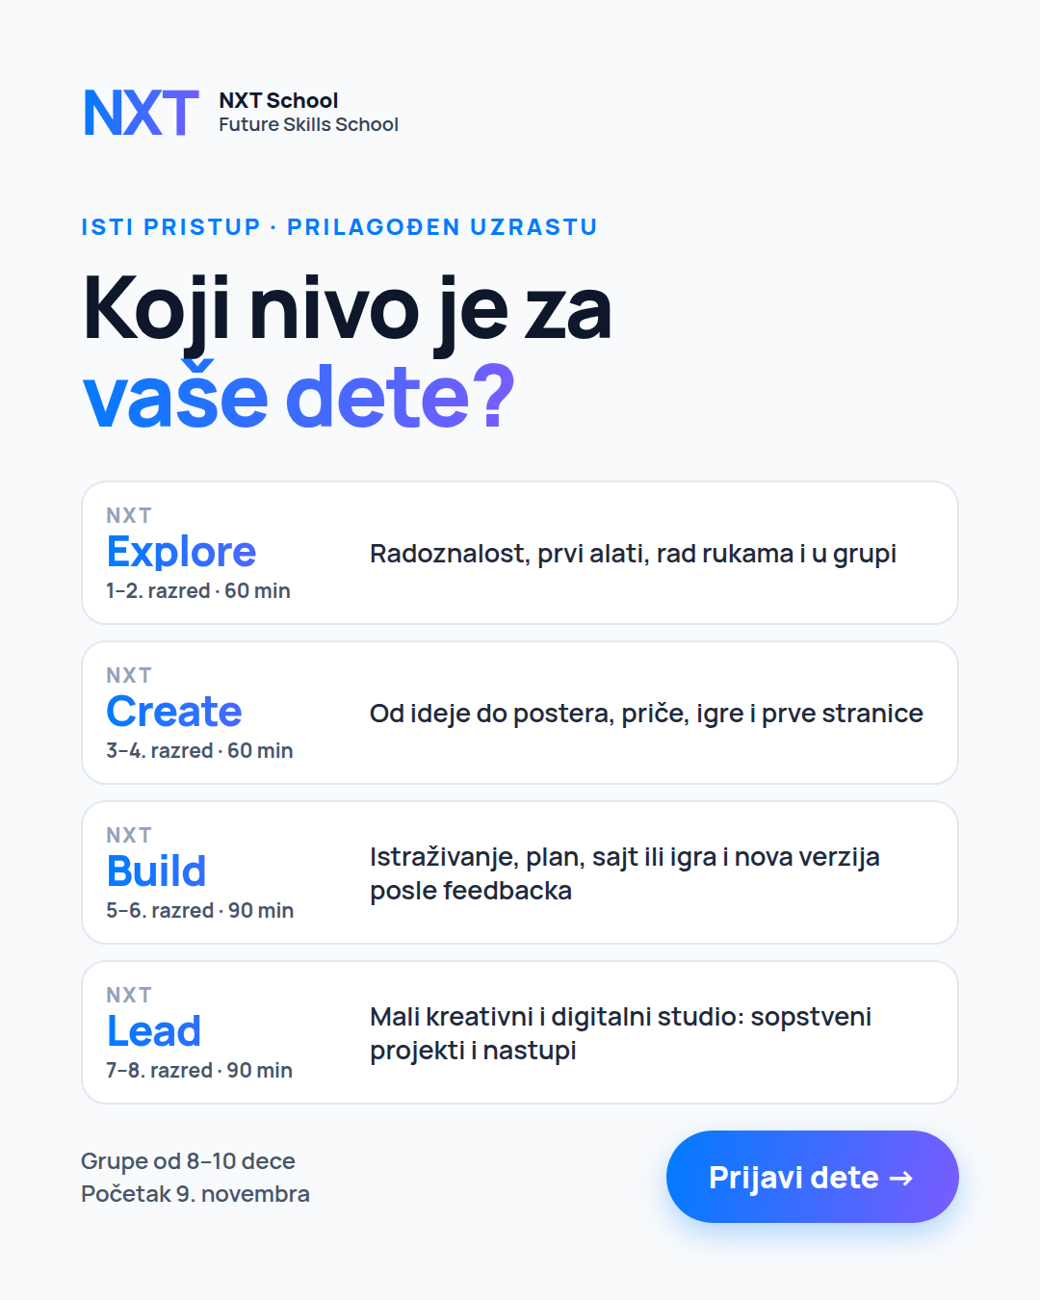 | R4 · C2 "Koji nivo je za vaše dete?" | NEW | STATIC · 4:5 + 9:16 | Live Tue 13 Oct.

TEST THIS PERIOD  • Prospecting: which angle wins (CPL + qualified leads from Ops).  • P1 real space photo vs P1 graphic.  • Retargeting: R1 price vs R2 objections vs R4 levels — judge on CPL. | TO DO THIS PERIOD  • Nikola: O2 (Open Day + winner’s hook) by Tue 13 Oct · 2–3 variants of the winning angle by Wed 14 Oct · O3 countdown by Fri 16 Oct.  • Igor: Šmiranti shoot before ~18 Oct — photos + "Pitali smo decu" videos (see photo/video request list).  • Ops (Ana): log kid’s grade + lost reason on every call.

NEW | KEEP | TEST | PAUSE / ENDS | OFF | STATIC · 4:5 + 9:16 | PHOTO · 4:5 + 9:16 | VIDEO · 9:16 Reel | MOTION 6 s / CAROUSEL
NXT SCHOOL · WEEKLY CREATIVE PLAN · META
Week 3 · 19–25 Oct — Winner variants, first real content, Open Day push
Goal: spend design time only on the winning angle, add the first video Reel, push the Open Day (Mon 26 Oct, 18–20 h). Max 7 ads live in prospecting.
W1 · 6–11 Oct  Launch | W2 · 12–18 Oct  First read + Open Day + RT | W3 · 19–25 Oct  Winner + first real content | W4–5 · 26 Oct–8 Nov  Real content + last call

1 · PROSPECTING ad set 1.1 · ~3,700 RSD/day
 | Ad · creative | Status | Format | What to do / note
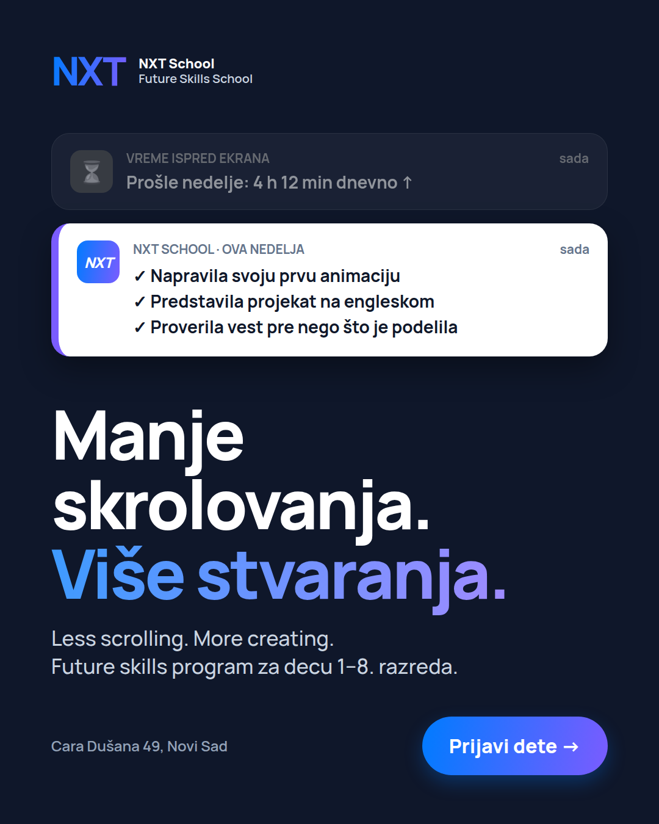 | Winner variants (2–3 ads, one change each)  example: Serbian headline of C3 | NEW | depends on angle ↓ | If 1 Hero wins → kid PHOTO + CAROUSEL "6 oblasti"  If 2 wins → artifact PHOTO · Serbian headline STATIC · MOTION 6 s  If 3 wins → kid presenting PHOTO · If 4 wins → MOTION 6 s · If Offer wins → date-first STATIC
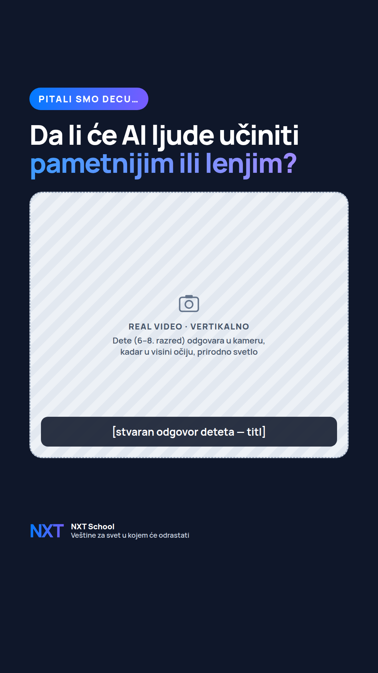 | P6 · Reel "Pitali smo decu…"  Angles 4 + 1 | NEW | VIDEO · 9:16 Reel | 15–30 s from the shoot. Burned-in captions. Runs whatever angle wins.
 | Top-3 original statics from W2 | KEEP | STATIC · 4:5 + 9:16 | They are the "parents" of the variants — keep them running.
 | Bottom angles | PAUSE / ENDS | — | Stay paused.

2 · OPEN DAY ad set 2.1 · runs to Mon 26 Oct, 17 h · Open Day 18–20 h
 | Ad · creative | Status | Format | What to do / note
 | O1 · C6 Open Day | KEEP | STATIC · 4:5 + 9:16 | Until Mon 26 Oct, 17 h.
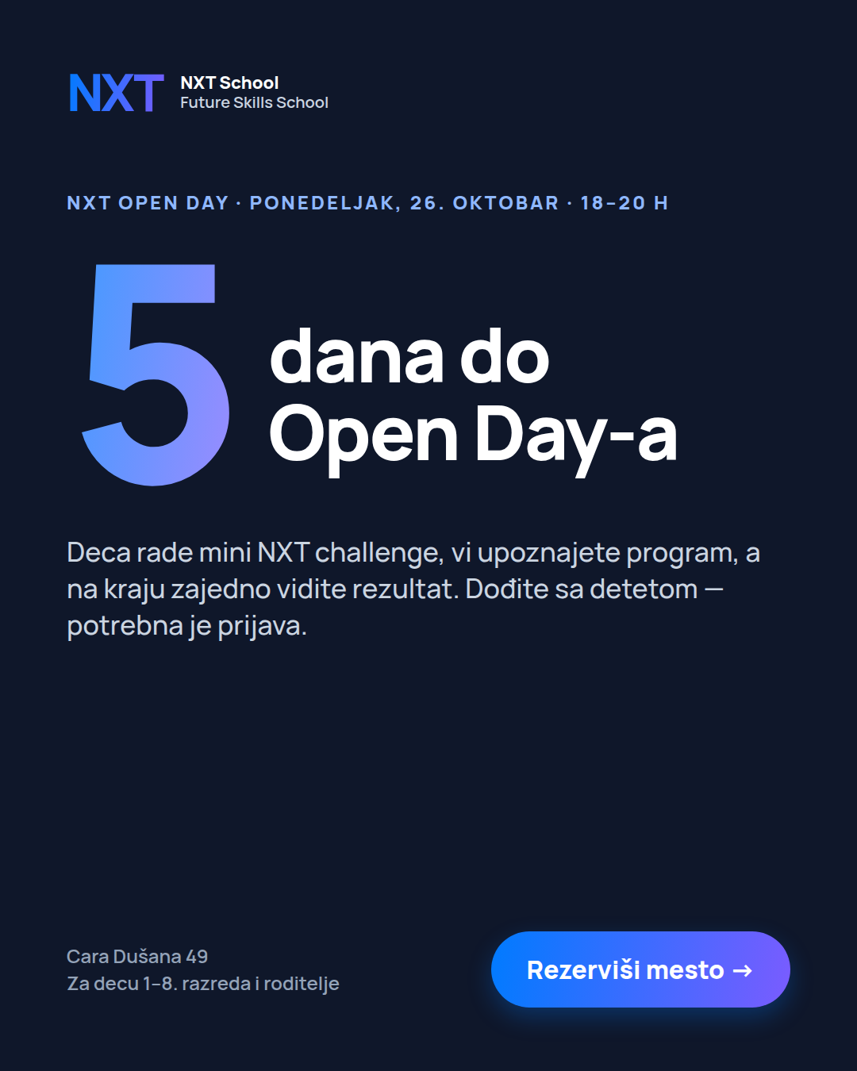 | O3 · Countdown  "Još 5 dana" 21–23 · "U ponedeljak!" 24–26 | TEST | STATIC · 4:5 + 9:16 | Live 21 Oct next to O1.
 | O2 · Open Day + winner’s hook | KEEP | STATIC · 4:5 + 9:16 | Until Mon 26 Oct, 17 h.

3 · RETARGETING ad set 3.1 · max 4 ads
 | Ad · creative | Status | Format | What to do / note
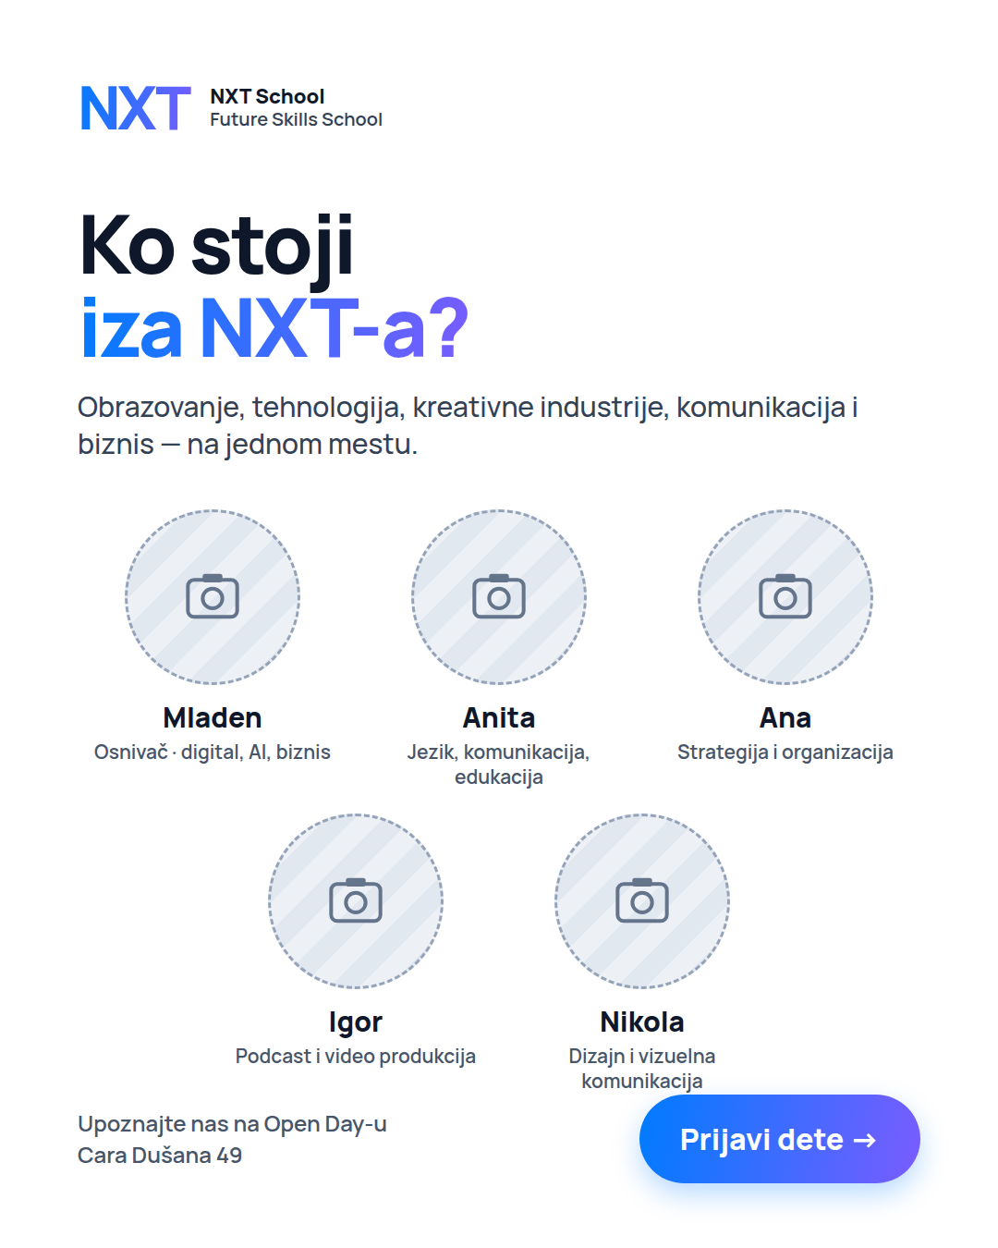 | R5 · "Ko stoji iza NXT-a?" — real team portraits | NEW | PHOTO · 4:5 + 9:16 | Replaces the weakest of R1 / R2 / R4.
 | Best 2 of R1 / R2 / R4 | KEEP | STATIC · 4:5 + 9:16 | Refresh the layout if frequency > 3 per week.
 | R3 · C6 Open Day | KEEP | STATIC · 4:5 + 9:16 | Until Mon 26 Oct, 17 h.

TEST THIS PERIOD  • Each winner variant vs its parent — keep only if CPL is better after ≥ 1,500 impressions.  • O3 countdown vs O1 (Open Day registrations).  • R5 team vs the remaining retargeting ads. | TO DO THIS PERIOD  • Igor: Reel edit by ~20 Oct · shot plan + consent forms for the Open Day.  • Nikola: R6 last call + R7 recap layouts by Mon 26 Oct.  • Ops: Open Day reminders Sat 24 Oct (48 h before) + Mon 26 morning.

NEW | KEEP | TEST | PAUSE / ENDS | OFF | STATIC · 4:5 + 9:16 | PHOTO · 4:5 + 9:16 | VIDEO · 9:16 Reel | MOTION 6 s / CAROUSEL
NXT SCHOOL · WEEKLY CREATIVE PLAN · META
Weeks 4–5 · 26 Oct – 8 Nov — Real content + last call before 9 Nov
Goal: swap mockups for real photos and video, close enrolments before the program starts on Mon 9 Nov. Budget 60/30/10 on winners.
W1 · 6–11 Oct  Launch | W2 · 12–18 Oct  First read + Open Day + RT | W3 · 19–25 Oct  Winner + first real content | W4–5 · 26 Oct–8 Nov  Real content + last call

1 · PROSPECTING ad set 1.1 · until 8 Nov
 | Ad · creative | Status | Format | What to do / note
 | Top 2 ads — real kid-photo versions | NEW | PHOTO · 4:5 + 9:16 | Same copy, real photos from the shoot / Open Day.
 | "Kids Explain the Future" Reels | NEW | VIDEO · 9:16 Reel | 20–40 s, one kid per Reel.
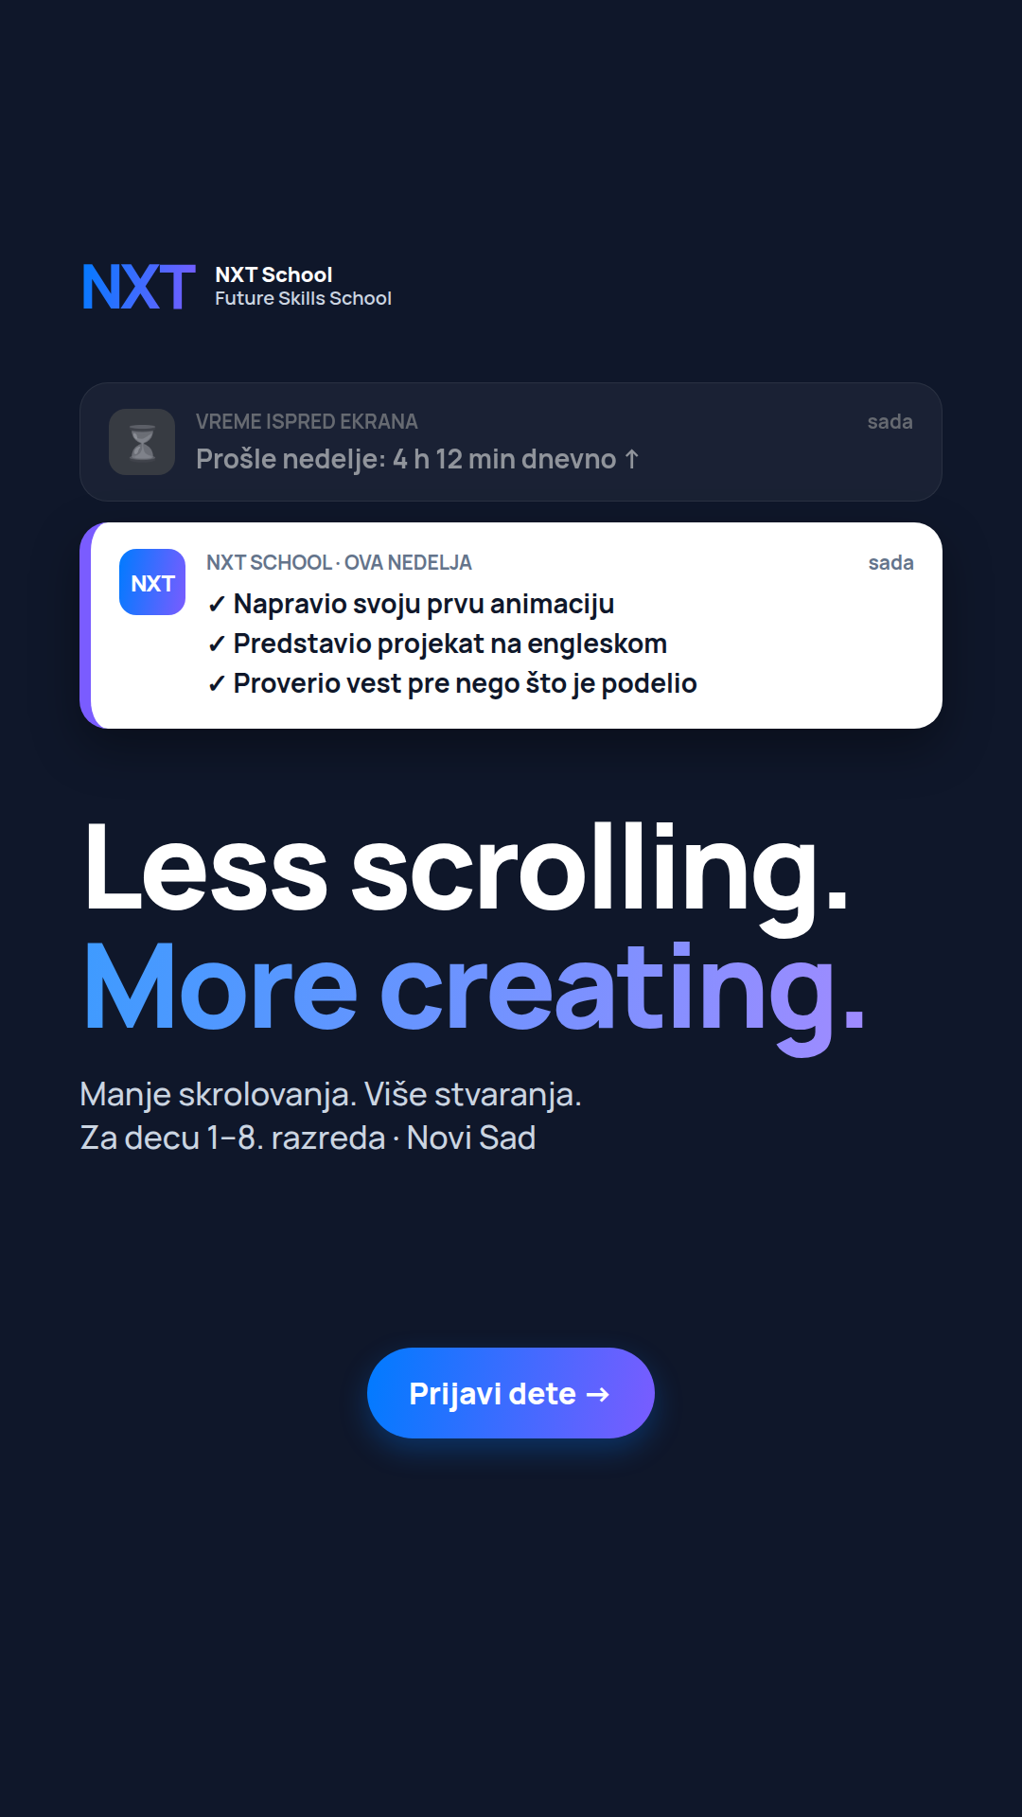 | 15 s Reel "scroll → create" | NEW | VIDEO · 9:16 Reel | From the scroll → create footage.
 | Best W3 variants + P6 Reel | KEEP | depends on angle ↓ | 60% to the winner · 30% its variants · 10% new tests.

2 · OPEN DAY ad set 2.1
 | Ad · creative | Status | Format | What to do / note
 | Last day Mon 26 Oct — stops 17 h, Open Day 18–20 h | OFF | — | From Tue 27 Oct: registrants who didn’t enrol move into retargeting.

3 · RETARGETING ad set 3.1 · until 8 Nov
 | Ad · creative | Status | Format | What to do / note
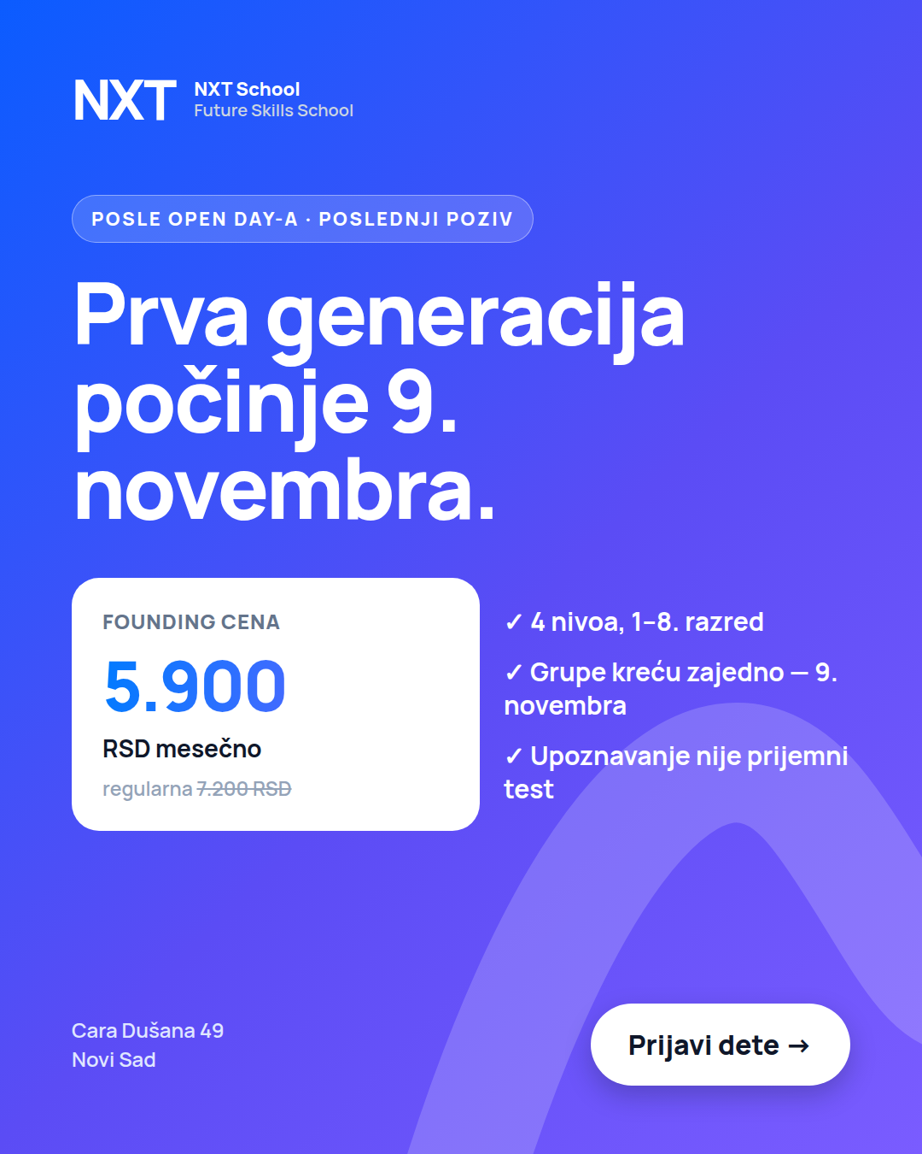 | R6 · "Počinjemo 9. novembra" (last call) | NEW | STATIC · 4:5 + 9:16 | From Tue 27 Oct (after the Open Day).
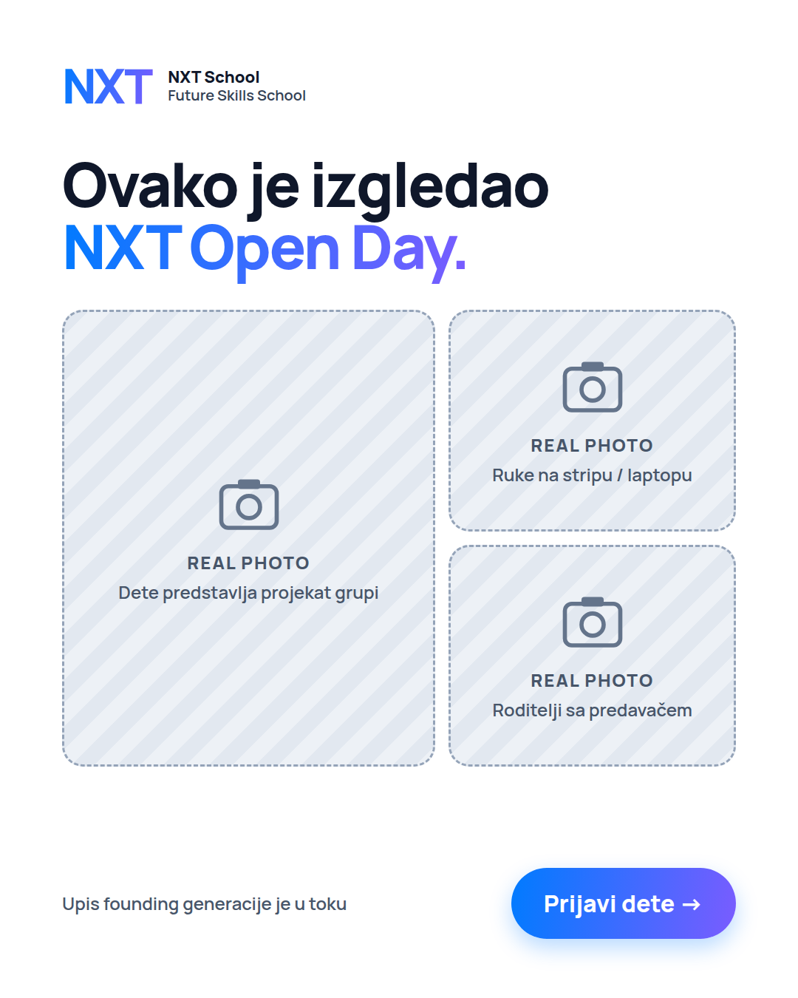 | R7 · Open Day recap | NEW | PHOTO · 4:5 + 9:16 | Real photos from Mon 26 Oct — signed consent only.
 | Best of R1 / R2 / R4 / R5 | KEEP | STATIC · 4:5 + 9:16 | Max 4 ads live in total.

TEST THIS PERIOD  • Real photo vs graphic version of the winners.  • R6 last call vs R7 recap.  • After 9 Nov: pause acquisition; everyone who didn’t enrol → January audience. | TO DO THIS PERIOD  • Igor: Open Day selects within 48 h.  • Ana: first parent quotes + Google review requests.  • Viktor: enrolment cut-off before 9 Nov on site and form.  • Paid: build the 90-day non-converter audience for January.

NEW | KEEP | TEST | PAUSE / ENDS | OFF | STATIC · 4:5 + 9:16 | PHOTO · 4:5 + 9:16 | VIDEO · 9:16 Reel | MOTION 6 s / CAROUSEL

