NXT SCHOOL · DESIGN BRIEF · BATCH 4 OF 4
Batch 4 — for Weeks 4–5 (26 Oct – 8 Nov)
Last call before 9 Nov, the Open Day recap, real-photo versions of the best ads and two more Reels.
# | Deliverable | Format | Due
B4-1 | R6 · Last call | STATIC 4:5 + 9:16 | Mon 26 Oct
B4-2 | R7 · Open Day recap | PHOTO-BASED 4:5 + 9:16 | ~Tue 27 Oct
B4-3 | Top 2 ads · real-photo versions | PHOTO-BASED 4:5 + 9:16 | Wed 28 Oct
B4-4 | Reels · Kids Explain + scroll → create | VIDEO 9:16 (with Igor) | Wed 28 Oct

RULES FOR EVERY BATCH
Brand: Manrope ExtraBold headlines · navy #0F172A · light #F8FAFC · blue #007BFF → purple #7A5CFF gradient as accent only · ≥ 40% whitespace · final NXT logo file (the mockups use a placeholder wordmark).
Sizes: feed 4:5 = 1080 × 1350 (≥ 60 px margins) + story 9:16 = 1080 × 1920 (keep top 250 px and bottom 380 px free of text and CTA). Re-layout for 9:16 — never just crop.
CTA: one pill, "Prijavi dete →" (Open Day ads: "Prijavi se →"). Answers on phone-size text: min ~24 px at 1080 width.
Facts = the website: regular 7.200 RSD · Open Day ponedeljak, 26. oktobar, 18–20 h · no "besplatno" until confirmed · level copy + "6 oblasti" as on the site.
Never: AI-generated children’s faces · rows of kids staring at screens · "Demo Day" (it’s NXT Showcase) · seat counts (the site’s "Broj mesta je ograničen" is fine). Real child photos need signed parental consent.
Delivery: PNG, named AdID_Creative_v#_ratio (e.g. P2_C3_LessScrolling_v1_9x16.png) → shared folder → Mladen signs off → Filip uploads.

B4-1 R6 · Last call "Počinjemo 9. novembra" Retargeting · 27 Oct → 8 Nov
INSPIRATION  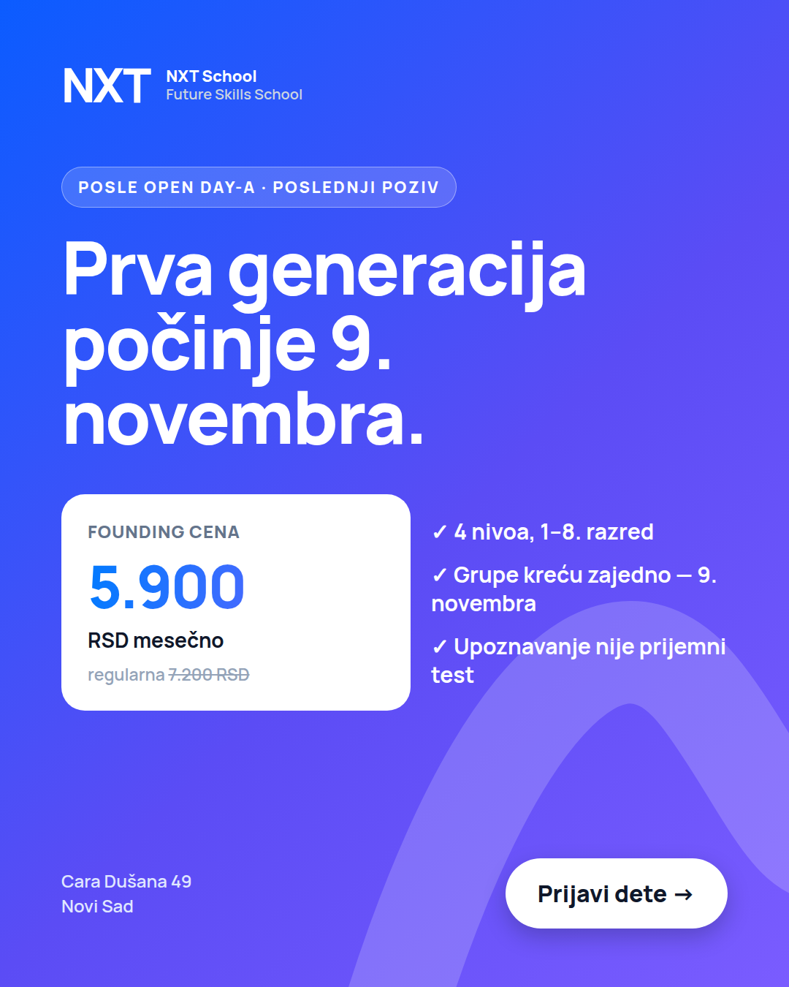  Mockup R6 (4:5) | FINALIZE MOCKUP STATIC · 4:5 + 9:16 Due: Mon 26 Oct  UPDATED 6 OCT (website) · regular price 7.200 · tick 2 = "Grupe kreću zajedno — 9. novembra" · goes live Tue 27 Oct (after the Open Day).  Job: close warm parents before the program starts.  Make / improve:  • Same look as C5 (gradient), the date is the hero.  • Price card + 3 ticks.  • 4:5 + 9:16.  On the image (exact text):  — badge: POSLE OPEN DAY-A · POSLEDNJI POZIV  — headline: Prva generacija počinje 9. novembra.  — price: FOUNDING CENA 5.900 RSD mesečno · regularna 7.200 RSD  — ticks: 4 nivoa, 1–8. razred · Grupe kreću zajedno — 9. novembra · Upoznavanje nije prijemni test  — CTA: Prijavi dete →  Avoid: countdown gimmicks or seat counts.  Copy that runs with it: headline "Počinjemo 9. novembra" · primary: Last call text (appendix).

B4-2 R7 · Open Day recap Retargeting · from ~27 Oct
INSPIRATION  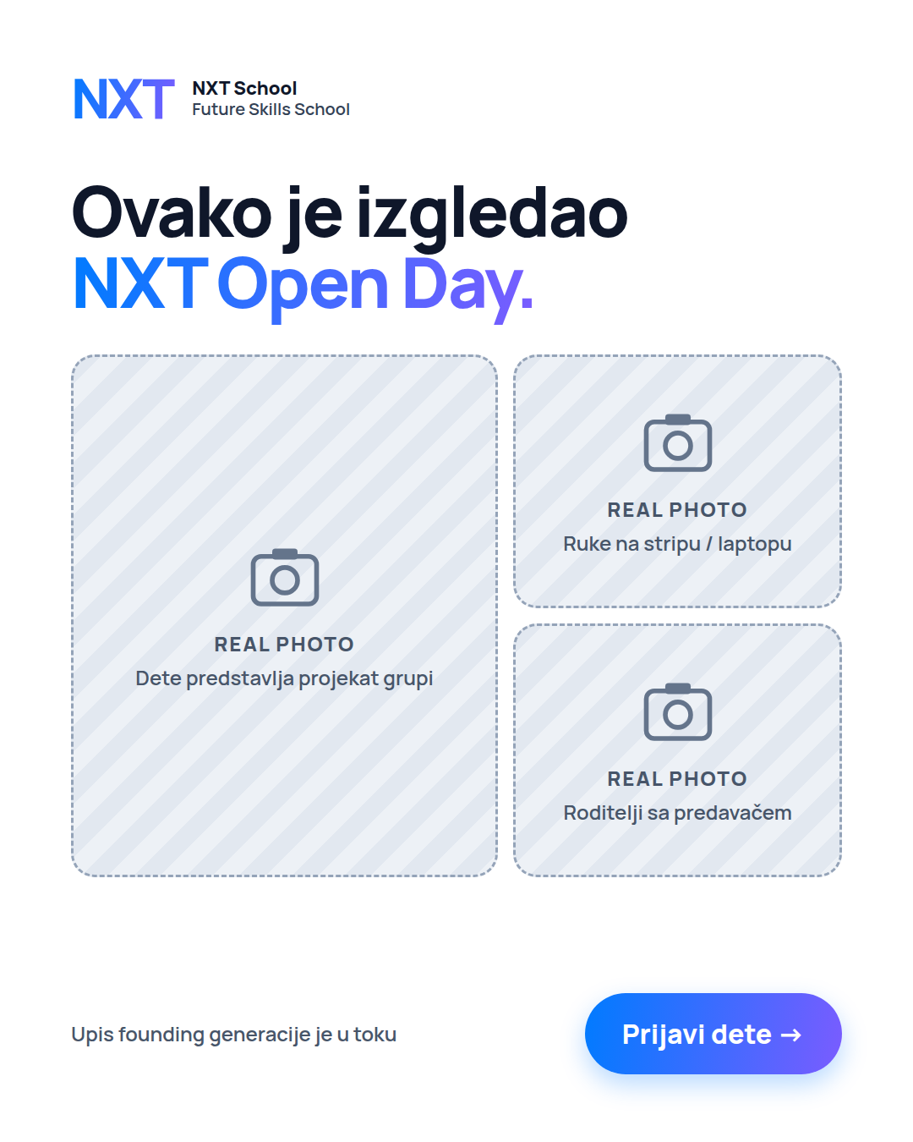  Layout wireframe  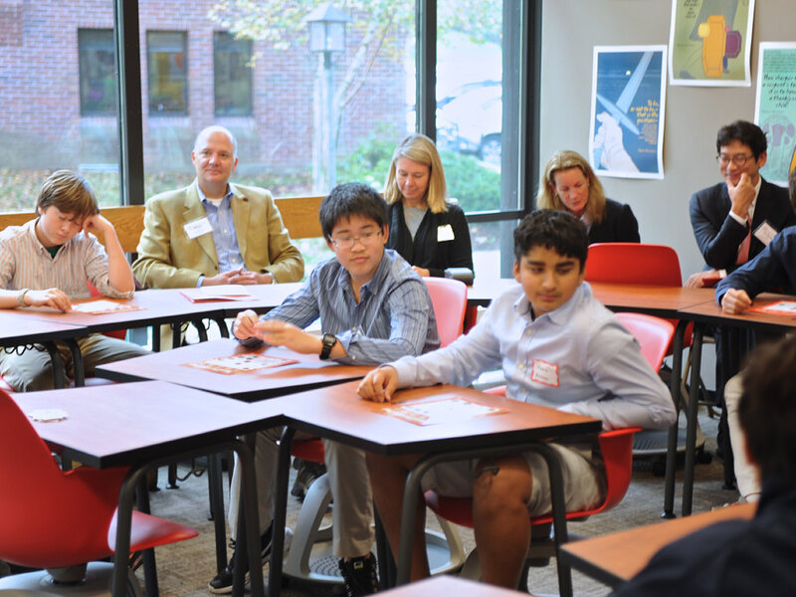  Reference: Open Day room | NEW · NEEDS PHOTOS PHOTO-BASED · 4:5 + 9:16 Due: 48 h after Igor’s Open Day selects (~Tue 27 Oct)  Job: show real kids and parents at NXT — first social proof.  Make / improve:  • 3-photo collage: one big (a kid presenting / Show & Tell) + two small (hands on a project, parents with the team).  • Warm, natural grading; no heavy filters.  • Only photos with signed consent; no kids’ names.  On the image (exact text):  — headline: Ovako je izgledao NXT Open Day.  — footer: Upis founding generacije je u toku · CTA: Prijavi dete →  Needs: Igor’s Open Day selects + consent list  Avoid: posed group photos, photos of kids without consent.  Copy that runs with it: headline "Upis prve generacije je u toku" · short "Ovako je izgledao NXT Open Day. Upis founding generacije je u toku — početak 9. novembra."

B4-3 Top 2 ads — real-photo versions Prospecting · W4–5
INSPIRATION  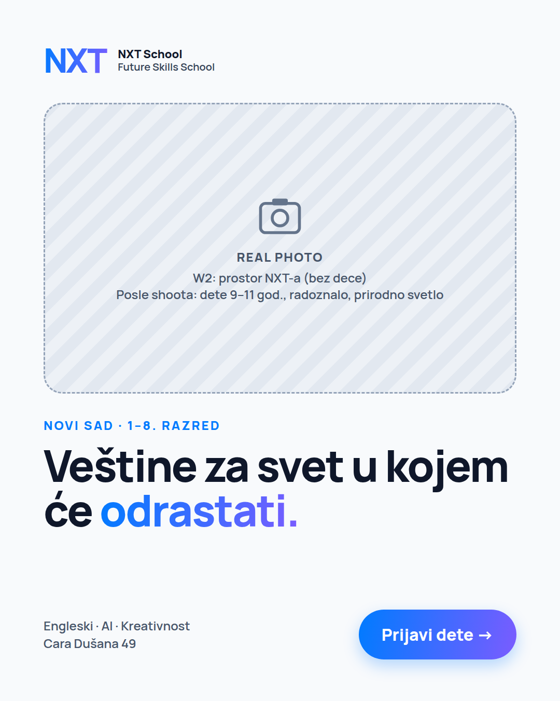  Layout idea  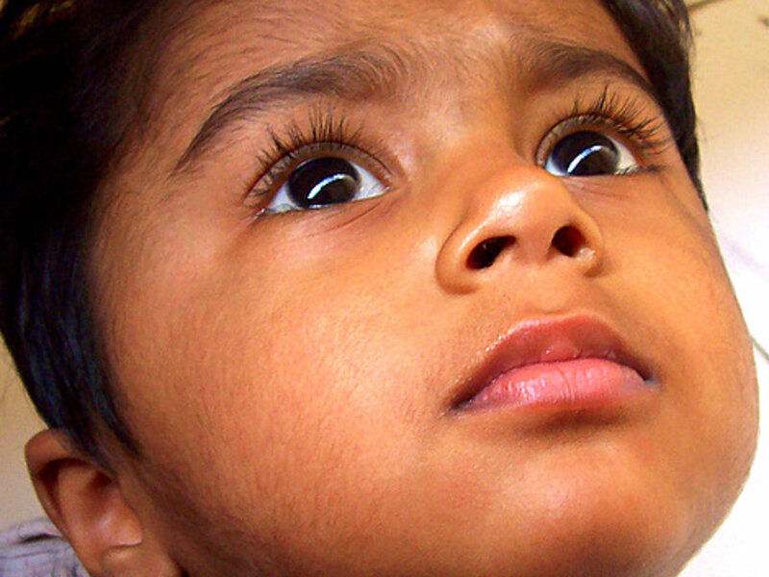  Reference: curious kid  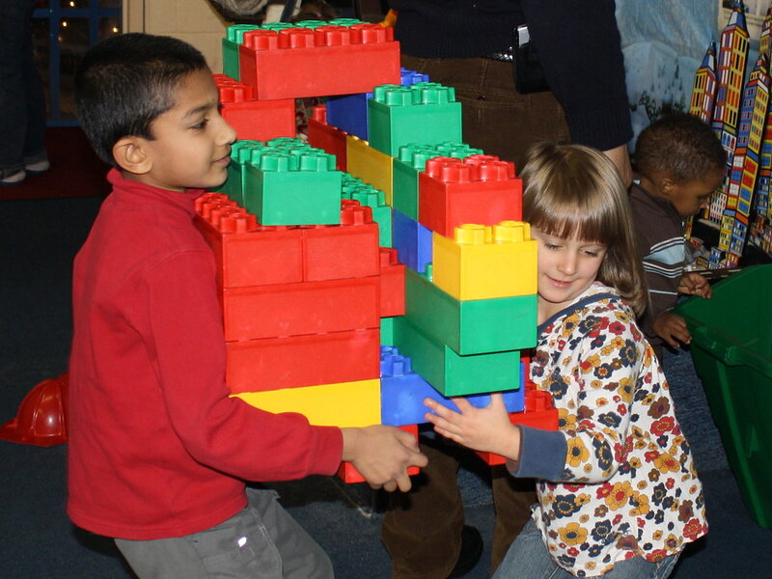  Reference: hands making | NEW · NEEDS PHOTOS PHOTO-BASED · 4:5 + 9:16 Due: Wed 28 Oct  Job: does a real photo lift the two best ads? — one change: the visual.  Make / improve:  • Filip names the top 2 ads on Mon 26 Oct.  • Keep text and layout; replace the graphic area with the best matching real photo from the shoot / Open Day.  • Kid-eye-height photos, natural light; leave room for the headline.  On the image (exact text):  — Same text as the original ads.  Needs: shoot + Open Day selects  Avoid: stock photos, rows of screens, kids without consent.  Copy that runs with it: same as the originals.

B4-4 Reels — "Kids Explain the Future" + 15 s "scroll → create" Prospecting · W4–5 · video by Igor
INSPIRATION  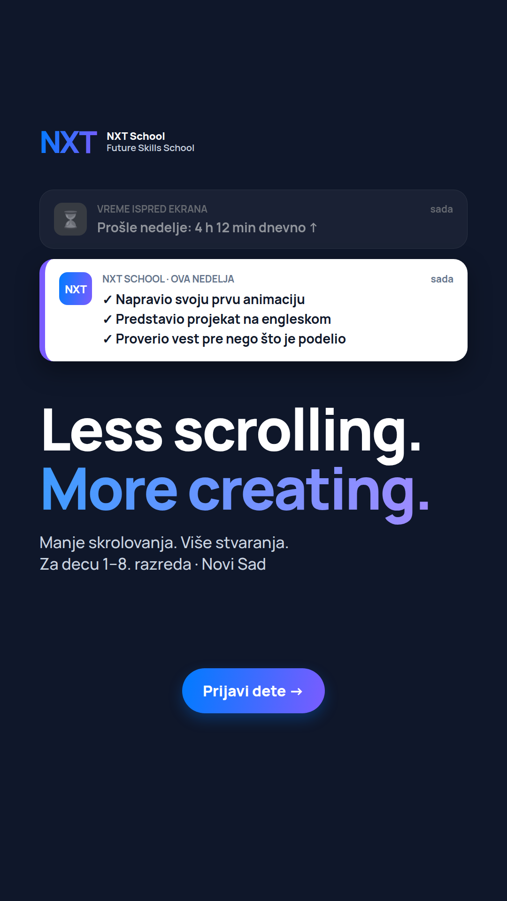  Look for "scroll → create" text cards  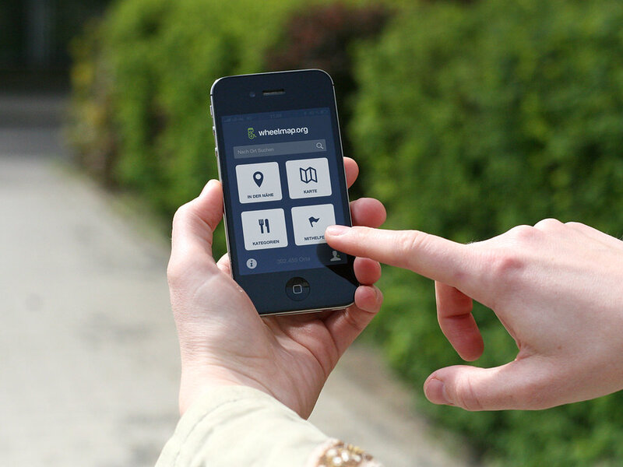  Reference: scroll b-roll | NEW DESIGN VIDEO 9:16 · design parts Due: Wed 28 Oct (with Igor)  Job: two more native Reels from real footage.  Make / improve:  • Reuse the P6 caption style, end card and cover template.  • "Kids Explain the Future": title card with the prompt question.  • "Scroll → create": two text cards — cold grey for scrolling, warm brand colours for making.  On the image (exact text):  — Kids Explain title: Kako zamišljaš školu budućnosti?  — scroll → create cards: 4 h dnevno skrolovanja? → Ovde deca stvaraju. → …i predstavljaju šta su napravila.  — end card: NXT School · Prijavi dete · početak 9. novembra  Needs: Igor’s edits  Avoid: music-only reliance — every message must read with sound off.  Copy that runs with it: Reel caption adapted (appendix).

