NXT SCHOOL · DESIGN BRIEF · BATCH 2 OF 4
Batch 2 — for Week 2 (12–18 Oct)
Open Day + retargeting statics, and the first real photo (the space) in the Hero ad.
# | Deliverable | Format | Due
B2-1 | O1 / R3 · C6 Open Day | STATIC 4:5 + 9:16 | Fri 9 Oct
B2-2 | R2 · FAQ | STATIC 4:5 + 9:16 | Mon 12 Oct
B2-3 | R4 · C2 Levels | STATIC 4:5 + 9:16 | Mon 12 Oct
B2-4 | P1-photo · Hero with space photo | PHOTO-BASED 4:5 + 9:16 | when photos arrive (~Fri 9 Oct)
B2-5 | O2 · winner + Open Day band | STATIC 4:5 + 9:16 | Tue 13 Oct

RULES FOR EVERY BATCH
Brand: Manrope ExtraBold headlines · navy #0F172A · light #F8FAFC · blue #007BFF → purple #7A5CFF gradient as accent only · ≥ 40% whitespace · final NXT logo file (the mockups use a placeholder wordmark).
Sizes: feed 4:5 = 1080 × 1350 (≥ 60 px margins) + story 9:16 = 1080 × 1920 (keep top 250 px and bottom 380 px free of text and CTA). Re-layout for 9:16 — never just crop.
CTA: one pill, "Prijavi dete →" (Open Day ads: "Prijavi se →"). Answers on phone-size text: min ~24 px at 1080 width.
Never: AI-generated children’s faces · rows of kids staring at screens · "Demo Day" (it’s NXT Showcase) · "mesta ograničena" without a real seat count. Any real child photo needs signed parental consent.
Delivery: PNG, named AdID_Creative_v#_ratio (e.g. P2_C3_LessScrolling_v1_9x16.png) → shared folder → Mladen signs off → Filip uploads.

B2-1 O1 / R3 · C6 Open Day Open Day from 12 Oct + Retargeting from 13 Oct
INSPIRATION  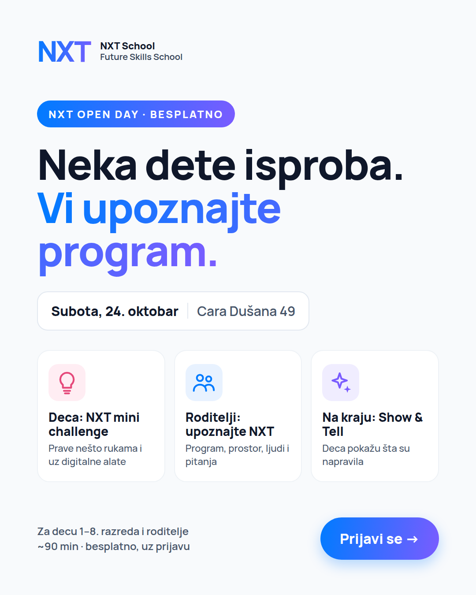  Mockup C6 (4:5)  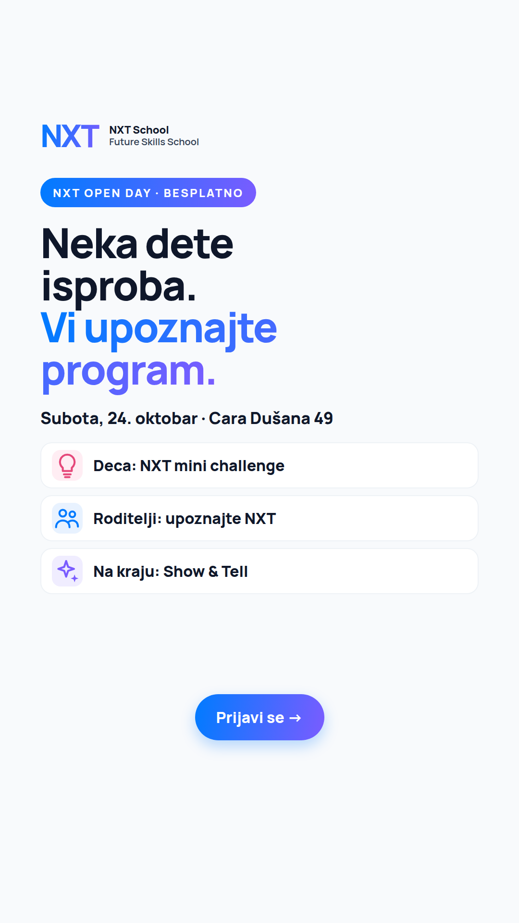  Story version (9:16) | FINALIZE MOCKUP STATIC · 4:5 + 9:16 Due: Fri 9 Oct  Job: experience-led invite that fills the Open Day.  Make / improve:  • Date + address card prominent; keep the date as ONE editable text layer (date still to confirm).  • 3 step tiles in the order the day happens.  • Build the 9:16 from the story mock.  On the image (exact text):  — badge: NXT OPEN DAY · BESPLATNO  — headline: Neka dete isproba. Vi upoznajte program.  — date card: Subota, 24. oktobar · Cara Dušana 49  — tiles: Deca: NXT mini challenge · Roditelji: upoznajte NXT · Na kraju: Show & Tell  — footer: Za decu 1–8. razreda i roditelje · ~90 min · besplatno, uz prijavu  — CTA: Prijavi se →  Avoid: workshop names we haven’t confirmed (the old "AI detektivi" etc.).  Copy that runs with it: headline "NXT Open Day · Subota, 24. oktobar" · short "Deca rade kratak NXT mini challenge, vi upoznajete program i ljude iza NXT-a. Oko 90 min, besplatno."

B2-2 R2 · FAQ "Još razmišljate?" Retargeting from 13 Oct
INSPIRATION  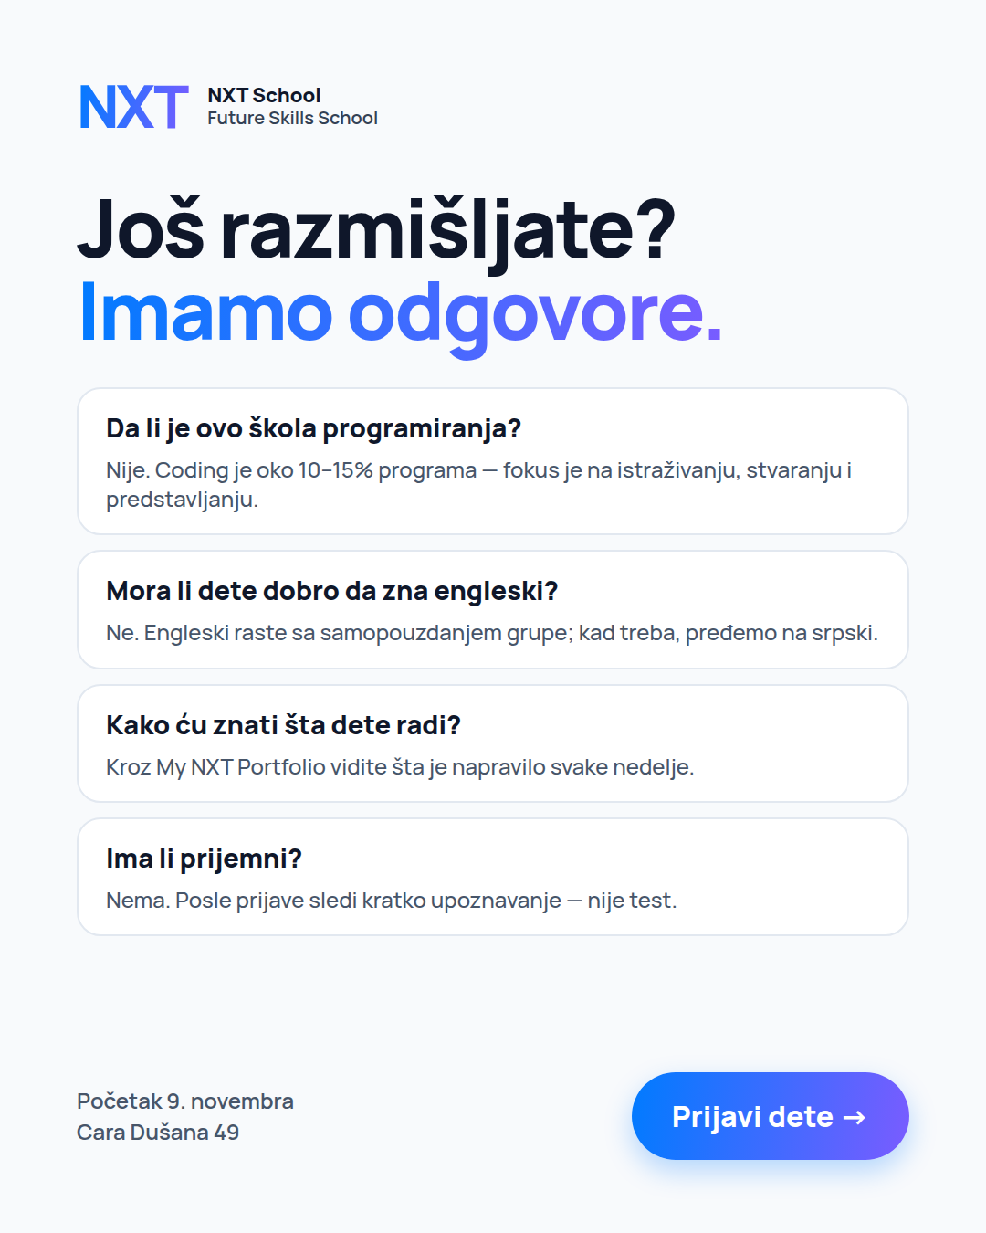  Mockup R2 (4:5) | FINALIZE MOCKUP STATIC · 4:5 + 9:16 Due: Mon 12 Oct  Job: remove the 4 doubts that stop warm parents.  Make / improve:  • Questions bold, answers max 2 lines each.  • Readable on a phone: answers at least ~24 px at 1080 width.  • 9:16: same 4 cards stacked, slightly smaller headline.  On the image (exact text):  — headline: Još razmišljate? Imamo odgovore.  — Q1 Da li je ovo škola programiranja? — Nije. Coding je oko 10–15% programa — fokus je na istraživanju, stvaranju i predstavljanju.  — Q2 Mora li dete dobro da zna engleski? — Ne. Engleski raste sa samopouzdanjem grupe; kad treba, pređemo na srpski.  — Q3 Kako ću znati šta dete radi? — Kroz My NXT Portfolio vidite šta je napravilo svake nedelje.  — Q4 Ima li prijemni? — Nema. Posle prijave sledi kratko upoznavanje — nije test.  — footer: Početak 9. novembra · Cara Dušana 49 · CTA: Prijavi dete →  Avoid: more than 4 questions; tiny text.  Copy that runs with it: headline "Još razmišljate? Imamo odgovore." · primary: FAQ text (Creative Plan appendix).

B2-3 R4 · C2 "Koji nivo je za vaše dete?" Retargeting from 13 Oct
INSPIRATION  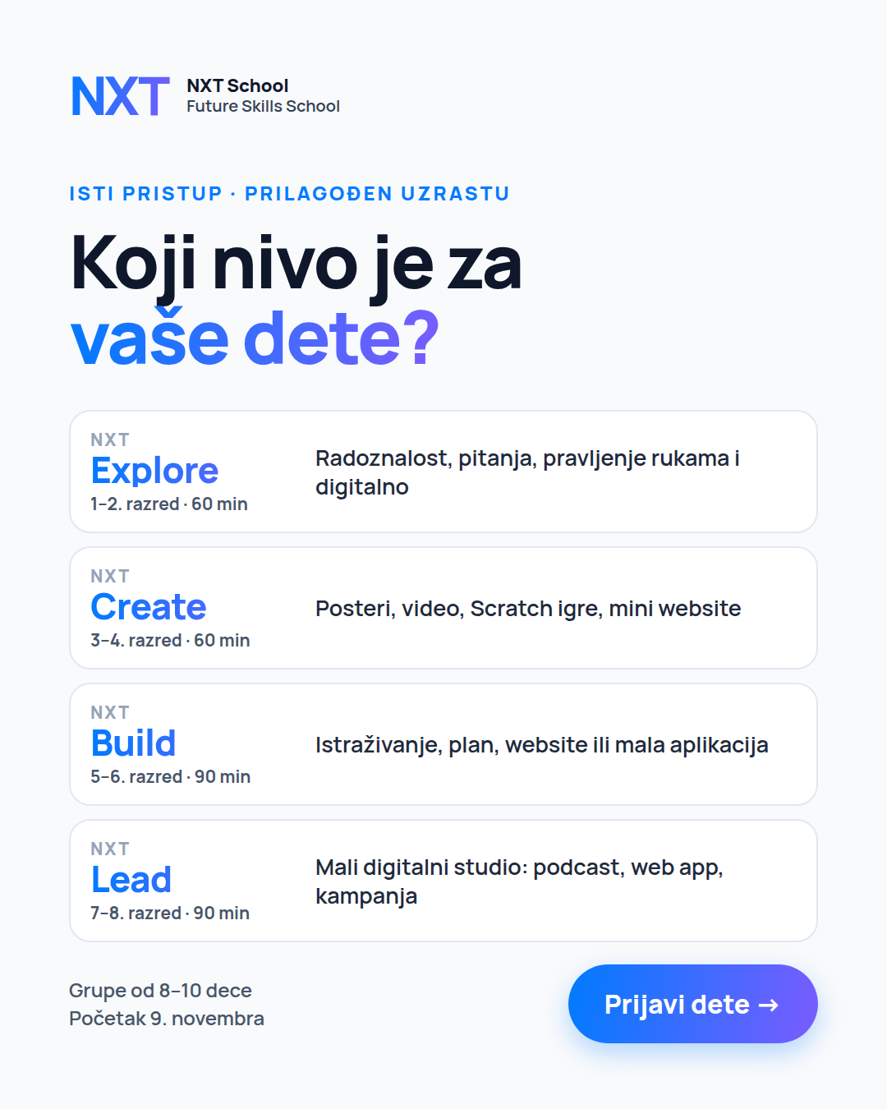  Mockup C2 (4:5) | FINALIZE MOCKUP STATIC · 4:5 + 9:16 Due: Mon 12 Oct  Job: let parents find their kid’s level in seconds (and show us which grades click).  Make / improve:  • Level names in the gradient, grade + class length small under each.  • The NXT Lead row must look grown-up, not "kids".  • Optional: one small icon per level.  On the image (exact text):  — kicker: Isti pristup · prilagođen uzrastu  — headline: Koji nivo je za vaše dete?  — Explore · 1–2. razred · 60 min — Radoznalost, pitanja, pravljenje rukama i digitalno  — Create · 3–4. razred · 60 min — Posteri, video, Scratch igre, mini website  — Build · 5–6. razred · 90 min — Istraživanje, plan, website ili mala aplikacija  — Lead · 7–8. razred · 90 min — Mali digitalni studio: podcast, web app, kampanja  — footer: Grupe od 8–10 dece · Početak 9. novembra · CTA: Prijavi dete →  Avoid: cartoon mascots or toy-like icons for Build / Lead.  Copy that runs with it: headline "Koji nivo je za vaše dete?" · short "Isti NXT pristup, prilagođen uzrastu. Grupe od 8–10, početak 9. novembra."

B2-4 P1-photo · C1 Hero with a real space photo Prospecting · test vs P1 graphic
INSPIRATION  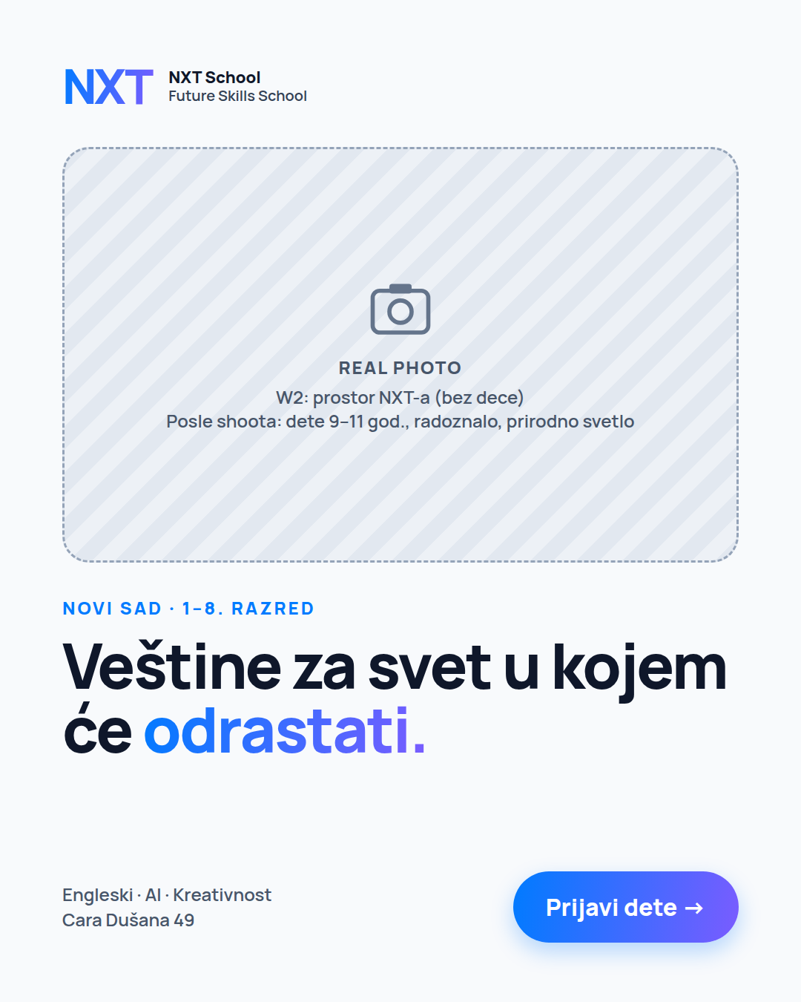  Layout wireframe  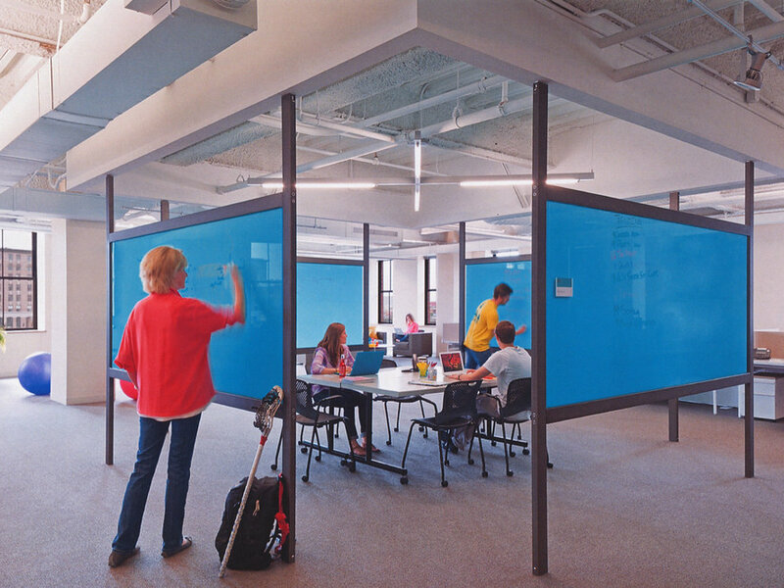  Reference: type of space shot | NEW · NEEDS PHOTOS PHOTO-BASED · 4:5 + 9:16 Due: when Igor’s space photos arrive (~Fri 9 Oct)  Job: does a real photo beat the graphic? — ONE change only: the background.  Make / improve:  • Same layout and text as P1.  • Photo fills the top ~45%; keep the gradient wave as an accent line.  • Grade the photo for clean text contrast (light, airy, no heavy filters).  On the image (exact text):  — Same as B1-1 (kicker, headline, chips, CTA). No new text.  Needs: Igor’s best wide shot of the empty space (tables, materials, light)  Avoid: empty rows of computers; dark or cluttered corners.  Copy that runs with it: same as P1.

B2-5 O2 · winning P-ad + Open Day band Open Day from 13 Oct
INSPIRATION  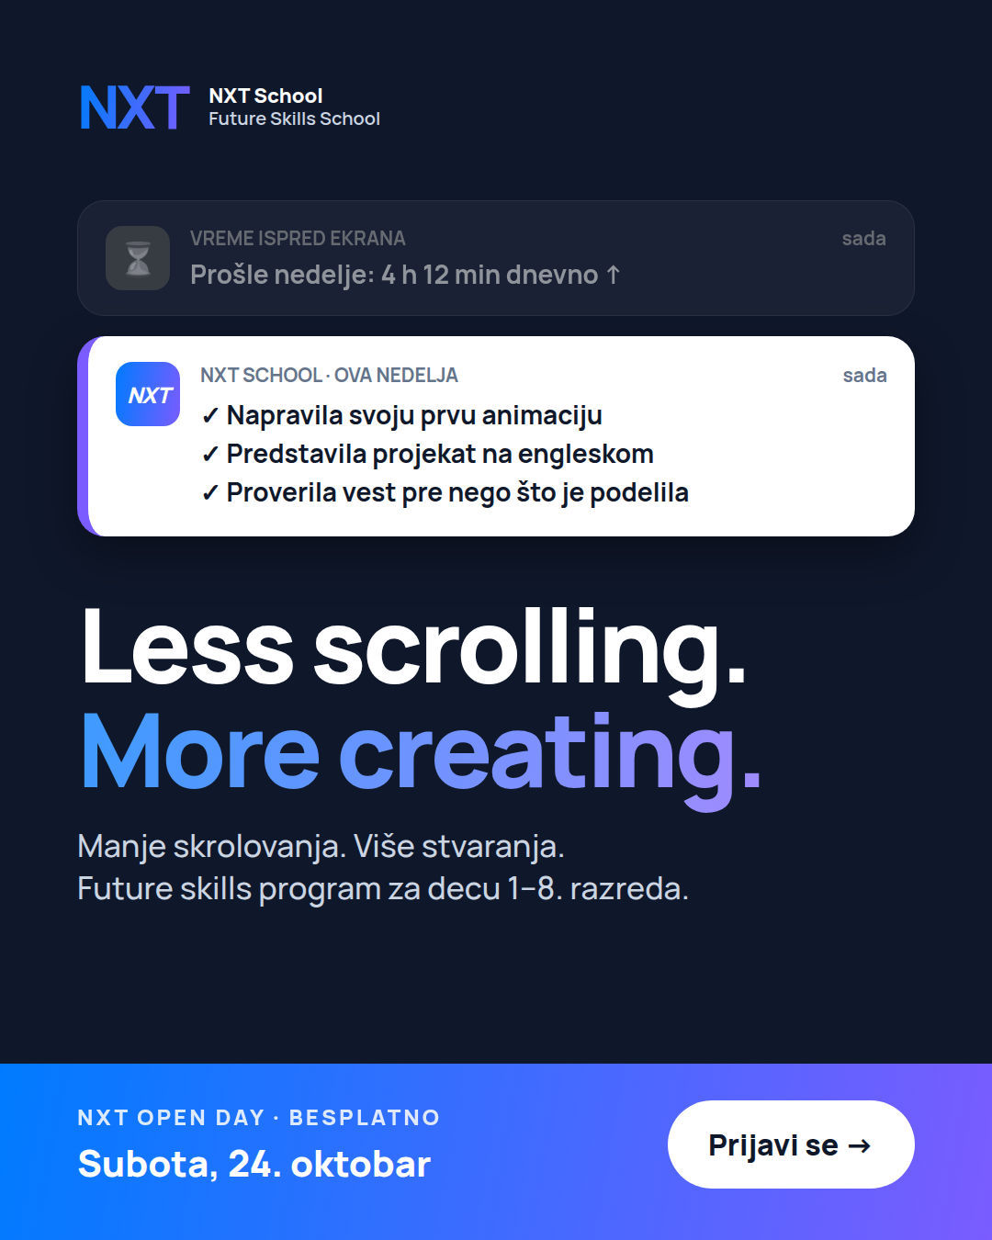  Example: C3 + band (4:5) | REUSE + EDIT STATIC · 4:5 + 9:16 Due: Tue 13 Oct  Job: reuse the visual parents already responded to, to fill the Open Day.  Make / improve:  • Filip tells you on Mon 12 Oct which P-ad leads.  • Replace its footer with the gradient Open Day band; everything else stays.  • Do both 4:5 and 9:16.  On the image (exact text):  — band: NXT OPEN DAY · BESPLATNO / Subota, 24. oktobar  — CTA (white pill): Prijavi se →  Avoid: changing the headline or visual of the winner.  Copy that runs with it: Open Day copy, first line adapted to the winning angle.

