NXT SCHOOL · DESIGN BRIEF · BATCH 3 OF 4
Batch 3 — for Week 3 (19–25 Oct)
Variants of the winning angle, the Open Day countdown, the team ad with real portraits and the first Reel package.
# | Deliverable | Format | Due
B3-1 | Winner variants (2–3) | STATIC / MOTION / CAROUSEL | Wed 14 Oct
B3-2 | O3 · Countdown (2 versions) | STATIC 4:5 + 9:16 | Fri 16 Oct
B3-3 | R5 · Team | PHOTO-BASED 4:5 + 9:16 | when portraits are ready
B3-4 | P6 · Reel design parts | VIDEO 9:16 (with Igor) | ~Tue 20 Oct

RULES FOR EVERY BATCH
Brand: Manrope ExtraBold headlines · navy #0F172A · light #F8FAFC · blue #007BFF → purple #7A5CFF gradient as accent only · ≥ 40% whitespace · final NXT logo file (the mockups use a placeholder wordmark).
Sizes: feed 4:5 = 1080 × 1350 (≥ 60 px margins) + story 9:16 = 1080 × 1920 (keep top 250 px and bottom 380 px free of text and CTA). Re-layout for 9:16 — never just crop.
CTA: one pill, "Prijavi dete →" (Open Day ads: "Prijavi se →"). Answers on phone-size text: min ~24 px at 1080 width.
Never: AI-generated children’s faces · rows of kids staring at screens · "Demo Day" (it’s NXT Showcase) · "mesta ograničena" without a real seat count. Any real child photo needs signed parental consent.
Delivery: PNG, named AdID_Creative_v#_ratio (e.g. P2_C3_LessScrolling_v1_9x16.png) → shared folder → Mladen signs off → Filip uploads.

B3-1 Winner variants (2–3 ads, one change each) Prospecting · W3 · ONLY for the winning angle
INSPIRATION  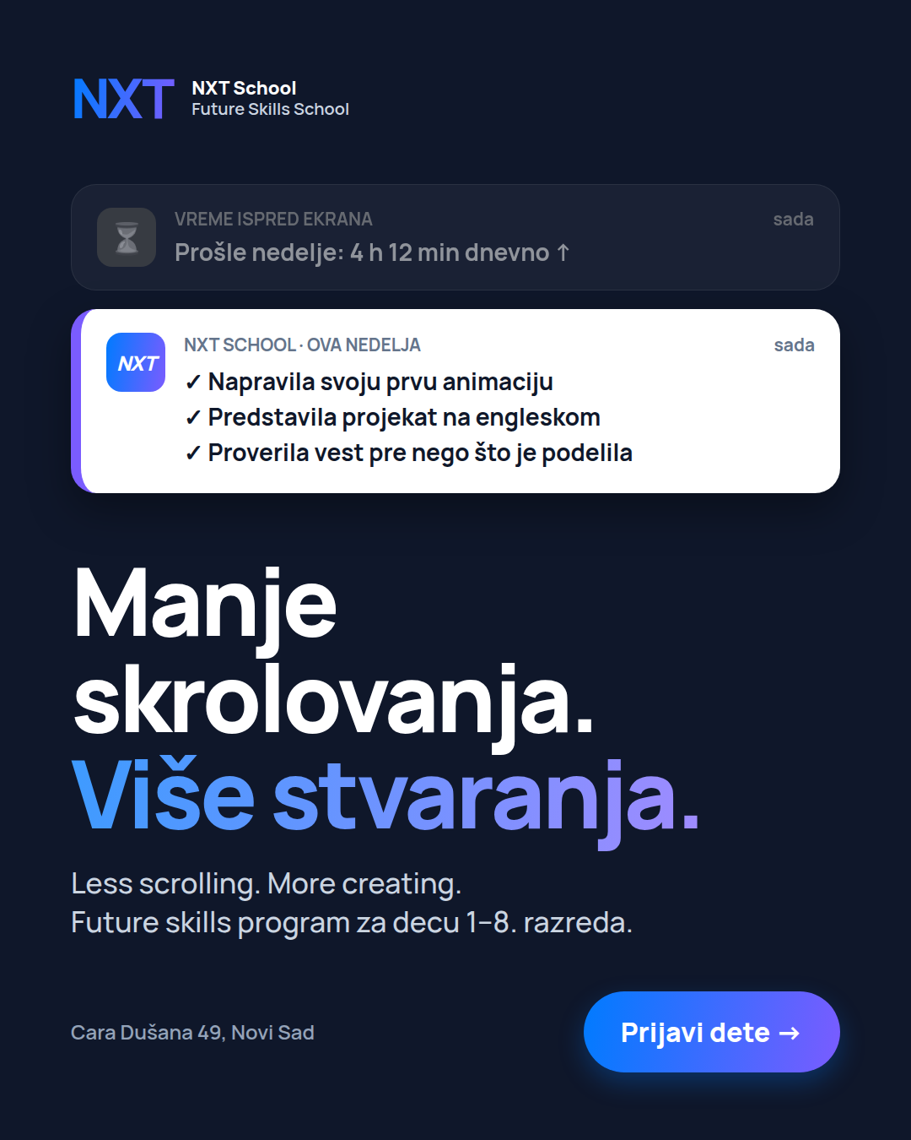  Example: C3 with Serbian headline  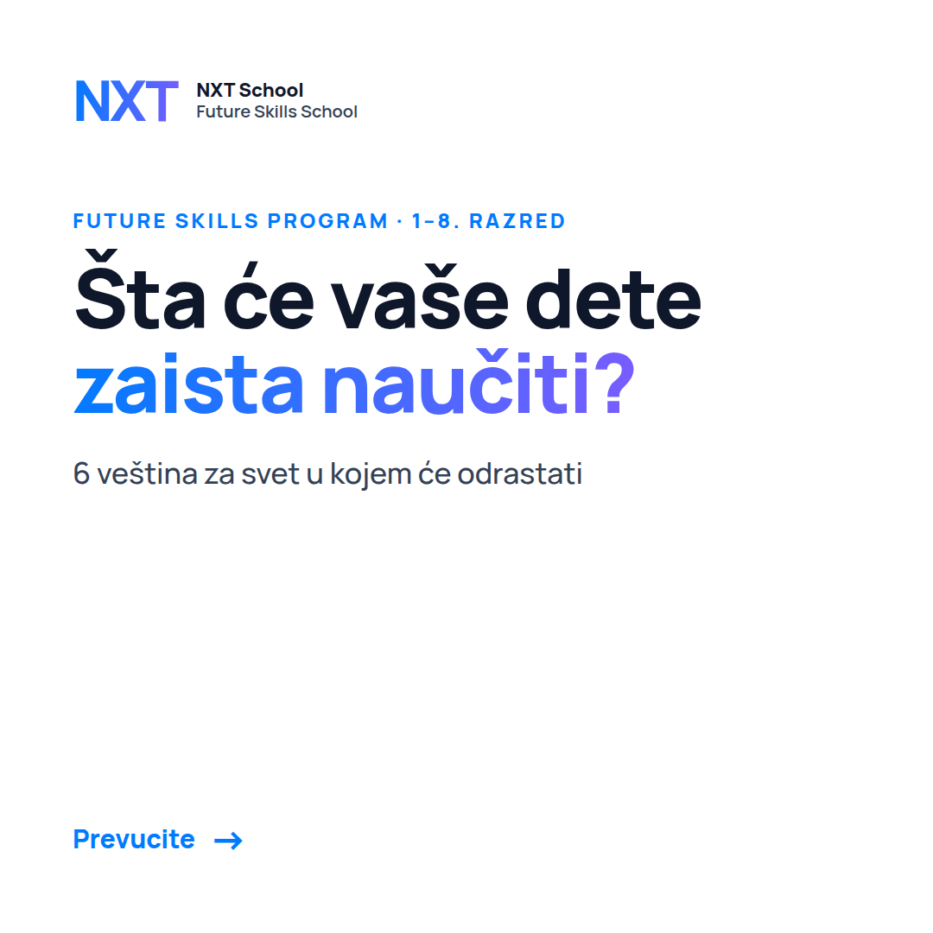  Carousel card 1 (if angle 1 wins) | NEW DESIGN STATIC / MOTION / CAROUSEL Due: Wed 14 Oct  Job: beat the winning ad with one change at a time. Filip names the winner on Mon 12 Oct.  Make / improve:  • If 1 Hero wins: (a) C1 with the curious-kid photo · (b) "6 veština" carousel 1:1 (7 cards).  • If 2 Less scrolling wins: (a) Serbian headline version · (b) artifact photo "Ovo sam danas napravio" · (c) 6 s motion: alerts slide in.  • If 3 English wins: (a) kid-presenting photo · (b) Serbian-first headline.  • If 4 AI wins: (a) 6 s motion: steps build 1 → 4 · (b) static safety hook "Da li bi vaše dete prepoznalo lažnu poruku?"  • If Offer wins: (a) date-first layout "Počinje 9. novembra" · (b) portfolio visual.  On the image (exact text):  — Same text as the winner except the ONE thing being tested.  Needs: photos from the Šmiranti shoot for the photo variants  Avoid: changing two things in one variant.  Copy that runs with it: same copy as the winner; name files _v2, _v3.

B3-2 O3 · Open Day countdown Open Day · 19–23 Oct · test vs O1
INSPIRATION  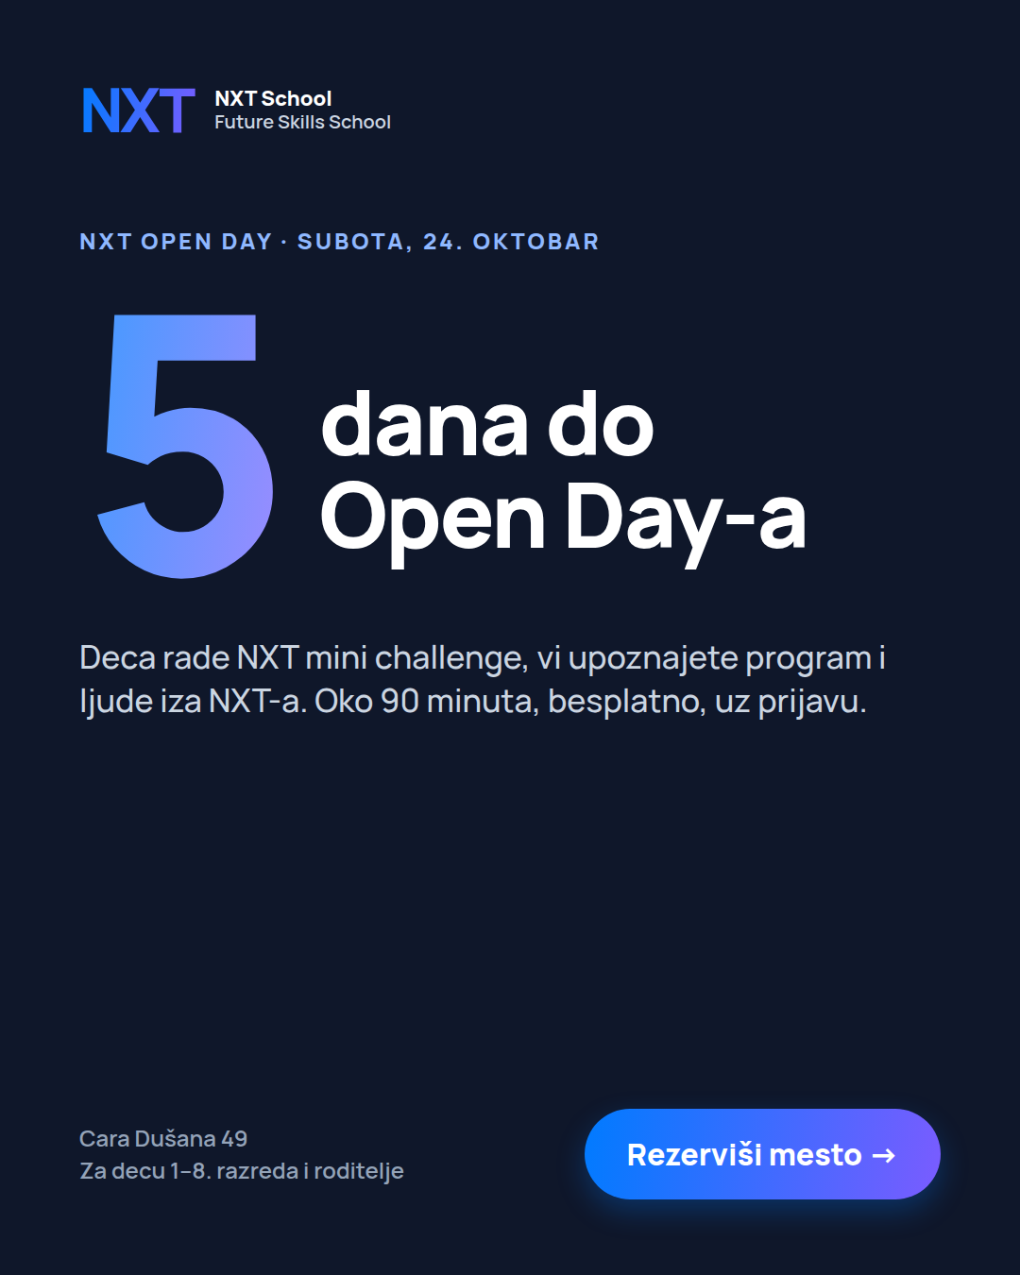  Mockup countdown (4:5) | FINALIZE MOCKUP STATIC · 4:5 + 9:16 Due: Fri 16 Oct  Job: does urgency beat the experience message in the last 5 days?  Make / improve:  • Two versions — only the big number / headline changes.  • Version A: "5 dana do Open Day-a" (19–21 Oct) · Version B: "Ove subote!" (22–23 Oct).  • Both in 4:5 + 9:16.  On the image (exact text):  — kicker: NXT Open Day · Subota, 24. oktobar  — big: 5 dana do Open Day-a / Ove subote!  — sub: Deca rade NXT mini challenge, vi upoznajete program i ljude iza NXT-a. Oko 90 minuta, besplatno, uz prijavu.  — CTA: Rezerviši mesto →  Avoid: fake scarcity numbers.  Copy that runs with it: first line "Još 5 dana do NXT Open Day-a." / "Ove subote je NXT Open Day."

B3-3 R5 · "Ko stoji iza NXT-a?" (team) Retargeting from W3
INSPIRATION  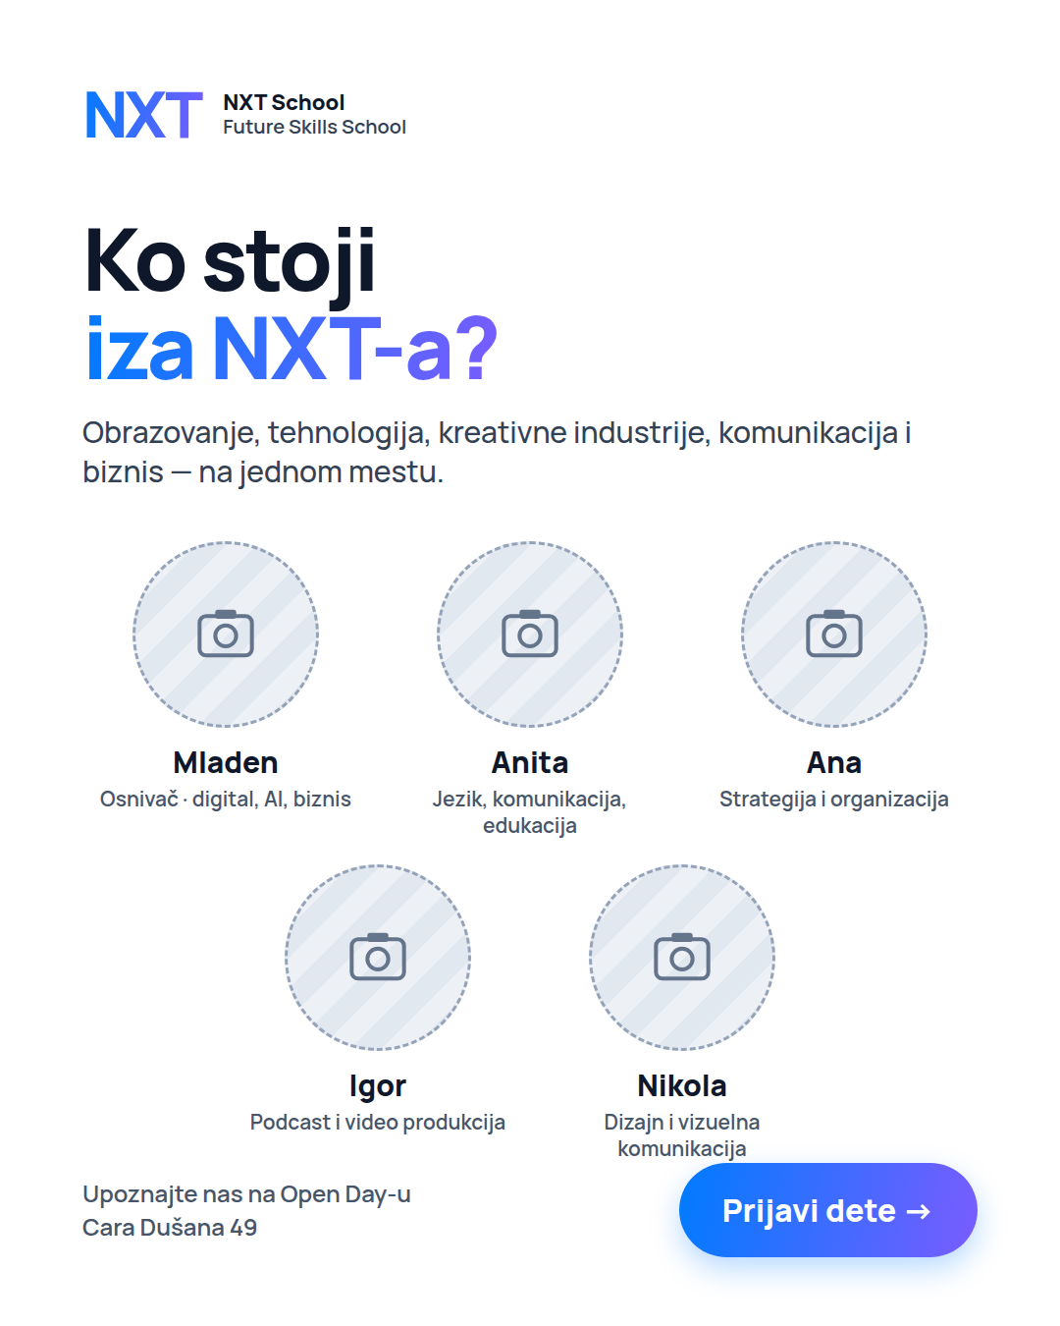  Layout wireframe    Reference: portrait style | NEW · NEEDS PHOTOS PHOTO-BASED · 4:5 + 9:16 Due: when portraits are ready (~W2–W3)  Job: answer "who are these people?" — trust for warm parents.  Make / improve:  • 5 real portraits, same crop and same background treatment (cut-out on light, or all shot in the space).  • Names + short roles; Mladen confirms the role wording.  • Not presented as "nastavni kadar" — teachers are added once hired.  On the image (exact text):  — headline: Ko stoji iza NXT-a?  — sub: Obrazovanje, tehnologija, kreativne industrije, komunikacija i biznis — na jednom mestu.  — Mladen — Osnivač · digital, AI, biznis · Anita — Jezik, komunikacija, edukacija · Ana — Strategija i organizacija · Igor — Podcast i video produkcija · Nikola — Dizajn i vizuelna komunikacija  — footer: Upoznajte nas na Open Day-u · CTA: Prijavi dete →  Needs: Igor’s team portraits  Avoid: corporate stock look, mixed lighting between portraits.  Copy that runs with it: headline "Ljudi iza NXT-a" · primary: Team text (appendix).

B3-4 P6 · Reel "Pitali smo decu…" — design parts Prospecting · W3 · video by Igor
INSPIRATION  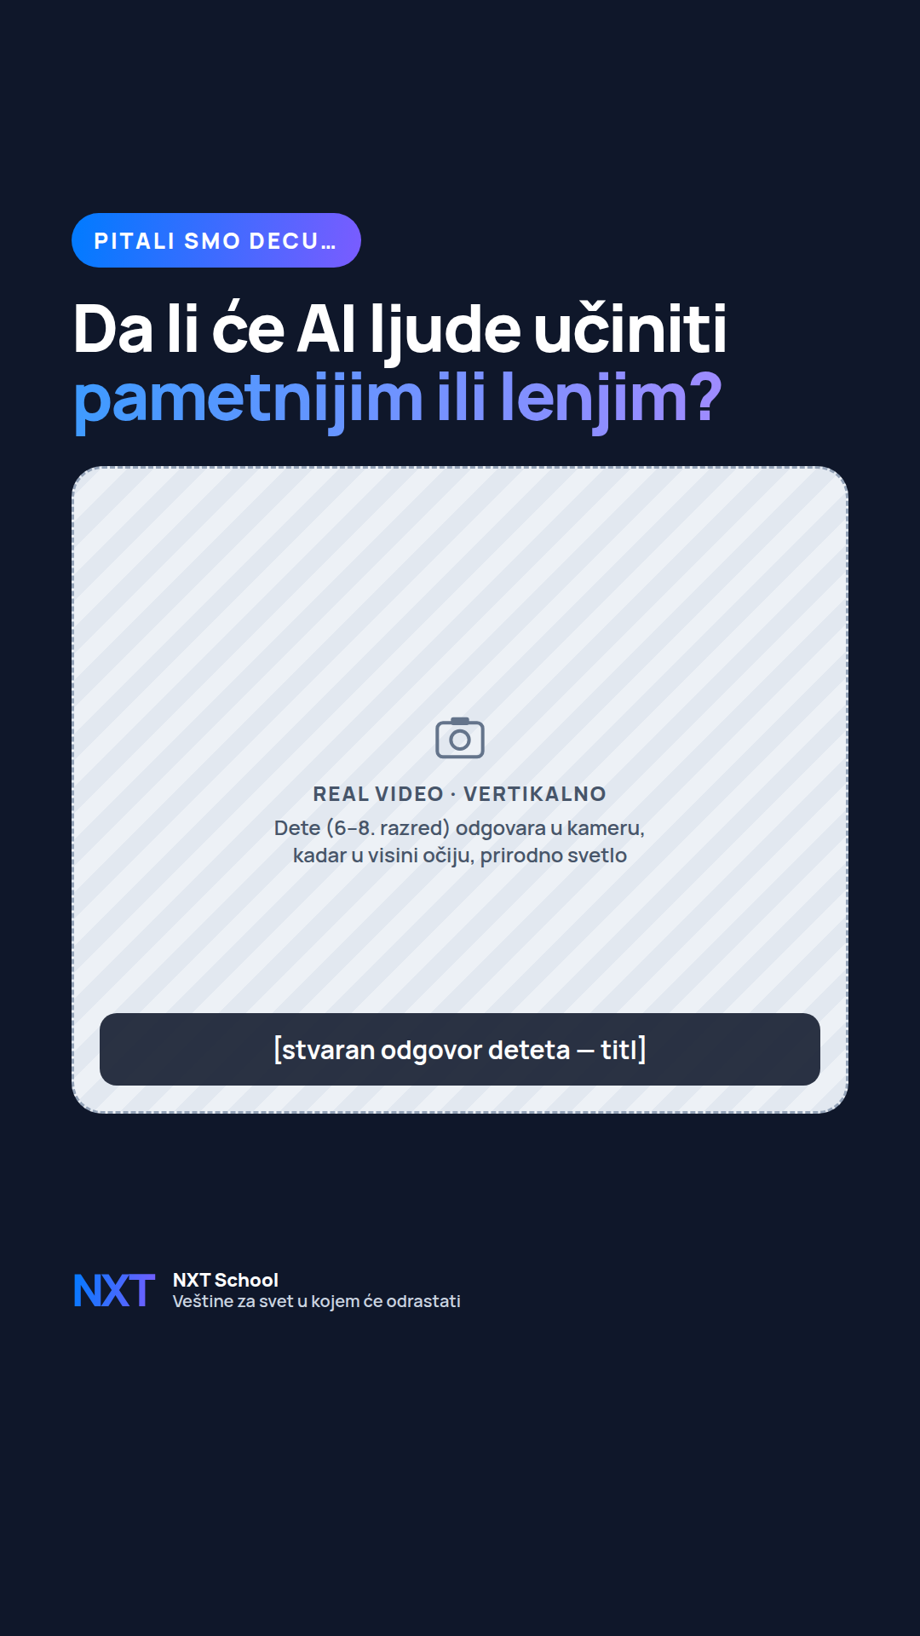  Reel frame mockup (9:16)  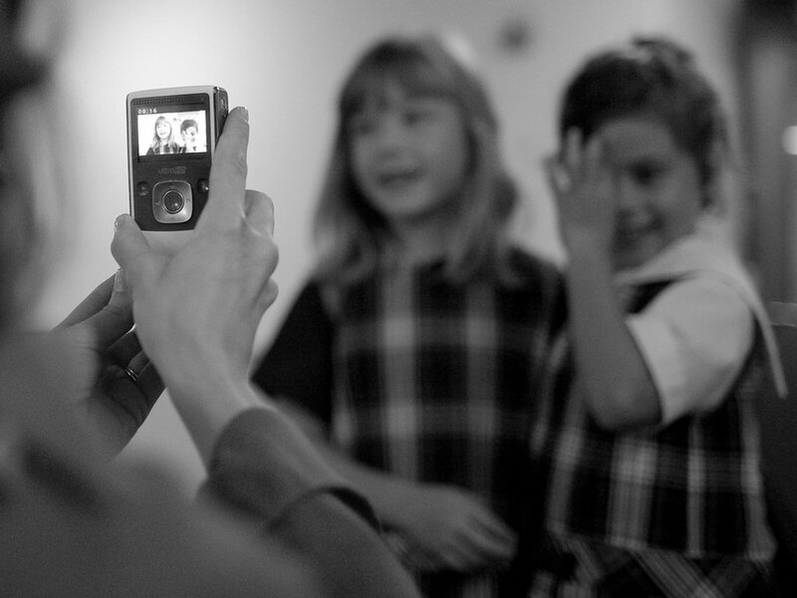  Reference: interview shot | NEW DESIGN VIDEO 9:16 · design parts Due: ~Tue 20 Oct (with Igor)  Job: package Igor’s interview edit so it reads with sound off.  Make / improve:  • Title card for the first 2 s: the question in big type.  • Caption style: burned-in subtitles, Manrope, white on a navy bar, bottom third (above the safe zone).  • End card (2–3 s): logo + "Veštine za svet u kojem će odrastati" + "Prijavi dete".  • Cover frame for the Reel grid.  On the image (exact text):  — title: PITALI SMO DECU… — Da li će AI ljude učiniti pametnijim ili lenjim?  — (second edit for younger kids: Kako će izgledati škola za 20 godina?)  — end card: NXT School · Veštine za svet u kojem će odrastati · Prijavi dete  Needs: Igor’s edit + list of usable answers  Avoid: captioning cast kids as "NXT deca" or "naša deca"; any child without signed consent.  Copy that runs with it: Reel caption (appendix).

