NXT SCHOOL · META LAUNCH · CREATIVE PLAN — SHORT VERSION
Which ad goes where, in what format, with what copy
Angles 1–4 + Offer run side by side from day 1 (that is the test) · Open Day runs on its dates · weeks: W1 6–11 Oct · W2 12–18 · W3 19–25 · W4 26 Oct–8 Nov · program starts Mon 9 Nov.
Static (4:5 feed + 9:16 story) | Real photo / video | Motion / carousel — winning angle only | Off
Launch statics — direction mocks; real photos replace them from W2–W3 (full specs in the long Creative Plan)
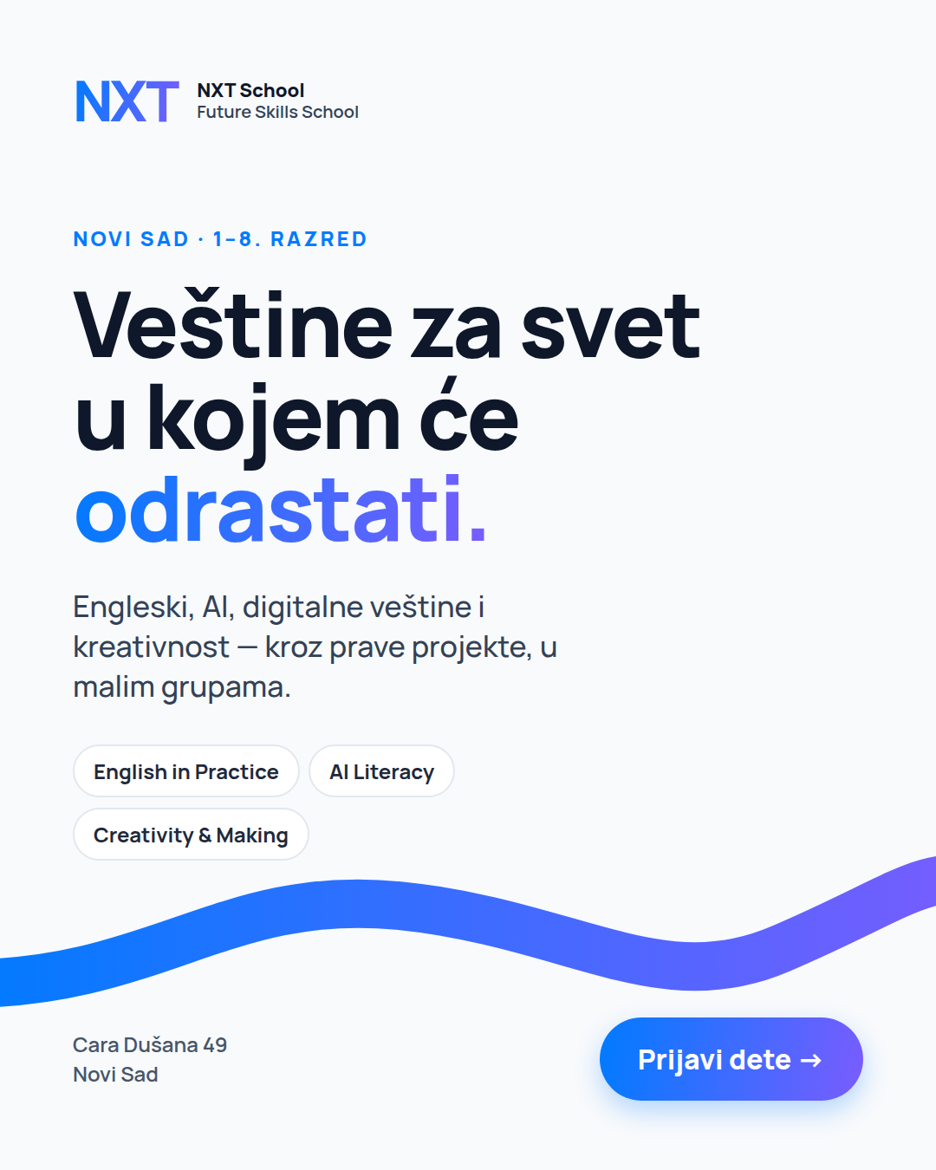  P1 · C1 Hero | 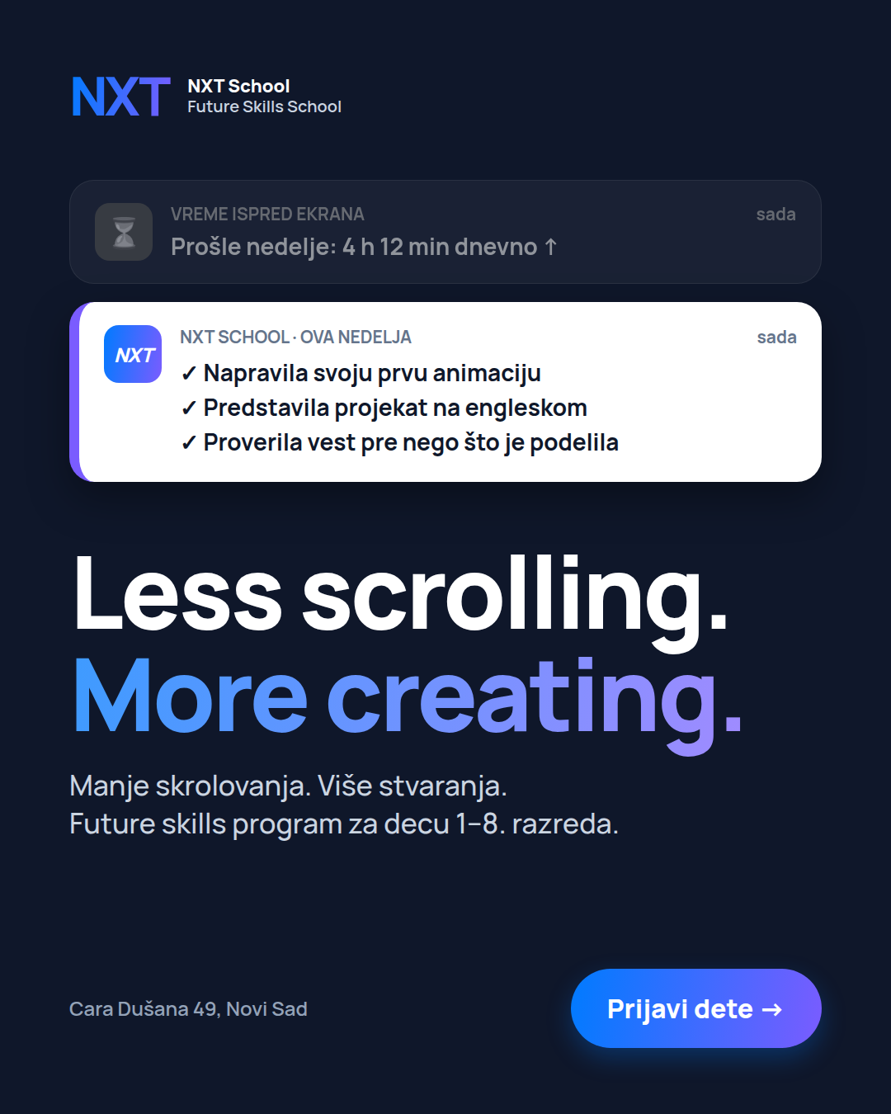  P2 · C3 | 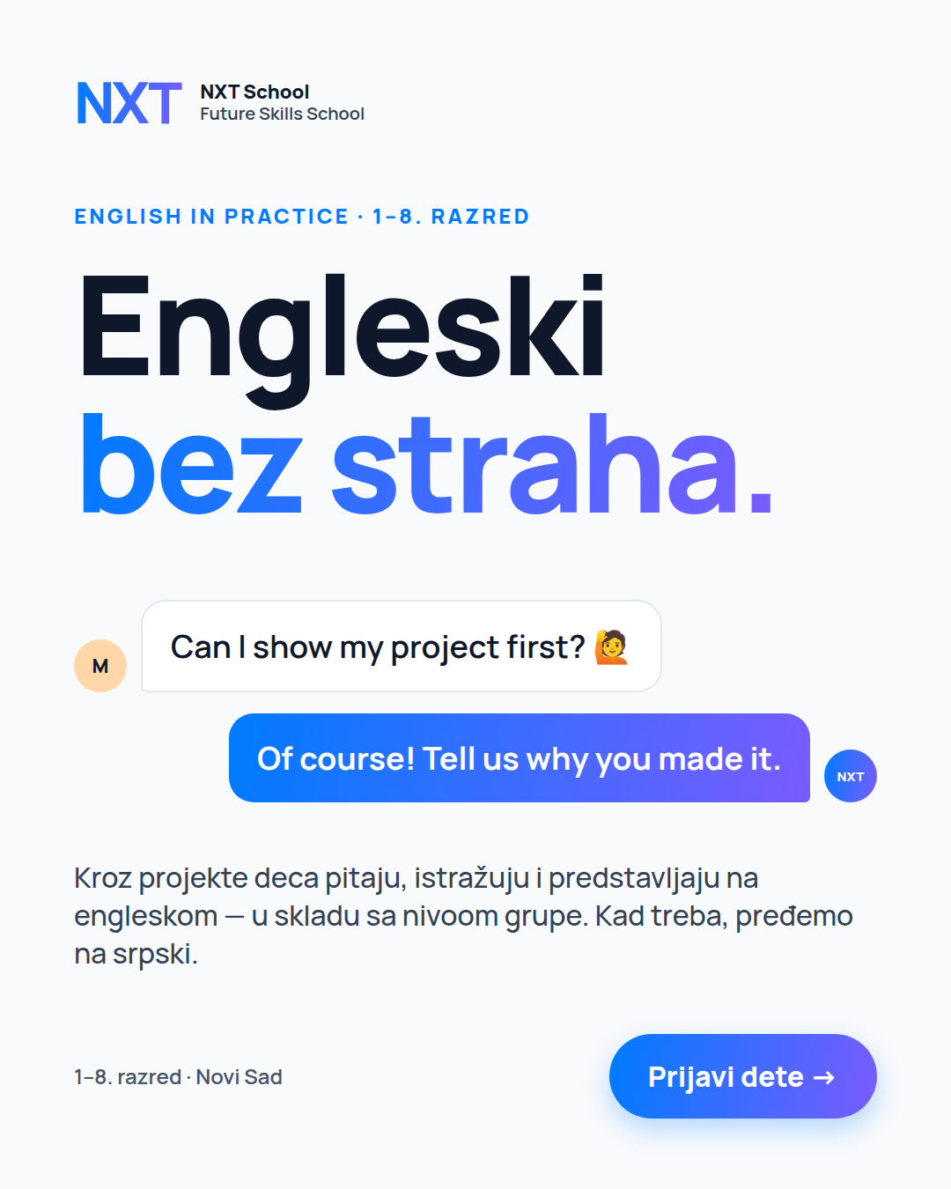  P3 · C4 |   P4 · C7 | 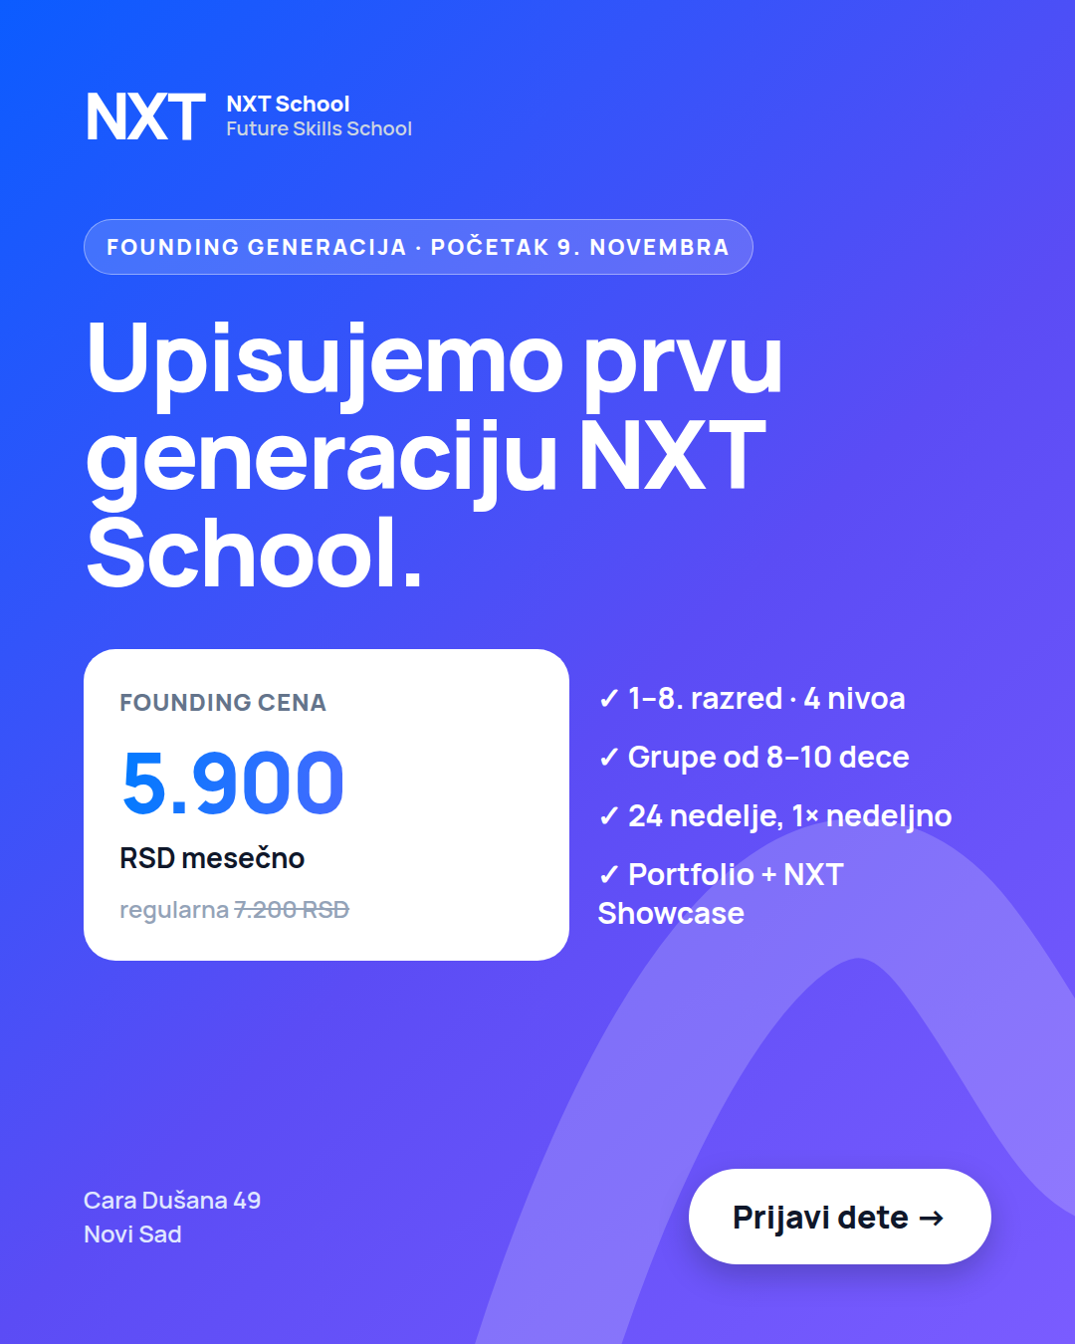  P5/R1 · C5 | 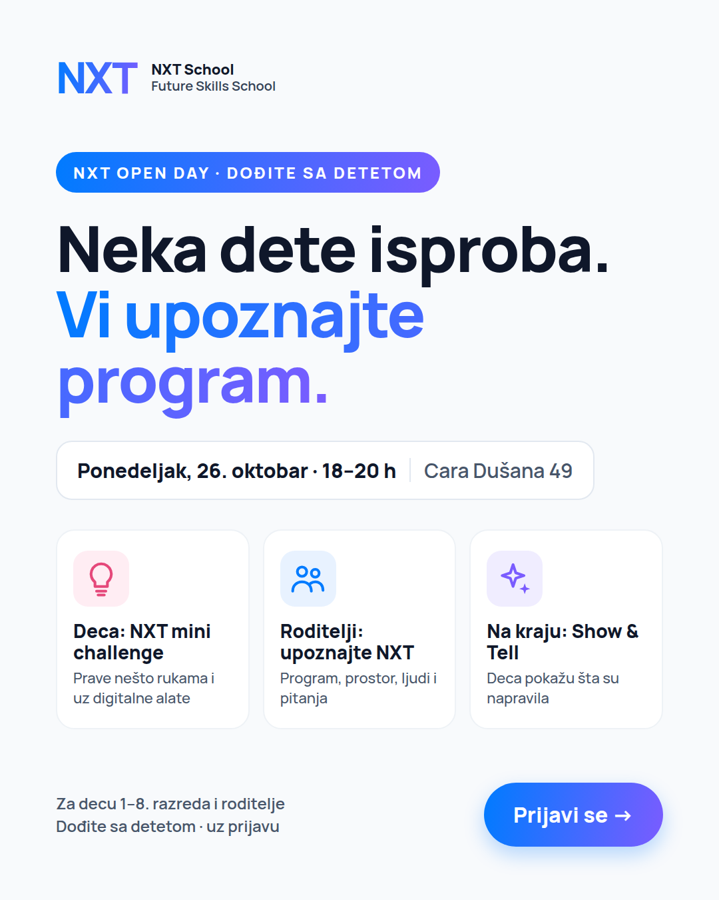  O1/R3 · C6 | 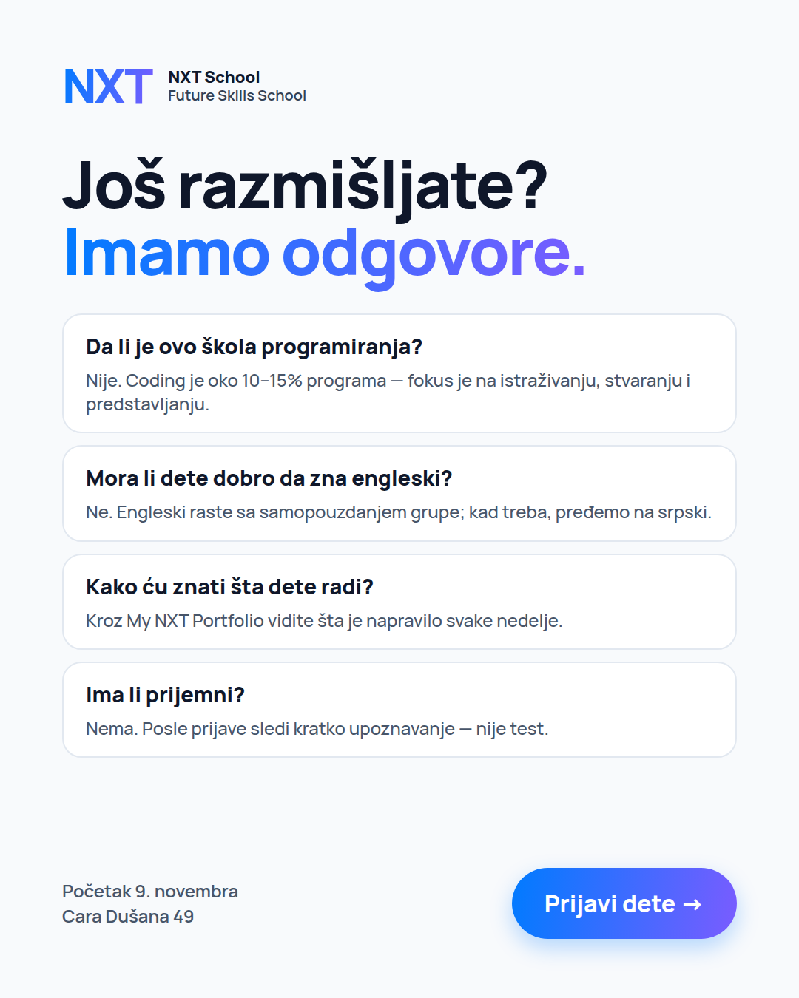  R2 · FAQ | 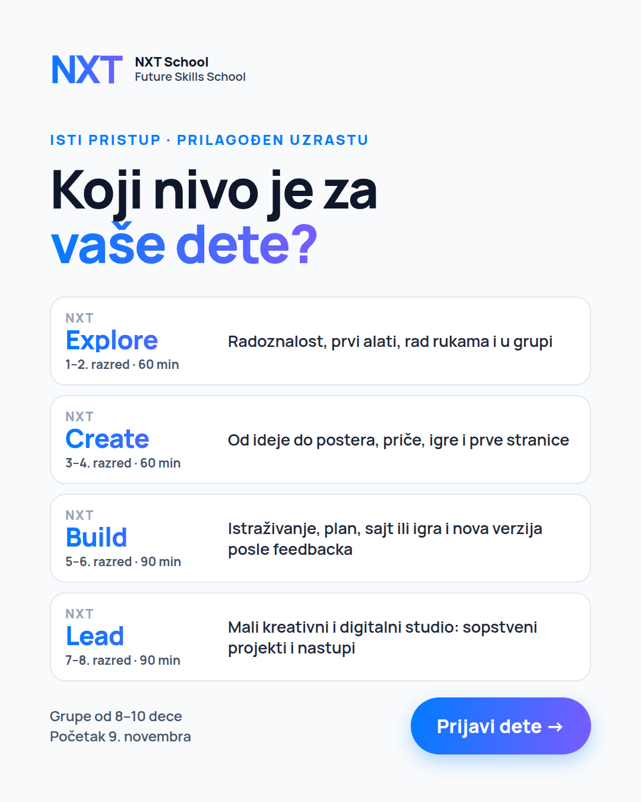  R4 · C2

1 · PROSPECTING ad set 1.1 Broad_NS15km_25-55 · 112k RSD · 6 Oct → 8 Nov · cold parents · 5 statics side by side from day 1
Ad | Creative · angle | Now (launch) | Next (W2–W4) | Headline | Primary text — short (long version: full Creative Plan)
P1 | C1 Hero  Angle 1 · Hero | Static | W2 real space photo → W3 kid photo | Veštine za svet u kojem će odrastati | Future Skills School za decu od 1. do 8. razreda u Novom Sadu. Istraživanje, stvaranje, AI, engleski i prezentovanje — kroz prave projekte, u grupama od 8–10. Početak 9. novembra.
P2 | C3 Less scrolling  Angle 2 | Static | W3 artifact photo or 6 s motion* · W4 15 s Reel "scroll → create" | Manje skrolovanja. Više stvaranja. | Manje pasivnog skrolovanja, više stvaranja. U NXT School svaki čas se završava nečim što je dete samo napravilo. 1–8. razred · grupe 8–10 · Novi Sad · početak 9. novembra.
P3 | C4 English  Angle 3 | Static | W3 photo: kid presenting in English* | Engleski bez straha — kroz projekte | Zna reči, ali ne priča? Kroz projekte deca pitaju, istražuju i predstavljaju na engleskom. Engleski raste zajedno sa samopouzdanjem grupe. 1–8. razred, Novi Sad, početak 9. novembra.
P4 | C7 AI literacy  Angle 4 | Static | W3 6 s motion "Ask → Decide"* · P6 Reel runs next to it | Pitaj. Proveri. Poboljšaj. Ti odluči. | Vaše dete već koristi AI i internet. Da li zna kako da razmišlja uz njih? U NXT School: Pitaj → Proveri → Poboljšaj → Ti odluči. 1–8. razred, Novi Sad.
P5 | C5 Founding  Offer | Static | W4 date-first version · parent quote (photo) | Founding cena: 5.900 RSD mesečno | Founding generacija NXT School: 5.900 RSD mesečno umesto 7.200. 1–8. razred, grupe 8–10, početak 9. novembra. Upoznavanje nije prijemni test.
P6 | Reel "Pitali smo decu…"  Angles 4 + 1 | Off — starts W3 | W3 real video 15–30 s · W4 "Kids Explain the Future" | Veštine za svet u kojem će odrastati | Pitali smo decu: da li će AI ljude učiniti pametnijim ili lenjim? Poslušajte šta kažu. U NXT School deca uče da razmišljaju uz AI. 1–8. razred · početak 9. novembra.
* only for the angle that wins the first read (W2, after 20–30 leads). Losing angles stay static or get paused.

2 · OPEN DAY ad set 2.1 BroadWarm_NS12km · 23k RSD · 12 → 26 Oct · goal: Open Day registrations · Mon 26 Oct, 18–20 h
Ad | Creative · angle | Now (launch) | Next (W2–W4) | Headline | Primary text — short (long version: full Creative Plan)
O1 | C6 Open Day  Angle D | Static from 12 Oct | Ends 26 Oct | NXT Open Day · Ponedeljak, 26. oktobar, 18–20 h | Dođite na NXT Open Day — ponedeljak, 26. oktobar, 18–20 h, Cara Dušana 49. Deca rade kratak NXT mini challenge, vi upoznajete program i ljude iza NXT-a. Na kraju deca pokažu šta su napravila. Ponedeljak, 18–20 h — dođite sa detetom, potrebna je prijava.
O2 | Best P-ad + Open Day band  Angle D | Static from 13 Oct | Ends 26 Oct | NXT Open Day · Ponedeljak, 26. oktobar, 18–20 h | Isti Open Day tekst, prva rečenica prema uglu pobednika — npr. "Manje skrolovanja, više stvaranja — dođite da vidite kako to izgleda."
O3 | Countdown  Angle D | Off | W3 static: "Još 5 dana" (21–23 Oct) · "U ponedeljak!" (24–26 Oct) | Još 5 dana do NXT Open Day-a | Još 5 dana do NXT Open Day-a. / U ponedeljak je NXT Open Day. + Open Day tekst (O1).

3 · RETARGETING ad set 3.1 Warm_30d · 15k RSD · from 13 Oct → 8 Nov · site visitors, started form, engagers · max 4 ads live
Ad | Creative · angle | Now (launch) | Next (W2–W4) | Headline | Primary text — short (long version: full Creative Plan)
R1 | C5 Founding  Offer | Static from 13 Oct | Stays to 8 Nov | Početak: 9. novembar | Founding generacija NXT School: 5.900 RSD mesečno umesto 7.200. 1–8. razred, grupe 8–10, početak 9. novembra. Upoznavanje nije prijemni test.
R2 | FAQ  Offer | Static from 13 Oct | Refresh visual if frequency > 3/week | Još razmišljate? Imamo odgovore. | Nije škola programiranja (coding je ~10–15%). Engleski raste sa samopouzdanjem grupe. Napredak deteta vidite u My NXT Portfolio. Nema prijemnog — samo kratko upoznavanje.
R3 | C6 Open Day  Angle D | Static from 13 Oct | Ends 26 Oct | NXT Open Day · Ponedeljak, 26. oktobar, 18–20 h | Open Day tekst (kao O1).
R4 | C2 Levels  Angle 1 | Static from 13 Oct | Stays to 8 Nov | Koji nivo je za vaše dete? | Explore (1–2) · Create (3–4) · Build (5–6) · Lead (7–8) — isti NXT pristup, prilagođen uzrastu. Grupe od 8–10, početak 9. novembra.
R5 | Team "Ko stoji iza NXT-a?"  Offer / trust | Off | W3 real team portraits | Ljudi iza NXT-a | NXT School je nastao spajanjem obrazovanja, tehnologije, kreativnih industrija, komunikacije i poslovnog iskustva. Upoznajte nas na Open Day-u.
R6 | Last call  Offer | Off | W4 static (26 Oct → 8 Nov) | Počinjemo 9. novembra | Prva generacija NXT School počinje u ponedeljak, 9. novembra. Grupe kreću zajedno — dete se ne može priključiti usred programa. Founding cena 5.900 RSD mesečno.
R7 | Open Day recap  Angle D | Off | W4 real Open Day photos (consent) | Upis prve generacije je u toku | Ovako je izgledao NXT Open Day. Upis founding generacije je u toku — početak 9. novembra.
Format timeline — what each angle looks like week by week
Angle | W1 · 6–11 Oct · launch | W2 · 12–18 Oct · first read | W3 · 19–25 Oct · winner + first real | W4 · 26 Oct–8 Nov · real + last call
1 · Hero | P1 static | P1 + real space photo · R4 levels | If 1 wins: kid photo, "6 oblasti" carousel | Real photo / video, Open Day footage
2 · Less scrolling | P2 static | P2 static | If 2 wins: artifact photo, SR headline, 6 s motion | 15 s Reel "scroll → create"
3 · English | P3 static | P3 static | If 3 wins: kid presenting in English (photo) | Presenting clips from shoot / Open Day
4 · AI + digital | P4 static | P4 static | P6 Reel "Pitali smo decu" · 6 s motion if 4 wins | "Kids Explain the Future" Reels
Offer | P5 static | + R1, R2 FAQ, R4 in retargeting | R5 team (real photos) | R6 last call · parent quotes
D · Open Day | Off — prep | O1, O2, R3 static | O3 countdown · Open Day Mon 26 | R7 recap (real photos)
Every ad: 4:5 + 9:16 · CTA button Prijavite se · 2 text options (short above + long from the full Creative Plan) · [brackets] = confirm before use · Mladen signs off all copy.
Never: "Demo Day" (→ NXT Showcase) · "škola programiranja" · "naša deca" for cast kids · seat counts that aren’t real · partner names before consent.

