NXT SCHOOL · DESIGN BRIEF · BATCH 1 OF 4
Batch 1 — Week 1 launch statics
For Nikola. Finalize the 5 launch mockups into production files. Everything is a designed static — no photos needed.
# | Deliverable | Format | Due
B1-1 | P1 · C1 Hero | STATIC 4:5 + 9:16 | Tue 6 Oct AM
B1-2 | P2 · C3 Less scrolling | STATIC 4:5 + 9:16 | Tue 6 Oct AM
B1-3 | P3 · C4 English | STATIC 4:5 + 9:16 | Tue 6 Oct AM
B1-4 | P4 · C7 AI literacy | STATIC 4:5 + 9:16 | Tue 6 Oct AM
B1-5 | P5 / R1 · C5 Founding | STATIC 4:5 + 9:16 | Tue 6 Oct AM

RULES FOR EVERY BATCH
Brand: Manrope ExtraBold headlines · navy #0F172A · light #F8FAFC · blue #007BFF → purple #7A5CFF gradient as accent only · ≥ 40% whitespace · final NXT logo file (the mockups use a placeholder wordmark).
Sizes: feed 4:5 = 1080 × 1350 (≥ 60 px margins) + story 9:16 = 1080 × 1920 (keep top 250 px and bottom 380 px free of text and CTA). Re-layout for 9:16 — never just crop.
CTA: one pill, "Prijavi dete →" (Open Day ads: "Prijavi se →"). Answers on phone-size text: min ~24 px at 1080 width.
Facts = the website: regular 7.200 RSD · Open Day ponedeljak, 26. oktobar, 18–20 h · no "besplatno" until confirmed · level copy + "6 oblasti" as on the site.
Never: AI-generated children’s faces · rows of kids staring at screens · "Demo Day" (it’s NXT Showcase) · seat counts (the site’s "Broj mesta je ograničen" is fine). Real child photos need signed parental consent.
Delivery: PNG, named AdID_Creative_v#_ratio (e.g. P2_C3_LessScrolling_v1_9x16.png) → shared folder → Mladen signs off → Filip uploads.

B1-1 P1 · C1 Hero Prospecting · angle 1 · live day 1
INSPIRATION  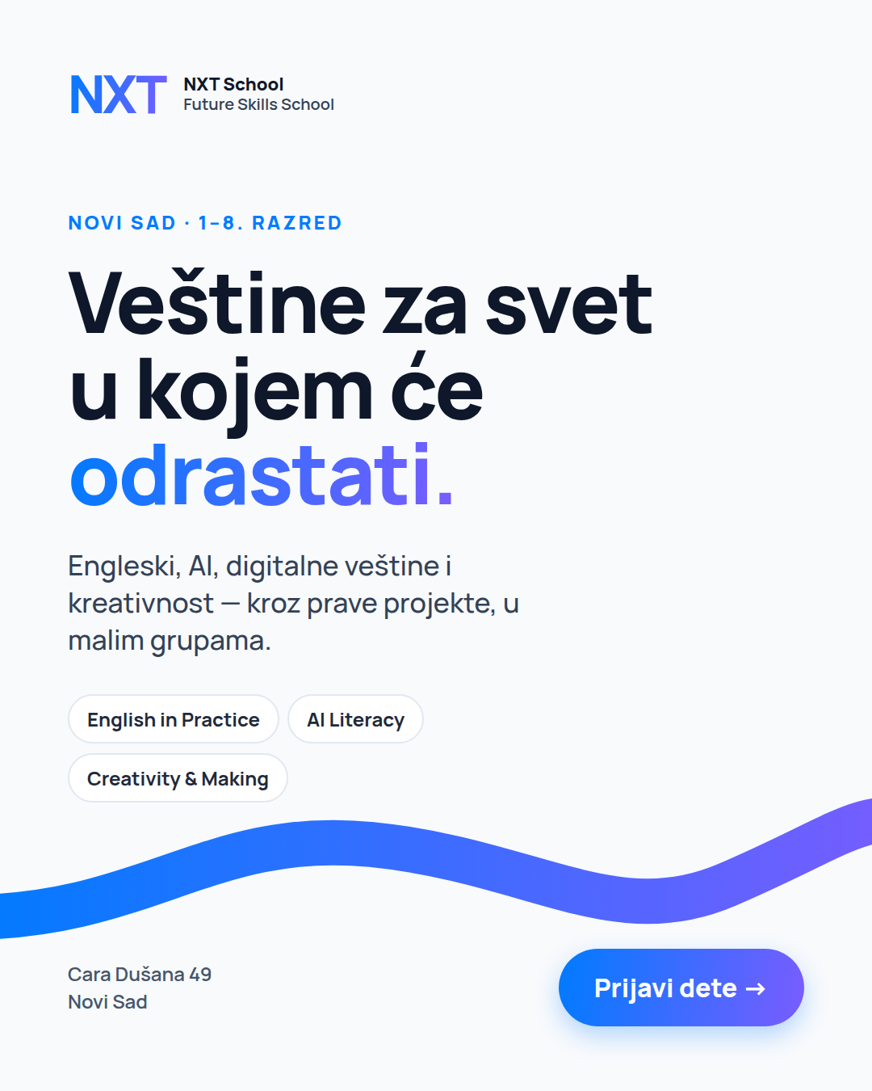  Mockup C1 (4:5) | FINALIZE MOCKUP STATIC · 4:5 + 9:16 Due: Tue 6 Oct AM  Job: benchmark ad — does the core positioning pull cold parents?  Make / improve:  • Swap the placeholder wordmark for the final logo.  • Keep the big headline + gradient wave; keep the chips.  • 9:16: headline in the middle third, chips under it, CTA above the bottom safe zone.  On the image (exact text):  — kicker: Novi Sad · 1–8. razred  — headline: Veštine za svet u kojem će odrastati.  — sub: Engleski, AI, digitalne veštine i kreativnost — kroz prave projekte, u malim grupama.  — chips: English in Practice · AI Literacy · Creativity & Making  — footer: Cara Dušana 49, Novi Sad · CTA: Prijavi dete →  Needs: final logo file  Avoid: photos of kids (none yet), extra badges or prices.  Copy that runs with it: headline "Veštine za svet u kojem će odrastati" · short "Future Skills School za decu od 1. do 8. razreda u Novom Sadu… Početak 9. novembra."

B1-2 P2 · C3 Less scrolling Prospecting · angle 2 · live day 1
INSPIRATION  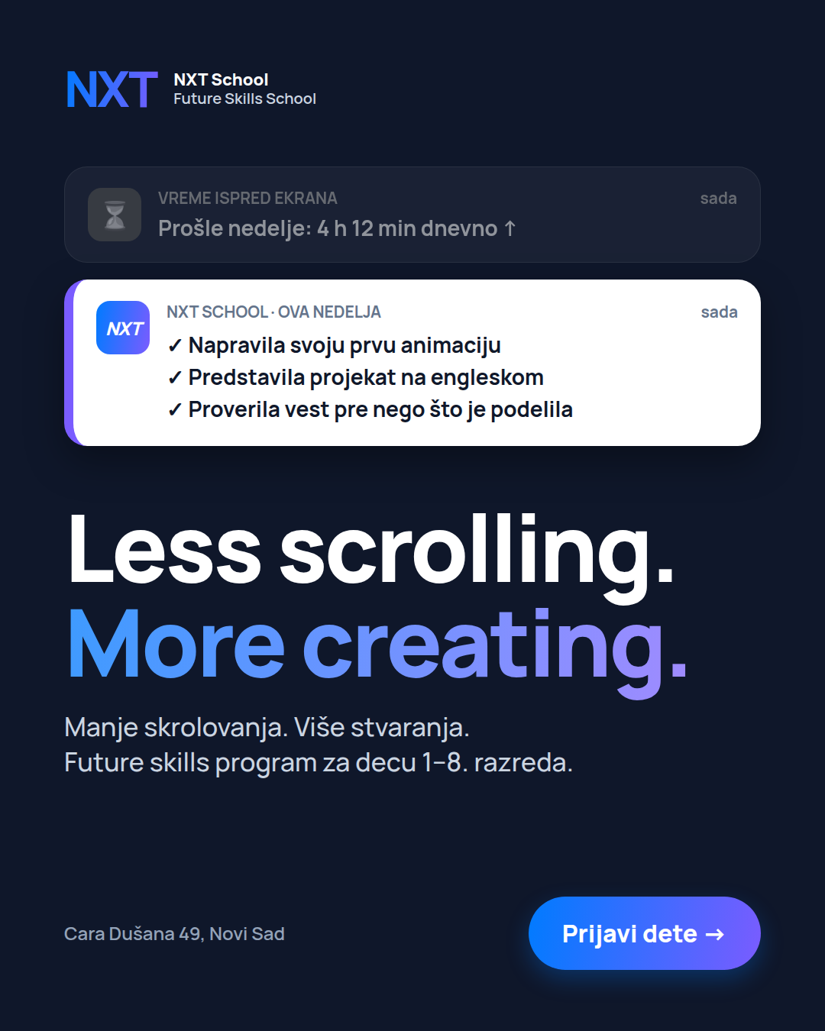  Mockup C3 (4:5)  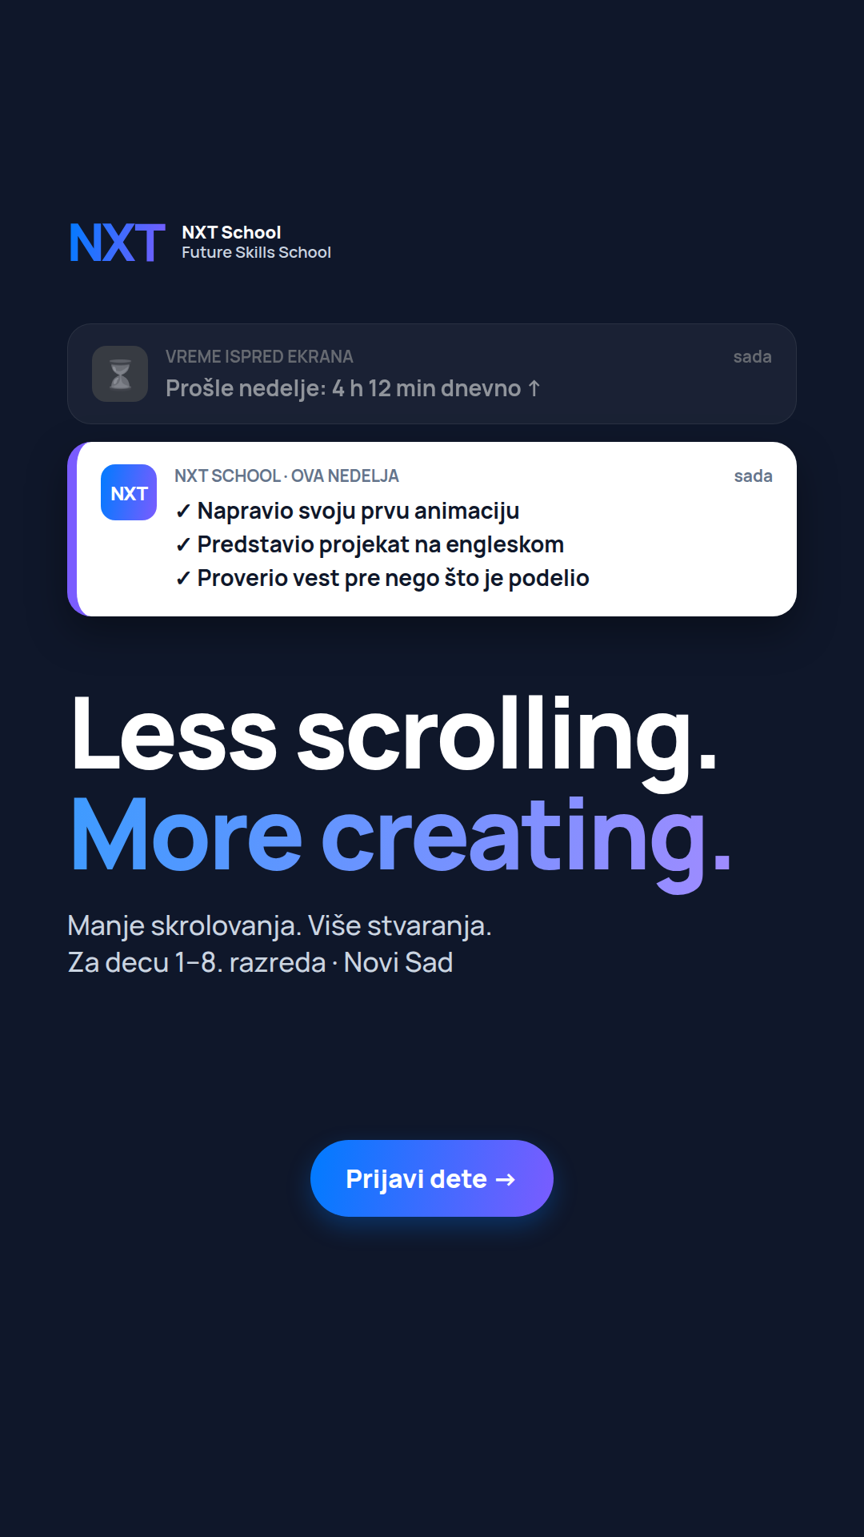  Story version (9:16, boy copy) | FINALIZE MOCKUP STATIC · 4:5 + 9:16 Due: Tue 6 Oct AM  Job: does the screen-time worry stop parents mid-scroll?  Make / improve:  • Alerts should feel like real phone banners — the grey one reads as "bad", the white NXT one as "good".  • English headline big, Serbian subline right under it.  • 9:16 = the story mock (boy copy "Napravio…").  On the image (exact text):  — alert 1: VREME ISPRED EKRANA — Prošle nedelje: 4 h 12 min dnevno ↑  — alert 2: NXT SCHOOL · OVA NEDELJA — ✓ Napravila svoju prvu animaciju ✓ Predstavila projekat na engleskom ✓ Proverila vest pre nego što je podelila  — headline: Less scrolling. More creating.  — sub: Manje skrolovanja. Više stvaranja. Future skills program za decu 1–8. razreda.  — CTA: Prijavi dete →  Avoid: copying real phone-brand UI or logos; a guilt-tripping tone.  Copy that runs with it: headline "Manje skrolovanja. Više stvaranja." · short "Manje pasivnog skrolovanja, više stvaranja. U NXT School svaki čas se završava nečim što je dete samo napravilo."

B1-3 P3 · C4 English Prospecting · angle 3 · live day 1
INSPIRATION  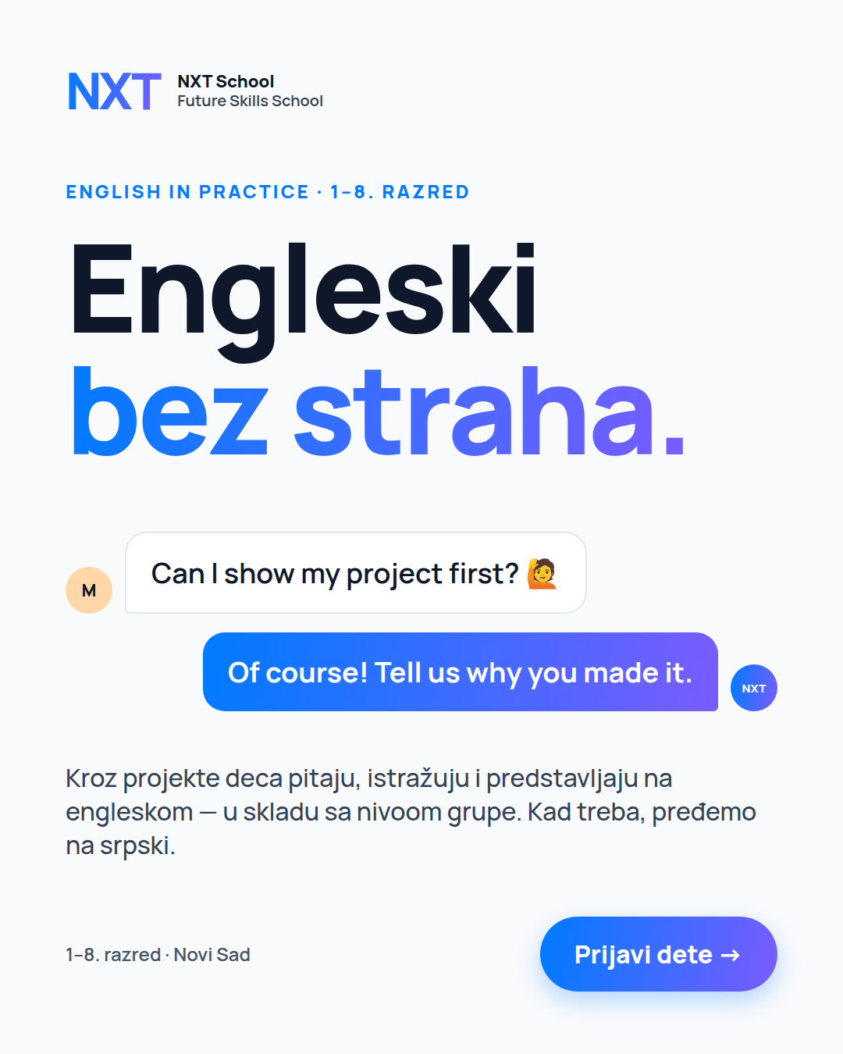  Mockup C4 (4:5) | FINALIZE MOCKUP STATIC · 4:5 + 9:16 Due: Tue 6 Oct AM  UPDATED 6 OCT (website) · English angle is now "Engleski bez straha." — the "English is not a subject / language we use" line is dropped. This ad is live → swap today.  Job: English confidence for the “zna reči, ali ne priča” parent — kids speak English through projects, without fear.  Make / improve:  • Crisp chat bubbles: kid on the left, mentor (NXT avatar) on the right in the gradient.  • Serbian headline big; the English chat shows it in action.  • 9:16: bubbles under the headline, Serbian line above the CTA.  On the image (exact text):  — kicker: English in Practice · 1–8. razred  — headline: Engleski bez straha.  — bubble kid: Can I show my project first? 🙋  — bubble mentor: Of course! Tell us why you made it.  — sub: Kroz projekte deca pitaju, istražuju i predstavljaju na engleskom — u skladu sa nivoom grupe. Kad treba, pređemo na srpski.  — CTA: Prijavi dete →  Avoid: flags, grammar-book visuals, classroom-blackboard look · the old "English is not a subject / language we use" line (dropped).  Copy that runs with it: headline "Engleski bez straha — kroz projekte" · short "Zna reči, ali ne priča? Kroz projekte deca pitaju, istražuju i predstavljaju na engleskom."

B1-4 P4 · C7 AI literacy Prospecting · angle 4 · live day 1
INSPIRATION  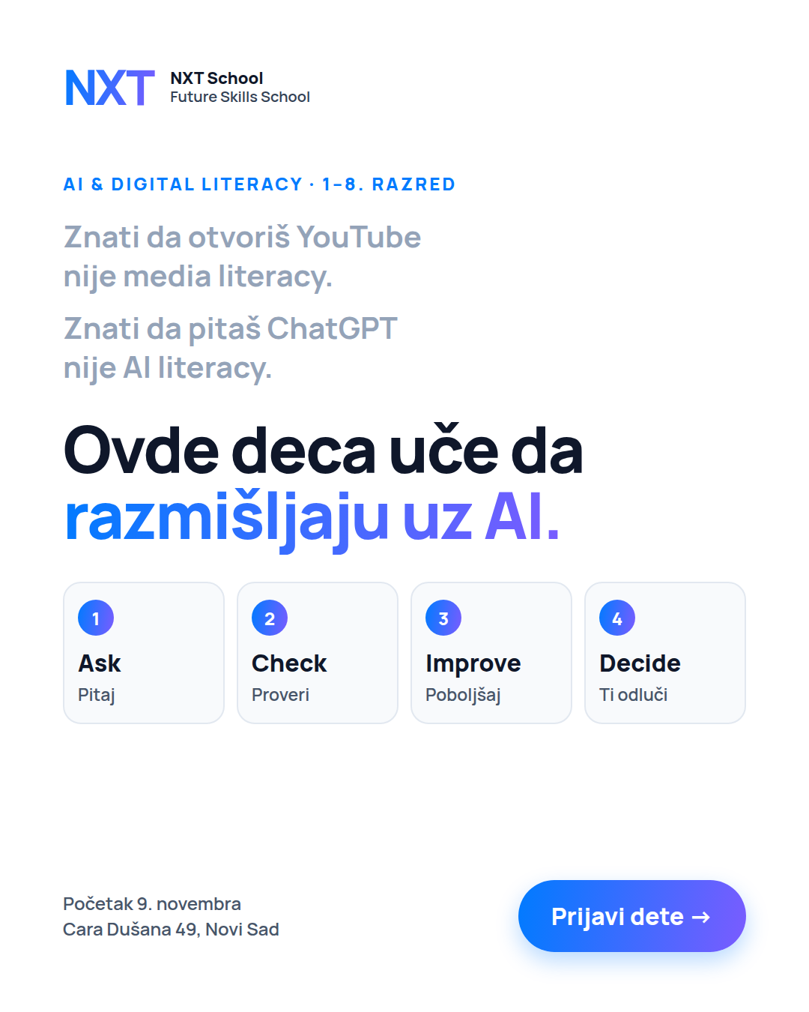  Mockup C7 (4:5) | FINALIZE MOCKUP STATIC · 4:5 + 9:16 Due: Tue 6 Oct AM  Job: "my kid already uses AI — but do they think with it?"  Make / improve:  • Grey contrast lines clearly lighter than the headline.  • 4 step cards equal width, numbered; a subtle arrow between steps is fine.  • 9:16: steps as a 2 × 2 grid.  On the image (exact text):  — kicker: AI & digital literacy · 1–8. razred  — grey lines: Znati da otvoriš YouTube nije media literacy. / Znati da pitaš ChatGPT nije AI literacy.  — headline: Ovde deca uče da razmišljaju uz AI.  — steps: 1 Ask · Pitaj — 2 Check · Proveri — 3 Improve · Poboljšaj — 4 Decide · Ti odluči  — footer: Početak 9. novembra · Cara Dušana 49 · CTA: Prijavi dete →  Avoid: robots, glowing brains, circuit boards, sci-fi AI clichés.  Copy that runs with it: headline "Pitaj. Proveri. Poboljšaj. Ti odluči." · short "Vaše dete već koristi AI i internet. Da li zna kako da razmišlja uz njih?"

B1-5 P5 / R1 · C5 Founding Prospecting (offer) + Retargeting from 13 Oct
INSPIRATION  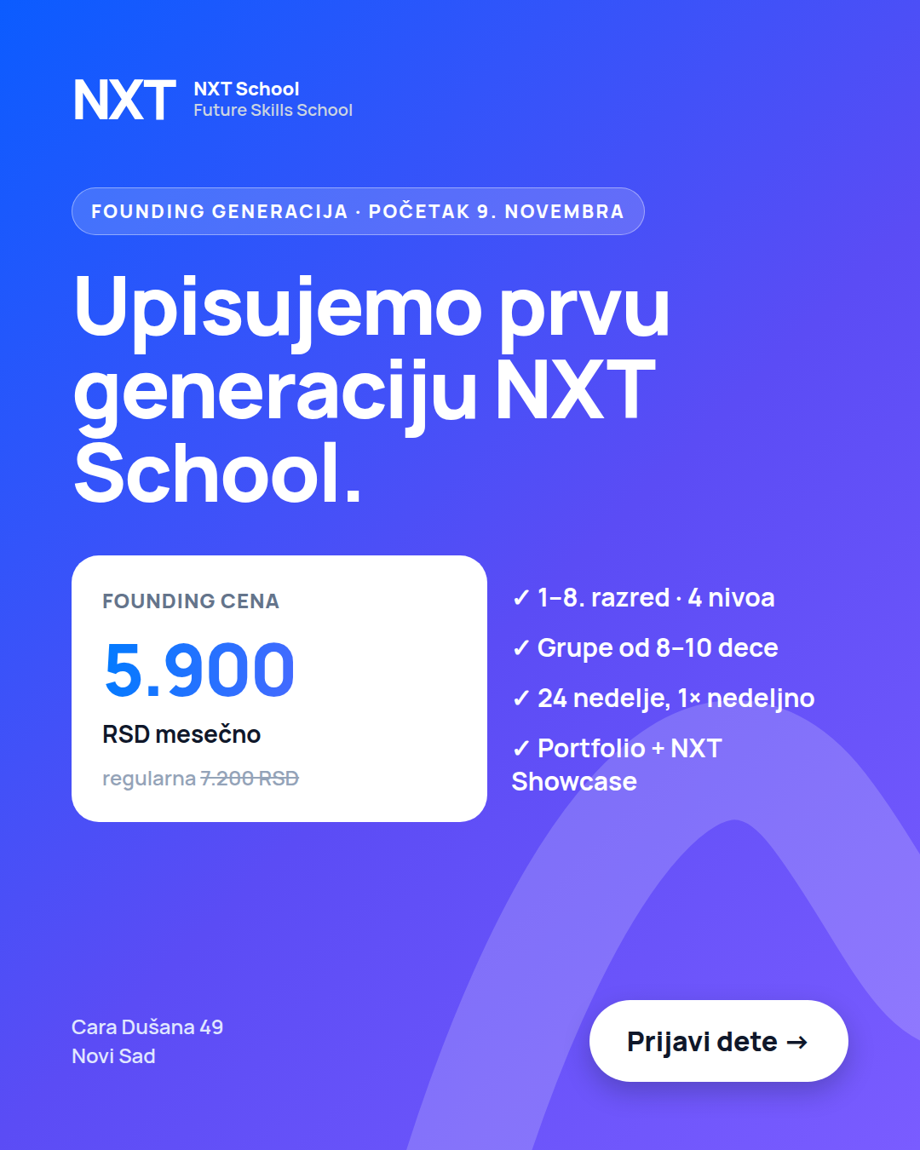  Mockup C5 (4:5) | FINALIZE MOCKUP STATIC · 4:5 + 9:16 Due: Tue 6 Oct AM  UPDATED 6 OCT (website) · regular price is 7.200 RSD (was 6.400) — fix the file that went live today.  Job: does a clear price + start date pre-qualify parents?  Make / improve:  • The white price card is the hero; the struck-through regular price must still be readable.  • Badge carries the start date, not scarcity.  • Same file is reused as R1 in retargeting.  On the image (exact text):  — badge: FOUNDING GENERACIJA · POČETAK 9. NOVEMBRA  — headline: Upisujemo prvu generaciju NXT School.  — price: FOUNDING CENA 5.900 RSD mesečno · regularna 7.200 RSD  — ticks: 1–8. razred · 4 nivoa · Grupe od 8–10 dece · 24 nedelje, 1× nedeljno · Portfolio + NXT Showcase  — footer: Cara Dušana 49, Novi Sad · CTA: Prijavi dete →  Avoid: "mesta ograničena" (no real seat cap yet), sale/discount styling.  Copy that runs with it: headline "Founding cena: 5.900 RSD mesečno" · short "Founding generacija NXT School: 5.900 RSD mesečno umesto 7.200… Upoznavanje nije prijemni test."

