NXT SCHOOL · WHO WE TALK TO
Parent personas
Four parents we write every ad for. Inferred from the brief, blueprint and action plan — no customer data yet. Quotes are hypotheses in the parents’ own voice, to be checked against the first 20–30 leads.
Pain: passive screen time and the guilt about it; afternoons disappear into YouTube.  Wants: hands-on activity, a safe small group, something made every week, English without pressure.  Objection → answer: "Zar to nije još jedan ekran?" → Ekran je alat: papir, Lego, skice — svaki čas se završi nečim opipljivim.  Buying moment: October, once the school routine settles and the tablet habit shows; Open Day with her daughter.  Angles & ads: 2 Less scrolling (P2) · Open Day (O1) · FAQ (R2)  Reach: IG + FB feed & Stories · school parents’ Viber groups (word of mouth) · Open Day | Pain: school teaches like 20 years ago; AI is used to skip thinking, not to think better.  Wants: critical thinking, AI literacy, real projects (website, app) and proof of progress.  Objection → answer: "Je l’ to igranje sa ChatGPT-jem?" → Ask → Check → Improve → Decide · coding samo 10–15% · projekti, ne alati · portfolio.  Buying moment: decides fast when the program has substance — reads the details, checks who is behind it.  Angles & ads: 1 Hero (P1) · 4 AI (P4, P6 Reel) · Levels (R4) · Team (R5)  Reach: FB + IG feed and Reels · long copy works for him · program section on the LP
   | PRIMARY · ~40% of leads*  Jelena, 36  Screen-time mama  Works full-time, hybrid · daughter Mila, 8 · 2. razred → NXT Explore
  „Čim dođe iz škole — tablet. Ne želim da ga zabranim, želim da ga koristi za nešto pametno.“
   | PRIMARY · ~30% of leads*  Marko, 42  Future-minded tata  IT / business, uses AI daily · son Luka, 11 · 5. razred → NXT Build
  „Ja svaki dan radim sa AI-em, a on ga koristi samo da prepiše domaći.“
Pain: a shy kid: English on paper, but no courage to speak or present.  Wants: English used naturally, confidence in front of others, warm mentors, a small group.  Objection → answer: "Već ide na engleski." → NXT nije škola jezika: engleski se koristi i raste sa samopouzdanjem; kad treba — srpski; NXT Showcase pred roditeljima.  Buying moment: after a presentation or test where her kid froze; after a parent-teacher meeting.  Angles & ads: 3 English (P3) · FAQ (R2) · Offer with Showcase (P5)  Reach: IG feed & Stories · mom communities · later: parent quotes and progress stories | Pain: the teen won’t go to anything that feels "for kids"; mala matura is next year.  Wants: the teen owns a real project (game, podcast, website) and actually wants to come.  Objection → answer: "Neće hteti da ide." → NXT Lead = mali digitalni studio: biraju temu, prave prave stvari, ništa infantilno · 90 min jednom nedeljno.  Buying moment: the teen shares a Reel, or comes to the Open Day and likes it.  Angles & ads: Reel "Pitali smo decu" (P6) · Levels (R4) · Open Day (O1)  Reach: Reels & Stories (the teen sees them too) · Open Day with the teen
  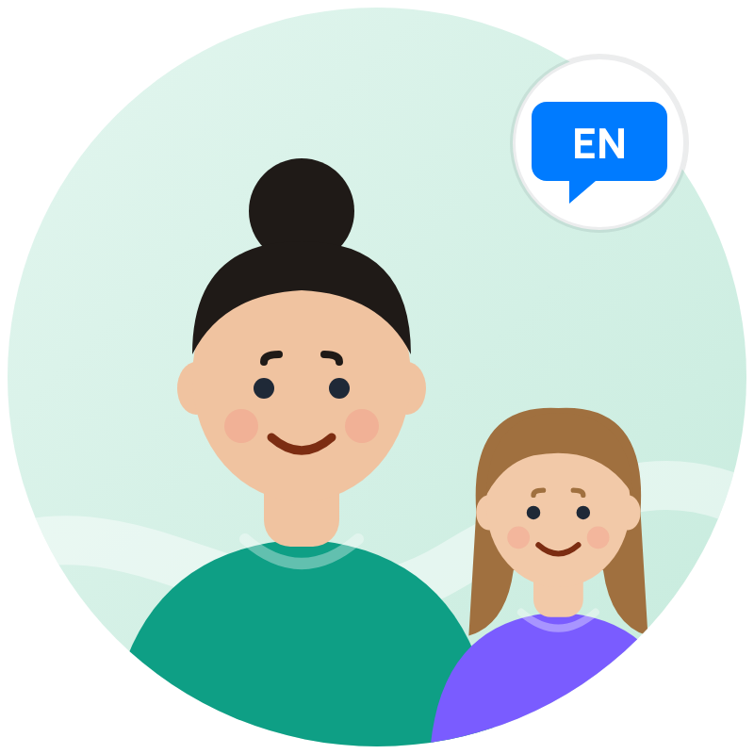 | SECONDARY · ~20% of leads*  Ivana, 39  English & confidence mama  Teacher / public sector · daughter Sara, 10 · 4. razred → NXT Create · already in English school
  „Ide na engleski tri godine, zna sve reči — ali kad treba da progovori, zaledi se.“
  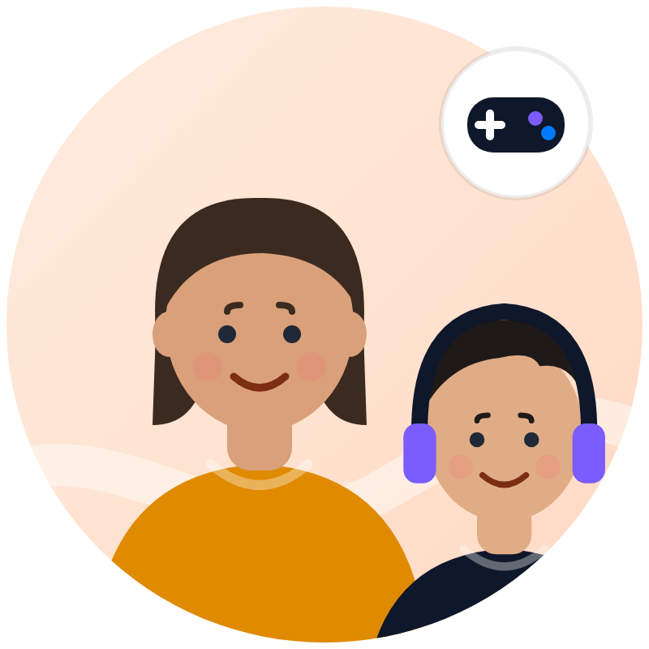 | SECONDARY / TEST · ~10% of leads*  Sanja & Dragan, 45  Parents of a teen gamer  Both working · son Nikola, 13 · 7. razred → NXT Lead · the teen co-decides
  „Ne mogu da ga odvojim od Roblox-a. Ako ga već zanima — neka nauči da napravi nešto svoje.“ Nikola: „Samo da ne liči na školu.“

ALL FOUR SHARE  Small groups (8–10) · a schedule that works with school shifts · visible progress (My NXT Portfolio) · price is only an objection when the value isn’t clear. | VALIDATE IN W1–W2  Ops logs for every lead: kid’s grade, main reason, top objection. After 20–30 leads, compare with the razred split and re-weight angles. *Shares are hypotheses.

