NXT SCHOOL · LANDING PAGE REVIEW
nxtschool.edu.rs → a short ad page that converts
6 Oct 2026 (updated: the live site is the source of truth) · Reviewed: homepage copy, structure, CTAs, form and tags · Traffic: Meta P1–P6, O1–O3, R1–R7 · Prototype: landing-page/prijava.html. Live mobile screenshots of the site were blocked by the host’s bot-check (section 3).
VERDICT  Fix-first. Good brand page, weak ad page. Keep it for organic; send ads to a short /prijava/. | HOMEPAGE TODAY  ~1,650 words · 15 sections · 10+ menu links · every CTA leaves to /upis/ · 7-field form | PROPOSED /prijava/  ~530 words · 7 blocks · no menu · one action · form on the same page, 5 fields | ON MOBILE  Form starts on screen ~3.5 of 5 · sticky “Prijavi dete” = 1 tap from anywhere

Resolved — the live site wins. Ads and all creative docs are updated to match it.
 | Site (source of truth) | Was in ads / docs | Updated
Regular price | 7.200 RSD | 6.400 RSD | C5, R6, carousel card 7 · 1-pager, creative plan, short plan, briefs
Open Day | Mon 26 Oct, 18–20 h · come with your child · registration needed | Sat 24 Oct · “~90 min · besplatno” | C6, O2 band, O3 countdown (“U ponedeljak!”), story · flight 12 → 26 Oct (stops 17 h) · weekly plan, briefs, photo list
Also aligned | Level descriptions · “6 oblasti” · groups start together | “6 veština” · older level copy | C2 levels, carousel cards 1–2, R6 last call
Still open: is the Open Day free? The site doesn’t say, so “besplatno” is out of all creatives until Mladen confirms.
1 Message match — does the first screen repeat the ad’s promise?
Ad | Ad promise | Homepage today | Match | Send to
P1 · C1 Hero | “Veštine za svet u kojem će odrastati” | Same H1 ✓ | STRONG | /prijava/
P2 · C3 | “Less scrolling. More creating.” | “Less scrolling.” is section 7 of 15 | WEAK | ?angle=scroll
P3 · C4 | “English is not a subject here.” | Same line — section 9 of 15 | WEAK | ?angle=english
P4 · C7, P6 reel | “Ovde deca uče da razmišljaju uz AI.” | “AI je asistent…” — section 8 of 15 | WEAK | ?angle=ai
P5, R1 · C5 | “Upisujemo prvu generaciju” + 5.900 RSD | Price chip on screen 1; offer in section 11 | PARTIAL | ?angle=offer
O1–O3, R3 · C6 | Open Day + date | Section 12; button → /open-day/ | CHECK | /open-day/ (not reviewed: date + form must be on screen 1)
Read: only P1 lands on its own promise. P2–P4 parents arrive at the hero, don’t see what they clicked for, and leave. One page with a hero that changes per ad (?angle=) fixes all of them.
2 Homepage → /prijava/: what stays, what goes
Homepage section | On /prijava/ | Homepage section | On /prijava/
Hero | Block 1 — changes per ad | Program raste (levels) | Block 3
Šta NXT jeste — i šta nije | One line in block 2 | Roditelj vidi napredak | Block 4 + team faces
Less scrolling · AI · English | Block 2 cards + hero per ad | Prva generacija (price) | Block 5
Šest oblasti | Cut → “ceo program” link | Open Day | Box in block 5
Kako izgleda program | Cut | Cara Dušana 49 | Hero chip + footer
Kako izgleda jedan čas | Cut → video later (DIC action 5) | Česta pitanja | Block 7 — top 4
Šest koraka | Cut | Upiši dete u NXT (form) | Block 6 — 5 fields, “Prijavi dete”
Menu (10+ links) | Cut — logo + 1 button | Footer | Contact + privacy only
Pink = cut from the ad page (stays on the homepage for organic visitors). Nothing is deleted from the site.
3 Findings — each with a concrete fix
 | Finding | Fix
● KILLER | Too long for a paid click. ~1,650 words and 15 sections. A parent from a 5-second ad has to scroll past all of it to reach the form. | Ads go to /prijava/: 7 blocks, ~530 words. Homepage stays as is for organic and SEO.
● KILLER | Every “Upiši dete” button leaves the page (→ /upis/#prijava), although the same form already sits at the bottom of the homepage. An extra page load on mobile data = drop-off. | All buttons anchor to #prijava on the same page.
● KILLER | Message match only for P1. The P2/P3/P4 promises sit 50–60% down the page. | Dynamic hero: same page, the headline changes with ?angle= (sections 7–8).
● FRICTION | 10+ exits: full menu (Program, 4 levels, Za roditelje, Ljudi, Upis, Open Day, FAQ). | No menu on /prijava/: logo + one “Prijavi dete” button.
● FRICTION | “Upiši dete” sounds like commitment and payment; the ads say “Prijavi dete”. | “Prijavi dete” everywhere + “Prijava vas ne obavezuje na upis.”
● FRICTION | 7-field form. “Kako ste čuli za NXT?” repeats what UTMs already know; “Ime deteta” can wait for the call. | 5 fields + hidden UTM fields (source, campaign, ad, angle).
● FRICTION | Crawler + preview risk. Our test hit a bot-check page on mobile; Meta’s crawler and in-app browser can hit it too. No og:image, so shared links show no picture. | Viktor: let Meta’s crawler (facebookexternalhit) through the bot-check, add og:image 1200×630, test in Meta Sharing Debugger + PageSpeed mobile.
● FRICTION | Form anxiety, thin proof up top. “What happens after I apply” is buried in the FAQ; no real photos or team faces near the top. | 3 steps beside the form (“Nije prijemni test”); team faces + real photos as soon as the shoot is done.
● FRICTION | No sticky CTA on mobile. | Bottom bar: “Početak 9. novembra · od 5.900 RSD” + “Prijavi dete”.
● FINE | Keep: H1 = P1 promise · good meta title/description · transparent price + 6 payments (pre-qualifies leads) · strong “Šta NXT jeste — i šta nije” · good FAQ answers · consent-gated pixel already sends Lead + CompleteRegistration. | Reused on /prijava/ — nothing to rebuild.
4 Quick wins vs structural
QUICK WINS — homepage  This week · Viktor · ~1–2 h  - Site = source of truth: tell Paid before any price or date change.  - Hero + header buttons → #prijava on the same page, text “Prijavi dete”.  - Remove “Kako ste čuli” and “Ime deteta”; add hidden UTM fields.  - Add og:image (1200×630, C1 visual).  - Let Meta’s crawler through the bot-check; test in Sharing Debugger.  - Sticky mobile bar with “Prijavi dete”. | STRUCTURAL — new /prijava/  Before W2 (12 Oct) · Viktor ~½ day + Paid  - Build /prijava/ from the prototype: 7 blocks, no menu, noindex.  - Dynamic hero snippet (?angle=), section 8.  - Same form widget + same Lead event → tracking unchanged.  - Switch ad URLs per the map in section 7.  - Real photos + team faces in as soon as the shoot is done.  - Review /open-day/ with the same checklist (O-ads land there).
5 How we’ll know it works
- Main number: cost per Lead per ad. Secondary: landing page view → Lead rate per angle, form starts vs. submits.
- Directional check for 7 days: keep one P1 copy pointing to the homepage next to P1 → /prijava/ (same creative), then move everything to the winner.
- No uplift promises: we recommend, measure, iterate. If an angle gets clicks but no leads, the page (not the ad) is the first suspect.
6 Proposed /prijava/ — 7 blocks, one action
# | Block | What it says | Job
1 | Hero (changes per ad) | The ad’s promise · “Prijavi dete” + “Dođi na Open Day” · chips: Početak 9. novembra · Grupe do 10 dece · od 5.900 RSD · Cara Dušana 49 | Message match + key facts in 3 seconds
2 | Šta dete radi | 3 cards: prave stvari · engleski koji se koristi · razmišljaju uz AI + “Nije škola programiranja…” | What it is — and is not
3 | Nivoi #nivoi | Explore · Create · Build · Lead — razred, trajanje časa, vreme za računarom (sajt) | “Is it for my child?” · R4 lands here
4 | Za roditelje | My NXT Portfolio + Future Skills Passport + Showcase + team faces | Proof
5 | Cena + Open Day | Founding 5.900 RSD, 6 uplata, sve uključeno, regularna 7.200 · “grupe kreću zajedno” · Open Day box (pon 26. 10, 18–20 h) | Offer + real urgency
6 | Prijava #prijava | 5 fields · “Šta se dešava posle prijave” in 3 steps · “ne obavezuje na upis” | Conversion, no anxiety
7 | FAQ #pitanja | 4 top questions + link to all · R2 lands here | Last objections
One page, five first screens — the hero headline swaps with the ad’s URL:
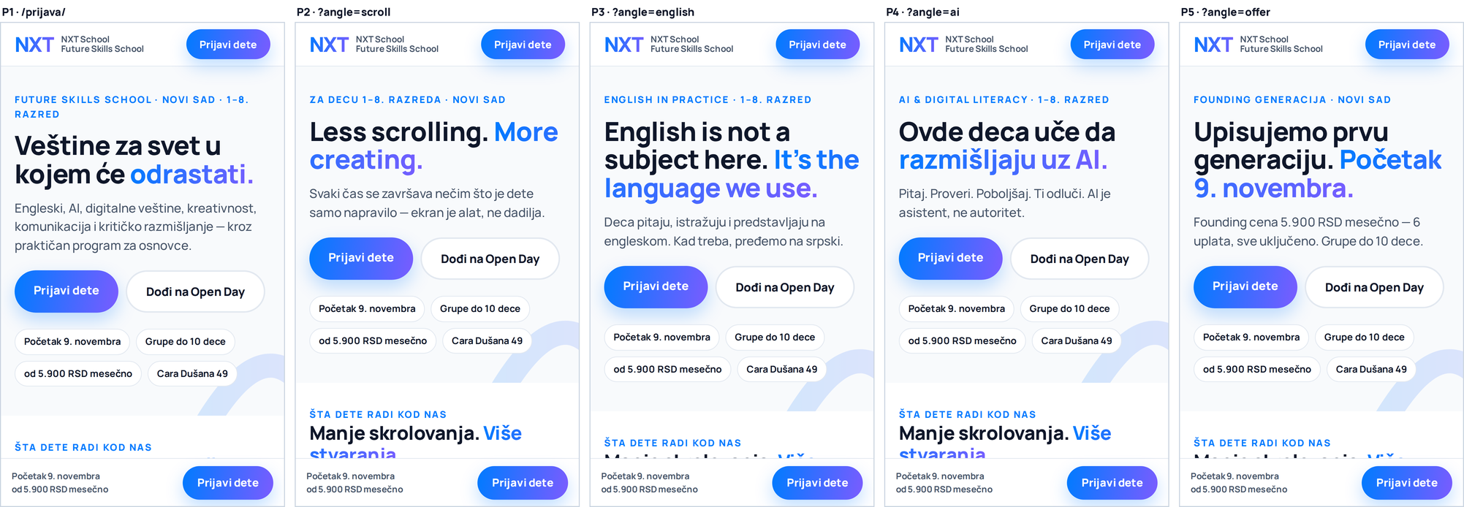
Prototype on iPhone 13. Sticky “Prijavi dete” bar at the bottom of every screen.
The whole page on mobile — the form starts on screen ~3.5 (pink line); on the homepage it is the last section:
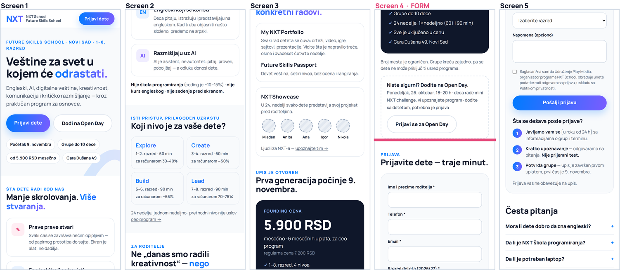
7 Ad URL map
Ads | Landing URL (nxtschool.edu.rs…)
P1 · C1 Hero, R5 team | /prijava/
P2 · C3 Less scrolling | /prijava/?angle=scroll
P3 · C4 English | /prijava/?angle=english
P4 · C7 AI literacy, P6 reel “Pitali smo decu” | /prijava/?angle=ai
P5, R1 · C5 Founding · R6 last call · R7 recap | /prijava/?angle=offer
R4 · C2 Levels | /prijava/#nivoi
R2 · FAQ “Još razmišljate?” | /prijava/#pitanja
O1–O3, R3 · Open Day | /open-day/
Meta → URL parameters (all ads):
utm_source=meta&utm_medium=paid&utm_campaign={{campaign.name}}&utm_content={{ad.name}}
These fill the hidden form fields, so every lead shows which ad and angle brought it — this replaces “Kako ste čuli”.
8 Implementation — Viktor (Elementor), ~½ day
- Duplicate the homepage → new page /prijava/ · template Elementor Canvas (no theme header/footer) · SEO plugin: noindex.
- Rebuild the 7 blocks from the prototype (landing-page/prijava.html + screenshots), reusing existing widgets and styles; delete the rest.
- Header: logo + button → #prijava. Mobile bar: a section with Sticky: bottom, visible on mobile only.
- Hero widgets → Advanced → CSS ID: hero-kicker, hero-title, hero-sub. Put an HTML widget right under the hero with the snippet below (runs before the rest of the page paints).
- Form: copy the existing Elementor form (same Lead / CompleteRegistration events). Remove “Ime deteta” + “Kako ste čuli”; add hidden fields utm_source, utm_campaign, utm_content, angle (Default value → Request parameter).
- QA: open every URL from section 7 on a phone · send a test lead and check Lead in Events Manager (Test events) · Sharing Debugger · PageSpeed mobile.

<script>
// Hero message match: ?angle=scroll|english|ai|offer (no parameter = default hero)
var ANGLES = {
scroll: {
k: 'Za decu 1–8. razreda · Novi Sad',
h: 'Less scrolling. <span class="g">More creating.</span>',
s: 'Svaki čas se završava nečim što je dete samo napravilo — ekran je alat, ne dadilja.' },
english: {
k: 'English in Practice · 1–8. razred',
h: 'English is not a subject here. <span class="g">It’s the language we use.</span>',
s: 'Deca pitaju, istražuju i predstavljaju na engleskom. Kad treba, pređemo na srpski.' },
ai: {
k: 'AI & digital literacy · 1–8. razred',
h: 'Ovde deca uče da <span class="g">razmišljaju uz AI.</span>',
s: 'Pitaj. Proveri. Poboljšaj. Ti odluči. AI je asistent, ne autoritet.' },
offer: {
k: 'Founding generacija · Novi Sad',
h: 'Upisujemo prvu generaciju. <span class="g">Početak 9. novembra.</span>',
s: 'Founding cena 5.900 RSD mesečno — 6 uplata, sve uključeno. Grupe do 10 dece.' }
};
function el(id) {
var w = document.getElementById(id);
return w && (w.querySelector('.elementor-heading-title, p') || w);
}
var a = ANGLES[new URLSearchParams(location.search).get('angle')];
if (a) {
el('hero-kicker').textContent = a.k;
el('hero-title').innerHTML = a.h;
el('hero-sub').textContent = a.s;
}
</script>
“.g” = the blue→purple gradient text class; Viktor maps it to the site’s existing gradient style.
9 Comments on the prototype screens
Numbered pins on the mobile page; blue = why it’s there, pink = to confirm / to do. Same images as PNGs in landing-page/annotated/ for Slack.
