NXT SCHOOL · META LAUNCH · CONTENT REQUESTS
Photos & video: what we have now, what to ask for
Launch ads are designed graphics — no photos needed. Real photos and video then upgrade them week by week. Reference images below are free stock: they show the type of shot, not the final look.
W1 · LAUNCH  Designed statics only | W2 · THIS WEEK  Space + team photos | W3 · BEFORE OPEN DAY  Shoot photos + first Reel | W4 · AFTER 26 OCT  Open Day photos + video

0 STATIC NOW — runs from day 1, zero photos needed Nikola designs these from the brand board
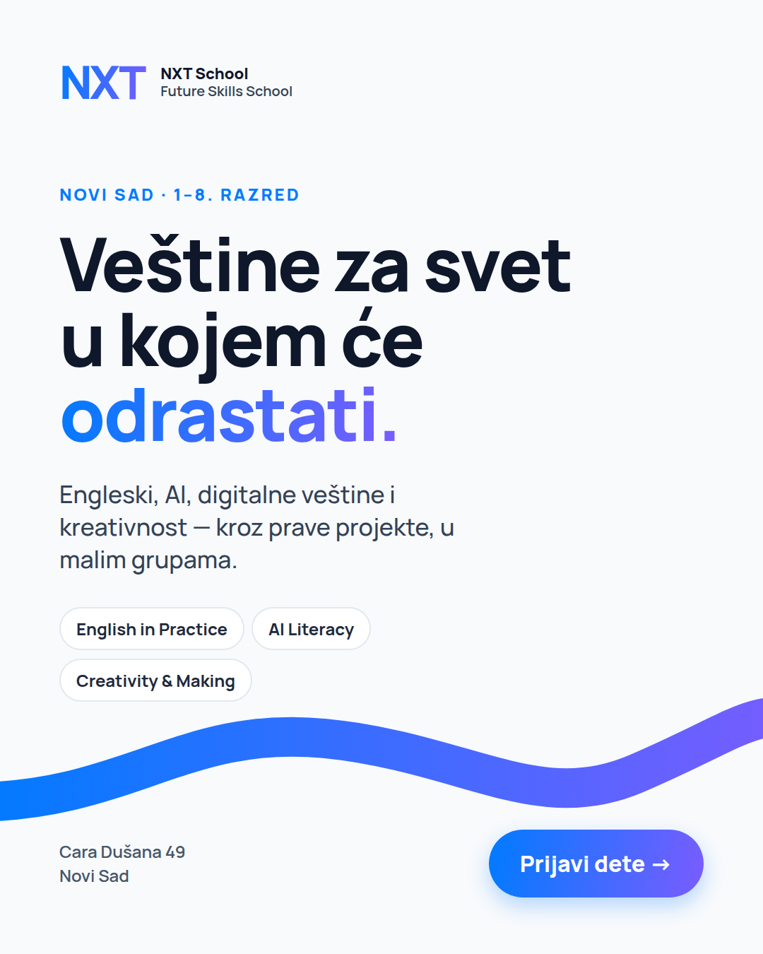  P1 Hero | 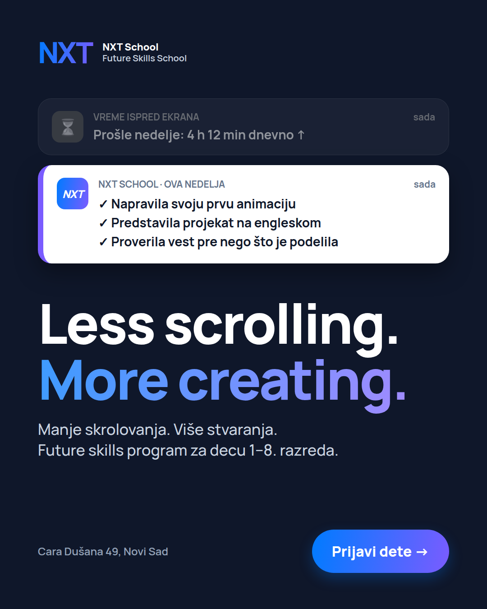  P2 Less scrolling | 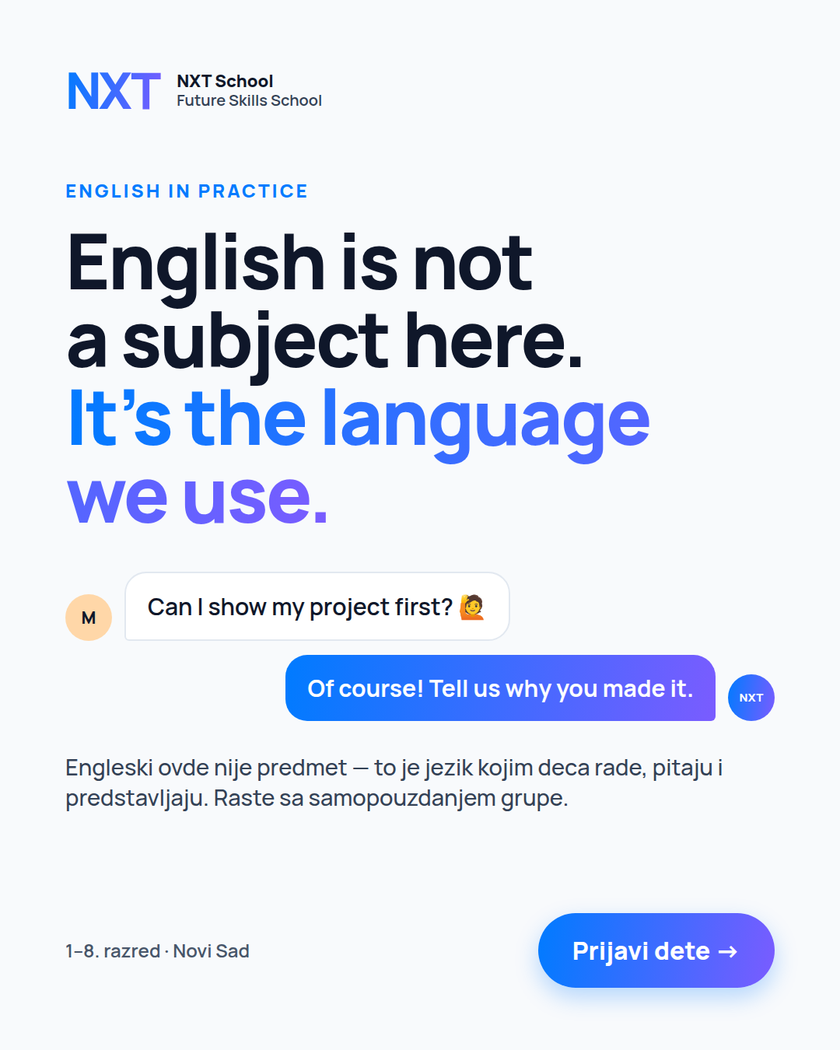  P3 English |   P4 AI literacy | 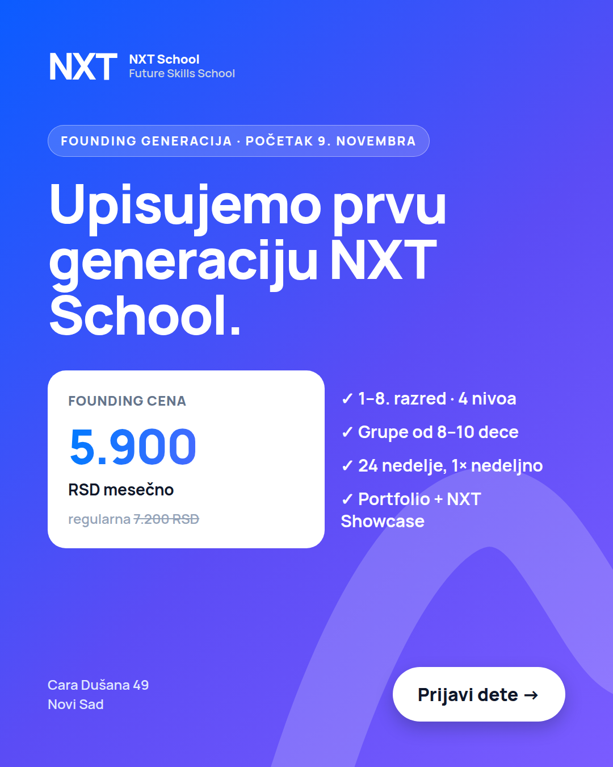  P5 / R1 Founding | 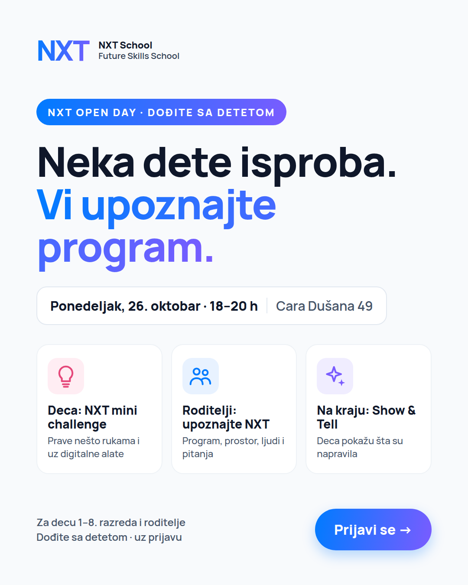  O1 Open Day | 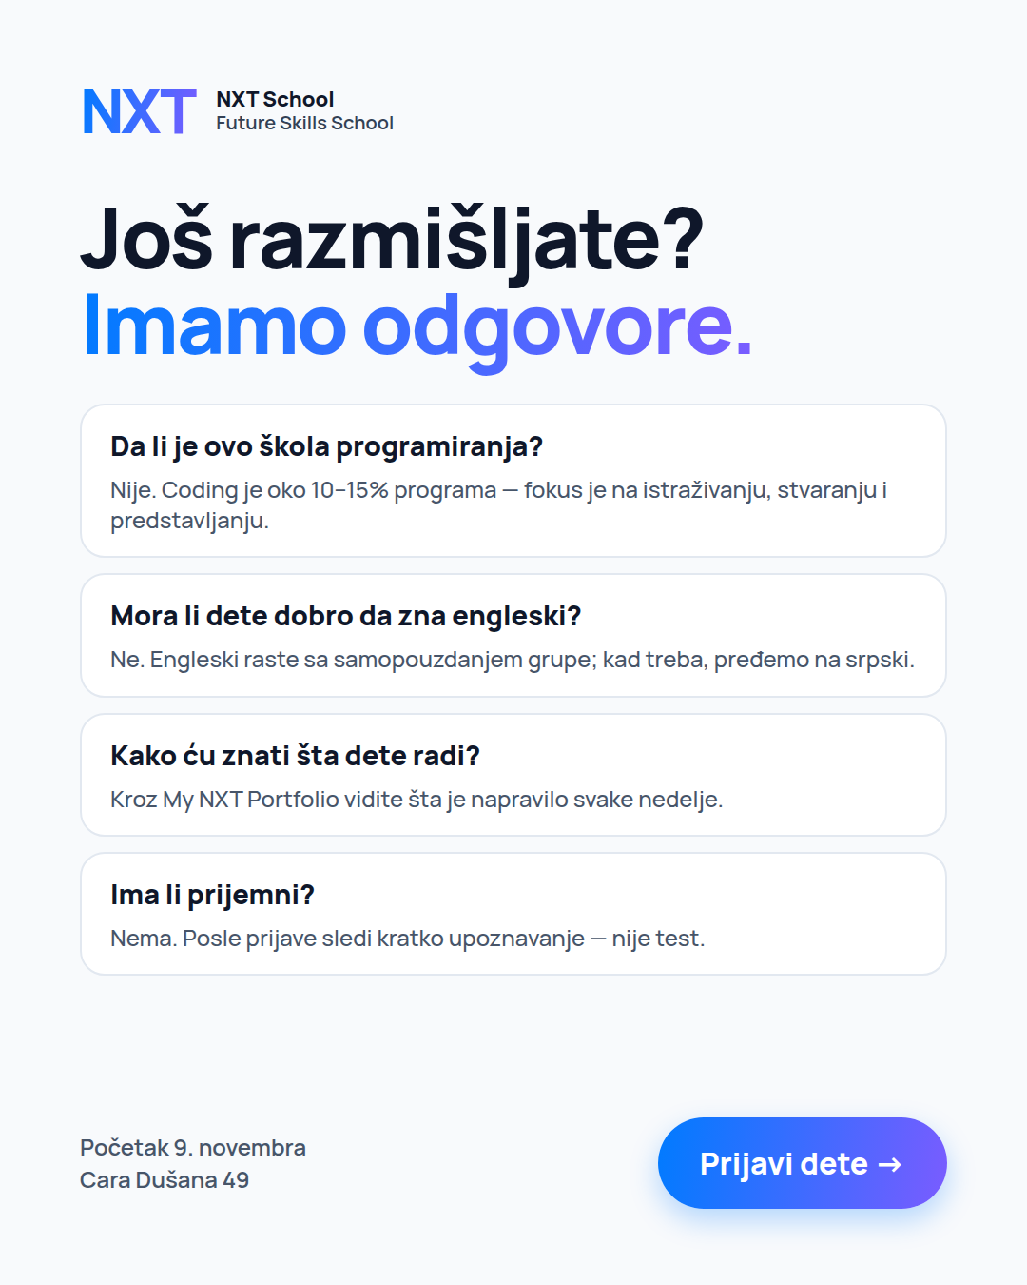  R2 FAQ | 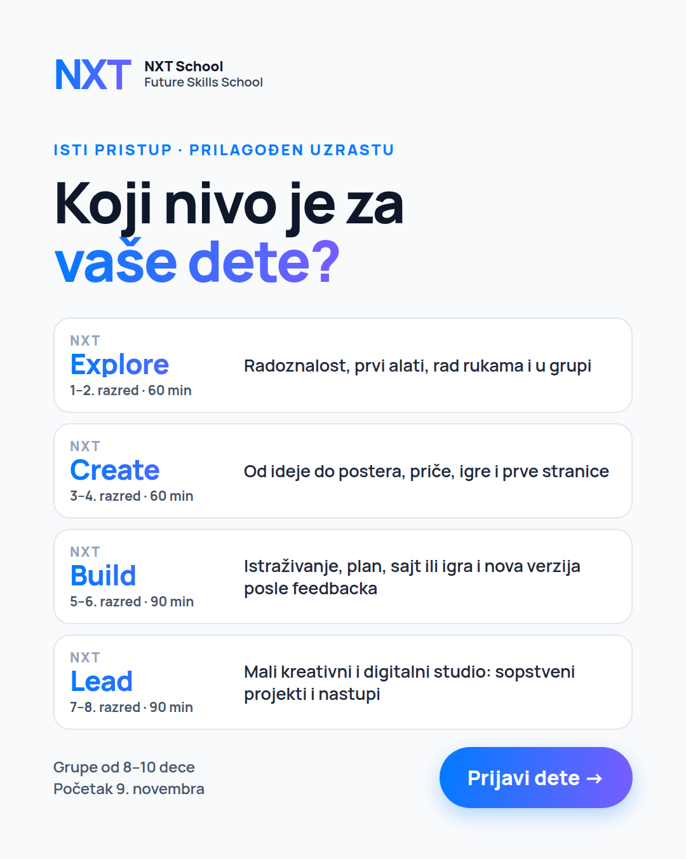  R4 Levels
Also design-only: O3 countdown, R6 "Počinjemo 9. novembra". Everything below upgrades or replaces these.

1 PHOTOS NOW — ask Igor this week (a good phone is enough) W2 · within 1–3 days
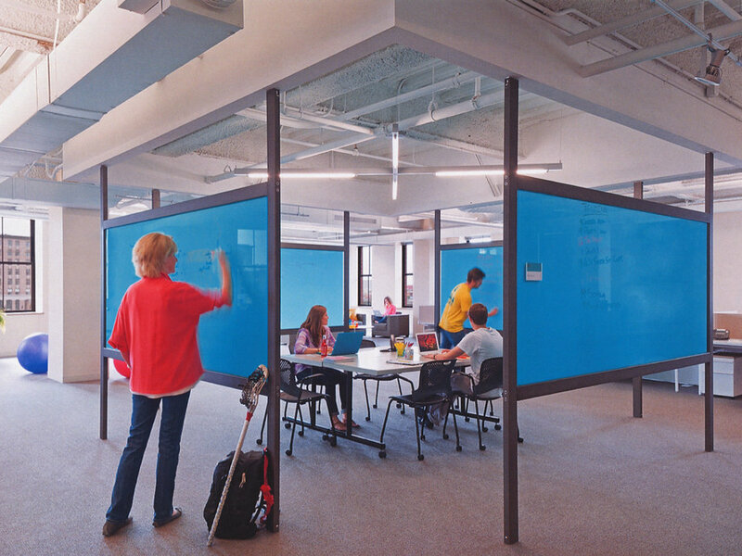  The space, empty  Ask for: wide shot + corners: tables, materials shelf, presentation zone, entrance. Natural light. No rows of empty computers.  Format: photo · horizontal + vertical  → Feeds: P1 photo version (W2), R5 background, website |   Team portraits  Ask for: Mladen, Anita, Ana, Igor, Nikola — chest-up, natural smile, in the space, same light for everyone.  Format: photo · leave room to crop 4:5  → Feeds: R5 "Ko stoji iza NXT-a?", website "Ljudi iza NXT-a" | 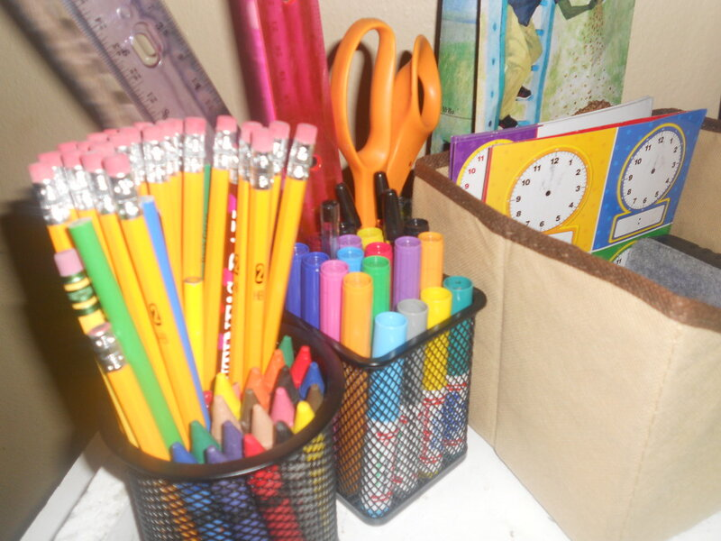  Materials & brand details  Ask for: markers, paper, Lego, sketches, posters ("Less scrolling…"), logo, hoodie. Close-ups and top-down.  Format: photo · close-up  → Feeds: backgrounds for story versions, Open Day ads, social | What this unlocks right away  • P1 Hero gets a real space photo instead of the graphic background (W2).  • R5 team ad can go live (W3).  • Website trust section gets real faces.  Plain, real and well-lit beats perfect. Don’t wait for the big shoot.

2 ASK FOR — shoot PHOTOS (Šmiranti kids + 1–2 mentors) W3 · before the Open Day · Igor shoots, Nikola art-directs
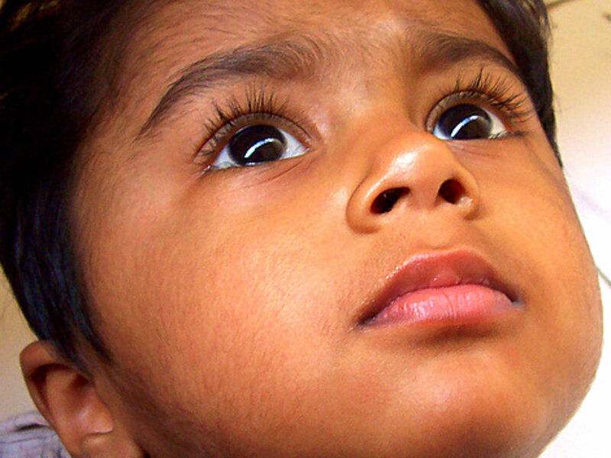  Curious kid, looking up  Ask for: age 9–11, looking up / off-frame, space blurred behind, empty area above the head for the headline.  Format: photo · vertical + horizontal  → Feeds: P1 Hero photo version (W3) | 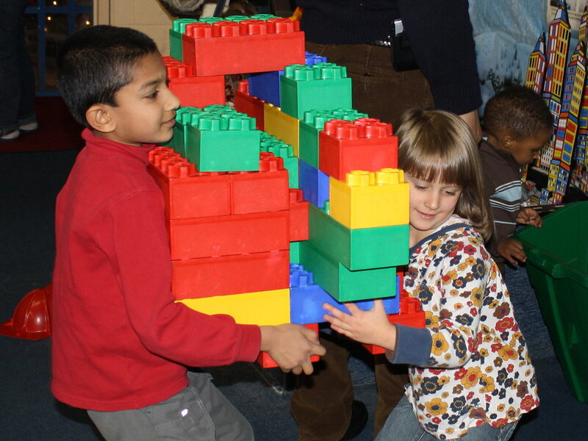  Hands making things  Ask for: Lego, paper prototypes, sketches, cardboard — hands only AND hands + face.  Format: photo + 5 s clips  → Feeds: P2 "Ovo sam danas napravio" (W3), Reel | 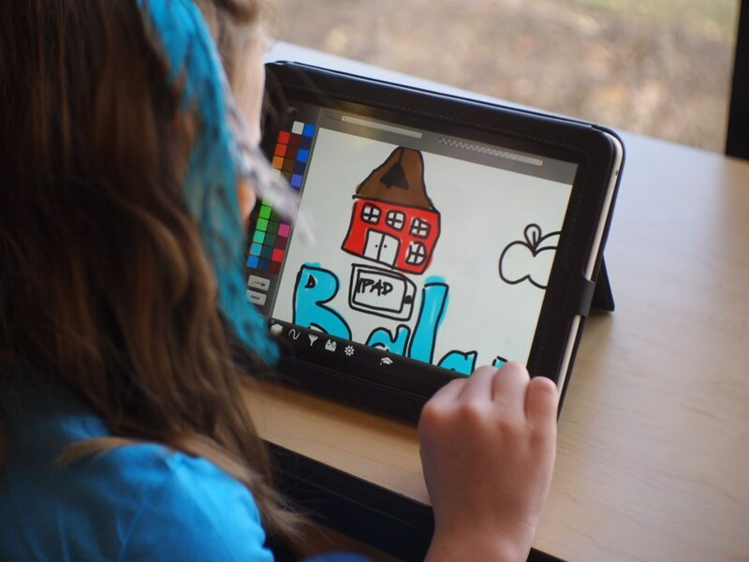  Kid creating on a screen  Ask for: over the shoulder; the screen shows THEIR project (Scratch, Canva, comic). One kid — never rows of screens.  Format: photo + short clip  → Feeds: P2 / P4 variants, Reel | 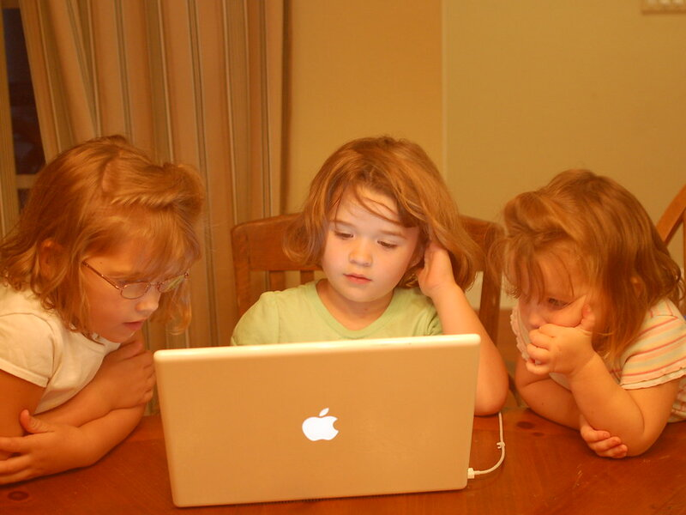  Pair & team work  Ask for: 2–4 kids around one table or laptop — pointing, discussing, laughing. Mixed ages and genders.  Format: photo + clip  → Feeds: P3 / P4 photo versions, R7
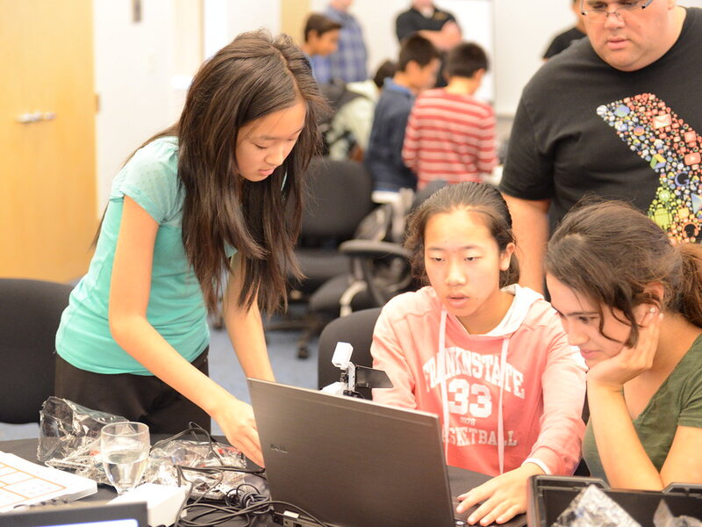  Mentor with kids  Ask for: mentor at kid eye level, explaining or listening — warm, never lecturing from the front.  Format: photo  → Feeds: R5 trust, website, landing page | 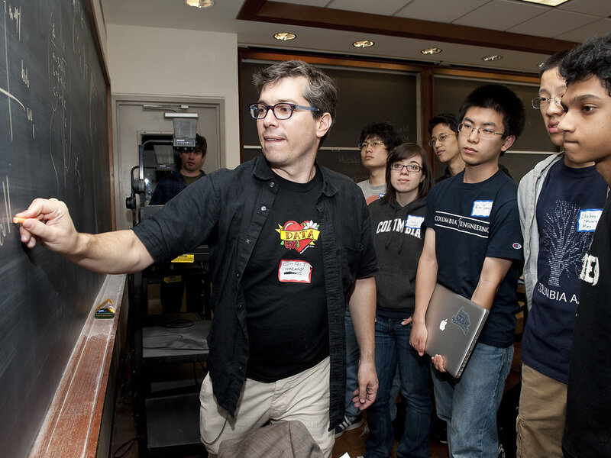  Kid presenting (in English)  Ask for: a kid standing, showing a poster or screen; the group listening, then clapping. (Reference shows the composition only.)  Format: photo + 10–15 s clip  → Feeds: P3 English photo version (W3), Showcase story | 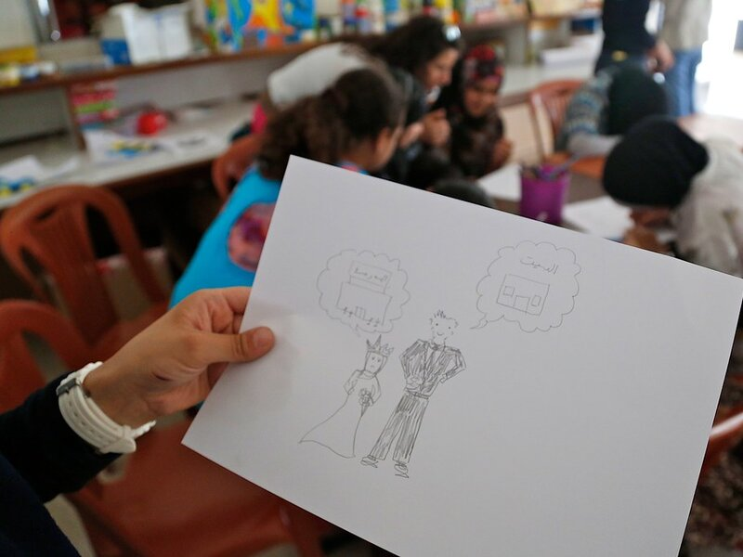  Proud moment  Ask for: kid holds the finished thing up to the camera — "Ovo sam danas napravio".  Format: photo · vertical  → Feeds: P2 / Offer variants, "Made at NXT" | 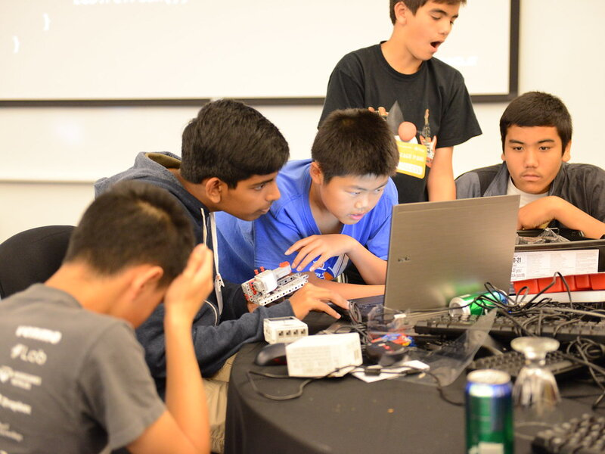  Teens as a studio (7–8)  Ask for: older kids planning on a whiteboard, laptops, a mic — grown-up, never "kiddy".  Format: photo + clip  → Feeds: R4 Levels (NXT Lead), Lead-targeted Reels

3 ASK FOR — VIDEO (same shoot) + OPEN DAY W3 shoot → W4 Open Day, 26 Oct
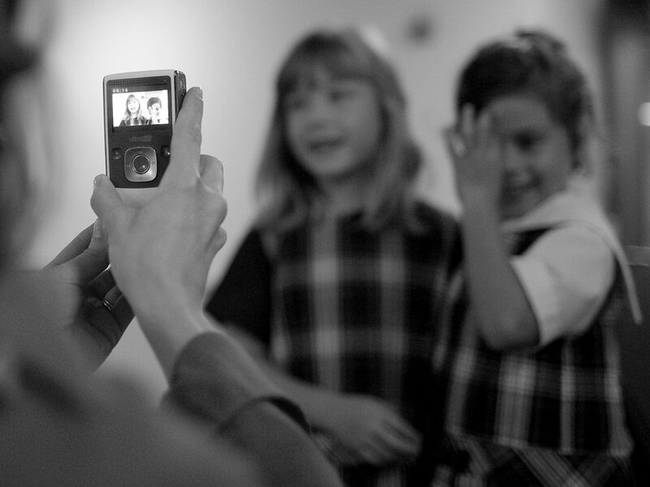  "Pitali smo decu…"  Ask for: same question to 4–6 kids per age group (1–2 · 3–5 · 6–8): "Kako će izgledati škola za 20 godina?" / "Da li će AI ljude učiniti pametnijim ili lenjim?" Eye level, clip-on mic.  Format: 9:16 video → 15–30 s edit  → Feeds: P6 Reel (W3) | 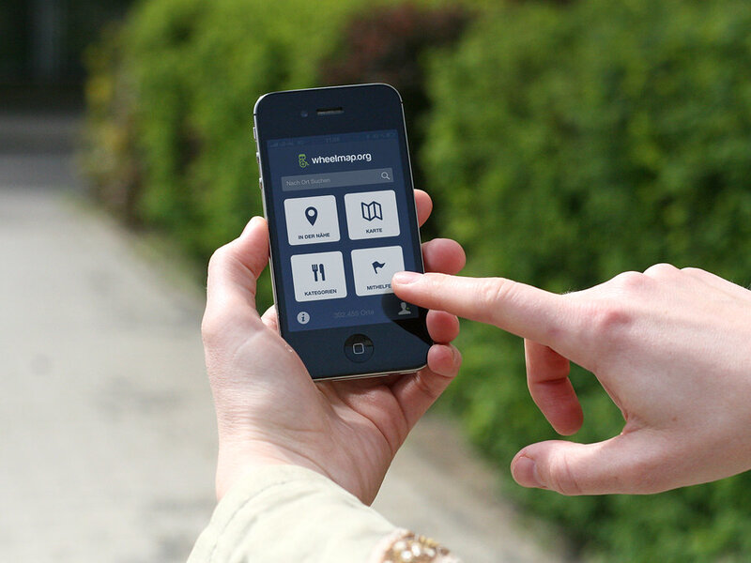  Scroll → create b-roll  Ask for: thumb scrolling a phone (cold, grey) → the same hands drawing or building (warm). 5–10 s each.  Format: 9:16 + 4:5 video  → Feeds: 15 s Reel "scroll → create" (W4), P2 motion | 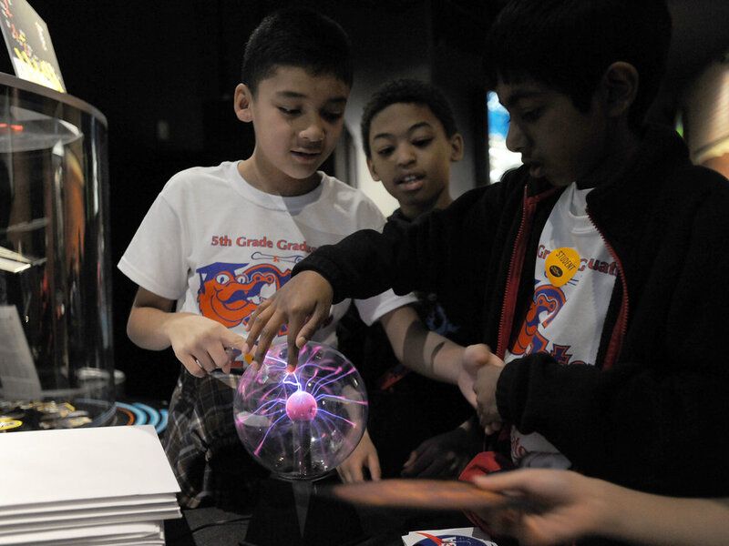  "Kids Explain the Future"  Ask for: one kid explains how they imagine school, jobs or AI in 20–40 s. Prompt them, don’t script them.  Format: 9:16 video  → Feeds: W4 Reels, organic social | 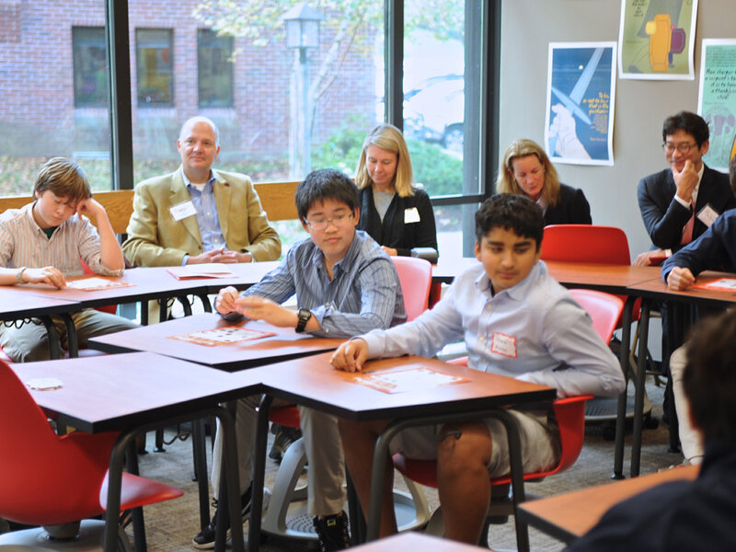  Open Day, 26 Oct  Ask for: evening event (18–20 h, bring a light): mini challenge in action, kids’ Show & Tell, parents with the team, one wide room shot, 15–20 s parent quotes ("Šta vam se svidelo?").  Format: photo + video · consent at the door  → Feeds: R7 recap, R6, website, January wave

EVERY SHOT  Vertical and horizontal · camera at kid eye level · natural light · creative studio, not a computer classroom · faces happy and busy, not posed. | CONSENT & DELIVERY  Signed parental consent for every child · cast kids are never called NXT students · raw files + 20 best selects within 48 h, named by shot (e.g. B6_presenting_01).
Reference photos: Flickr via Openverse, CC BY unless noted — internal reference only, not for ads. Credits: Phil Manker · citirecruitment · Lyn Lomasi · Nisha A · WellspringCS · flickingerbrad · whiteafrican · steveonjava · hackNY (BY-SA) · DFID - UK Department for International Development · greg westfall. · SOZIALHELDEN · NASA Goddard Space Flight Center · EaglebrookSchool.

