NXT SCHOOL · DESIGN BRIEF · CAROUSEL
Carousel — “Šta će vaše dete zaista naučiti?” (6 oblasti)
For Nikola. 8 cards, 1:1, built from the website’s “Šest oblasti” section. Mockups are the target; copy is final unless Mladen changes it. Images: design-briefs/images/Carousel_6_oblasti.
# | Deliverable | Format | Due
C6-1 | Cover + closing card | CAROUSEL 1:1 · 1080 × 1080 | Wed 14 Oct
C6-2 | Cards 2–7 · 6 areas | CAROUSEL 1:1 · 1080 × 1080 | Wed 14 Oct

RULES FOR EVERY BATCH
Brand: Manrope ExtraBold headlines · navy #0F172A · light #F8FAFC · blue #007BFF → purple #7A5CFF gradient as accent only · ≥ 40% whitespace · final NXT logo file (the mockups use a placeholder wordmark).
Sizes: feed 4:5 = 1080 × 1350 (≥ 60 px margins) + story 9:16 = 1080 × 1920 (keep top 250 px and bottom 380 px free of text and CTA). Re-layout for 9:16 — never just crop.
CTA: one pill, "Prijavi dete →" (Open Day ads: "Prijavi se →"). Answers on phone-size text: min ~24 px at 1080 width.
Facts = the website: regular 7.200 RSD · Open Day ponedeljak, 26. oktobar, 18–20 h · no "besplatno" until confirmed · level copy + "6 oblasti" as on the site.
Never: AI-generated children’s faces · rows of kids staring at screens · "Demo Day" (it’s NXT Showcase) · seat counts (the site’s "Broj mesta je ograničen" is fine). Real child photos need signed parental consent.
Delivery: PNG, named AdID_Creative_v#_ratio (e.g. P2_C3_LessScrolling_v1_9x16.png) → shared folder → Mladen signs off → Filip uploads.

C6-1 Cover + closing card Carousel 1:1 · cards 1 and 8
INSPIRATION  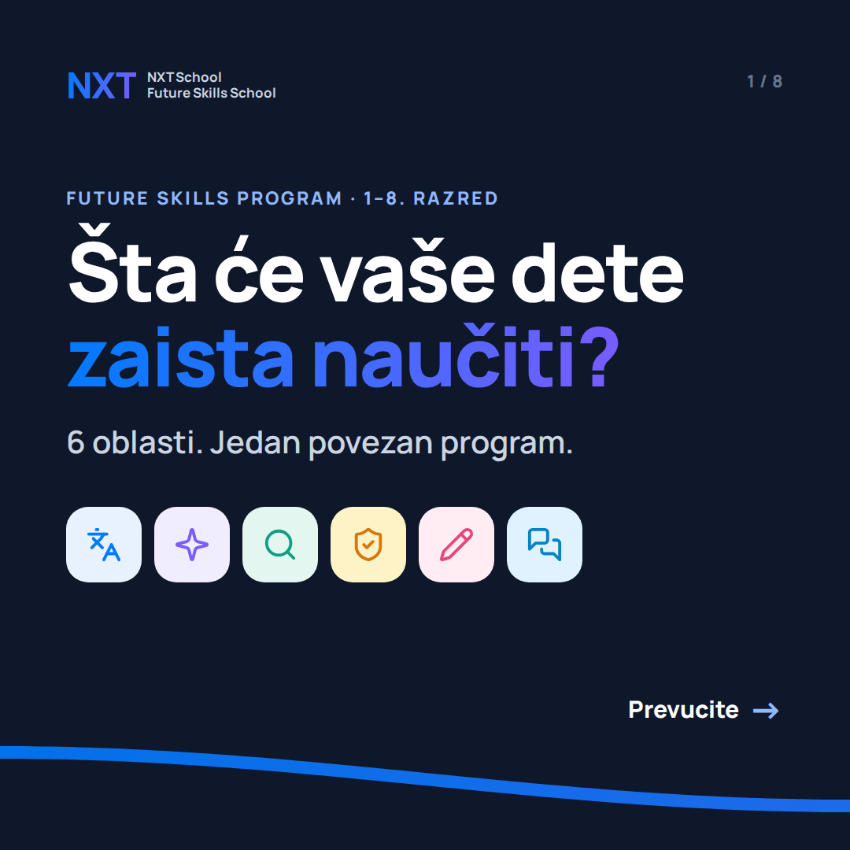  Card 1 · cover  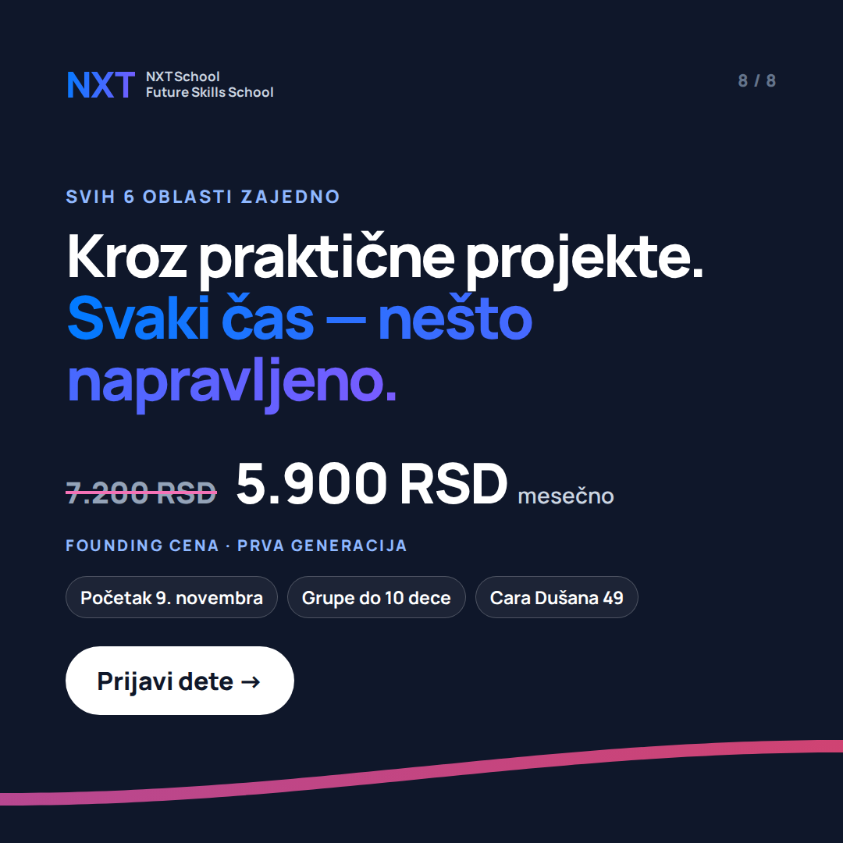  Card 8 · close | FINALIZE MOCKUP STATIC / MOTION / CAROUSEL Due: Wed 14 Oct  Job: stop the scroll with the parent’s real question, close with the offer and one CTA.  Make / improve:  • Navy cards open and close the set; cards 2–7 are light.  • Build all 8 cards as ONE 8640 × 1080 artboard, then slice into 1080 × 1080 — the gradient wave must run unbroken from card to card (that is what makes people swipe).  • “Prevucite →” only on the cover. Card counter top right on every card.  On the image (exact text):  — card 1 kicker: FUTURE SKILLS PROGRAM · 1–8. RAZRED  — card 1 headline: Šta će vaše dete zaista naučiti?  — card 1 sub: 6 oblasti. Jedan povezan program. + the 6 area icons  — card 8 kicker: SVIH 6 OBLASTI ZAJEDNO  — card 8 headline: Kroz praktične projekte. Svaki čas — nešto napravljeno.  — card 8 price: 7.200 RSD 5.900 RSD mesečno · FOUNDING CENA · PRVA GENERACIJA  — card 8 chips: Početak 9. novembra · Grupe do 10 dece · Cara Dušana 49 · CTA: Prijavi dete →  Avoid: more than one CTA in the set; flags for English.  Copy that runs with it: headline “6 oblasti. Jedan povezan program.” · primary “Šta će vaše dete zaista naučiti u NXT School? 6 oblasti koje se ne uče kao odvojeni predmeti, već zajedno, kroz praktične projekte. 1–8. razred · grupe do 10 dece · početak 9. novembra. Founding cena 5.900 RSD mesečno (regularna 7.200). 👉 Prijavi dete”

C6-2 Cards 2–7 · the 6 areas (website copy) Carousel 1:1 · one area per card
INSPIRATION  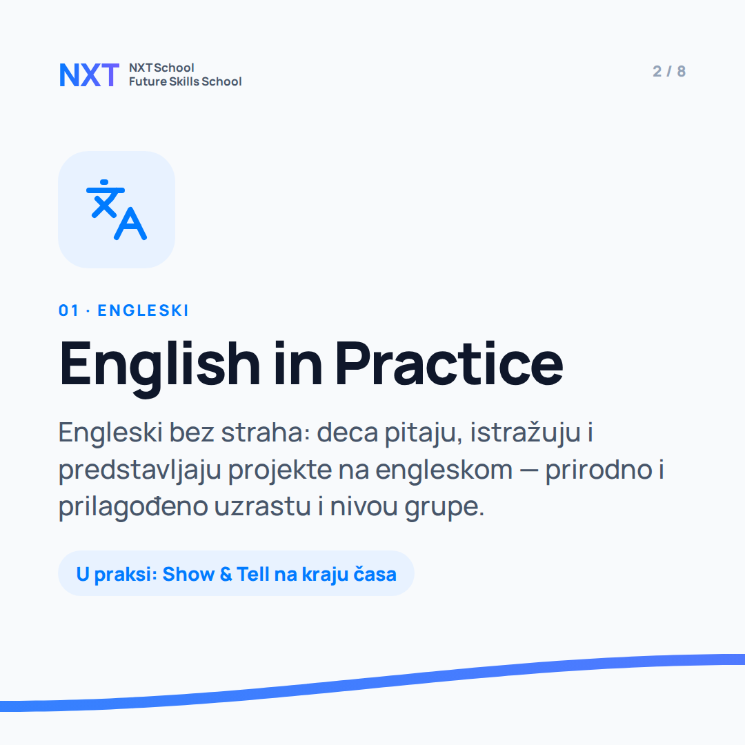  Card 2  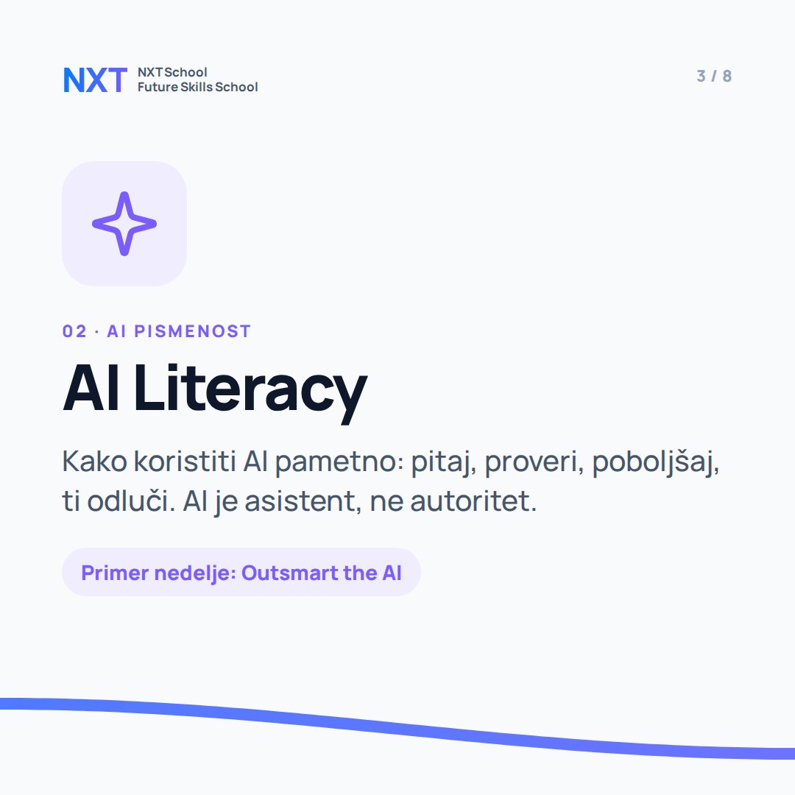  Card 3  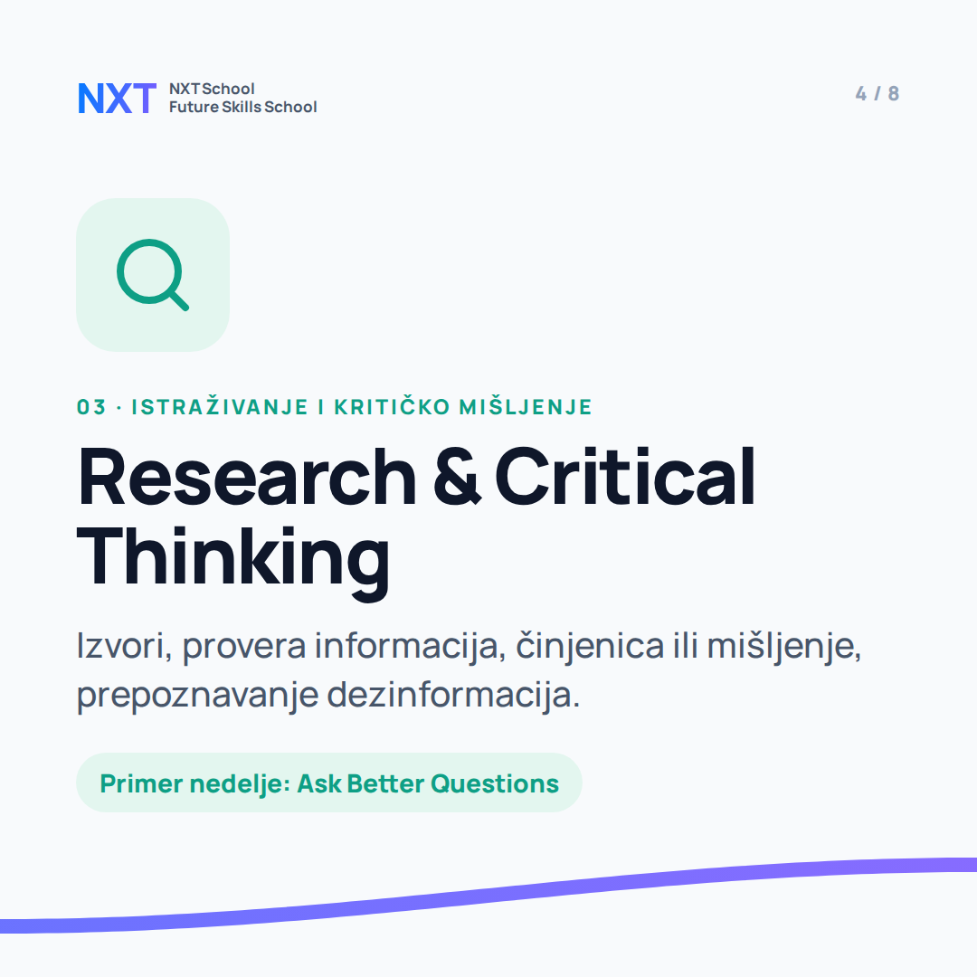  Card 4 | FINALIZE MOCKUP STATIC / MOTION / CAROUSEL Due: Wed 14 Oct  Job: make each area concrete in 3 seconds: icon → name → one sentence → a real example week.  Make / improve:  • Same grid on all 6: icon tile, numbered kicker, English area name (as on the site), Serbian description, example chip.  • One accent colour per area (blue, purple, green, amber, pink, sky) — icon, kicker and chip use it.  • Later, swap the icon tile for a real class photo per area (consent!) — layout stays.  On the image (exact text):  — 02 English in Practice — Engleski bez straha: deca pitaju, istražuju i predstavljaju projekte na engleskom — prirodno i prilagođeno uzrastu i nivou grupe. · chip: U praksi: Show & Tell na kraju časa  — 03 AI Literacy — Kako koristiti AI pametno: pitaj, proveri, poboljšaj, ti odluči. AI je asistent, ne autoritet. · chip: Primer nedelje: Outsmart the AI  — 04 Research & Critical Thinking — Izvori, provera informacija, činjenica ili mišljenje, prepoznavanje dezinformacija. · chip: Primer nedelje: Ask Better Questions  — 05 Digital Skills & Online Safety — Dokumenti, prezentacije, fajlovi i digitalni alati — uz privatnost, prevare i digitalni trag. · chip: Nedelje 9–12: provera informacija i bezbednost  — 06 Creativity & Making — Dizajn, video, audio, fizički prototipi, logika i osnove programiranja. · chip: Primer nedelje: Design Is a Decision  — 07 Communication & Teamwork — Prezentovanje, timski rad, inicijativa, planiranje i rešavanje problema. · chip: Primer nedelje: NXT Money Game  Avoid: “radni jezik” on the English card (dropped line); more than ~25 words per description.  Copy that runs with it: per-card headlines in Ads Manager = the area names.

