NXT SCHOOL · DESIGN BRIEF · UPDATE
Update — what changes on the existing designs
For Nikola · 6 Oct. Images: design-briefs/images/UPDATE_website_alignment (U1–U8). The live site is the source of truth. 8 designs change; layouts stay — only the text below. Start with C4 and C5 (both live). The mockups in the left column show the target.
FACTS (WEBSITE) + MESSAGING — USE EVERYWHERE
Founding 5.900 RSD mesečno, 6 uplata za ceo program · regularna 7.200 RSD · Open Day ponedeljak, 26. oktobar, 18–20 h, Cara Dušana 49, “dođite sa detetom · uz prijavu” · no “besplatno” until Mladen confirms · start 9. novembra · grupe do 10 · “6 oblasti” · English angle = “Engleski bez straha” (no “not a subject / language we use”).
Delivery: same file names with _v2 (e.g. P5_C5_Founding_v2_4x5.png) → shared folder → Mladen signs off → Filip swaps the live ads.

New target (mockup) | Creative · where | Change exactly (old → new) — layout stays | Formats
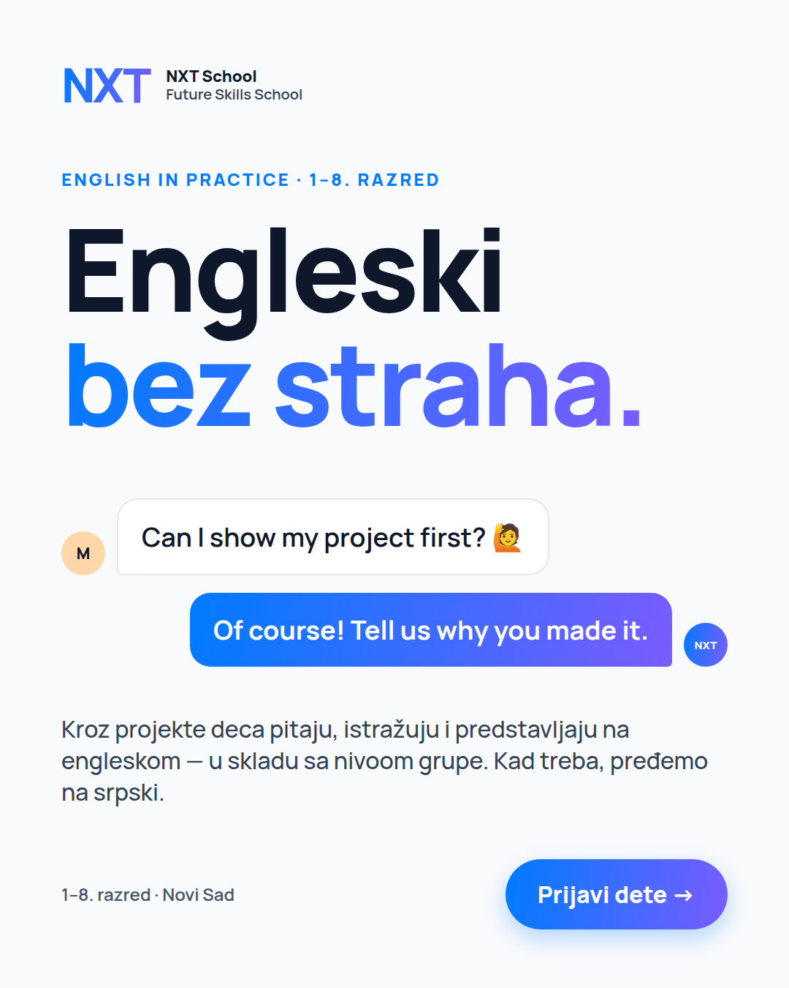 | U1 · P3 · C4 English  Prospecting (LIVE now)  Due: TODAY · Tue 6 Oct | • headline: English is not a subject here. It’s the language we use. → Engleski bez straha.  • kicker: English in Practice → English in Practice · 1–8. razred  • sub: Engleski ovde nije predmet — to je jezik kojim deca rade… → Kroz projekte deca pitaju, istražuju i predstavljaju na engleskom — u skladu sa nivoom grupe. Kad treba, pređemo na srpski.  • chat bubbles stay as they are | 4:5 + 9:16
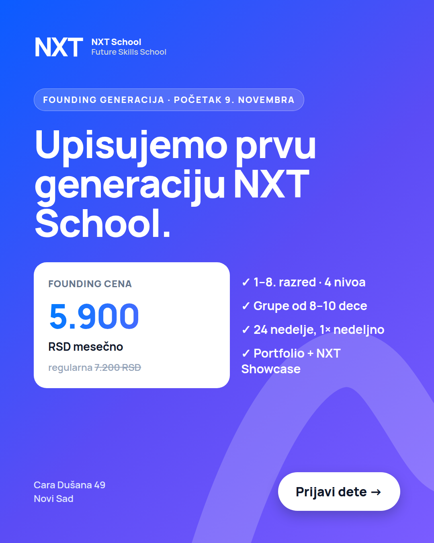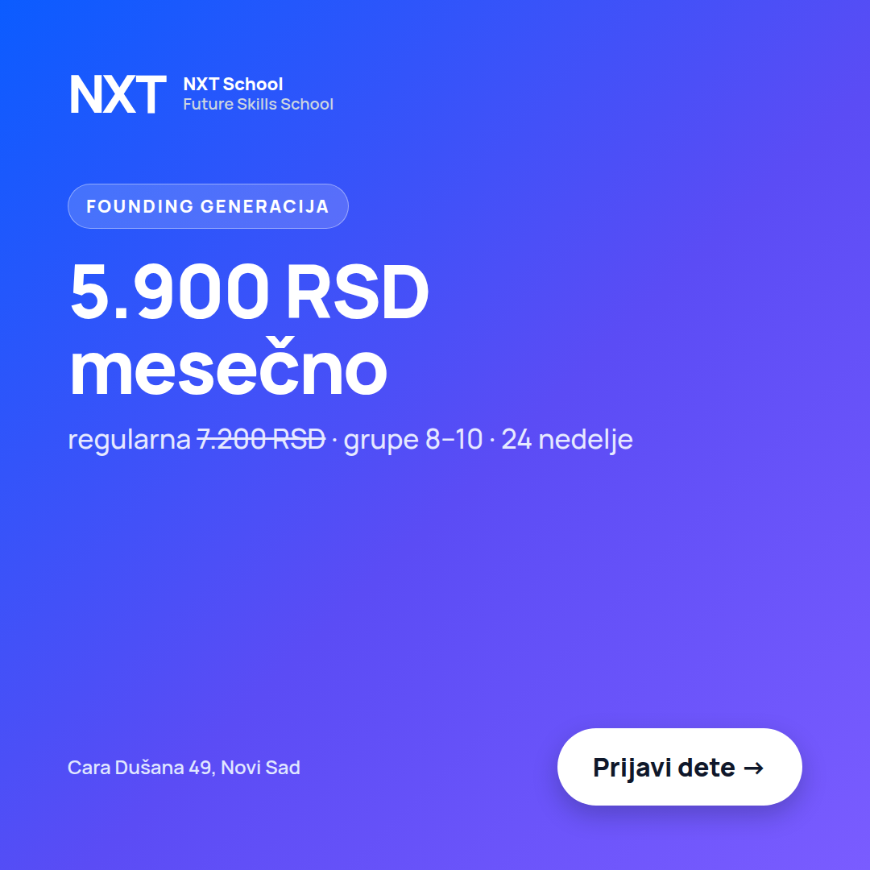 | U2 · P5 / R1 · C5 Founding  + carousel card 7  Prospecting (LIVE now) + Retargeting  Due: TODAY · Tue 6 Oct | • price card: regularna 6.400 RSD → 7.200 RSD  • card 7 sub line: regularna 6.400 → 7.200 RSD · grupe 8–10 · 24 nedelje | 4:5 + 9:16 · card 1:1
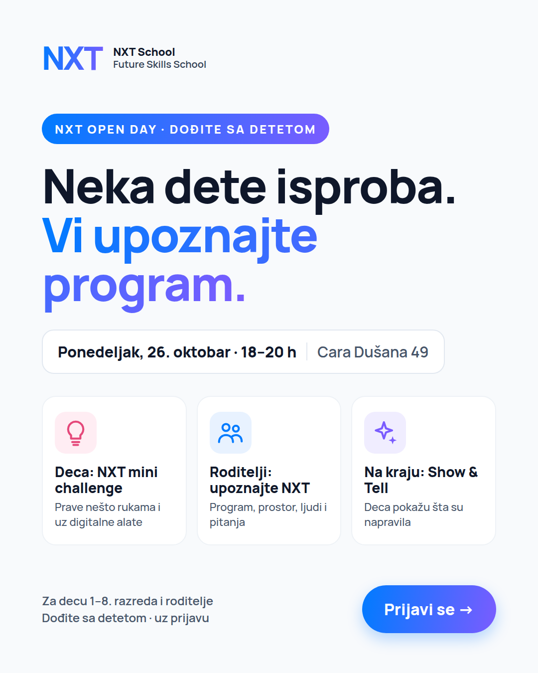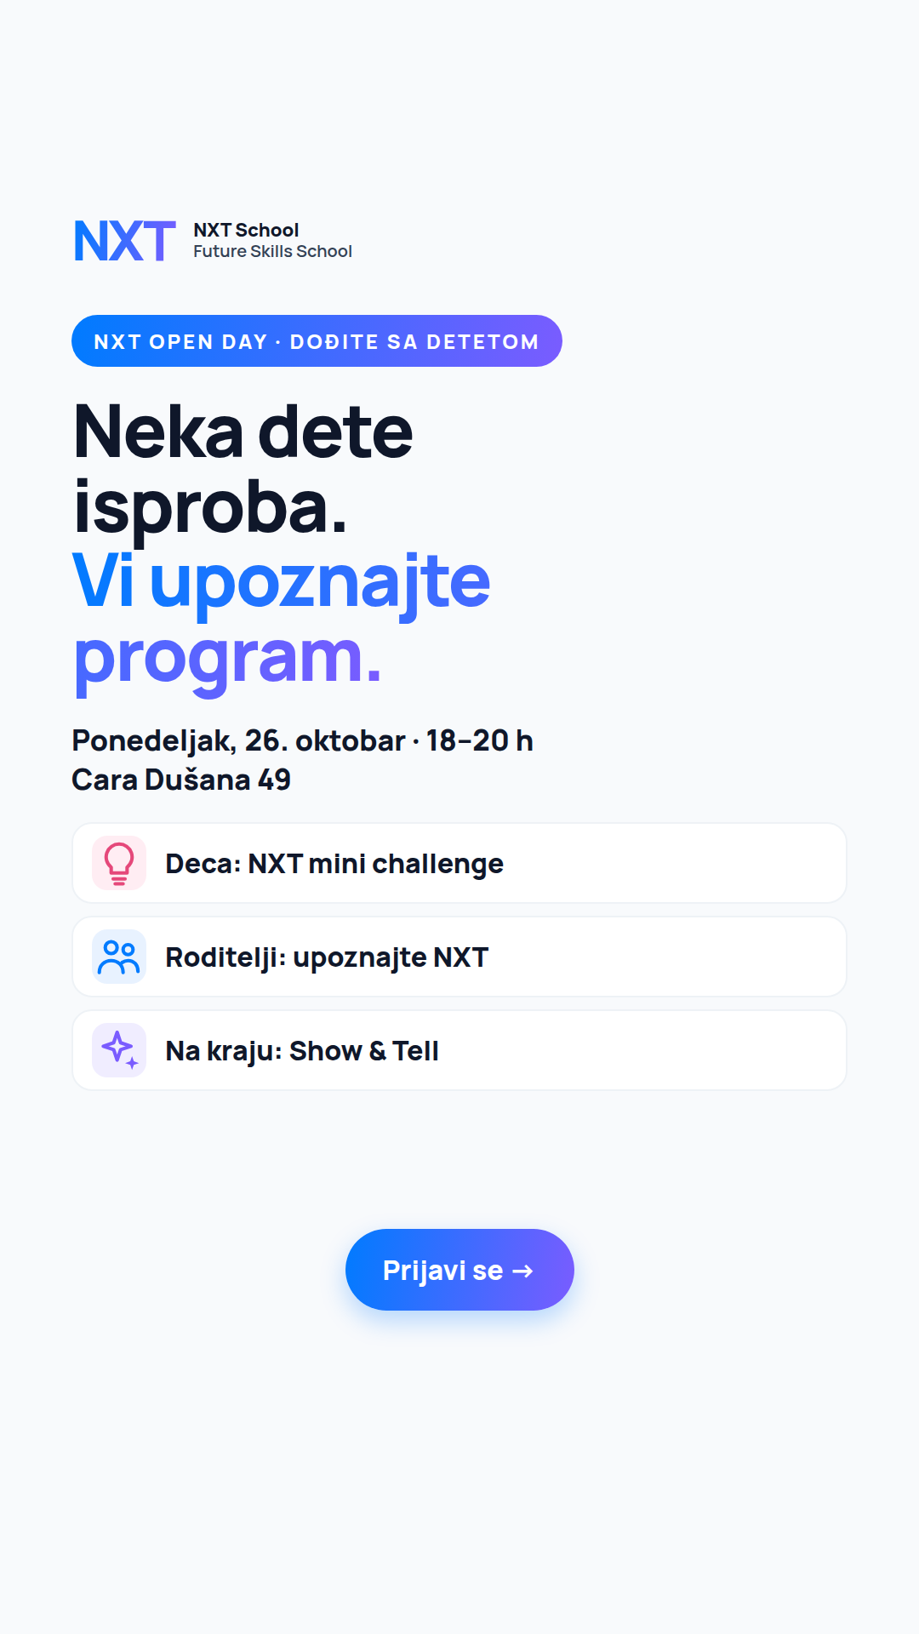 | U3 · O1 / R3 · C6 Open Day  feed + story  Open Day from 12 Oct, Retargeting from 13 Oct  Due: Fri 9 Oct | • badge: NXT OPEN DAY · BESPLATNO → DOĐITE SA DETETOM  • date chip: Subota, 24. oktobar → Ponedeljak, 26. oktobar · 18–20 h | Cara Dušana 49  • footer: ≈90 min · besplatno, uz prijavu → Dođite sa detetom · uz prijavu  • story: same date line + "Cara Dušana 49" on line 2 | 4:5 + 9:16
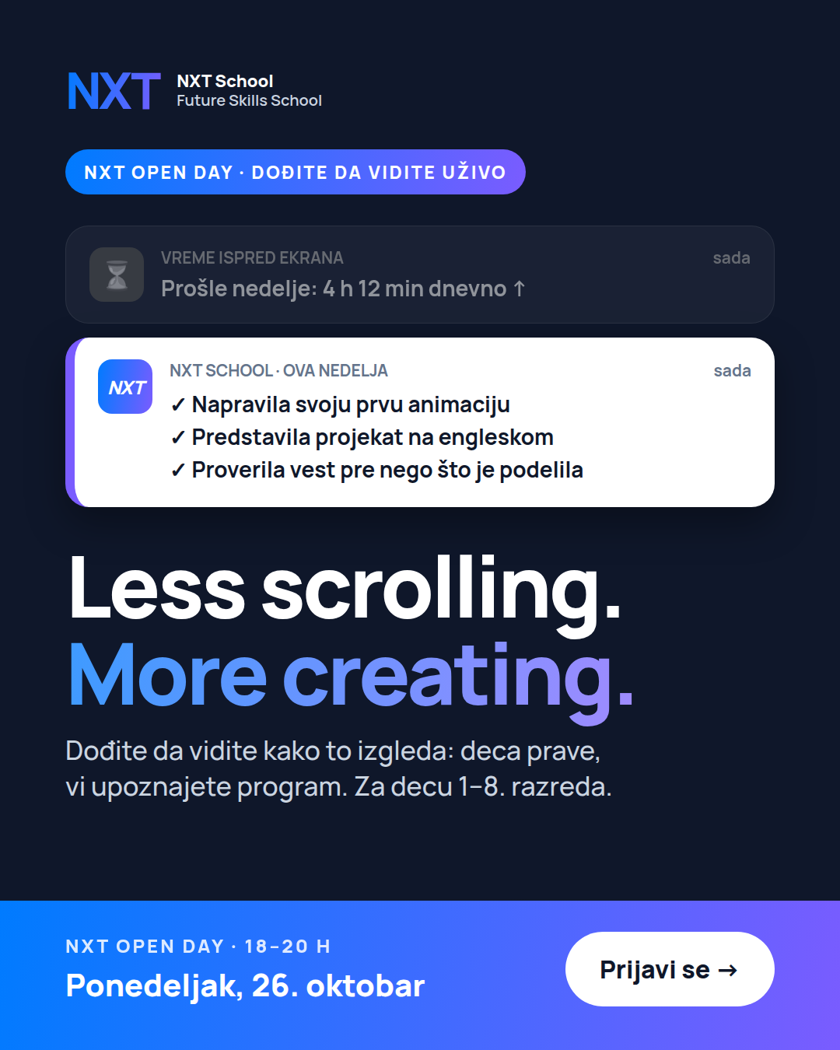 | U4 · O2 · winner + Open Day framing  Open Day from 13 Oct  Due: Tue 13 Oct | • winner’s headline + visual unchanged  • add kicker on top: NXT OPEN DAY · DOĐITE DA VIDITE UŽIVO  • subline → Dođite da vidite kako to izgleda: deca prave, vi upoznajete program.  • band: NXT OPEN DAY · BESPLATNO 18–20 H / Subota, 24. oktobar Ponedeljak, 26. oktobar | 4:5 + 9:16
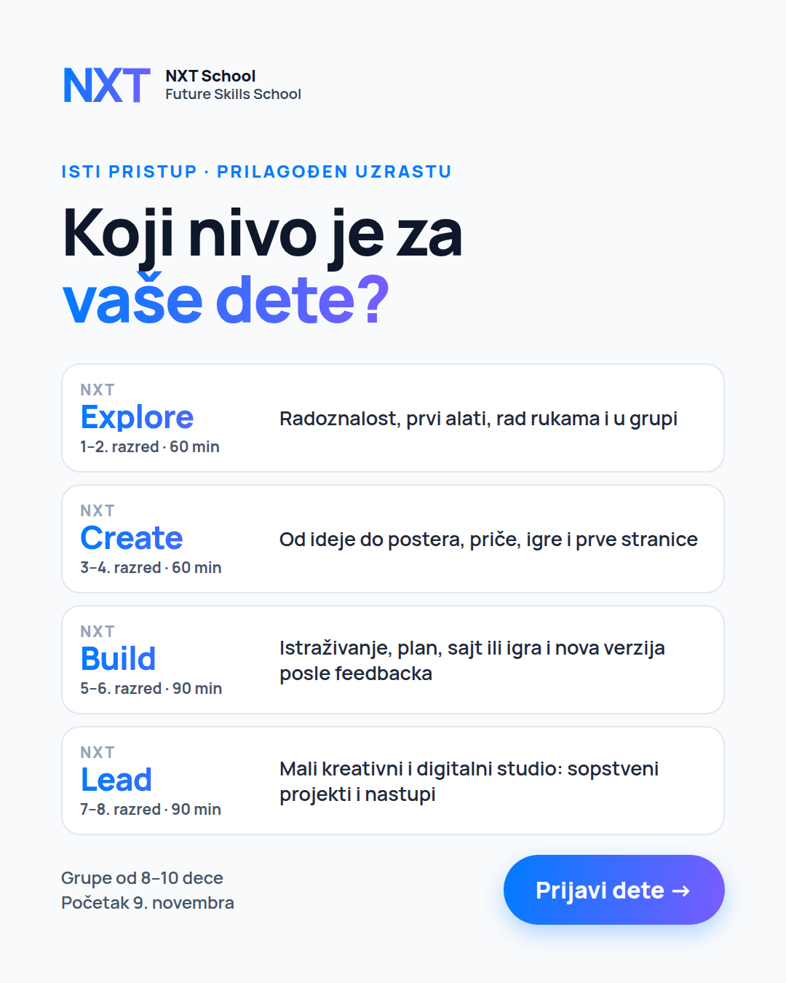 | U5 · R4 · C2 "Koji nivo je za vaše dete?"  Retargeting from 13 Oct  Due: Mon 12 Oct | • Explore → Radoznalost, prvi alati, rad rukama i u grupi  • Create → Od ideje do postera, priče, igre i prve stranice  • Build → Istraživanje, plan, sajt ili igra i nova verzija posle feedbacka  • Lead → Mali kreativni i digitalni studio: sopstveni projekti i nastupi | 4:5 + 9:16
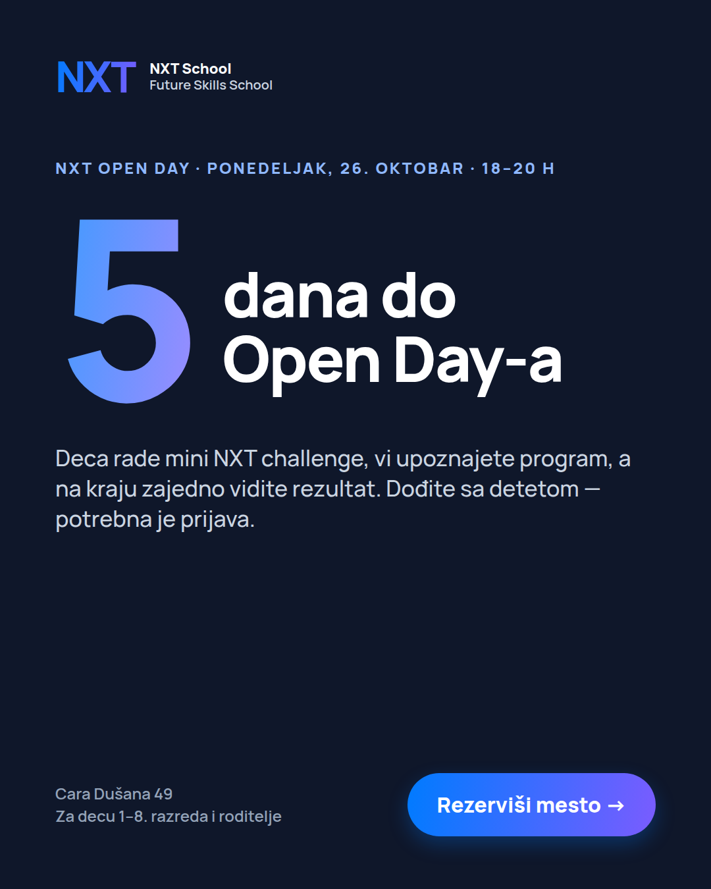 | U6 · O3 · Open Day countdown  2 versions  Open Day · A 21–23 Oct · B 24–26 Oct  Due: Fri 16 Oct | • kicker: NXT Open Day · Subota, 24. oktobar → Ponedeljak, 26. oktobar · 18–20 h  • version B: Ove subote! → U ponedeljak!  • sub: Deca rade mini NXT challenge, vi upoznajete program, a na kraju zajedno vidite rezultat. Dođite sa detetom — potrebna je prijava. | 4:5 + 9:16
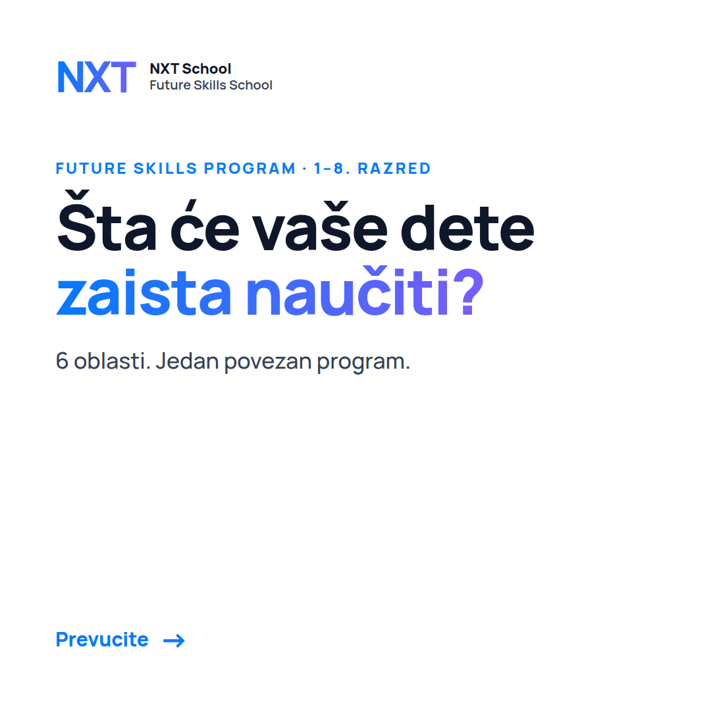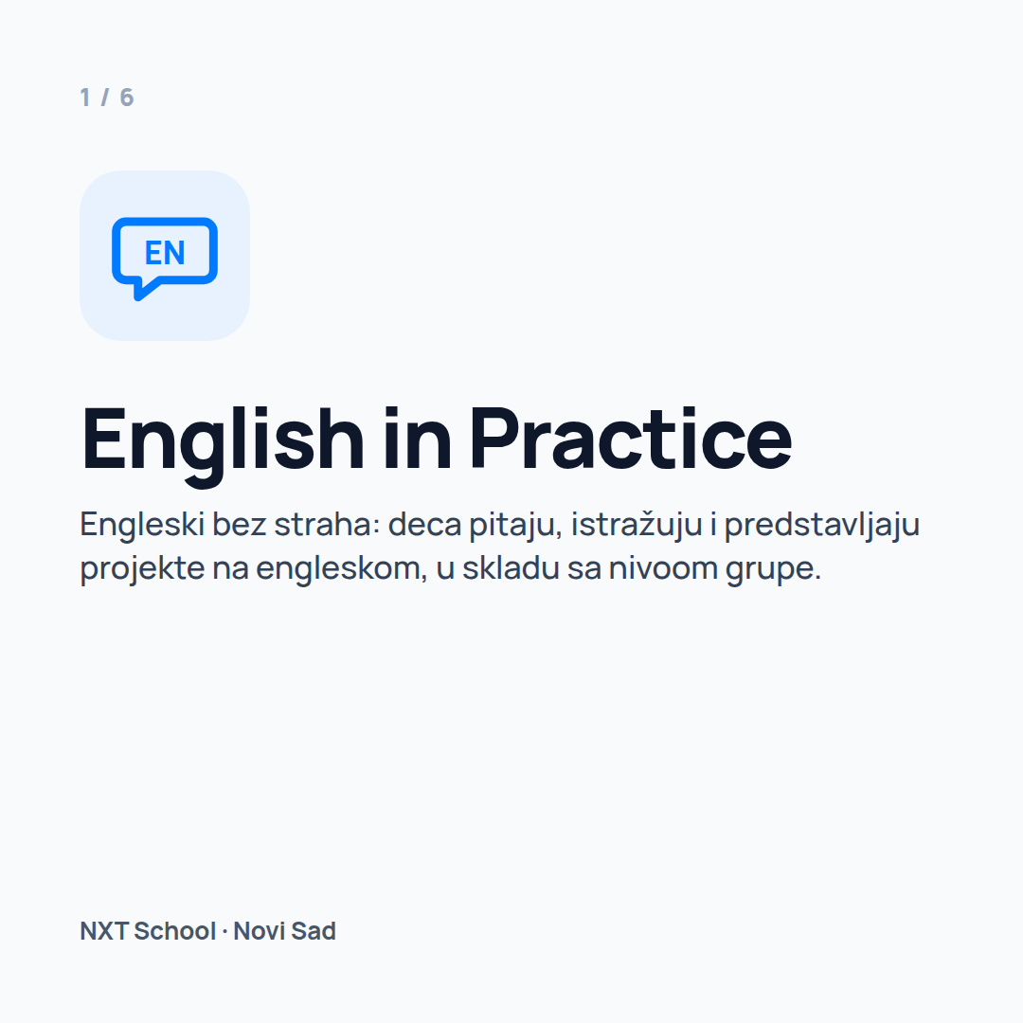 | U7 · Carousel cards 1–2  (only if angle 1 wins)  Prospecting W3  Due: Wed 14 Oct | • card 1 sub: 6 veština za svet u kojem će odrastati → 6 oblasti. Jedan povezan program.  • card 2 text: Engleski bez straha: deca pitaju, istražuju i predstavljaju projekte na engleskom, u skladu sa nivoom grupe. | 1:1
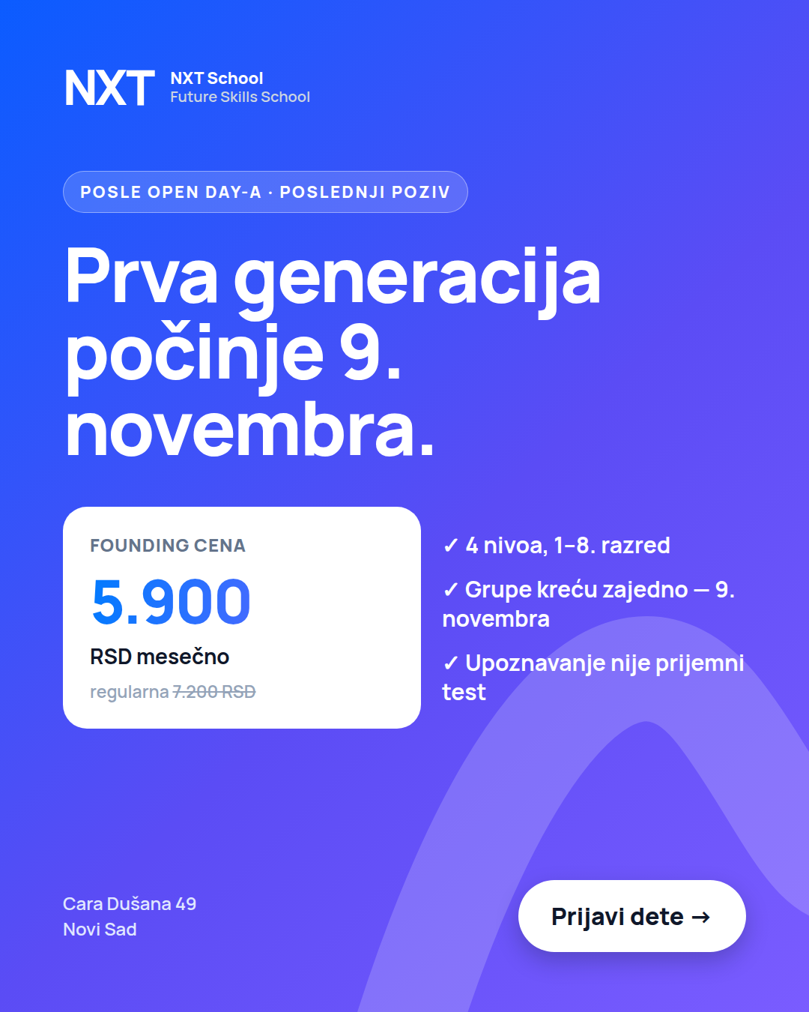 | U8 · R6 · Last call  "Počinjemo 9. novembra"  Retargeting from Tue 27 Oct  Due: Mon 26 Oct | • price card: regularna 6.400 → 7.200 RSD  • tick 2: My NXT Portfolio → Grupe kreću zajedno — 9. novembra | 4:5 + 9:16
Also updated in Batches 1–4 (pink “UPDATED 6 OCT” line on each affected card). Questions on facts → Filip; final sign-off → Mladen.

