NXT SCHOOL · FUTURE SKILLS SCHOOL
Launch Campaign & Creative Strategy
Angle map · media plan · budgets · platforms · creative strategy · launch creatives · ad copy
Prepared for | Play Media launch team (Paid · Design · Copy · Photo/Video · Ops/CRM)
Date | Monday, 5 October 2026 — paid launch target Tue 6 / Wed 7 October
Market | Novi Sad · parents of pupils in grades 1–8 · Cara Dušana 49
Budget | 100,000–150,000 RSD media, first month (base plan: 120,000 RSD)
How to read | 3 versions of each section. V1 = MAIN (recommended, best practice). V2 and V3 are alternative setups for inspiration / fallback switches.

TL;DR
- Run V1 "Consolidated Validation Launch": Meta-led, one broad prospecting ad set optimizing for application_submit, 5 creatives × 3 copy angles, Google Search as the intent net, Open Day campaign from 12 Oct, retargeting from 13 Oct.
- Budget: pace at 120k RSD (~4,000 RSD/day); unlock 150k only when CPL ≤ 1,000 RSD and ≥ 50% of leads are call-qualified. Split: 60% Meta prospecting · 15% Open Day · 10% retargeting · 15% Google.
- Calendar reality: we launch ~5 weeks after the September "upis na vannastavne" window. Sell the Founding generation + Open Day (proposed Sat 24 Oct) as the decision moment. Next natural wave = semester 2 (January) — prep in December.
- Lead message: "Less scrolling. More creating." (problem angle) is the most likely scroll-stopper for parents; "Future skills / AI done right" is the differentiator; "Founding generacija" closes.
- Targets month 1: ~90–120 applications at ≤ 1,000 RSD CPL → 15–25 enrolled founding students (2–3 groups). Media pays back with ~4 enrolled kids (1 kid ≈ 35,400 RSD over 24 weeks).
- Fix before shooting/AI visuals: mood-board kids are teens (~14–16); our core buyer has a 7–12-year-old → visuals must show younger kids. No AI-generated children faces in ads — typographic/UI creatives until the real shoot.

1. What the brief & brand board tell us
Analysis of the Slack brief, offer and brand board → what each signal means for paid. (Staging site was not reachable from my environment, so ad↔landing-page congruence is assumed from the brief; check before launch.)
Signal from brief / board | So what for paid & creative
Grades 1–8 = two different buyers. Grades 1–4: parent decides alone. Grades 5–8: kid co-decides. | 1–4: safety, English confidence, screen time, small groups. 5–8: AI, creating real things, presenting, "cool". Every ad must say "1–8. razred"; form field razred gives the demand split weekly.
New category — "not a coding school, not an English school". | Category needs explaining in 3 seconds. Ads must answer "what will my kid actually do here?" → outcome-led creatives (e.g., "made an animation, presented in English").
Price 5,900 founding / 6,400 regular RSD per month; 24 weeks. | Mid-premium. Showing price pre-qualifies leads and protects Ops time. Founding discount = honest urgency (small groups of 8–10 = real scarcity).
Launch date 5–7 Oct. | Most families locked extracurriculars in September. Position NXT as the upgrade / swap from passive screen time, use Open Day as the decision moment, plan a January wave.
Budget 100–150k RSD (~€850–1,280) in a ~370k-population metro. | Small budget + small audience → consolidate. Meta will not reach 50 conversions/week per ad set — "learning limited" is expected; don't fragment into many ad sets.
Funnel: website form → Fast Lane (GHL) pipeline; events application_start / application_submit. | Optimize Meta for Lead = application_submit. No checkout → never Purchase objective. Store UTMs on the contact so every enrolment traces back to an ad.
Brand board: Manrope, navy/blue/purple, clean premium, lots of whitespace. | Ads should look like the brand board, not like a kids' party flyer or SaaS. Gradient = accent only. Mood-board line "Small School for Big Minds" ≠ locked line "Future Skills School" → use the locked line.
Mood-board models are teens. | Core demand will likely be grades 1–5 (ages 7–11). Use younger kids (mixed gender, natural, real) in every photo-based creative.
Key messages (two in English). | English lines double as proof of "English is the language we use" — but always pair with a Serbian subline so parents of 1st–2nd graders don't bounce.
Serbian school shifts (pre podne / posle podne alternate weekly in most primary schools). | Weekly-class scheduling is a hidden objection. If groups/terms accommodate both shifts, say it in ads and on the LP ("termini usklađeni sa smenama").

2. Campaign strategy — 3 versions
 | V1 · MAIN (recommended) | V2 · Inspiration | V3 · Inspiration
Name | Consolidated Validation Launch | Grade-Split Lead Machine | Open Day–First Experience Funnel
Core idea | One broad Meta ad set, website applications, creative does the targeting. Validate demand, price, message, grade mix in 2–3 weeks. | 3 ad sets split by age band (1–2 / 3–4 / 5–8 razred), Meta Instant Forms for cheaper, faster leads. | Don't ask cold parents to apply for 6 months — invite them to experience NXT (Open Day + free trial class). Close in person.
Platforms | Meta 85% · Google Search 15% | Meta 80% · Google Search 20% | Meta 58% · local creators 25% · Google 10% · offline QR 7%
Conversion | application_submit (website) | Instant Form lead (synced to GHL) | Open Day / trial registration → enrolment on site
Strength | Cleanest data, highest lead intent, matches funnel already built | Fastest grade-demand read, lowest CPL | Highest trust, produces real content & testimonials
Weakness | Higher CPL than forms; depends on LP quality | Lower intent, more Ops calling, 3× creative load | Slow hard data (enrolments after 24 Oct), no-show risk
Use when | Default launch (now) | Fallback if LP CVR < 3% or CPL > 1,800 RSD after week 1 | Phase 2 if ads get clicks but few applications (interest without trust)

V1 · MAIN — Consolidated Validation Launch
Why this is best practice here: small budget + small city + new category = the algorithm needs every conversion signal in one place, and the team needs a clean read on which message wins. One prospecting ad set, broad audience, 5 distinct creatives across 4 emotional territories, optimized for the real business event (application_submit).

Campaign structure
Campaign | Objective · optimization | Ad set / targeting | Ads | Live
NXT_META_LEADS_PROSP_Launch_2610 | Leads · website · Lead (application_submit) · 7d click / 1d view | 1 ad set · Broad + Advantage+ audience · Novi Sad +15 km · 25–55 | 6 ads: C1×B, C1×A, C2×B, C3×A, C4×B-EN, C5×C | Tue 6 / Wed 7 Oct
NXT_META_LEADS_OPENDAY_2610 | Leads · website · custom conversion on Open Day thank-you page | 1 ad set · Broad + warm audiences · Novi Sad +12 km | C6 Open Day (static + Story) + best prospecting ad re-cut | Mon 12 → Fri 23 Oct
NXT_META_LEADS_RT_2610 | Leads · application_submit | 1 ad set · web visitors 30d, application_start w/o submit 14d, IG/FB engagers 60d · exclude applicants | C5 Founding, FAQ/objection ad, Open Day | From Tue 13 Oct (audience ≥ 1k)
NXT_GADS_SEARCH_Category_2610 | Max clicks (CPC cap 60–80 RSD) → Max conversions after 15 conv. | 4 ad groups: Engleski za decu · IT/AI za decu · Kursevi/radionice za decu · Brand · Novi Sad presence | 1 RSA per ad group + sitelinks, callouts, location | Wed 7 Oct

Audience setup (Meta)
Setting | Prospecting | Retargeting | Open Day
Location | Novi Sad, pin Cara Dušana 49 +15 km (Petrovaradin, Sr. Kamenica, Veternik, Futog, Kać) · "people living in" | Same | +12 km
Age / gender | 25–55 · all (Advantage+ suggestion 28–50) | 25–60 · all | 25–55 · all
Detailed (suggestion only) | Parents with children 6–8 / 8–12 / 13–17 (where available) · Education · English language · Parenting | — | Parents · engagers
Custom audiences | — | Web visitors 30d · application_start no submit 14d · IG/FB engagers 60d · 50% video viewers 30d | Warm + broad
Exclusions | Applicants (Lead event 30d + GHL list upload) · team | Applicants | Open Day registrants
Placements | Advantage+ placements, exclude Audience Network (junk-lead risk) | Same | Same
Creative enhancements | Turn off AI text/image generation & auto music (brand control); keep placement adaptations | Same | Same

Budget — V1 (base 120,000 RSD)
Line | Live | RSD / month | % | ≈ RSD / day
Meta – Prospecting Launch | 6 Oct → 5 Nov | 72,000 | 60% | 2,400
Meta – Open Day | 12 → 23 Oct | 18,000 | 15% | ~1,500
Meta – Retargeting | 13 Oct → 5 Nov | 12,000 | 10% | ~500
Google Search | 7 Oct → 5 Nov | 18,000 | 15% | 600
Total |  | 120,000 | 100% | ~4,000 avg

Budget tier | Meta prospecting | Open Day | Retargeting | Google | Rule
100k (floor) | 62,000 | 15,000 | 8,000 | 15,000 | Hold here if CPL > 1,500 RSD after day 10 while fixing LP/creative
120k (base) | 72,000 | 18,000 | 12,000 | 18,000 | Start pace
150k (scale) | 88,000 | 22,000 | 18,000 | 22,000 | Unlock when CPL ≤ 1,000 & ≥ 50% call-qualified; +20% per 3–4 days
After the first clear winner (≈ day 10–14): 60/30/10 — 60% to the proven winner, 30% to iterations of it, 10% to new angles.

KPIs & decision rules
Metric | Target | Red flag | Action
CPM | 200–450 RSD | > 600 RSD | Creative fatigue / too narrow → refresh, broaden
Link CTR | ≥ 1.0% | < 0.6% after 1,500 impressions | Pause ad, replace with new hook on same angle
LP conversion (click → submit) | 6–12% | < 3% | LP problem (mobile, form length, trust) → fix or test V2 Instant Form
CPL (application) | ≤ 1,000 RSD (great ≤ 800) | > 1,800 RSD after 7 days | Check LP + creative; drop to 100k tier while fixing
Ad with 0 leads | — | Spent 2× target CPL (2,000 RSD) | Pause
Winner | CPL ≤ 800 & ≥ 5 leads | — | Make 2 iterations (new hook / new visual, same angle)
Speed to lead (Ops) | ≤ 15 min in working hours | > 2 h | Leads go cold — biggest hidden CPL killer
Lead → enrolled | 15–25% | < 10% | Lead quality or sales script; check "lost reason" field
Rules: hands off for the first 72 h (QA only). Judge creatives at ≥ 1,000–1,500 impressions each. If fewer than 10 submits in the first 5 days, temporarily optimize for application_start to feed the algorithm, then switch back.

Validation framework (the real goal of phase 1)
Question | How we read it | Decision it drives
Demand — is there enough? | Applications/week, CPL, Open Day registrations | ≥ 25 applications/week at ≤ 1,000 RSD → open more groups / scale to 150k
Price — does 5,900/6,400 hold? | Ops logs "lost reason = cena" on every lost lead; Founding (price-visible) ad CVR vs others | > 40% of qualified leads lost on price → test value framing / payment plan before cutting price
Message — which angle sells? | Cost per qualified lead by utm_content (angle in ad name) | Winner angle gets 60% + drives website hero and Open Day messaging
Grade mix — who is buying? | "razred" field in GHL, weekly report; per creative | Which groups open first; age-specific creatives for wave 2

Sequencing — first 5 weeks
Week | Focus | Paid actions
W1 · 6–11 Oct | Launch & QA | Prospecting + Google live. Daily check: leads land in GHL with phone/email, Lead event fires, UTMs stored. No edits for 72 h.
W2 · 12–18 Oct | First read + Open Day | Cut CTR losers, 2 iterations of best angle. Open Day campaign live 12 Oct. Retargeting live 13 Oct.
W3 · 19–24 Oct | Open Day push | Shift budget toward Open Day + RT. GHL SMS/email reminders to registrants (D-3, D-1, same day). Open Day Sat 24 Oct (proposed).
W4–5 · 25 Oct–8 Nov | Real content + close | Replace graphic/AI visuals with real Open Day & shoot photos. Parent quotes (with consent). "Poslednja founding mesta" urgency. Apply 60/30/10.
December | Semester-2 wave prep | New creatives on winning angle, retarget all non-enrolled leads, January enrolment push.

Economics sanity check (base plan)
Step | Assumption | Result
Meta applications | 84k RSD (prospecting + RT) ÷ 800–1,200 RSD CPL | 70–105 applications
Google applications | 18k RSD ÷ ~50 RSD CPC × 5% CVR | ~15–20 applications
Open Day | 18k RSD ÷ 250–450 RSD per registration | 40–70 registrations (families)
Enrolments | 15–25% of ~90–120 applications (+ Open Day closes) | 15–25 founding students = 2–3 groups
Value per student | 5,900 RSD × ~6 months (24 weeks) | ≈ 35,400 RSD
Payback | 120,000 RSD media ÷ 35,400 | ~4 enrolled kids pay back the month
CAC ceiling | ≈ 1–1.5 months of fees | 6,000–8,800 RSD per enrolled student
Capacity check: confirm how many groups/seats exist before claiming "mesta ograničena" — the claim must be true, and 25 enrolments may already fill launch capacity.

V2 · Inspiration — Grade-Split Lead Machine
Idea: validate the grade distribution and age-specific messaging as fast as possible. Three ad sets, each with age-tailored creative (Meta can't target a child's grade, so the creative self-selects the parent). Leads come through Meta Instant Forms (higher-intent form type) with qualifying questions, synced natively into Fast Lane / GHL.
Campaign / ad set | Message & creative | Form questions | RSD / month
AS1 · 1–2. razred "Mali istraživači" | Curiosity, English through play, safe small groups | Razred · nivo engleskog · smena · telefon | 22,000
AS2 · 3–4. razred "Mladi kreatori" | Projects, presenting, first AI tools, media literacy | Same | 22,000
AS3 · 5–8. razred "Future skills" | AI literacy, portfolio, Demo Day, English as working language | Same | 22,000
Meta – Open Day | Open Day invite (website) | — | 16,000
Meta – Retargeting | Founding offer + FAQ | — | 14,000
Google Search | Same as V1, more budget for "engleski za decu" terms | — | 24,000
Total |  |  | 120,000
- Pros: Instant Form CPL often 30–50% lower; grade demand visible within 7–10 days; no LP dependency.
- Cons: lower intent (more no-answers), splits a small budget into 3 learning phases, triples creative production, heavier Ops calling load.
- Switch trigger: V1 LP CVR < 3% or CPL > 1,800 RSD after 7 days — move one ad set to Instant Form as a test, not the whole account.

V3 · Inspiration — Open Day–First Experience Funnel
Idea: a 6-month commitment is a big ask from a cold ad. Paid sells a free, low-friction first step — Open Day + free trial class ("Probni NXT čas") — and enrolment happens in person, where the space, teachers and kids' experience do the selling. Founding price offered to Open Day/trial families with a deadline.
Line | Role | RSD / month | %
Meta – Open Day & trial registrations (Leads) | Main acquisition | 52,000 | 43%
Meta – school-radius geo (1–1.5 km around nearby primary schools) | Hyper-local reach to parents near schools | 8,000 | 7%
Meta – Retargeting (registrants, attendees, visitors → apply) | Close after the experience | 10,000 | 8%
Local creators (2–3 Novi Sad family/parent profiles, partnership ads) | Trust & reach via real voices | 30,000 | 25%
Google Search | Intent capture | 12,000 | 10%
Offline QR activation (handout distribution at kids' venues; print cost excluded) | Local awareness, tracked with UTM QR | 8,000 | 7%
Total |  | 120,000 | 100%
- Pros: lowest friction, strongest trust builder, Open Day becomes the first real brand experience, generates photos/videos/testimonials for the next wave.
- Cons: hard enrolment data only after 24 Oct; 30–50% no-show risk; event quality and capacity become the bottleneck.
- Use: as phase 2 if V1 shows interest (clicks, LP time) but low applications. V1 already borrows the Open Day campaign from this version.

Platforms — role per version
Platform | Role | V1 Main | V2 | V3
Meta (FB + IG) feed, Stories, Reels | Core reach & lead gen; parents 28–50 live here | 85% | 80% | 58%
Google Search | Captures existing intent ("engleski za decu Novi Sad", brand searches created by Meta/offline) | 15% | 20% | 10%
Local creators / partnership ads | Borrowed trust; best after real content exists | — (month 2) | — | 25%
Offline QR (handout, posters) | Tracked via utm_source=print | Organic (no media) | — | 7%
TikTok | Not month 1: small budget, weaker lead quality for this audience. Revisit with Demo Day / kid-made content. | — | — | —
YouTube / Display | Not month 1: awareness spend we can't afford yet | — | — | —

Tracking, naming & UTM (paid must-haves)
Item | Setup
Meta conversion | Standard Lead event on successful application_submit (form success callback or thank-you page) + custom conversion "NXT – Application Submit". application_start as custom event (diagnostic).
Open Day conversion | Separate thank-you URL (e.g. /hvala-open-day) → custom conversion "NXT – Open Day Registration" so it never pollutes application data.
GHL attribution | Hidden fields → contact custom fields: utm_source, utm_medium, utm_campaign, utm_content, utm_term, fbclid, gclid. Tag: "src-meta" / "src-google" / "src-print".
Phase 2 (month 2) | Send pipeline stage Upisan back to Meta (Conversions API / offline event) → later optimize for enrolments, not just forms.
Campaign name | NXT_[PLATFORM]_[OBJECTIVE]_[FUNNEL]_[Name]_[YYMM] → NXT_META_LEADS_PROSP_Launch_2610
Ad set name | [Audience]_[Geo]_[Age] → Broad_NS15km_25-55
Ad name | [CreativeID]_[Angle]_[Format]_[v] → C3_LessScrolling_A_Static45_v1
Meta URL parameters | utm_source={{site_source_name}}&utm_medium=paid_social&utm_campaign={{campaign.name}}&utm_content={{ad.name}}&utm_term={{adset.name}}&utm_id={{campaign.id}}
Google final URL suffix | utm_source=google&utm_medium=cpc&utm_campaign={campaignid}&utm_content={creative}&utm_term={keyword} (auto-tagging ON)
Print QR | utm_source=print&utm_medium=qr&utm_campaign=handout_openday_2610

Go / no-go before spend (from the brief's blocker list)
Check | Owner | Pass when
Test submission with UTMs creates contact + Opportunity in NXT Admissions pipeline | Web / Ops | Contact has valid phone + email, child, razred, English level, UTMs
Thank-you page, confirmation email, internal notification | Web | All three fire on test lead
GA4 + Meta Pixel events (application_start, application_submit / Lead) | Web + Paid | Visible in Events Manager Test Events & GA4 DebugView
Mobile LP, CTAs, anchors, no placeholders | Web + all | Every "Prijavi dete" goes to the form; reviewed on iOS + Android
Price, location, program details correct everywhere (site, ads, form) | Paid + Copy | 5,900 / 6,400 RSD · Cara Dušana 49 · 24 weeks · 1–8. razred
Who calls the lead and how fast | Ops | Named caller, ≤ 15 min SLA, pipeline stages + lost-reason field live

3. Creative strategy — 3 versions
 | V1 · MAIN | V2 · Inspiration | V3 · Inspiration
Name | Clear & Premium — Outcome-first | Parent-native / UGC feel | Bold Manifesto — Contrast
Idea | Brand-board quality statics that answer who / what / where in 3 seconds and sell outcomes, not features. | Looks like content, not ads: Notes-app lists, FAQ chats, teacher selfie videos, phone-shot Reels. | Category creation through big type and contrast: strikethroughs, before/after, provocative questions.
Best for | Cold prospecting at launch, all placements | Reels/Stories, trust, after real people are on camera | Scroll-stopping awareness + retargeting
Risk | Can look "too polished" → mitigate with real photos ASAP | Can feel cheap vs. premium brand; needs real faces | Can feel preachy / guilt-tripping parents
Guardrail | One message per ad, max ~12 words on image | Never fake testimonials or fake parent chats | Warm, never shaming: blame the scroll, not the parent

V1 · MAIN — Clear & Premium, Outcome-first

Principles
- 3-second test: logo + who (1–8. razred) + what (one concrete outcome) + where (Novi Sad) must read at thumb-scroll speed.
- Outcomes > features: "napravila svoju prvu animaciju" beats "Creativity & Making". Parents buy what their kid will be able to do.
- One message per creative. Serbian headline, or English brand line + Serbian subline.
- Visual system: light (#F8FAFC) and navy (#0F172A) backgrounds alternate for feed variety; blue #007BFF → purple #7A5CFF gradient as accent only; Manrope ExtraBold headlines; ≥ 40% whitespace; one CTA pill "Prijavi dete →".
- Imagery until the shoot: typographic / UI-style graphics + brand shapes. No AI-generated children's faces (parents spot them and trust drops). If stock is used: real kids aged 7–12, mixed gender, natural light — not teens.
- Formats: every creative in 4:5 (1080×1350) for feed and 9:16 (1080×1920) for Stories/Reels — keep top ~14% and bottom ~20% clear of text.
- 4 emotional territories, no near-duplicates: aspiration (C1), mechanism/proof (C2, C4), problem (C3), offer/timing (C5).

Angle map (main)
# | Angle (persona × pain/desire × owned proof) | Territory | Creatives | Copy
A | Parent of a 1st–6th grader × "stalno je na telefonu" × kids create real projects, portfolio, Demo Day | Problem | C3, C1 | Angle A
B | Parent worried about AI & the future × "will school prepare my kid?" × AI literacy + English + media literacy in one program | Aspiration / mechanism | C1, C2, C4 | Angle B
C | Warm, price-aware parent × "is it worth it, is it now?" × founding price 5,900 vs 6,400, groups 8–10 | Offer / timing | C5 (+ RT) | Angle C

V2 · Inspiration — Parent-native / UGC feel
- Notes-app wish list (mock in section 4): "Ove godine želim da moje dete…" — relatable parent voice, honest, launch-safe.
- FAQ chat creative: a chat between a parent and NXT team ("Da li je ovo škola programiranja?" → "Nije 🙂 …") — clearly NXT answering, never a fake parent-to-parent chat.
- Teacher / founder selfie video (20–30 s): hook "Ako vaše dete više skroluje nego što stvara — ovo je za vas." → who we are → what kids do → founding price → CTA.
- "A day at NXT" Reels from the shoot and Open Day: hands, laptops, kids presenting in English, laughs. Kid-perspective camera height.

V3 · Inspiration — Bold Manifesto / Contrast
- Strikethrough manifesto (mock in section 4): "Nije još jedna škola programiranja. Nije još jedna škola engleskog. Ovo je NXT."
- Screen-time ask: "Koliko sati nedeljno vaše dete skroluje? Dajte nam samo jedan od njih."
- Before / after phone: left — endless feed (grey); right — the same phone showing a kid-made comic/animation (full colour).
- Question carousel: "Ume li vaše dete da prepozna lažnu vest? Da pita AI pravo pitanje? Da predstavi ideju na engleskom?" → last card: "Ovde to uči."

4. Launch creatives
Mock-ups below are built on the brand board (Manrope, NXT palette) as direction for Nikola, not final art: swap the "NXT" wordmark for the final logo file and drop in real photos once the shoot is done. PNGs are in the creatives/ folder next to this doc.

V1 · MAIN — the 5 required launch creatives
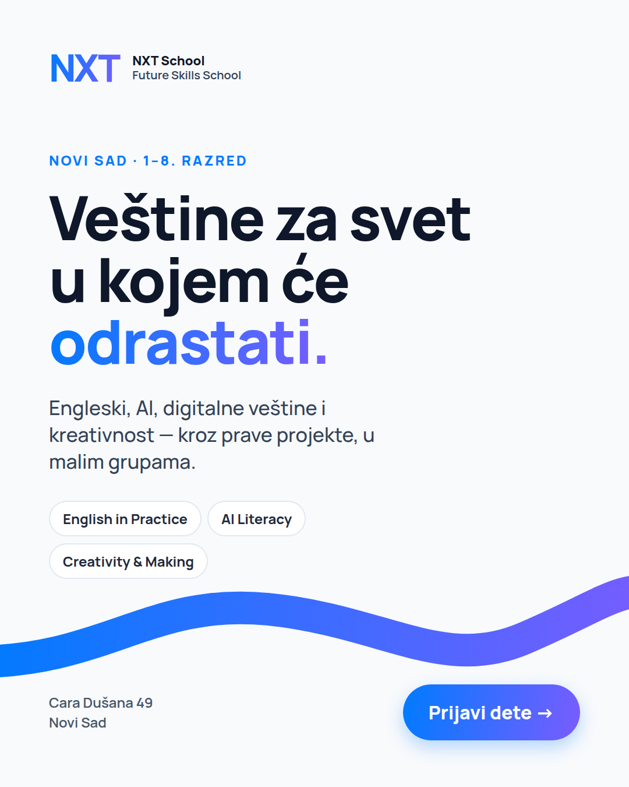 | C1 · Hero / Brand — "Veštine za svet u kojem će odrastati."  Angle: B (aspiration) — also run with Angle A copy to test copy on the same visual.  On image: kicker "Novi Sad · 1–8. razred" · headline · subline "Engleski, AI, digitalne veštine i kreativnost — kroz prave projekte, u malim grupama." · 3 skill chips · CTA.  Photo version (post-shoot): curious 9–11-year-old looking up/off-frame, NXT wave behind (as on the brand board), headline left.  Hypothesis: cheapest reach + brand recall; benchmark ad for the account.  Formats: 4:5, 9:16.

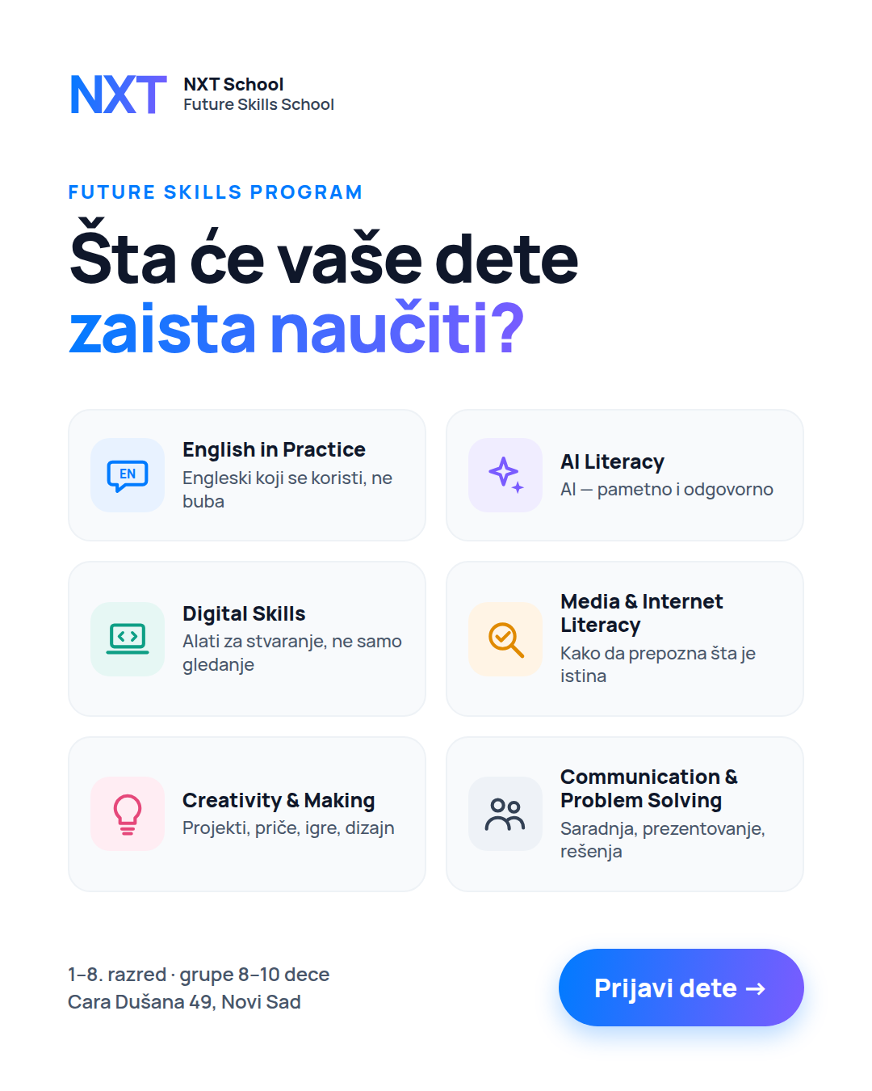 | C2 · Future Skills — "Šta će vaše dete zaista naučiti?"  Angle: B (mechanism) — answers the #1 parent question for a new category.  On image: 6 skill tiles with brand-board icon style, each with an outcome line in Serbian.  Carousel version: 1 card per skill + final card founding offer → test vs static in week 2.  Hypothesis: highest LP conversion rate (parents arrive already understanding the program).  Formats: 4:5, 9:16 (tiles stacked 1 column), carousel 1:1.

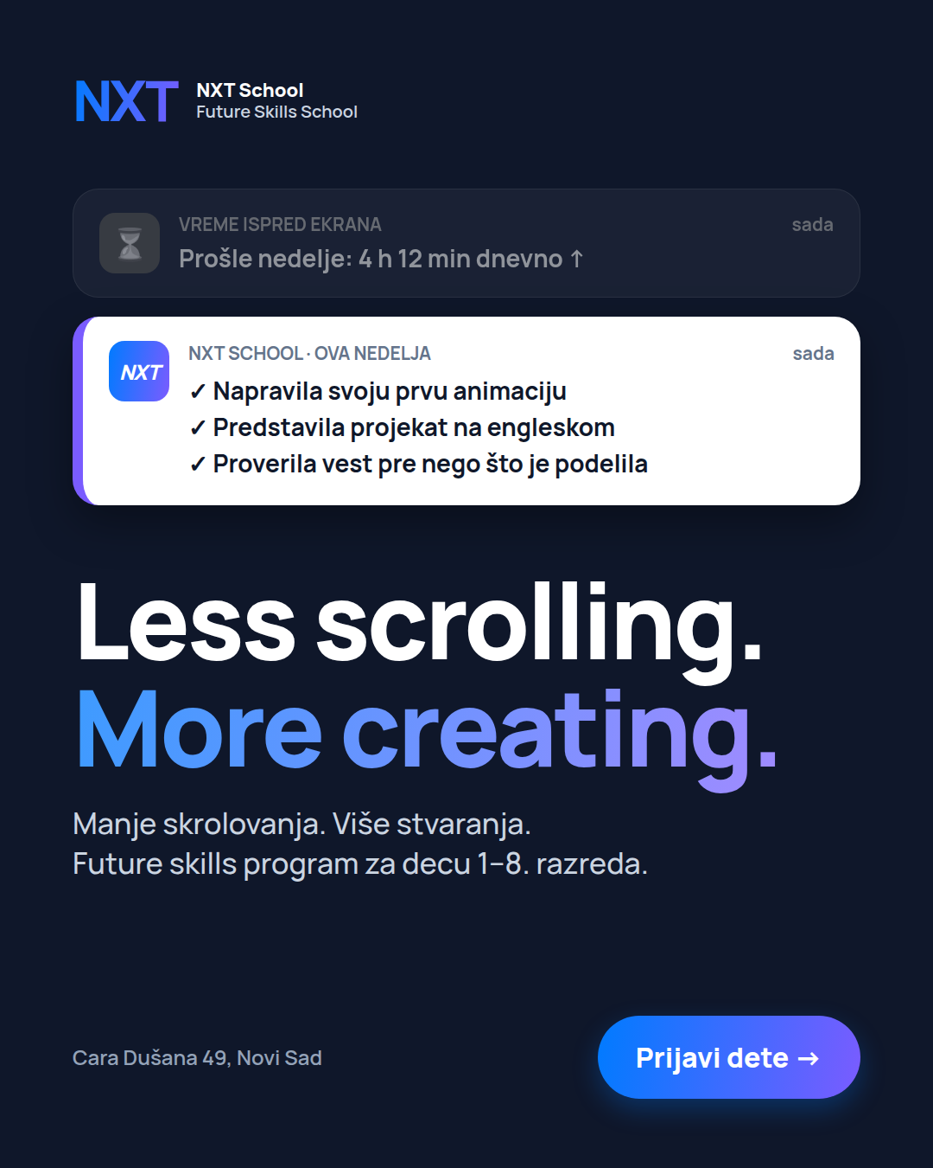 | C3 · "Less scrolling. More creating."  Angle: A (problem) — the scroll-stopper.  On image: two phone notifications — greyed "Vreme ispred ekrana: 4 h 12 min dnevno ↑" vs bright "NXT School · ova nedelja: ✓ animacija ✓ prezentacija na engleskom ✓ proverena vest". English line + Serbian subline.  Variants: boy version ("Napravio…") for A/B; Story version with notifications animating in (simple 6 s motion).  Hypothesis: best CTR with parents of grades 1–6.  Formats: 4:5, 9:16, 6 s motion.

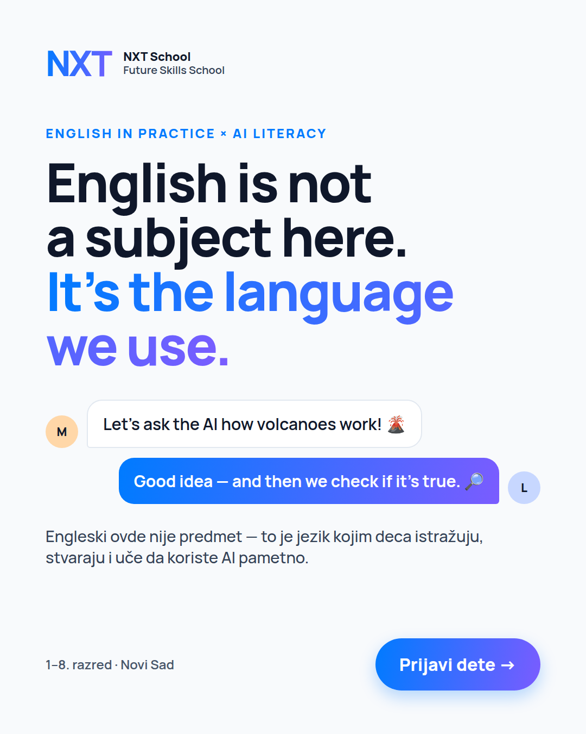 | C4 · English + AI — "English is not a subject here. It's the language we use."  Angle: B-EN (mechanism / differentiation vs English schools).  On image: headline + kid chat bubbles: "Let's ask the AI how volcanoes work!" → "Good idea — and then we check if it's true." (English + AI + media literacy in one line). Serbian subline mandatory.  Photo version: two kids at a laptop, one pointing at the screen, bubbles overlaid.  Hypothesis: resonates with parents of grades 4–8 and English-aware parents.  Formats: 4:5, 9:16.

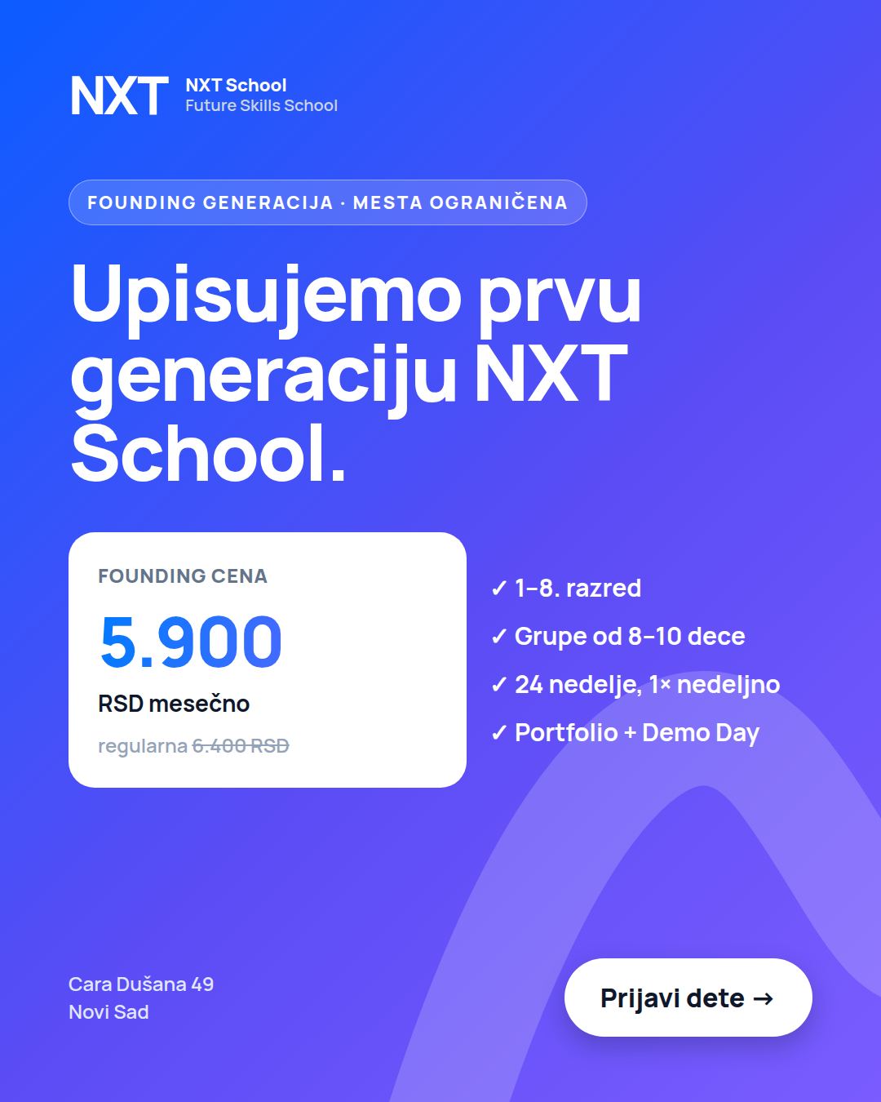 | C5 · Founding Generation — "Upisujemo prvu generaciju NXT School."  Angle: C (offer / timing).  On image: badge "Founding generacija · mesta ograničena", price card 5.900 RSD / mesečno (regularna 6.400 struck through), 4 proof ticks, location, CTA.  Hypothesis: pre-qualifies cold traffic on price; strongest in retargeting.  Watch-out: only claim "mesta ograničena" if seat cap is real; add founding deadline once set.  Formats: 4:5, 9:16.

C6 · Open Day (needed by 12 Oct) — spec
Element | Direction
Headline | "NXT Open Day" · Subota, 24. oktobar · Cara Dušana 49 (date to confirm)
Hook line | "Neka dete isproba. Vi upoznajte program."
Mini activities (on image as 3 tiles) | AI detektivi (prepoznaj lažnu vest) · English Escape Room · Napravi svoj strip za 20 minuta
Proof line | Besplatno · uz prijavu · broj mesta ograničen
CTA | "Prijavi se za Open Day" (separate thank-you page for tracking)

V2 & V3 · Inspiration creatives
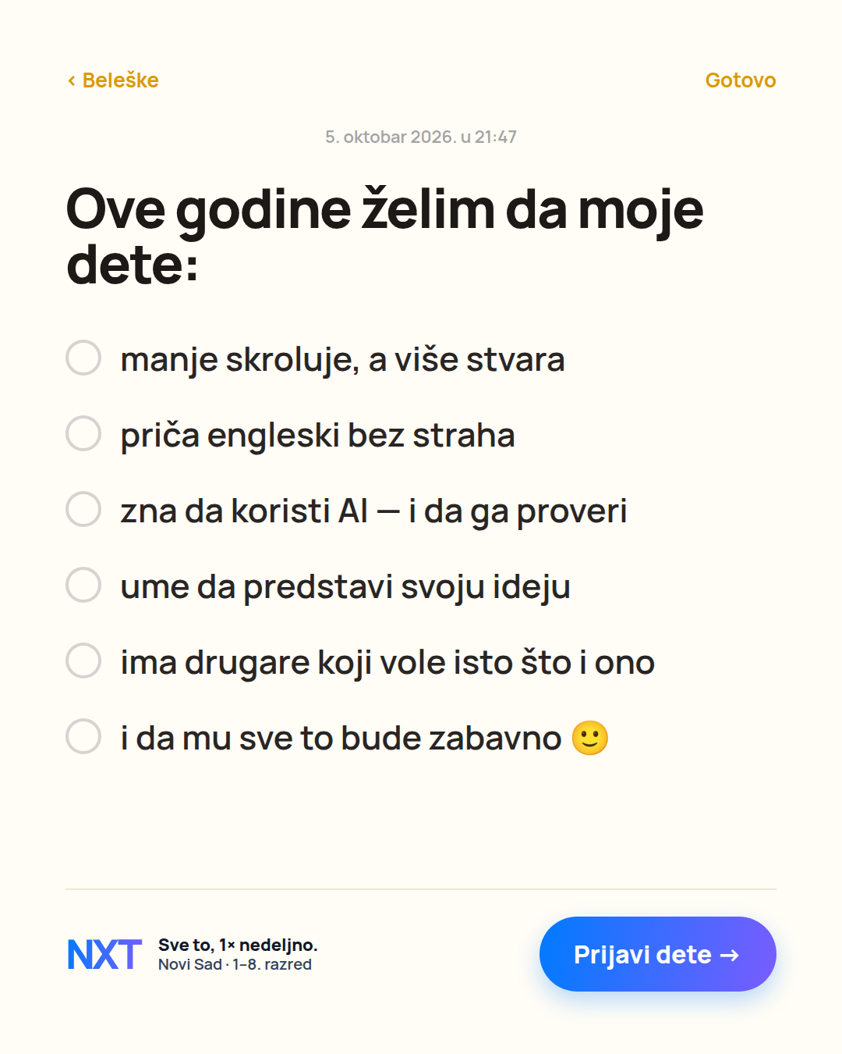  V2 · Parent-native — Notes-app wish list  Feels like a real parent note; outcomes framed as wishes (launch-safe, no fake results). | 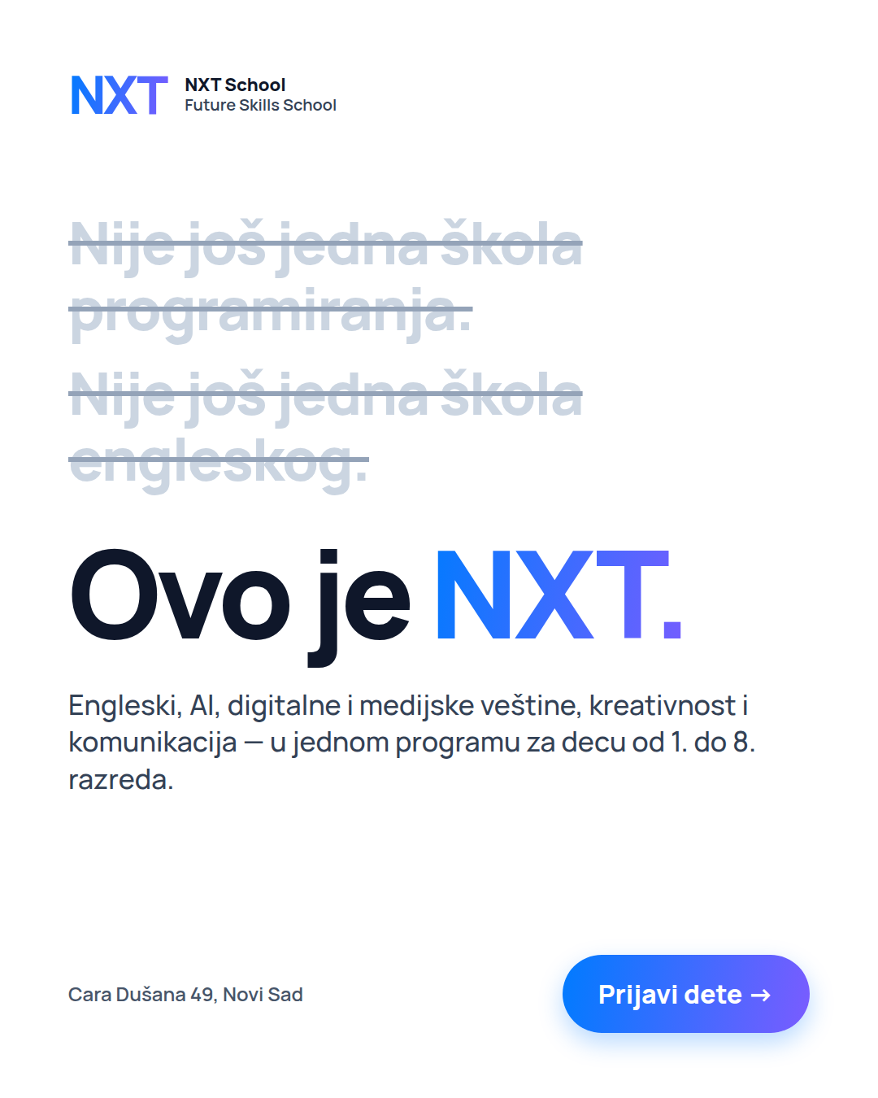  V3 · Manifesto — "Ovo je NXT."  Uses the brief's own positioning as a pattern interrupt; strongest as awareness + RT.

5. Ad copy (Serbian, paste-ready)
V1 MAIN = 3 copy angles with a full stack each (primary long + short as two text options in the same ad, 3 headlines, description, CTA). V2/V3 = alternative tones for inspiration. [Brackets] = confirm before use.

V1 · MAIN copy angles
ANGLE A — "Less scrolling. More creating." · Problem → solution · C3, C1
PRIMARY TEXT — LONG
Vaše dete već zna da skroluje. Kod nas uči da stvara.

U NXT School deca od 1. do 8. razreda jednom nedeljno, u maloj grupi od 8–10, rade na pravim projektima:
→ prave prezentacije, priče, animacije i mini-igre
→ uče da koriste AI i digitalne alate pametno i odgovorno
→ proveravaju informacije umesto da veruju svemu što vide
→ i sve to rade na engleskom — kao jeziku kojim se radi, ne kao predmetu

Na kraju programa: portfolio i Demo Day na kom dete predstavlja svoj rad.

📍 Cara Dušana 49, Novi Sad
Founding generacija: 5.900 RSD mesečno (regularna 6.400 RSD)

Less scrolling. More creating. 👉 Prijavi dete
PRIMARY TEXT — SHORT
Manje skrolovanja, više stvaranja. Future skills program za decu od 1. do 8. razreda u Novom Sadu — engleski, AI, digitalne veštine i pravi projekti, u grupama od 8–10. Founding cena: 5.900 RSD mesečno.
HEADLINES (3)
Manje skrolovanja. Više stvaranja.
Neka ekran postane alat, ne navika
Future skills za decu 1–8. razreda
DESCRIPTION
Cara Dušana 49 · grupe od 8–10 dece
CTA BUTTON
Sign Up (Prijavite se)

ANGLE B — "Future skills, AI done right" · Aspiration + responsibility · C1, C2, C4
PRIMARY TEXT — LONG
Vaše dete će odrastati uz AI. Pitanje je samo — da li će znati da ga koristi pametno?

Internet, AI i digitalni alati već su deo dečjeg sveta. NXT School je Future Skills program za decu od 1. do 8. razreda koji ih uči da te alate koriste kritički, kreativno i odgovorno.

Šta dete uči:
• English in Practice — engleski koji se koristi, ne buba
• AI Literacy i digitalne veštine
• medijsku pismenost — kako da prepozna šta je istina na internetu
• kreativnost, komunikaciju i rešavanje problema

Nije još jedna škola programiranja. Nije još jedna škola engleskog. To je mesto gde deca uče da istražuju, stvaraju i predstavljaju svoje ideje.

24 nedelje · 1× nedeljno · grupe 8–10 · Cara Dušana 49, Novi Sad

Veštine za svet u kojem će odrastati. 👉 Prijavi dete
PRIMARY TEXT — SHORT
AI, internet i digitalni alati već su deo dečjeg sveta. U NXT School deca od 1. do 8. razreda uče da ih koriste pametno — kroz engleski, prave projekte i rad u malim grupama. Novi Sad, Cara Dušana 49.
C4 VARIANT — FIRST LINE (ENGLISH-LED)
Engleski ovde nije predmet. To je jezik kojim radimo — dok deca istražuju, prave projekte i uče da koriste AI pametno.
HEADLINES (3)
Veštine za svet u kojem će odrastati
AI pismenost za decu 1–8. razreda
Engleski je ovde jezik rada
DESCRIPTION
English · AI · Digital · Creativity
CTA BUTTON
Sign Up (Prijavite se)

ANGLE C — "Founding generacija" · Offer / timing / trust · C5 + retargeting
PRIMARY TEXT — LONG
Upisujemo prvu, founding generaciju NXT School u Novom Sadu.

Šta dobija dete:
✓ 24 nedelje praktičnog rada, jednom nedeljno
✓ malu grupu od 8–10 dece svog uzrasta
✓ engleski koji koristi, a ne samo uči
✓ AI, digitalne i medijske veštine kroz prave projekte
✓ portfolio i Demo Day na kraju programa

Šta dobijate vi: founding cenu od 5.900 RSD mesečno umesto 6.400 RSD [za ceo program].

Broj mesta u grupama je ograničen.
📍 Cara Dušana 49, Novi Sad

👉 Prijavite dete — javljamo vam se [u roku od 24 h] sa detaljima programa i terminima.
PRIMARY TEXT — SHORT
Founding generacija NXT School: 5.900 RSD mesečno umesto 6.400. Za decu od 1. do 8. razreda, grupe od 8–10, 24 nedelje praktičnog rada. Mesta su ograničena.
HEADLINES (3)
Founding cena: 5.900 RSD mesečno
Upis prve generacije je u toku
Mesta u grupama su ograničena
DESCRIPTION
1–8. razred · Cara Dušana 49
CTA BUTTON
Apply Now / Sign Up

SUPPORT COPY — Open Day (C6) & Retargeting FAQ
OPEN DAY — PRIMARY
Dođite na NXT Open Day — [subota, 24. oktobar], Cara Dušana 49.

Deca isprobavaju mini-radionice: AI detektivi, English Escape Room i „napravi svoj strip za 20 minuta“. Vi u međuvremenu upoznajete predavače, program i prostor.

Besplatno, uz prijavu — broj mesta je ograničen.
👉 Prijavite se za Open Day
OPEN DAY — HEADLINE
NXT Open Day · [Subota, 24. oktobar]
RETARGETING — PRIMARY (OBJECTIONS)
Još razmišljate? Evo odgovora na 3 najčešća pitanja roditelja:

1) Da li je ovo škola programiranja? Nije. Spajamo engleski, AI i digitalne veštine, medijsku pismenost, kreativnost i komunikaciju.
2) Da li dete mora dobro da zna engleski? Ne. [Grupe su po uzrastu i nivou], a engleski se uči korišćenjem.
3) Koliko košta? Founding cena je 5.900 RSD mesečno (regularna 6.400 RSD).

Founding mesta su ograničena. 👉 Prijavi dete
RETARGETING — HEADLINE
Još razmišljate? Imamo odgovore.

V2 · Inspiration copy — parent-native tone
V2-1 · Honest question (pairs with Notes-app creative)
PRIMARY TEXT
Iskreno pitanje za roditelje osnovaca u Novom Sadu: koliko sati nedeljno vaše dete skroluje? 📱

A koliko sati nešto stvara — priču, prezentaciju, igru, svoj mali projekat?

Napravili smo NXT School baš za taj drugi broj. Jednom nedeljno, u maloj grupi, deca rade na pravim projektima — na engleskom, uz AI i digitalne alate koje uče da koriste pametno.

Ako vam ovo zvuči kao nešto za vaše dete, prijava je kratka. 👇
HEADLINE
Za decu koja hoće da stvaraju

V2-2 · Teacher voice (selfie video / static with portrait)
PRIMARY TEXT / VO
Zovem se [ime] i biću predavač u NXT School.

Godinama radim sa decom i jedno sam naučila: deca ne pamte gradivo — pamte ono što su sama napravila.

Zato kod nas nema bubanja. Deca istražuju, prave projekte, predstavljaju ih na engleskom i uče da koriste AI tako da im pomaže, a ne da misli umesto njih.

Upisujemo prvu generaciju, od 1. do 8. razreda. Vidimo se u Cara Dušana 49. 👋
HEADLINE
Upoznajte NXT School

V3 · Inspiration copy — manifesto tone
V3-1 · Manifesto (pairs with "Ovo je NXT." creative)
PRIMARY TEXT
Nije još jedna škola programiranja.
Nije još jedna škola engleskog.

NXT School je mesto gde deca od 1. do 8. razreda uče ono što svet u kojem odrastaju već traži: da istražuju, proveravaju informacije, stvaraju, sarađuju i predstavljaju svoje ideje — na engleskom, uz AI i digitalne alate.

Ovo je NXT. 👉 Prijavi dete
HEADLINE
Ovo je NXT School

V3-2 · Screen-time ask
PRIMARY TEXT
Koliko sati nedeljno vaše dete skroluje?
Dajte nam samo jedan od njih.

Jedan termin nedeljno, 24 nedelje, mala grupa — i na kraju portfolio i Demo Day na kom dete predstavlja ono što je samo napravilo.

Less scrolling. More creating.
HEADLINE
Jedan termin nedeljno. 24 nedelje stvaranja.

Google Search — RSA & keywords (V1)
Headlines (≤ 30 characters, count in brackets) — pin H1 "NXT School Novi Sad" to position 1 only in the Brand ad group.
NXT School Novi Sad (19) | Future Skills škola za decu (27) | Engleski, AI i kreativnost (26)
Za decu od 1. do 8. razreda (27) | Male grupe od 8–10 dece (23) | Founding cena 5.900 RSD/mes (27)
Less scrolling. More creating (29) | Engleski kao jezik rada (23) | AI pismenost za decu (20)
Projekti, portfolio, Demo Day (29) | Cara Dušana 49, Novi Sad (24) | Više od kursa programiranja (27)
Veštine za budućnost (20) | Upis prve generacije u toku (27) | Prijavi dete danas (18)
Descriptions (≤ 90 characters)
Engleski, AI, digitalne veštine i kreativnost kroz prave projekte. Grupe od 8–10 dece. | 86
Program od 24 nedelje, 1× nedeljno, za decu od 1. do 8. razreda. Cara Dušana 49. | 80
Founding generacija: 5.900 RSD mesečno umesto 6.400. Mesta u grupama su ograničena. | 83
Deca uče da istražuju, proveravaju informacije, stvaraju i predstavljaju. Prijavi dete. | 87

Ad group | Keywords (phrase match)
Engleski za decu | "engleski za decu novi sad" · "škola engleskog za decu" · "kurs engleskog za decu" · "engleski za osnovce"
IT / AI za decu | "programiranje za decu novi sad" · "it škola za decu" · "ai za decu" · "robotika za decu novi sad" · "kurs računara za decu"
Kursevi / radionice | "kursevi za decu novi sad" · "radionice za decu novi sad" · "vannastavne aktivnosti novi sad" · "aktivnosti za decu posle škole"
Brand | "nxt school" · "nxt škola" · "nxtschool"
Negatives (account) | posao · plata · besplatno · online · odrasli · beograd · pdf · knjiga · udžbenik · igrice

6. Owners, open questions & next steps
Owner | Needs from this doc | By
Filip (Paid) | Build V1 structure, audiences, UTMs, Google RSA; QA events; launch | Tue 6 / Wed 7 Oct
Nikola (Design) | Finalize C1–C5 in 4:5 + 9:16 from mocks with final logo; C6 Open Day by Fri 9 Oct | Mon 5 Oct EOD (C1–C5)
Ilona (Copy) | Proof Angle A/B/C copy; confirm bracketed claims; Open Day messaging | Mon 5 Oct EOD
Igor (Photo/Video) | Shot list priority: kids 7–12, kid-eye height, presenting in English, hands on projects, laptop + AI moments, 9:16 + 4:5 framing; parental consent forms | Shoot before or at Open Day
Stjepan (Ops/CRM) | ≤ 15 min speed-to-lead, 3 call attempts + SMS/WhatsApp + email in 48 h; stages: Nova prijava → Kontaktiran → Zakazan (poziv / probni čas / Open Day) → Ponuda → Upisan / Izgubljen + lost reason (cena · termin · uzrast · drugo) | Before launch

Open questions to confirm before launch
- Program start date and weekly schedule per age group — do terms work for both school shifts (pre podne / posle podne)?
- Are groups split by age band (e.g., 1–2 / 3–4 / 5–8) and English level? (copy currently says "dece svog uzrasta")
- Is the founding price locked for the full 24 weeks? Is there a founding deadline or seat cap?
- How many groups / seats at launch? (scarcity claims must be true)
- Open Day date (proposed Sat 24 Oct) and whether registration uses a separate form / thank-you page.
- Free trial class offered? (affects V3 and retargeting offer)
- Lead response promise in copy ("javljamo se u roku od 24 h") — can Ops guarantee it?
- Session length (for "jedan sat" style hooks) and teacher credentials for trust copy.

