NXT SCHOOL · META LAUNCH
Creative Plan
What runs in each campaign & ad set · when · in what format · what we test · mockups showing the direction
Builds on | Meta Launch 1-pager · NXT Concept & Program Blueprint · Action plan do kraja godine
Key dates | Launch Tue 6 / Wed 7 Oct · Open Day Sat 24 Oct (proposed) · program starts Mon 9 Nov · enrolment push ends ~8 Nov
Goal | 30–40 enrolled in the November cohort. First 20–30 leads = validation, not scaling. Everyone who doesn’t convert becomes the January pool.
How it runs | Angles 1–4 + Offer run in parallel from day 1 (that is the test) · angle D (Open Day) runs 12–23 Oct · static first → real space photos (W2) → shoot + first Reels (W3) → Open Day content + last call (W4). Colours: blue = static, purple = motion/carousel, green = real photo/video.
Ad naming | P = Prospecting · O = Open Day · R = Retargeting · C1–C7 = core creatives · T = test variant · S = story / Reel (9:16)
Who decides | Messaging sign-off: Mladen · design: Nikola · shoot: Igor (casting via Šmiranti) · paid setup: Play Media Paid Team · landing / Fast Lane: Viktor
Status of visuals | Direction mockups on the brand board. Final logo + real photos replace them; grey hatched boxes = where a real photo / video goes.

At a glance — creatives per ad set
Campaign · ad set | START · W1–W2  static | TEST · W3  winner + first real content | SWAP IN · W4  real content + last call
1 · Prospecting  1.1 Broad_NS15km_25-55  112k · 6 Oct → 8 Nov | Angles 1–4 + Offer side by side, from day 1  P1 C1 Hero (1)  P2 C3 Less scrolling (2)  P3 C4 English (3)  P4 C7 AI literacy (4)  P5 C5 Founding (Offer) | On the winning angle only:  - one-change variants (static / motion / carousel)  - first Reel: "Pitali smo decu…"  - real space / kid photos | - real-photo versions of top 2  - "Kids Explain the Future" Reels  - Open Day footage
2 · Open Day  2.1 BroadWarm_NS12km  23k · 12–23 Oct | Angle D · from 12 Oct  O1 C6 Open Day (feed + story)  O2 best P-ad + Open Day band (13 Oct) | From 19 Oct: O1 vs O3 countdown — both static | Campaign ends 23 Oct · Open Day Sat 24
3 · Retargeting  3.1 Warm_30d  15k · from 13 Oct | Offer + trust · from 13 Oct  R1 C5 Founding  R2 FAQ (4 questions)  R3 C6 Open Day (until 23 Oct)  R4 C2 "Koji nivo?" (4 levels) | R5 "Ko stoji iza NXT-a?" with real team photos · R1 vs R2 vs R4 | R6 "Počinjemo 9. novembra" (last call) + R7 Open Day recap

Static — feed 4:5 + story 9:16 | Motion / carousel (test) | Real photo / video | Off

When each angle runs — and in what format
Angles 1–4 and the Offer don’t take turns — all five start on day 1, side by side in Prospecting. That IS the test: same audience, same budget, one ad per angle, and the data shows which angle wins. Only angle D (Open Day) is tied to dates.

Angle | W1 · 6–11 Oct  Launch | W2 · 12–18 Oct  First read | W3 · 19–25 Oct  Iterate + first real | W4 · 26 Oct–8 Nov  Real + last call
1 · Hero  "Veštine za svet u kojem će odrastati." | P1 C1  Static | P1 + real space-photo version · R4 levels in RT | If 1 wins: kid-photo C1, "6 veština" carousel | Real photo / video, Open Day footage
2 · Less scrolling  "Less scrolling. More creating." | P2 C3  Static | P2  Static | If 2 wins: SR headline, "Ovo sam danas napravio" artifact photo, 6 s motion | 15 s Reel "scroll → create" from the shoot
3 · English  "English is not a subject here." | P3 C4  Static | P3  Static | If 3 wins: kid presenting in English (photo), SR-first headline | Presenting clips from shoot / Open Day
4 · AI + digital world  "Pitaj. Proveri. Poboljšaj. Ti odluči." | P4 C7  Static | P4  Static | P6 Reel "Pitali smo decu: AI — pametniji ili lenjiji?" + 6 s motion if 4 wins | "Kids Explain the Future" Reels
Offer · Founding  "Upisujemo prvu generaciju." | P5 C5 (cold)  Static | + R1, R2 FAQ, R4 levels in RT  Static | R5 team (real photos) · R1 vs R2 vs R4 | R6 "Počinjemo 9. novembra" + parent quotes
D · Open Day  "Neka dete isproba." | Off — design prep | O1 (feed + story), O2 recut, R3  Static | O1 vs O3 countdown · ends 23 Oct · Open Day Sat 24 | R7 recap  Real photos

Static — feed 4:5 + story 9:16 | Motion / carousel (test) | Real photo / video | Off

The logic in one line: launch 5 different messages in one ad set → let the first 20–30 leads pick the angle → spend design time only on the winner → swap mockups for real photos and kids’ content as fast as it exists. January then sells "what NXT kids already do", not "a new school".

Why it starts static — and when real content takes over
- No kid footage yet, and statics are the cleanest test: only the angle differs, so we know the angle won. Nikola can ship 5 by launch, each with a native 9:16.
- Real space photos arrive within days: they go into the hero and team ads in W2 — don’t wait for the big shoot (Šmiranti casting, before the Open Day).
- Video arrives in W3: "Pitali smo decu…" and "Kids Explain the Future" are content formats, not ads — that is exactly why they work as Reels ads. Motion variants only for the winning angle.
- ⚠ Cast kids are not NXT students: never caption pre-launch content as "naša deca" or "NXT deca".

1. Creative rules (all campaigns)
- 3-second test: logo + who (1–8. razred) + one concrete outcome + Novi Sad must read at thumb-scroll speed.
- Show making, not screens: every creative should prove "svaki čas se završava nečim opipljivim". With real photos: hands, paper prototypes, Lego, sketches, a kid presenting — never rows of kids staring at monitors. NXT looks like a creative studio, not a computer classroom.
- One message per ad. Max ~12 words of headline on the image. English brand lines always get a Serbian subline.
- Brand look: light #F8FAFC and navy #0F172A backgrounds alternate; blue #007BFF → purple #7A5CFF gradient only as accent; Manrope ExtraBold headlines; ≥ 40% whitespace; one CTA pill "Prijavi dete →".
- Tone: adults talking to parents — warm, confident, concrete. No slang, no emoji-heavy "cool" (blueprint Hard NO: adults trying to look cool in front of kids). NXT Lead (7–8) creatives must never look infantile.
- People: until the shoot, typographic / UI graphics only. No AI-generated children’s faces. Photos: kids matching the level shown, natural light, kid-eye height, signed consent.
- Every ad gets native feed + story versions — never let Meta auto-crop 4:5 into 9:16.

Message bank — use these lines everywhere
Line | Use for
Veštine za svet u kojem će odrastati. | Angle 1, end cards
Less scrolling. More creating. · Ekran je alat. | Angle 2
„Ovo sam danas napravio.“ — svaki čas se završava nečim opipljivim | Angle 2, Offer
English is not a subject here. It’s the language we use. · Engleski raste sa samopouzdanjem grupe. | Angle 3, FAQ
Znati da pitaš ChatGPT nije AI literacy. · Ask → Check → Improve → Decide (Pitaj · Proveri · Poboljšaj · Ti odluči) | Angle 4
4 nivoa: Explore 1–2 · Create 3–4 (60 min) · Build 5–6 · Lead 7–8 (90 min) | R4 levels, FAQ
My NXT Portfolio — roditelj vidi napredak svake nedelje | Offer, retargeting
NXT Showcase — svako dete predstavi svoj rad pred roditeljima | Offer
Upoznavanje nije prijemni test. · Početak: ponedeljak, 9. novembar | Offer, FAQ, last call

Never say
- "Demo Day" → it is NXT Showcase (each group) and NXT Stage (flagship).
- "Škola programiranja" or coding-heavy promises — coding is ~10–15% of the program.
- "Naša deca" / "NXT deca" for kids who aren’t enrolled yet (cast or pre-launch content).
- "Mesta ograničena" or seat counts unless the number is real — use the real start date (9 Nov) for urgency instead.
- Partner or school names before written consent · "prva grupa" → "prva generacija" · Podcast / Stage as if they already exist.

Formats & safe zones
Format | Size (px) | Rule | Used for | When
Static feed 4:5 | 1080 × 1350 | ≥ 60 px margins; CTA pill bottom-right | All ads | W1 →
Static story 9:16 | 1080 × 1920 | Keep top 250 px and bottom 380 px free of text & CTA | All ads (native version) | W1 →
Real space / team photos | 4:5 + 9:16 | Creative-studio feel; no empty computer rows | C1 version, R5 team | W2 →
Reels 15–30 s | 1080 × 1920 | Question on screen in first 2 s; burned-in captions; end card logo + CTA | P6 "Pitali smo decu…", Kids Explain the Future | W3 →
Carousel 1:1 · Motion 6 s | 1080 × 1080 · 4:5 + 9:16 | Carousel: hook card → offer card · Motion: first frame works as a static | Winning angle only | W3
Real kid photo / video | 4:5 + 9:16 | Kid-eye height, natural light, signed consent | Top 2 ads, Reels, R7 | W3 →

Ad-level setup in Ads Manager
- 2 primary-text options per ad (long + short from the same angle — Appendix), 1–3 headlines, description, CTA button Prijavite se (Sign Up).
- Advantage+ creative: turn off generative text/image/background and auto-music (brand control). Placement customization ON so each placement gets its native asset.
- Ad name = CreativeID_Angle_Format_version, e.g. P2 · C3_LessScrolling_2_Static45_v1 (flows into utm_content).
- If Šmiranti also posts the kids’ content, run it as a partnership ad (their handle + ours) — borrowed trust, same asset.

2. Campaign 1 — Prospecting
1 · PROSPECTING · Ad set 1.1 Broad_NS15km_25-55
Objective: Leads · conversion: application_submit · Budget 112,000 RSD (W1 3,000/day → ~3,700/day from W2) · 6 Oct → 8 Nov
Job of the creatives: find which message makes cold Novi Sad parents apply — and which grades respond.
Angles: 1–4 + Offer, all live in parallel from day 1 · formats: static (W1–W2) → winner variants + first Reels (W3) → real content (W4)

 | W1 · 6–11 Oct | W2 · 12–18 Oct | W3 · 19–25 Oct | W4 · 26 Oct–8 Nov
This ad set | P1–P5 live · angles 1–4 + Offer side by side  Static | First read on 20–30 leads → pause bottom 1–2  Static + space photo | Round 2: winner variants + P6 "Pitali smo decu" Reel | Round 3: real-photo versions + Reels

START — W1 · 5 static ads, angles 1–4 + Offer side by side
All five go live together on day 1, in the same ad set — one ad per angle, so each angle gets a fair read and nothing competes with a near-duplicate.
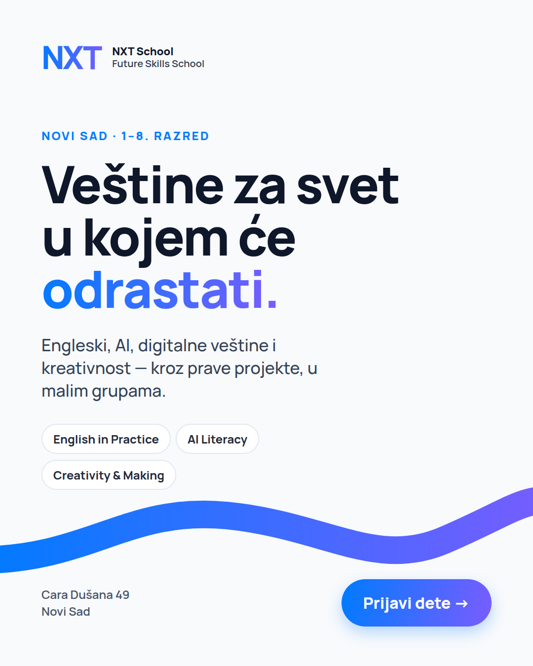 | P1 · C1 Hero × Angle 1 (Hero / positioning)  When · format: From W1 · static · real space-photo version from W2  Name: C1_Hero_1_Static45_v1  What it tests: the core positioning — our benchmark ad for parents thinking about the future.  On image: "Novi Sad · 1–8. razred" · "Veštine za svet u kojem će odrastati." · "Engleski, AI, digitalne veštine i kreativnost — kroz prave projekte, u malim grupama." · 3 skill chips.  Primary text: Angle 1 (Appendix) — opens "Deca koja danas kreću u školu odrastaće u svetu koji se menja brže od bilo kog programa."  Headline: Veštine za svet u kojem će odrastati · Formats: 4:5 · 9:16

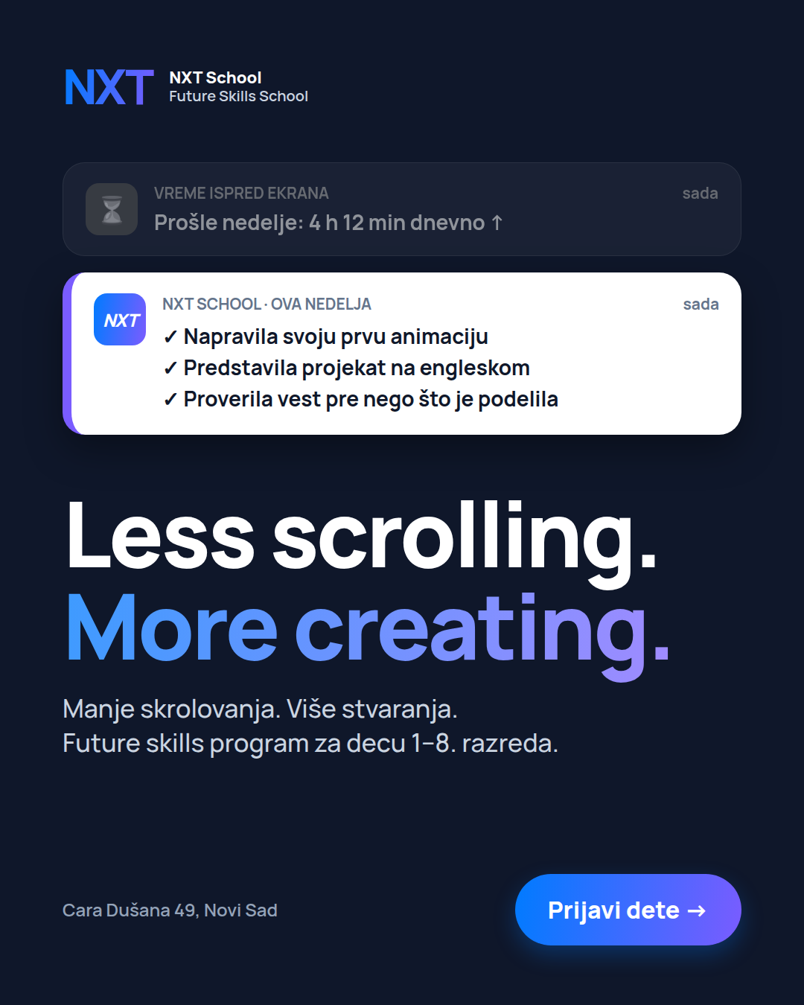 | P2 · C3 Less scrolling × Angle 2  When · format: From W1 · static · artifact photo or 6 s motion in W3 if angle 2 wins  Name: C3_LessScrolling_2_Static45_v1  What it tests: the screen-time worry, answered with "the screen is a tool" — expected CTR leader with parents of 1st–6th graders.  On image: greyed alert "Vreme ispred ekrana: 4 h 12 min dnevno ↑" vs bright "NXT School · ova nedelja: ✓ animacija ✓ prezentacija na engleskom ✓ proverena vest" · "Less scrolling. More creating." + Serbian subline.  Primary text: Angle 2 — opens "Vaše dete već zna da skroluje. Kod nas uči da stvara."  Headline: Manje skrolovanja. Više stvaranja. · Formats: 4:5 · 9:16

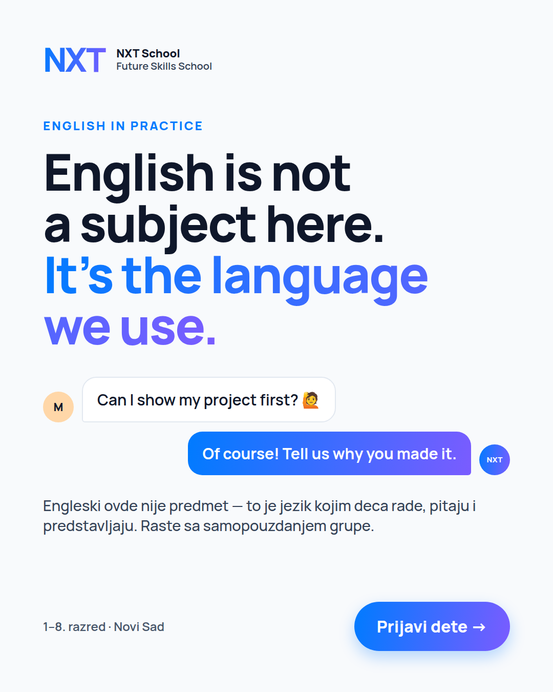 | P3 · C4 English × Angle 3  When · format: From W1 · static · kid-presenting photo in W3 if angle 3 wins  Name: C4_English_3_Static45_v1  What it tests: English as the working language — our edge vs English schools.  On image: "English is not a subject here. It’s the language we use." + chat: "Can I show my project first?" → "Of course! Tell us why you made it." + "Raste sa samopouzdanjem grupe."  Primary text: Angle 3 — opens "English is not a subject here. It’s the language we use."  Headline: Engleski je ovde jezik rada · Formats: 4:5 · 9:16

 | P4 · C7 AI literacy × Angle 4 (AI + digital world) — NEW  When · format: From W1 · static · P6 "Pitali smo decu" Reel joins in W3  Name: C7_AILiteracy_4_Static45_v1  What it tests: "my kid already uses AI and the internet — but do they know how to think with it?"  On image: grey contrast lines "Znati da otvoriš YouTube nije media literacy. / Znati da pitaš ChatGPT nije AI literacy." → "Ovde deca uče da razmišljaju uz AI." + 4 steps Ask · Check · Improve · Decide.  Primary text: Angle 4 — opens "Znati da pitaš ChatGPT nešto nije AI literacy."  Headline: Pitaj. Proveri. Poboljšaj. Ti odluči. · Formats: 4:5 · 9:16

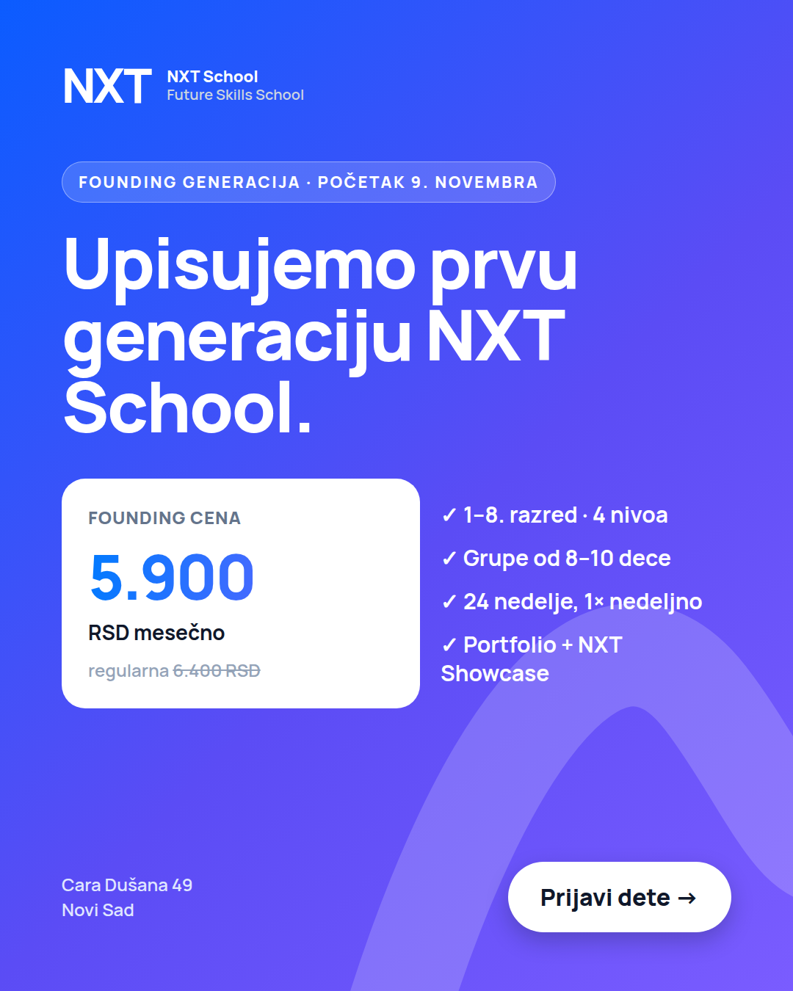 | P5 · C5 Founding × Offer  When · format: From W1 in Prospecting · from W2 also R1 in Retargeting · static  Name: C5_Founding_O_Static45_v1  What it tests: does a clear price + start date pre-qualify cold parents? (also reused as R1)  On image: badge "Founding generacija · početak 9. novembra" · "Upisujemo prvu generaciju NXT School." · price card 5.900 RSD/mes (regularna 6.400) · 1–8. razred · 4 nivoa · grupe 8–10 · 24 nedelje · Portfolio + NXT Showcase.  Primary text: Offer · Headline: Founding cena: 5.900 RSD mesečno  Formats: 4:5 · 9:16 · ⚠ confirm the founding price is locked for all 24 weeks

TEST — W2 first read → W3 winner variants + first real content
Round | When | Format | What | How we judge
Round 1 · Angle test | W1–W2 | Static (+ space photo in W2) | P1–P5 side by side. Hands off for 72 h. First 20–30 leads = validation, not scaling. | Per ad: CPL, link CTR, LP conversion — plus, with Ops, qualified and contacted rate. Starved ad (< 500 impressions by day 5) = a "no".
Round 2 · Winner + first real | W3 | Static + motion / carousel + first Reel | Pause bottom 1–2. Add 2–3 one-change variants of the winner + P6 "Pitali smo decu" Reel. Max 7 ads live. | Variant beats its parent on CPL after ≥ 1,500 impressions → keep; else pause.
Round 3 · Real content | W4 (to 8 Nov) | Real photo + video | Real-photo versions of the top 2, "Kids Explain the Future" Reels, Open Day footage. | Same CPL rule + lead quality (qualified → enrolled).

Iteration library — W3, only for the angle that wins (one change per variant)
If the winner is… | Test 1 | Test 2 | Test 3
1 · Hero (P1) | Photo: real space vs typographic (from W2) | Photo: kid 9–11 version (after the shoot) | Carousel: "6 veština" — one skill per card
2 · Less scrolling (P2) | Static: Serbian headline vs English | Photo: "Ovo sam danas napravio" — a real artifact (paper prototype, comic) | Motion 6 s: alerts slide in one by one
3 · English (P3) | Photo: kid presenting in English | Static: Serbian-first headline | Static: dialogue from an older level (Build / Lead project)
4 · AI (P4) | Video: P6 "Pitali smo decu" Reel (runs anyway) | Motion 6 s: Ask → Check → Improve → Decide builds in | Static: safety hook "Da li bi vaše dete prepoznalo lažnu poruku?"
Offer (P5) | Static: date-first ("Počinje 9. novembra") vs price-first | Static: portfolio visual ("vidite šta je napravilo") | Photo: parent quote from Open Day (with consent)

Test mockups — direction for Nikola
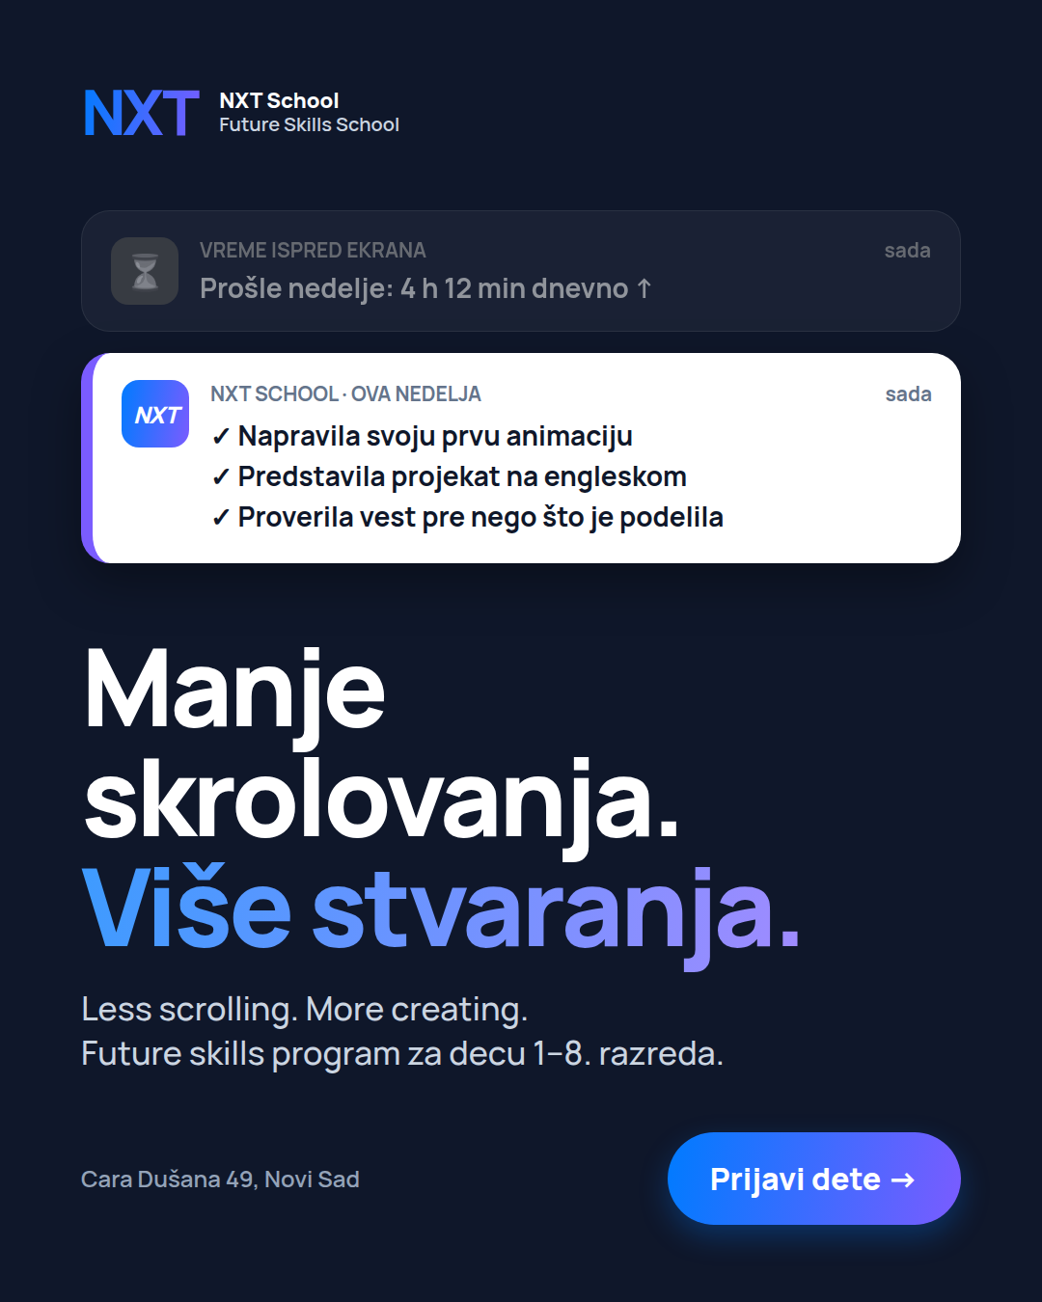  T · C3 Serbian headline  W3 · static · language test vs P2 | 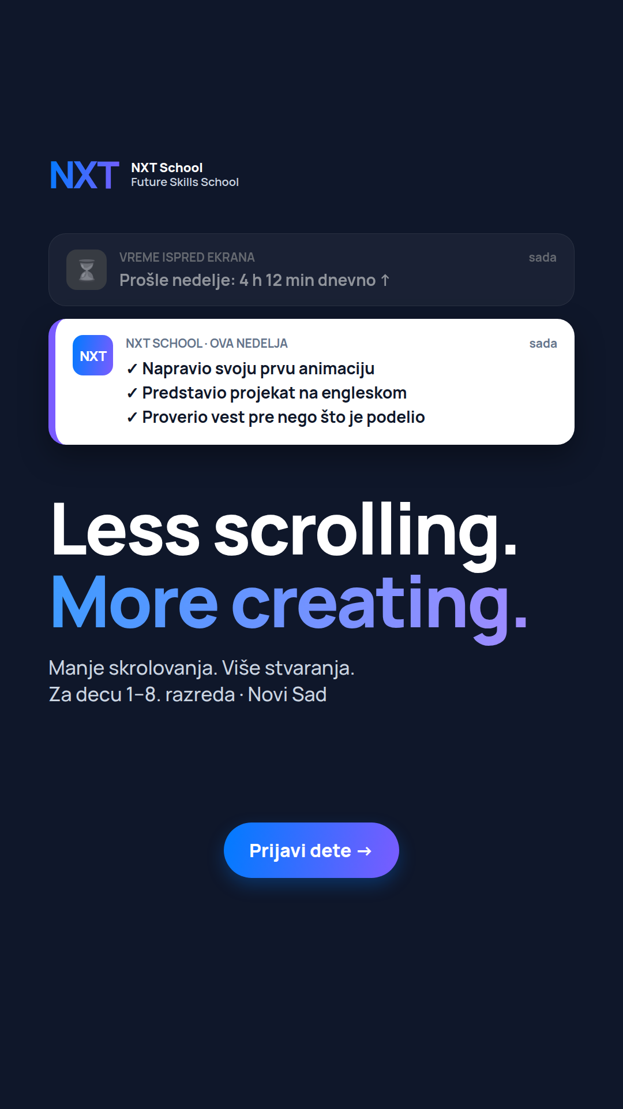  S · C3 story 9:16  From W1 · static · P2 story | 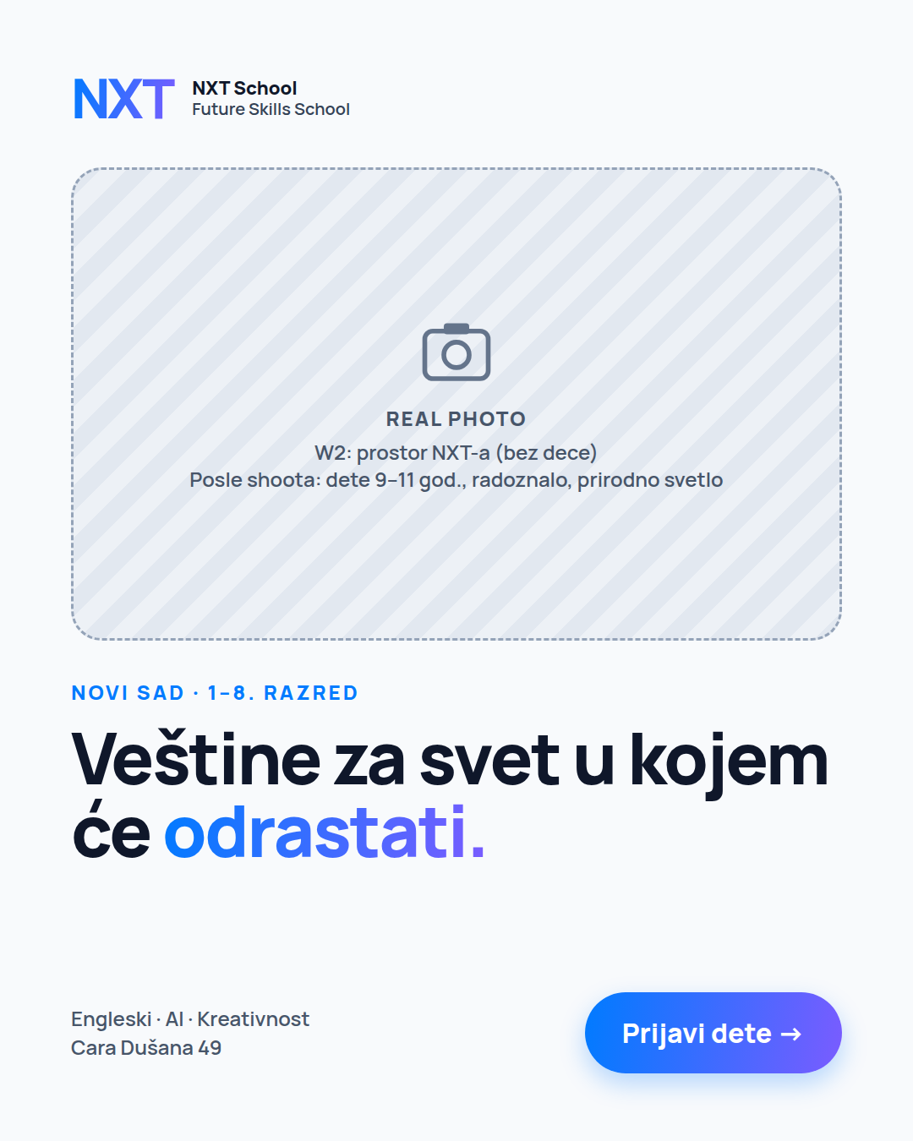  T · C1 photo version  W2 space photo → kid photo after shoot

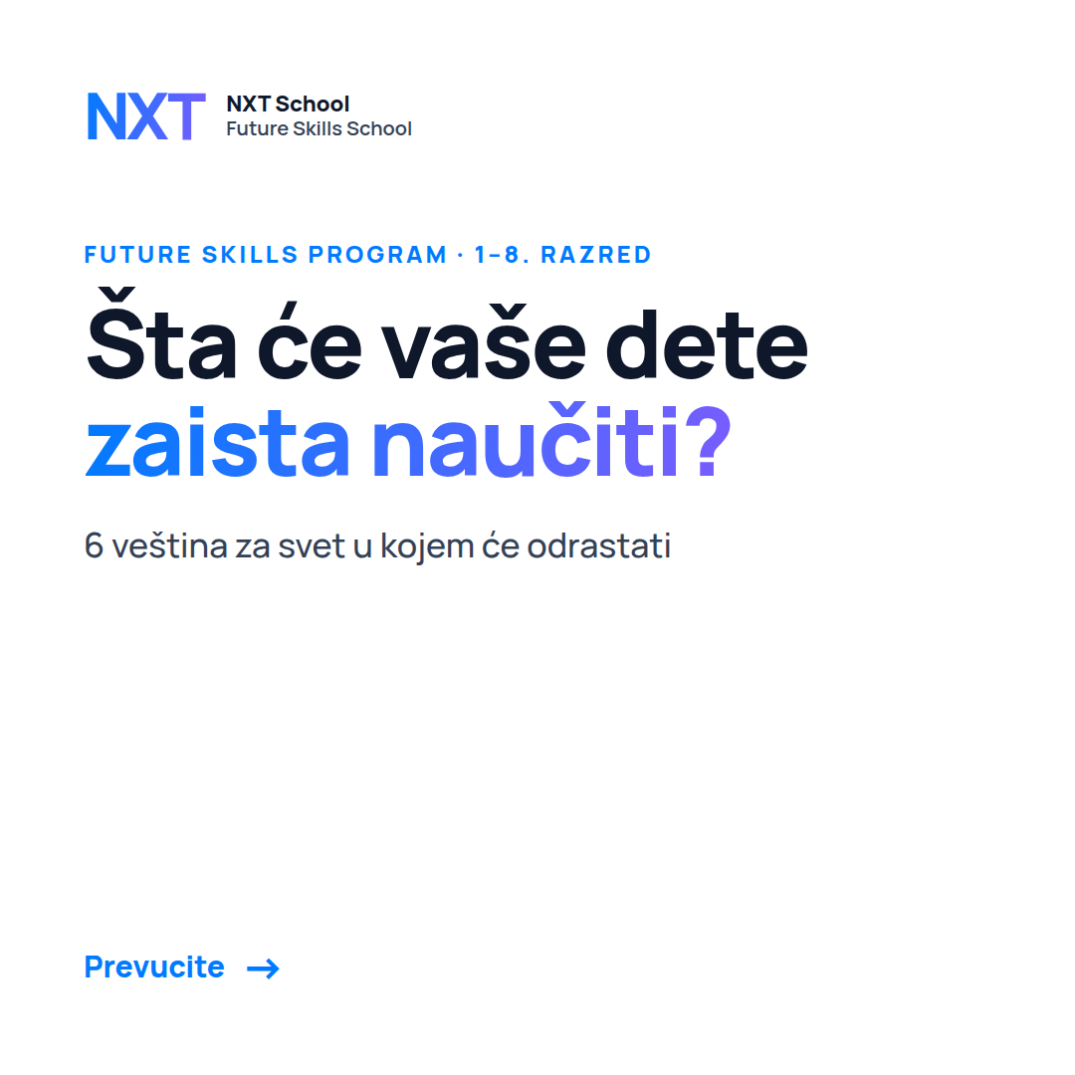  Carousel card 1  W3 if angle 1 wins · hook | 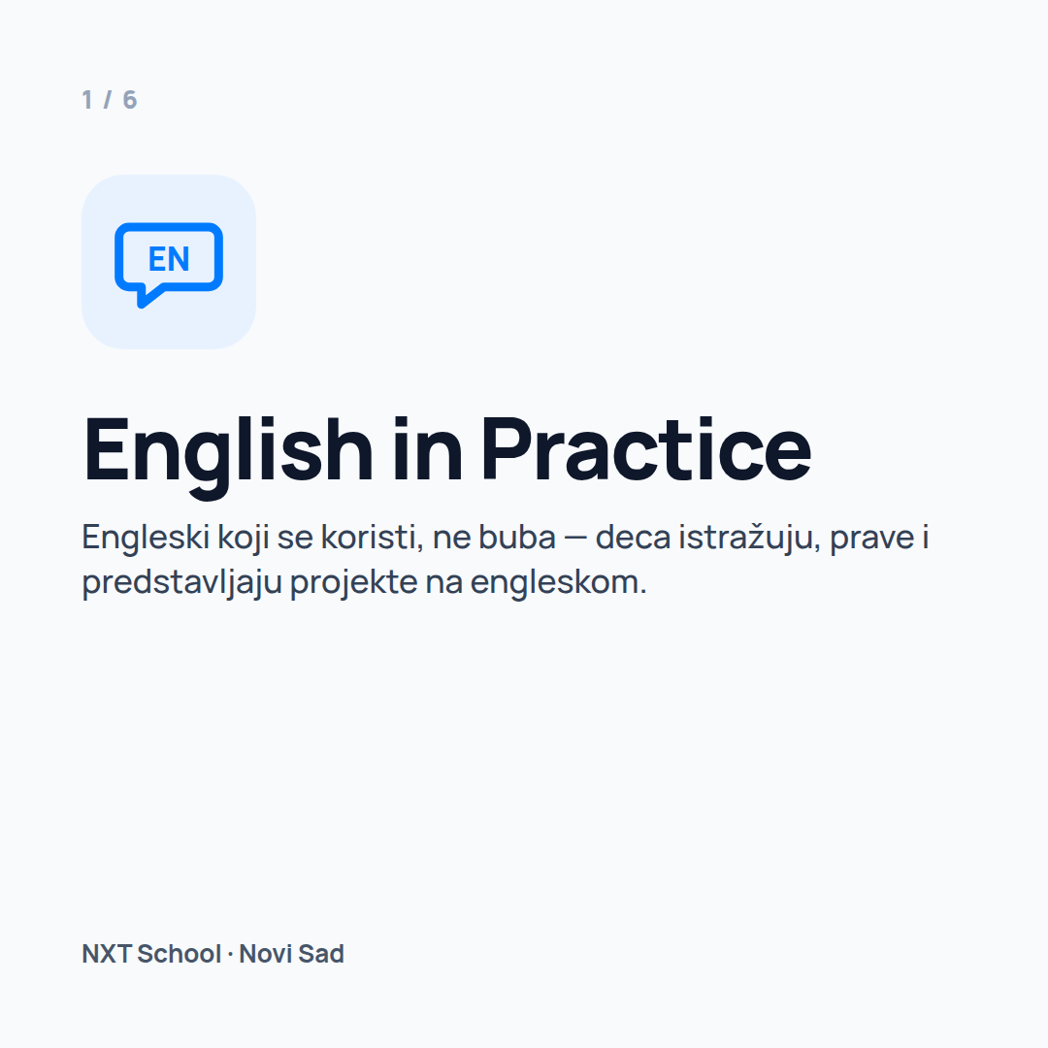  Cards 2–6  W3 · one skill per card | 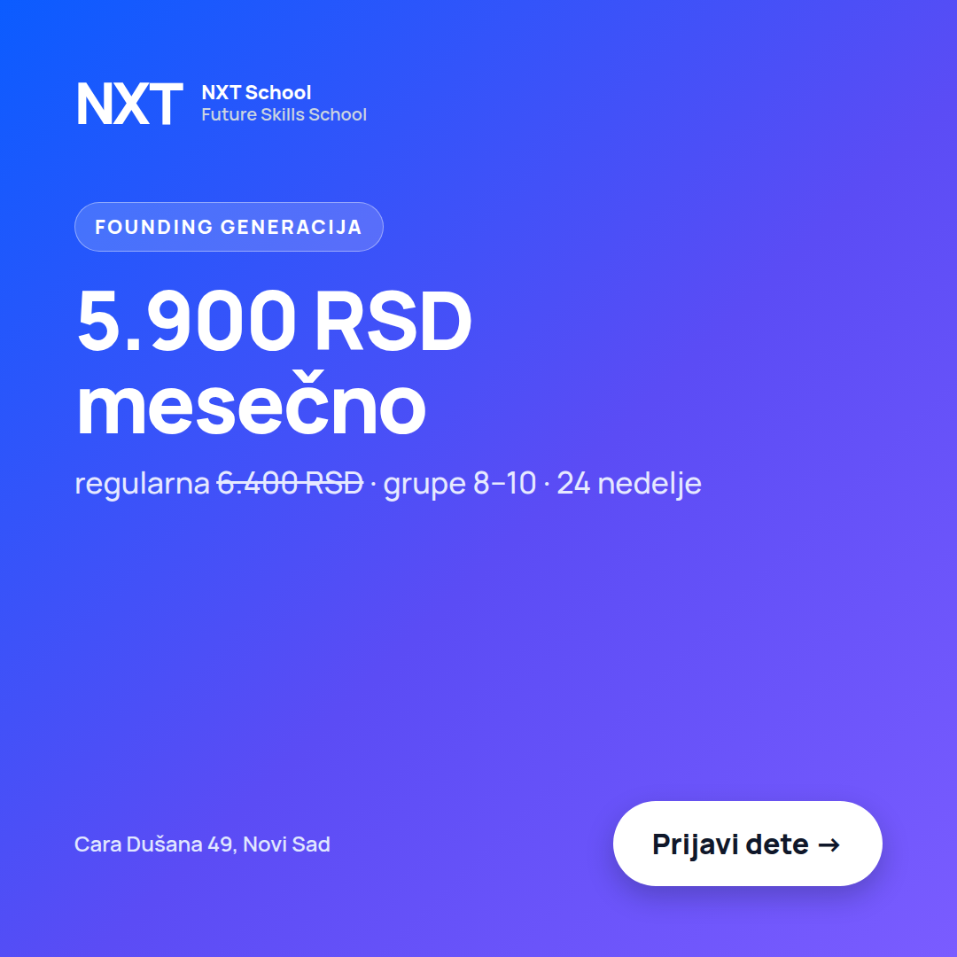  Card 7  W3 · founding offer + CTA

W3 · P6 "Pitali smo decu…" Reel — content format used as an ad
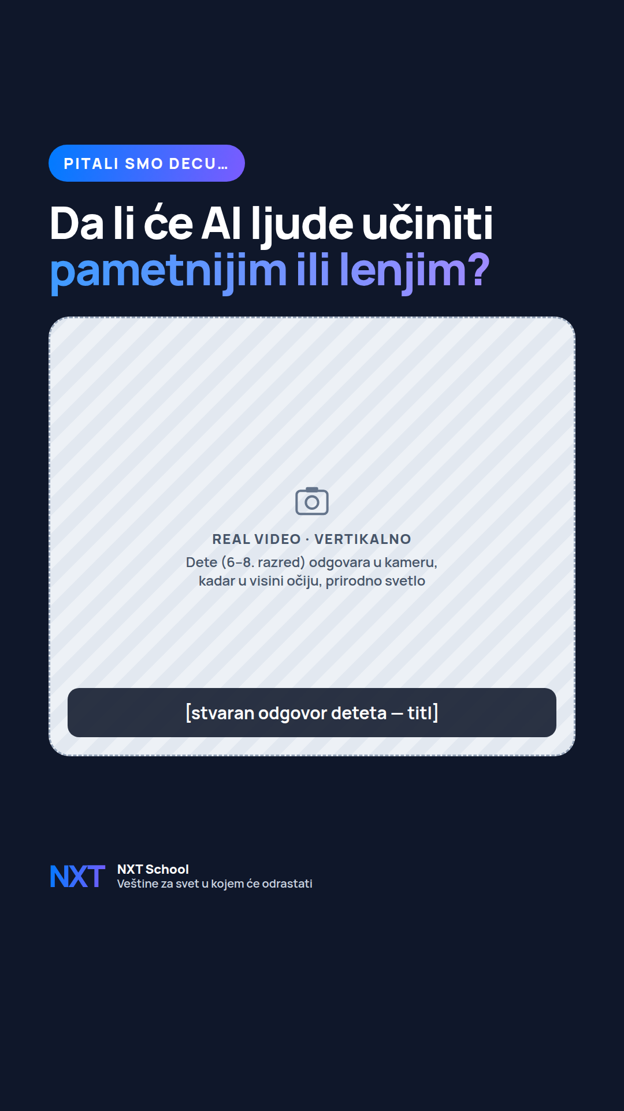 | P6 · "Pitali smo decu…" Reel  When · format: W3 → · real video 9:16 · joins ad set 1.1  Questions by age: 1–2 / 3–5 razred: "Kako će izgledati škola za 20 godina?" · 6–8 razred: "Da li će AI ljude učiniti pametnijim ili lenjim?"  Length: 15–30 s · 4–6 kids · one answer each, best first.  First 2 s: the question on screen + the first answer. Captions burned in (most people watch muted).  End card: NXT logo · "Veštine za svet u kojem će odrastati" · Prijavi dete.  Ad copy: Reel caption (Appendix) · supports angles 4 and 1.  ⚠ Cast kids (Šmiranti) — never captioned as NXT students; signed parental consent.

W4 · 15 s Reel "scroll → create" — storyboard (from the shoot)
Time | Shot (kid-eye height, vertical) | Text on screen
0–2 s | Close-up: kid’s thumb scrolling a phone, cold grey grade | "4 h dnevno skrolovanja?"
2–6 s | Same hands sketching on paper, then building it on a laptop at NXT, warm colour | "Ovde deca stvaraju."
6–11 s | Kid presenting the project in English to the group; peers react | "…i predstavljaju šta su napravila."
11–15 s | End card: logo, 1–8. razred, početak 9. novembra | "Prijavi dete" + founding price

3. Campaign 2 — Open Day
2 · OPEN DAY · Ad set 2.1 BroadWarm_NS12km
Objective: Leads · conversion: Open Day registration (separate thank-you page) · Budget 23,000 RSD (~1,900/day) · 12 → 23 Oct
Job of the creatives: fill the Open Day — sales + trust + content event, the low-risk first step for undecided parents.
Angle: D only · runs W2–W3 · formats: static feed + story throughout
The day (~90–120 min): kids do an NXT mini challenge while parents hear what NXT is + Q&A → kids show their result → space, talks, applications on the spot.

 | W1 · 6–11 Oct | W2 · 12–18 Oct | W3 · 19–25 Oct | W4 · 26 Oct–8 Nov
This ad set | Off — design prep | O1 live 12 Oct · O2 13 Oct  Static feed + story | O1 vs O3 countdown · ends 23 Oct  Static | Off — Open Day done (Sat 24) → R7 recap in RT

START — W2 (from 12 Oct) · angle D · static
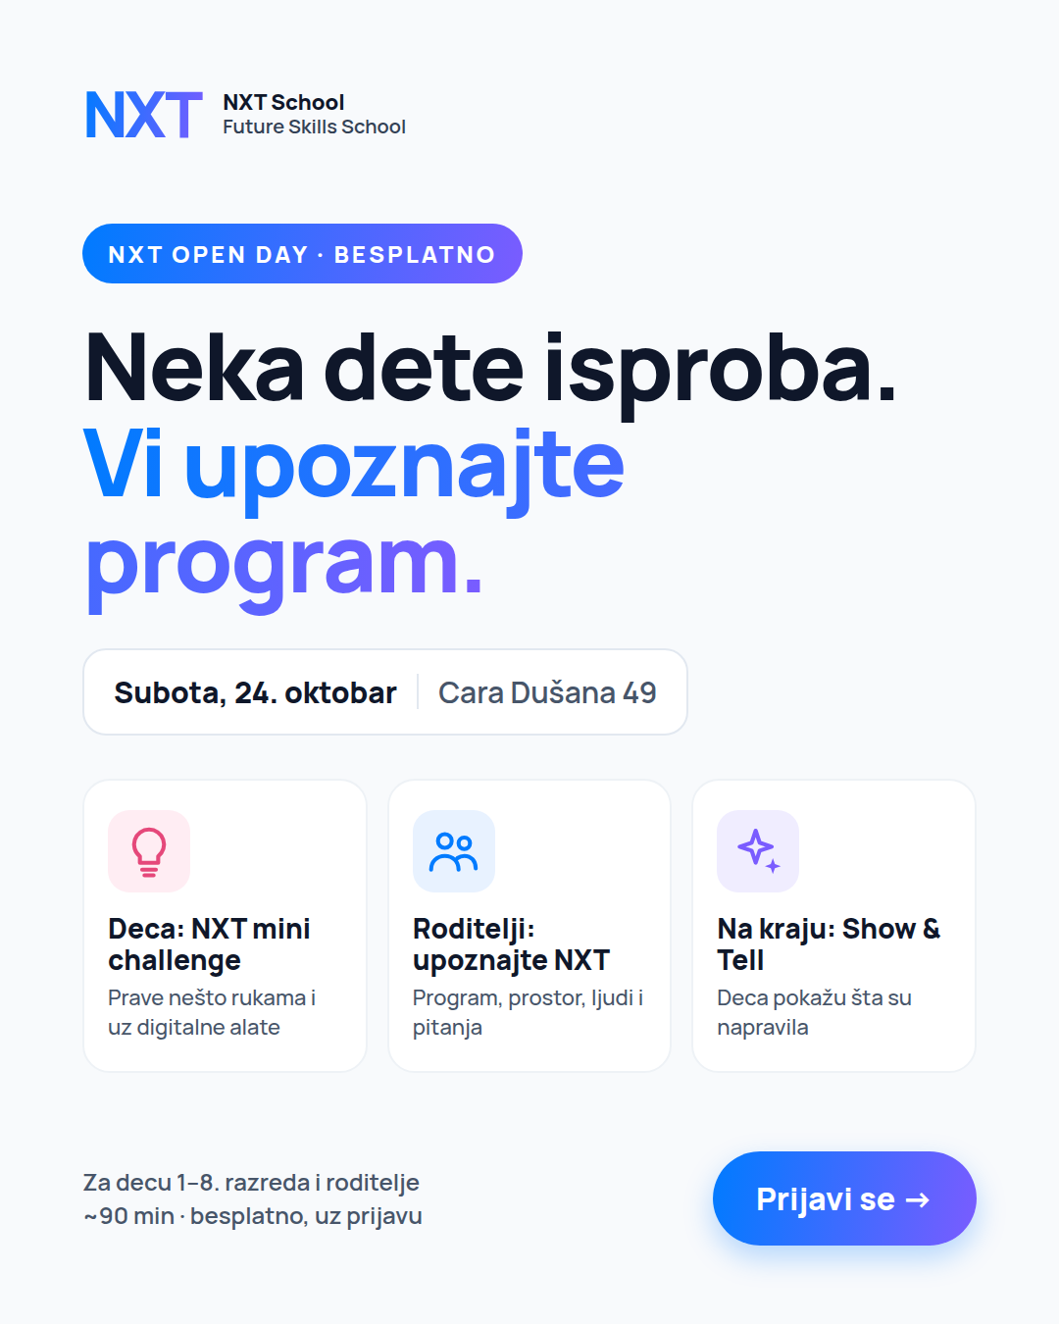 | O1 · C6 Open Day (feed)  When · format: W2–W3 · 12 → 23 Oct · static feed + story  Name: C6_OpenDay_D_Static45_v1 · live 12 Oct  What it does: experience-led invite — "Neka dete isproba. Vi upoznajte program."  On image: badge "NXT Open Day · besplatno" · date + address · 3 steps: Deca: NXT mini challenge · Roditelji: upoznajte NXT · Na kraju: Show & Tell · "~90 min · besplatno, uz prijavu".  Primary text: Open Day (Appendix) · Headline: NXT Open Day · Subota, 24. oktobar  Formats: 4:5 + 9:16 (story mock below) · date to confirm before production

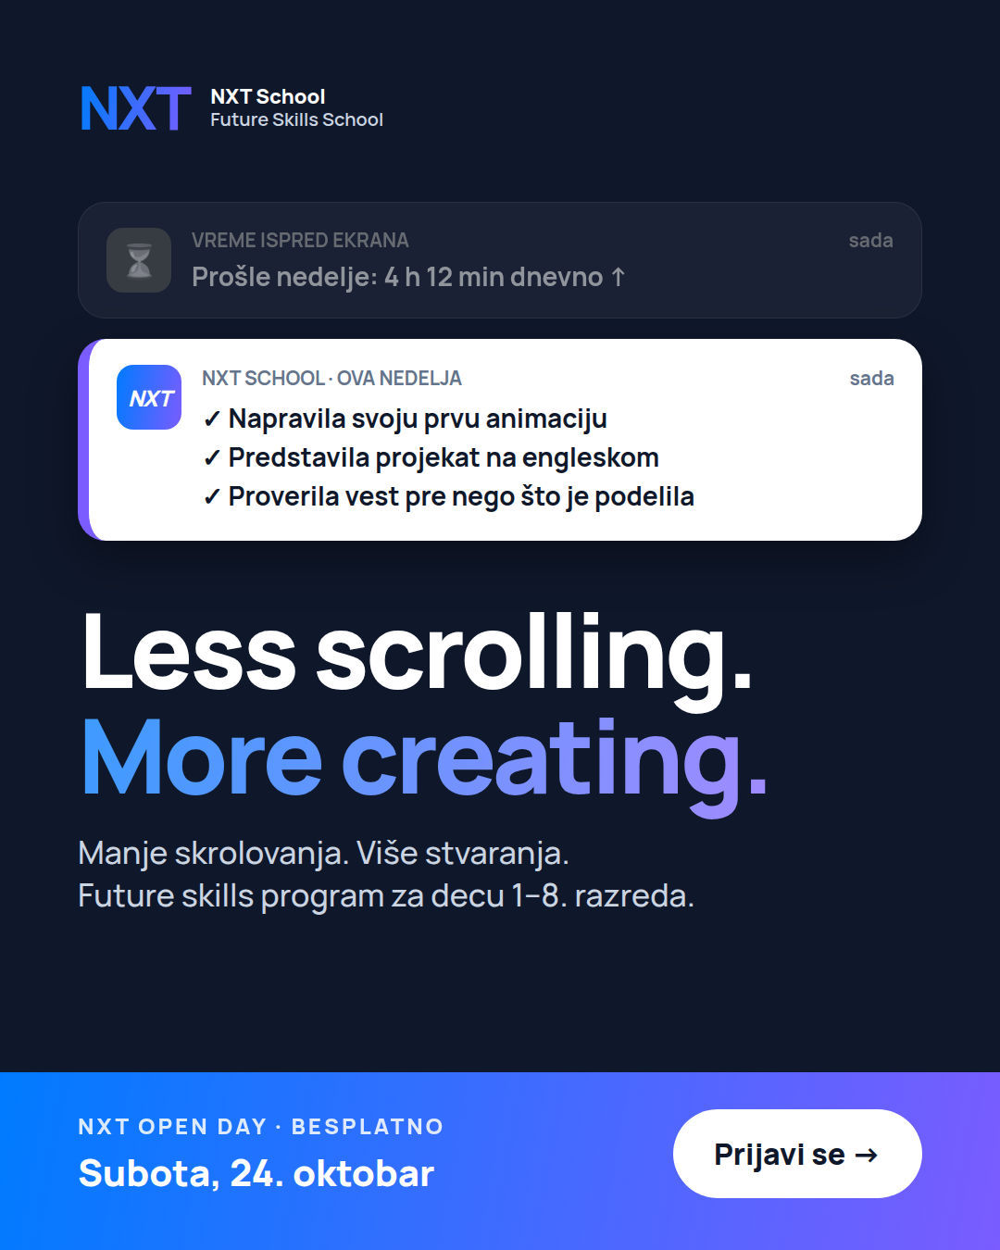 | O2 · Best prospecting ad + Open Day band  When · format: W2–W3 · 13 → 23 Oct · static (recut of the winning P-ad)  Name: [winner]_OpenDay_D_Static45_v1 · live ~13 Oct (after first read)  What it does: reuses the visual parents already responded to; swaps the footer for an Open Day band (date + "Prijavi se"). Mock uses C3 — use whichever P-ad leads on day 6–7.  Primary text: Open Day copy, first line adapted to the angle (e.g. "Manje skrolovanja, više stvaranja — dođite da vidite kako to izgleda.")  Formats: 4:5 + 9:16

TEST — W3 (19 → 23 Oct) · countdown vs experience · static
From 19 Oct, add O3 countdown next to O1. Urgency usually wins in the final days; we check that rather than assume it. Two quick versions: "Još 5 dana" (19–21 Oct) and "Ove subote!" (22–23 Oct).
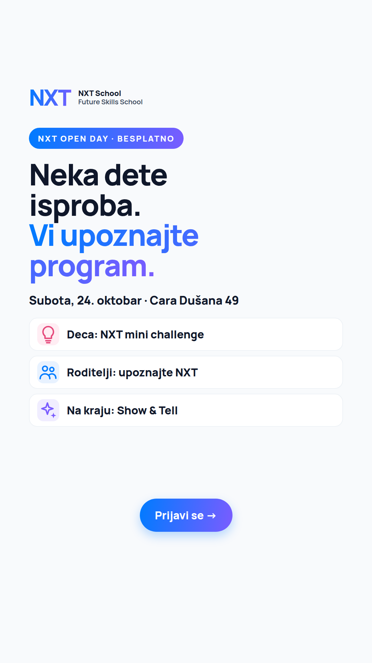  S · C6 story 9:16  W2–W3 · static · O1 story | 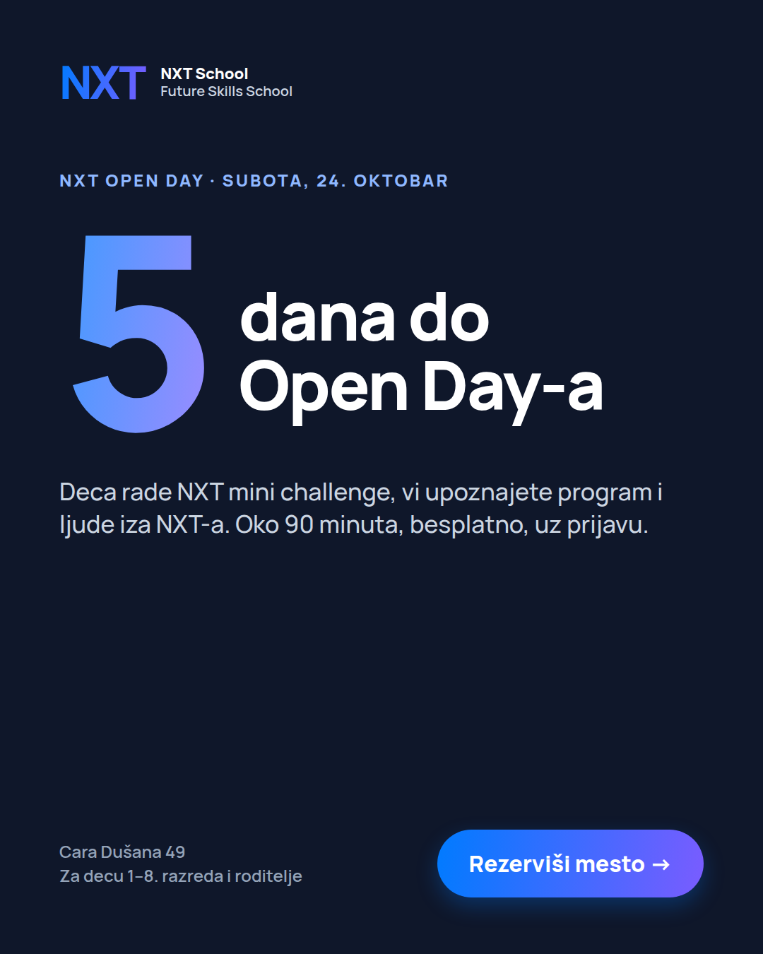  O3 · Countdown (test)  W3 · static · vs O1

Not creative, but critical (Viktor · Ana): Open Day landing page + Fast Lane registration, auto-confirmation, reminders 48 h before and on the day, attendance status, post-event follow-up, photo/video consent at the door.

4. Campaign 3 — Retargeting
3 · RETARGETING · Ad set 3.1 Warm_30d
Objective: Leads · conversion: application_submit · Budget 15,000 RSD (~580/day) · from 13 Oct (audience ≥ 1k)
Audience: site visitors 30d · started form, no submit 14d · IG/FB engagers 60d · excl. applicants
Job of the creatives: remove the last doubt — price, "which level is my kid?", "who are these people?", timing.
Angles: Offer + trust, plus D (Open Day) until 23 Oct · max 4 ads live at once · formats: static → real team / Open Day photos

 | W1 · 6–11 Oct | W2 · 12–18 Oct | W3 · 19–25 Oct | W4 · 26 Oct–8 Nov
This ad set | Off — audience building | R1, R2, R3, R4 live 13 Oct  Static | R5 team (real photos) replaces the weakest · R3 ends 23 Oct | R6 last call + R7 recap  Real photos

START — W2 (from 13 Oct) · offer + trust · static
R1 · C5 Founding (price + start date)
When · format: From W2 · static
Name: C5_Founding_O_Static45_RT_v1
What it does: reminds warm parents of the founding price, the start date and what’s included.
Primary text: Offer · Headline: Founding cena: 5.900 RSD mesečno

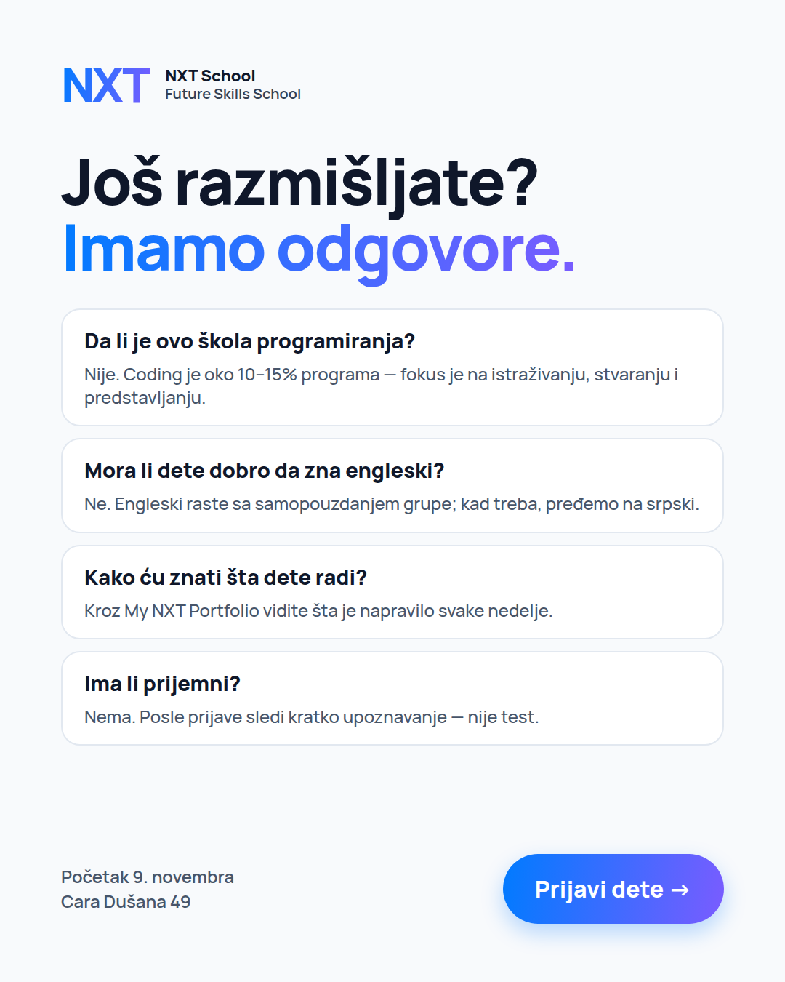 | R2 · FAQ "Još razmišljate?" (objection-led)  When · format: From W2 · static · refresh when frequency > 3/week  Name: R2_FAQ_O_Static45_v1  What it does: answers the 4 questions that stop parents: is it a coding school? does my kid need good English? how will I know what they do? is there an entrance test?  On image: 4 Q&A cards + CTA. Swap in real questions from Ops calls after week 1.  Primary text: FAQ (Appendix) · Headline: Još razmišljate? Imamo odgovore.

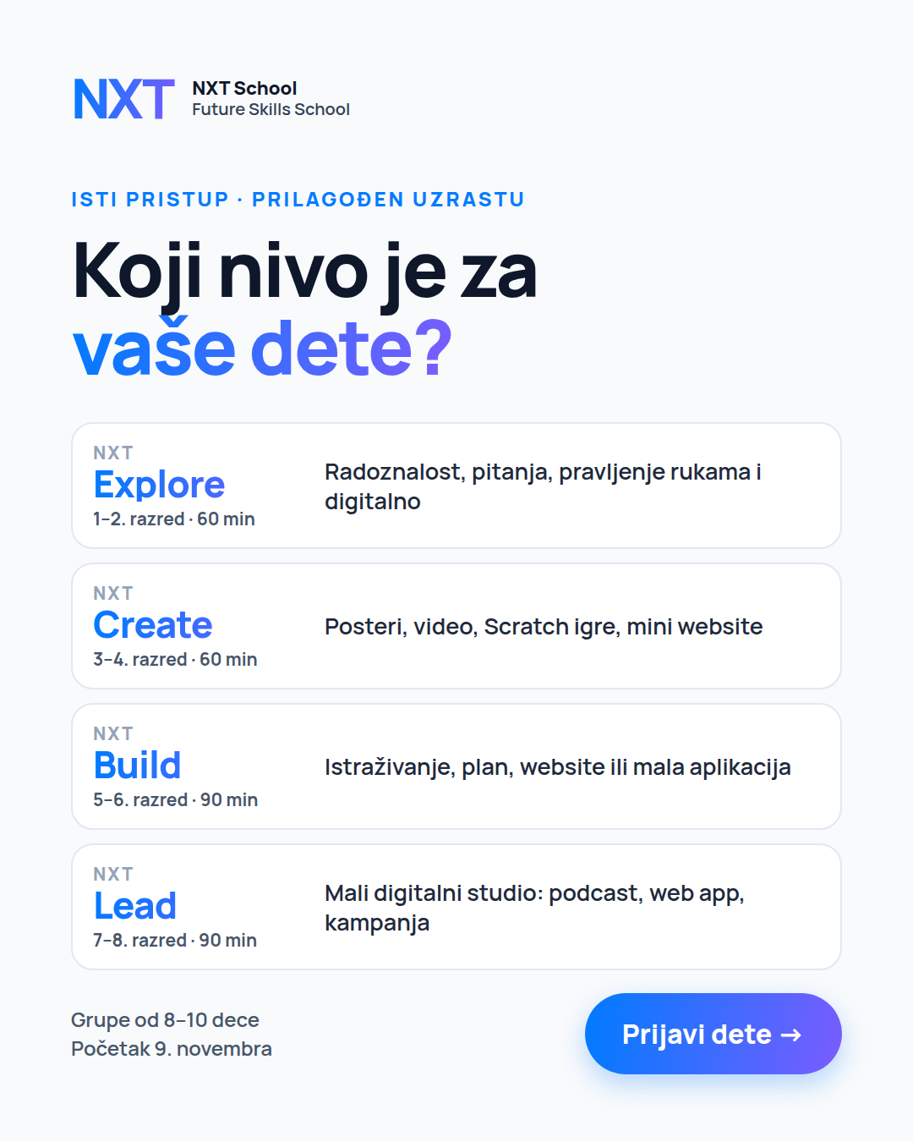 | R4 · C2 "Koji nivo je za vaše dete?" — NEW  When · format: From W2 · static  Name: C2_Levels_O_Static45_v1  What it does: lets parents find their kid’s level in seconds — and gives us a grade-mix signal (which levels get clicks).  On image: 4 levels with grades, class length and one-line outputs: Explore · Create · Build · Lead.  Primary text: Levels (Appendix) · Headline: Koji nivo je za vaše dete?  Note: the NXT Lead line must sound grown-up, not "kids".

R3 · C6 Open Day (angle D · W2–W3 · static) — same asset as O1, shown to warm parents until 23 Oct (people who visited but didn’t apply are the best Open Day guests).

ADD IN W3 — trust
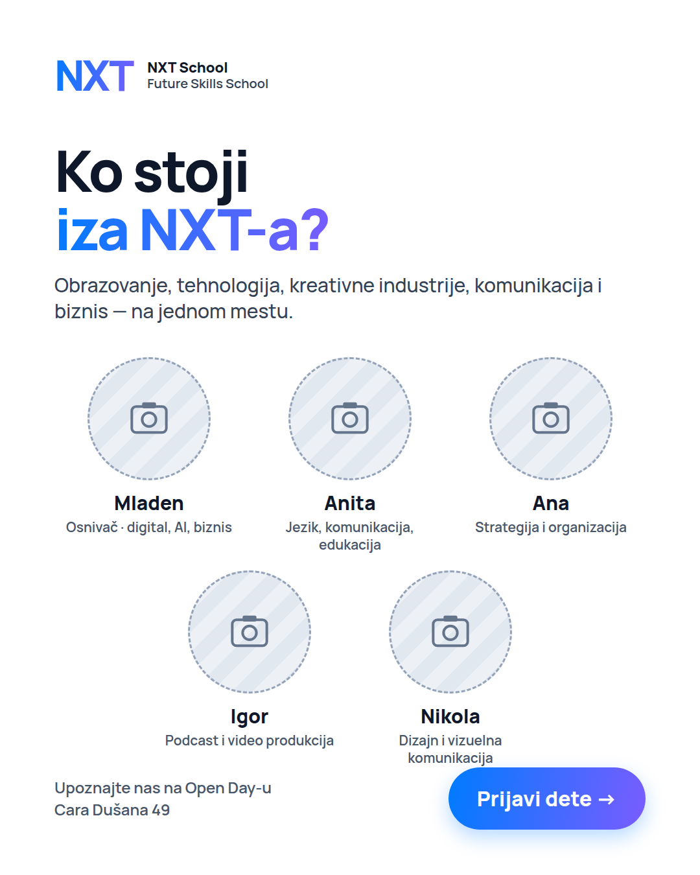 | R5 · "Ko stoji iza NXT-a?" (team)  When · format: W3 → · real team photos (as soon as they are taken)  Name: R5_Team_O_Photo45_v1  What it does: answers "who are these people?" — the website’s "Ljudi iza NXT-a" section as an ad.  On image: 5 real portraits with roles (Mladen, Anita, Ana, Igor, Nikola); teachers added as soon as they are hired.  Primary text: Team (Appendix) · ⚠ Mladen confirms roles; not presented as "nastavni kadar".

TEST — W2–W4 · price vs objections vs levels
R1 price + date vs R2 objections vs R4 levels — judge on CPL and qualified rate. Warm audiences are small: when frequency passes ~3 per week, refresh the visual (same message, new layout).

SWAP IN — W4 (26 Oct → 8 Nov) · last call + real photos
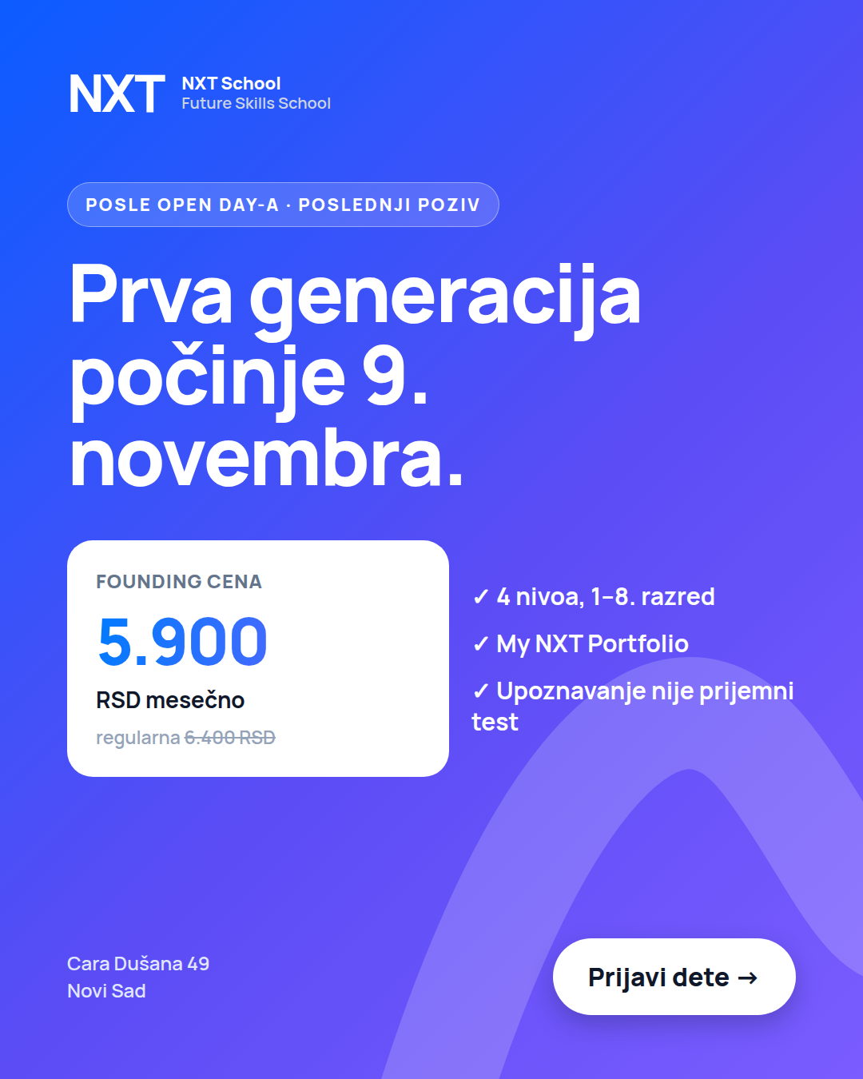  R6 · "Počinjemo 9. novembra"  W4 · static · last call, real date urgency | 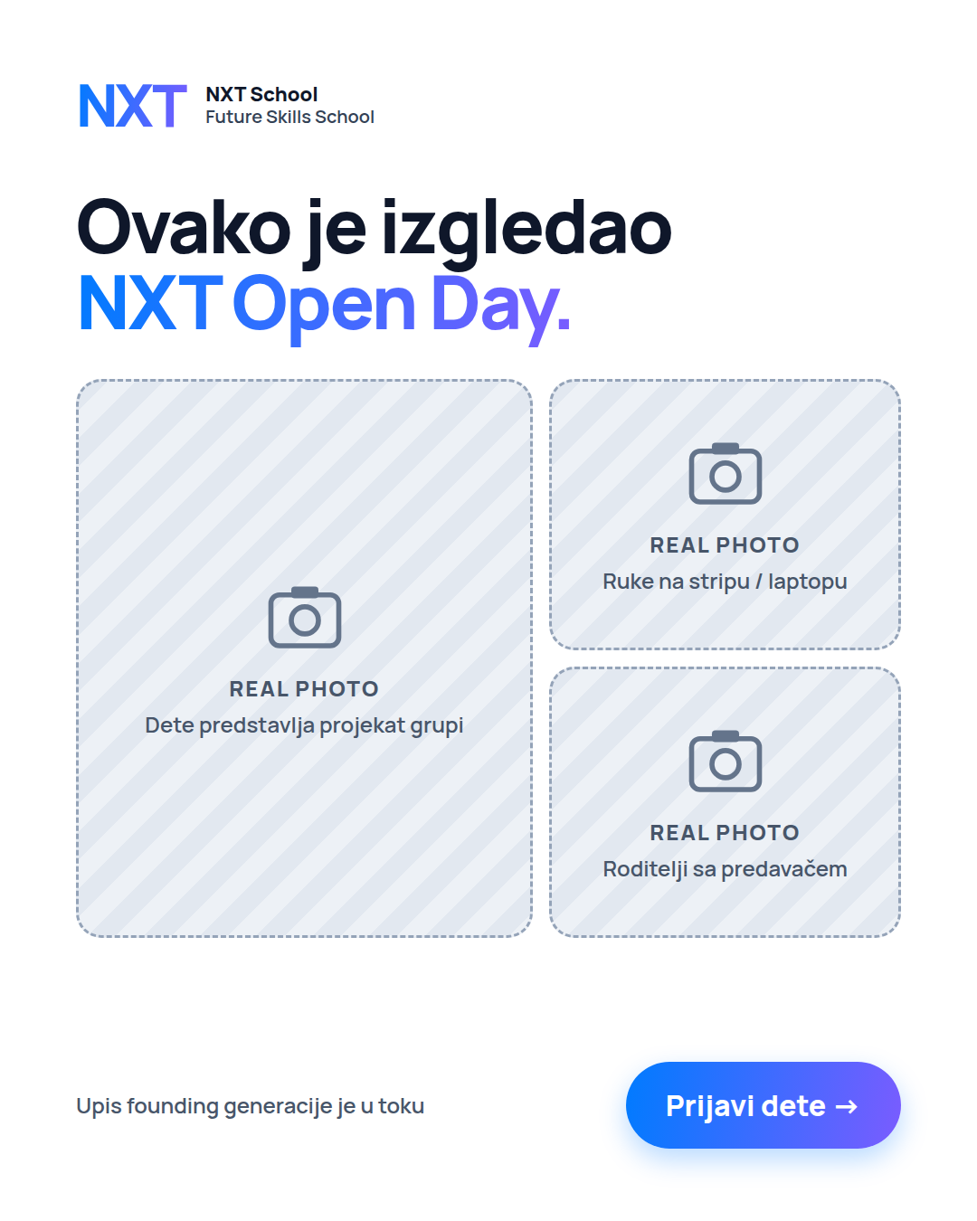  R7 · Open Day recap  W4 · real photos from 24 Oct (consent!)

After 9 Nov: non-converters stay in a 90-day audience for the January wave. January sells a program that already exists — real work, portfolio examples, parent quotes.

5. Testing calendar & decision rules
Week | Formats live | Prospecting (1.1) | Open Day (2.1) | Retargeting (3.1)
W1 · 6–11 Oct | Static (feed + story) | P1–P5 live — angles 1–4 + Offer side by side. No edits for 72 h. | Off · prep C6 + story | Off · audience building
W2 · 12–18 Oct | Static + real space photos | First read on 20–30 leads. Pause bottom 1–2. Space-photo C1. | Angle D: O1 live 12 Oct · O2 13 Oct | R1, R2, R3, R4 live 13 Oct
W3 · 19–25 Oct | Static + motion / carousel + first Reels | Round 2: winner variants + P6 "Pitali smo decu" Reel | O1 vs O3 countdown · ends 23 Oct · Open Day Sat 24 | R5 team · R3 ends 23 Oct
W4 · 26 Oct–8 Nov | Real photo + video | Round 3: real-photo versions, Kids Explain the Future · 60/30/10 on winners | — | R6 last call + R7 recap · enrolment closes before 9 Nov
After 9 Nov | — | Pause acquisition → collect social proof (Made at NXT, Inside NXT) | — | Non-converters → January pool

Decision rules
- First 20–30 leads = validation. Don’t scale or rebuild anything before then.
- Cut an ad at ≥ 1,500 impressions with link CTR < 0.6%, or 2,000 RSD spent with 0 leads.
- Winner = CPL ≤ 800 RSD with ≥ 5 leads that Ops rates as qualified → it gets the variants and, later, the real photos.
- One change per variant (headline OR visual OR format) — otherwise we learn nothing.
- Fatigue: CTR drops 30% from its peak or frequency > 3/week (retargeting) → refresh the visual, keep the message.
- Track from day 1, not just Meta CPL: CPL · qualified lead rate · contact rate · lead → enrolment · CAC. Target maths: 30–40 enrolled ≈ 150–200 leads at ~20% lead → enrolment → CPL ≤ 1,000 RSD at 150k.

6. Production list
All messaging is signed off by Mladen before production. Viktor implements (pages, forms, tracking) but doesn’t decide messaging or creative direction.

Design (Nikola)
Asset | Formats | For ads | Due
C1 Hero, C3 Less scrolling, C4 English, C7 AI literacy, C5 Founding | Static 4:5 + 9:16 each | P1–P5, R1 | Tue 6 Oct AM (launch blocker)
C6 Open Day | 4:5 + 9:16 | O1, R3 | Fri 9 Oct
R2 FAQ, C2 "Koji nivo?" | 4:5 + 9:16 | R2, R4 | Mon 12 Oct
C1 with real space photo | 4:5 + 9:16 | P1 (W2 version) | As soon as space photos arrive (~W2)
O2 = winning P-ad + Open Day band | 4:5 + 9:16 | O2 | Tue 13 Oct
R5 team with real portraits | 4:5 + 9:16 | R5 | When portraits are shot (~W2–W3)
Round-2 variants (winning angle only) | per test | P-variants | Wed 14 Oct
O3 countdown ("Još 5 dana" + "Ove subote!") | 4:5 + 9:16 | O3 | Fri 16 Oct
R6 last call, R7 Open Day recap | 4:5 + 9:16 | R6, R7 | Mon 26 Oct

Photo / video (Igor · art direction Nikola · casting via Šmiranti)
Shot | Feeds into
Space without kids — tables, making materials, presentation zone (creative studio, not computer classroom) | C1 space version (W2), R5 background
Team portraits: Mladen, Anita, Ana, Igor, Nikola | R5 team
Tactile / making close-ups: paper prototypes, sketches, Lego, materials | Angle 2 "Ovo sam danas napravio" test, Reel
One kid at a computer (not rows) · pair work · team work | C4 photo version, Reels
Mentor with kids · a kid presenting in English | Angle 3 photo, Reel, R7
"Pitali smo decu…" — ages 1–2 / 3–5 / 6–8 | P6 Reel (W3)
"Kids Explain the Future" | W4 Reels
Open Day: mini challenge, parents with the team, kids’ Show & Tell | R7 recap, website, PR
Every shot horizontal + vertical · branded hoodie/shirt if available | All formats
Consent & honesty: signed parental consent for every child on camera · cast kids are not NXT students (no "naša deca") · no partner or school names in ads until written agreement.

Appendix — primary texts (Serbian, paste-ready)
[Brackets] = confirm before use. Each ad gets the long and short text of its angle as two text options. Emojis kept to 📍 and 👉 only (tone rule).
ANGLE 1 — Hero "Veštine za svet u kojem će odrastati." · P1
LONG
Deca koja danas kreću u školu odrastaće u svetu koji se menja brže od bilo kog programa.

NXT School je Future Skills School za osnovce u Novom Sadu. Ovde deca uče kako da istražuju, razmišljaju, stvaraju, sarađuju i predstave ono što su napravila — uz digitalne alate, AI i engleski kao prirodne delove rada.

Ne učimo prvenstveno alate. Razvijamo način razmišljanja i način rada.
→ 4 nivoa: Explore (1–2), Create (3–4), Build (5–6), Lead (7–8)
→ grupe od 8–10 dece, 24 nedelje, jednom nedeljno
→ svaki čas se završava nečim što je dete samo napravilo
→ My NXT Portfolio — vidite napredak svake nedelje

📍 Cara Dušana 49 · početak: 9. novembar
Founding cena: 5.900 RSD mesečno (regularna 6.400 RSD)

Veštine za svet u kojem će odrastati. 👉 Prijavi dete
SHORT
Future Skills School za decu od 1. do 8. razreda u Novom Sadu. Istraživanje, stvaranje, AI, engleski i prezentovanje — kroz prave projekte, u grupama od 8–10. Početak 9. novembra.
HEADLINES
Veštine za svet u kojem će odrastati · Future Skills School za 1–8. razred · Početak: 9. novembar

ANGLE 2 — "Less scrolling. More creating." · P2
LONG
Vaše dete već zna da skroluje. Kod nas uči da stvara.

Poenta nije manje tehnologije po svaku cenu — nego manje pasivnog korišćenja i više stvaranja. Ekran je alat: ako ga koristimo, koristimo ga da nešto napravimo.

Zato se svaki čas u NXT School završava nečim opipljivim: crtežom, posterom, videom, prezentacijom, Scratch igrom, maketom ili nastupom. A mnogo toga počinje rukama — papir, markeri, Lego, skice.

Sve što dete napravi ide u njegov My NXT Portfolio, koji vi vidite.

1–8. razred · grupe od 8–10 · 📍 Cara Dušana 49, Novi Sad
Founding cena: 5.900 RSD mesečno (regularna 6.400 RSD)

Less scrolling. More creating. 👉 Prijavi dete
SHORT
Manje pasivnog skrolovanja, više stvaranja. U NXT School svaki čas se završava nečim što je dete samo napravilo. 1–8. razred · grupe 8–10 · Novi Sad · početak 9. novembra.
HEADLINES
Manje skrolovanja. Više stvaranja. · „Ovo sam danas napravio.“ · Ekran je alat, ne dadilja

ANGLE 3 — "English is not a subject here." · P3
LONG
English is not a subject here. It’s the language we use.

U NXT School engleski nije čas gramatike — to je jezik kojim deca rade: postavljaju pitanja, istražuju, koriste AI i predstavljaju svoje projekte.

Kod mlađih su to jednostavne instrukcije, pojmovi i kratke prezentacije. Kod starijih — istraživanje izvora na engleskom, razgovor i delovi celih projekata.

Kad treba objasniti nešto složeno, pređemo na srpski. Engleski raste zajedno sa samopouzdanjem grupe.

1–8. razred · 4 nivoa · grupe od 8–10 · 📍 Cara Dušana 49
Founding cena: 5.900 RSD mesečno 👉 Prijavi dete
SHORT
Engleski ovde nije predmet — to je jezik kojim deca rade, pitaju i predstavljaju. Raste sa samopouzdanjem grupe. 1–8. razred, Novi Sad, početak 9. novembra.
HEADLINES
Engleski je ovde jezik rada · English is the language we use · Hrabrost da pričaju engleski

ANGLE 4 — AI + digital world "Pitaj. Proveri. Poboljšaj. Ti odluči." · P4
LONG
Znati da pitaš ChatGPT nešto nije AI literacy.
Znati da otvoriš YouTube nije media literacy.

Vaše dete već koristi internet, video i sve više AI. Ali da li zna kako da razmišlja uz njih?

U NXT School deca uče jedno pravilo za svaki AI alat: Ask → Check → Improve → Decide. Pitaj. Proveri. Poboljšaj. Ti odluči.

Uče da AI može da zvuči sigurno i kad nije u pravu, kako da provere izvor, koje podatke ne unose i kako da prepoznaju scam ili lažni video — bez straha od interneta.

NXT ne uči dete da prepusti posao AI-u. Uči ga da radi bolje uz AI.

1–8. razred · grupe od 8–10 · 📍 Cara Dušana 49 · početak 9. novembra
👉 Prijavi dete
SHORT
Vaše dete već koristi AI i internet. Da li zna kako da razmišlja uz njih? U NXT School: Pitaj → Proveri → Poboljšaj → Ti odluči. 1–8. razred, Novi Sad.
HEADLINES
Pitaj. Proveri. Poboljšaj. Ti odluči. · AI pismenost za decu 1–8. razreda · Da radi bolje uz AI, ne umesto njega

OFFER — Founding generacija · P5, R1
LONG
Upisujemo prvu, founding generaciju NXT School. Početak: ponedeljak, 9. novembar.

Šta dobija dete:
✓ 24 nedelje praktičnog rada, jednom nedeljno (60 ili 90 min, zavisno od uzrasta)
✓ grupu od 8–10 dece svog nivoa: Explore, Create, Build ili Lead
✓ svaki čas završen nečim što je samo napravilo
✓ My NXT Portfolio i Future Skills Passport
✓ NXT Showcase — predstavljanje svog rada pred roditeljima

Šta dobijate vi: founding cenu od 5.900 RSD mesečno umesto 6.400 RSD [za ceo program] i stalan uvid u to šta dete radi.

Posle prijave sledi kratko upoznavanje — nije prijemni test.
📍 Cara Dušana 49, Novi Sad 👉 Prijavite dete
SHORT
Founding generacija NXT School: 5.900 RSD mesečno umesto 6.400. 1–8. razred, grupe 8–10, početak 9. novembra. Upoznavanje nije prijemni test.
HEADLINES
Founding cena: 5.900 RSD mesečno · Početak: 9. novembar · Upis prve generacije je u toku

OPEN DAY · O1, O2, O3, R3
PRIMARY
Dođite na NXT Open Day — [subota, 24. oktobar], Cara Dušana 49.

Umesto prezentacije od sat vremena: deca rade kratak NXT mini challenge, a vi u međuvremenu upoznajete program, prostor i ljude iza NXT-a i postavljate pitanja. Na kraju deca pokažu šta su napravila.

Traje oko 90 minuta. Besplatno, uz prijavu.
👉 Prijavite se za Open Day
O3 COUNTDOWN FIRST LINE
Još 5 dana do NXT Open Day-a. / Ove subote je NXT Open Day.
HEADLINE
NXT Open Day · [Subota, 24. oktobar]

FAQ · R2
PRIMARY
Još razmišljate? Evo odgovora na najčešća pitanja roditelja:

1) Da li je ovo škola programiranja? Nije. Coding je oko 10–15% programa — deca uče da istražuju, stvaraju, sarađuju i predstavljaju, uz AI, digitalne alate i engleski.
2) Mora li dete dobro da zna engleski? Ne. Engleski raste sa samopouzdanjem grupe, a kad treba, pređemo na srpski.
3) Kako ću znati šta dete radi? Kroz My NXT Portfolio vidite šta je napravilo svake nedelje.
4) Ima li prijemni? Nema. Posle prijave sledi kratko upoznavanje — nije test.

Founding cena: 5.900 RSD mesečno (regularna 6.400). Početak 9. novembra. 👉 Prijavi dete
HEADLINE
Još razmišljate? Imamo odgovore.

LEVELS — "Koji nivo je za vaše dete?" · R4
PRIMARY
Isti NXT pristup, prilagođen uzrastu:

NXT Explore (1–2. razred, 60 min) — radoznalost, pitanja, pravljenje rukama i digitalno, Show & Tell.
NXT Create (3–4. razred, 60 min) — posteri, video, Scratch igre, mini website; AI uz proveru.
NXT Build (5–6. razred, 90 min) — istraživanje, plan, website ili mala aplikacija, feedback i nova verzija.
NXT Lead (7–8. razred, 90 min) — mali kreativni i digitalni studio: podcast, web aplikacija, kampanja, istraživački projekat.

Grupe od 8–10 · početak 9. novembra · 📍 Cara Dušana 49 👉 Prijavi dete
HEADLINE
Koji nivo je za vaše dete?

TEAM — "Ko stoji iza NXT-a?" · R5
PRIMARY
Ko stoji iza NXT-a?

NXT School je nastao spajanjem obrazovanja, tehnologije, kreativnih industrija, komunikacije i poslovnog iskustva.

[Mladen — osnivač · digital, AI, biznis · Anita — jezik, komunikacija, edukacija · Ana — strategija i organizacija · Igor — podcast i video produkcija · Nikola — dizajn i vizuelna komunikacija]
Predavače predstavljamo čim se tim kompletira.

Upoznajte nas na Open Day-u ili prijavite dete. 👉
HEADLINE
Ljudi iza NXT-a

LAST CALL — "Počinjemo 9. novembra" · R6
PRIMARY
Prva generacija NXT School počinje u ponedeljak, 9. novembra.

Founding cena od 5.900 RSD mesečno (regularna 6.400) važi za prvu generaciju [— upis do početka programa].
Posle prijave sledi kratko upoznavanje — nije prijemni test.

📍 Cara Dušana 49, Novi Sad 👉 Prijavi dete
HEADLINE
Počinjemo 9. novembra

REEL CAPTION — "Pitali smo decu…" · P6
PRIMARY
Pitali smo decu: da li će AI ljude učiniti pametnijim ili lenjim? Poslušajte šta kažu.

U NXT School deca uče da razmišljaju uz AI — da pitaju, provere, poboljšaju i sama odluče.
1–8. razred · Novi Sad · početak 9. novembra 👉 Prijavi dete
HEADLINE
Veštine za svet u kojem će odrastati

