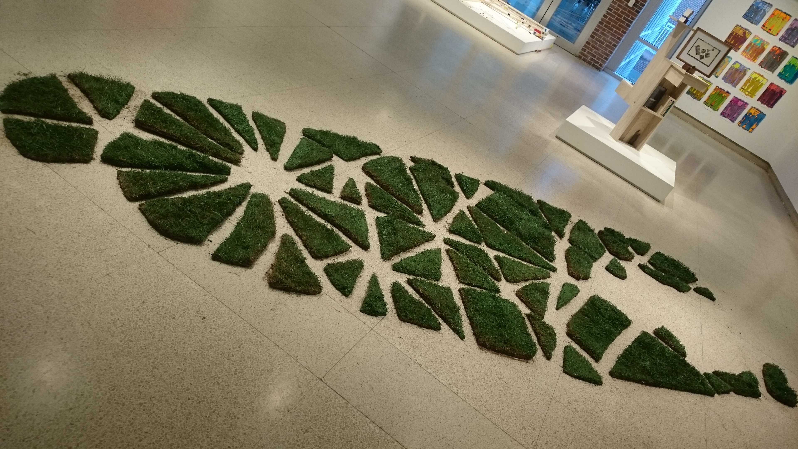 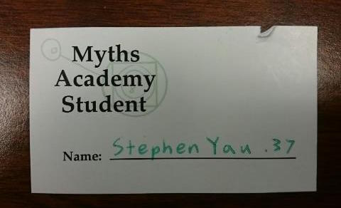

MYTH NARRATIVE

By: Stephen Yau.37

In the Spring of 2016, Zeus decided that humans needed to experience being as large as the gods were. Most of the other Gods and Goddesses on Mount Olympus agreed with the mighty king of Gods. Only Hades disagreed, but no one cared about his opinion. Zeus mandated that in order for humans to be able to feel this gift, they would need to venture into the Hopkins Hall gallery between April 4th and April 18th. It would be a limited time gift. Only those lucky enough to hear about would get this experience. He added several exhibitions to the gallery in Hopkins Hall, the most notable of which was a life size Ohio State Oval model. When humans entered the gallery, the oval would seem miniature, but in reality, the humans were the ones that were not normal sized. The humans asked Zeus to extend the fourteen-day time frame in which this gift was available, but Zeus refused this extension. Instead, he made the Friday before the deadline a “rest” day. He demanded that people not go to their classes and to skip work in order to experience this gift. Most people followed Zeus’ orders, but there were a select few that did not heed to all-powerful thunder God. After some humans heard that they missed the opportunity to experience being God-sized, they begged Zeus to reopen the gallery. Zeus looked at them sadly and just shook his head. He then said, “You people are the reason that Arsenal is the best English soccer team in the league right now.”