Journal of Experimental Psychology: Copyright 2002 by the American Psychological Association, Inc. Human Perception and Performance 0096-1523/02/$5.00 DOI: 10.1037//0096-1523.28.5.1163

2002, Vol. 28, No. 5, 1163–1175

Recognition Memory for Briefly Presented Pictures: The Time Course of Rapid Forgetting

Mary C. Potter, Adrian Staub, Janina Rado, and Daniel H. O’Connor

Massachusetts Institute of Technology

When viewing a rapid sequence of pictures, observers momentarily understand the gist of each scene but have poor recognition memory for most of them (M. C. Potter, 1976). Is forgetting immediate, or does some information persist briefly? Sequences of 5 scenes were presented for 173 ms/picture; when yes–no testing began immediately, recognition was initially high but declined markedly during the 10-item test. With testing delays of 2 or 6 s, the decline over testing was less steep. When 10 or 20 pictures were presented, there was again a marked initial decline during testing. A 2-alternative forced-choice recognition test produced similar results. Both the passage of time and test interference (but not presentation interference) led to forgetting. The brief persistence of information may assist in building a

coherent representation over several fixations.

Visual information arrives as a succession of fixations, snapshots with typical durations between about 100 and 500 ms. How much do we remember about each of these fixations, and for how long? Some form of visual short-term memory spanning several fixations seems required to account for our ability to navigate in an environment, locate objects efficiently in search, carry out a smooth succession of actions, and the like. Yet, research has shown that carryover from the preceding to the present fixation lacks detail; contrary to earlier speculations, there is no collagelike combination of the two fixations (e.g., Henderson & Hollingworth, 1999; Irwin, 1992). Moreover, detection of a feature change in a scene that one was viewing only 80 ms previously can be very difficult (Rensink, O’Regan, & Clark, 1997, 2000), suggesting that little information is maintained from one glimpse to the next.

This

document

is

copyrighted

by

the

American

Psychological

Association

or

one

of

its

allied

publishers.

This

article

is

intended

solely

for

the

personal

use

of

the

individual

user

and

is

not

to

be

disseminated

broadly.

It has been shown, however, that meaningful pictures that have been viewed for as little as 1 or 2 s are remembered for long periods, provided that the recognition test does not include new pictures (distractors) that are highly similar to the to-beremembered old pictures (Nickerson, 1965; Potter & Levy, 1969; Shepard, 1967; Standing, 1973). But when pictured scenes are presented more rapidly, in a sequence that simulates successive fixations with durations of 125–333 ms, most of the pictures cannot be recognized after the sequence (Potter & Levy, 1969; see

Mary C. Potter, Adrian Staub, Janina Rado, and Daniel H. O’Connor, Department of Brain and Cognitive Sciences, Massachusetts Institute of Technology.

Adrian Staub is now at the Department of Philosophy, University of Pittsburgh. Janina Rado is now at the Department of Linguistics, University of Tu¨bingen, Tu¨bingen, Germany. Daniel H. O’Connor is now at the Department of Psychology, Princeton University.

This research was supported by Grant MH47432 from the National Institute of Mental Health. We thank Chris Hooker and J. DiMase for research assistance and Virginia Valian for comments on an earlier version of the article.

Correspondence concerning this article should be addressed to Mary C. Potter, NE20-453, Massachusetts Institute of Technology, Cambridge,

Massachusetts 02139. E-mail: mpotter@mit.edu

also Potter, 1976, and Intraub, 1979, 1980).[1] To rule out the hypothesis that viewers could not perceive and understand the pictures at such high rates, Potter (1975, 1976) presented the same sequences and instructed viewers to try to detect a specific target picture named in advance of each sequence. The target names were general descriptions, such as *a boat* or *a picnic,* that could match widely different pictures, so it would have been difficult for viewers to detect the target picture without first perceiving and comprehending it. A second group was shown the to-be-detected picture in advance of each sequence, so they knew exactly what the target would look like. A third group of participants simply viewed the sequences and were later tested for recognition, as in Potter and Levy’s experiments.

As shown in Figure 1, even when the target was specified only by a name, detection was much better at each rate of presentation than recognition memory for those pictures (Potter, 1975, 1976; see also Intraub, 1981). (Not surprisingly, detection was still better when the picture itself was given in advance.) For example, at 167 ms more than 70% of the name target pictures were detected, whereas fewer than 20% of the pictures were correctly recognized when tested shortly after viewing. These findings indicate that viewers have a momentary understanding of pictures presented at rates in the range of eye fixations but many are then forgotten. A brief period of uninterrupted consolidation seems to be necessary for even short-term retention.

|  |
| --- |
| 1163 |

Other findings show that pictures can be recognized when shown for as brief an interval as 100 ms, even when a visual-noise mask follows the picture, provided that the mask is not itself a to-be-attended stimulus such as another picture (Loftus, Hanna, & Lester, 1988; Potter, 1976). That is, a glimpse of 100 ms is sufficient for encoding and memory, as long as another picture does not have to be encoded within about 500 ms. Visual-noise masks cause interference when the presentation duration is very

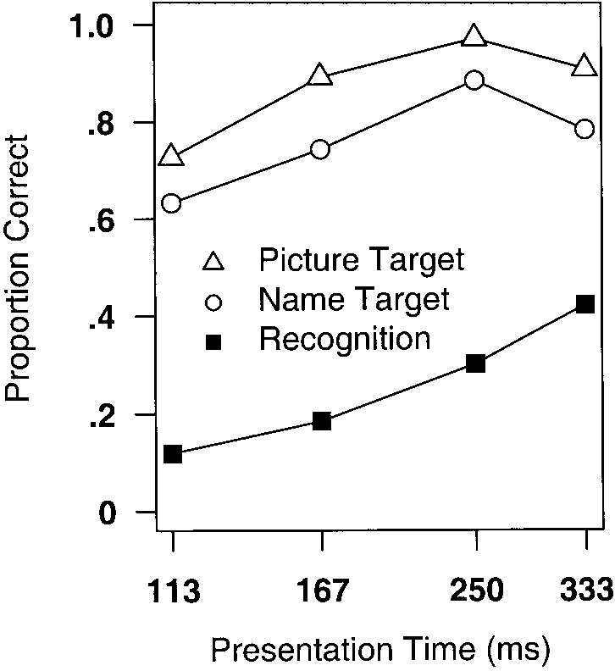

*Figure 1.* Proportions of correct detections of specified pictures compared with recognition memory for pictures. In the detection task, targets were specified by showing the picture in advance or by giving a short verbal title. Recognition memory was corrected for guessing (Ycorr). Presentation time is on a log scale. From “Short-Term Conceptual Memory for Pictures,” by M. C. Potter, 1976, *Journal of Experimental Psychology: Human Learning and Memory, 2,* p. 511. Copyright 1976 by the American Psychological Association.

short (e.g., 50 ms or less); by about 100 ms, however, a meaningless noise mask no longer prevents perception. The temporal difference between noise and picture masking led Potter (1976) to make a distinction between perceptual masking by pattern and conceptual masking resulting from attention to a subsequent meaningful event (see also Intraub, 1984). Loftus and Ginn (1984) followed up this work by presenting pictures for 50 ms, followed immediately or after 300 ms by a mask that was either a noise mask (perceptual) or another picture (perceptual and conceptual). The luminance of the mask was either high or low. When the stimulus onset asynchrony (SOA) was 50 ms, mask luminance, but not conceptual content, affected later memory for the picture: High-luminance masks produced more memory loss than lowluminance masks. When the SOA was 300 ms, the conceptual variable, but not luminance, affected later memory: Picture masks produced more memory loss than noise masks.

Potter (1976) proposed that perceptual identification requires about 100 ms.[2] Consolidation requires an additional 300 ms, on average, so that the median processing time for perception and consolidation of a picture seen for the first time is about 400 ms. If a picture is not consolidated, it is immediately forgotten.

But are such briefly presented pictures forgotten immediately after viewing, or does some information persist for a time, even when the picture is fated to be forgotten? Knowing the time course of picture forgetting is central to understanding how visual information is combined across fixations. In the present series of experiments, we examined the time course of forgetting of briefly presented pictures, focusing on the first seconds after a picture has been presented. Does forgetting occur immediately when the next to-be-attended picture appears, or is it more gradual? If the latter, what factors cause forgetting? In previous research with rapidly presented pictures, the sequences were between 12 and 16 pictures in length and recognition testing began after a delay of up to a minute, so considerable time could elapse between presentation of a picture and its test. Potter and Levy (1969) reported that at the two shortest SOAs they used, 125 and 167 ms (but not at 250 or 333 ms), performance declined significantly from the first to the second half of the 32-item test (half old pictures and half new pictures), suggesting that some of the memory loss did not occur immediately. There was no evidence of a recency effect in the presentation sequence except for the last picture, which was always remembered well regardless of duration. There is, however, no information in any of these studies about picture retention in the first seconds after presentation.

This

document

is

copyrighted

by

the

American

Psychological

Association

or

one

of

its

allied

publishers.

This

article

is

intended

solely

for

the

personal

use

of

the

individual

user

and

is

not

to

be

disseminated

broadly.

The questions we addressed in the present study were as follows: Is the memory of an incompletely consolidated picture lost immediately, when the picture is replaced by another picture, or is the representation lost more gradually, over the following seconds? That is, does the initial representation of the picture linger at least briefly, and, if so, what factors determine when forgetting occurs? We considered three possible factors: simple passage of time, interference from preceding or following pictures in the presentation sequence, and interference from the recognition test.

In all of the experiments reported here, pictures were shown in a continuous sequence for 173 ms per picture, a rate of approximately 6 pictures per second. At this rate, the masking (interference) effect of the next picture would presumably be conceptual rather than perceptual. In most of the experiments, each sequence consisted of 5 pictures plus a sixth picture that served as a conceptual mask and was treated as a filler. In Experiments 4 and 5, there were 10 and 20 pictures per sequence, respectively, along with the filler. The presentation duration of 173 ms was chosen because the earlier work just reviewed showed that, at this rate, most pictures can be identified during presentation, but more than half cannot be recognized when memory is tested a minute or two later. Each sequence was followed immediately or after a short delay by a recognition test. (The sixth picture in the sequence was not tested for recognition.) If consolidation of a given picture happens to be complete before the next picture appears, then a picture’s position in the presentation sequence or the delay until recognition is tested should have little effect on recognition performance, given the normal robustness of picture memory. If, however, a picture has been understood but not fully consolidated when the next picture arrives, a memory trace of the picture might persist for a time before being lost either through the simple passage of time or because of interference from additional pictures in the presentation sequence or the test sequence.

To evaluate these hypotheses, we began the yes–no recognition test 293 ms after the offset of the presentation sequence in Experiment 1, 5.7 s after offset in Experiment 2, and 1.7 s after offset in Experiment 3. In Experiment 4, 10 rather than 5 pictures were presented, and, in Experiment 5, 20 pictures were presented. In Experiment 6, with 5-picture sequences, a two-alternative forcedchoice recognition test was used. In Experiments 4–6, the delay before testing began was 293 ms, as in Experiment 1. Variables examined in the data analyses included serial position in presentation, serial position in the recognition test, and the interaction between these variables.

# Experiment 1

The general method, as just outlined, was similar in all of the present experiments. We describe it in detail here; in later experiments, the method was the same except as specified.

## Method

*Participants.* Twenty volunteers from the Massachusetts Institute of Technology community were paid for their participation. All reported normal or corrected vision. No one participated in more than one of the present experiments.

*Materials and apparatus.* The pictures were 660 color photographs with widely varied content, chosen from commercially available compact discs. They included pictures of animals, people engaged in various activities, nature scenes, and city scenes. Pictures were assigned randomly to the 60 trials; no picture was repeated except in the recognition test. These pictures were stored as PICT files 300 pixels in width 200 pixels in height. They were presented on an Apple PowerPC 7500/100 computer with a 17-in. monitor set at a resolution of 832 624 pixels and a refresh rate of 75 Hz; MacProbe software was used (Hunt, 1994). The pictures as displayed were 10.6 7.1 cm, subtending approximately 13° of visual angle horizontally and 9° vertically when viewed from the normal distance of 45 cm. Pictures were shown against a medium gray background, and this background was present throughout. The room was dimly illuminated.

*Design and procedure.* Each trial consisted of 5 presentation pictures plus a sixth picture that served as a conceptual mask, along with 10 test pictures consisting of the 5 presentation pictures and 5 distractors. The serial positions of the 5 presentation pictures were counterbalanced across participants so that each picture appeared in each serial position. Half of the 10-item recognition tests (30 trials) began with an old picture, and half began with a distractor. In the 30 trials beginning with an old picture, that picture was drawn equally often from each of the 5 serial positions in the presentation sequence. The rest of the old and new test pictures were randomly ordered on each trial, with the constraint that no more than 2 old or 2 new pictures appeared consecutively.

Before each trial, the word *ready* appeared on the screen, indicating that the participant could press the space bar to begin the trial. The sequence began with a red fixation cross in a black rectangle framed by red edging that was the same size as the pictures. The fixation array was presented for 293 ms, followed by a blank of 200 ms and six pictures in sequence for 173 ms each. The sixth picture was regarded as a filler and was not tested for recognition. Immediately following the last picture, a white square slightly larger than the pictures was presented for 293 ms, followed by the first test picture. (The purpose of the white square was to signal the end of the presentation sequence and the beginning of the test sequence.)

This

document

is

copyrighted

by

the

American

Psychological

Association

or

one

of

its

allied

publishers.

This

article

is

intended

solely

for

the

personal

use

of

the

individual

user

and

is

not

to

be

disseminated

broadly.

Each test picture was presented for 400 ms, followed by a blank screen until the participant responded by pressing a *yes* or a *no* key on the keyboard. The reason for the relatively short presentation duration was to encourage the viewer to make a rapid decision and to minimize the elapsed time during the test. Reaction time (RT) to make the decision was recorded and used to measure the average duration of the recognition test; no other analyses of RTs were carried out. After 107 ms the next test picture appeared, and the cycle repeated for the 10 test pictures. Participants were instructed to view the presentation sequence and then respond to the test pictures as rapidly as they could, consistent with accuracy. They were told that they need not be absolutely sure that a picture was an old picture to press *yes.* They were not given any information about how many of the test pictures in each trial were old pictures. Between trials, there was a brief interval while the computer loaded the pictures for the next trial, after which the word *ready* appeared on the screen. There were four practice trials using a different set of pictures.

*Data analyses.* In this and the following experiments (except Experiment 6), we analyzed the data using three measures, calculated separately for each participant in each of the relevant cells in the design. The first measure we analyzed was proportion of *yes* responses, separately for true yeses (TYs) and false yeses (FYs). For TYs, there were 25 cells[3]: 5 serial positions in presentation 5 relative serial positions in the test. For FYs and for the other two analyses, there were 5 cells, the 5 relative serial positions in the test.[4] Second, we used a high-threshold guessing correction (Ycorr) often used in studies of picture memory: *P*(Ycorr) [*P*(TY) *P*(FY)]/[1 *P*(FY)], where *P* is proportion.

Third, we used *A,* which is an alternative to *d* that can be calculated even when the false alarm rate is zero for a given participant in a given condition (Donaldson, 1993; Grier, 1971; Macmillan & Creelman, 1991; Pollack & Norman, 1964). Because the results from the Ycorr analyses and the *A* analyses were in most cases similar, we report only the Ycorr results except when only one of the two analyses was significant at the .05 level or better; in that case, we specify which analysis was significant and which was not.[5] Because we were particularly interested in serial position effects in testing, we calculated *P*(Ycorr) for each participant at each of the five relative serial positions of the old versus the new pictures in the test.[6],[7] For analyses of serial position effects in the presentation sequence, uncorrected *P*(TY) was used (unlike test serial position, there is no measure of FYs that corresponds to presentation serial position).

## Results and Discussion

Recognition memory for the pictures was very good at the beginning of the recognition test but declined markedly thereafter (Figure 2B), showing that memory for to-be-forgotten pictures persists at least briefly. Serial position in the presentation sequence was flat, except for a small primacy effect for the first picture (Figure 2A). Overall, old pictures were recognized 53% of the

*Figure 2.* Probability of recognizing an old picture (TY), falsely recognizing a new picture (FY), and recognizing an old picture corrected for guessing (Ycorr), as a function of serial position of presentation (A) and relative serial position in the recognition test (B) in Experiment 1.

time, and new pictures were falsely recognized 10% of the time. Figure 2A shows proportions of TYs as a function of the serial position of the five pictures in the presentation sequence, and Figure 2B shows these proportions as a function of the serial position in the test sequence. Figure 2B also shows proportions of

FYs and guessing-corrected proportions of yeses (Ycorr).

An analysis of variance (ANOVA) was carried out on *P*(TY), with presentation position, test position, and whether or not the first tested item was an old picture as variables. The main effect of presentation position (Figure 2A) was significant, *F*(4, 76) 13.62, *p*  .001: There was a primacy effect for the first picture presented, but (to our surprise) there was no suggestion of a recency effect. We found a primacy effect in almost all of the present experiments (except Experiments 5 and 6), and we assume that it resulted from the undivided attention the viewer gave to the first picture, whereas when subsequent pictures appeared the viewer had to switch attention from the previous picture. As shown in Figure 2B, there was a highly significant main effect of test position, *F*(4, 76) 130.08, *p*  .001, with markedly higher performance early in testing. This effect interacted with presentation position, *F*(16, 304) 1.70, *p*  .05, with a suggestion of a recency effect for the fourth and fifth pictures in presentation when they were the first positive items tested. There was a significant main effect of whether the test began with an old picture or a distractor, *F*(1, 19) 43.05, *p*  .001; inspection showed that this effect was due to better recognition of the first old picture when it was the first test item (85% correct) that when it followed one or two distractors (73% correct).

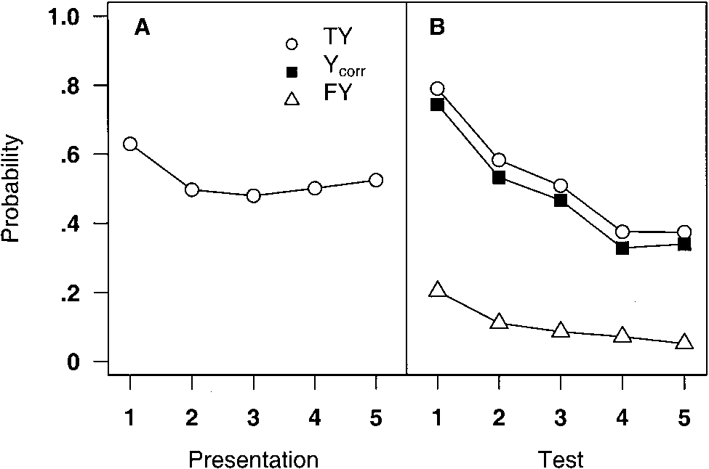

This

document

is

copyrighted

by

the

American

Psychological

Association

or

one

of

its

allied

publishers.

This

article

is

intended

solely

for

the

personal

use

of

the

individual

user

and

is

not

to

be

disseminated

broadly.

As is evident in Figure 2B, the proportion of FY responses to distractors was also higher in the early test positions, suggesting that the significant effect of test position may have been due to a criterion shift rather than to better picture memory early in the test. After applying the high-threshold guessing correction *P*(Ycorr), as shown in Figure 2B, there was still a highly significant test position effect, *F*(4, 76) 91.95, *p*  .001. A test of linear trend over serial position was significant, *F*(1, 19) 204.37, *p*  .001; there was also a significant quadratic component, *F*(1, 19) 47.34, *p*  .001.

There was a main effect of whether the first test item was old or new, with higher performance when the test began with an old picture, *F*(1, 19) 47.86, *p*  .001. This effect interacted with test position, with the benefit of beginning with an old picture less marked late in the test sequence, *F*(4, 76) 11.22, *p*  .001. This finding with respect to whether the first test item was old or new was replicated in Experiments 3, 4, and 5 but not in Experiment 2 (this variable was not applicable to Experiment 6). Experiments 1, 3, 4, and 5 all showed the same pattern: There was higher performance when the first tested item was old, especially for the first relative serial position, and the advantage dropped off in later serial positions. To simplify the presentation of results, we do not report the statistical results for this variable in the subsequent experiments. We do, however, report the *P*(TY) value for the first old item when it was the first test item versus the second or third test item, because this comparison provides a finer breakdown of serial position at the beginning of the test than does relative serial position (which takes into account whether a given old picture is the first old picture tested but not whether that picture is the very first test item, which occurs on only 50% of the trials).

The extent of the loss of information over the test is seen when one considers guessing-corrected (Ycorr) scores for all 10 serial positions (see Footnote 6). When an old picture was tested in the first serial position, it was recognized 82% of the time. After nine intervening test pictures (including distractors), old pictures tested in the tenth and final serial position were recognized on only 35% of the trials. Thus, most of the presented pictures were recognized provided that they were tested immediately; more than half were forgotten if they were not tested until the end of the test sequence, a matter of about 8 s.

The two main findings of Experiment 1 were that there was little or no evidence of a recency effect in presentation, but there was a marked loss of memory for the pictures, particularly early in the recognition test. Given that recognition testing interferes with memory for subsequently tested pictures, one might also expect that pictures in the presentation sequence would cause memory interference, which would show up as a recency effect (less interference when fewer pictures followed a given picture). There was a hint of a recency effect in the interaction between the two serial position effects, with the most recent pictures benefiting slightly when tested immediately; however, this effect did not show up in later experiments. In any case, the intervention of up to four added pictures (a total of up to 700 ms) during presentation did not seem to create as much interference as did the viewing of one or two test pictures for 400 ms each, followed by a decision.

The evidence of rapid forgetting during the test sequence but not during the presentation sequence can be explained in either of two ways. The first explanation emphasizes the different time scales of the presentation and test periods. The total duration of the presentation sequence was just over 1 s, whereas each of the 10 test pictures, with the yes–no response, required an average of approximately 800 ms (8 s for the 10 test pictures). So perhaps forgetting occurs during the test sequence merely because of the passage of time. The second explanation is that the process of viewing successive test pictures, comparing them with memory, and responding to them interferes with the stored representations of not-yettested pictures. In other words, sensitivity to the old pictures may decrease during the test period either because the time between presentation and test is increasing as the test period continues or because of what takes place during this interval. Or both factors could contribute to the memory loss.

# Experiment 2

To examine the hypothesis that mere passage of time is responsible for the memory loss, in Experiment 2 we interposed an additional delay of 5.4 s between the presentation sequence and the recognition test. If the decrease in recognition performance over the course of the test period is due to simple passage of time, recognition should be lower in Experiment 2, with a reduced serial position effect during the test. If, on the other hand, the decrease in sensitivity over the course of the test period occurs only because participants must view and respond to intervening pictures, the level of recognition performance should remain unchanged from Experiment 1 to Experiment 2.

## Method

Except for the additional pause of 5.4 s (including a 400-ms fixation array immediately before the first test picture) between the presentation sequence and the test, the method of Experiment 2 was identical to that of Experiment 1. On each trial, after presentation of the sixth picture and the 293-ms white square, a light gray blank screen appeared for 5 s. A fixation array (a white cross on a black background surrounded by a white frame) then appeared for 400 ms, followed by the first test picture. The test sequence was the same as in Experiment 1. There were 20 participants.

## Results and Discussion

As shown in Figure 3B, the extra 5.4-s delay between the end of the presentation sequence and the first test picture diminished the benefit for pictures tested at the beginning of the recognition test, showing that picture memory declined during an unfilled delay. Nonetheless, there was a significant further decline over the recognition test. Moreover, performance was substantially worse after approximately 5.4 s of testing in Experiment 1 (Relative Serial Position 4) than after the same unfilled delay in Experiment 2. As in Experiment 1, the serial position in presentation was flat except for a primacy effect for the first picture (Figure 3A). Overall, in Experiment 2 old pictures were recognized 51% of the time and new pictures were falsely recognized 9% of the time.

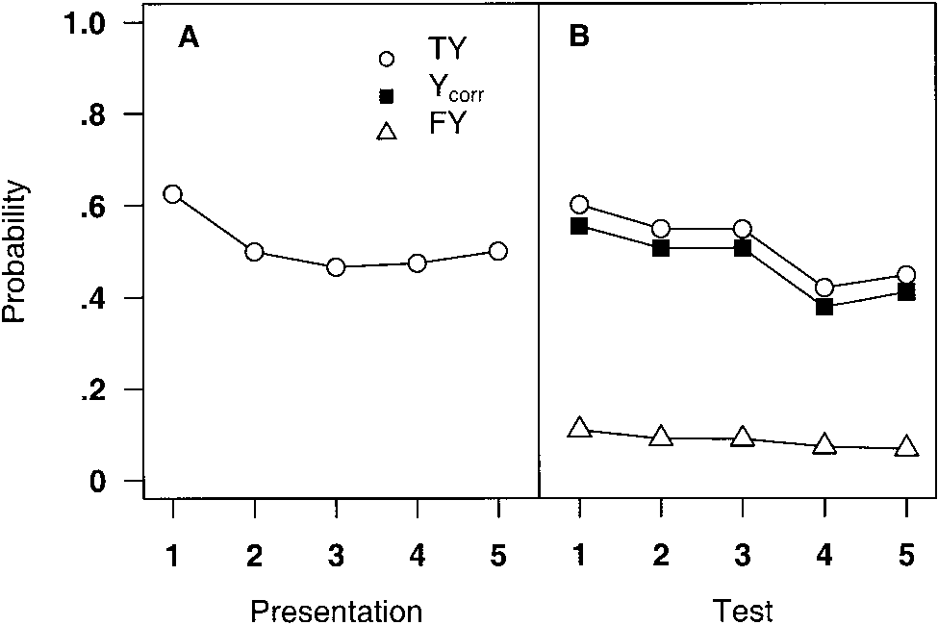

This

document

is

copyrighted

by

the

American

Psychological

Association

or

one

of

its

allied

publishers.

This

article

is

intended

solely

for

the

personal

use

of

the

individual

user

and

is

not

to

be

disseminated

broadly.

In the analysis of *P*(TY), the main effect of presentation position (Figure 3A) was significant, *F*(4, 76) 13.12, *p*  .001. The pattern of results was extremely similar to that of Experiment 1, with a primacy effect but no evident recency effect. As shown in Figure 3B, there was again a significant main effect of test position, *F*(4, 76) 29.86, *p*  .001, with higher performance early in testing. There was no interaction between presentation and test position (*F*  1). In contrast with Experiment 1, when the first picture tested was old it did not attract more correct yeses (TY .58) than when the first old picture appeared after one or two distractors (TY .63).

The proportion of FY responses to distractors is also shown in Figure 3B; although *P*(FY), like *P*(TY), decreased over test position, the effect was not marked. In the analysis of *P*(Ycorr), there was again a highly significant test position effect, *F*(4, 76) 27.16, *p*  .001, with a significant linear trend, *F*(1, 19) 58.12, *p*  .001.

As a comparison of Figures 2A and 2B with Figures 3A and 3B shows, the two experiments had almost identical means for serial position of presentation. The test serial position effects look somewhat different, however: With a delay, performance dropped in the first test position but actually was higher in later test positions than when testing began without delay. Nonetheless, the general pattern was similar in the two experiments: There was a decline over testing. An analysis of the two experiments together using *P*(Ycorr) showed no main effect of experiment (*F*  1) and a significant main effect of test position (*p*  .001). There was a significant interaction between these two variables (*p*  .001).

One question is whether the different test serial position results in the two experiments can be accounted for simply by elapsed time rather than testing per se. Because participants controlled the timing during the test, we can only estimate the elapsed time in Experiment 1; on average, about six pictures (three old and three new) would have been tested in the time equal to the extra 5.4-s delay in Experiment 2. If one roughly matches for delay by displacing Experiment 2’s function so that Serial Positions 1 and 2 overlap Serial Positions 4 and 5 in Experiment 1, performance in Experiment 1 is much lower, indicating that interference from

*Figure 3.* Probability of recognizing an old picture (TY), falsely recognizing a new picture (FY), and recognizing an old picture corrected for guessing (Ycorr), as a function of serial position of presentation (A) and relative serial position in the recognition test (B) in Experiment 2.

testing contributes to the drop in performance, along with delay.

A major difference between the two experiments was the higher accuracy on the first item tested when there was no delay. This finding suggests that immediately after presentation, there is more complete information about the presented pictures than after a 5.4-s delay, as well as a somewhat lower criterion for saying yes (as indicated by the increase in FYs). The difference in the first test position between the two experiments was present after correcting for FYs by calculating *P*(Ycorr).

A possible reason for the differential performance on the first test picture in Experiment 1, however, was that viewers did not immediately realize that the first test picture was in fact a test picture rather than the next picture in the presentation sequence. (Recall that a white square somewhat larger than the pictures appeared for 293 ms between the offset of the final filler picture and the onset of the first test picture, and the latter remained in view for 400 ms rather than the 173 ms of the presented pictures.) During the practice trials, participants often hesitated before making a yes–no response to the first test picture, but why this uncertainty would increase the propensity to respond yes is not obvious. To reduce or eliminate this uncertainty and to examine the effect of a delay intermediate between the delays in Experiments 1 and 2, in Experiment 3 we set the delay between the presentation and test sequences at 1.7 s, including a 400-ms fixation display preceding the first test picture, as in Experiment 2.

# Experiment 3

The purpose of Experiment 3 was to assess whether the added 5.4-s delay in Experiment 2 was itself responsible for the drop in initial performance in the recognition test or whether the delay simply made it easier for the participants to distinguish between the presentation and test sequences, reducing their bias to say yes to early test pictures. If delay itself was responsible for the loss of information, then a shorter delay should lead to a smaller loss. If, however, the problem was that the presentation and test sequences were difficult to distinguish, creating momentary confusion, then a shorter delay sufficient to make a visible break between the presentation and test sequences should have the same effect as the longer delay. As described later, the results of Experiment 3 were inconsistent with the confusion hypothesis and lent support to the delay hypothesis.

## Method

Except as specified, the method of Experiment 3 was the same as that of Experiment 2. The main difference was that the 5-s blank used in Experiment 2 was reduced to 1 s in Experiment 3. As in Experiment 2, there was a 293-ms white square immediately after the masking picture, a blank, and then a 400-ms fixation array before the first test picture; thus, the interval between the offset of the masking picture and the onset of the first test picture was 1.7 s. There were 10 participants.

A minor change was made in the arrangement of the pictures: 20 of the 600 experimental pictures (distractors plus presented pictures) were interchanged between trials to reduce possible conceptual confusion within a trial. (This change was made for the purposes of another set of experiments.) The same changed arrangement was used in all subsequent experiments reported here.

## Results and Discussion

As shown in Figure 4B, with a delay of 1.7 s between presentation and the beginning of testing, there was again a dropoff in performance during testing. The rate of forgetting was less than that with no delay but greater than that with the longer delay of 5.7 s. As in the no-delay condition, *P*(FY) was also high early in testing. Thus, performance with an intermediate delay was intermediate between the shorter and longer delays in Experiments 1 and 2, respectively. Overall, old pictures were recognized 44% of the time, and new pictures were falsely recognized 9% of the time.

This

document

is

copyrighted

by

the

American

Psychological

Association

or

one

of

its

allied

publishers.

This

article

is

intended

solely

for

the

personal

use

of

the

individual

user

and

is

not

to

be

disseminated

broadly.

In the analysis of *P*(TY), the main effect of presentation position (Figure 4A) was significant, *F*(4, 36) 5.33, *p*  .01. There was a primacy effect and a smaller recency effect. As shown in Figure 4B, there was again a significant main effect of test position, *F*(4, 36) 25.89, *p*  .001, with higher performance early in testing. This effect did not interact with presentation position (*F*  1). When the first old picture was the first test item, *P*(TY) was .70; when the first test item was a distractor and the first old picture was the second or third test item, *P*(TY) was .58.

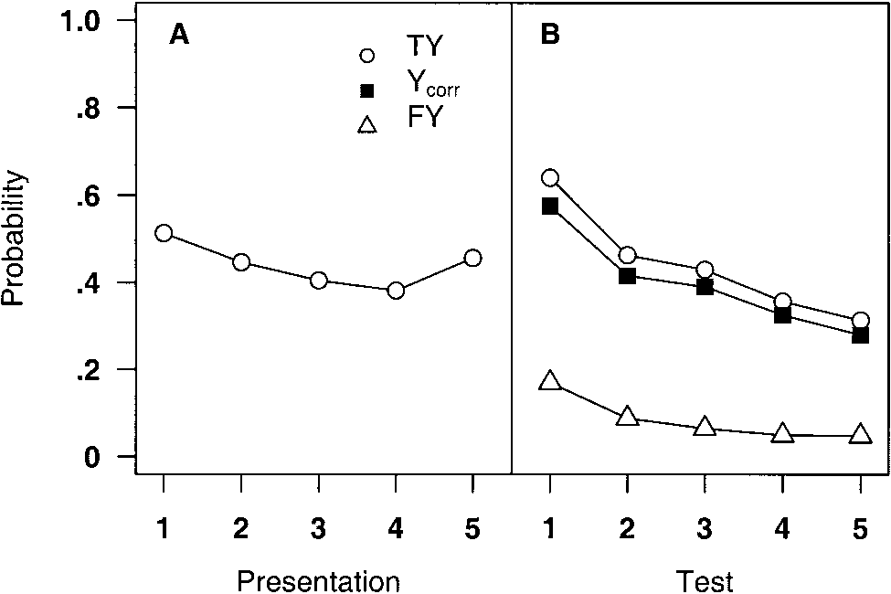

*Figure 4.* Probability of recognizing an old picture (TY), falsely recognizing a new picture (FY), and recognizing an old picture corrected for guessing (Ycorr), as a function of serial position of presentation (A) and relative serial position in the recognition test (B) in Experiment 3.

The analysis of *P*(Ycorr) again showed a main effect of test position, *F*(4, 36) 15.78, *p*  .001, with a significant linear trend, *F*(1, 19) 57.13, *p*  .001.[8] As can be seen in Figure 4, the pattern of results was highly similar to that of Experiment 1 (Figure 2), although overall performance was somewhat lower in the present experiment, particularly in the early serial positions of the test. An analysis of the two experiments together, using *P*(Ycorr), showed no main effect of experiment, *F*(1, 28) 3.16, *p*  .086, but a significant interaction between experiment and test position, *F*(4, 112) 4.24, *p*  .01, with better performance in the early part of the test when there was no delay.

Taken together, the results of Experiments 1–3 show that memory for just-seen pictures decays somewhat if recognition testing is delayed for an additional 1.4 or 5.4 s, and recognition testing itself creates further interference. When the first picture tested is old, performance is remarkably high, especially at the shortest delay. With a 5-s delay, the special advantage of this first test picture disappears.

In contrast, intervening pictures in the presentation phase did not appear to interfere with memory, given that at least one picture immediately followed each to-be-tested picture, as was the case here. However, because there were only five pictures in the presentation sequence, along with the sixth filler picture, which served as a conceptual mask, the sequence might have been too short to reveal such interference.

# Experiment 4

In Experiment 4, we lengthened the presentation sequence to 10 pictures and a filler picture, and we lengthened the recognition test to 20 pictures (old and new). If subsequent pictures in the presentation sequence produce retroactive memory interference, then a 10-item sequence should be long enough to reveal such an effect: There should be some benefit for pictures toward the end of the sequence relative to early serial positions. In addition, the recognition test used in Experiment 4 was longer, allowing us to discover whether the falloff that we had observed during the test would be of the same magnitude with a 10-item memory set and whether performance would level off later in the test.

## Method

In Experiment 4, the 60 sequences of Experiment 3 were paired to make 30 sequences, each consisting of 10 presented pictures (along with an 11th picture as a conceptual mask) and 20 test pictures, half old and half new (distractors). Except as noted, the method of Experiment 4 was the same as that of Experiment 1. There were 20 participants.

The minor rearrangement of pictures in trials used in Experiment 3 was also used in Experiment 4. The serial positions of the 10 presentation pictures were counterbalanced over participants. Whereas in the previous experiments the initial fixation array appeared for 293 ms plus a blank of 200 ms, in the present experiment the fixation array appeared for 506 ms plus the blank.

The order of old and new pictures in each test sequence was assigned at random, subject to constraints similar to those of Experiment 1: No more than three consecutive old or new pictures could appear in any trial, and the first picture tested was equally often an old or a new picture. Within subjects, a picture in any given presentation position had an equal probability of being tested first, second, third, and so forth. In addition, in Experiment 4, two orders of each test sequence were used (between subjects), counterbalanced with the order of presentation. The second test order reversed the order of the old pictures in each trial so that the tenth old picture became the first old picture, the ninth became the second, and so on. In a similar manner, the order of the distractors was reversed.

## Results and Discussion

As shown in Figure 5A, with a presentation sequence of 10 pictures there was still no evidence of a recency effect in presentation. As in Experiment 1, performance fell off rapidly over the first three test positions (Figure 5B). Overall, old pictures were recognized 48% of the time, and new pictures were falsely recognized 13% of the time.

In the analysis of *P*(TY), the main effect of presentation position (Figure 5A) was significant, *F*(9, 171) 2.97, *p*  .01. The pattern of results was similar to that of Experiment 1, with a primacy effect for the first picture presented (58%) but no other effects, with Presentation Pictures 2–10 recognized 45%–48% of the time. As shown in Figure 5B, there was a significant main effect of test position, *F*(9, 171) 44.29, *p*  .001, with higher performance early in testing. There was no interaction with presentation position (*F*  1).

This

document

is

copyrighted

by

the

American

Psychological

Association

or

one

of

its

allied

publishers.

This

article

is

intended

solely

for

the

personal

use

of

the

individual

user

and

is

not

to

be

disseminated

broadly.

In the analysis of *P*(Ycorr), the main effect of test position was again significant, *F*(9, 171) 16.27, *p*  .001, with a significant linear trend, *F*(1, 19) 55.59, *p*  .001, and a marked quadratic trend, *F*(1, 19) 143.44, *p*  .001, reflecting the flattening of the downward curve after the early serial positions. When the first old picture was the first test item, *P*(TY) was .89; when the first old picture followed one or two distractors, *P*(TY) was .65.

As can be seen in Figure 5B the pattern of results was similar to that of Experiment 1 (Figure 2B) for the first five test positions. An analysis of the two experiments together using *P*(Ycorr), including only the first five presentation positions and test positions in Experiment 4 (25% of the data), showed no main effect of experiment (*F*  1); a main effect of test position, *F*(4, 152) 151.80, *p*  .001; and an interaction between experiment and test position, *F*(4, 152) 5.46, *p*  .001. Inspection of the data showed that, in both experiments, average performance declined monotonically over the first three serial positions, although the exact pattern of decline differed slightly (as can be seen in Figures 2B and 5B, as well as in Figure 7).

The striking finding in Experiment 4 is how little difference the addition of five pictures to the presentation sequence made: The presentation serial position looked identical to that in Experiment 1, with a primacy effect for the first picture only and no evidence of a recency effect. In the recognition test, there was the same dramatic falloff in performance over the first three test positions and a relatively flat level of performance thereafter. There was no additional memory loss evident in the 20-item test.

|  |
| --- |
| *Figure 5.* Probability of recognizing an old picture (TY), falsely recognizing a new picture (FY), and recognizing an old picture corrected for guessing (Ycorr), as a function of serial position of presentation (A) and relative serial position in the recognition test (B) in Experiment 4. |

Before discussing these results further, we report the results of Experiment 5, in which the length of the presentation sequence was increased to 20 pictures plus a picture mask. The recognition test consisted of a sample of 5 old pictures together with 5 distractors.

# Experiment 5

The purpose of Experiment 5 was to extend the presentation sequence to 20 pictures so as to discover whether the flat serial position function in presentation would break down with such a long sequence. As described later, the function remained flat.

## Method

Although in most respects Experiment 5 used the same method as that of Experiments 1 and 4, there was a major modification in the design. On each trial 21 pictures were presented (including the final masking picture), but only 5 old pictures were tested (from Serial Positions 1, 5, 10, 15, and 20), mixed with 5 distractors. Thus, the test was the same length as that of Experiment 1. This modification allowed us to have more trials as well as to avoid a long test sequence, because our interest was primarily in the early part of the test. There were 20 participants.

The pool of 660 pictures from the previous experiments was used to make 25 trials along with 2 practice trials with presentation lengths of 20 items plus the mask. In the 10-picture recognition test that followed, the old pictures were those from Presentation Positions 1, 5, 10, 15, and 20, together with 5 new pictures as distractors. The order of the 5 pictures in these presentation positions was counterbalanced as in the earlier experiments so that each of the 5 pictures appeared equally often in Serial Positions 1, 5, 10, 15, and 20 (between subjects). The serial positions of the other 15 pictures and the mask were held constant.

The order of old and new pictures in each test sequence was assigned at random, separately for the first 10 and second 10 participants, with the constraint that no more than three consecutive old or new pictures could appear in any trial. As a further counterbalancing measure, the order of the old pictures on the test was reversed for the second 5 participants in each of the two groups of 10 participants: The first old picture was exchanged with the fifth old picture and the second with the fourth; the third remained in the middle position. Across participants, the first picture tested was equally often an old or a new picture.[9] As in Experiment 4, the fixation array at the beginning of each trial was presented for 506 ms.

## Results and Discussion

The main result was that there was again no evidence of a serial position effect in presentation, as can be seen in Figure 6A. (Note that only Serial Positions 1, 5, 10, 15, and 20 were tested.) There was again a loss of accuracy over the first serial positions of the test (Figure 6B), and again there was no interaction between presentation position and test position. In comparison with presentation sequences of 5 or 10 pictures, however, initial test performance was somewhat lower in Experiment 5. Overall, 58% of the old pictures were recognized, and 29% of the distractors were falsely recognized.

The analysis of *P*(TY) showed no significant effect of presentation position, *F*(4, 76) 0.94, even though there were 18 intervening to-be-remembered pictures between the first and last items. Thus, the flat presentation position functions seen in Experiments 1–5 remained flat even when the presentation sequence consisted of 20 items. Unlike the earlier experiments, there was no primacy benefit for the first picture in the sequence. The effect of test position was highly significant, *F*(4, 76) 9.98, *p*  .001. As shown in Figure 6B, performance was higher early in the test than it was later, as in the previous experiments. There was no interaction between presentation position and test position.

This

document

is

copyrighted

by

the

American

Psychological

Association

or

one

of

its

allied

publishers.

This

article

is

intended

solely

for

the

personal

use

of

the

individual

user

and

is

not

to

be

disseminated

broadly.

In the analysis of *P*(Ycorr), the main effect of test position was significant, *F*(4, 76) 3.19, *p*  .05, with a significant linear

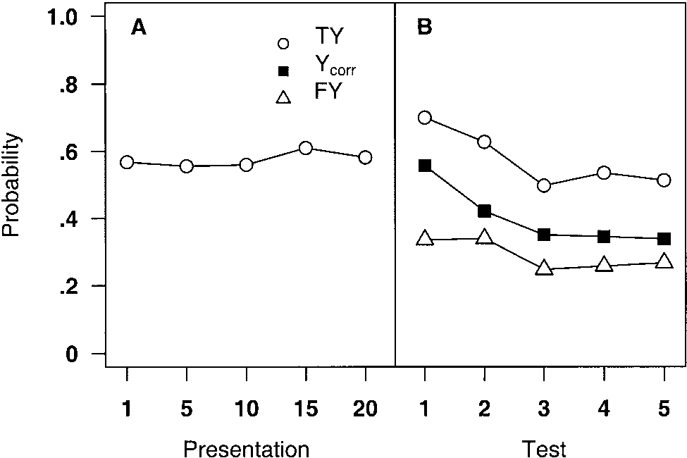

*Figure 6.* Probability of recognizing an old picture (TY), falsely recognizing a new picture (FY), and recognizing an old picture corrected for guessing (Ycorr), as a function of serial position of presentation (A) and relative serial position in the recognition test (B) in Experiment 5. As shown, only 5 of the 20 serial positions of presentation were included in the recognition test.

trend, *F*(1, 19) 14.69, *p*  .01, and a quadratic trend, *F*(1, 19) 7.29, *p*  .05. When the first old picture was the first test item, *P*(TY) was .73; when the first old picture followed one or more distractors, *P*(TY) was .67.

As noted earlier, performance early in the test in Experiment 5 was not as strikingly high as in Experiments 1 and 4. To compare the three experiments, we analyzed *P*(Ycorr) for the first five relative serial positions in the test sequence (five old pictures and five new pictures), that is, all of the test trials in Experiments 1 and 5 and the first 5 of the 10 test trials in Experiment 4. The means for the three experiments, as a function of test position, are shown in Figure 7. Overall, in Experiment 1, *P*(Ycorr) was .48; in Experiment 4, it was .45; and in Experiment 5, it was .40. The difference among the experiments fell short of significance (*p*  .092). (In the *A* analysis comparing the three experiments, however, the main effect of experiment was significant at the .001 level.) The main effect of test position was highly significant, *F*(4, 228) 68.17, *p*  .001, and there was an interaction with experiment, *F*(8, 228) 3.37, *p*  .01. Inspection of Figure 7 indicates that the difference among the experiments was present only in the first two or three test positions, in which Experiment 5 showed less of an early benefit than the other two experiments. At Serial Positions 4 and 5, the three curves completely overlapped.

Why might we expect performance early in the test to suffer more from having a long presentation sequence than does performance later in the test? The result is similar to the flattening effect of a short delay before the test: Sheer passage of time appears to reduce the early-test benefit selectively (compare Figures 2B, 3B, and 4B). The presentation duration for 21 pictures was about 3.6 s, as compared with about 1 s for 6 pictures and 1.9 s for 11 pictures. The increased interval between presentation and test (on average)

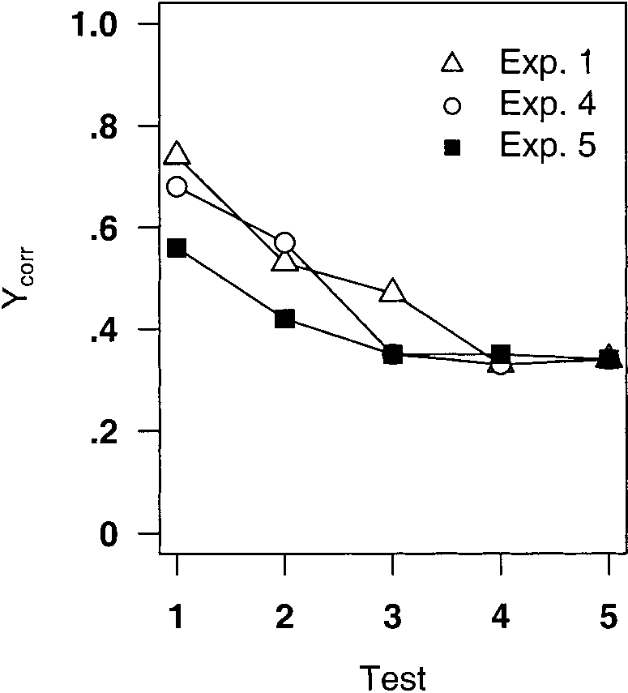

*Figure 7.* Probability of recognizing an old picture corrected for guessing (Ycorr), as a function of relative serial position in the recognition test, in Experiment 1 (five presentation pictures), in Experiment 4 (10 pictures; results for the first 5 relative serial positions are shown), and in Experiment 5 (20 presentation pictures; but only 5 pictures from Serial Positions 1, 5, 10, 15, and 20 were tested, mixed with distractors). Exp. experiment.

might have led to the loss of the most fragile picture memories, the ones that might survive most briefly, only long enough to provide the early-test benefit we have observed. The problem with this delay explanation, however, is that it predicts a recency benefit (or at least an interaction between the serial position in presentation and that in the test), and we found none. Delay as a consequence of a longer presentation sequence appears not to have the same negative effect as delay between the offset of the presentation sequence and the onset of the test. We return to these questions in the General Discussion section.

Overall, the results of Experiment 5 are striking in their similarity to those of the earlier experiments. That is, performance does not seem to be affected by presentation position, whether the presentation sequence consists of 5 items and a mask or 20 items and a mask. In all cases, there is little or no progressive loss of information with additional presentation items but a marked loss during the recognition test. As Potter and Levy (1969) claimed, pictures seem to be processed only until the next to-be-attended picture appears. Once that picture appears and interrupts processing of the previous picture, there seems to be no further interference from subsequent pictures in the presentation sequence.

Previous studies have shown, however, that conceptual masking by a following stimulus is reduced or eliminated if the viewer has an incentive to continue to focus attention on the now-replaced picture and no incentive to attend to the masking stimulus. Intraub (1984) showed viewers sequences of 16 pictures in which brief (112 ms) and long-duration (1.5 s) pictures alternated. If instructed to attend to the brief pictures, viewers were able to recognize those pictures reasonably well in a later test (and their recognition memory for the long pictures was not as good as when equal attention was given to both long and short pictures), whereas if they were instructed to attend to the long pictures, their memory for the brief pictures was not much above chance. Thus, if viewers concentrate their attention on a brief event, they increase the likelihood of retaining it, but at the expense of the following event. In the present experiments, there was no incentive to attend selectively to one picture at the expense of others, and presumably in this situation the onset of the next picture transferred attention promptly from the previous to the new picture.

This

document

is

copyrighted

by

the

American

Psychological

Association

or

one

of

its

allied

publishers.

This

article

is

intended

solely

for

the

personal

use

of

the

individual

user

and

is

not

to

be

disseminated

broadly.

In contrast to the absence of presentation serial position effects (other than primacy), the recognition test itself produced substantial additional interference, such that the first old picture tested was more likely to be recognized than later items, and in general there was a falloff in recognition over the first several items tested. Measurement of this memory loss was complicated by a corresponding shift in the criterion for saying yes to a picture; that is, the probability of saying yes to both old pictures (TY) and new pictures (FY) decreased over the first part of the recognition test. However, after correction for guessing with *P*(Ycorr) and *A,* there was still a robust effect of test position in each of the five experiments. Nonetheless, we carried out a final experiment in which the yes–no recognition test used in Experiments 1–5 was replaced by a two-alternative forced-choice test. Use of a forcedchoice test tends to eliminate guessing bias (variation in the criterion for saying yes), although, as shown later, there is still the possibility of another kind of bias based on left–right position.

# Experiment 6

The purpose of Experiment 6 was to eliminate differential criteria in the recognition test by using a forced-choice test.[10]

## Method

Experiment 6 was identical to Experiment 1 except that the recognition test consisted of pairs of pictures, one old and one new, presented side by side; the participant responded by pressing a key to select the old picture in each pair. There were 10 participants. In the recognition test, each of the five old pictures was paired with one of the five distractors; in each case, the picture and distractor were in the same relative serial position in the yes–no recognition test as in Experiments 1–3. That is, the first old picture was paired with the first distractor in that sequence, and so forth. Thus, there were five two-alternative forced choices after each presentation sequence. The two test pictures were presented side by side, separated by 3.4 cm, for 1 s. The old picture appeared equally often in the left and right positions, over all trials, and was counterbalanced over serial position in a trial. (The counterbalancing was not perfect: In the 60 trials, in Test Positions 2 and 4 the old picture was on the left 29 times and on the right 31 times, and in Test Position 3 the old picture was on the left 28 times and on the right 32 times.) Otherwise, the left–right position was random except for the constraint that, on a given trial, the old picture was on the left on either two or three of the five test pairs. Between groups of 5 participants, the order of the test pairs was reversed, with the fifth pair becoming the first pair, and so on. As before, the serial position of the five presentation pictures was counterbalanced over participants (within each group of 5).

The participant pressed the *d* or the *k* key on the keyboard, corresponding to the left picture and the right picture, respectively, to indicate which was the old picture. The instruction was to make the decision as rapidly and accurately as possible. RT between the onset of the pair of test pictures and the keypress was recorded. Immediately after making that response, the participant was prompted to give a confidence rating using the key 1 (*guess*), 2 (*maybe*), or 3 (*sure*) on the keyboard number pad. The next fixation and test pair appeared after a blank interval of 293 ms.

## Results and Discussion

The use of a two-alternative forced-choice testing procedure resulted in the same declining accuracy over test trials seen in the earlier experiments and the same primacy effect (but no recency effect) in presentation. Overall, participants chose the correct picture on .72 of the trials (chance .50). Figure 8A shows the results as a function of serial position in presentation; Figure 8B shows the results as a function of test position. An ANOVA was carried out on proportion of correct responses, with presentation position, test position, and whether the old picture was on the left or the right as variables. There was an effect of presentation position, *F*(4, 36) 3.75, *p*  .05, showing the usual primacy benefit for the first picture in presentation; there was also a significant effect of test position, *F*(4, 36) 4.02, *p*  .01. A linear trend analysis of test position was significant, *F*(1, 9) 7.45, *p*  .05 (the quadratic trend was also significant, *p*  .05). Inspection of Figure 8B shows that performance on the first test pair was higher than that on the other four pairs, with an irregular drop in performance after the second pair. Presentation and test positions did not interact.

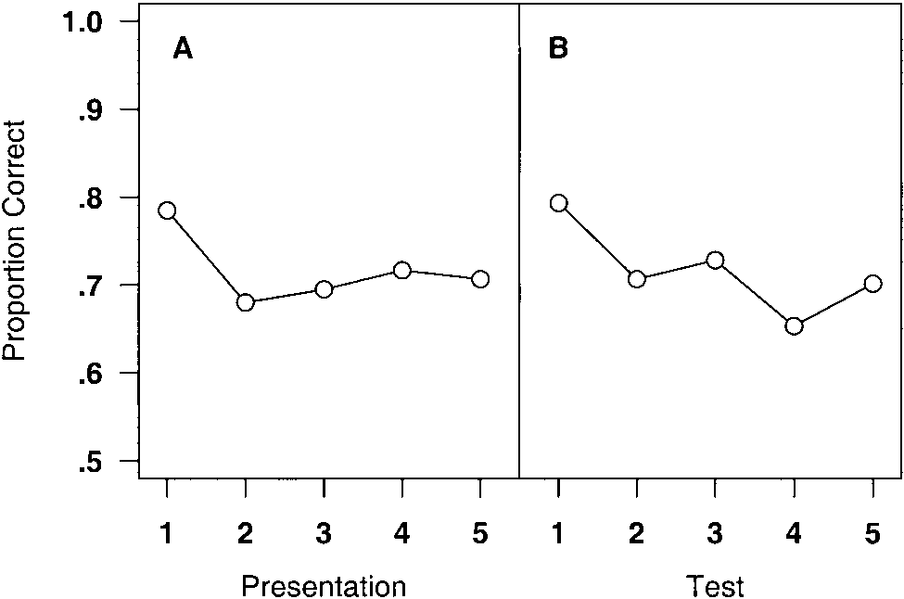

This

document

is

copyrighted

by

the

American

Psychological

Association

or

one

of

its

allied

publishers.

This

article

is

intended

solely

for

the

personal

use

of

the

individual

user

and

is

not

to

be

disseminated

broadly.

There was a main effect of which side the old picture appeared on, with .76 and .68 correct responses when the old picture was on the left and the right, respectively, *F*(1, 9) 5.86, *p*  .05. This factor interacted with test position, *F*(4, 36) 3.81, *p*  .05; inspection of the data showed that the left-position bias occurred in Serial Positions 1, 3, and 5 but not 2 and 4. We have no explanation for this pattern, which could have been item specific (the left–right positions of given picture pairs were randomized but not counterbalanced). No other interactions were significant, all

*F*s 1.

RTs for correct responses were also analyzed after truncation of RTs that were longer than 3 s (7% of responses) to 3 s. The effect of serial position in the test was significant, *F*(4, 36) 5.36, *p*  .01, with the shortest mean RT (1,562 ms) for the first pair and the longest (1,751 ms) for the fifth pair. This result is consistent with the evidence that participants had more information about the pictures at the beginning of the test than they did later. There was no effect of whether the old picture was on the left or the right.

Finally, confidence measures were analyzed. Of the responses rated *sure,* .89 were correct; of those rated *maybe,* .69 were correct; and of those rated *guess,* .55 were correct. Clearly, confidence judgments reflected the likelihood that a response was, in fact, correct. ANOVAs were carried out on mean level of confidence, given that responses were correct, to determine whether the confidence judgments provided information over and above the correctness of the response. Presentation serial position affected confidence, *F*(4, 36) 3.76, *p*  .05, with higher confidence when the correctly recognized picture had been in the first serial position than when it had been in the other positions. Test position also affected confidence, *F*(4, 36) 10.35, *p*  .001, with the highest confidence in the first test position (2.50) and the lowest in the last test position (1.97). However, it is important to note that confidence was also somewhat higher for wrong responses early in the test sequence, *F*(4, 36) 4.82, *p*  .01. In the first test position confidence for these wrong responses averaged 1.89, and in the last test position confidence averaged 1.52, suggesting a degree of irrational exuberance at the beginning of the test. The excessive confidence for wrong responses early in testing is consistent with the relatively high FY rates seen early in yes–no recognition testing in the preceding experiments. On the whole, the confidence ratings reinforce the accuracy effects observed in all of the present experiments.

What Experiment 6 confirms is that, even with criterion bias eliminated by use of the forced-choice procedure, immediately after presentation viewers know more about the pictures they have just seen, are more confident about their decisions, and respond more rapidly than they do on the second and subsequent forcedchoice tests. This result is entirely consistent with the results we obtained in Experiments 1–5 using the yes–no recognition procedure.

*Figure 8.* Proportions of correct trials in a two-alternative forced-choice picture recognition test, as a function of serial position of presentation (A) and serial position in the recognition test (B) in Experiment 6.

# General Discussion

The purpose of the present study was to determine whether poor memory for scenes presented in a rapid sequence is the result of immediate forgetting as soon as the next scene appears or whether information about the scene persists for a time even though it is slated to be forgotten within a minute or two. To investigate this question, we presented short sequences of pictures that participants had never before seen for 173 ms each and followed each sequence either immediately or up to 5.7 s later by a test of recognition memory. Two results observed in the present experiments are striking, and we discuss them in turn. First, there was a rapid loss of information about just-seen pictures in the first few seconds after presentation and during recognition testing. Second, in the presentation sequence, just one immediately following to-beattended picture was enough to stop processing, and further pictures in the sequence had no apparent negative effect on retention, so no recency effect was evident (apart from the untested last picture that served as a mask).

The first finding is that pictures are initially well remembered but then half or more are rapidly forgotten early in the recognition test, particularly when the recognition test begins immediately after presentation of the pictures. In Experiment 1, when the first test picture was an old picture (one that had been in the sequence), it was recognized 82% of the time (corrected for FYs at that serial position), whereas when the tenth and last picture tested was an old picture, it was recognized only 35% of the time. Thus, most pictures were initially processed successfully and could be remembered if tested immediately after the end of the presentation sequence, and yet more than half of these pictures were forgotten in the course of the next 8 s or so of recognition testing.

One explanation of this apparent rapid loss that we considered was that a viewer’s criterion for making a recognition response changes during the test, and in fact there was strong evidence in the present experiments for a shift in criterion. The FY rate was higher at the beginning of the test than it was later in the test. Correcting for this shift in criterion, whether by a high-threshold guessing correction or by *A,* did not eliminate the test interference effect, however; the main effect of test position was still significant and showed a significant downward linear trend in all six experiments. Moreover, in Experiment 6, with a two-alternative forced-choice test, we still obtained a significant performance loss over the five test pairs.[11]

A second possible explanation for rapid forgetting during the test is that the memory loss was due to decay during the time between initial perception and test of a given picture. In the recognition test, each picture appeared for 400 ms, and a response was made; the entire test took about 8 s (depending on a participant’s RTs). To examine the hypothesis that memory decayed as a function of elapsed time, in Experiment 2 we introduced an extra delay of 5.4 s before the onset of the first test picture. Indeed, the delay did reduce the accuracy of recognition at the beginning of the test (with a compensating improvement in memory for pictures later in the test), but there was still a significant linear effect of test position on recognition accuracy in addition to the effect of elapsed time during the test. Thus, the passage of time did result in significant memory loss, but interference during the test was still evident. In Experiment 3, with a shorter added delay (1.4 s), performance as a function of test position was intermediate between that in Experiments 1 and 2, consistent with the evidence that performance begins to fall off with even a short delay before memory testing. Thus, the results support the hypothesis that the rapid memory loss we observed was the result of two factors: the passage of time between presentation and test and the number of intervening test pictures.

A natural inference from this conclusion is that serial position in the presentation sequence would also affect picture memory, with the more recent pictures remembered better than earlier pictures both because less time would (on average) elapse between presentation and test and because there would be fewer intervening pictures in the presentation sequence. (The final filler picture in the sequence intervened in every case.) However, the second finding mentioned at the beginning of this section contradicted that expectation: There was virtually no evidence for any recency benefits in the serial position of presentation. Whether a given picture was followed by only 1 other picture (the filler) or by up to 20 pictures, later memory was the same. (The only serial position effect was a small but significant primacy effect for the first picture presented that was seen in all experiments except Experiment 5.) The lack of a recency effect is consistent with Potter and Levy’s (1969) claim that picture processing is terminated as soon as another to-beattended picture appears; they, too, found a flat serial position function except for the first and last pictures (see also Intraub, 1980; Potter, 1976). The flat serial position function in the present experiments (except for the first and last pictures) means that the memory representation that exists at the moment processing is shifted to the next picture is not subject to further interference as additional pictures are presented.

This

document

is

copyrighted

by

the

American

Psychological

Association

or

one

of

its

allied

publishers.

This

article

is

intended

solely

for

the

personal

use

of

the

individual

user

and

is

not

to

be

disseminated

broadly.

Given that both delay and testing interfered with picture memory, it is surprising that intervening pictures in the presentation sequence had virtually no interfering effect. With respect to delay, however, the presentation was fast, so the maximum difference in elapsed time as a function of serial position was less than 1 s in Experiments 1–3 and 6, and it was 1.6 s in Experiment 4 with 10 pictures. These time differences might have been too short to reveal the expected recency effect; however, in Experiment 5 with 20-picture sequences, the maximum difference in elapsed time was 3.3 s, which was in the range of delays that showed some evidence for forgetting in Experiments 2 and 3. Thus, unlike unfilled delays between presentation and test, filling the delay with more pictures in the presentation sequence appears to have cancelled any negative effect of delay. Even apart from delay, retroactive interference from the encoding and storage of additional pictures would be expected to result in a recency benefit. Perhaps the short time available to process the pictures (173 ms) in some way reduced the amount of interference, as compared with the 400-ms duration of each test picture plus about 400 ms for the recognition decision. Alternatively, the attempt to query memory in the recognition test and perhaps to recall and rehearse the pictures during the delay may create more interference than do identification and storage of additional pictures during presentation.

Even though the length of the presentation sequence did not alter the flat presentation serial position function, increasing length was associated with an overall reduction in accuracy that was marginal in the *P*(Ycorr) analysis but highly significant in the *A* analysis. Note that this analysis of Experiments 1, 4, and 5 included only the first 10 test trials (half old pictures and half new), so the length of the test sequence was held constant across experiments. Apparently, the storage of a larger number of pictures on a given trial tended to reduce the level of performance, perhaps by increasing noise at retrieval, a result that would not be surprising given the standard list-length effect observed in studies of verbal memory.

## Relation to Other Phenomena

The time course of forgetting in the present study contrasts with that of *change blindness,* the apparently immediate loss of detailed information about a picture. Change blindness is the inability of viewers to detect a change in one feature of a picture, and it has been observed when an interval as short as 80 ms intervenes between the initial and changed versions; at longer intervals, the problem is even more acute (see Rensink et al., 1997; Simons & Levin, 1997). Change blindness suggests either that many specifics of a picture are lost immediately or that these details were not perceived in the first place. Showing the first view for as long as 8 s and thus giving ample time for encoding the picture does not reduce change blindness (Rensink et al., 2000), which suggests that many specifics are perceived but lost immediately. On the other hand, recent work by Hollingworth and Henderson (2002) and Hollingworth, Williams, and Henderson (2001) shows that once an object in a scene has been fixated, detection of a change in that object remains well above chance for many seconds, as the participant continues to scan the picture looking for changes; detection of the change occurs on refixation of the object.

In any case, change blindness is a phenomenon very different from the forgetting observed in the present experiments. Whereas on a change blindness trial there is no question that the picture remains the same in most respects and is thus highly familiar, in the present experiments the question is whether a given test picture is familiar at all. There are no test pictures that would be readily confused with one of the presentation pictures on a given trial, so the observer is safe in saying yes if the picture seems somewhat familiar. Thus, change blindness studies assess the level of detail in immediate memory for a picture, whereas the present study examined the persistence of a representation sufficient to make the picture seem familiar when presented again among dissimilar pictures.

*Iconic memory* (e.g., Sperling, 1960) and *visual short-term memory* (VSTM), as described by Phillips and his colleagues (see Phillips, 1983, for a review of studies of VSTM), are also distinct from the short-lasting memory found in the experiments reported here. Iconic memory is a very brief form of relatively literal perceptual memory (but see Coltheart, 1983, for a somewhat different characterization), but it cannot account for the fleeting picture memory found in this study because it is eliminated by noise masking and, under photopic conditions, lasts no longer than about 300 ms. VSTM is a form of short-lasting visual memory observed in experiments such as those of Phillips and Christie (1977), who presented viewers briefly with a 4 4 matrix in which an average of eight random squares were white and then tested memory by presenting a second matrix that was either identical to the preceding one or had one white cell added or deleted. They found that the most recent matrix could be maintained for several seconds in VSTM, provided that no other such matrices were presented in the interval and the participant continued to attend to the remembered matrix. VSTM was shown to be capacity limited not only in that only the most recent matrix was well remembered but also in that larger matrices were less accurately remembered. Clearly, the persistence of information about as many as 20 briefly presented pictures cannot rely on VSTM.

This

document

is

copyrighted

by

the

American

Psychological

Association

or

one

of

its

allied

publishers.

This

article

is

intended

solely

for

the

personal

use

of

the

individual

user

and

is

not

to

be

disseminated

broadly.

*Conceptual short-term memory* (CSTM) is a short-lasting memory component proposed by Potter (1993, 1999) that represents conceptual information about recent and current stimuli, such as the meaning of a picture or meanings of words and phrases computed as one reads or listens. The reasons for regarding this brief memory representation as conceptual rather than (say) perceptual include its apparent role in rapid selection between two words on the basis of meaning, in relation to context (Potter, Moryadas, Abrams, & Noel, 1993; Potter, Stiefbold, & Moryadas, 1998), and its putative role in sequential visual search tasks in which the targets are defined by meaning or category but vary in physical form (e.g., Chun & Potter, 1995; Luck, Vogel, & Shapiro, 1996; Potter, 1976). During the brief time that information about stimuli is in CSTM, associative links can be exploited to extract whatever structure is present (such as sentence structure or the gist of a picture) or to match the stimulus to a target specification in a search task. Any momentarily active information that does not become incorporated into such a structure (such as the irrelevant meaning of an ambiguous word or a nontarget picture) will be quickly forgotten.

In relation to rapidly presented pictures, the CSTM claim is that some pictures are adequately encoded and consolidated into longer term memory during even brief viewing, but others are represented only in CSTM and are vulnerable to interference in the first few seconds after viewing. However, we do not know whether the picture representation that persisted for several seconds in the present study is sufficiently abstract to be considered conceptual rather than wholly or partly perceptual. Do viewers remember only the picture’s conceptual content or gist, or do they also remember visual features such as color, shape, and layout? Work of Irwin and Andrews (1996), Gordon and Irwin (2000), and Henderson (1997) suggests that this representation of previous fixations may be conceptual rather than literal, inasmuch as viewers may not notice literal changes that are conceptually consistent with the earlier fixation. Earlier work showed that the gist of a scene is understood quickly even though the scene may then be forgotten (fairly) rapidly (e.g., Intraub, 1980, 1981; Potter, 1976), which is consistent with the assumption that conceptual information is abstracted rapidly. Intraub (1981) showed, however, that along with the gist viewers remembered specific pictorial information such as the colors and layout. The relative roles of such specific pictorial information and more abstract conceptual information, in the case of the brief memory for pictures observed in the present experiments, have been explored by Potter, Staub, and O’Connor (2002).

## Conclusion and Implications

The present finding that there is brief persistence of scene information over a time period that is the equivalent of several subsequent fixations has important implications for normal perception. Being able to carry forward some information from recent fixations may help the viewer to form a coherent representation of the immediate environment without burdening memory with a large inventory of fixation snapshots.

# References

Chun, M. M., & Potter, M. C. (1995). A two-stage model for multiple target detection in rapid serial visual presentation. *Journal of Experimental Psychology: Human Perception and Performance, 21,* 109–127.

Coltheart, M. (1983). Iconic memory. *Philosophical Transactions of the Royal Society of London, Series B, 302,* 283–294.

Donaldson, W. (1993). Accuracy of *d* and *A* as estimates of sensitivity. *Bulletin of the Psychonomic Society, 31,* 271–274.

Fabre-Thorpe, M., Richard, G., & Thorpe, S. J. (1998). Rapid categorization of natural images by rhesus monkeys. *NeuroReport, 9,* 303–308.

Gordon, R. D., & Irwin, D. E. (2000). The role of physical and conceptual properties in preserving object continuity. *Journal of Experimental Psychology: Learning, Memory, and Cognition, 26,* 136–150.

Grier, J. B. (1971). Nonparametric indexes for sensitivity and bias: Computing formulas. *Psychological Bulletin, 75,* 424–429.

Henderson, J. M. (1997). Transsaccadic memory and integration during real-world object perception. *Psychological Science, 8,* 51–55.

Henderson, J. M., & Hollingworth, A. (1999). High-level scene perception. *Annual Review of Psychology, 50,* 243–271.

Hollingworth, A., & Henderson, J. M. (2002). Accurate visual memory for previously attended objects in natural scenes. *Journal of Experimental Psychology: Human Perception and Performance, 28,* 113–136.

Hollingworth, A., Williams, C. C., & Henderson, J. M. (2001). To see and remember: Visually specific information is retained in memory from previously attended objects in natural scenes. *Psychonomic Bulletin & Review, 8,* 761–768.

Hunt, S. M. J. (1994). MacProbe: A Macintosh-based experimenter’s workstation for the cognitive sciences. *Behavior Research Methods, Instruments & Computers, 26,* 345–351.

Intraub, H. (1979). The role of implicit naming in pictorial encoding. *Journal of Experimental Psychology: Human Learning and Memory, 5,* 78–87.

Intraub, H. (1980). Presentation rate and the representation of briefly glimpsed pictures in memory. *Journal of Experimental Psychology: Human Learning and Memory, 6,* 1–12.

Intraub, H. (1981). Rapid conceptual identification of sequentially presented pictures. *Journal of Experimental Psychology: Human Perception and Performance, 7,* 604–610.

Intraub, H. (1984). Conceptual masking: The effects of subsequent visual events on memory for pictures. *Journal of Experimental Psychology: Learning, Memory, and Cognition, 10,* 115–125.

Irwin, D. E. (1992). Memory for position and identity across eye movements. *Journal of Experimental Psychology: Learning, Memory, and Cognition, 18,* 307–317.

Irwin, D. E., & Andrews, R. V. (1996). Integration and accumulation of information across saccadic eye movements. In T. Inui & J. L. McClelland (Eds.), *Attention and performance XVI: Information integration in perception and communication* (pp. 125–155). Cambridge, MA: MIT

Press.

Keysers, C., Xiao, D.-K., Foldiak, P., & Perrett, D. I. (2001). The speed of sight. *Journal of Cognitive Neuroscience, 13,* 90–101.

Loftus, G. R., & Ginn, M. (1984). Perceptual and conceptual masking of pictures. *Journal of Experimental Psychology: Learning, Memory, and Cognition, 10,* 435–441.

Loftus, G. R., Hanna, A. M., & Lester, L. (1988). Conceptual masking: How one picture captures attention from another picture. *Cognitive Psychology, 20,* 237–282.

This

document

is

copyrighted

by

the

American

Psychological

Association

or

one

of

its

allied

publishers.

This

article

is

intended

solely

for

the

personal

use

of

the

individual

user

and

is

not

to

be

disseminated

broadly.

Luck, S. J., Vogel, E. K., & Shapiro, K. L. (1996, October 17). Word meanings can be accessed but not reported during the attentional blink. *Nature, 383,* 616–618.

Macmillan, N. A., & Creelman, C. D. (1991). *Detection theory: A user’s guide.* Cambridge, England: Cambridge University Press.

Nickerson, R. S. (1965). Short-term memory for complex meaningful visual configurations: A demonstration of capacity. *Canadian Journal of Psychology, 19,* 155–160.

Phillips, W. A. (1983). Short-term visual memory. *Philosophical Transactions of the Royal Society of London, Series B, 302,* 295–309.

Phillips, W. A., & Christie, D. F. M. (1977). Components of visual memory. *Quarterly Journal of Experimental Psychology, 29,* 117–133.

Pollack, I., & Norman, D. A. (1964). A nonparametric analysis of recognition experiments. *Psychonomic Science, 1,* 125–126.

Potter, M. C. (1974). [Normal–normal slope of ROC curves for picture recognition]. Unpublished raw data.

Potter, M. C. (1975, March 14). Meaning in visual search. *Science, 187,* 965–966.

Potter, M. C. (1976). Short-term conceptual memory for pictures. *Journal of Experimental Psychology: Human Learning and Memory, 2,* 509– 522.

Potter, M. C. (1993). Very short-term conceptual memory. *Memory & Cognition, 21,* 156–161.

Potter, M. C. (1999). Understanding sentences and scenes: The role of conceptual short term memory. In V. Coltheart (Ed.), *Fleeting memories* (pp. 13–46). Cambridge, MA: MIT Press.

Potter, M. C., & Levy, E. I. (1969). Recognition memory for a rapid sequence of pictures. *Journal of Experimental Psychology, 81,* 10–15.

Potter, M. C., Moryadas, A., Abrams, I., & Noel, A. (1993). Word perception and misperception in context. *Journal of Experimental Psychology: Learning, Memory, and Cognition, 19,* 3–22.

Potter, M. C., Staub, A., & O’Connor, D. H. (2002). *Conceptual representation of glimpsed pictures.* Manuscript submitted for publication.

Potter, M. C., Stiefbold, D., & Moryadas, A. (1998). Word selection in reading sentences: Preceding versus following contexts. *Journal of Experimental Psychology: Learning, Memory, and Cognition, 24,* 68–100. Rensink, R. A., O’Regan, J. R., & Clark, J. J. (1997). To see or not to see: The need for attention to perceive changes in scenes. *Psychological Science, 8,* 368–373.

Rensink, R. A., O’Regan, J. K., & Clark, J. J. (2000). On the failure to detect changes in scenes across brief interruptions. *Visual Cognition, 7,* 127–145.

Shepard, R. N. (1967). Recognition memory for words, sentences, and pictures. *Journal of Verbal Learning and Verbal Behavior, 6,* 156–163. Simons, D. J., & Levin, D. T. (1997). Change blindness. *Trends in Cognitive Sciences, 1,* 261–267.

Sperling, G. (1960). The information available in brief visual presentations. *Psychological Monographs, 74*(11, Whole No. 498).

Standing, L. (1973). Learning 10,000 pictures. *Quarterly Journal of Experimental Psychology, 25,* 207–222.

Thorpe, S., Fize, D., & Marlot, C. (1996, June 6). Speed of processing in the human visual system. *Nature, 381,* 520–522.

Received March 21, 2001

Revision received January 4, 2002

Accepted January 22, 2002

1. The simulations used unrelated pictures, eliminating the overlap of information from one fixation to the next and therefore enabling one to test memory for scenes viewed for durations equivalent to single fixations, without saccadic interruptions.
2. In behavioral studies and single-cell recordings in the anterior superior temporal sulcus of monkeys, search has been shown to be above chance for rapid serial visual presentation sequences at rates as high as 72 Hz, at least when the target pictures are already familiar (Keysers, Xiao, Foldiak, & Perrett, 2001). In other experiments with monkeys and humans trained or instructed to respond to new pictures that include any kind of animal, performance is well above chance with single-trial unmasked presentations as short as 20 ms (Fabre-Thorpe, Richard, & Thorpe, 1998; Thorpe, Fize, & Marlot, 1996).
3. There were 50 cells when we included as a variable whether the first test item on a given trial was an old picture or a distractor.
4. There were 10 cells when we included the first test item’s type (old or distractor) as a variable.
5. The main reason for reporting the Ycorr results rather than *A* is that the former measure is transparently related to the raw *P*(TY) and *P*(FY) results, which we also report. The second reason is that previous studies of picture memory (Potter, 1974) indicate that the variances of the distributions of the familiarity of old and new pictures differ, such that the variance is much greater for old pictures, suggesting that a measure such as *A* that assumes symmetry between these distributions is inappropriate.
6. We also calculated Ycorr and *A* for each participant using all 10 serial positions; these results are not reported in detail because the randomization of the serial positions of old and new pictures resulted in percentages of old pictures that ranged from 37% to 63% across the 10 serial positions, and there were half as many data points on average at each serial position. When relevant, we do report these results; in general, they were consistent with the results based on the 5 relative serial positions.
7. As far as we know, ours is the first study of recognition memory to look at false alarm rate as well as at hit rate as a function of serial position in testing.
8. Test position was not significant in the *A* analysis, although mean *A* declined monotonically from .82 to .78 over the five serial positions.
9. Because the number of trials was 25, for a given participant there could not be an equal number beginning with an old item and with a new item. Thus, the first 10 participants had 12 test trials that began with an old picture, and the second 10 participants had 13 such trials.
10. Our reason for using a yes–no test in the earlier experiments was that forced-choice decisions are the outcome of comparing two familiarity judgments: the familiarity of the old picture and that of the new picture. Thus, there are two sources of variance rather than one. Moreover, only with a yes–no test was it possible to track changes in criterion over the recognition test.
11. Why, in Experiments 1, 3, 4, and 5, was there an apparent shift in criterion, reflected in fewer FYs, over the course of the test sequence? Participants were very likely to say yes to an old picture in Test Position 1, but they were also somewhat likely to mistakenly say yes to a new picture in this position. Both TYs and FYs declined rapidly over the course of the first several test positions. We found this pattern not only in the present experiments but also in several others not reported here, in all of which the recognition test began very shortly after presentation. It is important to note that we found the same effect when the test was in the form of a verbal title describing the picture (Potter, Staub, & O’Connor, 2002). The effect was largely eliminated in Experiment 2, however, in which an additional 5.4-s delay was inserted between presentation and test. The quick arrival of the first test item is apparently what is responsible for the tendency to say yes to this item and, to some extent, those immediately following. In summary, the shift in criterion is itself a finding that requires future explanation, but this shift did not account for our central results.