**Using what you’ve learned in class, your books, notes, etc., complete this Hands-On Test in 3 hours 50 minutes or less. 100 points possible.**

1. Complete the example shown below. First create the following GUI. (**10 points**)

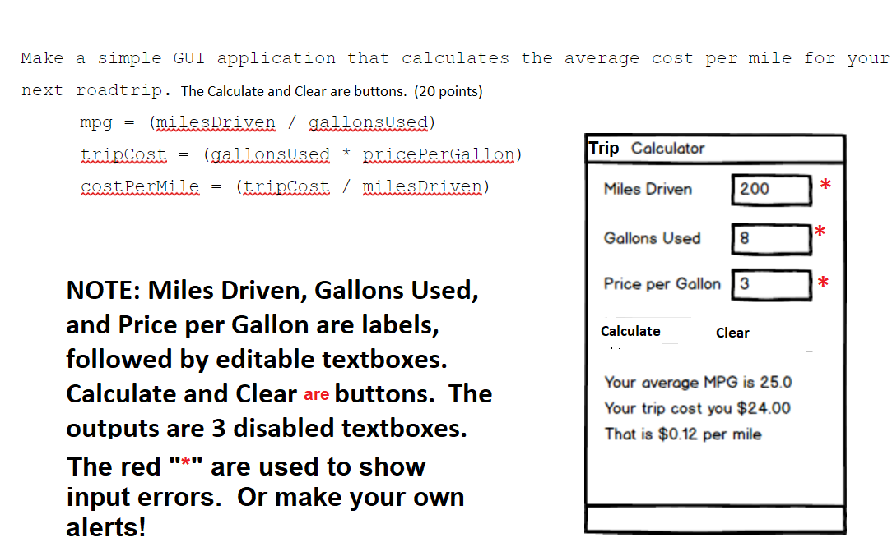

**// Use these constants please**

* MINGALLONS = 1 // Minimum gallons of gas used
* MAXGALLONS = 100 // Maximum gallons of gas used
* MINMILES = 1 // Minimum miles driven
* MAXMILES = 1000 // Maximum miles driven
* MINPPG = 1.00 // Minimum price per gallon of gas
* MAXPPG = 5.00 // Minimum price per gallon of gas

1. For each of the three lines of output shown on the bottom of the image above, add a function expression (total of 3 @ 5 points each, or **15 points** total) which utilizes the MPG, trip cost, and cost per mile formulas given above.
2. Add a ProcessEntries() function that acts like a driver to call one or more of these functions. (**5 points**).
3. Add 2 additional function expressions to: 1) Clear the form when the Clear button is clicked. 2) Alias the document.getElementById(id) function with $(id). These are worth 5 points each or **10 points** total.
4. Be sure to *register* the necessary functions in the window.onload() method (**5 points**).
5. Identify the 5/6 errors below. Circle them/explain the type of error. (**10 points**).

"use strikt"; //misspelled

var totOdds = 0;

var totEvens = 0;

var $ = function(id) {

return document.getElementByID(id);

};

var processEntries = function() {

var rn = 0;

$("randomNumber").value = "";

$("status").value = "";

rn = Math.floor(Math.random() * 1000) + 1;

$("randomNumber").value = rn;

oddsOrEven(rn);

};

var oddOrEven = function(rn) {

var res = rn % 2;

if(res == 1)

{

totOdds+;

$("status").value = "Odd";

}

else if (res === 0)

{

totEvens++;

$("status").value = "Even";

}

$("totOdds").valu = totOdds;

$("totEvens").value = totEvens;

};

window.onload = function() {

$("calculate").onclick = processEntries;

};

1. Modularize the guessing game program as shown below, i.e. you will make it a GUI form with working components from the HOT1 guessing game. (**10 points**)

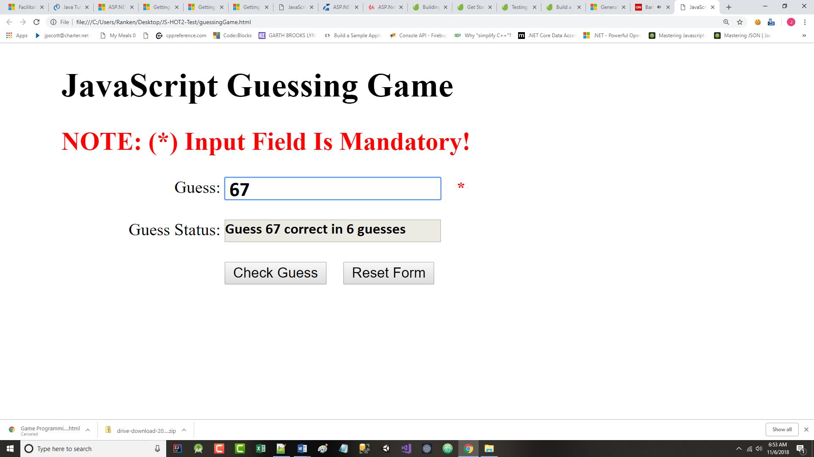

And add the following constants:

* MINNUMBER = 1 // Minimum allowable number
* MAXNUMBER = 100 // Maximum allowable number

1. For the line of output shown above in the disabled textbox, add a function expression that will determine if the guess is *illegal* (i.e., non-numeric or out of range), too low, too high, or correct. For any *bad* input, either use a <span> red as we did in class or create your own alert() to explain the error. (**5 points** total).
2. Add some kind of ProcessEntries() function that acts like a driver to call one or more functions. (**5 points**).
3. Add 2 additional function expressions to: 1) Clear the form when the Reset Form button is clicked. 2) Alias the document.getElementById(id) function with $(id). These are worth 5 points each or **10 points** total.
4. Be sure to *register* the necessary functions in the window.onload() method (**5 points**).

The remaining 10 points will be determined by your use of good variable names, correct syntax, sound logic, and following the requirements in #s 1 and 2 above. (**10 points**).