Potentially useful tutorial for live-plotting streaming data over Serial: <https://www.thepoorengineer.com/en/arduino-python-plot/>

## TODOs:

* In Eagle, see if the INT pin can be connected, otherwise dump it. 2017-12-26
* Consider a TCA9548A 1-to-8 I2C multiplexer to allow multiple MAX30105 chips to all be addressed, even though they have a fixed I2C address. See <https://learn.adafruit.com/adafruit-tca9548a-1-to-8-i2c-multiplexer-breakout> for an example. As-is the Teensy 3.5/3.6 only have 3 independent I2C ports (SDA/SCL 0,1,2) which would only support 3 sensors.

## Project goals

* Build a low-cost, low power, small digital module to measure mussel heart rate through the shell.
* Module will be built to be connected to 4-conductor cable to supply V+, GND, and I2C signal lines SCL and SDA, so that it can be connected and powered from a microcontroller.
* Powered off of 5V or 3.3V power supply, but module will have 1.8V converter to deal with interfacing with MAX3010x sensor logic pins.

## Sensor chip options (MAX3010x family):

* MAX30101
  + $5.02 each at digikey, MAX30101EFD+-ND
* MAX30102
  + $7.37 each at digikey, MAX30102EFD+-ND
  + Has a slightly narrower-spec’d ADC clock rate, and carries a ESD resistance rating of 2.5kV and latchup immunity of ± 250mA, which the other chips do not quote
  + Pin 7 in a NC on this chip because it lacks a green LED, while the 30101 and 30105 use pin 7 as the green LED driver pin.
* MAX30105
  + $4.51 each at digikey, MAX30105EFD+-ND
  + Sold as a particle sensor and smoke detector, but should be functionally identical to the MAX30101, and the Sparkfun MAX3010x library already can use this chip to read heart rate when run in Red+IR or IR-only mode.

## MAX3010x chip notes

* Recommends a 1µF capacitor minimum (10µF recommended) near the VLED+ input pins on the chip. Also a 4.7µF capacitor on the VDD input.
* Slower sample rates permit higher ADC resolution (15-18 bits) when coupled with different pulse widths for the LEDs. To get the full 18bit resolution at 1000 samples per second, you can use up to 411µs pulsewidth, but you could not get 1600 samples per second at 411µs pulsewidth. (See Table 12 of datasheet).
* If using the INT pin, you need to put a 4.7kohm pullup resistor on it.
* On the 30101 and 30105, it is possible to use the red, IR, or green LEDs for heart rate measurements.
* Sensor circuitry and I2C comms should only need 1.1mA max to run (not counting LED voltage, which is supplied to separate inputs on the chip). Typical current will be 600µA.

## Arduino library:

* <https://github.com/sparkfun/SparkFun_MAX3010x_Sensor_Library>
* The example sketch “Example4_HeartBeat_Plotter.ino” works with the prototype Teensy3.5 and RevB sensor board sporting a MAX30105 chip. Open the Arduino Serial Plotter to show the output

## TCA9517 logic level shifter notes (Texas Instruments)

* Hook the I2C bus master (i.e. the Teensy) to the B-side inputs (2.7-5.5V). Hook the MAX3010x sensor to the A-side inputs (0.9-5.5V tolerant).
* Use 10k ohm pull-ups on both sides of the logic level chip, so you should have 4 pull-ups in total hanging off the SDA and SCL inputs and outputs. The pull-ups should be attached to the appropriate voltage (3.3-5V on the B-side, 1.8V on the A-side).
* Use a 100nF (0.1µF) bypass capacitor on both VCCA and VCCB lines.
* 8-VSSOP package (3mm width) aka 8-TSSOP or 8-MSOP

## MIC5365 1.8V voltage regulator (MIC5365-1.8YC5-TR Microchip Technology, formerly Micrel)

* This chip will generate the 1.8V supply for VDD to the MAX3010x sensor chip.
* Size SC-70 (C5) 5-pin package is only 2.4mm wide max at the legs.
* 1µF bypass capacitors (10V ceramic X5R or X7R, size 0402) are recommended on both the input and output of the regulator.
* The EN enable pin should be tied high to Vcc if not being used. Pulling to ground disables the regulator, which we don’t need in this application currently.

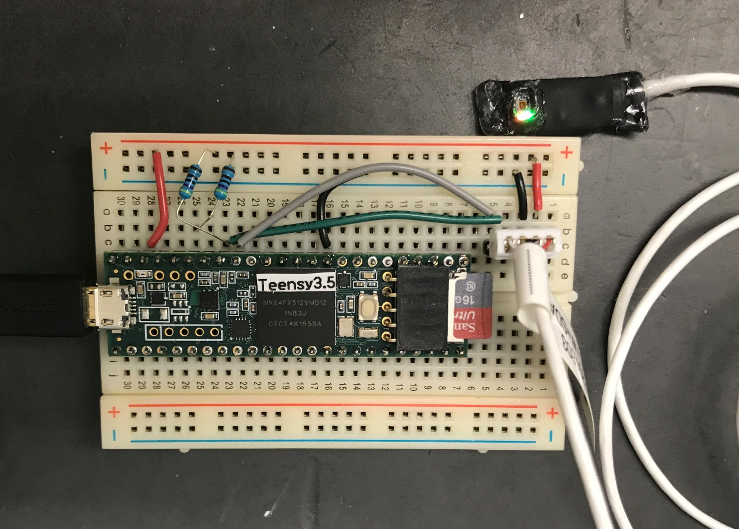

Figure 1. Prototype setup with Teensy 3.5 and RevB heart rate sensor using MAX30105 chip. 2018-05-22. This setup successfully senses pulse on a finger and plots the raw readings to the Arduino Serial Plotter using the Sparkfun library [https://github.com/sparkfun/SparkFun_MAX3010x_Sensor_Library example sketch Example4_HeartBeat_Plotter.ino](https://github.com/sparkfun/SparkFun_MAX3010x_Sensor_Library%20example%20sketch%20Example4_HeartBeat_Plotter.ino).

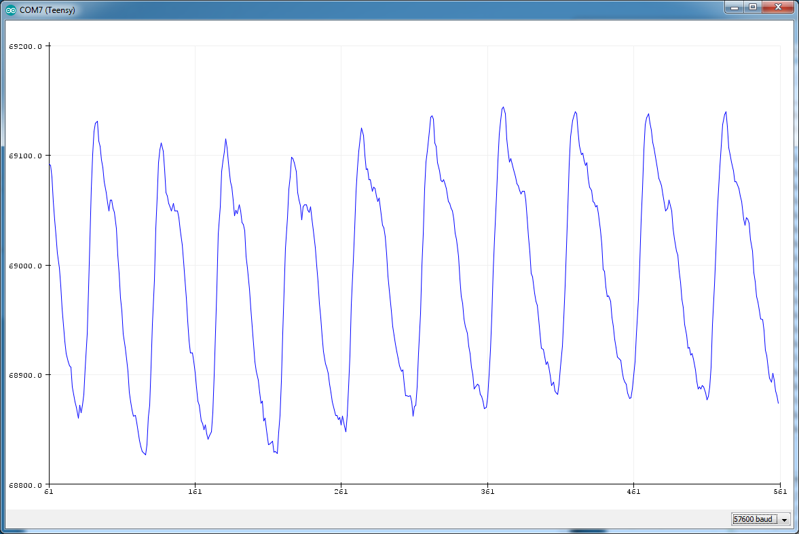

Figure 2. Heart rate signal from a Mytilus californianus mussel, using MAX30105 sensor attached to exterior of shell using Blu-Tack.

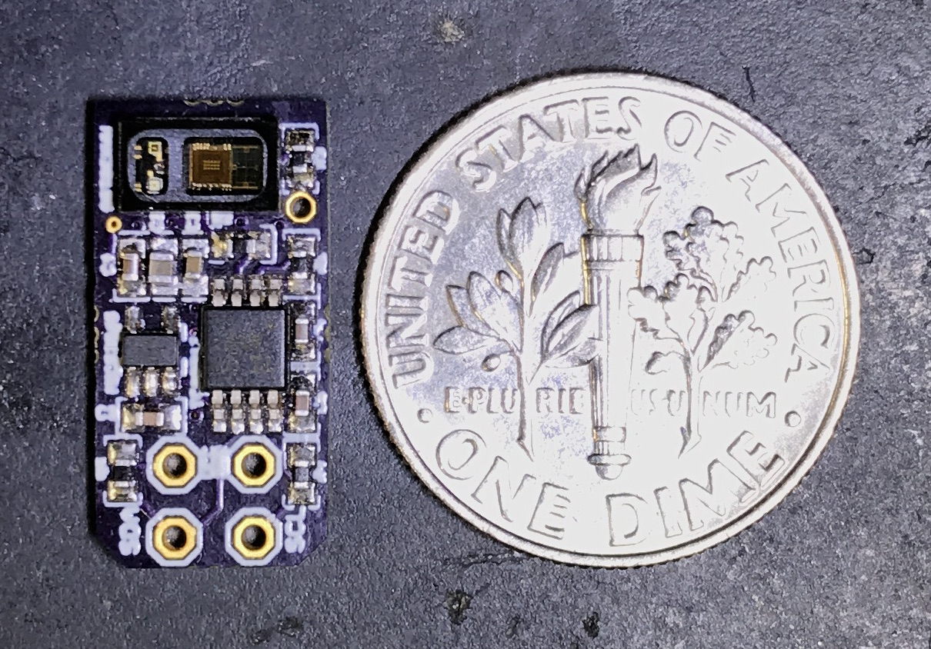

Figure 3. Revision B sensor circa 2017.

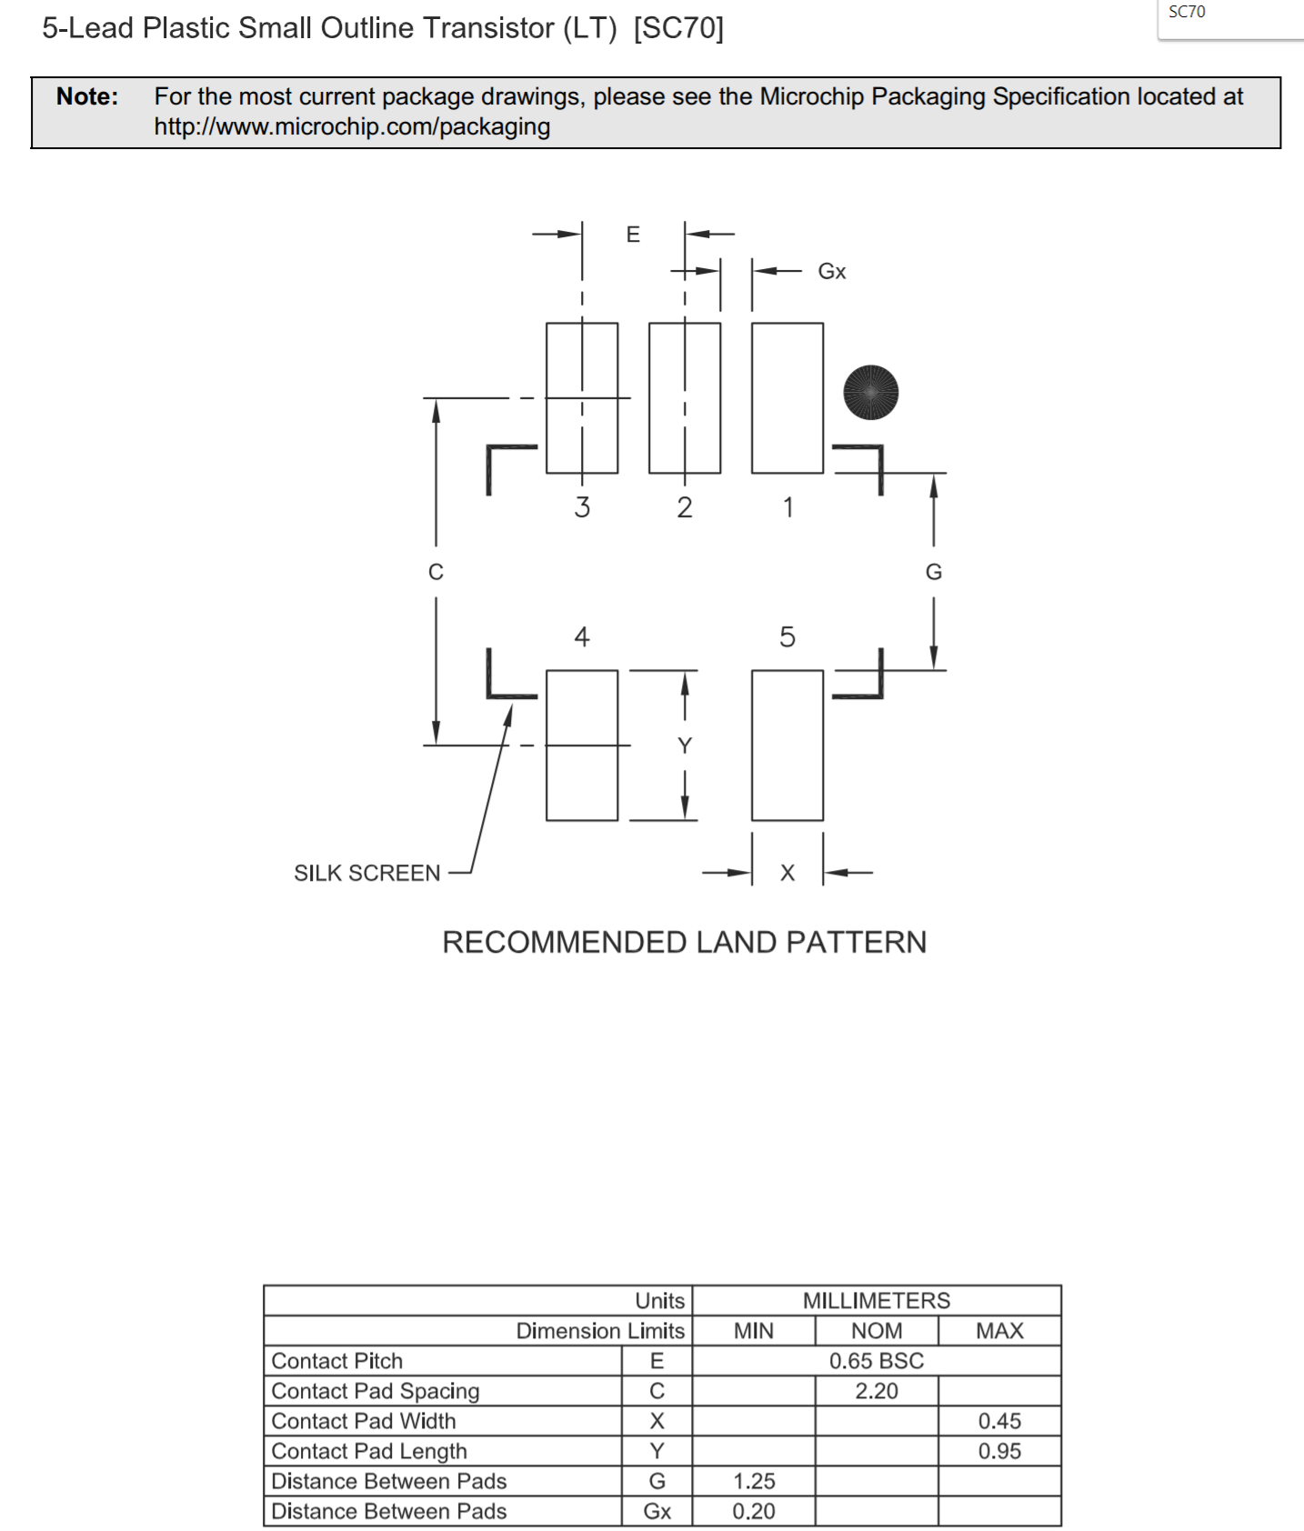

Figure . Footprint for SC70-5 package used in the voltage regulator MIC5365.

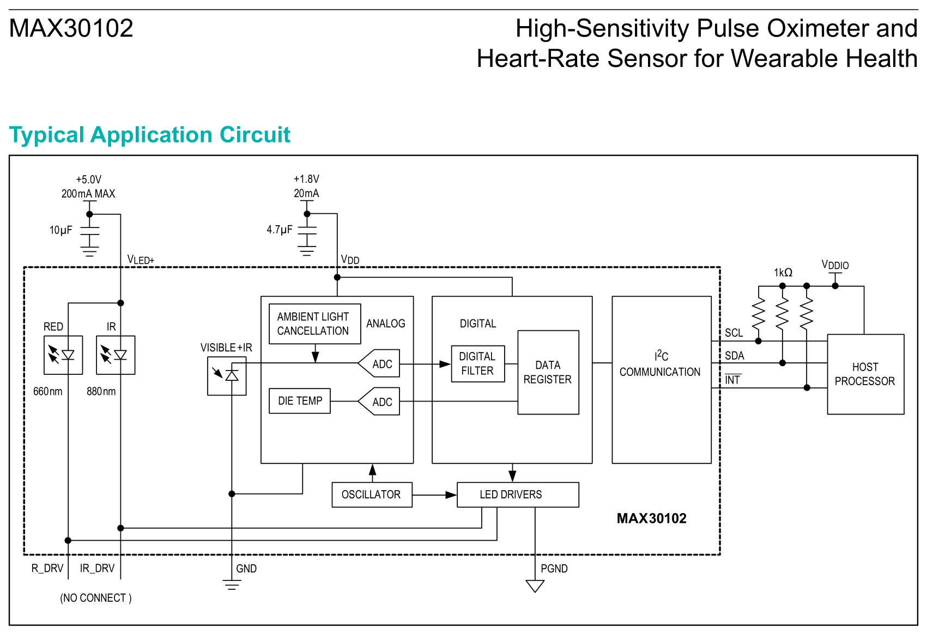

Figure 5. MAX30102 heart rate sensor application circuit. Note the capacitors on both VLED+ and VDD.

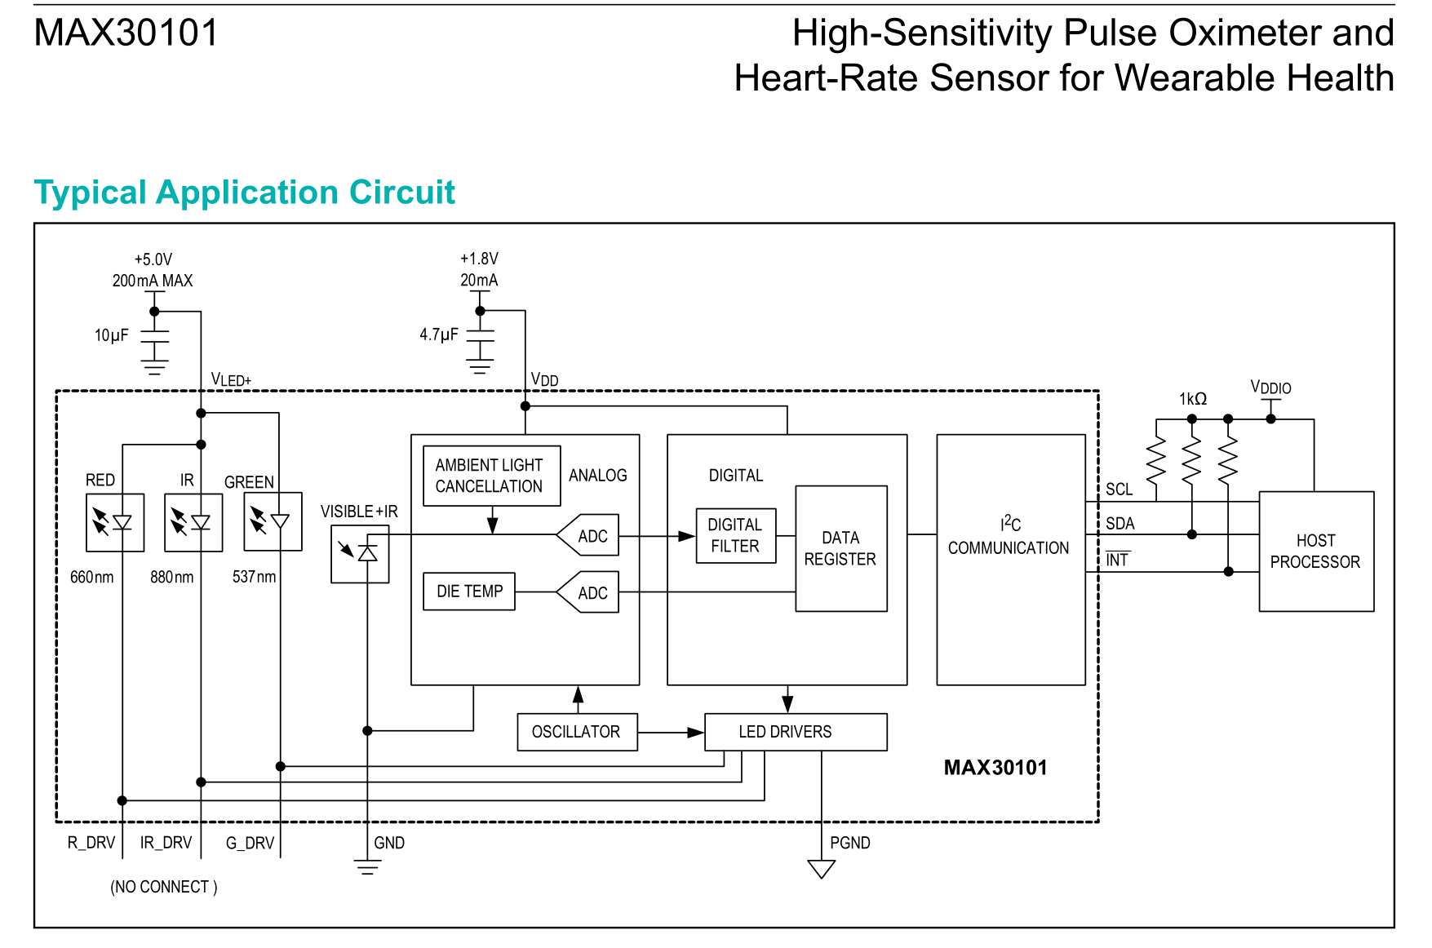

Figure 6. MAX30101 heart rate sensor application circuit, with the green LED that MAX30102 doesn’t have. Note the capacitors on VLED+ and VDD.

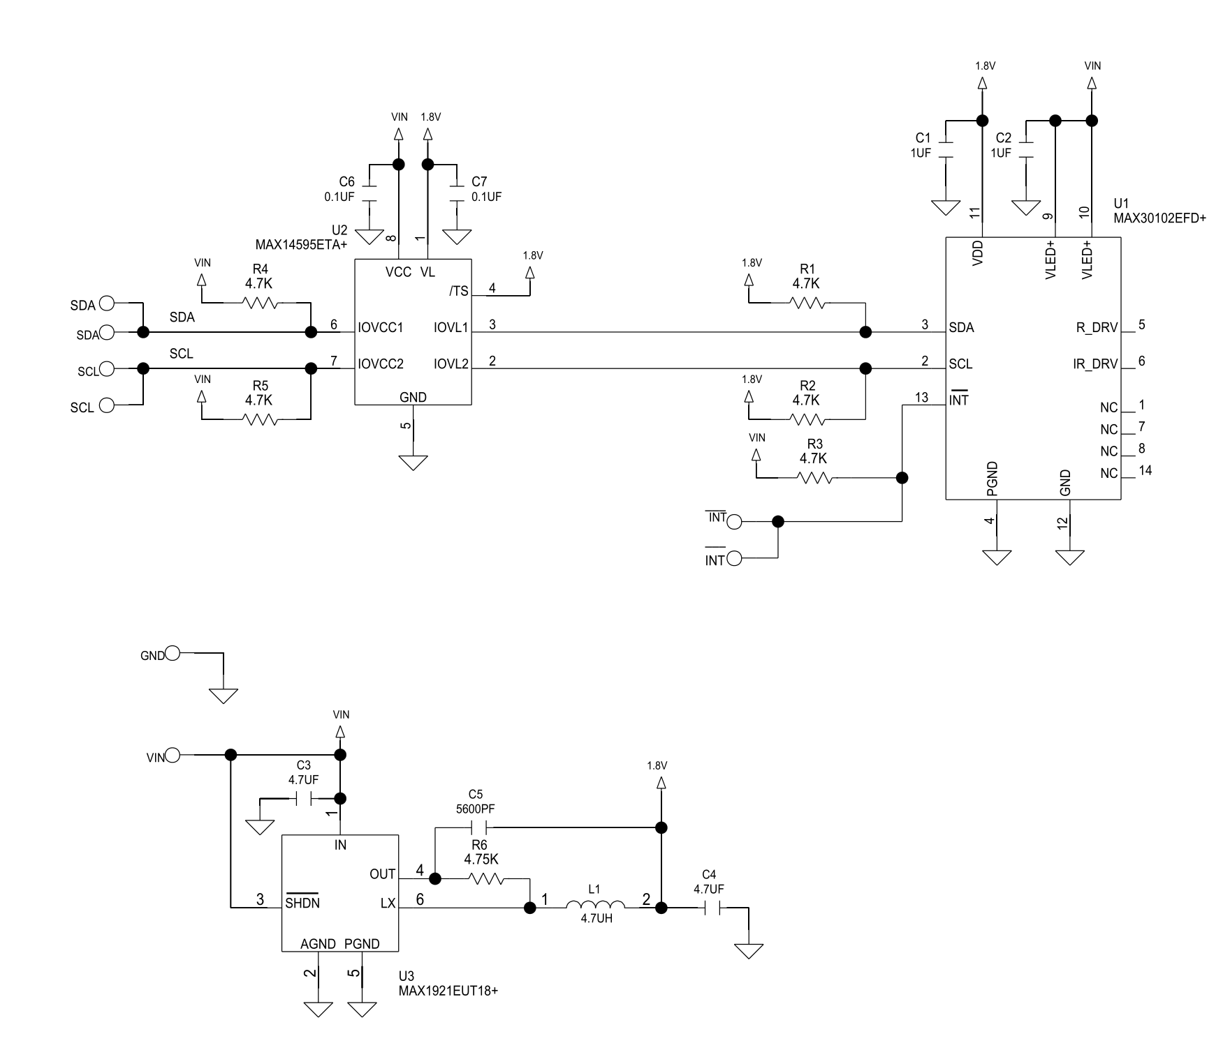

Figure . MAXREFDES117 reference design schematic. The MAX14595ETA+ is a logic-level voltage shifter for the I2C data lines. MAX1921EUT is a switching voltage buck regulator designed to step input voltages from the 3.3-5V range down to 1.8V for the logic level shifter and MAX3010x sensor chip. Note that C2 here is recommended to be up to 10µF in the datasheet, rather than the 1µF value depicted here. Similarly, the datasheet recommends the C1 capacitor hooked to VDD be 4.7µF rather the 1µF shown here.