String functions – conceptually similar, just functionality and slightly different syntax

* Concat – output data formatted with concatenation
  + Used to concatenate different columns in output.
  + SELECT CONCAT(author_lname, ‘, ‘, author_fname) AS ‘full name’ FROM books;
    - Outputs a table with one column labeled ‘full name’ the contents are the last name, first name of the column books
  + SELECT author_fname AS first, author_lname as last, CONCAT(author_fname, ‘, ‘, author_lanme) AS full FROM books;
    - Same as last time, but now there’s extra columns with just first and last
  + Concat_ws - shortcut
    - First argument is a string that will be inserted in between all of the other arguments in the output
* Substring – output data formatted by substring
  + SELECT SUBSTRING(‘Hello World’, 1, 4);
    - Substring array starts at 1 instead of 0
    - Outputs ‘Hell’
    - Only passing in one number (instead of 2), goes from that number to end
    - A single negative number counts from end (-3 selects last 3)
  + SELECT SUBSTRING(“Coraline”, 1, 4);
    - “Cora”
  + SELECT SUBSTRING (title, 1, 10) FROM books;
    - Outputs first 10 char of every title
  + SUBSTR() also works
* **You can nest string functions**
  + - SELECT CONCAT(SUBSTRING(author_fname, 1, 1), '. ', author_lname) FROM books;
    - Outputs “F. LastName” in a single column
* REPLACE – replace specific parts of a string with something else.
  + REPLACE(string, selector, replacer)
* REVERSE
  + 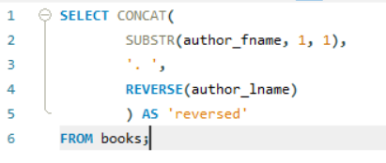
* CHAR_LENGTH – tells you how many characters are in a given string
* UPPER and LOWER
  + Change case of all characters in the string to “upper” or “lower”