Michael Kearns

ELEC-3225

Professor Carpenter

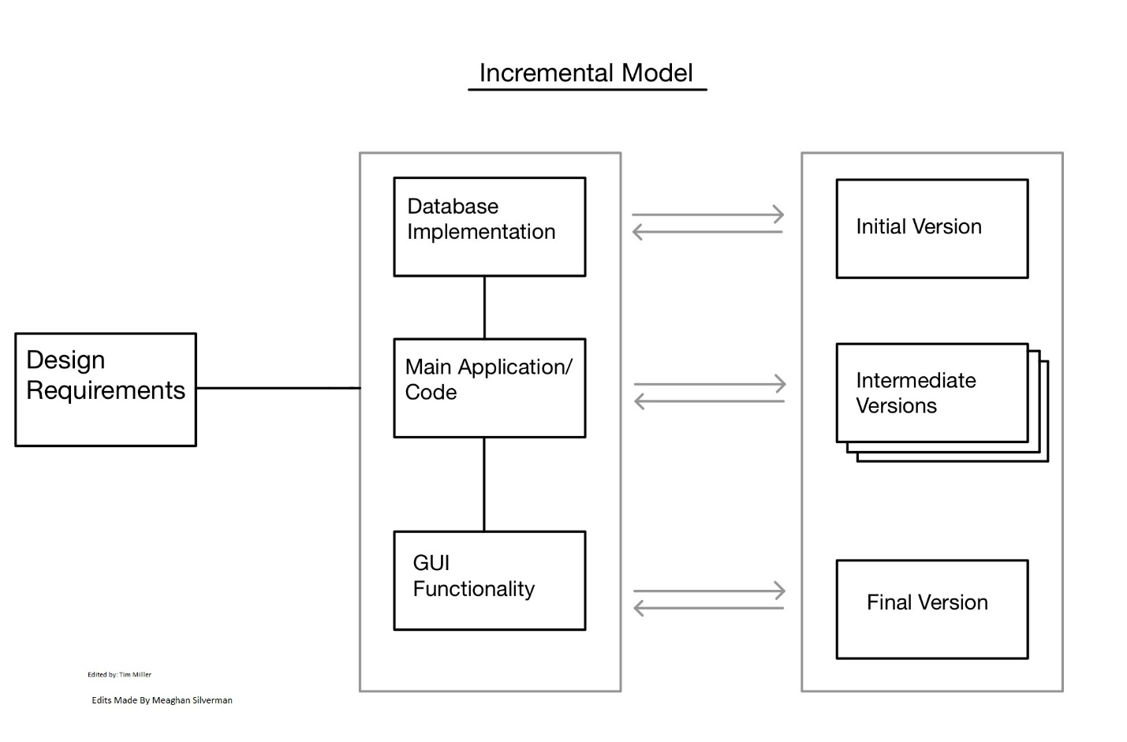

Incremental Versions:

* Need classes for User, Student, Instructor, and Administrator
  + First iteration would include having a minimal number of objects operating with the system, which have been taken from assignment 1
  + Each iteration should focus on increasing the capacity of objects in the system.
  + Final iteration should meet the requirement of 100 students, 10 instructors, and 1 administrator
* Database Implementation
  + First iteration should focus on creating tables, populating tables with vital info
    - This information can be taken from assignment 2
  + Intermediate iterations need to focus on getting tables connected to overall system.
    - Allow for students to register
    - Allow for changes to be made by admin
  + Final iteration needs to have all requirements met
    - Database should cover:
      * User login/logout
      * User information
      * Course registration
      * Multiple semesters, course limitations
* GUI
  + First iteration does not require GUI
  + Intermediate iterations should allow more and more functionality to be displayed on GUI
    - User login/logout
    - Printing schedules and information
  + Final iteration should have all aspects of system displayed and interactive through GUI

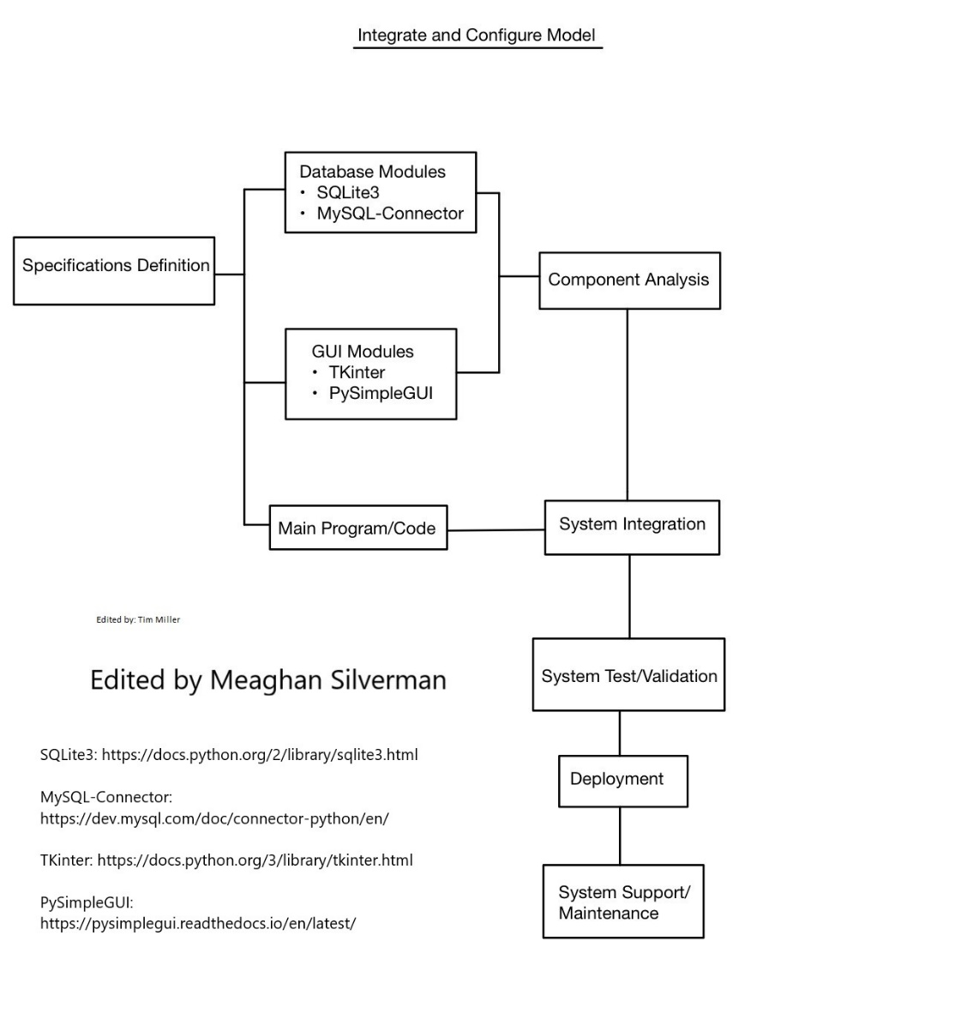

* Need to integrate Python packages for database and GUI systems
  + Multiple packages for each. SQLite3 and MySQL-Connector have a lot of documentation
  + TKinter and PySimpleGUI also have a lot of documentation. A lot of documentation is important because it allows for an easier integration.
* Only integration required for this program should be for GUI and Database. The main program can be built solely off the requirements laid out.
* Integrate and configure and Incremental design will work very well for this project.

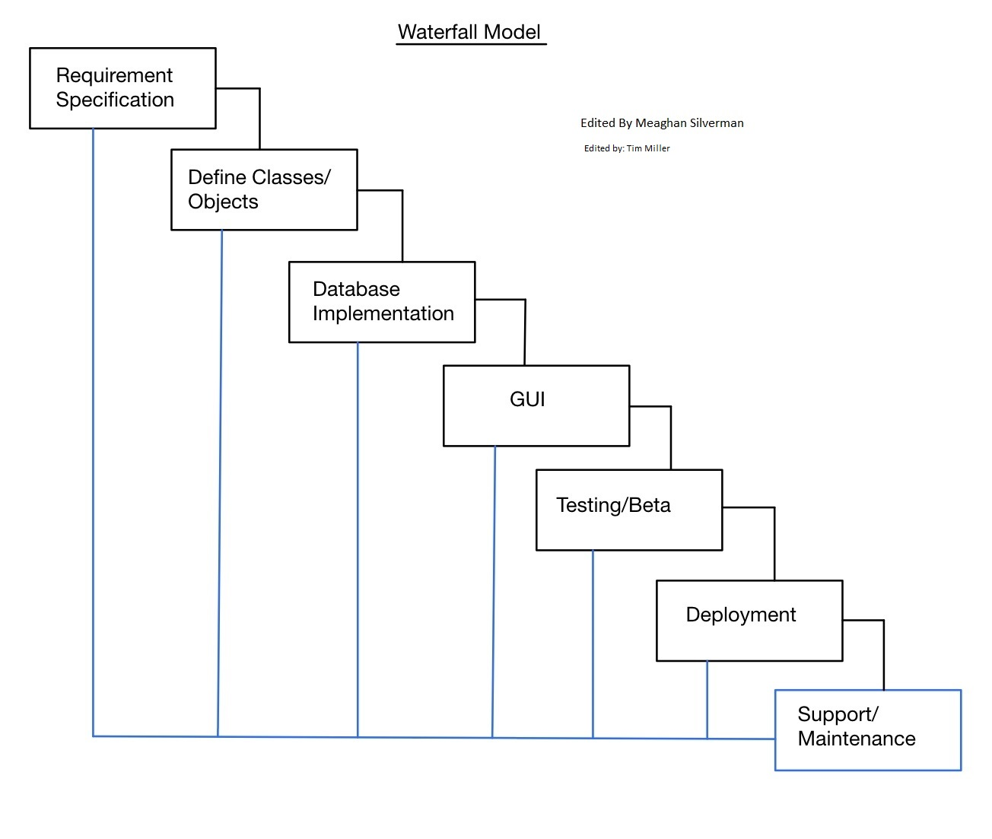

Requirements:

* Classes for User, Student, Instructor, and Administrator
  + User contains the basic functions for every class such as searching courses and modifying their schedule
  + Students need to print their schedules and check for conflicts
  + Instructor needs to print schedule and view students registered for their courses
  + Administrators need to add/delete courses and change attributes of students/instructors within database
* Once classes are built out, focus on database implementation and connection
  + This will be with printouts to terminal. Each user needs to have their functionality working before moving onto GUI
* GUI is to be worked on after the main functionality works using just printouts in terminal
* After GUI is completed, begin beta testing.
  + Work on support/maintenance for anything found during testing
* Deployment and continued support/maintenance can be completed after testing and bugs are worked out.