Design Documentation
WEBD1000 - Website Development

Maria Millett
#W0533284

Practical 3 – Wireframing
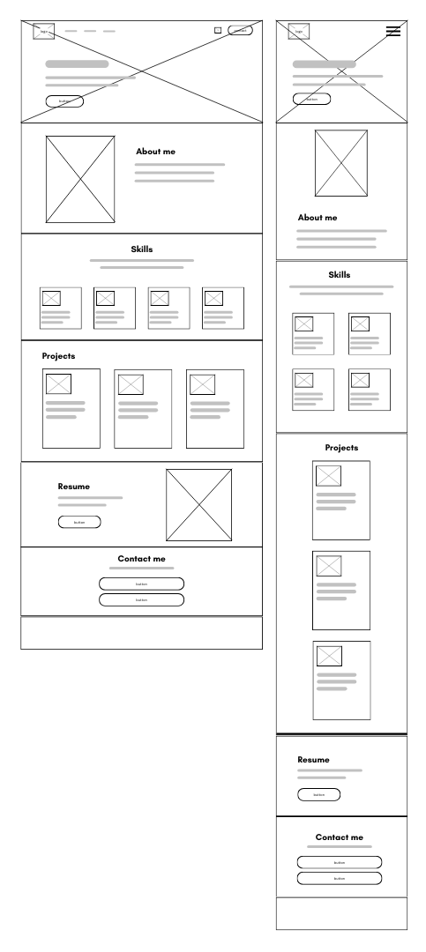
Figure 1 Wireframe

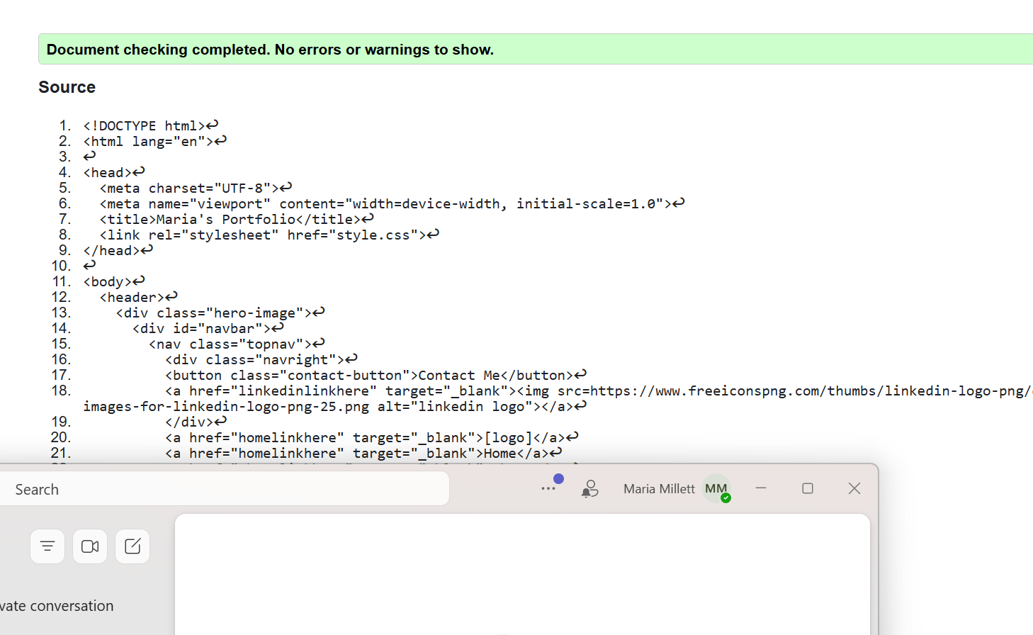
Practical 4 – Text, Links, Images, Accessibility
Figure 2 Validation from HTML validator

Practical 8 – Flexbox
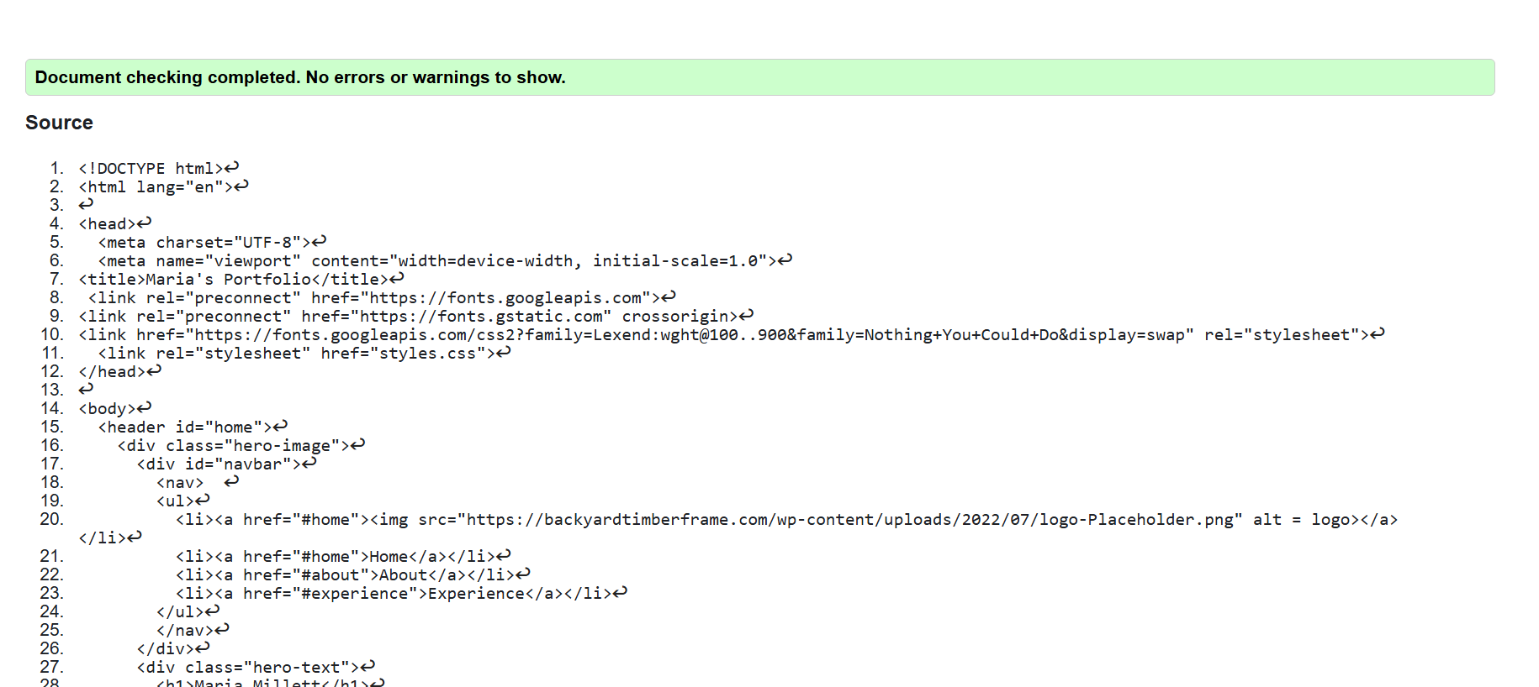
Figure 3 W3School Validation of HTML
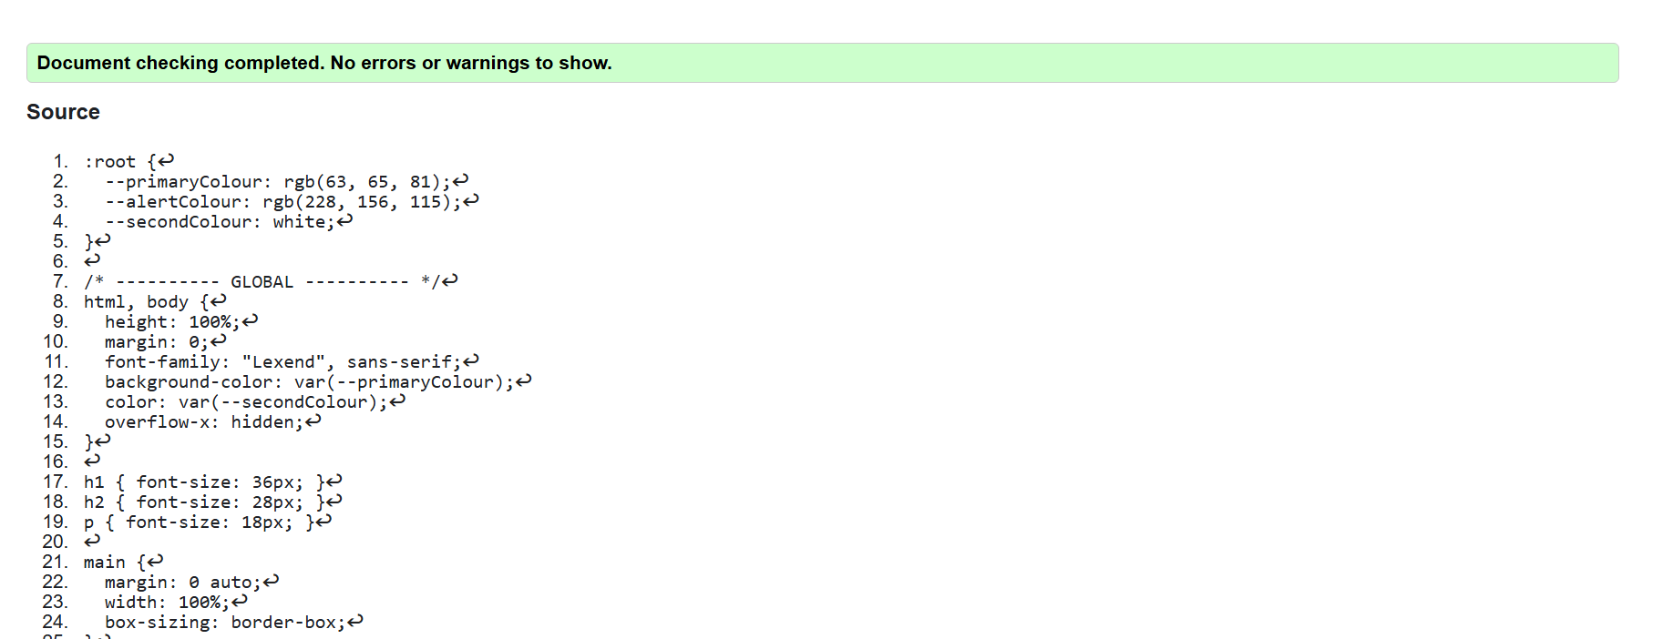
Figure 4 W3School Validation of CSS

Practical 9 – CSS Grid and Reflection
I have tried to keep to my wireframe as much as possible. However, I did change how the skills section will display on small mobile devices. For smaller screens, it is better to have them as one column instead of two for readability. However, I kept to the two columns from my wireframe for tablet sized screens.
From this process I learned how important it is to build the mobile version of the website at the same time as the desktop/large screen. I worked ahead a bit in the beginning, but it was difficult to backtrack for the media screens, and I am still working on setting all the variables as I go. Lesson learned!

Practical 10 – Animation
Animations added:
- Logo rotates on hover
- Skills elements raise slightly on hover
- Contact button hover color transition
Effects added in CSS:
The transform property was applied within (element):hover{} to define the visual parameters (e.g., rotate, translate)
The transition property was used set the time and ease of the animation. For example, transition: transform 0.3s ease; to animate over 0.3s seconds with the ease effect.

Practical 11 – Peer Review
COMMENTS RECEIVED
Comment from: | Comment | Accept/Reject | Rationale
Zahera | -Add a hamburger menu for mobile view. | Accept | A hamburger menu would make the mobile view cleaner to look at.

COMMENTS MADE
Comment made to: | Comment:
Wafi | - Higher contrast on the text since it was hard to read.
Josh | - More padding so elements are not stuck to the left side.
Jason | - Higher contrast on words since it was hard to read.

