Methods
Data. First, we used biophysical NbS mitigation potential estimates from Naturebase v3 (The Nature Conservancy, 2025), which provides sequestration and avoided-emission potential (tCO₂e yr⁻¹ ) across 20 NbS pathways spanning cropland, forest, grassland and wetland ecosystems for 216 countries. We assess the total NCS potential per country (the sum across all 20 pathways) as well as biome-level totals (cropland, forest, grassland, wetland) and activity-type totals (protection, management, restoration).
Second, we represent political risk using the World Governance Indicators (WGI) 2024 release (World Bank). We used the Political Stability and Absence of Violence/Terrorism dimension (PV.EST; scale −2.5 to +2.5) as a primary measure of political risk, with lower scores indicating higher instability and conflict exposure. We also ran sensitivity analyses using all six WGI dimensions (Voice & Accountability, Government Effectiveness, Regulatory Quality, Rule of Law, and Control of Corruption).
Finally, we constructed two complementary measures of NbS project implementation. Market-based implementation was measured using the global database of nature-based carbon offset project boundaries (Karnik et al., 2024; doi:10.5281/zenodo.11459391), which catalogues 575 georeferenced projects across 55 countries from six carbon registries (Verra, n = 294; Climate Action Reserve, n = 134; American Carbon Registry, n = 96; EcoRegistry, n = 33; Gold Standard, n = 17; BioCarbon Registry, n = 1), spanning three project types: Improved Forest Management (IFM, n = 252), Afforestation/Reforestation/ Revegetation (ARR, n = 190), and Avoided Deforestation (AD, n = 133). Community-based implementation was measured using the UNDP Equator Initiative Solutions Database, scraped via the WordPress REST API (July 2025), yielding 2,351 community NbS initiatives across 140 countries with geolocation data.
Analysis. We matched NbS potential data with WGI scores for 189 countries. To measure the degree to which countries translate biophysical carbon opportunity aligns with investment in projects we computed total projects (market + community) per MtCO₂e yr⁻¹ of NbS potential for each country. Both NbS potential and the efficiency ratio were log₁₀-transformed prior to analysis to account for right-skewed distributions. We estimated bivariate relationships using Spearman rank correlations (robust to non-normality) and ordinary least-squares regressions controlling for income group (World Bank classification). All analyses were conducted in R 4.6.0.
To examine how political risk constrains the accessible NbS portfolio under different risk tolerances, we constructed cumulative potential curves for each NbS type. Countries were sorted from most to least politically stable (descending PV.EST) and cumulative NbS potential was computed as each successive country was added. The resulting curves show the share of potential accessible if an investor or policymaker limits engagement to countries above a given stability threshold. We report this separately for four biome types (cropland, forest, grassland, wetland) and three activity types (protection, management, restoration), with risk zones defined at PV.EST thresholds of −1 (fragile), 0 (average), and +1 (stable).

Results
The carbon opportunity is disproportionately located in high-risk countries. Figure 1A shows a significant negative relationship between NbS biophysical potential and political stability (Spearman ρ = −0.47, p < 0.001): countries with the largest total carbon sequestration and avoided-emission potential — principally in the Congo Basin, Amazon, and Southeast Asia — tend to have substantially lower political stability scores. This is not coincidental; tropical forest ecosystems, which harbour the majority of global NbS potential, are concentrated in regions that are also among the most politically fragile.
Despite this, stable countries see more investment: Figure 1B reveals the investment gap: when project counts are normalised by biophysical potential (projects per MtCO₂e yr⁻¹), the relationship with political stability reverses to positive. High-stability countries implement substantially more projects per unit of available carbon opportunity than their higher-risk counterparts.
The risk barrier is sharpest for protection and forest-type NbS. Protection-type activities show the steepest cumulative curve, meaning that their potential is most concentrated in fragile and high-risk countries: less than 25% of global protection potential lies in countries with above-average stability (PV > 0). Forest NbS follows a similar pattern, with the bulk of potential entering the cumulative total only as the fragile zone is included. By contrast, cropland and management-type activities show gentler curves, accumulating more potential in moderate- and low-risk countries, suggesting relatively greater opportunities for implementation without entering fragile contexts.
For investors and policymakers operating with strict risk constraints the accessible global NbS portfolio is substantially truncated, and predominantly cropland and management activities. Accessing the full scale of forest protection and wetland conservation potential requires either accepting higher political risk or deploying risk mitigation instruments (political risk insurance, sovereign guarantees, blended finance) specifically targeted at fragile and conflict-affected states.

Figure 1. Political stability and NbS biophysical potential and implementation efficiency across 189 countries. (A) Country-level total NbS mitigation potential (Naturebase v3, 2025) as a function of political stability (WGI Political Stability & Absence of Violence, 2024). Countries are coloured by World Bank income group. The black line shows an OLS regression fit with 95% confidence interval (Spearman ρ = −0.47, p < 0.001). High-potential countries are disproportionately concentrated among lower-income, less stable nations. (B) NbS implementation efficiency — total projects (market-based carbon offset projects, Karnik et al. 2024, n = 575; and community-based NbS initiatives, Equator Initiative 2024, n = 1,677 with location data) per MtCO₂e yr⁻¹ of biophysical potential — as a function of political stability. Countries with high NbS potential but zero recorded projects are labelled. The positive slope indicates that more politically stable countries implement more projects relative to their available carbon opportunity, despite holding less absolute potential.
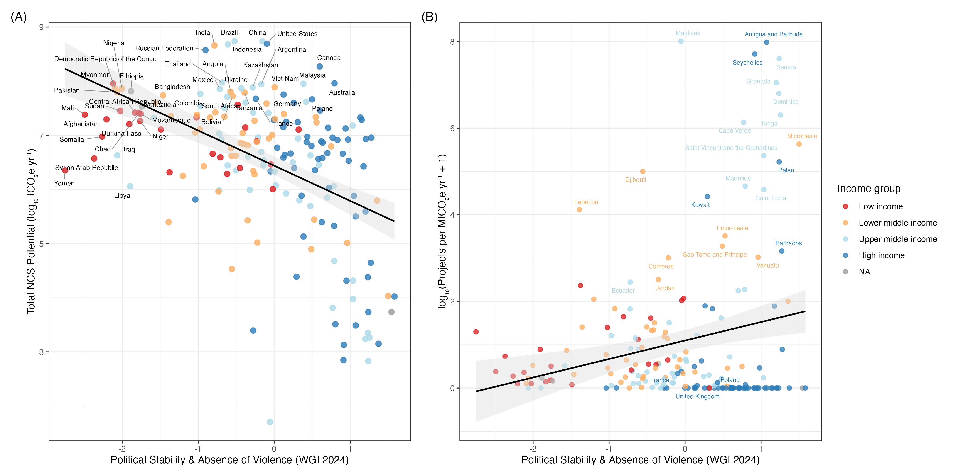

Figure 2. Cumulative NbS mitigation potential accessible as a function of political risk tolerance. The x-axis represents a minimum political stability threshold (WGI PV.EST, 2024): reading left-to-right, progressively higher-risk countries are included. The y-axis shows the cumulative potential of each NbS type as a percentage of its global total. Coloured lines represent four biome types (Forest, Grassland, Cropland, Wetland; Naturebase v3, 2025). Grey lines represent three activity types (Protection: solid; Management: long-dash; Restoration: dotted). Shaded risk zones correspond to Stable (PV > 1), Moderate (0 < PV ≤ 1), High Risk (−1 < PV ≤ 0), and Fragile (PV < −1) country classifications. Steeper curves indicate greater concentration of potential in high-risk countries.
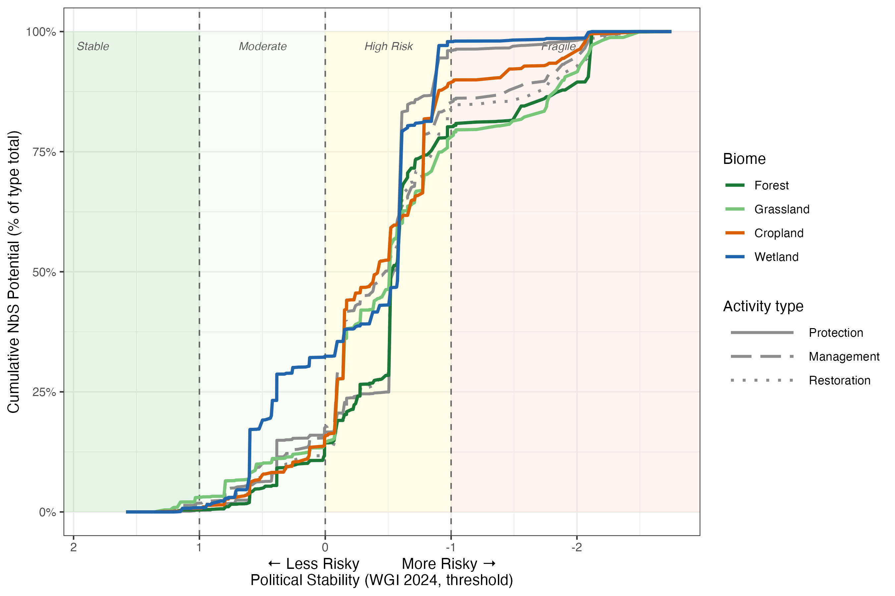

References
Karnik, A., Kilbride, J., Goodbody, T., Rachel, R. & Ayrey, E. (2024). A global database of nature-based carbon offset project boundaries [Dataset]. Zenodo. https://doi.org/10.5281/zenodo.11459391
The Nature Conservancy (2025). Naturebase v3. https://naturebase.org
UNDP Equator Initiative (2024). Nature-Based Solutions Database. https://www.equatorinitiative.org/knowledge-center/nature-based-solutions-database/
World Bank (2024). Worldwide Governance Indicators. https://www.worldbank.org/en/publication/worldwide-governance-indicators

