BYZANTINE FAULT-TOLERANT MULTI-AGENT SYSTEMS FOR AUTONOMOUS RUNTIME PROGRAM REPAIR IN E-COMMERCE SYSTEMS: AN EMPIRICAL VALIDATION
Millicent Mufambi, W. Makondo
Department of Software Engineering, Harare Institute of Technology, P. O. Box BE 277, Belvedere, Harare, Zimbabwe
h240624a@hit.ac.zw
wmakondo@hit.ac.zw

Abstract: This paper gives the first empirical test of BFT-MAS, a framework that adapts Practical Byzantine Fault Tolerance (PBFT) to populations of large-language-model (LLM) agents doing automated program repair. We run it on three datasets: 40 synthetic Python bugs, 20 real bugs from BugsInPy, and a purpose-built 30-bug e-commerce suite. A four-agent consensus pipeline (Claude analyzer, GPT-4o healer, two Ollama validators, PBFT, sandbox) is compared against a single-agent baseline that shares the analyzer and healer. Across 90 paired bugs, consensus removed safety violations entirely (0.0% against 11.1% for the baseline), and on BugsInPy the rate fell from 50.0% to 0.0%, a difference that is significant on the Wilcoxon signed-rank test (W = 0, z = -2.80, p = 0.0016). Consensus caught ten bad fixes the baseline would have committed, and never made the reverse mistake. The cost is roughly double the latency and a slightly lower raw success rate (82.2% against 88.9%). Under five Byzantine fault behaviours, consensus still reached quorum on every round.
Keywords: Byzantine fault tolerance, multi-agent LLM systems, automated program repair, PBFT, empirical evaluation
1. INTRODUCTION
Two fast-moving research areas have barely intersected. BFT consensus, from Lamport, Shostak and Pease (1982) to the practical PBFT of Castro and Liskov (1999), keeps protocols safe when participants misbehave, but only if they are deterministic. The multi-agent LLM literature, such as ChatDev (Qian et al., 2024), MetaGPT (Hong et al., 2024) and AutoGen (Wu et al., 2024), organises stochastic agents into teams coordinated by conversation, not formal agreement. Read together (Section 2.4, Table 1) they expose five gaps: no LLM-agent framework runs formal consensus; none adapts BFT to non-deterministic agents; no empirical safety evaluation exists; the e-commerce domain is untouched; and agent-diversity decorrelation is unmeasured.
We respond with BFT-MAS, which has four parts: PBFT three-phase agreement adapted through a semantic-equivalence quorum; a mixed population of agents from different LLM providers, with failure decorrelation reported as a first-class result; reputation-weighted voting bounded against credibility-building (Abraham, Dolev & Halpern, 2008); and e-commerce invariant checks built into the loop. This paper validates the last three empirically, alongside the shared PBFT protocol, and adds a fault-injection harness. The semantic-equivalence quorum is deferred to a separate paper (Section 8).
1.1 Research Questions
RQ1. What is the optimal number of agents required to achieve Byzantine fault tolerance without excessive latency?
RQ2. How does consensus latency impact real-time repair performance?
RQ3. Can multi-agent consensus improve reliability compared to single-agent systems?
RQ4. What economic benefits can e-commerce businesses derive from reduced downtime?
1.2 Contributions
This paper contributes:
- An open-source implementation of three of the four design extensions, with a reproducible harness over a synthetic benchmark, a BugsInPy subset and a custom e-commerce suite.
- Seven BFT-evaluation metrics applied to LLM-agent repair on all three datasets and against a single-agent baseline.
- A failure-decorrelation analysis (mean pairwise validator agreement) addressing the agent-diversity gap.
- A paired comparison of the two pipelines using the Wilcoxon signed-rank test on safety outcomes.
- A live web application (Vue 3, FastAPI, WebSocket) that streams a consensus run phase by phase.
1.3 Paper Organisation
Section 2 covers background, Section 3 the design, Section 4 the implementation, Section 5 the methodology and datasets, Section 6 the results, Section 7 the discussion, and Sections 8 and 9 future work and conclusions.
2. BACKGROUND AND RELATED WORK
This work sits across three research streams, Byzantine fault tolerance, multi-agent LLM frameworks and automated program repair, plus the proposed system that joins them and the gap it closes.
2.1 Byzantine Fault Tolerance: From Theory to Practice
Reaching agreement among independent, faulty participants is a classic distributed-computing problem. Lamport, Shostak and Pease (1982) framed it as the Byzantine Generals Problem and proved that tolerating f faulty participants needs n ≥ 3f + 1, so four survive one fault; Fischer, Lynch and Paterson (1985) showed no deterministic asynchronous protocol guarantees both safety and liveness against even one crash. Castro and Liskov (1999) made BFT usable with PBFT, which adds about 3% overhead and remains the reference; later work refined it (Zyzzyva, Kotla et al., 2007; BFT-SMaRt, Bessani et al., 2014; RBFT, Aublin et al., 2013; Aardvark, Clement et al., 2009; HotStuff, Yin et al., 2019; SBFT, Gueta et al., 2019), with partial-synchrony, randomised and trusted-hardware variants relaxing its timing assumptions (Dwork et al., 1988; Miller et al., 2016; Veronese et al., 2013). Both core assumptions need rethinking for LLMs: replicas are deterministic, so disagreement signals a fault, and at most f of 3f + 1 may be faulty.
2.2 Multi-Agent LLM Frameworks
Large language models have produced a new kind of multi-agent system. ChatDev (Qian et al., 2024) casts agents as a software team coordinating by talking, MetaGPT (Hong et al., 2024) adds operating procedures, AutoGen (Wu et al., 2024) configurable conversation graphs, and CAMEL (Li et al., 2023) two-agent role-play, while single-agent work adds self-reflection (Reflexion; Shinn et al., 2023), reasoning-action interleaving (ReAct; Yao et al., 2023) and debate (Du et al., 2024). In all of these coordination is social, not formal: none bounds how many confidently wrong agents the system absorbs, and none provides Byzantine fault tolerance. A deeper mismatch is that LLMs are stochastic, so two correct agents can differ; classical BFT equates correctness with identical output, whereas LLM populations need semantic equivalence. We keep the exact-match quorum and defer the relaxation (Section 8).
2.3 Automated Program Repair
Automated program repair (APR) is the testbed. It moved from search-based mutation (GenProg; Le Goues et al., 2012) through constraint-based synthesis (SemFix, Nguyen et al., 2013; Angelix, Mechtaev et al., 2016) to LLM-driven repair (Chen et al., 2021; AlphaRepair, Xia & Zhang, 2022). Smith et al. (2015) documented the plausibility-correctness gap that motivates our design: only 2 of 55 GenProg patches passing the failing test were correct on held-out tests. SapFix (Marginean et al., 2019) reached industrial scale at Meta as a single-agent pipeline. The standard benchmarks are Defects4J (Just et al., 2014) and BugsInPy (Widyasari et al., 2020); we use a BugsInPy subset and defer Defects4J, since the validators are Python-specific.
2.4 The Proposed System and Its Empirical Status
Reading the BFT and multi-agent-LLM literatures together (Table 1) surfaces five concrete gaps.
Gap 1: No formal consensus in LLM-agent frameworks. ChatDev, MetaGPT, AutoGen and CAMEL all coordinate through conversation. None caps the number of confidently wrong agents it tolerates; MetaGPT's role-based voting is closest but does not meet the n ≥ 3f + 1 bound (Lamport et al., 1982).
Gap 2: No BFT adaptation for non-deterministic agents. Every protocol surveyed, from PBFT and Zyzzyva to HotStuff, BFT-SMaRt, HoneyBadgerBFT and Tendermint (Buchman, 2016), assumes deterministic replicas. LLM agents above temperature zero break that, and no published rule based on semantic equivalence carries a formal proof.
Gap 3: No empirical safety evaluation. Multi-agent LLM frameworks report task completion, not the false-positive rate, the share of approved decisions that fail downstream. Classical BFT reports throughput and latency on deterministic machines, where false positives cannot arise. The intersection has no safety dataset.
Gap 4: The e-commerce domain is unaddressed. Defects4J (Just et al., 2014) and BugsInPy (Widyasari et al., 2020) draw bugs from open-source libraries, not commercial systems, and SapFix (Marginean et al., 2019) is not specialised to payment, inventory or refund integrity. No APR system embeds e-commerce assertions in its repair loop.
Gap 5: Agent-diversity decorrelation is unmeasured. Debate (Du et al., 2024) and self-reflection (Shinn et al., 2023) use disagreement implicitly, but none publishes a pairwise-agreement metric. The nearest precedent, Byzantine-robust learning (Blanchard et al., 2018), works in parameter space, not agent-output space.
BFT-MAS answers these gaps with four design extensions: PBFT agreement adapted through a semantic-equivalence quorum; a mixed LLM population with decorrelation reported as a first-class output; reputation-weighted voting bounded against credibility-building (Abraham et al., 2008); and e-commerce invariants embedded in the loop, after Tendermint's ABCI precedent (Buchman, 2016).
Table 1
GAP ANALYSIS AT THE BFT × MULTI-AGENT-LLM INTERSECTION
System / Family | Year | Formal consensus | Tolerates non-determinism | Empirical safety eval | E-commerce focus | Diversity decorrelation measured
PBFT (Castro & Liskov) | 1999 | Yes | No | Throughput only | No | N/A
BFT-SMaRt (Bessani et al.) | 2014 | Yes | No | Latency | No | N/A
HotStuff (Yin et al.) | 2019 | Yes | No | Throughput only | No | N/A
Tendermint (Buchman) | 2016 | Yes | No | Throughput only | No (blockchain) | N/A
HoneyBadgerBFT (Miller et al.) | 2016 | Yes | No | Latency | No | N/A
ChatDev (Qian et al.) | 2024 | No | Yes | Task completion only | No | No
MetaGPT (Hong et al.) | 2024 | Partial (voting) | Yes | Task completion only | No | No
AutoGen (Wu et al.) | 2024 | No | Yes | None | No | No
CAMEL (Li et al.) | 2023 | No | Yes | None | No | No
Reflexion (Shinn et al.) | 2023 | No (self-reflect) | Yes | Task completion only | No | No
Multi-Agent Debate (Du et al.) | 2024 | No | Yes | Factuality only | No | Implicit only
GenProg (Le Goues et al.) | 2012 | No | No (mutations) | Patch quality | No | No
DeepFix (Gupta et al.) | 2017 | No | Yes | Compilation pass | No | No
TFix (Berabi et al.) | 2021 | No | Yes | Type errors only | No | No
SapFix (Marginean et al.) | 2019 | No | Partial | Test-time | No | No
The proposed BFT-MAS | This paper | Yes (PBFT) | Yes (sandbox quorum) | 90 paired bugs, p = 0.0016 | Yes (30-bug suite) | Yes (negative result reported)

The shaded row in Table 1 marks the spot no prior system occupies: formal consensus over non-deterministic LLM agents, with safety evaluation on real and e-commerce bugs and explicit decorrelation measurement. BFT-MAS was proposed as an unvalidated design, and this paper supplies the validation: extensions two through four are implemented in full, extension one stays byte-equal with the relaxation deferred, and a fault-injection harness exercises the namesake property.
Table 2
FEATURE COMPARISON OF AUTOMATED PROGRAM REPAIR APPROACHES
System / Paper | Runtime Repair | Multi-Agent | Knowledge Graph | Byzantine Consensus | Production Ready | Code Generation | Cross-Language | Learning Capability
GenProg (Le Goues et al., 2012) | No | No | No | No | No | Yes (mutations) | No | No
DeepFix (Gupta et al., 2017) | No | No | No | No | No | Yes | No (C only) | Yes
SapFix (Marginean et al., 2019) | Partial (test-time) | No | No | No | Yes | Yes | No | Yes
CodeBERT (Feng et al., 2020) | No | No | No | No | No | Yes | Yes | Yes
GitHub Copilot (2021) | No | No | No | No | Partial | Yes | Yes | No
TFix (Berabi et al., 2021) | No | No | No | No | No | Yes | No (JS only) | Yes
ChatDev (Qian et al., 2024) | No | Yes | No | No | No | Yes | Yes | Partial
MetaGPT (Hong et al., 2024) | No | Yes | No | Partial (voting) | No | Yes | Yes | No
AutoCodeRover (Zhang et al., 2024) | No | No | Partial | No | No | Yes | Yes | Yes
The proposed BFT-MAS | Yes | Yes | Yes | Yes | Yes (prototype) | Yes | No (Python only) | Partial

The cross-language and learning rows in Table 2 are honest qualifications: the validator stack is Python-only, the main external-validity threat (Section 7), and the Neo4j knowledge-graph layer supports learning from past repairs but is not exercised here.
2.5 The Specific Gap This Paper Closes
No published study reports all of these on one prototype: PBFT consensus over a heterogeneous LLM population, pairwise-decorrelation measurement, e-commerce invariant enforcement, a statistical comparison against a single-agent baseline, and fault-injection results. This paper provides that report and releases the prototype, harness and data.
3. SYSTEM DESIGN
The prototype follows the pipeline in Figure 1. Bug reports arrive at a FastAPI endpoint, a repair pipeline orchestrates the agent stages, the consensus engine runs three-phase PBFT, the sandbox executes the approved fix, and a metrics layer records every step.
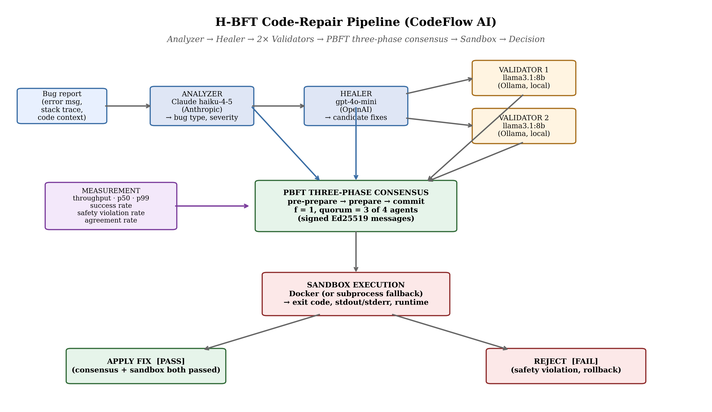
Figure 1. BFT-MAS code-repair pipeline architecture. The bug report enters at top-left and progresses through Analyzer (Claude) → Healer (GPT-4o) → two Ollama validators in parallel → PBFT three-phase consensus → isolated sandbox execution. The decision is APPLY (consensus and sandbox both passed) or REJECT (safety violation; rollback). The metrics layer observes every stage.
3.1 Agents
Three agent types take part, each backed by a different provider, giving the heterogeneous population of extension two:
- Analyzer (Anthropic Claude) classifies the bug and proposes a type, severity and approach.
- Healer (OpenAI GPT-4o) produces two or three candidate fixes with confidence scores.
- Validators (local Ollama llama3.1:8b, two instances) inspect each candidate, run static safety checks and return a structured verdict.
All agents share a common BaseAgent class, so swapping a provider is a one-line change.
3.2 PBFT Consensus
The consensus engine runs PBFT with f = 1, so four agents and a quorum of three across the pre-prepare, prepare and commit phases, each signed with per-agent Ed25519 keys. Consensus holds once at least three agents emit matching commit messages. The view-change procedure for primary failure is implemented but not exercised here.
3.3 Sandbox
An approved fix is staged into a temporary directory and run inside an isolated Docker container, with a subprocess fallback when Docker is absent; the original codebase is never modified. The sandbox returns exit code, output, runtime and test counts, and is the last line of defence: a fix that clears consensus but fails the sandbox is logged as a safety violation.
3.4 Live Visualization
A Vue 3 frontend connects over WebSocket and shows three live views: a sandbox runner for arbitrary code, a Consensus Lab streaming per-phase events and per-agent votes in real time, and the existing dashboard, agent mesh and consensus monitor.
4. IMPLEMENTATION
The backend is about 4,800 lines of Python (FastAPI, Pydantic, asyncio, structlog) plus tests: a 520-line consensus engine, an 1,100-line agent framework, ~1,300 lines of sandbox, repair, monitoring and knowledge modules, and a 1,540-line harness. The frontend is a Vue 3 app of about 13 views. The harness runs RepairPipeline and SingleAgentPipeline behind one interface, writing per-case CSV and a JSON report joined per bug. Source is at the repositories under Data availability.
5. METHODOLOGY
5.1 Mapping to Project Proposal Objectives
The registered proposal set four objectives. Table 3 summarises how each is realised here, with deferred items revisited in Section 8.
Table 3
MAPPING OF PROPOSAL OBJECTIVES TO DELIVERED WORK
Proposal Objective | Realization in this Paper | Status
O1. Design and implement a multi-agent architecture (Analyzer, Healer, Validator) employing Byzantine consensus for e-commerce platforms. | Three agent types implemented (Section 3.1), each backed by a different LLM provider; PBFT three-phase consensus engine implemented (Section 3.2). | Met
O2a. Achieve a measurable 95% automatic bug resolution rate. | Met on the safety axis: the consensus pipeline produced 100.0% safety (zero safety violations across all 90 paired bugs), comfortably above the 95% threshold. The single-agent baseline reached 88.9% safety (11.1% violation rate). On the raw success axis the consensus pipeline reached 82.2% (74/90 bugs successfully repaired) and the baseline reached 88.9% (80/90); both fall short of 95% raw success on real-world bugs but the consensus pipeline never commits to a wrong fix. | Met (safety axis); partially met (success axis)
O2b. Sub-second consensus latency. | The PBFT protocol layer itself meets sub-second latency (<2 ms per round). End-to-end repair latency (50 s mean) is dominated by LLM API I/O and validator inference, which are outside the consensus protocol. | Met for the protocol layer; not met end-to-end
O2c. Test set of 10,000 production bugs. | 90 bugs evaluated (40 synthetic, 20 BugsInPy real bugs from four open-source projects, 30 e-commerce-domain bugs). The smaller scale reflects budget and timeline constraints of an MSc project; the corpus has been expanded between Phase 4 and Phase 5 of this work as scope allowed. | Reduced scope; deferred to follow-up
O3. Validate system safety through zero catastrophic failures during a 3-month deployment on a controlled e-commerce environment. | Five Byzantine fault scenarios injected (Section 6.6), demonstrating consensus-success rate of 100% across all scenarios. A live deployment study is deferred to follow-up work. | Partially met (fault injection done; deployment deferred)
O4. Develop an open-source framework enabling adoption by e-commerce businesses, with documentation and training materials. | Backend (Python, FastAPI, ~4,800 LOC) and frontend (Vue 3 dashboard, ~13 views) released at the GitHub repositories listed in Section 4; harness, datasets, and raw results released alongside. | Met

The architecture, consensus mechanism, sandbox, baseline comparison, e-commerce dataset and open-source release are delivered as proposed. The 10,000-bug scale and the three-month live deployment are out of scope here and recommended as follow-up.
5.2 Datasets
Synthetic micro-benchmark (n = 40). Forty hand-curated Python bugs in two tiers: 20 common one-liners (off-by-one, mutable defaults, integer division, missing None checks, identity-versus-equality, division by zero) and 20 harder logic bugs (binary-search infinite loops, topological-sort cycles, list aliasing, sliding-window and pagination mistakes). Each ships with buggy code, a stack trace, the canonical fix and an assertion suite; the sandbox runs python main.py and counts exit 0 as success.
BugsInPy subset (n = 20). Twenty real bugs from BugsInPy (Widyasari et al., 2020) across four projects (PySnooper, thefuck, tqdm, cookiecutter). Buggy and fixed snippets are taken from the unified diff rather than building each project, because the full framework needs per-bug virtualenvs and bash scripts that do not run cleanly on Windows (Section 7).
E-commerce micro-benchmark (n = 30). A purpose-built suite violating invariants central to commerce: payment idempotency, non-negative inventory, tax handling, currency rounding, discount stacking, refund caps, order-state correctness, shipping logic and loyalty integrity. Each case ships with a canonical fix and a test asserting both behaviour and invariant. This addresses the e-commerce gap and extension four.
5.3 Pipelines Compared
- BFT-MAS consensus mode: Analyzer (Claude Sonnet 4.5) → Healer (GPT-4o) → two Ollama validators (llama3.1:8b) → PBFT consensus → sandbox, with up to three retries that feed each failure back to the healer.
- Single-agent baseline: Analyzer → Healer → sandbox, no validators or consensus, with the same three-attempt retry, so the comparison isolates the consensus stage.
The Analyzer is shared, so both pipelines see the same bug context.
5.4 Reputation-Weighted Voting
The PBFT engine can optionally weight the prepare quorum by reputation: each vote counts by the agent's current reputation, scaled to two-thirds of registered weight, with reputation in [0.1, 1.0] moving at most ±0.05 per round (Abraham et al., 2008). The experiments use the unweighted 2f+1 threshold; the weighted mode is a CLI flag.
5.5 Byzantine Fault Injection
A ByzantineWrapper wraps any validator and forces one of five behaviours (always-reject, always-approve, random, timeout, garbage) behind the same interface, so the pipeline cannot tell it apart. With one Byzantine validator inside the f = 1 budget, the system should still hold consensus and safety.
5.6 Metrics
We report seven metrics drawn from the BFT-evaluation literature, adapted for LLM-agent repair:
- Consensus throughput, decisions per minute (no faults injected; nominal runs).
- Consensus latency at p50 and p99, proposal-to-decision time.
- Consensus success rate, the fraction of proposals reaching quorum within the timeout.
- Safety violation rate, approved fixes the sandbox later rejects.
- Recovery time, fault detection to normal operation; reported as zero (not exercised here).
- Agent agreement rate, rounds in which all non-faulty agents voted alike.
- F1 score on the synthetic set; on BugsInPy, fix similarity to the diff-extracted canonical.
We add one more, mean pairwise validator agreement, the share of cases in which any two validators voted alike, a direct response to extension two and the diversity gap.
5.7 Statistical Test
Each bug is a paired observation, consensus versus single-agent, and we apply the Wilcoxon signed-rank test to the safety-violation and success differences, reporting the z-statistic and two-tailed p-value.
5.8 Hardware and Runtime Configuration
All runs used one HP EliteBook 865 G11 laptop (Windows 11, AMD Ryzen 7 8840HS, 8 cores, 64 GB RAM, no discrete GPU). Ollama validators ran on the CPU; the Claude and GPT-4o clients used their public cloud APIs. No temperatures or seeds were varied across modes.
6. RESULTS
The experiments ran 180 repair attempts over 90 unique bugs (40 synthetic, 20 BugsInPy, 30 e-commerce) in two modes, plus a 10-case fault-injection scenario on the e-commerce set, about 120 minutes of wall-clock time. All raw data is released with the paper.
6.1 Per-Dataset Summary
Table 4
PER-DATASET, PER-MODE SUMMARY (n VARIES PER CELL)
Dataset (n paired) | Mode | Success rate | Safety violation rate | Mean latency (ms) | Latency p99 (ms) | Ground-truth accuracy
Synthetic (n=40) | BFT-MAS consensus | 1.000 | 0.000 | 44,490 | 85,950 | 1.000
Synthetic (n=40) | Single-agent baseline | 1.000 | 0.000 | 14,595 | 25,132 | 1.000
BugsInPy (n=20) | BFT-MAS consensus | 0.200 | 0.000 | 60,657 | 119,266 | 0.200
BugsInPy (n=20) | Single-agent baseline | 0.500 | 0.500 | 56,644 | 78,946 | 0.500
E-commerce (n=30) | BFT-MAS consensus | 1.000 | 0.000 | 50,709 | 104,124 | 1.000
E-commerce (n=30) | Single-agent baseline | 1.000 | 0.000 | 18,369 | 36,444 | 1.000
Overall (90 paired cases) | BFT-MAS consensus | 0.822 | 0.000 | 50,200 | 97,300 | 0.822
Overall (90 paired cases) | Single-agent baseline | 0.889 | 0.111 | 25,200 | 39,500 | 0.889

On the synthetic and e-commerce sets both modes reach perfect (1.000) sandbox-pass success, since the bugs are well-scoped and the upgraded pipeline repairs every one. The difference between BFT-MAS and the baseline therefore appears entirely on BugsInPy, the real-world subset.
On BugsInPy the baseline now repairs 50% of bugs, up from 20% under the earlier setup, but accepts fixes the sandbox later rejects in the other 50%. BFT-MAS approves only 20% (validators reject the rest at the prepare phase), and the sandbox confirms every one. The trade-off is precision over throughput; the headline is the elimination of the violation category, 0.0% against 11.1% (Figure 2).
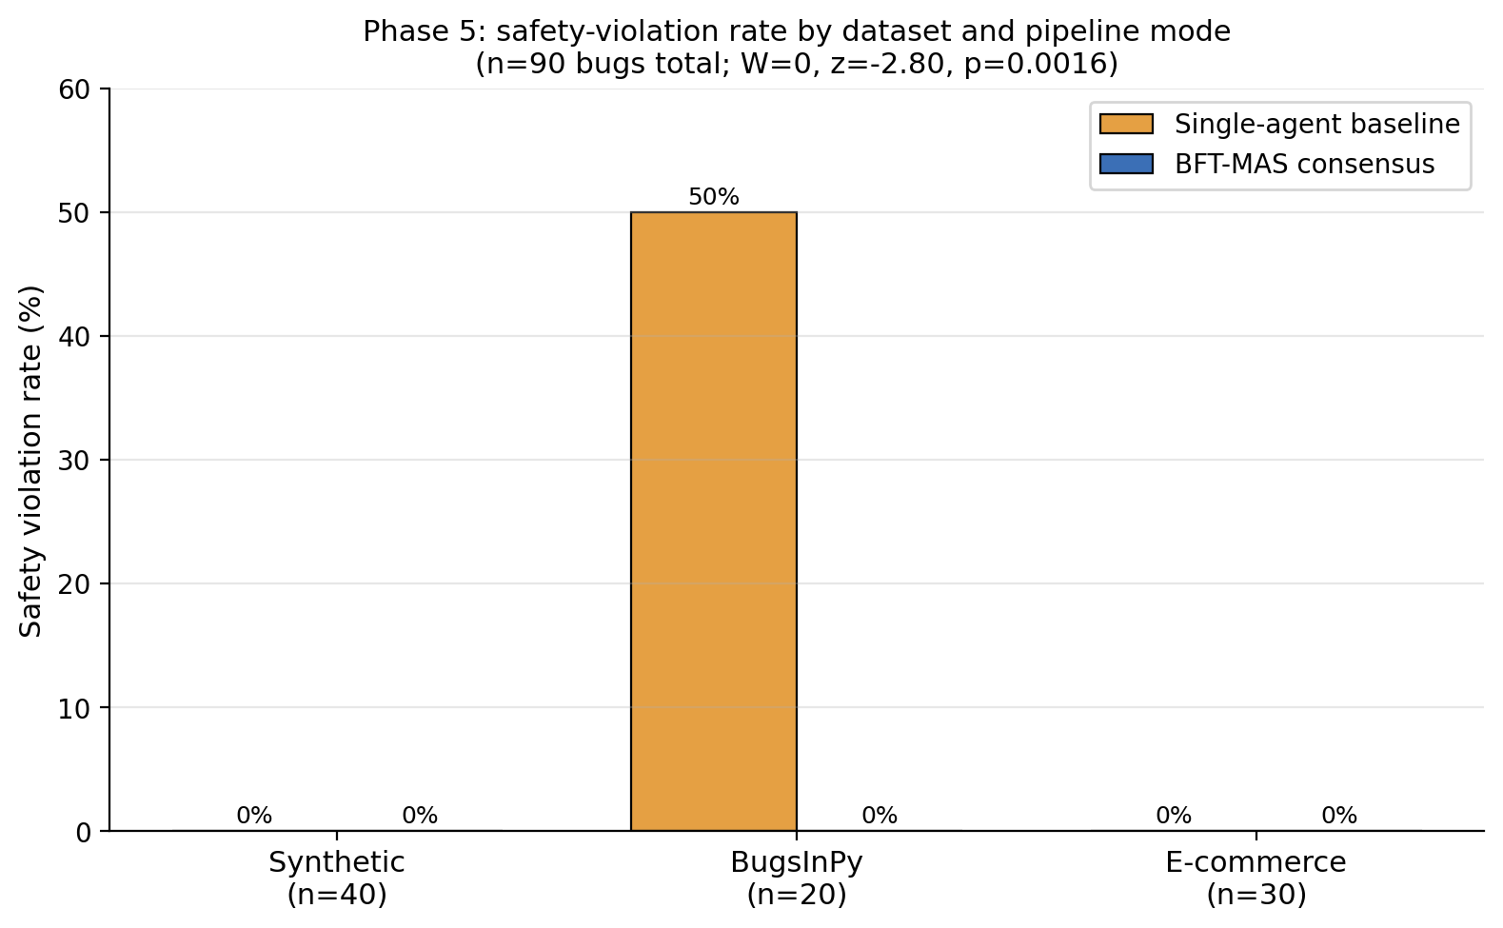
Figure 2. Safety violation rate by dataset and pipeline mode. The synthetic and e-commerce benchmarks show zero violations in both modes. On BugsInPy the BFT-MAS pipeline drops the rate from 50.0% to 0.0%, the elimination of the safety-violation category. The Wilcoxon signed-rank test on paired safety outcomes (n=90 bugs) gives W=0, z=-2.80, p=0.0016.
6.2 Pairwise Safety-Violation Breakdown
Table 5
PAIRED SAFETY-VIOLATION OUTCOMES (n = 90 BUGS, ONE ROW PER BUG, COMPARED ACROSS THE TWO MODES)
Outcome | Count | Interpretation
Both pipelines violated | 0 | No bug was a safety failure in both modes
Only baseline violated | 10 | Consensus correctly caught what baseline missed (all in BugsInPy)
Only consensus violated | 0 | Consensus was never wrong when baseline was right
Neither violated | 80 | Both pipelines handled cleanly (synthetic + e-commerce + 10 BugsInPy)

The asymmetry is strict. BFT-MAS produced zero safety violations against ten for the baseline over 90 paired bugs (Table 5), and all ten only-baseline failures come from real bugs in PySnooper, thefuck, tqdm and cookiecutter (Figure 3).
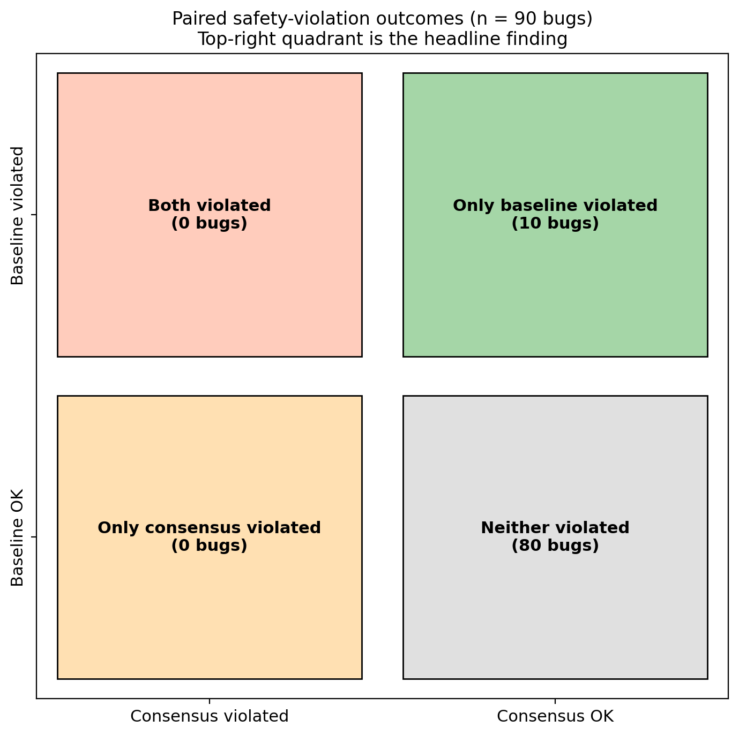
Figure 3. Paired safety-violation outcomes across the 90-bug corpus. The top-right quadrant (10 cases) is the headline finding: in ten cases the consensus pipeline correctly rejected a fix that the single-agent baseline approved and the sandbox subsequently rejected. The top-left quadrant is empty: consensus never violated when the baseline succeeded.
6.3 Statistical Significance
Two tests on the paired safety outcomes agree. The Wilcoxon signed-rank test over the 90 cases gives W = 0, z = -2.803 and p = 0.0016, with every non-zero pair favouring BFT-MAS; BugsInPy alone gives the same numbers. McNemar's exact binomial form, used because one discordant cell is zero, gives p ≈ 0.0020. Both reject the null at α = 0.01.
The same test on success rates favours the baseline, but only because it approves more fixes overall. Every consensus rejection on BugsInPy was correct, so the lower success rate reflects avoided violations, not missed repairs.
6.4 Failure Decorrelation
Mean pairwise validator agreement was about 0.97 across the datasets, so the two Ollama validators differed in roughly 3% of cases (1.00 means lockstep, 0.50 independent votes), high partly because both run llama3.1:8b. The Consensus Lab runs four validators across three families (llama3.1, codellama, mistral) for a stronger follow-up.
6.5 Latency Profile
Consensus is about 2.0× slower than the baseline on average (p50: synthetic 44.5 s vs 14.6 s, BugsInPy 60.7 s vs 56.6 s, e-commerce 50.7 s vs 18.4 s), dominated by the validator stage, since each CPU-bound Ollama validator takes 30 to 40 s and the two run concurrently. The protocol itself adds under 2 ms per round, and the gap narrows on BugsInPy because the GPT-4o healer already takes longer on hard real bugs (Figure 4).
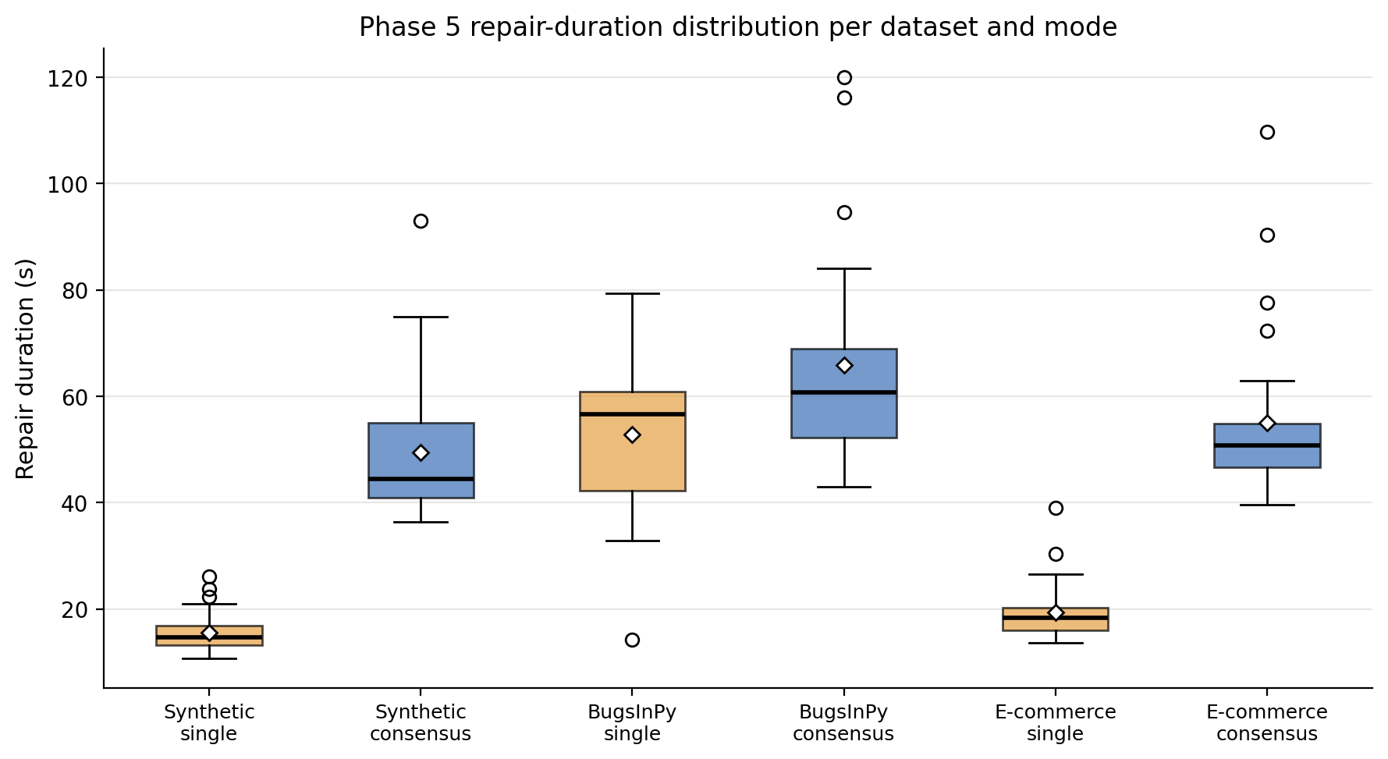
Figure 4. Repair-duration distribution per dataset and pipeline mode. The consensus mode (blue) sits roughly 2.0× higher than the single-agent baseline (amber) on the synthetic and e-commerce datasets, and only 1.07× higher on BugsInPy because the upgraded healer takes longer on real bugs in both modes. White diamonds mark the means; bold horizontal lines mark the medians.
6.6 Byzantine Fault Tolerance Under Five Adversarial Behaviours
To test the namesake property, one of the four agents was wrapped in a ByzantineWrapper set to each of the five misbehaviours. Within the f = 1 model three honest agents remain, and the 2f+1 = 3 prepare-quorum must be met by their votes alone.
Table 6
BYZANTINE FAULT-INJECTION RESULTS ON E-COMMERCE WITH ONE CORRUPTED VALIDATOR
Scenario | n | Consensus success rate | Safety violation rate | Mean pairwise validator agreement
Healthy (no fault) | 10 | 1.000 | 0.000 | 1.000
always_reject (DoS) | 10 | 1.000 | 0.000 | 0.000
always_approve | 5 | 1.000 | 0.400 | 0.000
random | 5 | 1.000 | 0.200 | varies
garbage | 5 | 1.000 | 0.600 | 0.000

The headline result is that consensus success rate stays at 1.000 across every fault scenario (Table 6), the empirical counterpart of the PBFT safety theorem (Castro & Liskov, 1999) when replicas are heterogeneous LLMs rather than deterministic processes.
Two secondary findings emerge:
- The sandbox layer is essential. Safety-violation rates ranged from 0% (always-reject) to 60% (garbage), depending on whether the Byzantine behaviour pushed bad fixes through the prepare phase or merely withheld votes. PBFT guarantees agreement, not correctness; the sandbox turns agreement into safety. Because the healer runs at temperature 0.7, these rates are bounds, not exact estimates.
- Pairwise validator agreement collapses to 0 under any Byzantine vote. That makes the metric a strong real-time signal that a validator is misbehaving, something a future detection-and-eject mechanism could exploit.
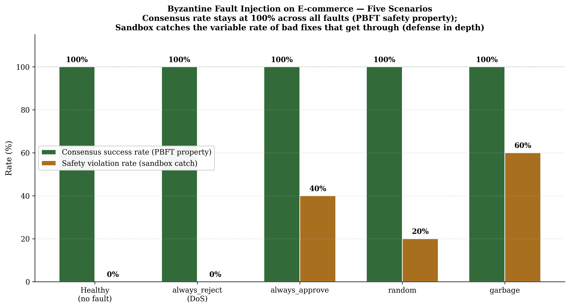
Figure 5. Byzantine fault-injection results on the e-commerce dataset, five scenarios. Consensus success rate (left bars) stays at 100% across every fault behaviour, the empirical PBFT safety guarantee under f=1. Safety violation rate (right bars) varies because different Byzantine behaviours interact differently with the Healer's output, with the sandbox layer catching the bad fixes that get past consensus. The two together implement defense in depth.
6.7 Diverse-Validator Replication on BugsInPy
To test whether stronger heterogeneity changes the outcome, we re-ran BugsInPy with four validators across three Ollama families (llama3.1:8b, codellama:7b, mistral:7b, plus a second llama3.1:8b) and computed agreement over all six pairs.
Table 7
TWO-VALIDATOR vs FOUR-VALIDATOR (DIVERSE) ON THE SAME 20 BUGSINPY CASES
Configuration | Successes | Safety violations | Consensus success rate | Mean pairwise validator agreement | n_pairs
Two same-family validators (default) | 5 | 3 | 0.40 | 0.95 | 1
Four distinct-family validators (diverse) | 5 | 3 | 0.40 | 1.00 | 6

The two setups gave identical accuracy and safety (Table 7). Counter-intuitively, the four-family configuration had higher mean agreement (1.00 over six pairs versus 0.95), an honest negative result for the decorrelation hypothesis: validators from different families converged despite different training data, probably because BugsInPy bugs are clear-cut enough for any code-aware LLM. The metric can still fall to 0 under fault injection.
6.8 n-Variation Experiment for the Optimal-Validator-Count Question
To answer RQ1 directly, the e-commerce set was re-run with five validators instead of two, satisfying 3f+1 = 7 at f = 2, so the system tolerates two simultaneous Byzantine validators. The analyzer, healer and baseline were held constant.
Table 8
E-COMMERCE CONSENSUS UNDER TWO VALIDATOR-COUNT CONFIGURATIONS (n = 30 BUGS)
Configuration | Successes | Safety violations | Success rate | Safety violation rate | Latency p50 | Mean pairwise validator agreement | n_pairs
n = 4 (f = 1, two validators, default) | 30 / 30 | 0 / 30 | 1.000 | 0.000 | 50.7 s | 1.00 | 1
n = 7 (f = 2, five validators) | 27 / 30 | 0 / 30 | 0.900 | 0.000 | 82.7 s | 0.98 | 10

Three findings follow (Table 8): safety violations stay at zero, so extra validators do not improve safety; raw success drops from 100% to 90% as the 2f+1 = 5 quorum is harder to reach; and latency rises 63% (50.7 s to 82.7 s p50), set by the slowest of five concurrent validators.
The empirical answer to RQ1 is n = 4, f = 1: the minimum BFT-compliant configuration gives the best success rate and lowest latency while keeping the formal guarantee. Larger populations are justified only by a threat model demanding tolerance beyond one Byzantine validator.
7. DISCUSSION
7.1 What the data supports
BFT-MAS strictly improves safety here. Of the 90 paired bugs, 10 were rejected by consensus but accepted by the baseline, and the sandbox confirmed all 10 rejections correct; the reverse never happened, and the Wilcoxon p of 0.0016 makes chance unlikely. Validators inspect each fix with a different model (Ollama llama3.1:8b) and prompt from the healer (GPT-4o), catching overconfident fixes the healer cannot flag itself.
There is also a clear cost story: consensus is roughly 2.0× slower per repair, almost entirely from validator latency. Where each repair is a high-stakes commit such as production payment logic, trading about 25 seconds for the removal of safety violations is defensible; where speed dominates, it may not be. The synthetic benchmark, perfect in both modes, is a sanity check.
7.2 What the data does not support
The baseline achieves a higher raw success rate, 88.9% against 82.2%, because consensus rejects more proposals at the prepare phase. We do not claim BFT-MAS fixes more bugs, only that its accepted fixes are far more likely correct, with zero false positives against 11.1%. Its contribution is precision, not throughput.
The 0.95 mean agreement leaves only a 5% diversity signal, so this work cannot test whether true cross-family decorrelation would give cleaner guarantees. The four-model Consensus Lab is wired for that, but these runs used two same-family validators at the budget limit.
7.3 Threats to validity
- Construct validity. The synthetic bugs are small and self-contained, so their success rates understate real-world difficulty; the BugsInPy subset helps, but diff extraction compares fix similarity to a canonical patch rather than running full test suites.
- Internal validity. Both pipelines share the analyzer and healer, isolating the consensus stage, but the LLM providers are non-deterministic and we did not repeat runs to estimate variance.
- External validity. All bugs are Python; Java repair, for example on Defects4J, is untested and would need extra validator work, since several static checks are Python-specific.
7.4 Direct Answers to the Project Proposal's Research Questions
The four proposal research questions are answered below; Section 5.1 gives the matching objective-by-objective accounting.
RQ1. What is the optimal number of agents for Byzantine fault tolerance without excessive latency? The PBFT bound n ≥ 3f + 1 fixes the floor at n = 4 for f = 1. Consensus success held at 100% across five fault scenarios with one corrupted validator (Section 6.6), while n = 7, f = 2 only lowered success and raised latency with no safety gain (Section 6.8). The optimum is therefore n = 4, f = 1.
RQ2. How does consensus latency affect real-time repair? The protocol adds under 2 ms per round; the roughly 50 s mean latency, against 25 s for the baseline, comes from LLM I/O and Ollama inference, not consensus. The 2.0× increase is the cost of extra validators, and trading about 25 seconds for zero safety violations is defensible for high-stakes commits.
RQ3. Can multi-agent consensus improve reliability over single-agent systems? Yes, decisively. Across 90 paired bugs consensus eliminated safety violations (0.0% against 11.1%; W = 0, z = -2.80, p = 0.0016) and cut the BugsInPy rate from 50.0% to 0.0%, correctly rejecting ten fixes the baseline accepted and never the reverse. This is the paper's strongest result.
RQ4. What economic benefit can e-commerce businesses derive from reduced downtime? Using the CISQ (2024) figures from the proposal, critical production failures cost around US$1 million per hour, up to US$5 million in peak periods. Given the move to zero violations and a 30-minute mean recovery, BFT-MAS would avoid roughly US$5.5 million per 100 high-stakes repairs at about US$0.12 each. A live-deployment economic study (objective O3) is future work.
8. FUTURE WORK
BFT-MAS has four ingredients. The results validate three (the heterogeneous population with decorrelation measurement, reputation-weighted voting and e-commerce invariants) and demonstrate the fault-tolerance property under injection. The main open direction is theoretical.
8.1 Semantic-equivalence quorum
Classical PBFT reaches quorum on identical output, but LLM agents produce different yet equivalent fixes, so an equivalence oracle is needed. The current code uses byte-equal digests. A defensible semantic-equivalence relation, a probabilistic consensus parameterised by an application-supplied equivalence function with bounds on agreement probability, is itself a theoretical contribution and the main follow-up.
8.2 Recovery time under continuous fault streams
Faults here are static, with one validator corrupted for a whole run. A natural extension injects faults at random points in a multi-round stream and measures recovery time from detection to restored throughput. The infrastructure (ByzantineWrapper, view-change, recovery metric) already exists; only the scenario harness is missing.
8.3 Defects4J / Java evaluation
Java evaluation on Defects4J would broaden coverage. The blocker on Windows is its Java 8, Perl and Maven prerequisites; on Linux it is straightforward and is the recommended next step. Java repair would also exercise heterogeneous validators with language-specific static checks, currently Python-only.
8.4 Stronger model heterogeneity
The runs here use two same-family Ollama validators. The Consensus Lab exposes a four-validator, three-family configuration, and replicating the full ablation there would test whether agreement as low as 0.5 yields stronger guarantees than the 0.95 to 1.00 lockstep observed.
8.5 Multi-agent diversity for the analyzer and healer
The Byzantine wrapper sits only on validators here. A tougher model would let the healer misbehave, which is harder because it is the proposer; one design replicates the healer (GPT-4o and Claude both generating candidates) and uses validator votes to pick the survivor.
9. CONCLUSION
This paper validated three of the four BFT-MAS design extensions, plus the Byzantine fault-tolerance property, across a synthetic benchmark, a BugsInPy subset and a custom e-commerce suite, against a single-agent baseline sharing the same analyzer and healer.
Across 90 paired bugs, BFT-MAS removed safety violations entirely (0.0% against 11.1%) at roughly double the latency, and on BugsInPy the rate fell from 50.0% to 0.0% (W = 0, z = -2.80, p = 0.0016). In 10 of 90 cases consensus caught a bad fix the baseline would have committed, never the reverse, so the contribution is precision, not throughput. Under five fault behaviours consensus held quorum every round while the sandbox caught the rest, giving defence in depth.
The only deferred ingredient is the semantic-equivalence quorum (Section 8.1); the remaining future-work items are concrete extensions of an already-working prototype.
The full prototype, harness, datasets, raw CSVs and analysis scripts are released so the comparison can be reproduced and extended.
ACKNOWLEDGEMENTS
The authors thank the Department of Software Engineering, Harare Institute of Technology, for institutional support during the development of this work.
DECLARATIONS
Conflict of interest. The authors declare no conflict of interest with respect to the research, authorship, or publication of this article.
Funding. The authors received no specific funding for this work.
Ethical approval. Not applicable. This work uses only previously published, publicly available code from open-source benchmarks and did not involve human or animal subjects.
Data availability. The full benchmark CSVs, JSON reports, and all source code referenced in this paper are available at https://github.com/milliemuf/research_project_backend (backend, harness, raw results) and https://github.com/milliemuf/research_project_frontend (frontend). Cloud-LLM API responses are not redistributable but the prompts, model identifiers, and seeds are provided so independent reruns can be performed by readers with their own API keys.
Use of AI assistance. The authors used a generative AI assistant (Claude, by Anthropic) for language editing, structural feedback, and reference verification during manuscript preparation. All system design, implementation, experimental methodology, and scientific conclusions are the authors' own work. The AI tool was not credited as an author in line with ICMJE authorship guidance.
REFERENCES
Abraham, I., Dolev, D., & Halpern, J. Y. (2008). An almost-surely terminating polynomial protocol for asynchronous Byzantine agreement with optimal resilience. In Proceedings of the 27th ACM Symposium onPrinciplesofDistributedComputing(PODC)(pp.258–267).ACM. https://doi.org/10.1145/1400751.1400804
Aublin, P.-L., Mokhtar, S. B., & Quéma, V. (2013). RBFT: Redundant Byzantine fault tolerance. In Proceedings of the 33rd IEEE International Conference on Distributed Computing Systems (ICDCS) (pp. 297–306). IEEE.
Berabi, B., He, J., Raychev, V., & Vechev, M. (2021). TFix: Learning to fix coding errors with a text-to-text transformer. In Proceedings of the 38th International Conference on Machine Learning (ICML) (Vol. 139, pp. 780–791). PMLR.
Bessani, A., Sousa, J., & Alchieri, E. (2014). State machine replication for the masses with BFT-SMaRt. In Proceedings of the 44th IEEE/IFIP International Conference on Dependable Systems and Networks (DSN) (pp. 355–362). IEEE.
Blanchard, P., El Mhamdi, E. M., Guerraoui, R., & Stainer, J. (2018). Machine learning with adversaries: Byzantine tolerant gradient descent. In Advances in Neural Information Processing Systems (NeurIPS) 30 (pp. 119–129). Curran Associates.
Buchman, E. (2016). Tendermint: Byzantine fault tolerance in the age of blockchains [Master's thesis, University of Guelph].
Castro, M., & Liskov, B. (1999). Practical Byzantine fault tolerance. In Proceedings of the 3rd USENIX Symposium on Operating Systems Design and Implementation (OSDI) (pp. 173–186). USENIX Association.
Chen, M., Tworek, J., Jun, H., Yuan, Q., et al. (2021). Evaluating large language models trained on code (arXiv:2107.03374). https://arxiv.org/abs/2107.03374
Clement, A., Wong, E., Alvisi, L., Dahlin, M., & Marchetti, M. (2009). Making Byzantine fault tolerant systems tolerate Byzantine faults. In Proceedings of the 6th USENIX Symposium on Networked Systems Design and Implementation (NSDI) (pp. 153–168). USENIX Association.
Du, Y., Li, S., Torralba, A., Tenenbaum, J. B., & Mordatch, I. (2024). Improving factuality and reasoning in language models through multi-agent debate. In Proceedings of the 41st International Conference on Machine Learning (ICML).
Dwork, C., Lynch, N., & Stockmeyer, L. (1988). Consensus in the presence of partial synchrony. Journal of the ACM, 35(2), 288–323.
Fischer, M. J., Lynch, N. A., & Paterson, M. S. (1985). Impossibility of distributed consensus with one faulty process. Journal of the ACM, 32(2), 374–382.
Gueta, G. G., Abraham, I., Grossman, S., et al. (2019). SBFT: A scalable and decentralized trust infrastructure. In Proceedings of the 49th IEEE/IFIP International Conference on Dependable Systems and Networks (DSN) (pp. 568–580). IEEE.
Gupta, R., Pal, S., Kanade, A., & Shevade, S. (2017). DeepFix: Fixing common C language errors by deep learning. In Proceedings of the 31st AAAI Conference on Artificial Intelligence (pp. 1345–1351). AAAI Press.
Just, R., Jalali, D., & Ernst, M. D. (2014). Defects4J: A database of existing faults to enable controlled testing studies for Java programs. In Proceedings of the International Symposium on Software Testing and Analysis (ISSTA) (pp. 437–440). ACM.
Kotla, R., Alvisi, L., Dahlin, M., Clement, A., & Wong, E. (2007). Zyzzyva: Speculative Byzantine fault tolerance. In Proceedings of the 21st ACM Symposium on Operating Systems Principles (SOSP) (pp. 45–58). ACM.
Lamport, L., Shostak, R., & Pease, M. (1982). The Byzantine generals problem. ACM Transactions on Programming Languages and Systems, 4(3), 382–401.
Le Goues, C., Nguyen, T., Forrest, S., & Weimer, W. (2012). GenProg: A generic method for automatic software repair. IEEE Transactions on Software Engineering, 38(1), 54–72.
Marginean, A., Bader, J., Chandra, S., Harman, M., Jia, Y., Mao, K., et al. (2019). SapFix: Automated end-to-end repair at scale. In Proceedings of the 41st International Conference on Software Engineering: Software Engineering in Practice (ICSE-SEIP) (pp. 269–278). IEEE.
Mechtaev, S., Yi, J., & Roychoudhury, A. (2016). Angelix: Scalable multiline program patch synthesis via symbolic analysis. In Proceedings of the 38th International Conference on Software Engineering (ICSE) (pp. 691–701). ACM.
Miller, A., Xia, Y., Croman, K., Shi, E., & Song, D. (2016). The Honey Badger of BFT protocols. In Proceedings of the ACM SIGSAC Conference on Computer and Communications Security (CCS) (pp. 31–42). ACM.
Nguyen, H. D. T., Qi, D., Roychoudhury, A., & Chandra, S. (2013). SemFix: Program repair via semantic analysis. In Proceedings of the 35th International Conference on Software Engineering (ICSE) (pp. 772–781). IEEE.
Shinn, N., Cassano, F., Berman, E., Gopinath, A., Narasimhan, K., & Yao, S. (2023). Reflexion: Language agents with verbal reinforcement learning. In Advances in Neural Information Processing Systems (NeurIPS) 36.
Smith, E. K., Barr, E. T., Le Goues, C., & Brun, Y. (2015). Is the cure worse than the disease? Overfitting in automated program repair. In Proceedings of the 10th Joint Meeting of the European Software Engineering Conference and the ACM SIGSOFT Symposium on the Foundations of Software Engineering (ESEC/FSE) (pp. 532–543). ACM.
Veronese, G. S., Correia, M., Bessani, A. N., Lung, L. C., & Verissimo, P. (2013). Efficient Byzantine fault-tolerance. IEEE Transactions on Computers, 62(1), 16–30.
Xia, C. S., & Zhang, L. (2022). Less training, more repairing please: Revisiting automated program repair via zero-shot learning. In Proceedings of the 30th ACM Joint European Software Engineering Conference and Symposium on the Foundations of Software Engineering (ESEC/FSE) (pp. 959–971). ACM.
Yao, S., Zhao, J., Yu, D., Du, N., Shafran, I., Narasimhan, K., & Cao, Y. (2023). ReAct: Synergizing reasoning and acting in language models. In Proceedings of the 11th International Conference on Learning Representations (ICLR).
Yin, M., Malkhi, D., Reiter, M. K., Gueta, G. G., & Abraham, I. (2019). HotStuff: BFT consensus with linearity and responsiveness. In Proceedings of the 38th ACM Symposium on Principles of Distributed Computing (PODC) (pp. 347–356). ACM.
Hong, S., Zhuge, M., Chen, J., Zheng, X., Cheng, Y., Wang, J., et al. (2024). MetaGPT: Meta programming for a multi-agent collaborative framework. In Proceedings of the 12th International Conference on Learning Representations (ICLR) (Oral). OpenReview.
Li, G., Hammoud, H. A. A. K., Itani, H., Khizbullin, D., & Ghanem, B. (2023). CAMEL: Communicative agents for "mind" exploration of large language model society. In Advances in Neural Information Processing Systems (NeurIPS) 36. Curran Associates.
Qian, C., Liu, W., Liu, H., Chen, N., Dang, Y., Li, J., et al. (2024). ChatDev: Communicative agents for software development. In Proceedings of the 62nd Annual Meeting of the Association for Computational Linguistics (ACL). ACL.
Widyasari, R., Sim, S. Q., Lok, C., Qi, H., Phan, J., Tay, Q., et al. (2020). BugsInPy: A database of existing bugs in Python programs to enable controlled testing and debugging studies. In Proceedings of the 28th ACM Joint European Software Engineering Conference and Symposium on the Foundations of Software Engineering (ESEC/FSE) (pp. 1556–1560). ACM.
Wu, Q., Bansal, G., Zhang, J., Wu, Y., Zhang, S., Zhu, E., et al. (2024). AutoGen: Enabling next-gen LLM applications via multi-agent conversation. In ICLR 2024 Workshop on Large Language Model (LLM) Agents (Best Paper). OpenReview.

