**How to use:**

1. Open rfid.exe.
2. Click on ‘settings’ button.

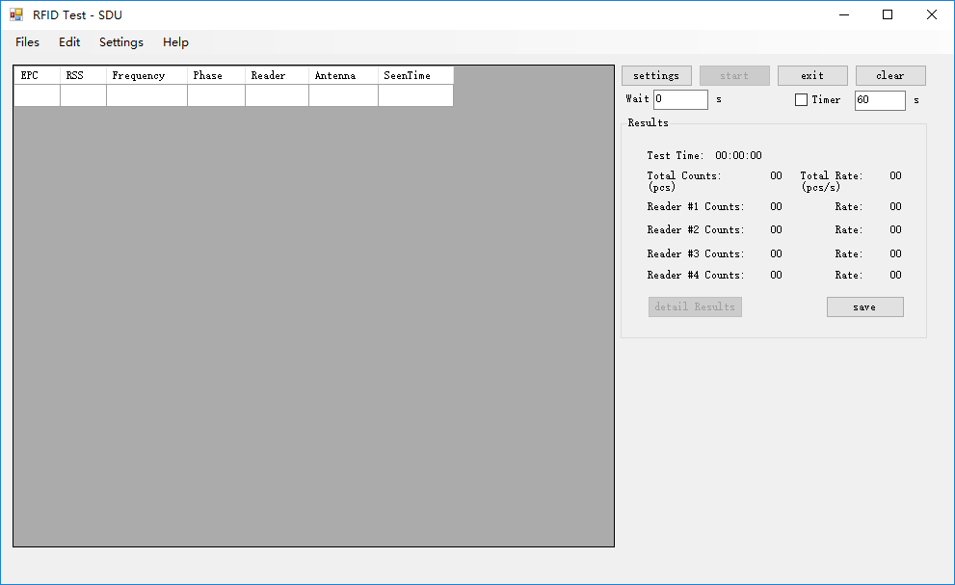

1. Setup the readers

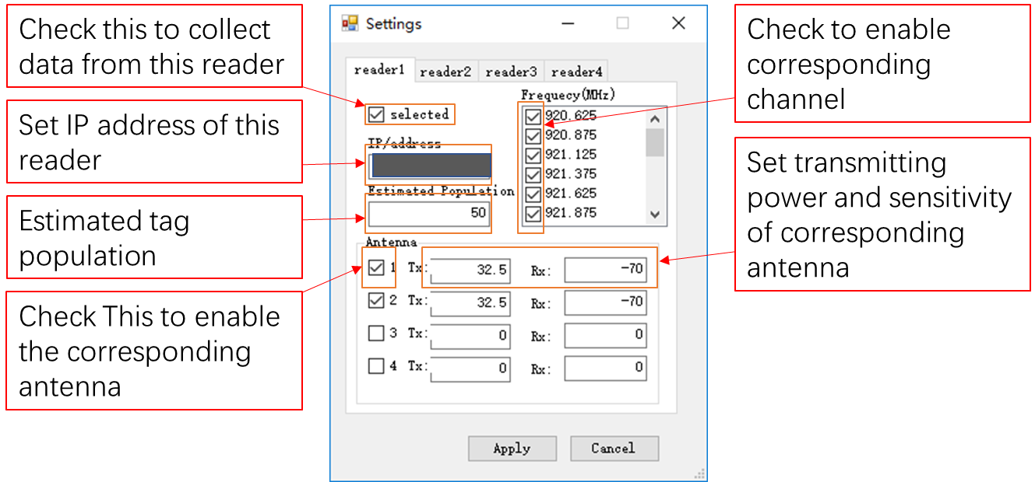

If you get this error message after clicking ‘Apply’, check the following questions:

Are all the selected readers properly powered?

Are the readers connected to the PC through Ethernet?

Do the readers support LLRP protocol?

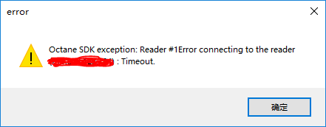

1. Click ‘Start’ to start an inventory session:

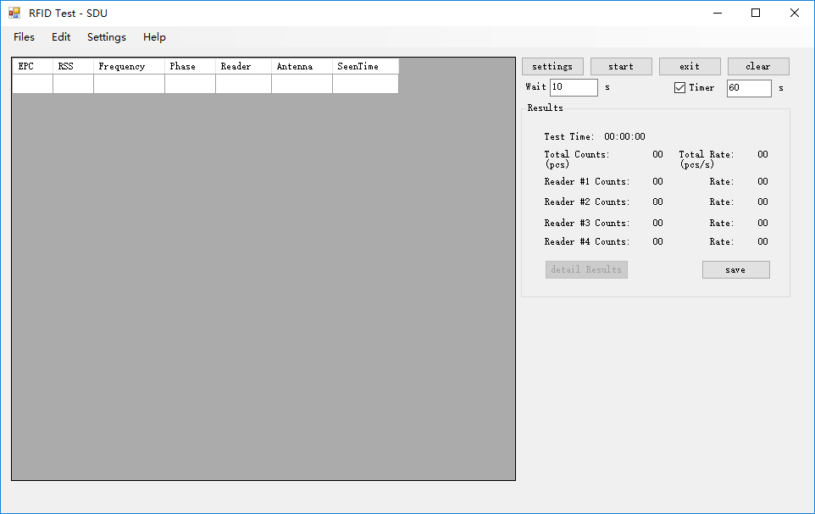

1. Press ‘Save’ to save the result to a ‘.csv’ file
2. 