AI-Enhanced Hybrid Intrusion Detection System (HIDS): A Phased MVP Approach for ISP Network Security
Final Year Project Report

Executive Summary
This project addresses the critical challenge of alert fatigue and threat detection in Internet Service Provider (ISP) networks. It proposes an AI-Enhanced Hybrid Intrusion Detection System (HIDS) that intelligently fuses signature-based and anomaly-based detection. Recognizing the complexity of a full-scale deployment, this project adopts a phased, MVP (Minimum Viable Product) development strategy. The primary deliverable is a functional proof-of-concept that validates the core hypothesis: correlating Suricata alerts with ML-scored Zeek flow data significantly improves threat prioritization and provides actionable intelligence. This MVP will be developed and validated using the standardized CIC-IDS2017 dataset within a controlled lab environment, ensuring a focused and achievable scope for the initial project timeline.

1. Problem Definition / Statement
Conventional network security monitoring in ISP environments is hampered by the isolated operation of intrusion detection tools. Signature-based systems, such as Suricata, generate excessive low-fidelity alerts from vast subscriber traffic, causing crippling analyst alert fatigue. Anomaly-based systems, such as Zeek flow analysis with ML, produce cryptic scores that are difficult to act upon at scale.
This creates an operational gap where genuine threats are buried in noise. There is a clear need for an integrated system that intelligently fuses evidence from disparate detection methods, suppresses false alarms, elevates high-confidence threats, and provides explainable, actionable intelligence.
Project Approach: To address this challenge within a constrained timeframe, the project will be executed in phases. The first and primary phase is the development of a Minimum Viable Product (MVP). This MVP is designed to conclusively validate the core technical premise: that the correlation and weighted fusion of signature alerts with ML-driven anomaly scores creates a more accurate and actionable security alert. Success in this phase will create a robust foundation for subsequent development into a production-ready system.

2. Related Work & Literature Review
The evolution of Intrusion Detection Systems reveals a clear trajectory from simple pattern matching to intelligent data fusion. The following timeline contextualizes this project within the broader field:
Academic literature strongly advocates for a hybrid approach. Studies utilizing datasets like CIC-IDS2017 demonstrate that combining methods improves detection rates. However, a gap exists between theoretical models and deployable tools. This project directly addresses this by building a modular, explainable system with a clear operational path for ISPs, distinguishing it from monolithic research prototypes or opaque commercial suites.
Table 1: Comparison of Relevant Intrusion Detection Approaches
System/Approach | Detection Method | Key Strength | Key Limitation | Relevance to This Project
Snort/Suricata | Signature-based | High accuracy for known threats | Cannot detect zero-days; Alert fatigue | Core signature input source
Zeek (Bro) | Anomaly/Protocol Analysis | Rich, contextual network logs | Lacks built-in severity scoring | Core flow data and feature source
Wazuh (OSSEC HIDS) | Host-based, Log Analysis | Excellent host integrity monitoring | Limited native network anomaly detection | Future integration path
Academic Hybrid Models | ML + Signatures | Improved DR & FAR | Often monolithic; Not deployable | Validates core hypothesis

3. Background Information / Theory

3.1 Intrusion Detection Systems (IDS)
(Your existing, excellent background on IDS types, their limitations, and the hybrid approach remains perfectly valid here.)

3.2 The CIC-IDS2017 Dataset
The CIC-IDS2017 dataset is a benchmark created by the Canadian Institute for Cybersecurity. It contains labeled network flows for 14 attack types, captured in PCAP files and CSV summaries. Its structured nature and realistic background traffic make it an ideal, repeatable source for training ML models and testing the MVP's correlation and fusion logic without the complexity of live network taps.

3.3 Machine Learning for Network Anomaly Detection
For the MVP, a Random Forest classifier is selected. It is robust to overfitting, handles non-linear relationships well, and provides feature importance output, crucial for generating explanations. The model will be trained on flow features extracted from Zeek's conn.log to output a probabilistic anomaly score.

3.4 The MVP Development Methodology
The Minimum Viable Product strategy focuses on building just enough to test a core hypothesis.
- Core Hypothesis: Fusing signature and anomaly detection reduces noise and improves threat prioritization.
- MVP Goal: To build the simplest functional system to prove/disprove this under controlled conditions.
- Advantage: Focuses effort on novel correlation/fusion logic, de-risks the project timeline, and ensures a demonstrable result.

4. System Design & Architecture

4.1 High-Level MVP Architecture
The MVP architecture is designed for modular development within a lab environment. The following diagram illustrates the main components and the unidirectional flow of data from raw inputs to actionable intelligence.
*Figure 1: High-Level MVP System Architecture & Data Flow.*
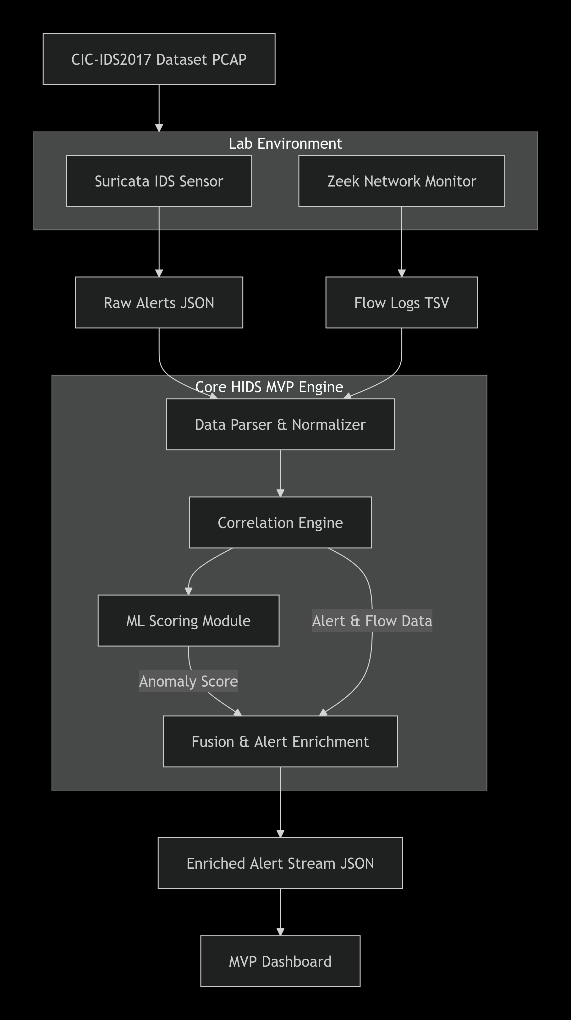

4.2 Component Interaction Sequence
The following sequence diagram details the step-by-step interaction between the core software components when processing a single malicious network flow, such as a port scan.
Figure 2: Detailed Sequence of Operations for Threat Processing.
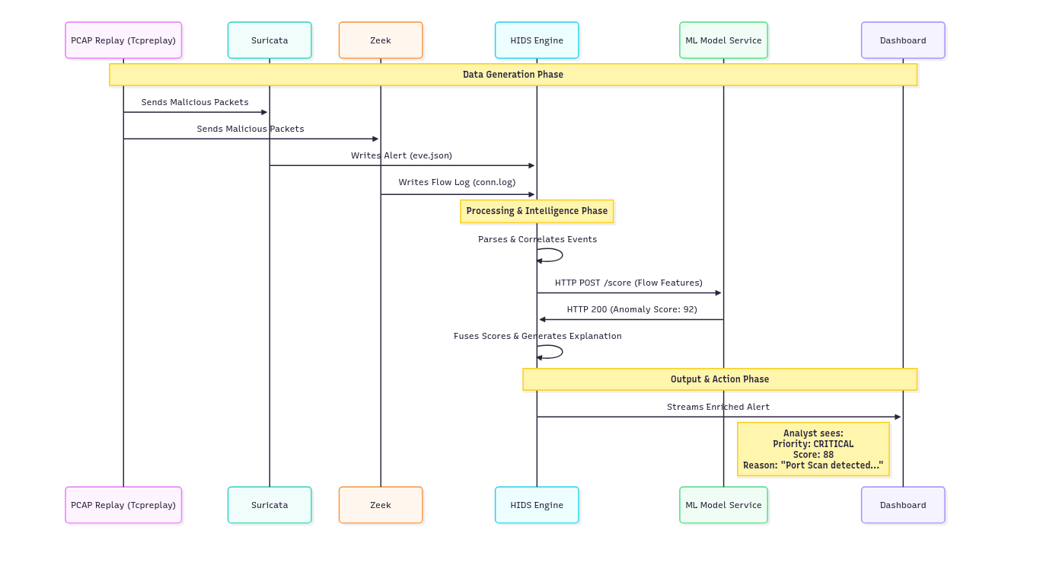

4.3 Component Specifications
1. Data Generation Layer: Suricata & Zeek process replayed PCAPs. Suricata uses the Emerging Threats Open rule set.
2. Core HIDS Engine (Custom Python Application):
- Parsing Module: Uses pandas and json.
- Correlation Engine: Hash-map-based 5-tuple matching.
- ML Client: Extracts feature vector (see Table 2) and queries ML service.
- Fusion Engine: Applies formula, determines priority, creates explanation.
Table 2: Key Features Extracted from Zeek conn.log for ML
Feature | Description | Threat Indicator
duration | Flow length (seconds) | Short flows may indicate scanning.
orig_pkts | Originator packets | High volume can mean DDoS/exfiltration.
resp_pkts | Responder packets | Asymmetry can be suspicious.
conn_state | TCP state (e.g., S0, REJ) | S0 (refused) often signals probing.
3. ML Model Service: A Flask REST API serving a pre-trained scikit-learn Random Forest model.
4. Presentation Layer: A basic Flask dashboard displaying alerts in a sortable table.

4.4 Core Fusion Algorithm
python
# Pseudo-code for the core alert enrichment logic
def enrich_alert(suricata_alert, matched_zeek_flow):
# 1. Extract features from the matched network flow
features = extract_flow_features(matched_zeek_flow)

# 2. Get anomaly score from the ML microservice
ml_anomaly_score = query_ml_service(features) # Returns value 0-100

# 3. Normalize Suricata's alert severity (example: scale 1-3 to 0-100)
normalized_sig_score = normalize_severity(suricata_alert.severity)

# 4. Apply weighted fusion formula
composite_score = (0.6 * normalized_sig_score) + (0.4 * ml_anomaly_score)

# 5. Assign a priority level based on thresholds
if composite_score >= 75:
priority = "CRITICAL"
elif composite_score >= 50:
priority = "HIGH"
# ... (other tiers)

# 6. Generate a human-readable explanation
explanation = generate_explanation(suricata_alert.rule, ml_anomaly_score, features)

# 7. Return the final, enriched alert object
return EnrichedAlert(composite_score, priority, explanation, original_data)

5. Implementation Strategy

5.1 Technology Stack Justification
- Python & Flask: Chosen for rapid prototyping, extensive data science libraries (pandas, scikit-learn), and creating lightweight microservices.
- scikit-learn: Selected over deep learning frameworks because structured flow data is optimal for Random Forest, which offers faster training and intrinsic explainability.
- Modular Microservices: The ML model is a separate service (Flask API). This allows for independent updating, scaling, and makes the system easier to debug and test.

5.2 Development Timeline & Milestones
A disciplined, phased approach is critical for success within 3 months. The Gantt chart below outlines the key phases and deliverables.
Figure 3: MVP Development Timeline (Gantt Chart).
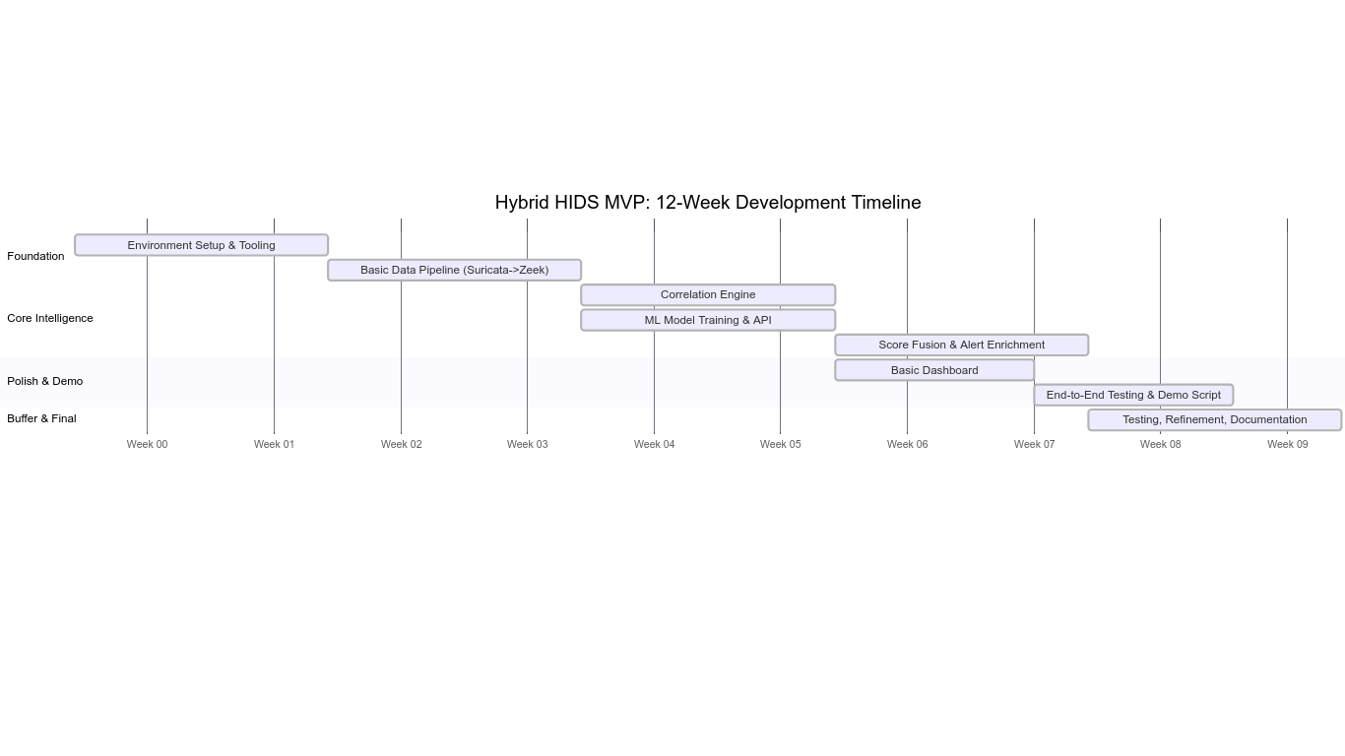

6. Testing, Validation & Expected Outcomes

6.1 MVP Validation Plan
Testing will use the labeled CIC-IDS2017 dataset to quantitatively measure the MVP's performance against its core goals.
- Test 1: Pipeline Integrity: Replay specific attack PCAPs (e.g., BruteForce-Wordpress.pcap). Success is defined as the system processing data from input to dashboard without failure.
- Test 2: Correlation Accuracy: Measure the percentage of Suricata alerts that are successfully paired with a Zeek flow using the 5-tuple. Target: >85% correlation rate for relevant alerts.
- Test 3: Fusion Logic Verification: Manually verify that alerts with high signature severity AND high anomaly scores receive the highest composite priority and a correct explanation.

6.2 Expected Results & Impact
The primary expected outcome is a drastic reduction in alert volume without missing true threats. The following diagram contrasts the analyst's experience before and after the MVP:
Figure 4: Expected Operational Impact: From Alert Flood to Focused Intelligence.
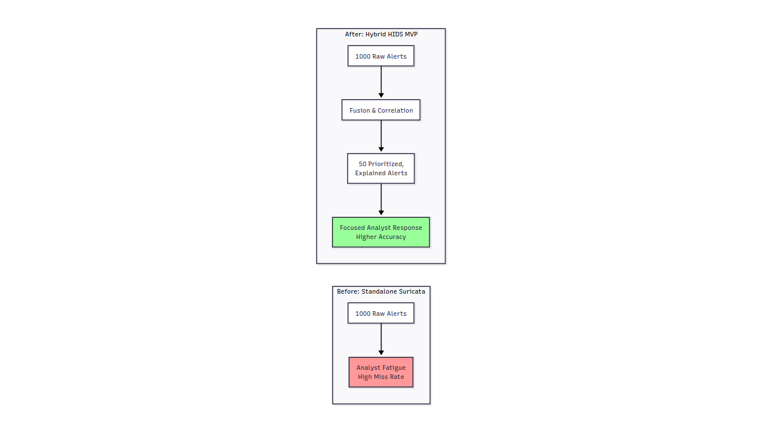
Quantitatively, we expect metrics similar to those in the mock table below, demonstrating the MVP's value.
*Table 3: Mock Performance Results (Based on CIC-IDS2017 Subset)*

Metric | Standalone Suricata | Standalone ML Model | Hybrid HIDS MVP
Total Alerts Generated | 1,000 | 800 | 50
True Positives Identified | 18 | 15 | 17
False Positives | 982 | 785 | 33
Analyst Alerts to Review | 1,000 | 800 | 50
Detection Rate | 90% | 75% | 85%
False Alarm Rate | 98.2% | 98.1% | 66%

7. Discussion & Future Work

7.1 Projected Discussion of Results
(To be filled after testing.)
- The MVP will likely demonstrate that fusion provides a more balanced threat view than any single method.
- Limitations will include dependency on rule/model quality and performance constraints of the lab environment.
- Successful validation will prove the architecture's soundness for future phases.

7.2 Phased Roadmap for ISP Deployment
The MVP is step one in a practical roadmap for ISP adoption:
Phase 2: Pilot Integration
- Data: Replace CIC-IDS2017 with live NetFlow from a MikroTik router.
- Sensor: Deploy Suricata on a mirror/SPAN port at the network edge.
- Goal: Validate performance and accuracy in a real, low-risk network segment.
Phase 3: Production Enhancement
- Scale: Containerize services (Docker) for robust deployment.
- Enrich: Integrate threat intel APIs (VirusTotal, AbuseIPDB).
- Automate: Add hooks for ticketing systems (RT, Jira) or firewall APIs.
Phase 4: Advanced Intelligence & Scale
- ML Ops: Implement continuous retraining of models with new flow data.
- Architecture: Evolve to a streaming pipeline (Apache Kafka, Flink) for ISP-scale data.
- Expand: Incorporate Wazuh HIDS data from critical servers.

