LabTrack Installation and Configuration
Applicable from version: LabTrack v0.3.0
Chris Mills, Head of Product (Calira)
Reviewed against LabTrack v0.3.0.1
Supported Platforms
- Windows 10 / Windows 11
- Administrator privileges required for installation

LabTrack interactive install 2
LabTrack configuration 5
Settings reference 7
Admin access 7
LabTrack interactive uninstall 8
Resetting LabTrack app configuration on Windows 10
LabTrack silent install and uninstall 11
Overview 11
Installation mode and uninstallation mode are independent 11
Silent installation 11
Silent uninstallation 12
Troubleshooting 12
Version history 13

LabTrack interactive install
- Double-click the installer provided by Calira, for example LabTrack_v0.3.0.1.exe, and accept the Windows permission prompt when it appears.
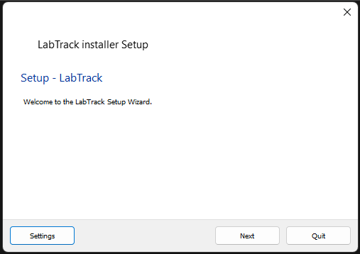
- Optional: select Settings in the bottom left corner to configure a network proxy.
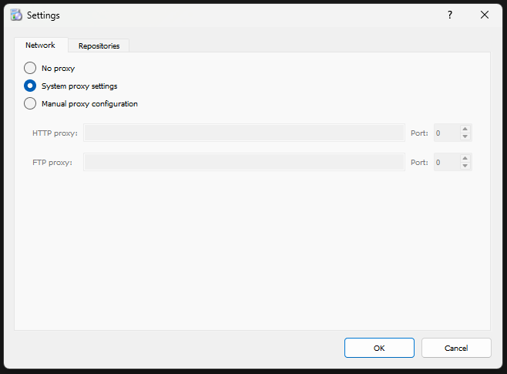
- Select Next, then choose an installation path. Accept the default unless your IT department has told you otherwise.
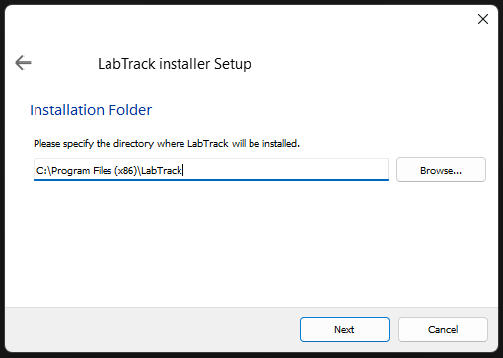
- Select Next and choose the components to install. Install all components unless you have been told otherwise.
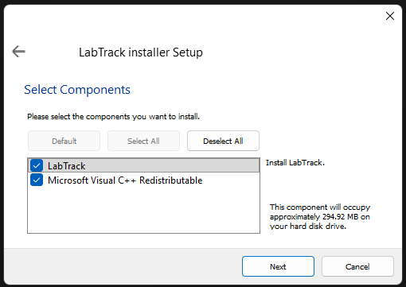
- Select Next. You can rename the Start menu entry, but this is not recommended because the entry will then no longer match the application name.
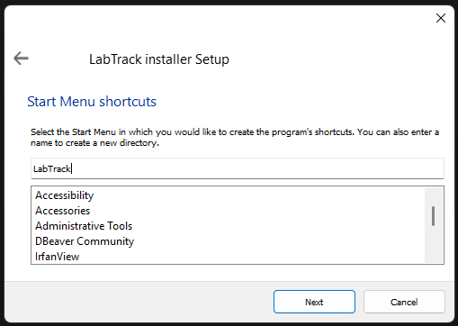
- Select Next, then Install.
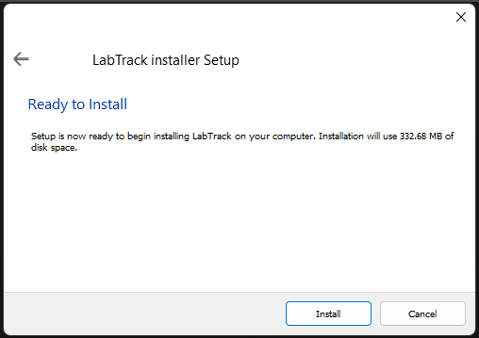
- Accept the Windows prompt to grant permission to install the application. The installation then runs.
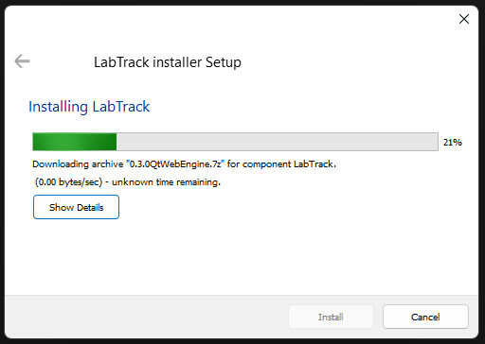
If pop-ups flash up and disappear
This is usually a conflict with an existing Microsoft Visual C++ installation. Cancel the install, run it again and clear the option to install Microsoft Visual C++.

LabTrack configuration
Log in as a Calira lab admin the first time LabTrack starts to set up the PC for its equipment. Settings are stored for the whole PC, so Windows asks for permission each time you save them. Accept the prompt.
LabTrack can be used with two basic approaches:
- Users require a booking to view the Windows desktop for the PC connected to the equipment. This enforces booking compliance and allows for comparing booked versus actual utilization.
- Users do not require a booking to view the Windows desktop for the PC connected to the equipment. This only supports actual utilization.

The steps to configure these two approaches are summarized in the diagram below.
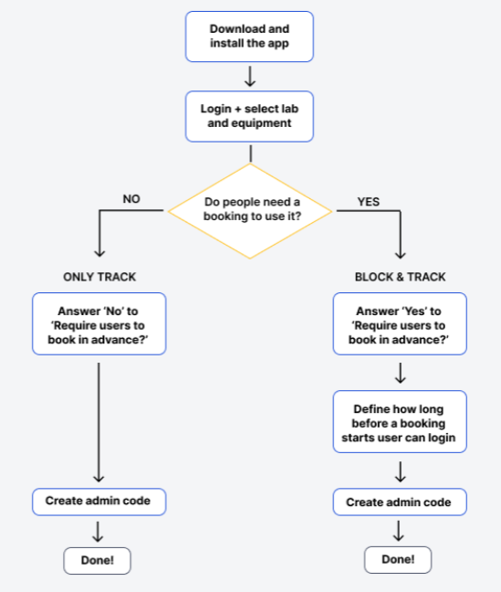
These steps are summarized in more detail in the table below:
Step Number | Enforce Bookings Step | Don’t Enforce Steps
1 | Log In | Log In
2 | Select your lab | Select your lab
3 | Select the connected equipment | Select the connected equipment
4 | Set launch on startup (usually yes) | Set launch on startup (usually yes)
5 | Select yes for “Require users to book in advance” | Select no for “Require users to book in advance”
6 | Set how much earlier than a booking a user can log in. | Decide whether to use a default session length when there is no booking.
7 | Set whether the LabTrack session should auto-end when the booking ends. | If using a default session length then set the length for the default.
8 | If you selected auto-end sessions then choose how long after the booking ends the LabTrack session ends.

Settings reference
Defaults are those in LabTrack v0.3.0.1. The researcher column explains what each setting changes for people using the PC. Researchers can read the LabTrack user guide for researchers for the full picture.
Setting | What it does for researchers | Default
Launch on system startup | LabTrack starts when Windows starts and locks the PC. Choose Yes for any PC that should always be locked. | Set during setup. Usually Yes.
Require users to book in advance | Yes: researchers need a confirmed booking of their own to unlock the PC. No: anyone can log in and LabTrack records the session without a booking. | Yes
How much earlier than a booking start can a user log in | How many minutes before a booking starts researchers can unlock the PC. Their actual start time is recorded at log in. | 15 minutes
Automatically end session when booking slot ends | LabTrack ends the researcher’s session after the booking finishes, so unattended sessions do not run on. Lab admins are never ended automatically. | Yes
Interval after booking end | How long after the booking ends the session is ended. Researchers get a warning 5 minutes before and can delay the end. | 15 minutes
Use default session length (no booking required) | Ends sessions with no booking after a fixed time. Only shown when bookings are not required. | Set during setup. Yes when bookings are not required.
Default session length without a booking | How long a session without a booking lasts before it is ended automatically. | 60 minutes

Admin access
Lab admins can always unlock the PC, with or without a booking, and are not ended automatically. To get to the Windows desktop without logging in, select Bypass with admin code on the log-in screen and enter the admin PIN. The PIN is stored on the PC. To set or change it, log in as a lab admin and click the config icon (cog wheel). Other users are returned to the LabTrack log-in screen if they try to leave it.
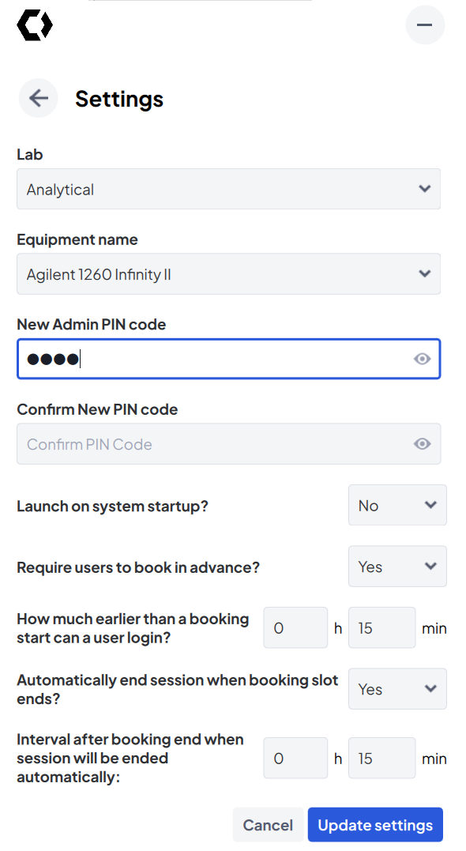

LabTrack interactive uninstall
Uninstalling LabTrack works the same way as for any Windows program.
- Open the Start menu, type “program” and select Add or remove programs. The installed apps list opens.
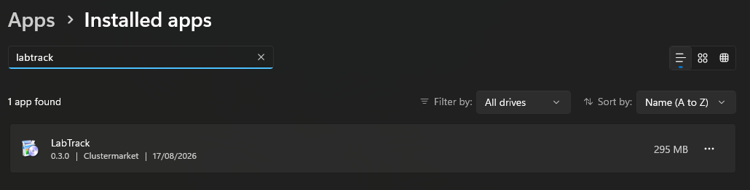
- Type “labtrack” in the search box at the top of the list.
- Select the ellipsis (“...”) on the LabTrack row and choose Uninstall.
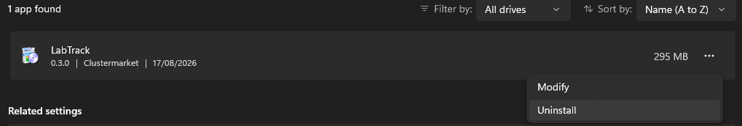
- The uninstaller opens. It gives you the option to remove all components.
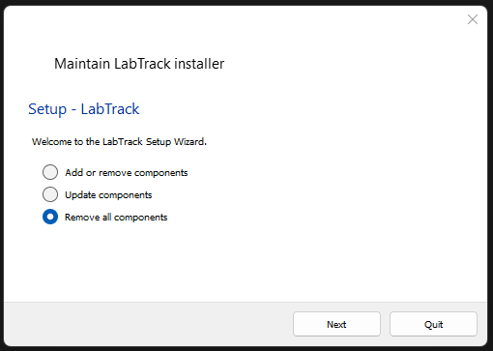
- Select Next, then Uninstall.
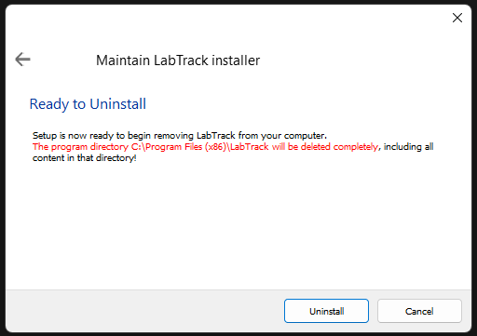
Uninstalling does not remove LabTrack’s settings. If you need a full reset, follow the steps below.

Resetting LabTrack app configuration on Windows
Use this reset if you see unexpected errors during installation or uninstallation that may come from an earlier installation, or when a PC needs to be set up for different equipment.
LabTrack keeps its settings in the Windows registry, so they stay after you uninstall. They include the lab and equipment the PC is set up for, the booking rules and the admin PIN. A reset removes all of them. A lab admin must then set the PC up again.
Registry location | What it holds
HKEY_LOCAL_MACHINE\SOFTWARE\Clustermarket\LabTrack | Current settings: lab, equipment, booking rules and admin PIN. On 64-bit Windows, also check HKEY_LOCAL_MACHINE\SOFTWARE\WOW6432Node\Clustermarket\LabTrack.
HKEY_CURRENT_USER\Software\Clustermarket\LabTrack | Settings from older versions. LabTrack copies them to the machine settings on first start if the machine settings are empty, so delete this key too.
HKEY_LOCAL_MACHINE\SOFTWARE\Microsoft\Windows\CurrentVersion\Run, value LabTrack | The start-up entry created by “Launch on system startup”.

- Uninstall LabTrack using the steps above.
- Press Win + R, type regedit and select OK. Select Yes when Windows asks for permission.
- Go to HKEY_CURRENT_USER\Software\Clustermarket. Right-click the LabTrack key and select Delete. If there is no LabTrack key, continue.
- Go to HKEY_LOCAL_MACHINE\SOFTWARE\Clustermarket. Right-click the LabTrack key and select Delete. Delete only the LabTrack key, not the Clustermarket key above it. Repeat under WOW6432Node if a LabTrack key exists there.
- Optional: if the PC was set to launch LabTrack on startup, go to HKEY_LOCAL_MACHINE\SOFTWARE\Microsoft\Windows\CurrentVersion\Run and delete the LabTrack value.
- Restart the PC, reinstall LabTrack and log in as a lab admin to set the PC up again.
Warning
Be careful when changing the registry. Incorrect changes can harm your system. Export a backup of the registry before you start.

LabTrack silent install and uninstall

Overview
From LabTrack v0.3.0, LabTrack supports both silent and interactive installation and uninstallation.
Important
Silent behaviour is not automatic.
Silent mode is enabled only when you provide the matching command-line flag.
Without the flag, the installer or uninstaller always runs in interactive mode.

Installation mode and uninstallation mode are independent
The way you installed LabTrack does not decide how you can uninstall it. All four combinations work.
Installed | Can be uninstalled
Silently | Interactively or silently
Interactively | Interactively or silently

Silent installation
The silent install installs LabTrack without showing any interface or asking for input. Run it from Windows PowerShell, as an administrator, in the folder that contains the installer.

Command
.\LabTrack_v0.3.0.1.exe silent=1 --verbose
Use the file name of the installer Calira gave you.

Behaviour
- No installer interface is shown.
- The installer goes through all steps on its own.
- The installer handles previous versions.
- The installation completes in the background.
- The exit code shows success or failure.

Notes
- silent=1 must be provided. Without it the installer always opens its interface.
- --verbose is recommended for logging and troubleshooting.

Silent uninstallation
Silent uninstall is opt-in. It runs silently only when you provide the silentUninstall=1 flag. It works whichever way LabTrack was installed.

Command
Run from Windows PowerShell, as an administrator, in the LabTrack installation directory:
cd "C:\Program Files (x86)\LabTrack"
.\maintenancetool.exe --uninstall silentUninstall=1
The path shown is the default. If LabTrack was installed somewhere else, use that folder.

Common pitfalls
- Running the uninstall without silentUninstall=1 and expecting it to run silently.
- Running the command outside the LabTrack installation directory.
- Running without administrator privileges.

Troubleshooting
What you see | Likely cause | What to do
Pop-ups flash up and disappear during install | Conflict with an existing Microsoft Visual C++ installation. | Cancel, run the installer again and clear the Visual C++ option.
Errors during install or uninstall | Settings or files left by an earlier installation. | Follow “Resetting LabTrack app configuration on Windows”.
The silent install or uninstall shows a window | The silent flag is missing. | Add silent=1 to the install command or silentUninstall=1 to the uninstall command.
The silent uninstall does nothing | The command ran outside the installation directory, or without administrator rights. | Open PowerShell as an administrator and run the command from the LabTrack folder.
Windows asks for permission when you save settings | LabTrack stores its settings for the whole PC and needs administrator rights to do that. | Accept the prompt. If you decline, the settings are not saved.
LabTrack does not start with Windows | Launch on system startup was set to No, or the start-up entry was not written. | Log in as a lab admin, open settings, set Launch on system startup to Yes and save.
The set-up screen appears again | The PC has no saved settings, for example after a reset. | Log in as a lab admin and set the PC up again.
“Equipment deleted. Application reset required.” | The equipment was deleted in Calira. | Select Reset equipment and set the PC up again for the correct equipment.
“Update available” | A newer version of LabTrack exists. | Get the new installer from Calira and install it over the existing version. Researchers should select Cancel.
A researcher cannot unlock the PC | No confirmed booking of their own inside the unlock window. | Check the booking in Calira and the unlock window in settings. See the user guide for researchers.
An admin cannot remember the admin PIN | The PIN is stored on the PC and cannot be read back. | Log in as a lab admin, open settings from the config icon and set a new PIN.
Log in fails with a connection error | The PC cannot reach Calira. | Check the PC’s internet access and proxy settings with your IT department.

