INTERNSHIP REPORT
A report submitted in partial fulfilment of the requirements for the Award of Degree of
BACHELOR
OF
COMPUTER SCIENCE & ENGINEERING
With Specialization in
AI&ML
By:
LOVEPREET KAUR
Roll No. : 2301301130
Under the Supervision of
MR. PANKAJ BAJAJ
Geeta Technical Hub
Geeta University, Naultha, Panipat 132145


SCHOOL OF COMPUTER SCIENCE & ENGINEERING
GEETA UNIVERSITY, PANIPAT
(09 September 2024)

GEETA UNIVERSITY, PANIPAT

CANDIDATE’S DECLARATION

I, Lovepreet Kaur, bearing Roll No. 2301301130, hereby declare that the work presented in this internship report titled “Generative AI”, submitted in partial fulfillment of the requirements for the award of the degree of Bachelor of Technology (B.Tech.) in Computer Science and Engineering with a specialization in Artificial Intelligence and Machine Learning, at the School of Engineering, Geeta University, Panipat, is an original and authentic record of my work.
The work was conducted from June 16, 2025 to July 31, 2025, under the esteemed guidance and supervision of Mr. Pankaj Bajaj, Chief Operating Officer (COO), GTH. To the best of my knowledge, this work has not been submitted, in part or full, for the award of any other degree or diploma at this or any other institution.

Signature of the student with date
(Lovepreet Kaur)

This is to certify that the above statement made by the candidate is correct to the best of my/our
knowledge.

Signature of the Head
(09/09/24)
(Mr. Pankaj Bajaj)

Appreciation Letter

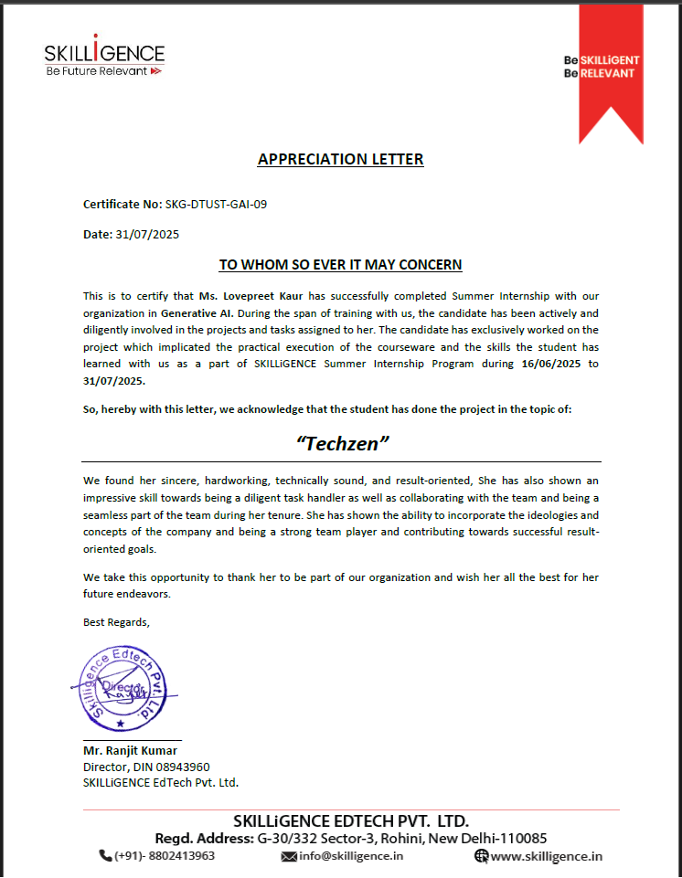

CERTIFICATE

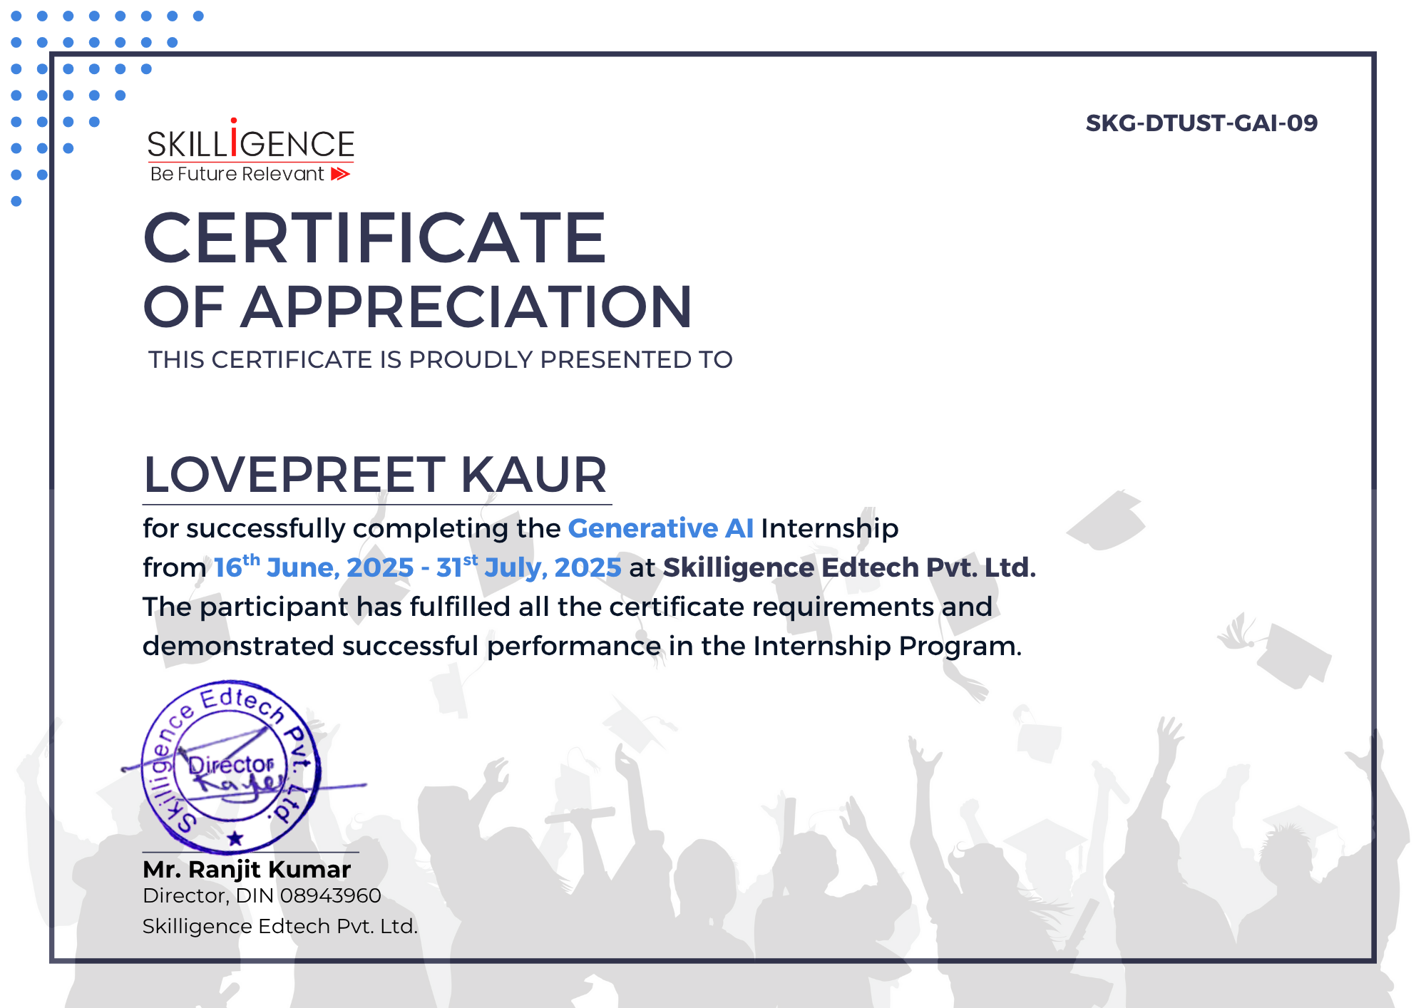

ACKNOWLEDGEMENT

I would like to express my sincere gratitude to Mr. Pankaj Bajaj, Chief Operating Officer (COO) of Geeta Technical Hub (GTH) , for his continuous support and guidance throughout my academic journey. His encouragement and approval enabled me to undertake this off-campus summer internship.
I am thankful to the entire team at Skilligence for giving me the opportunity to work on real-world projects in the domain of Generative AI. Their mentorship and the hands-on experience I gained have played a vital role in enhancing both my technical skills and professional development.
I also extend my appreciation to the faculty and staff of Geeta University for their academic support and motivation throughout the internship period.
Special thanks to my friends and colleagues for their collaboration and encouragement, and to my family for their unwavering support and inspiration throughout this journey.
Lovepreet Kaur
Roll No.: 2301301130
B.Tech. CSE (AI & ML)
Geeta University, Panipat

Abstract

This report presents the work completed during my summer internship at Skilligence, focusing on the domain of Generative Artificial Intelligence (GenAI). The internship provided a structured learning experience, starting from the basics of Python programming and progressing to advanced applications of GenAI using modern AI frameworks and libraries.
During the internship, I began by strengthening my foundation in Python and working with libraries like Pillow for basic image processing. This foundation paved the way for more advanced topics such as Natural Language Processing (NLP), transformer-based models, and deep learning using tools such as Gradio, Hugging Face Transformers, PyTorch, and TorchVision.
As part of the hands-on learning, I developed and deployed several AI-powered mini to major projects, including a story generator, image-to-story generator, text-to-image model, sentiment analyzer, and a fake news detection system. These projects allowed me to gain practical experience in building end-to-end machine learning applications and working with real-world data.
The internship emphasized not just technical skills but also model evaluation, optimization, and the ethical use of generative technologies. The experience significantly enhanced my understanding of GenAI workflows and the real-world impact of these systems.
In conclusion, the internship at Skilligence offered a valuable blend of theoretical knowledge and practical implementation in Generative AI, preparing me for future roles in AI development and research, and strengthening my confidence as an AI practitioner.

TABLE OF CONTENT
S.No. | Topic | Page No.
1 | Introduction
2 | Python: From Basics to Advanced

INTRODUCTION

Artificial Intelligence (AI) has witnessed remarkable growth in recent years, with Generative AI (GenAI) becoming one of its most influential and dynamic areas. GenAI emphasizes the creation of new content—such as text, images, audio, and code—through advanced deep learning models trained on extensive datasets. This report presents my learning journey during a summer internship at Skilligence, where I delved into the fundamentals, tools, and real-world applications of Generative AI.
The internship followed a structured roadmap that began with strengthening my Python programming skills, gradually moving into the study of essential libraries and frameworks required for GenAI development. The hands-on methodology allowed me to bridge the gap between theory and practice by designing and implementing functional AI-driven applications.
During this period, I worked with foundational libraries like Pillow, NumPy, and Pandas, along with data visualization tools such as Matplotlib and Seaborn, which enhanced my understanding of data processing and analysis. As I advanced, I gained practical exposure to powerful frameworks like Gradio, Hugging Face Transformers, and PyTorch, which are commonly used in cutting-edge AI research and development.
I also developed multiple projects, including a text-to-image generator, an AI Interview Trainer, a speech-to-text and text-to-speech system, a language translation tool, a summarization model, and an sentiment analysis systems. These projects relied heavily on Natural Language Processing (NLP) techniques and transformer architectures, which helped me strengthen both my conceptual understanding and technical expertise in Generative AI.
This report outlines the skills, tools, and knowledge acquired during the internship, along with the projects completed and challenges encountered. It highlights my professional growth and demonstrates my preparedness to contribute meaningfully to the rapidly expanding domain of Artificial Intelligence.

Python: From Basics to Advanced

Python acted as the backbone of my internship at Skilligence, providing the base for exploring AI, NLP, and Generative AI. The learning started with fundamental concepts and gradually moved into advanced programming practices, ensuring both clarity and efficiency in writing AI-focused code.

- Python Basics :-
In the initial stage of the internship, the following fundamental Python concepts were covered:
During the initial stage, I revised and practiced the following topics:
- Data Types & Variables → integers, strings, floats, lists, tuples, and dictionaries.
- Control Flow → if-else statements, while and for loops.
- Functions → defining reusable blocks with parameters and return values.
- Object-Oriented Basics → classes, objects, constructors, and inheritance.
- Error Handling → using try-except to handle invalid inputs or runtime errors.

✅ Example –
def check_even(num):
if num % 2 == 0: # Control flow with if-else
return f"{num} is Even"
else:
return f"{num} is Odd"

print(check_even(6)) # Output: 6 is Even
print(check_even(7)) # Output: 7 is Odd
- Advanced Python Concepts :-

As I progressed in my internship, I moved from basic Python to more powerful and professional coding techniques. These concepts made my code cleaner, faster, and easier to manage.

Object-Oriented Programming (OOP) :-
OOP is a way of structuring code where we group related data and functions together into something called a class.
- Class: Like a blueprint (e.g., a design for a car).
- Object: The actual thing made from that blueprint (e.g., an actual car).
This helps to make AI models and tools more organized and reusable.
Example:
class StoryGenerator:
def __init__(self, title):
self.title = title # Store the story title

def display(self):
print(f"Story Title: {self.title}")

# Creating an object
story = StoryGenerator("AI Adventure")
story.display()
Here, StoryGenerator is the blueprint, and story is an object made from it.

- File Handling :-
File handling means reading and writing data to files.
- Why needed: To save AI-generated outputs (like a story or image description) and load
3
datasets.

Example:
# Writing data
with open("output.txt", "w") as file:
file.write("This is an AI-generated text.")

# Reading data
with open("output.txt", "r") as file:
print(file.read())
Here, "w" means write mode (create/overwrite file) and "r" means read mode.

Exception Handling :-
Sometimes, programs crash because of unexpected errors (like dividing by zero). Exception handling prevents crashes by catching errors.
Example:
try:
number = int(input("Enter a number: "))
print(10 / number)
except ZeroDivisionError:
print("You can't divide by zero.")
except ValueError:
print("Please enter a valid number.")
This ensures the program doesn’t stop even if the user makes a mistake.

List Comprehensions :-
A shortcut for creating lists in a single line instead of writing long loops.
Example:
squares = [x**2 for x in range(5)]
print(squares) # Output: [0, 1, 4, 9, 16]
It’s cleaner and faster to write.

Lambda Functions :-
A one-line function without a name — useful for quick tasks.
Example:
multiply = lambda x, y: x * y
print(multiply(3, 4)) # Output: 12
I used this in my AI code for small transformations.

Decorators :-
A decorator is like adding extra features to an existing function without changing its code . Like adding a welcome message before every function.
Example:
def decorator(func):
def wrapper():
print("Before function call")
func()
print("After function call")
return wrapper
@decorator def say_hello():
print("Hello!")
say_hello()
Here, @decorator adds new behavior to say_hello() automatically.

As the foundational language for modern Artificial Intelligence development, Python played a crucial role in my internship at Skilligence. The internship began with a structured revision of Python fundamentals, followed by advanced programming concepts and hands-on practice with essential libraries. This phase was crucial in building the groundwork required to explore deep learning, natural language processing (NLP), and Generative AI tools.

- Python Basics :-
In the initial stage of the internship, the following fundamental Python concepts were covered:
- Data Types and Variables: Working with integers, floats, strings, lists, dictionaries, and tuples.
- Conditional Statements and Loops: Using if-elif-else, for, and while loops to control program flow.
- Functions: Writing reusable code using def, along with default arguments and return values.
- OOP Concepts: Understanding classes, objects, constructors, inheritance, and encapsulation.
- Exception Handling: Managing errors with try-except blocks for safer code execution.

✅ Example – Prime Number Checker

def is_prime(n):
if n <= 1:
return False
for i in range(2, int(n ** 0.5) + 1):
if n % i == 0:
return False
return True
print(is_prime(7)) # Output: True
2
- Advanced Python Concepts :-

As I progressed in my internship, I moved from basic Python to more powerful and professional coding techniques. These concepts made my code cleaner, faster, and easier to manage.

Object-Oriented Programming (OOP) :-
OOP is a way of structuring code where we group related data and functions together into something called a class.
- Class: Like a blueprint (e.g., a design for a car).
- Object: The actual thing made from that blueprint (e.g., an actual car).
This helps to make AI models and tools more organized and reusable.
Example:
class StoryGenerator:
def __init__(self, title):
self.title = title # Store the story title

def display(self):
print(f"Story Title: {self.title}")

# Creating an object
story = StoryGenerator("AI Adventure")
story.display()
Here, StoryGenerator is the blueprint, and story is an object made from it.

- File Handling :-
File handling means reading and writing data to files.
- Why needed: To save AI-generated outputs (like a story or image description) and load
3
datasets.

Example:
# Writing data
with open("output.txt", "w") as file:
file.write("This is an AI-generated text.")

# Reading data
with open("output.txt", "r") as file:
print(file.read())
Here, "w" means write mode (create/overwrite file) and "r" means read mode.

Exception Handling :-
Sometimes, programs crash because of unexpected errors (like dividing by zero). Exception handling prevents crashes by catching errors.
Example:
try:
number = int(input("Enter a number: "))
print(10 / number)
except ZeroDivisionError:
print("You can't divide by zero.")
except ValueError:
print("Please enter a valid number.")
This ensures the program doesn’t stop even if the user makes a mistake.

List Comprehensions :-
A shortcut for creating lists in a single line instead of writing long loops.
Example:
squares = [x**2 for x in range(5)]
print(squares) # Output: [0, 1, 4, 9, 16]
It’s cleaner and faster to write.

Lambda Functions :-
A one-line function without a name — useful for quick tasks.
Example:
multiply = lambda x, y: x * y
print(multiply(3, 4)) # Output: 12
I used this in my AI code for small transformations.

Decorators :-
A decorator is like adding extra features to an existing function without changing its code . Like adding a welcome message before every function.
Example:
def decorator(func):
def wrapper():
print("Before function call")
func()
print("After function call")
return wrapper
@decorator def say_hello():
print("Hello!")
say_hello()
Here, @decorator adds new behavior to say_hello() automatically.

As the foundational language for modern Artificial Intelligence development, Python played a crucial role in my internship at Skilligence. The internship began with a structured revision of Python fundamentals, followed by advanced programming concepts and hands-on practice with essential libraries. This phase was crucial in building the groundwork required to explore deep learning, natural language processing (NLP), and Generative AI tools.

- Python Basics :-
In the initial stage of the internship, the following fundamental Python concepts were covered:
- Data Types and Variables: Working with integers, floats, strings, lists, dictionaries, and tuples.
- Conditional Statements and Loops: Using if-elif-else, for, and while loops to control program flow.
- Functions: Writing reusable code using def, along with default arguments and return values.
- OOP Concepts: Understanding classes, objects, constructors, inheritance, and encapsulation.
- Exception Handling: Managing errors with try-except blocks for safer code execution.

✅ Example – Prime Number Checker

def is_prime(n):
if n <= 1:
return False
for i in range(2, int(n ** 0.5) + 1):
if n % i == 0:
return False
return True
print(is_prime(7)) # Output: True
2
- Advanced Python Concepts :-

As I progressed in my internship, I moved from basic Python to more powerful and professional coding techniques. These concepts made my code cleaner, faster, and easier to manage.

Object-Oriented Programming (OOP) :-
OOP is a way of structuring code where we group related data and functions together into something called a class.
- Class: Like a blueprint (e.g., a design for a car).
- Object: The actual thing made from that blueprint (e.g., an actual car).
This helps to make AI models and tools more organized and reusable.
Example:
class StoryGenerator:
def __init__(self, title):
self.title = title # Store the story title

def display(self):
print(f"Story Title: {self.title}")

# Creating an object
story = StoryGenerator("AI Adventure")
story.display()
Here, StoryGenerator is the blueprint, and story is an object made from it.

- File Handling :-
File handling means reading and writing data to files.
- Why needed: To save AI-generated outputs (like a story or image description) and load
3
datasets.

Example:
# Writing data
with open("output.txt", "w") as file:
file.write("This is an AI-generated text.")

# Reading data
with open("output.txt", "r") as file:
print(file.read())
Here, "w" means write mode (create/overwrite file) and "r" means read mode.

Exception Handling :-
Sometimes, programs crash because of unexpected errors (like dividing by zero). Exception handling prevents crashes by catching errors.
Example:
try:
number = int(input("Enter a number: "))
print(10 / number)
except ZeroDivisionError:
print("You can't divide by zero.")
except ValueError:
print("Please enter a valid number.")
This ensures the program doesn’t stop even if the user makes a mistake.

List Comprehensions :-
A shortcut for creating lists in a single line instead of writing long loops.
Example:
squares = [x**2 for x in range(5)]
print(squares) # Output: [0, 1, 4, 9, 16]
It’s cleaner and faster to write.

Lambda Functions :-
A one-line function without a name — useful for quick tasks.
Example:
multiply = lambda x, y: x * y
print(multiply(3, 4)) # Output: 12
I used this in my AI code for small transformations.

Decorators :-
A decorator is like adding extra features to an existing function without changing its code . Like adding a welcome message before every function.
Example:
def decorator(func):
def wrapper():
print("Before function call")
func()
print("After function call")
return wrapper
@decorator def say_hello():
print("Hello!")
say_hello()
Here, @decorator adds new behavior to say_hello() automatically.
Python Libraries for GenAI
During my internship in Generative AI, I learned and used several Python libraries that made it easier to build AI-powered applications. These libraries saved time, provided pre-built functions, and helped in quickly implementing ideas.
Below is an explanation of the main libraries I worked with:

Pillow (Python Imaging Library Fork) :-
Pillow is used for image processing — editing, resizing, converting formats, adding filters, etc.
Use :
- To process images before giving them to AI models.
- To generate or modify AI-created images.
Example:
#pip install Pillow in terminal
from PIL import Image

img = Image.new('RGB',(200,100),color='green')
img.show()
This creates an image of a box with green color.

Torch (PyTorch) :-
PyTorch is a deep learning library used to build and train neural networks.
Use:
- To work with AI models that generate text and images.
- To fine-tune pre-trained models for specific tasks.
Example:
import torch
# Create a simple tensor
x = torch.tensor([[1, 2], [3, 4]])
y = torch.tensor([[5, 6], [7, 8]])

# Matrix addition
z = x + y
print(z)
PyTorch is the backbone for running AI models in Transformers and Hugging Face.

Transformers :-
The transformers library by Hugging Face provides pre-trained AI models for NLP (Natural Language Processing) and other tasks.
Why I used it:
- For text generation, translation, summarization, and sentiment analysis.
Example (Text Generation):
from transformers import pipeline

# Create a text generation pipeline
generator = pipeline("text-generation", model="gpt2")

# Generate text
result = generator("Once upon a time, AI", max_length=30, num_return_sequences=1)
print(result[0]['generated_text'])
This generates a short story-like output using GPT-2.

Hugging Face Datasets :-
Provides datasets for AI training and testing.
Why I used it:
- To quickly load datasets for sentiment analysis and fake news detection.
Example:
from datasets import load_dataset

# Load a dataset
dataset = load_dataset("imdb")
print(dataset['train'][0])
This loads the IMDB movie review dataset for sentiment analysis.

Gradio :-
Gradio is used to create web-based interfaces for AI models without writing full frontend code.
Why I used it:
- To make interactive web apps for my AI models like Story Generator and Image-to-Story.
Example:
import gradio as gr

def greet(name):
return f"Hello {name}!"

interface = gr.Interface(fn=greet, inputs="text", outputs="text")
interface.launch()
This creates a small web app where users type their name and get a greeting.

NumPy :-
NumPy is used for mathematical and numerical operations.
Why I used it:
- For handling large datasets in AI projects efficiently.
Example:
import numpy as np

arr = np.array([1, 2, 3, 4])
print(arr.mean()) # Output: 2.5
NumPy is often used behind the scenes in AI model calculations.

Matplotlib & Seaborn :-
For data visualization.
Why I used it:
- To see trends in datasets before training AI models.
Example:
import matplotlib.pyplot as plt

data = [10, 20, 30, 40]
plt.plot(data)
plt.title("Sample Graph")
plt.show()
This helps in understanding datasets visually.
These libraries were the core tools that helped me in building and deploying Generative AI applications during my internship.

Projects Done During Internship

During my Generative AI internship at Skilligence, I worked on several hands-on projects that combined AI models, Python programming, and useful libraries. These projects helped me apply my learning from basic Python, advanced Python, and AI libraries into real-world applications.
Below are the projects I completed:

5.1 AI Text Composer (Prompt-based Text Generation using GPT-2)
Description:
This project generates multiple creative continuations of a given prompt using the GPT-2 model from Hugging Face Transformers. It demonstrates the ability of AI to produce coherent and contextually relevant text, which can be used for content creation, education, and storytelling.
Working Principle:
- The user enters a short starting prompt.
- The GPT-2 model tokenizes the input and predicts the most likely next words using its trained language patterns.
- The AI generates multiple variations of the continuation, each with different levels of creativity based on sampling parameters.
- The outputs are decoded and displayed as human-readable text.

Code Snippet:
from transformers import GPT2LMHeadModel, GPT2Tokenizer
import torch
model = GPT2LMHeadModel.from_pretrained("gpt2")
tokenizer = GPT2Tokenizer.from_pretrained("gpt2")
prompt = "The impact of AI on eductaion is"
inputs = tokenizer(prompt, return_tensors = "pt")
outputs = model.generate(
inputs.input_ids,
max_length=60,
do_sample=True,
num_return_sequences=3,
temperature=0.9,
top_k=40)
for i, output in enumerate(outputs):
print(f"\n--- Completion {i+1} ---")
print(tokenizer.decode(output, skip_special_tokens=True))
Output :
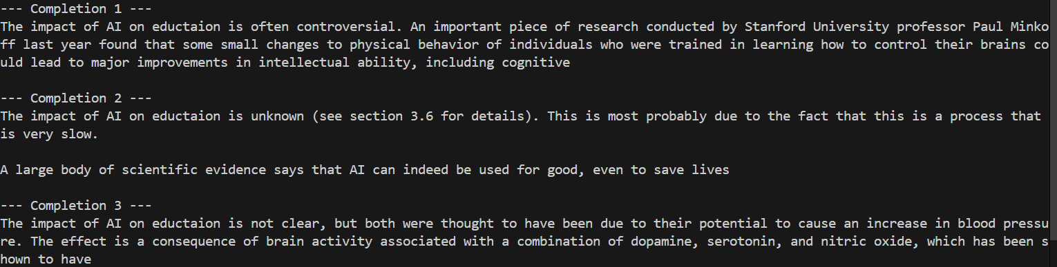

Learning Outcome:
- Learned to use GPT-2 for generating multiple text completions.
- Understood temperature and top-k sampling for controlling randomness in text generation.
- Gained experience in working with tokenizers and language model outputs in Hugging Face Transformers.

5.2 QuickSent: Simple Sentiment Analysis
Description:
This project demonstrates a basic sentiment analysis tool using Hugging Face’s pipeline API. It analyzes a given sentence and classifies its sentiment as Positive or Negative, along with a confidence score. This lightweight approach is ideal for quick prototyping of NLP-based applications.
Working Principle:
- User Input: The sentence to be analyzed is hardcoded or can be taken from user input.
- Model Processing: The Hugging Face sentiment-analysis pipeline automatically loads a pre-trained DistilBERT model.
- Output Display: The predicted sentiment label and confidence score are displayed in the console.

Code Snippet:

from transformers import pipeline

sentiment = pipeline("sentiment-analysis")
result = sentiment("Wow, I just love when everything goes perfectly — it's so boring!")
print(result)

Output:
Learning Outcome:
- Learned to quickly set up NLP pipelines using Hugging Face with minimal code.
- Understood the basics of sentiment classification in natural language processing.
- Gained experience in using pre-trained models without the need for manual model loading or training.

5.3 Polyglot: Multi-Language Translator
Description:
This project implements a multi-language translation tool using Hugging Face’s MarianMT models from the Helsinki-NLP collection. The system supports translation between English, Hindi, French, Spanish, German, and Tamil in both directions. A Gradio interface provides an easy-to-use front-end for entering text and selecting the desired translation direction.
Working Principle:
- Language Selection: The user chooses the translation direction from a dropdown menu (e.g., English to Hindi).
- Model Loading: Based on the selection, the corresponding pre-trained MarianMT model and tokenizer are loaded (cached for faster subsequent use).
- Tokenization & Translation: The input text is tokenized, passed to the model, and the translated output is generated.
- Result Display: The translated text is displayed in the Gradio interface.

Code Snippet:
from transformers import MarianMTModel, MarianTokenizer
import gradio as gr
translation_models = {
"English to Hindi": "Helsinki-NLP/opus-mt-en-hi",
"Hindi to English": "Helsinki-NLP/opus-mt-hi-en",
"English to French": "Helsinki-NLP/opus-mt-en-fr",
"French to English": "Helsinki-NLP/opus-mt-fr-en",
"English to Spanish": "Helsinki-NLP/opus-mt-en-es",
"Spanish to English": "Helsinki-NLP/opus-mt-es-en",
"English to German": "Helsinki-NLP/opus-mt-en-de",
"German to English": "Helsinki-NLP/opus-mt-de-en",
"English to Tamil": "Helsinki-NLP/opus-mt-en-ta",
"Tamil to English": "Helsinki-NLP/opus-mt-ta-en"}
cached_models = {}

def translate(text, direction):
model_name = translation_models[direction]
if model_name in cached_models:
tokenizer, model = cached_models[model_name]
else:
tokenizer = MarianTokenizer.from_pretrained(model_name)
model = MarianMTModel.from_pretrained(model_name)
cached_models[model_name] = (tokenizer, model)
inputs = tokenizer([text], return_tensors="pt", padding=True, truncation=True)
translated = model.generate(**inputs)
output = tokenizer.decode(translated[0], skip_special_tokens=True)
return output
gr.Interface(
fn=translate,
inputs=[gr.Textbox(label="Enter Text"),
gr.Dropdown(choices=list(translation_models.keys()), label="Translation Direction", value="English to Hindi")],
outputs="text",
title="Multi-Language Translator",
description="Translate between multiple languages using pretrained transformer models."
).launch()

Output :
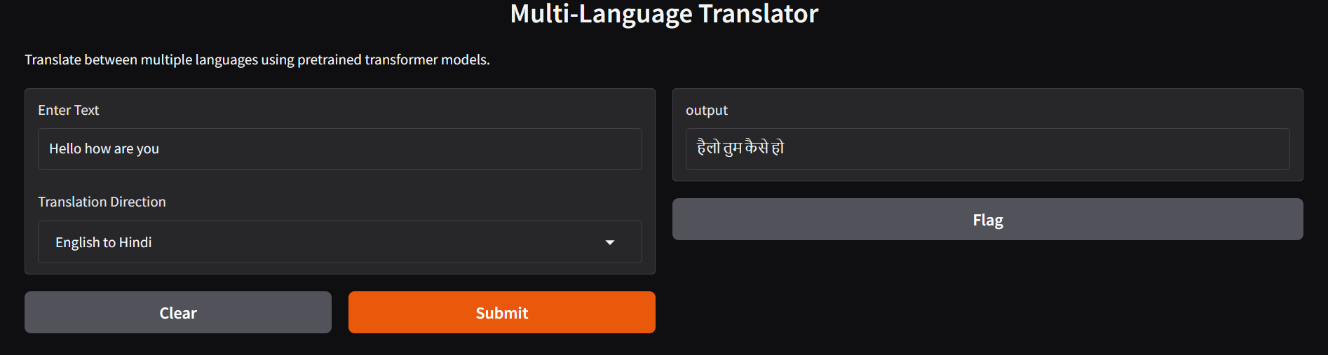

Learning Outcome:
- Learned to integrate MarianMT translation models from Hugging Face.
- Understood how to implement multi-language support in a single interface.
- Learned to use Gradio for building a simple and interactive translation application.
- Improved knowledge of model caching for performance optimization.

5.4 Multilingual Text-to-Speech Converter
Description:
This project converts English text into spoken audio in multiple languages. It first uses Hugging Face translation models to translate the input text into the selected target language (if needed), and then uses Google Text-to-Speech (gTTS) to generate the audio output. The project is powered by Generative AI for both translation and voice synthesis.
Working Principle:
- User Input: The user enters English text.
- Translation (if required):
  - If the target language is not English, the system uses Hugging Face MarianMT translation models to translate the text.
- Speech Generation:
  - The translated text is passed to gTTS, which generates natural-sounding speech in the target language.
- Output:
  - The generated audio is played to the user via Gradio's audio interface.

Code Snippet:

import gradio as gr

from transformers import pipeline

from gtts import gTTS

import tempfile, os, uuid

languages = {

"English": ("en", None),

"Hindi": ("hi", "Helsinki-NLP/opus-mt-en-hi"),

"Marathi": ("mr", "Helsinki-NLP/opus-mt-en-mr"),

"Tamil": ("ta", "Helsinki-NLP/opus-mt-en-ta"),

"Bengali": ("bn", "Helsinki-NLP/opus-mt-en-bn"),

"Gujarati":("gu", "Helsinki-NLP/opus-mt-en-gu"),

"Urdu": ("ur", "Helsinki-NLP/opus-mt-en-ur"),

"French": ("fr", "Helsinki-NLP/opus-mt-en-fr"),

}

translator_cache = {}

def speak(text, lang_name, slow_speed):

if not text.strip():

return None, "⚠ Please enter some text!"

tts_lang, model_id = languages[lang_name]

if model_id:

if model_id not in translator_cache:

translator_cache[model_id] = pipeline("translation", model=model_id)

translator = translator_cache[model_id]

text = translator(text, max_length=512)[0]["translation_text"]

tmp_path = os.path.join(tempfile.gettempdir(), f"{uuid.uuid4().hex}.mp3")

gTTS(text=text, lang=tts_lang, slow=slow_speed).save(tmp_path)

return tmp_path, "✅ Success!"

iface = gr.Interface(

fn=speak,

inputs=[

gr.Textbox(label="Enter English Text"),

gr.Dropdown(list(languages.keys()), value="Hindi", label="🌐 Select Language"),

gr.Checkbox(label="Slow Voice")

],

outputs=[

gr.Audio(type="filepath", label="🔊 Speech"),

gr.Textbox(label="ℹ Status")

],

title="English → Multilingual Speech (Translate + gTTS)",

description="Type English text, choose a language, and hear it spoken with automatic translation."

)

iface.launch()

Output: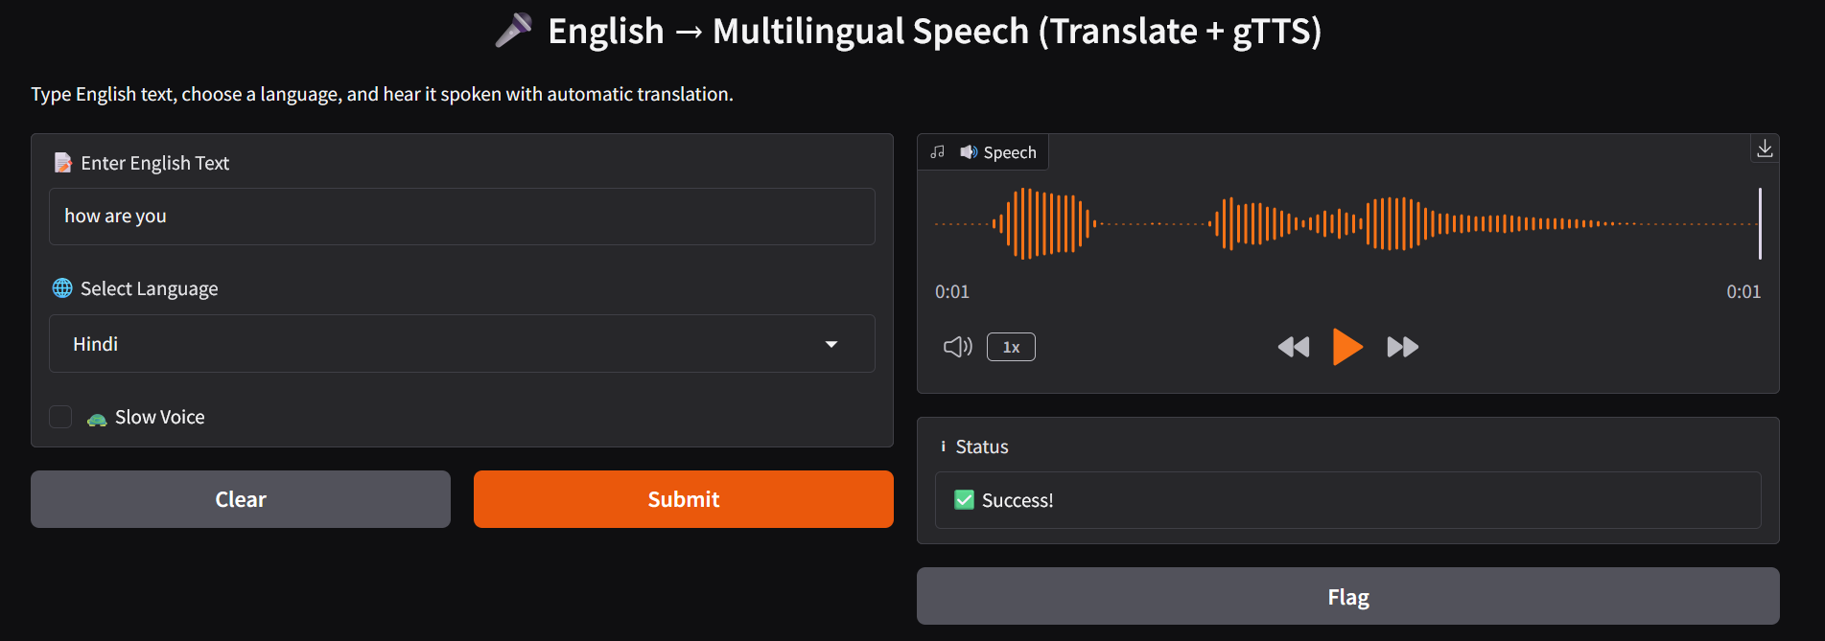

Learning Outcome:
- Learned how to integrate translation models with text-to-speech synthesis.
- Understood Hugging Face MarianMT translation workflow.
- Learned to create interactive AI tools using Gradio.
- Gained experience in working with multilingual AI applications.

5.4 – TruthShield – Fake News Detector

Description:
This project detects whether a given news statement is real or fake using a fine-tuned Transformer model from Hugging Face .It processes the input text, analyzes its linguistic and contextual patterns, and classifies it as REAL or FAKE .This helps combat misinformation and can be applied in journalism, social media monitoring, and fact-checking systems.

Working Principle:
- The user enters a news headline or statement.
- The model tokenizes the text and encodes it for analysis.
- A fine-tuned BERT-based model predicts the probability of the text being REAL or FAKE.
- The output is displayed with the predicted label and confidence score.

Code Snippet:

fake_news_detector = pipeline(
"text-classification",
model="mrm8488/bert-tiny-finetuned-fake-news-detection",
tokenizer="mrm8488/bert-tiny-finetuned-fake-news-detection"
)
news_text = "Breaking: Scientists have discovered a way to live forever by drinking coffee."

result = fake_news_detector(news_text)[0]
label = result['label']
score = result['score'] * 100

print(f"Prediction: {label}")
print(f"Confidence: {score:.2f}%")
Output:
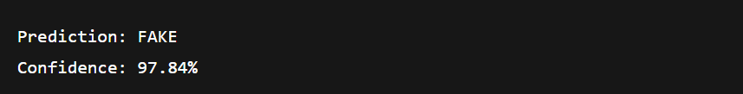

Learning Outcome:
- Learned how to use fine-tuned Transformer models for classification tasks.
- Understood the process of tokenization, encoding, and inference in NLP.
- Gained experience in applying AI to real-world problems like misinformation detection.

5.5 – DreamCanvas – Text to Image Converter

Description:
This project converts natural language prompts into realistic or artistic images using the Stable Diffusion deep learning model .By interpreting the textual description, the AI generates high-quality visuals that match the prompt, enabling creative applications such as art design, marketing, and concept visualization.

Working Principle:
- The user enters a descriptive text prompt.
- The Stable Diffusion model encodes the text and generates a latent representation of the image.
- This latent image is gradually refined and decoded into a final, high-resolution output.
- The resulting image is displayed to the user.

Code Snippet:

import torch
from diffusers import StableDiffusionPipeline
import gradio as gr

pipe = StableDiffusionPipeline.from_pretrained(
"CompVis/stable-diffusion-v1-4",
torch_dtype=torch.float16)
pipe.to("cuda" if torch.cuda.is_available() else "cpu")
def generate_image(prompt):
image = pipe(prompt).images[0]
return image

gr.Interface(
fn=generate_image,
inputs=gr.Textbox(label="Enter a text prompt", placeholder="e.g., a cat reading a newspaper"),
outputs="image",
title="Text to Image Generator",
description="Uses Stable Diffusion to turn text prompts into images"
).launch()

Learning Outcome:
- Learned to integrate Stable Diffusion with Python for generative art.
- Understood how latent diffusion models convert text into images.
- Gained experience with Gradio for building interactive AI-powered web apps.

Chapter 6 – Techzen

Description
TechZen is an AI-powered job application assistant that helps job seekers quickly identify suitable job opportunities based on their résumé or manually entered skills. It leverages Natural Language Processing (NLP) to extract relevant skills from the résumé, matches them with real-time job postings fetched from the Remotive Job API, and uses a Generative AI model (GPT) to create natural, concise summaries of the candidate’s expertise. The system is designed with a simple Gradio-based interface, making it easy to use without complex installations.

Working Principle
- Input Acquisition
  - The user uploads a résumé (PDF/TXT) or enters their skills manually.
- Skill Extraction
  - The system parses the uploaded résumé using pdfminer.six for text extraction.
  - A predefined skill dictionary is matched against the extracted text using regular expressions to identify key skills.
- Generative AI Summarization
  - The extracted skills are fed into a GPT-based text generation pipeline (distilgpt2) to create a natural language summary of the candidate’s abilities.
- Job Matching
  - The system sends skill keywords to the Remotive Job API to fetch real-time job postings.
  - Jobs are filtered based on user-selected country and optional city preferences.
  - Each job is scored based on skill overlap with the résumé.
- Output Display
  - The extracted skills and matching jobs are displayed in a Markdown table format with job titles, company names, locations, match percentage, and application links.

Code Snippet:

import os, re, itertools, requests, pandas as pd, gradio as gr
from pdfminer.high_level import extract_text
from transformers import pipeline, AutoTokenizer, AutoModelForCausalLM, set_seed
MODEL_ID = "distilgpt2"
gpt = pipeline(
"text-generation",
model=AutoModelForCausalLM.from_pretrained(MODEL_ID),
tokenizer=AutoTokenizer.from_pretrained(MODEL_ID),
max_length=80, do_sample=True, top_p=0.95, temperature=0.8
)
set_seed(42)
SKILLS = { "python","machine learning","deep learning","nlp","aws","gcp","azure",
"sql","pandas","numpy","pytorch","tensorflow","data visualization","docker",
"kubernetes","mlops","power bi","tableau","spark","hadoop","scikit-learn",
"matplotlib","seaborn","java","javascript","react","c++","flask","django",
"linux","git","github" }
def pdf_to_text(path): return extract_text(path)
def uploaded_to_text(f):
return pdf_to_text(f.name) if f.name.lower().endswith(".pdf") else f.read().decode("utf-8")
def extract_skills(t): return {s for s in SKILLS if re.search(rf"\b{s}\b", t.lower())}
def explain(sk):
return "No predefined skills detected." if not sk else gpt(
f"Summarise these skills in one friendly sentence: {', '.join(sorted(sk))}.")[0]["generated_text"].split(".")[0]+"."

def remotive(skill, limit=20):
try:
return requests.get(f"https://remotive.com/api/remote-jobs?search={skill}",
timeout=15).json().get("jobs", [])[:limit]
except: return []
def job_filter(skills, country, cities, limit=25):
jobs = list(itertools.chain.from_iterable(remotive(s, 30) for s in sorted(skills)[:5]))
out, seen = [], set()
for j in jobs:
loc = (j.get("candidate_required_location") or "").lower()
if country!="Any / Remote" and country.lower() not in loc: continue
if cities and not any(c.lower() in loc for c in cities): continue
key=(j["title"], j["company_name"])
if key not in seen: seen.add(key); out.append(j)
return out[:limit]
def run(resume_file, manual_text, country, city_raw):
if resume_file is None and not manual_text.strip():
return "⚠️ **Upload a résumé or type skills first.**", ""
text = resume_file and uploaded_to_text(resume_file) or manual_text
skills = extract_skills(text)
md_sk = ("#### Extracted Skills\n" + (", ".join(sorted(skills)) if skills else "_None_")
+ "\n\n" + explain(skills))
cities=[c.strip() for c in city_raw.split(",") if c.strip()]
jobs = job_filter(skills, country, cities)
if not jobs:
return md_sk, "### No matching jobs found with current filters."
rows=[]
for j in jobs:
overlap = extract_skills(j["description"]) & skills
rows.append({"Title":j["title"],"Company":j["company_name"],
"Location":j.get("candidate_required_location","—"),
"Match%":round(len(overlap)/max(1,len(skills))*100,1),
"URL":j["url"]})
md_jobs="### Suggested Jobs\n"+pd.DataFrame(rows)\
.sort_values("Match%",ascending=False).to_markdown(index=False)
return md_sk, md_jobs
COUNTRIES = ["Any / Remote","United States","India","Canada","United Kingdom",
"Germany","France","Australia","Singapore","Netherlands"]

with gr.Blocks(title="Job-Application Bot") as demo:
gr.HTML("<h1>Job Finder Bot</h1><p>Find jobs matching your resume skills.</p>")
with gr.Row():
resume = gr.File(label="Upload résumé (PDF/TXT)")
manual = gr.Textbox(lines=6,label="Or paste skills / experience")
with gr.Row():
country=gr.Dropdown(COUNTRIES,value="Any / Remote",label="Country")
cities =gr.Textbox(label="Cities (comma-separated, optional)")
btn = gr.Button("Submit 🔍")
skills_md = gr.Markdown()
jobs_md = gr.Markdown()
btn.click(run, inputs=[resume,manual,country,cities], outputs=[skills_md, jobs_md])
demo.launch()
Output:
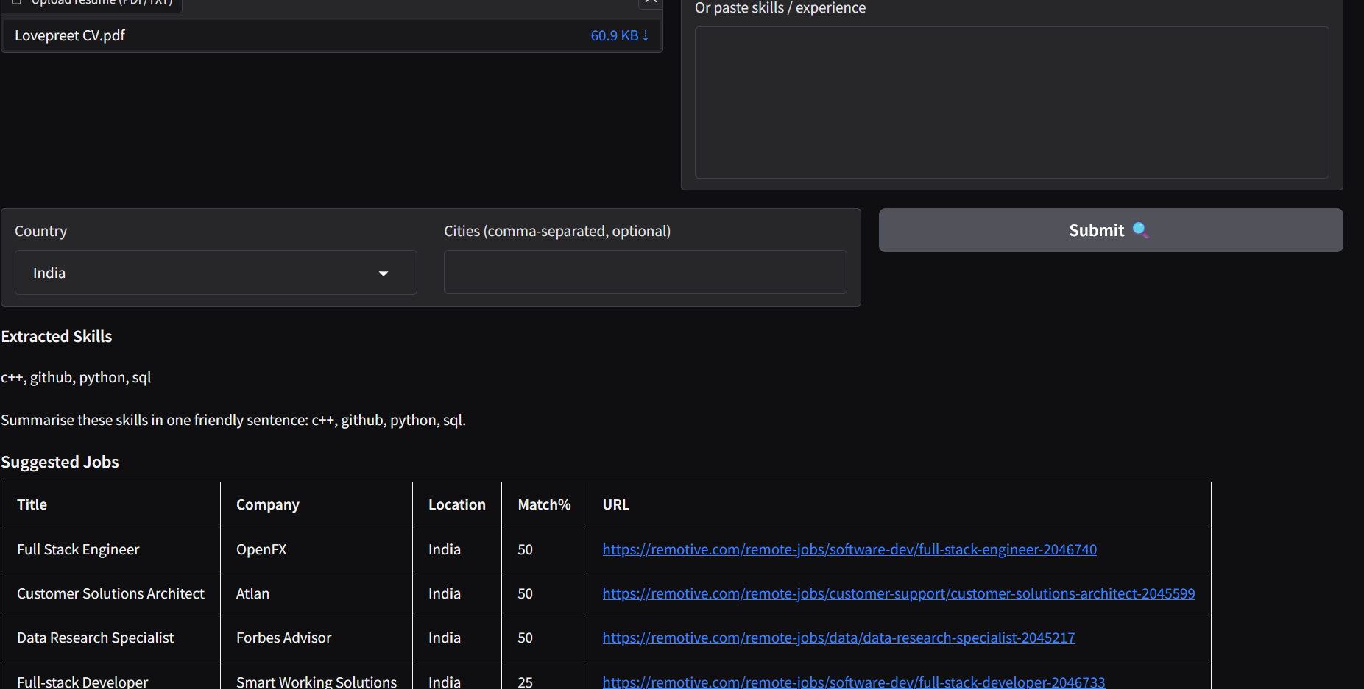

Chapter 7 – Conclusion
This report explored multiple Generative AI (GenAI) applications, ranging from simple text-based projects to advanced AI-powered platforms like TechZen – Job Finder. Through the practical implementation of these projects, the capabilities of modern AI models in text generation, sentiment analysis, text-to-speech conversion, fake news detection, and image generation were demonstrated.
The journey of developing these projects enhanced understanding in:
- Using Hugging Face Transformers for NLP and multimodal tasks.
- Deploying AI models using Gradio interfaces for user-friendly experiences.
- Building domain-specific GenAI applications with real-world utility.
The final project, TechZen, showcased how AI can revolutionize the job search and recruitment process by automating resume analysis, job matching, and personalized cover letter generation.
Generative AI is not just a research trend but a practical technology transforming industries. These projects lay the foundation for building more complex, scalable, and production-ready AI solutions in the future.

References
- Hugging Face. (n.d.). Transformers Documentation. Retrieved from https://huggingface.co/docs/transformers
- Google. (n.d.). gTTS: Google Text-to-Speech Python Library. Retrieved from https://pypi.org/project/gTTS/
- Gradio. (n.d.). Gradio: Build Machine Learning Web Apps. Retrieved from https://gradio.app/
- Sentence Transformers. (n.d.). all-MiniLM-L6-v2 Model Card. Retrieved from https://www.sbert.net/

