**The global biomass and number of terrestrial arthropods**

Yinon M. Bar-On*1, Yuval Rosenberg*1, Amir Fromm1, Meital Ostikar1, Aviv Shoshany1, Omer Giz1 and Ron Milo1

1 Department of Plant and Environmental Sciences, Weizmann Institute of Science, Rehovot, Israel

* These authors contributed equally

### Abstract

Insects and other arthropods are central to the terrestrial food-chain, and play important ecological roles such as nutrient cycling and pollination. Recent studies suggest populations of arthropods in many locations are rapidly decreasing, but no global quantification of their absolute population and biomass is available. Here, we synthesize over 8000 measurement-based evaluations of biomass and population densities of terrestrial arthropods across the globe, and estimate their total biomass and abundance across different taxa and habitats. We estimate that overall there are ≈1019 terrestrial arthropods on Earth (about 1 billion per person), with an uncertainty range of 0.5-2×1019, weighing ≈300 Mt (Megaton = 1012 grams) dry weight, with an uncertainty range of 100 - 500 Mt. This implies that today the mass of humans is of the same order of magnitude as all terrestrial arthropods combined. Mites and springtails are the most abundant, together comprising over 95% of the terrestrial arthropod population. However, termites are collectively the most massive, comprising over 40% of the total biomass of all terrestrial arthropods. In contrast to previous reports, we estimate that the total biomass of ants is much lower than that of humans (≈30 versus ≈120 Mt dry weight). While our estimates do not quantify temporal changes and suffer from biased coverage, they quantitatively summarize our current knowledge, as well as key gaps in our understanding of global abundance of arthropods, which could help guide future research.

### Introduction

With Earth entering the age of the Anthropocene, human domination of the planet impacts a myriad of ecological and geological processes. One measure of this influence is the elevated rate of species extinctions witnessed during the last century, which is estimated to be orders of magnitude above its background rates [(1, 2)](https://paperpile.com/c/DkZTjN/uVdvO+3aNIK). Measuring species extinction does not, however, capture the full breadth of our effect on wild communities. Recent analyses show that many extant vertebrate species, such as amphibians [(3)](https://paperpile.com/c/DkZTjN/I98q4) and birds [(4)](https://paperpile.com/c/DkZTjN/UkFZl), are suffering from rapidly decreasing populations, even if they don’t currently risk extinction [(5)](https://paperpile.com/c/DkZTjN/MkDpe).

Recently, many studies have observed dramatic declines in the populations of terrestrial insects and other arthropods (such as spiders, mites and centipedes) across the globe [(6–9)](https://paperpile.com/c/DkZTjN/Qc9Oo+oJTUx+kPP8E+O0Dnm). Most of these studies only measure relative changes in population or biomass, but do not measure their absolute inventory. While relative changes are an informative measure of population decline, knowing the absolute quantities of arthropods in different locations can help us better understand their significance, global distribution, and vulnerabilities. For example, natural populations may collapse if their population density is too low [(10, 11)](https://paperpile.com/c/DkZTjN/9FBJQ+BEVY), due to factors such as lack of genetic diversity. Moreover, general claims regarding the abundance of specific groups of arthropods, such as ants, have been made, with a famous claim stating that the total biomass of ants is similar to that of humanity [(12)](https://paperpile.com/c/DkZTjN/afeiH). However, a closer look at these claims reveals a shaky evidential basis, which calls for better data to help support or refute it.

Current knowledge of the global distribution of terrestrial arthropods is lacking. Tremendous efforts made by the International Biological Program in the 1960s and 1970s added significant knowledge regarding the abundance of specific groups of soil fauna in different biomes [(13)](https://paperpile.com/c/DkZTjN/G1Tea), with newer studies refining this picture for some key groups [(14)](https://paperpile.com/c/DkZTjN/w16KY). We have recently provided estimates of the global biomass of terrestrial arthropods [(15)](https://paperpile.com/c/DkZTjN/COn1e). Nevertheless, these attempts were very coarse and covered very limited data . Here we made a concerted effort to improve upon the previous attempts. We scoured the literature for measurements of absolute population and biomass densities of arthropods and collected ≈8000 such measurement based evaluations across over 600 sites in ≈300 different locations. We use these samples to estimate the global biomass and population size of terrestrial arthropods and provide a holistic view of their taxonomic composition and distribution. This collection reveals the current state of knowledge on the global abundance of arthropods and highlights key knowledge gaps, which future research should help close.

### Results

We integrated measurements distributed across ≈300 different locations (one location can have several sampling sites, see Methods) as shown in Fig. 1. The studies cover latitudes from 60º S to 80º N and all major biomes (see Fig. S1 of the Supplementary Information for the biome definitions). The available samples are clearly biased, with ≈50% of measurements in Europe and North America, reflecting the logistical challenges for research institutes to sample in remote locations. Central Asia and the world deserts are significantly undersampled. In these different localities, ≈600 different sampling sites were investigated. Our dataset contains measurements of both arthropod biomass density (measured in units of mass per area) and population density (measured in number of individuals per area). Overall, we found data for ≈390 sites with measured biomass density and ≈440 sites with measured population densities, with ≈220 of them estimating both biomass and population.

We integrated the data for global extrapolation by first dividing it based on habitat type, biome and taxonomy (see Methods). We divided the data based on these parameters to reduce statistical uncertainties while minimising possible biases. We focused on three distinct habitat types: soil, above-ground (surface-dwelling), and plant-associated arthropods. We separated the data according to these distinct habitat types, and calculated their mean biomass and population densities. Most samples measured the soil arthropod community, with a total of ≈430 sampling sites. The plant-associated community was sampled in ≈130 sites and the above-ground community in ≈50 sites.

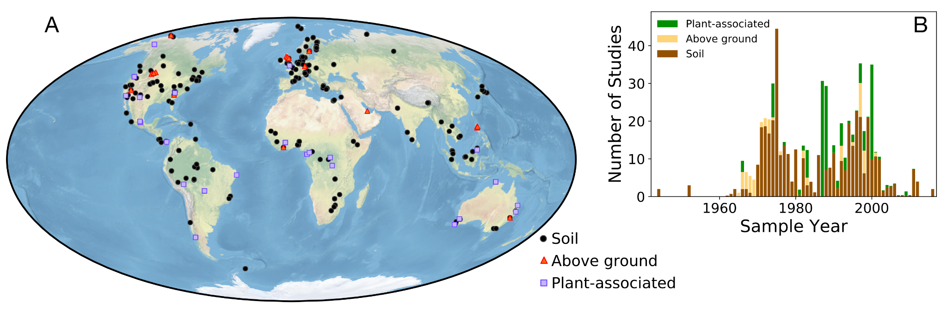

***Figure 1. Locations and dates of the arthropod abundance measurements used in this study.* (**A)  *A global map of the sampling locations.**The different colors represent the different habitat types examined in this study (see text). (B) Sampling year distribution of the sites in A (see Supplementary Information for further details).*

#### 

The three habitat types were sampled in different ways that vary in their taxonomic resolution. Above-ground and plant habitats were typically sampled using techniques which aim to collect all arthropods present. We treated the arthropods in these habitat types as a single group, since the available data was especially scarce there. Soils (that also include plant litter) were often sampled using techniques that collected only specific groups of arthropods. To compare and integrate these different soil samples, we roughly divided them based on their taxonomy into five groups - *Acari* (mites and ticks), *Collembola* (springtails), *Isoptera* (termites), *Formicidae* (ants) and all other arthropods (which we call ‘Others’), as depicted in Fig. 2. These groups do not represent the same taxonomic rank - for example *Formicidae* is a family, whereas *Acari* is a subclass. The group ‘Others’ contain about 93 percent of the known terrestrial arthropods species, where about 82 percent of them are insects [(16)](https://paperpile.com/c/DkZTjN/jkR0) and many of them inhibit the soil at least during part of their life cycles. Nevertheless, this division represents key groups of arthropods in the focus of many studies.

For each group of soil arthropods, we aggregated all samples based on the biome in which they were measured. We then calculated the average biomass and population density for each group of arthropods in each biome (see Methods), as presented in Figs. 3 and 4 (and tables S1, S2 of the supplementary data). Most measurements of the biomass of soil arthropods are located in forests and tundra, with lacking coverage of deserts. The highest mean biomass densities for a specific group of arthropods are recorded for termites in tropical regions.

We find the total biomass and population of soil arthropods in each biome by multiplying average densities by the global area of the biome, as seen in Fig. 5. We estimate the total mass of soil arthropods to be ≈250 Mt dry weight, with an estimated uncertainty range of 100 - 400 Mt (see Methods for further details). Over forty percent of the biomass is contributed by termites; ants, springtails, and mites and ticks contribute about ten percent each; and other soil arthropods contribute the remainder, as shown in Fig. 6A. We estimate the total population of soil arthropods to be ≈1019 individuals, with an estimated uncertainty range of 0.5-2×1019. Small arthropods such as mites and springtails account for >95% of the total population of soil arthropods, where about two thirds are mites and ticks and thirty percent are springtails.

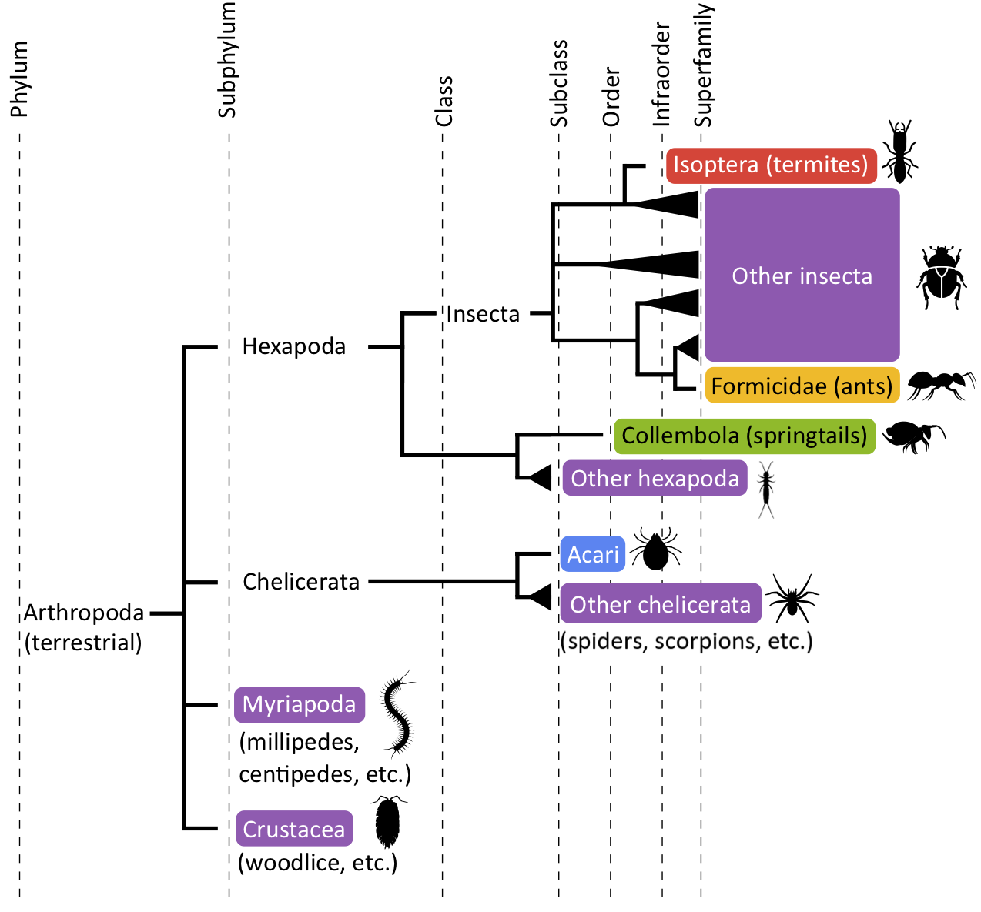

***Figure 2. The taxonomic groups used in this study.*** *A phylogenetic tree describing the relationships between the different taxonomic groups. Each color represents a single aggregated taxonomic group we consider.*

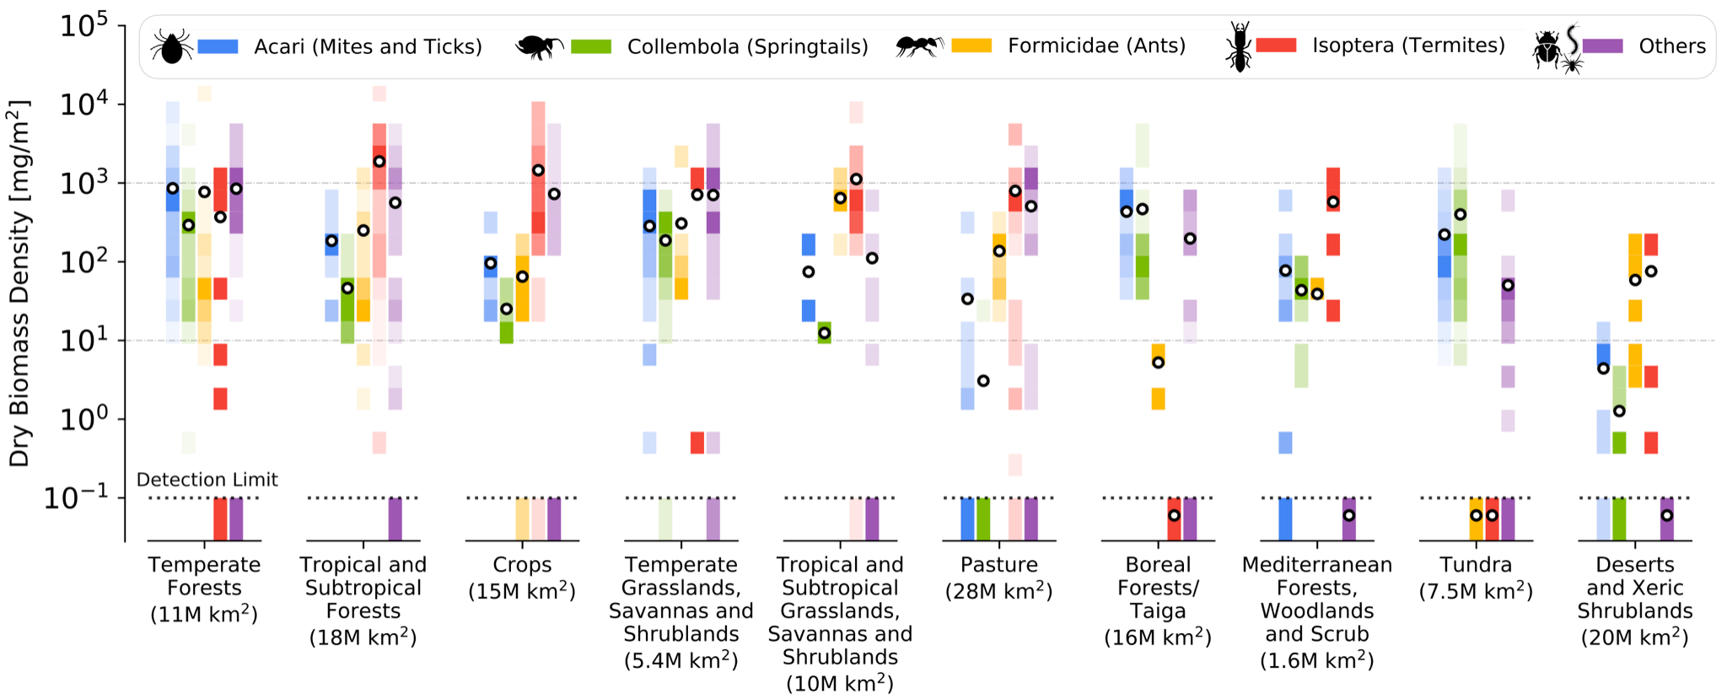

***Figure 3. Biomass density for different groups of soil arthropods across the global biomes.*** *In each biome and for each group of arthropods, biomass densities (in units of mg dry weight per m2)**reported in different sites are binned evenly in log scale. Each bin extends to roughly twice its minimal value. The shading of each bin represents the fraction of data points lying in the bin, with the darkest color representing the density bin with the highest number of measurements for a specific taxonomic group and biome, and the lightest color representing the rarest bin. Black and white circles mark the mean biomass density. The dashed lines represent the detection limit - the lowest available non-zero biomass measurement. The biomes are in descending order with respect to their total arthropods biomass density. The area of each biome is given in parentheses in units of millions of square kilometers (1M km2 = 106 km2 = 1012 m2). See Methods for definition of biomes.*

All biomass samples found for plant-associated arthropods (in canopies etc.) are located in forested biomes, whereas all biomass samples found for above-ground arthropods are located in biomes with annual vegetation. Figure 5 shows the overall biomass for these habitat types and biomes treating all arthropods as a single taxonomic group. We extrapolate the total global biomass of arthropods in these environments, and find that canopies contain ≈15 (uncertainty range: 5 - 35) Mt dry biomass, while above-ground, or surface dwelling arthropods, weigh about ≈50 (uncertainty range: 20 - 90) Mt. These contributions are much smaller than the biomass of soil arthropods, and together account for about a quarter of the total global biomass of ≈300 (uncertainty range: 100 - 500) Mt of terrestrial arthropods. The arthropods typically found above-ground and on canopies have larger body size than mites and springtails, which are mainly found in soils [(17)](https://paperpile.com/c/DkZTjN/f0kp). Thus, population densities of canopy and above-ground arthropods are much smaller than those of soil arthropods, and contribute negligibly to the global number of individual arthropods.

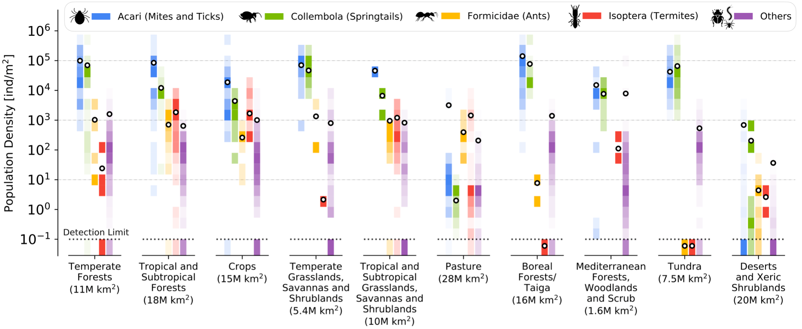

***Figure 4. Population density for different groups of soil arthropods in various biomes.*** *Marks are the same as in Fig. 3, but for population density data (number of individuals per area) instead of biomass density. The biomes are in descending order with respect to their total arthropods population density.*

To compare the biomass and populations of equivalent taxonomic ranking, we aggregated our estimates based on the subphylum of arthropods each group belongs to, as depicted in Fig. 6B. The subphylum that contributes the most to the total soil arthropod biomass is *Hexapoda* (mainly insects and springtails). It represents about seventy five percent of the total biomass, while *Chelicerata* (e.g. spiders and mites) and *Myriapoda* (e.g. millipedes and centipedes) contribute about ten percent each, and *Crustacea* (e.g. woodlice) account for about five percent. Insects dominate the subphylum *Hexapoda*, with springtails accounting for only about ten percent of its biomass in soils.We estimate that soil insects constitute ≈70% of the total biomass of soil arthropods, with ants and termites alone constituting ≈55%. Insects are likely to dominate the other habitat types as well, but the scarcity of data in these habitats does not allow us to resolve their exact contribution.

### Discussion

In this study we synthesized the most comprehensive collection of samples of arthropod abundance and biomass, spread across various geographical locations, habitat types and biomes. This collection allows us to look at the global distribution of the biomass and populations of terrestrial arthropods, extending earlier work on such characteristic biomass densities [(13, 14)](https://paperpile.com/c/DkZTjN/G1Tea+w16KY). We estimate the total biomass of terrestrial arthropods at about 300 Mt dry weight (range: 100-500 Mt, see Methods), while noting the significant caveats that are discussed below. This improves upon our recent estimate of about 400 Mt, made in [(15)](https://paperpile.com/c/DkZTjN/COn1e) using much less data. Similarly, we estimate the total number of terrestrial arthropods at about 1019 (uncertainty range: 0.5-2×1019), which is within the range of 1017-1019 estimated by Williams in the 1960s, based on limited data from UK soils [(18)](https://paperpile.com/c/DkZTjN/HMiZd).

When averaged globally, for every square meter of land there are roughly two grams of arthropod dry weight, most of which seem to be concentrated in the top-soil and plant litter. This biomass is dominated by the subphylum *Hexapoda*, with termites representing over 40% of the total dry mass (Fig. 6). Every square meter of top-soil contains tens of thousands of arthropods on average, the vast majority of which are very small mites and springtails. All other arthropods combined have densities of at most a few thousand individuals per square meter.

The distribution of biomass of terrestrial arthropods is in stark contrast to the distribution of marine arthropods. First, global biomass of marine arthropods is estimated as ≈1800 Mt dry weight [(19)](https://paperpile.com/c/DkZTjN/WtFk), which is almost an order of magnitude greater than that of terrestrial arthropods. Furthermore, the common marine arthropods are very different from their terrestrial counterparts: whereas the dominant groups of marine arthropods are part of the *Crustacea* subphylum, on land the dominant subphylum is *Hexapoda*, with crustaceans contributing only about five percent (Fig. 6).

We estimate that insects constitute about 200 Mt dry weight out of a total of ≈300 Mt for all arthropods. This challenging estimate assumes that the relative contribution of insects to the arthropod communities above-ground and on canopies is similar to their contribution in the soil. Changing this assumption would not affect this estimate significantly, since we estimate that above-ground and plant-associated arthropods weigh only ≈60 Mt in total.

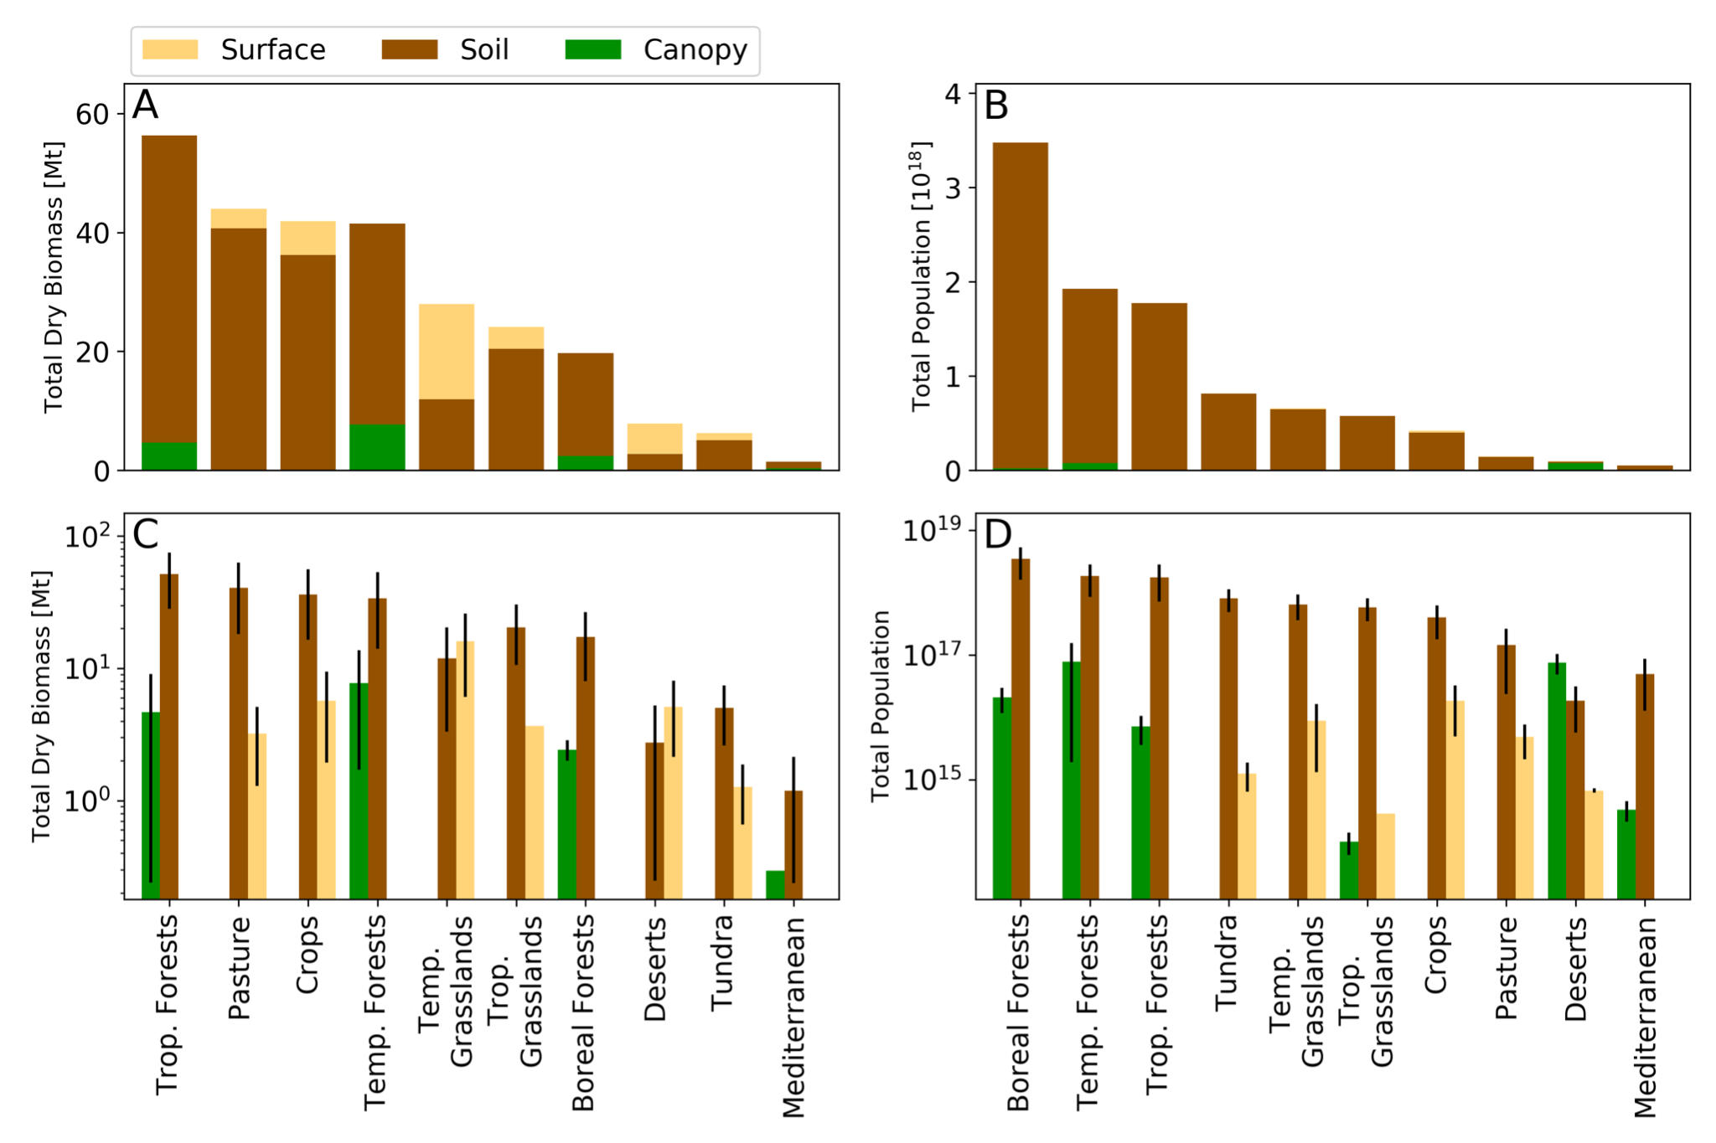

***Figure 5. Total biomass and number of individuals across biomes.*** *For each biome:*A. *and* C. *show the total dry biomass on a logarithmic and linear scales, respectively.* B. *and* D show the total populations. Soil arthropods are dominant over *canopy arthropods (green) and surface arthropods (yellow) in all biomes except deserts and temperate grasslands. See also supplementary data, for data in tabular format.*

Our analysis also allows us to revisit common claims regarding the mass of arthropods, for example, that the combined mass of all ants is similar to that of all of humanity. Originally, this statement appears as a side-note in [(12)](https://paperpile.com/c/DkZTjN/afeiH), and is based on the estimate by Williams of ~1018 arthropods, assuming ants represent about ~10% of the total number of arthropods, and a single ant weighs ~1 mg. When looking at the data synthesized here, we can better probe the assumptions on which the claim is based. The total number of terrestrial arthropods is dominated by the very small mites and springtails, which constitute >95% of the total number of individual arthropods. Our estimate suggests that ants represent less than one percent of the global arthropod population, and have a collective dry mass of ≈30 Mt. With a current global population of ≈8 billion humans, each having a dry weight of ≈15 kg [(20)](https://paperpile.com/c/DkZTjN/E1CwO), the total dry weight of humanity is about 120 Mt, or about four times greater than the total dry mass of ants.

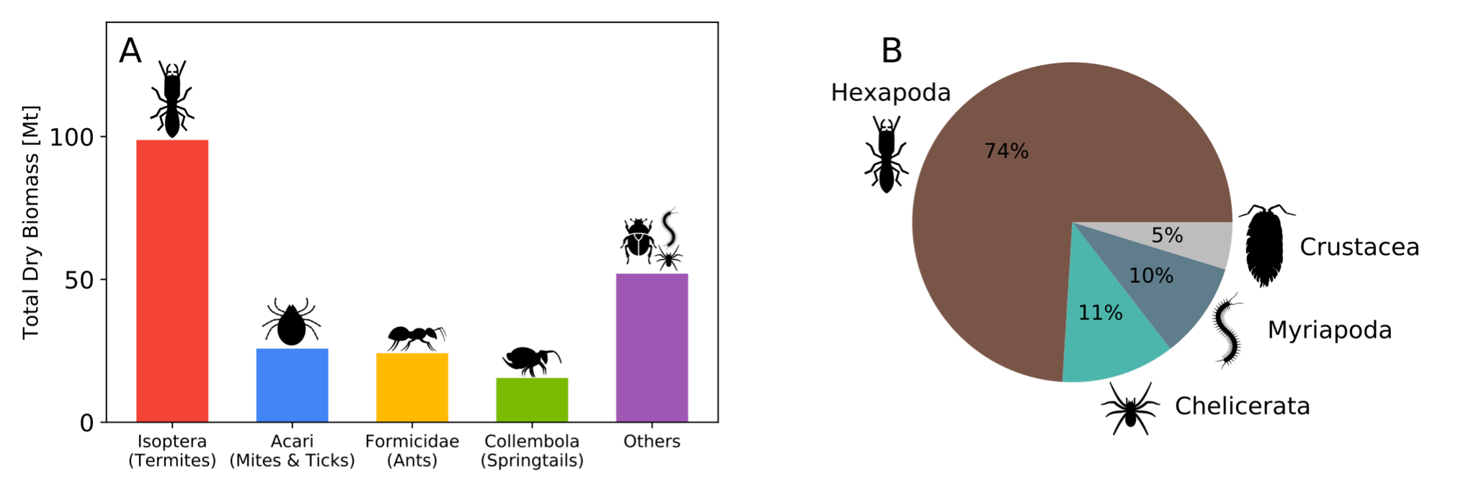

***Figure 6. Taxonomic distribution of the total biomass of soil arthropods.***A*. The distribution between different dominant groups of soil arthropods, as defined in the main text. These groups are not in the same taxonomic ranking, but they represent key groups of arthropods.* B*. A comparison between equally taxonomically ranked groups (the different subphyla) of soil arthropods.*

The results we present here should be taken with caution due to several caveats. First, despite the remarkable increase in available data from previous estimates, it is still very limited, far from covering the highly variable distribution of arthropods in space and time. Second, the data may be systematically biased in many ways, possibly beyond the projected range due to random errors. The samples are not at all randomly distributed: their locations (Fig. 1) are biased towards North America and Europe, with very few samples in vast areas such as Central Asia and Brazil. Even when considering the biome level, some groups of arthropods were significantly undersampled in specific biomes, for example mites and springtails in croplands or ants in boreal forests. Some biomes, such as deserts, mediterranean woodlands and shrublands are lacking in coverage for most groups of arthropods. Another possible sampling bias may originate from the tendency of researchers to sample arthropods in locations in which they are more abundant, leading to an overestimate of their global abundance. This biased coverage of biomes and habitat types (like soil or canopy), add to possible inefficient sampling and biases due to different sampling, extraction, and biomass evaluation methodologies [(13, 21)](https://paperpile.com/c/DkZTjN/G1Tea+5txC).

Beyond the biases in the measured data reported, there are some possible biases introduced by our methodology for global extrapolation. Aggregating measurements based on biomes miss many of the important factors which influence abundance of species, such as their life-history. For example, the distribution of termites in the tropics is markedly different between Asia and Africa, and considering both regions together as part of the tropical forests biome lead to a biased estimate of the global abundance. Ideally, we would like to stratify our measurements across important environmental, geographical and evolutionary factors to reduce such possible bias. This, however, will greatly reduce the already small sample sizes, and increase the effects of statistical uncertainty in our estimates. This is an example of a common tradeoff in statistics termed the bias-variance tradeoff.

To help assess the extent of such a bias and its implications on our results, we conducted several sensitivity analyses. First, we looked specifically at one of the groups with the largest risk of inserting such bias - termites. Termites are known to be distributed markedly differently between biogeographical realms, and they constitute a major contributor to the global biomass of arthropods. We conducted an in depth analysis of the distribution of termites in different biomes and biogeographical realms. From this in-depth analysis, detailed in the SI, we have generated estimates of the total biomass of termites, and saw it agrees with our estimate from the biome-level aggregation of data. Second, we took several taxa which have the highest number of measurements, and looked at the extent by which their distribution within each biome changes between biogeographical realms. The results of the analysis, detailed in the SI, suggest that the impact of such bias on our final estimate of the total biomass of terrestrial arthropods is within the range of uncertainty of our estimate. We have also conducted several sensitivity analyses quantifying the sensitivity of our estimation methodology to potential biases in the source data (see Supplementary Information). Overall, these sensitivity analyses indicate that at the global level, our results may be considered robust to systematic biases in our estimation methodology. At the biome level, however, our estimates are much more sensitive to such biases and should be considered with caution.

Most of the studies included in our dataset sampled soil arthropods and not above-ground or canopy arthropods. Our data covers canopy arthropods in the main tree-dominated biomes, but the number of sample sites there is very limited. The same is true for our samples of above-ground arthropods, which cover most biomes with annual vegetation. High biomass densities recorded in several nearby sites produce a very high biomass density estimate for above-ground arthropods in temperate grasslands. Therefore, estimates of the global biomass of above-ground and canopy arthropods are likely highly uncertain.

Our analysis misses some high-flying insects, but they probably contribute relatively little biomass globally. It’s difficult to measure the total biomass of high-flying insects, and relatively few studies do so. Radar-based reports of high-flying insect biomass in the UK [(22)](https://paperpile.com/c/DkZTjN/iGzcN) measured a total annual dry biomass of ≈1000 tons of insects across an area of 70,000 km2. This corresponds to about 2 Mt of annually flying insects when extrapolated globally. We take this figure as a rough upper bound for the arthropods biomass in the world skies. As a comparison, the world’s largest moth or butterfly migrations weigh less than a kilo-ton [(22)](https://paperpile.com/c/DkZTjN/iGzcN), and the most massive modern locust swarms can reach tens of kilo-tons [(Steedman 1990)](https://paperpile.com/c/DkZTjN/mJyp).

The vast majority of terrestrial arthropods are still wild. For example, the global population of managed honey bees weighs only about 0.06 Mt dry mass, a value two orders of magnitude smaller than the estimated mass of wild flying insects presented above. This estimate is based on roughly 100 million beehives [(23)](https://paperpile.com/c/DkZTjN/Ife4), with an average of about individuals [(24, 25)](https://paperpile.com/c/DkZTjN/Gj8x+e6gp), and 20 mg dry weight per individual bee [(26)](https://paperpile.com/c/DkZTjN/Btjy). The relatively low number of human-managed terrestrial arthropods stands in stark contrast to the state of the terrestrial mammals and birds: the biomass of wild mammals and birds is an order of magnitude smaller than the biomass of terrestrial livestock, which is similar to the biomass of terrestrial arthropods [(15)](https://paperpile.com/c/DkZTjN/COn1e).

Even with the above caveats in mind, our synthesis provides a holistic view of the current state of understanding of the global number and mass of terrestrial arthropods. This integrated dataset allows us to study global distributions of biomass across taxonomy and geography, and put their global biomass in context. For example, we estimate that terrestrial arthropods have an order of magnitude higher biomass than wild mammals, about 3 times more biomass than humans, but an order of magnitude lower biomass than marine arthropods [(15)](https://paperpile.com/c/DkZTjN/COn1e). It could serve as a basis for future research on the ecological roles played by terrestrial arthropods such as carbon turnover and nutrient cycling [(13)](https://paperpile.com/c/DkZTjN/G1Tea). Having a global collection of arthropod samples also highlights gaps in our current knowledge and areas which could greatly benefit from future research. One such group is insects, for which reports suggest dramatic recent population losses [(27)](https://paperpile.com/c/DkZTjN/ZHi1), highlighting the need for better quantification of their global abundance. Significant knowledge gaps also include the abundance of arthropods in deserts; soil microarthropods in croplands; and termites in general, which despite being abundant are difficult to sample well [(28)](https://paperpile.com/c/DkZTjN/E0WX), and have especially limited data outside the tropics. Ultimately, by building a knowledge base with an increased spatial and temporal resolution, we may be able to understand the basic environmental parameters which govern the global abundance of arthropods, as has been achieved in the past for other organisms [(29)](https://paperpile.com/c/DkZTjN/NWSav). Finally, sampling the absolute biomass and population densities of arthropods across the globe, especially with high temporal resolution and for less studied groups, will serve as a benchmark for monitoring the impact of humanity on their abundance and for their conservation.

### Methods

In the following, we describe the procedures for collecting and analyzing the data used here to estimate the biomass and population size of terrestrial arthropods. The data used for producing the results described in the study, as well as all of the code for analyzing it are available in annotated Jupyter Notebook format at the following link: <https://github.com/milo-lab/arthropod_biomass>.

Data collection

To collect as many samples of arthropod biomass and abundance, we have started our search from meta-analyses surveying the population and biomass densities of terrestrial arthropods. We have expanded on these initial studies by searching for broad terms such as “arthropods + biomass” in Google Scholar as well as specific search terms related to sampling techniques, such as “Tullgren funnel”. We have also used citation and author snowballing to extend the breadth of our dataset [(30)](https://paperpile.com/c/DkZTjN/8PfyD). For each sample, we have extracted the site at which the measurement was taken, as well as metadata such as the site location, biome, the type of habitat that was sampled (soil, above-ground or canopy), the taxon sampled, the sampling time (year and season), and the reported units for the sample (e.g. dry/wet weight). We kept track of the specific origin of the data in each study to allow us to trace back the source data. Our source data can be found on our github repository in the following link: <https://github.com/milo-lab/arthropod_biomass>. Overall, our dataset contains ≈100 studies, many of which are meta-analyses themselves. The data in our collection contains measurements of arthropod biomass and population densities throughout the last century. We integrate data from several decades which represents, to a first approximation, the current state of the biomass and population size of arthropods. Due to the fact that the data spread several decades, it will incorporate into our estimates some of the anthropogenic effects on arthropod populations.

#### Data preprocessing

We use filtering and harmonization to integrate the collected data before estimating the global biomass and population size of terrestrial arthropods. In the filtering stage, we removed data points which did not measure the natural abundance of arthropods, for example samples which were treated in some manner (e.g. addition of fertilizer or some chemical). In addition, we removed data from studies which reported the biomass or population densities of arthropods in units which are not useful for extrapolating densities of arthropods to larger areas (e.g. units reported per mass of foliage). We also removed studies which measured only a fraction of the arthropod population that were incompatible with the rest of our data and with our analysis procedure. The removed studies include those which measured only specific size fractions of the arthropod community or specific trophic modes like herbivores.

In the harmonization stage, we converted all of the data reported in the original studies into standard units which are consistent across all samples. These include conversion of biomass measurement into units of dry biomass density (mg/m2), which dominate the reported data for all groups except termites. Fresh (“wet”) biomass measurements were converted to dry biomass applying previously used effective dry weight percentages, using a default value of 70% water content for groups with missing estimates [(13)](https://paperpile.com/c/DkZTjN/G1Tea).

We converted measurements of population density (number of individuals) into biomass densities for soil studies that report only population densities, to extend our biomass dataset. We base this conversion on the average mass of an individual for each defined taxonomic group (see Fig. 2), calculated from a wide set of dual measurements, where both abundance and biomass were measured simultaneously. We excluded the group ‘Others’ from this conversion process, since the mass of individuals in this group is too varied. This conversion was applied only to the soil habitat type when dividing by the five taxonomic groups of Fig. 2.

We also standardized the metadata associated with each sample to allow us to integrate the data. This included standardizing the coordinates reported in each study. In cases where the source study did not report the coordinates of the sampling site, we attempted to locate the coordinates of the site from other research that was conducted in the same site, or from the most accurate description available. We marked these coordinates as “approximate” (Fig. 1). When accurate coordinates or descriptions were not available, we have resorted to less accurate region-based localization. Figure 1 shows the centers of these regions as “region-level coordinates”.

The ecological setting of each sample was categorized at the biome level based on the WWF ecoregion framework [(31)](https://paperpile.com/c/DkZTjN/uTkCj). To these natural biomes, we added two additional human-associated biomes - pastures and croplands [(32)](https://paperpile.com/c/DkZTjN/9I6Gr) (see Fig. S1 in the Supplementary Information). The surface area of each biome was calculated based on the map that defines the WWF ecoregions, and relative areas converted to pasture and croplands. We combined several biomes of similar nature into “aggregated biomes” in order to base our estimates on more available data. We combined all tropical and subtropical forests (WWF biomes 1,2,3); all temperate forests (WWF biomes 4,5); temperate grasslands, savannas and shrublands (WWF biome 8) were combined with montane grasslands and shrublands (WWF biome 10). We also excluded flooded grasslands and savannas, and mangroves (WWF biomes 9,14).

#### Statistical analysis

The basic methodology for estimating the global biomass and population size of terrestrial arthropods based on our harmonized dataset is stratifying samples based on habitat types, biomes and taxonomy, calculating statistics such as the mean biomass and population densities for each stratified set of samples, and then extrapolating them across the entire extent of that environment. First, we divided our samples to the different habitat types they sample: soil, above-ground, and canopy. For soil arthropods, where more samples are available, we divided our samples into five taxonomic groups (see Fig. 2) - *Acari* (mites and ticks), *Collembola* (springtails), *Isoptera* (termites), *Formicidae* (ants), and the remaining arthropods (which we call ‘Others’). For above-ground and canopy arthropods, we treated all arthropods as a single group to mitigate the scarcity of the available data. For each group, we divided the samples between the different biomes we have defined in the previous section.

We aim to treat each site as a single measurement. A specific locality may contain several different sampling sites if they represent distinct ecosystems within the same biome. For example, a tree-grass mosaic environment includes the tree-associated ecosystem and the grass-associated ecosystem. Each site may contain several samples of the same taxon of arthropods, for example in different times of the year. To obtain a single estimate per site, we calculated the mean value (biomass or population density) for each taxon in each site; and summed up the values for the taxa within each taxonomic group defined above. We arrived at the characteristic value for each group within each site. Next, we used bootstrapping (see Supplementary Information) to average the biomass or population density of each group between the different sites of each biome and arrived at a statistical distribution for the characteristic densities of each group in each biome. The means of these distributions are shown by the black circles of Figs. 3 and 4. We multiply the resulting distribution of characteristic biomass or population density by the total area of each biome to arrive at the distribution of the total biomass or population of each group in each biome. Finally, we summed the various distributions using a Monte-Carlo process to arrive at the distribution of total biomass or population in each habitat type, from which we extracted the mean and random errors (the means of these final distributions were almost identical to their medians, the random errors were taken as the 95% confidence interval).

For each taxonomic group in each biome and habitat type, we extracted a 95% confidence interval from the resulting distributions described above (error bars of Fig.5). The uncertainty ranges reported in the main text were calculated by taking the sum of the lower or upper bounds of the 95% confidence intervals for each such distribution. We use this sum of bounds of the 95% confidence intervals to account for random, and some possible systematic errors, as this way of summing includes possible correlations between the underlying statistical errors. This procedure increased the uncertainty range by up to a factor of 4 with respect to the random error. As a sensitivity check, we also calculated the above estimates using a range of modified assumptions (grouping and averaging the data in different reasonable ways), and also after removing parts of our data (see Supplementary Information).

**Acknowledgements**

Avi Flamholz, Yael Leshno

### References

1. [S. L. Pimm, *et al.*, The biodiversity of species and their rates of extinction, distribution, and protection. *Science* **344**, 1246752 (2014).](http://paperpile.com/b/DkZTjN/uVdvO)

2. [G. Ceballos, *et al.*, Accelerated modern human–induced species losses: Entering the sixth mass extinction. *Science Advances* **1**, e1400253 (2015).](http://paperpile.com/b/DkZTjN/3aNIK)

3. [S. N. Stuart, *et al.*, Status and trends of amphibian declines and extinctions worldwide. *Science* **306**, 1783–1786 (2004).](http://paperpile.com/b/DkZTjN/I98q4)

4. [K. V. Rosenberg, *et al.*, Decline of the North American avifauna. *Science* **366**, 120–124 (2019).](http://paperpile.com/b/DkZTjN/UkFZl)

5. [G. Ceballos, P. R. Ehrlich, R. Dirzo, Biological annihilation via the ongoing sixth mass extinction signaled by vertebrate population losses and declines. *Proc. Natl. Acad. Sci. U. S. A.* **114**, E6089–E6096 (2017).](http://paperpile.com/b/DkZTjN/MkDpe)

6. [F. Sánchez-Bayo, K. A. G. Wyckhuys, Worldwide decline of the entomofauna: A review of its drivers. *Biol. Conserv.* **232**, 8–27 (2019).](http://paperpile.com/b/DkZTjN/Qc9Oo)

7. [C. A. Hallmann, *et al.*, More than 75 percent decline over 27 years in total flying insect biomass in protected areas. *PLoS One* **12**, e0185809 (2017).](http://paperpile.com/b/DkZTjN/oJTUx)

8. [B. C. Lister, A. Garcia, Climate-driven declines in arthropod abundance restructure a rainforest food web. *Proc. Natl. Acad. Sci. U. S. A.* **115**, E10397–E10406 (2018).](http://paperpile.com/b/DkZTjN/kPP8E)

9. [S. Seibold, *et al.*, Arthropod decline in grasslands and forests is associated with landscape-level drivers. *Nature* **574**, 671–674 (2019).](http://paperpile.com/b/DkZTjN/O0Dnm)

10. [I. A. Hatton, A. P. Dobson, D. Storch, E. D. Galbraith, M. Loreau, Linking scaling laws across eukaryotes. *Proc. Natl. Acad. Sci. U. S. A.* **116**, 21616–21622 (2019).](http://paperpile.com/b/DkZTjN/9FBJQ)

11. [C. H. Flather, G. D. Hayward, S. R. Beissinger, P. A. Stephens, Minimum viable populations: is there a “magic number” for conservation practitioners? *Trends Ecol. Evol.* **26**, 307–316 (2011).](http://paperpile.com/b/DkZTjN/BEVY)

12. [B. Hölldobler, E. O. Wilson, *The superorganism: the beauty, elegance, and strangeness of insect societies* (WW Norton & Company, 2009).](http://paperpile.com/b/DkZTjN/afeiH)

13. [H. Petersen, M. Luxton, A Comparative Analysis of Soil Fauna Populations and Their Role in Decomposition Processes. *Oikos* **39**, 288–388 (1982).](http://paperpile.com/b/DkZTjN/G1Tea)

14. [N. Fierer, M. S. Strickland, D. Liptzin, M. A. Bradford, C. C. Cleveland, Global patterns in belowground communities. *Ecol. Lett.* **12**, 1238–1249 (2009).](http://paperpile.com/b/DkZTjN/w16KY)

15. [Y. M. Bar-On, R. Phillips, R. Milo, The biomass distribution on Earth. *Proc. Natl. Acad. Sci. U. S. A.* **115**, 6506–6511 (2018).](http://paperpile.com/b/DkZTjN/COn1e)

16. [N. E. Stork, How Many Species of Insects and Other Terrestrial Arthropods Are There on Earth? *Annu. Rev. Entomol.* **63**, 31–45 (2018).](http://paperpile.com/b/DkZTjN/jkR0)

17. [S. Roy, M. M. Roy, R. Bano, P. Saxena, “Soil Microarthropods: Biodiversity and Role in Grassland and Agroforestry Ecosystems” in *Agroforestry*, (Springer, Singapore, 2017), pp. 669–689.](http://paperpile.com/b/DkZTjN/f0kp)

18. [C. B. Williams, The Range and Pattern of Insect Abundance. *Am. Nat.* **94**, 137–151 (1960).](http://paperpile.com/b/DkZTjN/HMiZd)

19. [Y. M. Bar-On, R. Milo, The Biomass Composition of the Oceans: A Blueprint of Our Blue Planet. *Cell* **179**, 1451–1454 (2019).](http://paperpile.com/b/DkZTjN/WtFk)

20. [W. M. Hern, How many times has the human population doubled? Comparisons with cancer. *Popul. Environ.* (1999).](http://paperpile.com/b/DkZTjN/E1CwO)

21. [H. M. André, X. Ducarme, P. Lebrun, Soil biodiversity: myth, reality or conning? *Oikos* **96**, 3–24 (2002).](http://paperpile.com/b/DkZTjN/5txC)

22. [G. Hu, *et al.*, Mass seasonal bioflows of high-flying insect migrants. *Science* **354**, 1584–1587 (2016).](http://paperpile.com/b/DkZTjN/iGzcN)

23. [Food and Agriculture Organization of the United Nations (FAO), FAOSTAT (2021) (March 2021).](http://paperpile.com/b/DkZTjN/Ife4)

24. [S. F. Sakagami, H. Fukuda, Life tables for worker honeybees. *Res. Popul. Ecol.*  **10**, 127–139 (1968).](http://paperpile.com/b/DkZTjN/Gj8x)

25. [E. P. on P. P. P. A. T. R. (ppr), EFSA Panel on Plant Protection Products and their Residues (PPR), Scientific Opinion on the science behind the development of a risk assessment of Plant Protection Products on bees (Apis mellifera,Bombusspp. and solitary bees). *EFSA Journal* **10**, 2668 (2012).](http://paperpile.com/b/DkZTjN/e6gp)

26. [N. Hrassnigg, K. Crailsheim, Differences in drone and worker physiology in honeybees (Apis mellifera). *Apidologie*  **36**, 255–277 (2005).](http://paperpile.com/b/DkZTjN/Btjy)

27. [P. Eggleton, The State of the World’s Insects. *Annu. Rev. Environ. Resour.* **45**, 61–82 (2020).](http://paperpile.com/b/DkZTjN/ZHi1)

28. [D. E. Bignell, P. Eggleton, “Termites in Ecosystems” in *Termites: Evolution, Sociality, Symbioses, Ecology*, T. Abe, D. E. Bignell, M. Higashi, Eds. (Springer Netherlands, 2000), pp. 363–387.](http://paperpile.com/b/DkZTjN/E0WX)

29. [J. van den Hoogen, *et al.*, Soil nematode abundance and functional group composition at a global scale. *Nature* **572**, 194–198 (2019).](http://paperpile.com/b/DkZTjN/NWSav)

30. [A. Sayers, Serial – Tips and tricks in performing a systematic review. *British Journal of General Practice* **57**, 999–999 (2007).](http://paperpile.com/b/DkZTjN/8PfyD)

31. [D. M. Olson, *et al.*, Terrestrial Ecoregions of the World: A New Map of Life on Earth. *BioScience* **51**, 933 (2001).](http://paperpile.com/b/DkZTjN/uTkCj)

32. [N. Ramankutty, A. T. Evan, C. Monfreda, J. A. Foley, Farming the Planet. Part 1: The 1 Geographic Distribution of Global Agricultural Lands in the Year 2000 (2007).](http://paperpile.com/b/DkZTjN/9I6Gr)

33. , [A classification of the biogeographical provinces of the world (2016) (June 21, 2021).](http://paperpile.com/b/DkZTjN/nYw0)

### Supplementary Information

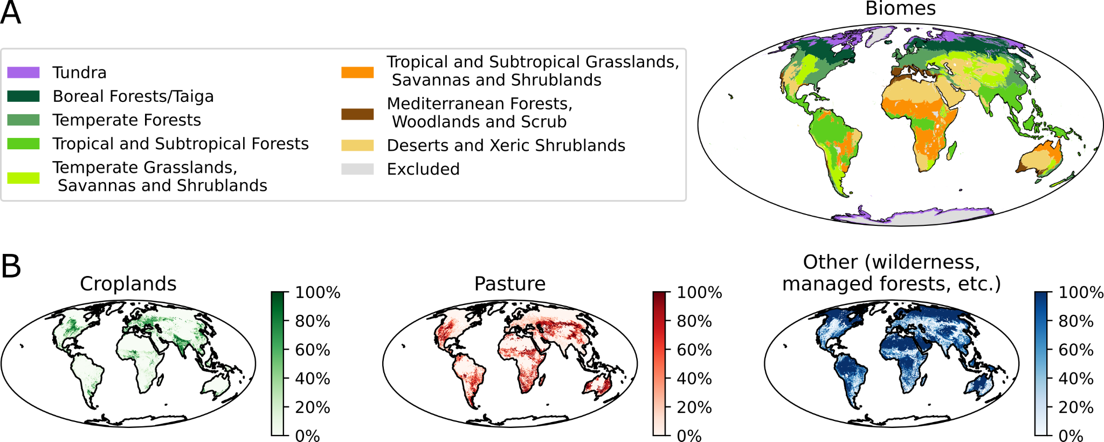

***Figure S1. The geographic definition of the different biomes used in this study.*** *A. The geographic range of the different aggregated biomes used in this study, except croplands and pastures (see Methods). B. The fraction of land surface at each location covered by croplands, pasture or other land (such as wilderness, managed forests etc.). We removed the surface area of croplands and pastures from each biome, and defined them as two separate biomes.*

### Sensitivity analyses

Assessing the impact of the geographic binning

In this study, measurements of terrestrial arthropod biomass were divided into different bins based on the biome in which the measurement site is located (Fig. 1 & S1). The average biomass density in each biome was calculated and multiplied by the total area of the biome to estimate the total biomass of terrestrial arthropods in it. The geographic resolution at which this binning was performed is quite coarse and thus doesn’t take into account important differences between different locations within the same biome. To assess how robust is our the total biomass estimate to the resolution of geographic binning, we performed two sensitivity analyses.

In the first sensitivity analysis, we attempt to divide biomes into finer bins based on different biogeographic realms [(33)](https://paperpile.com/c/DkZTjN/nYw0). There are 6 main biogeographic realms, namely the Nearctic, Palearctic, Afrotropical, Indomalayan, Austalasian and Neotropical realms. For this sensitivity analysis, we use a specific subset of the source data that includes taxa and biomes which contain data from different biogeographic realms. We estimated the total biomass of terrestrial arthropods in these biomes using two different methodologies - relying on biome-level average biomass density, or relying on biome-biogeographic realm-level average biomass density. The results of this sensitivity analysis, suggest that the effect of using a coarser geographical resolution is not significant, and increases the estimate of the total biomass of arthropods in this specific subset of data by about 10%.

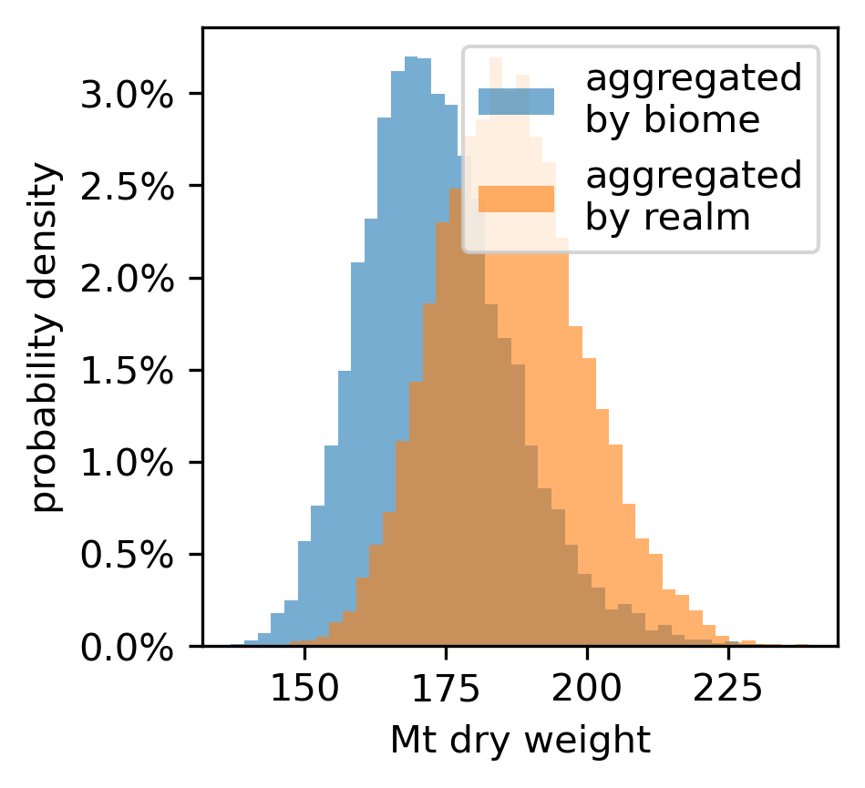

**Figure S2. The effect of binning measurements with a finer geographic resolution on the estimate of the biomass terrestrial arthropods.** Each histogram represents the distribution of estimates produced by binning measurements of arthropod biomass in different sites to bins of different geographic resolution. The blue histogram represents the method used in the main analysis, which bins sites to different biomes. The orange histogram represents an alternative binning based on a finer geographic resolution, dividing each biome into the different biogeographic realms in it.

The second sensitivity analysis we use looks at the effect of reducing the resolution of geographic binning to one bin - the entire ice-free land surface. For each taxonomic group, we calculate the average biomass density across all sampled sites, and multiply the average biomass density by the total ice-free land surface area to get the total biomass of terrestrial arthropods in each taxonomic group. The results of this sensitivity analysis, presented in Fig. S3, show that binning all data into a single geographical bin increases the estimate of the total biomass of terrestrial arthropods about 2-fold, which is within the uncertainty of our estimate for the total biomass of terrestrial arthropods.

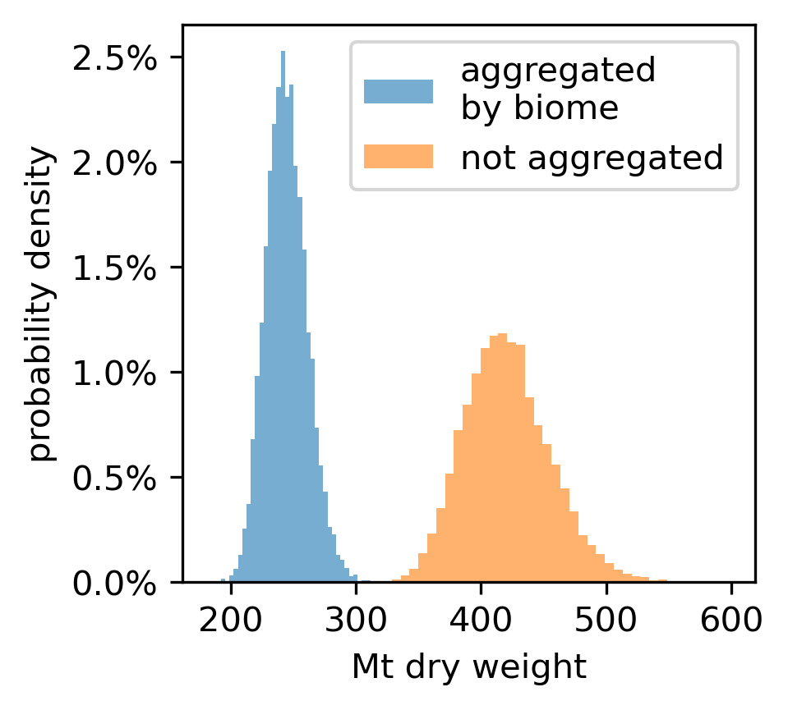

**Figure S3. The effect of binning measurements with a coarser geographic resolution on the estimate of the biomass terrestrial arthropods.** Each histogram represents the distribution of estimates produced by binning measurements of arthropod biomass in different sites to bins of different geographic resolution. The blue histogram represents the method used in the main analysis, which bins sites to different biomes. The orange histogram represents an alternative binning based on a coarser geographic resolution, binning all sites into a single bin.