ST-GCN 1

ST-GCN 2

ST-GCN 3

ST-GCN 4

ST-GCN 5

ST-GCN 6

ST-GCN 7

ST-GCN 8

ST-GCN 9

Softmax

BN

Pool *(global avg)*

*64 channels*

*64 channels*

*64 channels*

*64 channels*

*128 channels*

*256 channels*

*256 channels*

*256 channels*

*128 channels*

*128 channels*

*400 classes*

ST-GCN 0

*3 channels*

**ST-GCN**

GCN

TCN

*Residual*

Conv

BN

ReLU

Conv

BN

Dropout

ReLU

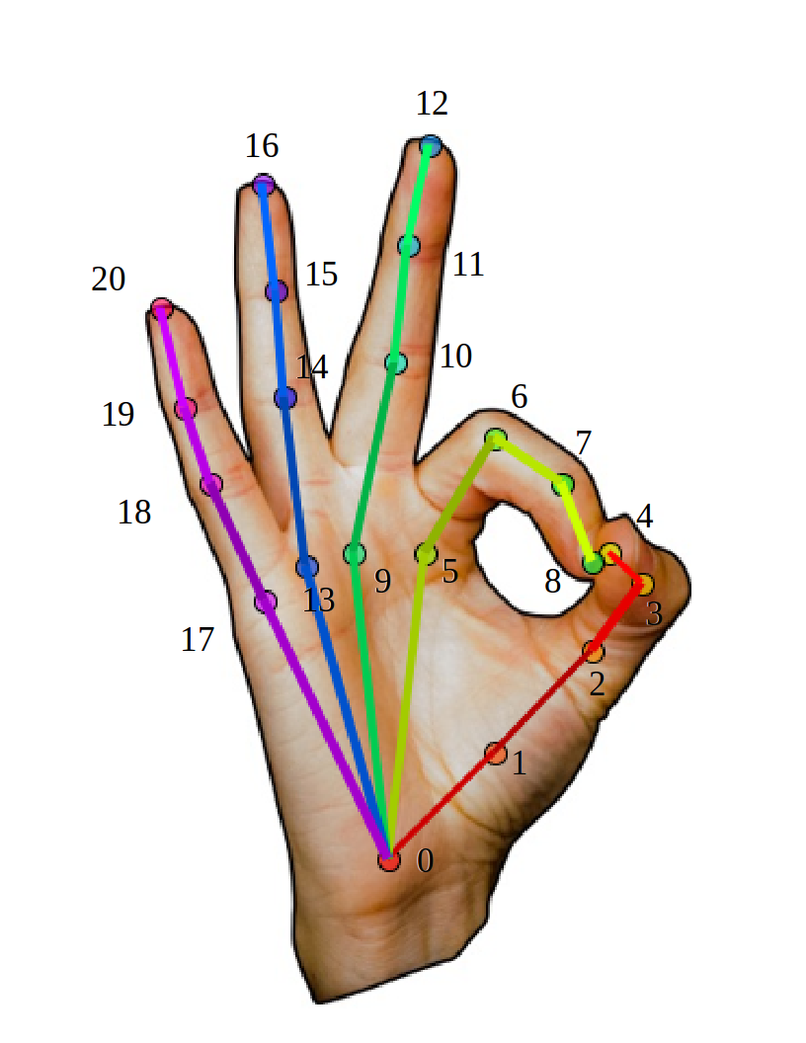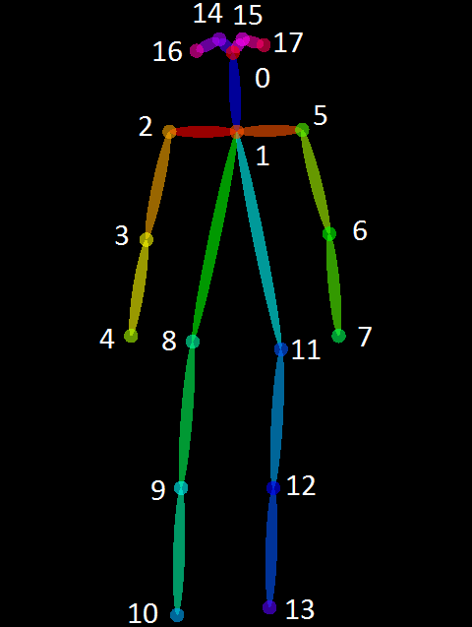



0

1

2

3

4

5

6

7

8

9

10

1

3

0

2

4