Milo Knowles

6.036

Project 3

Writeup

**Part 1: K-Means Results (with k=1, 2, 3, 4, 5)**

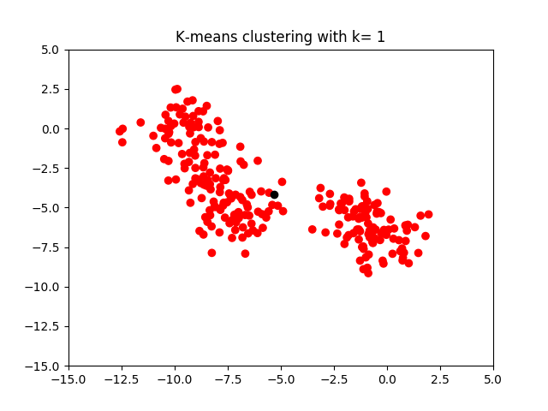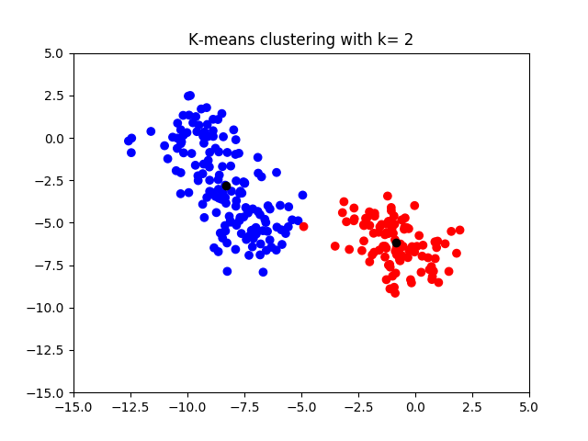

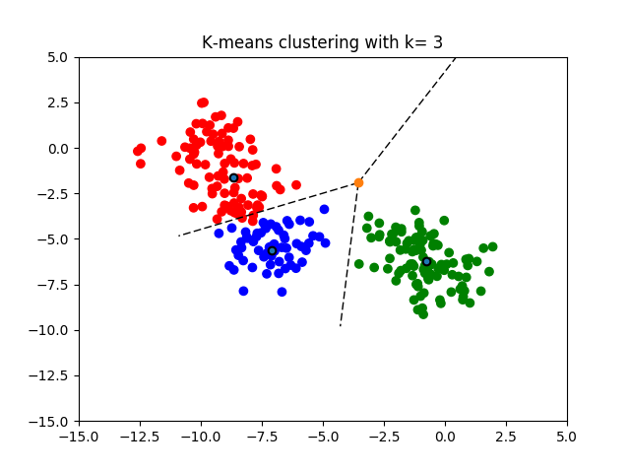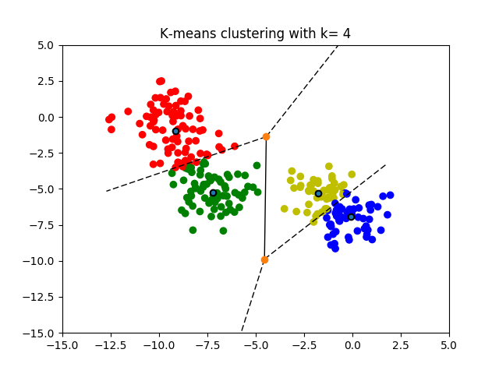

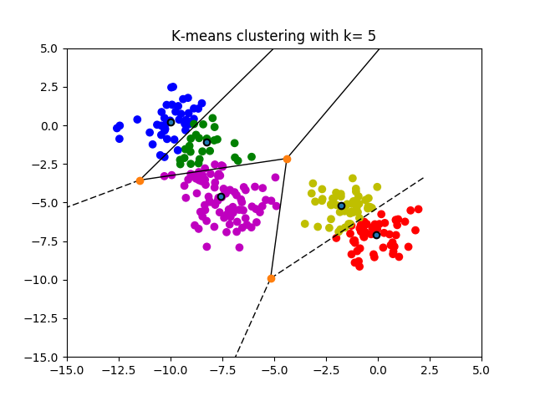

**Part 1: EM Results (with k=1, 2, 3, 4, 5)**

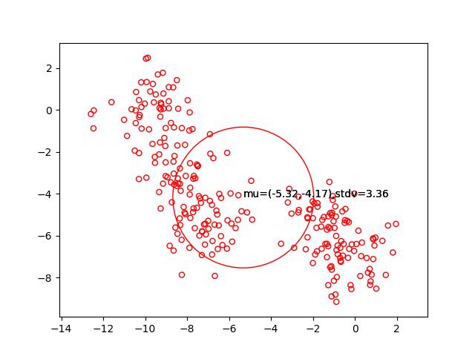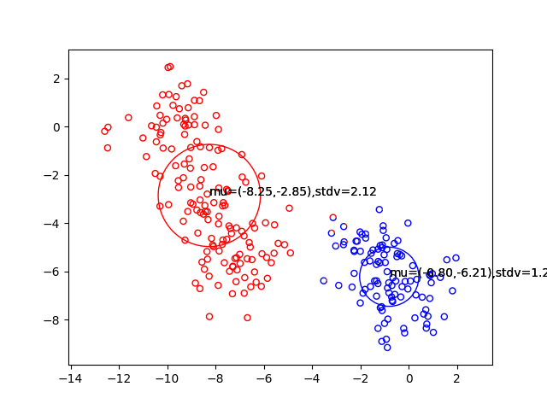

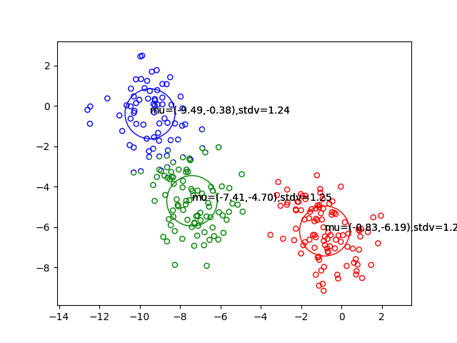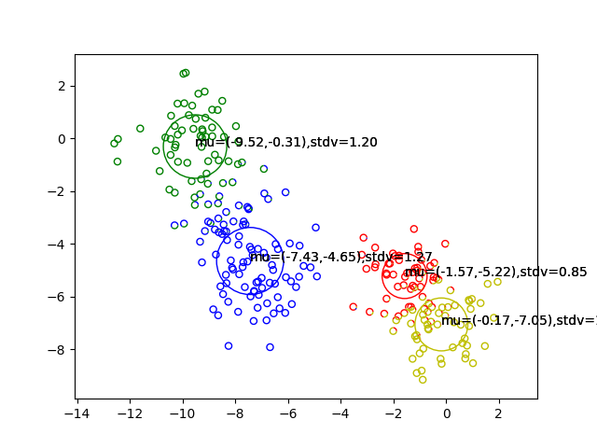

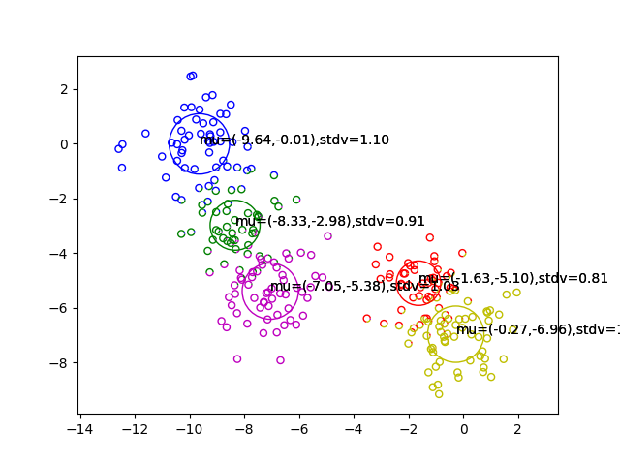

**Log Likelihoods (for plots above)**

K=1: -1315.32

K=2: -1139.73

K=3: -1072.59

K=4: -1058.96

K=5: -1045.62

1-5. For the most part, K-Means and EM produced very similar results for each K=1, 2, 3, 4, 5. Up to an arbitrary coloring, both algorithms seems to cluster points similarly. # TODO