GROWTH CURVE FOR MATURE AND IMMATURE DOLPHINS (SPLITTING BY SEX)
VON BERTALANFFY GROWTH MODEL

Stranded common dolphins 2065
Dolphins with length data 1283
Dolphins with sex data 1646
Dolphins with age data 440
Dolphins with maturity data 256
Dolphins with all the data 144
___________________________________________________________________________________

von Bertalanffy growth model (All)

Formula: length ~ Linf * (1 - exp(-K * (age - to)))

Parameters:
Estimate Std. Error t value Pr(>|t|)
Linf 204.49512 2.57864 79.303 < 2e-16 ***
K 0.23275 0.02557 9.101 8.11e-16 ***
to -4.10388 0.51631 -7.948 5.66e-13 ***
---
Signif. codes: 0 ‘***’ 0.001 ‘**’ 0.01 ‘*’ 0.05 ‘.’ 0.1 ‘ ’ 1

Residual standard error: 12 on 140 degrees of freedom

Number of iterations to convergence: 5
Achieved convergence tolerance: 2.606e-06
von Bertalanffy growth model (All mature)
Formula: length ~ Linf * (1 - exp(-K * (age - to)))

Parameters:
Estimate Std. Error t value Pr(>|t|)
Linf 207.0479 17.1032 12.106 3.39e-16 ***
K 0.1241 0.3264 0.380 0.705
to -15.3536 51.4824 -0.298 0.767
---
Signif. codes: 0 ‘***’ 0.001 ‘**’ 0.01 ‘*’ 0.05 ‘.’ 0.1 ‘ ’ 1

Residual standard error: 10.44 on 48 degrees of freedom

Number of iterations to convergence: 5
Achieved convergence tolerance: 3.665e-06
von Bertalanffy growth model (All immature)
Formula: length ~ Linf * (1 - exp(-K * (age - to)))

Parameters:
Estimate Std. Error t value Pr(>|t|)
Linf 193.01469 6.13496 31.461 < 2e-16 ***
K 0.31286 0.06555 4.773 7.07e-06 ***
to -3.29847 0.64775 -5.092 1.96e-06 ***
---
Signif. codes: 0 ‘***’ 0.001 ‘**’ 0.01 ‘*’ 0.05 ‘.’ 0.1 ‘ ’ 1

Residual standard error: 12.74 on 89 degrees of freedom

Number of iterations to convergence: 7
Achieved convergence tolerance: 4.374e-06

von Bertalanffy growth model (Mature males)
Formula: length ~ Linf * (1 - exp(-K * (age - to)))

Parameters:
Estimate Std. Error t value Pr(>|t|)
Linf 217.5755 16.6832 13.042 6.11e-10 ***
K 0.1904 0.2841 0.670 0.512
to -3.8654 14.6079 -0.265 0.795
---
Signif. codes: 0 ‘***’ 0.001 ‘**’ 0.01 ‘*’ 0.05 ‘.’ 0.1 ‘ ’ 1

Residual standard error: 11.4 on 16 degrees of freedom

Number of iterations to convergence: 72
Achieved convergence tolerance: 5.907e-07
von Bertalanffy growth model (Immature males)
Formula: length ~ Linf * (1 - exp(-K * (age - to)))

Parameters:
Estimate Std. Error t value Pr(>|t|)
Linf 194.8224 10.7939 18.049 4.63e-12 ***
K 0.4623 0.1624 2.847 0.0117 *
to -1.6475 0.7130 -2.311 0.0345 *
---
Signif. codes: 0 ‘***’ 0.001 ‘**’ 0.01 ‘*’ 0.05 ‘.’ 0.1 ‘ ’ 1

Residual standard error: 14.05 on 16 degrees of freedom

Number of iterations to convergence: 8
Achieved convergence tolerance: 4.387e-06

von Bertalanffy growth model (Mature females)
Formula: length ~ Linf * (1 - exp(-K * (age - to)))

Parameters:
Estimate Std. Error t value Pr(>|t|)
Linf 267.0915 755.8075 0.353 0.726
K 0.0183 0.1929 0.095 0.925
to -57.9264 335.5022 -0.173 0.864

Residual standard error: 9.273 on 29 degrees of freedom

Number of iterations to convergence: 89
Achieved convergence tolerance: 0.7

von Bertalanffy growth model (Immature females)
Formula: length ~ Linf * (1 - exp(-K * (age - to)))

Parameters:
Estimate Std. Error t value Pr(>|t|)
Linf 192.30003 6.80946 28.240 < 2e-16 ***
K 0.29254 0.06914 4.231 6.93e-05 ***
to -3.69370 0.79259 -4.660 1.46e-05 ***
---
Signif. codes: 0 ‘***’ 0.001 ‘**’ 0.01 ‘*’ 0.05 ‘.’ 0.1 ‘ ’ 1

Residual standard error: 12.11 on 70 degrees of freedom

Number of iterations to convergence: 7
Achieved convergence tolerance: 9.389e-06
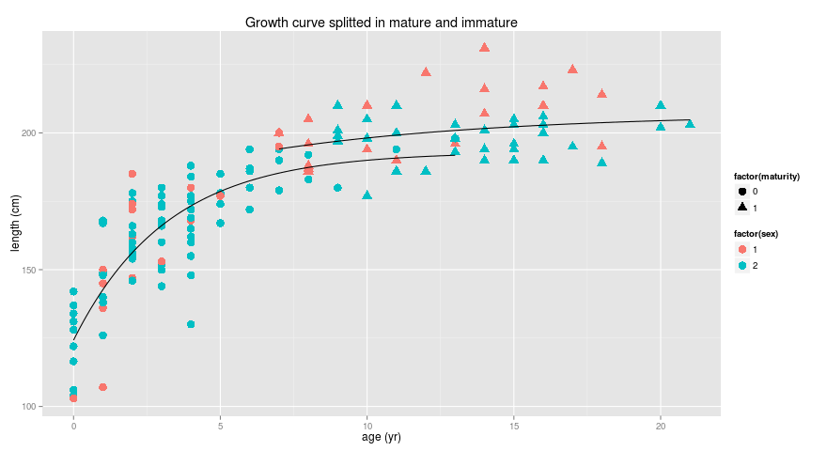
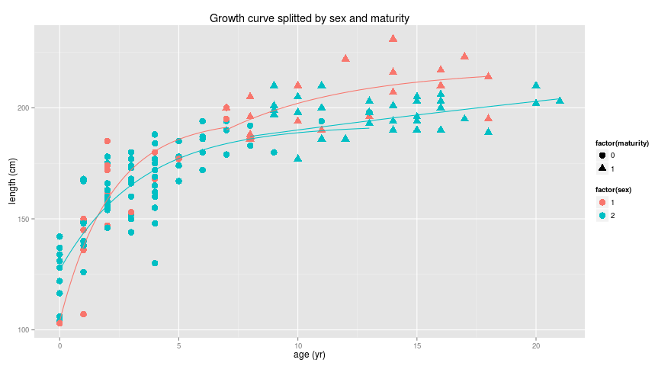

Figure: von Bertalanffy growth model: Males and Females (red, blue). Matures and immatures (filled circle, filled triangle).

Fixing to = 0 (mature and immature)

von Bertalanffy growth model (All)

Formula: length ~ Linf * (1 - exp(-K * (age - to)))

Parameters:
Estimate Std. Error t value Pr(>|t|)
Linf 189.1503 3.8800 48.750 < 2e-16 ***
K 1.0854 0.1414 7.675 2.49e-12 ***
---
Signif. codes: 0 ‘***’ 0.001 ‘**’ 0.01 ‘*’ 0.05 ‘.’ 0.1 ‘ ’ 1

Residual standard error: 36.67 on 141 degrees of freedom

Number of iterations to convergence: 13
Achieved convergence tolerance: 9.374e-06
von Bertalanffy growth model (All mature)
Formula: length ~ Linf * (1 - exp(-K * (age - to)))

Parameters:
Estimate Std. Error t value Pr(>|t|)
Linf 202.67957 2.08251 97.325 < 2e-16 ***
K 0.40913 0.06708 6.099 1.65e-07 ***
---
Signif. codes: 0 ‘***’ 0.001 ‘**’ 0.01 ‘*’ 0.05 ‘.’ 0.1 ‘ ’ 1

Residual standard error: 10.4 on 49 degrees of freedom

Number of iterations to convergence: 7
Achieved convergence tolerance: 1.442e-06
von Bertalanffy growth model (All immature)
Formula: length ~ Linf * (1 - exp(-K * (age - to)))

Parameters:
Estimate Std. Error t value Pr(>|t|)
Linf 174.0094 6.0004 28.999 < 2e-16 ***
K 1.5708 0.3681 4.267 4.89e-05 ***
---
Signif. codes: 0 ‘***’ 0.001 ‘**’ 0.01 ‘*’ 0.05 ‘.’ 0.1 ‘ ’ 1

Residual standard error: 43.21 on 90 degrees of freedom

Number of iterations to convergence: 9
Achieved convergence tolerance: 9.644e-06

von Bertalanffy growth model (Mature males)
Formula: length ~ Linf * (1 - exp(-K * (age - to)))

Parameters:
Estimate Std. Error t value Pr(>|t|)
Linf 213.92939 4.58816 46.626 < 2e-16 ***
K 0.30070 0.04293 7.005 2.12e-06 ***
---
Signif. codes: 0 ‘***’ 0.001 ‘**’ 0.01 ‘*’ 0.05 ‘.’ 0.1 ‘ ’ 1

Residual standard error: 11.15 on 17 degrees of freedom

Number of iterations to convergence: 4
Achieved convergence tolerance: 6.934e-06
von Bertalanffy growth model (Immature males)
Formula: length ~ Linf * (1 - exp(-K * (age - to)))

Parameters:
Estimate Std. Error t value Pr(>|t|)
Linf 180.7143 10.4027 17.372 2.95e-12 ***
K 1.2953 0.3363 3.852 0.00128 **
---
Signif. codes: 0 ‘***’ 0.001 ‘**’ 0.01 ‘*’ 0.05 ‘.’ 0.1 ‘ ’ 1

Residual standard error: 29.04 on 17 degrees of freedom

Number of iterations to convergence: 9
Achieved convergence tolerance: 7.585e-06

von Bertalanffy growth model (Mature females)
Formula: length ~ Linf * (1 - exp(-K * (age - to)))

Parameters:
Estimate Std. Error t value Pr(>|t|)
Linf 197.2835 1.9429 101.538 < 2e-16 ***
K 0.4662 0.1399 3.333 0.00229 **
---
Signif. codes: 0 ‘***’ 0.001 ‘**’ 0.01 ‘*’ 0.05 ‘.’ 0.1 ‘ ’ 1

Residual standard error: 8.04 on 30 degrees of freedom

Number of iterations to convergence: 3
Achieved convergence tolerance: 0.2524

von Bertalanffy growth model (Immature females)
Formula: length ~ Linf * (1 - exp(-K * (age - to)))

Parameters:
Estimate Std. Error t value Pr(>|t|)
Linf 172.5837 6.9522 24.824 < 2e-16 ***
K 1.6982 0.5481 3.099 0.00279 **
---
Signif. codes: 0 ‘***’ 0.001 ‘**’ 0.01 ‘*’ 0.05 ‘.’ 0.1 ‘ ’ 1

Residual standard error: 46.45 on 71 degrees of freedom

Number of iterations to convergence: 10
Achieved convergence tolerance: 6.033e-06

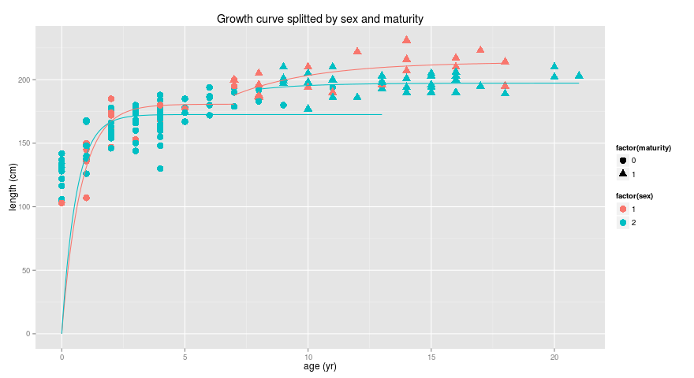
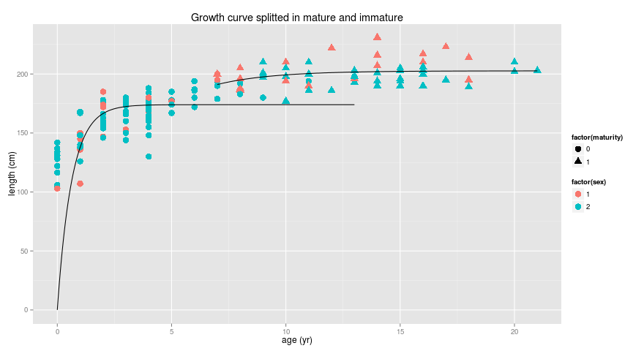
Figure: von Bertalanffy growth model: Males and Females (red, blue). Matures and inmatures (filled circle, filled triangle).

