**Problem Name: Binary_Reflection**

**Category: Forensic**

**Analyzation:**

At first I opened it on hexeditor and saw that pdf magic bytes or starting headers are at the very end. From there and from the challenge name "reflection" I got a clue that the corrupted pdf was just a reversed pdf

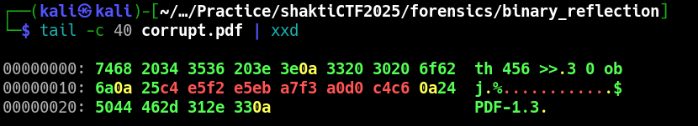

**Solution:**

Use this command to fix the broken pdf "tac corrupt.pdf > reversed.pdf", then opening the fixed pdf u can find the flag which is "**shaktictf{pdf_pr3tty_d4m4g3d_f0rm4t}**"