ROLL NO- SIB65

NAME- Milonee Vyas

# PSDL ASSIGNMENT

# Program

#include <xc.h> #include <stdio.h> #include <stdlib.h> #include <pic18f4550.h>

void main(void) { int i;

int source1[]={0x50,0x80,0x10,0x25,0x60}; //source mem block int dest[]={0x00,0x00,0x00,0x00,0x00}; //destination mem block for(i=0;i<=4;i++)

{

dest[i]=source1[i];

} TRISD=0;

for(i=0;i<=4;i++) //counter=5

{

PORTD=dest[i]; //source to destination

// for(int n=0;n<1000;n++){

// for(int j=0;j<500;j++){

// }

//}

}

return;

}

# Output

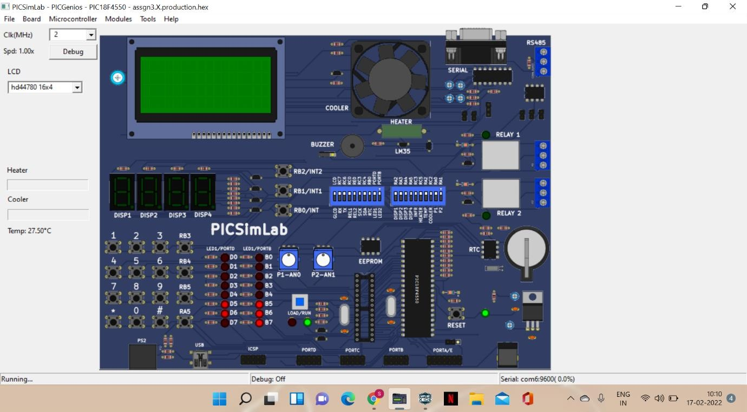

**Program**

#include <xc.h> #include <stdio.h> #include <stdlib.h> #include <pic18f4550.h>

void main(void) {

int source[]={0x1,0x2,0x3,0x4,0x5}; int dest[]={0x6,0x7,0x8,0x9,0xa}; int temp,i,j,k;

for(i=0;i<5;i++){ temp=source[i]; source[i]=dest[i]; dest[i]=temp;

} TRISB=0;

TRISD=0;

for(i=0;i<5;i++){ PORTB=dest[i]; PORTD=source[i];

// for(j=0;j<1000;j++){

// for(k=0;k<100;k++){

// }

// }

}

return;

}

# Output

