ROLL NO- SIB65

NAME- Milonee Vyas

program i) #include <xc.h> #include <stdio.h> #include <stdlib.h>

#include <pic18f4550.h> void main(void) {

int a,b,count; a=18;

b=3;

count=0; while(a>=b){

a=a-b; count++;

} TRISD=0;

PORTD=count; return;

}

# Output-

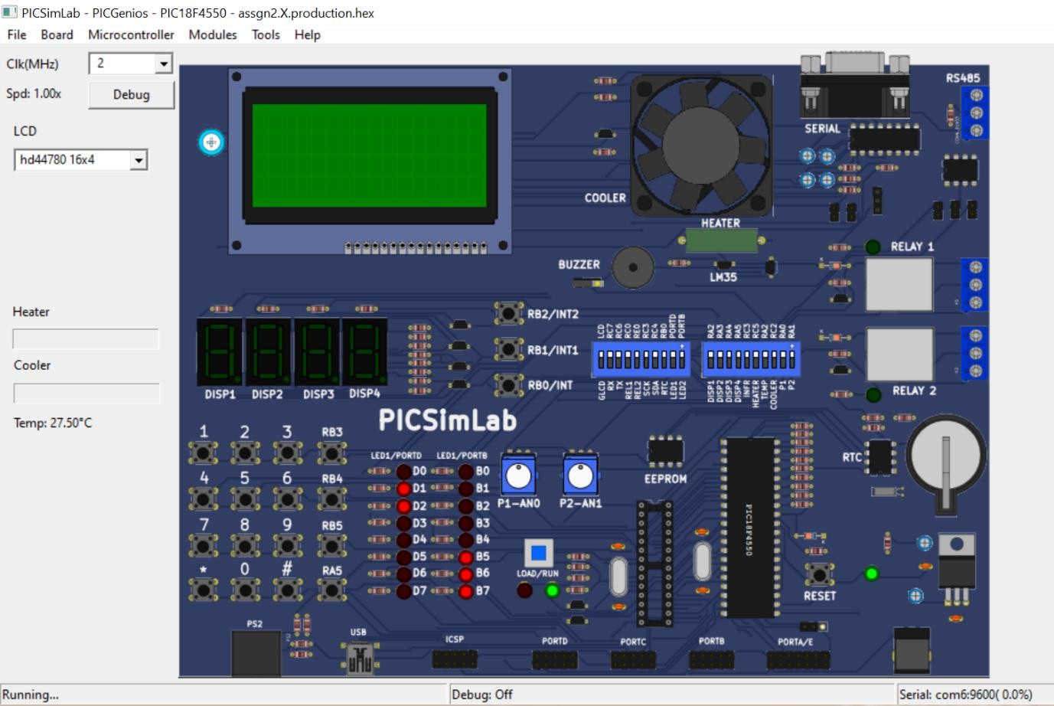

Program ii) #include <xc.h> #include <stdio.h> #include <stdlib.h>

#include <pic18f4550.h> void main(void) {

int a,b,i,multi; a=0x04; b=0x03;

multi=0x00; for(i=0;i<b;i++){

multi=multi+a;

}

TRISD=0; //initializing port_d as output PORTD=multi;

}

# Output-

