// Embedded C program for sorting the numbers in ascending and descending order. 1) Ascending order:

#incIude<xc.h> #incIude <stdio.h>
#incIude <stdIib.h> #include<pic18f4550.h»
void main(void)(
int i,j,t;
int a[]=(0x45,0x03,0x06,0x13,0x32,0x02,0x50,0x23}; for(i=1;i<=7;i++)
for(j=0;j<7;j++) if(a[j]>a[j+1])
( t=a[j];
a[j]=a[j+1]; a[j+1]=t;

TRISD=0;
for(i=0;i<=7;i++)

PORTD = a[i]; for(int k=0;k<1000;k++)

for(int n=0;n<100;n++)

return;

2) Descending Order:

#incIude<xc.h> #incIude <stdio.h> #incIude <stdIib.h>
#incIude<pic18f4550.h> void
main(void){ int i,j,t;
int a[]={0x45,0x03,0x06,0x13,0x32,0x02,0x50,0x23};
for(i=1;i<=7;i++) for(j=0;j<7;j++)
if(a[j]<a[j+1]) ( t=a[j];
a[j]=a[j+1]; a[j+1]=t;

TRISD=0;
for(i=0;i<=7;i++)

PORTD = a[i];
for(int k=0;k<1000;k++) for(int n=0;n<100;n++)

return;

OUTPUT:

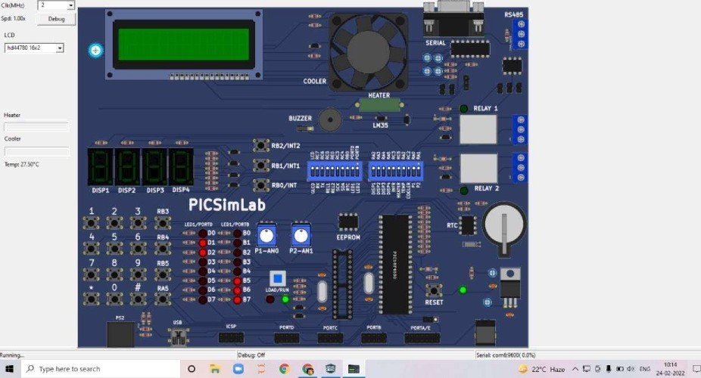

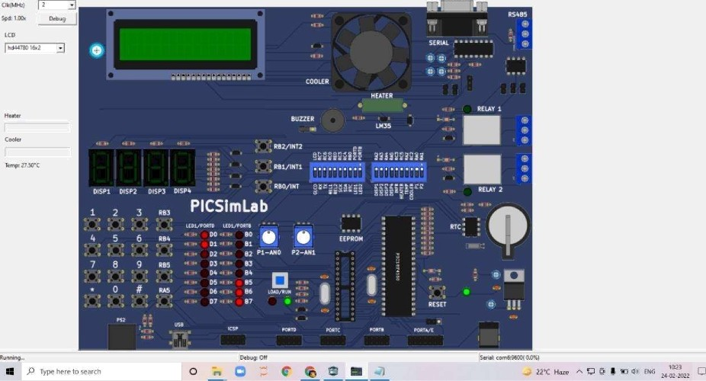
” I* B‹. a› ri •.ii. klodu!e‹ For I Hel g


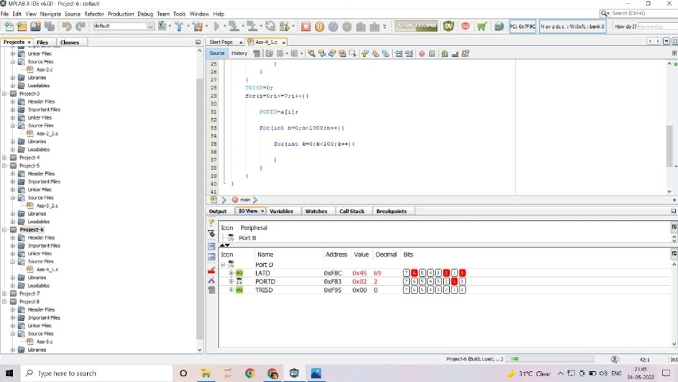
‘ *“”‘*‘ '“"""”‘ ”*" ‘*“* ’"” '* **"”“‘*'”” "‘
i o view
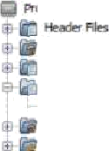
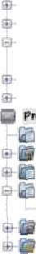
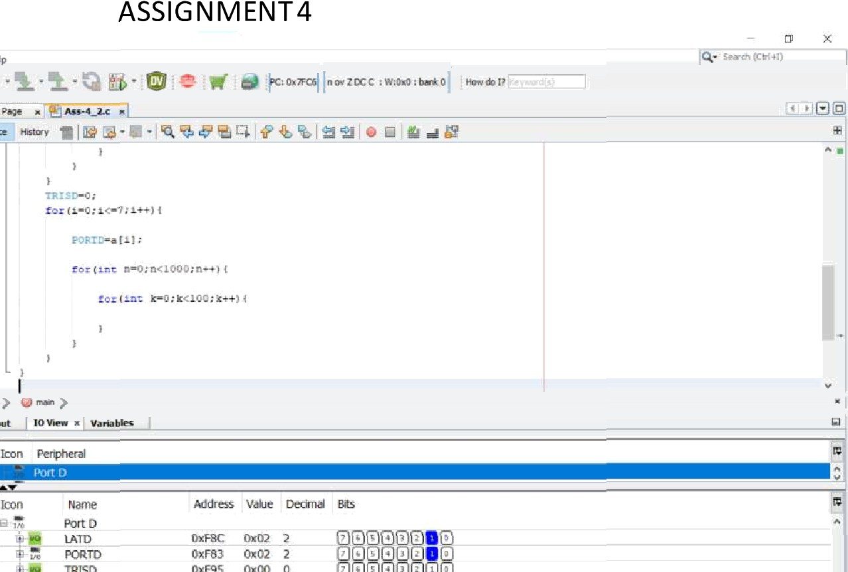
NAME:POORVADlYABEHRE ROLLNO:568

