Chapter 1
Attack Mechanisms, Threat Landscape, and Security Gaps in E-Banking Systems

1.1 Attack Mechanisms in E-Banking and E-Finance Services
Electronic banking and electronic finance service systems operate in one of the most adversarial computing environments in existence. The concentration of monetary value, the interconnectivity of financial networks, and the diversity of access channels create opportunities for attackers at every layer of the technology stack. This section provides a systematic definition and taxonomy of attack mechanisms currently employed against e-banking and e-finance services, supported by representative case studies drawn from documented security incidents.
An attack mechanism, in the context of this dissertation, is defined as a systematic method or technique employed by an adversary to exploit a vulnerability in an e-banking or e-finance system component—whether technical, procedural, or human—in order to achieve an unauthorized objective such as theft of funds, exfiltration of sensitive data, disruption of service, or compromise of system integrity. Attack mechanisms differ from individual exploits in that they describe reusable patterns that can be adapted to multiple targets and environments.

1.1.1 Taxonomy of Attacks
We classify attack mechanisms against e-banking systems into six primary categories based on the attacker's objective and the layer of the system stack targeted: (1) credential and authentication attacks, (2) communication channel attacks, (3) application-layer attacks, (4) infrastructure attacks, (5) insider and supply-chain attacks, and (6) social engineering attacks. Table 1.1 summarizes these categories with representative techniques.
Credential and authentication attacks target the mechanisms by which users and systems prove their identity. Techniques include credential stuffing (automated injection of username-password pairs leaked from unrelated breaches), brute-force password guessing, pass-the-hash attacks against Windows authentication in bank internal networks, and exploitation of weak multi-factor authentication implementations that rely on SMS one-time passwords (OTPs) vulnerable to SIM-swapping.
Communication channel attacks intercept, modify, or replay data in transit between clients and servers or between server nodes. The classic man-in-the-middle (MITM) attack positions the adversary between communicating parties, potentially decrypting, altering, and re-encrypting messages. SSL stripping downgrades HTTPS connections to HTTP, while BGP hijacking reroutes network traffic through attacker-controlled routers. Replay attacks capture valid authentication messages and retransmit them to gain unauthorized access.
Application-layer attacks exploit vulnerabilities in banking software itself. SQL injection manipulates database queries through unsanitized user input. Cross-site scripting (XSS) injects malicious scripts into banking web pages viewed by other users. Cross-site request forgery (CSRF) tricks authenticated users into submitting unintended transactions. Business logic flaws may allow negative-amount transfers or bypass of transaction limits.
Infrastructure attacks target the servers, networks, and cloud platforms hosting banking services. Distributed denial-of-service (DDoS) attacks overwhelm servers with traffic, rendering services unavailable. Ransomware encrypts critical banking data and demands payment for decryption keys. Container escape attacks in cloud-hosted banking microservices can compromise co-located workloads.
Insider and supply-chain attacks leverage trusted positions or compromised third-party components. Malicious insiders with database access can exfiltrate customer records or manipulate account balances. Supply-chain compromises, such as the 2020 SolarWinds incident, insert backdoors into software updates distributed to thousands of organizations including financial institutions.
Social engineering attacks manipulate human psychology rather than technical vulnerabilities. Phishing emails impersonate banks to harvest credentials. Vishing (voice phishing) uses phone calls to trick customers into revealing authentication codes. Pretexting creates fabricated scenarios to persuade bank employees to override security controls.
Category | Techniques | Primary Target | Impact
Credential/Auth | Stuffing, brute force, SIM-swap | Login systems | Account takeover
Channel | MITM, SSL strip, replay, BGP hijack | Network layer | Data theft, fraud
Application | SQLi, XSS, CSRF, logic flaws | Banking apps | Data breach, fraud
Infrastructure | DDoS, ransomware, container escape | Servers/cloud | Outage, data loss
Insider/Supply-chain | Data exfiltration, backdoors | Internal systems | Mass breach
Social engineering | Phishing, vishing, pretexting | Users/employees | Credential theft
Table 1.1: Taxonomy of attack mechanisms against e-banking systems.

1.1.2 Case Studies
Case Study 1 — Bangladesh Bank Heist (2016): Attackers gained access to the Bangladesh Bank's internal network, likely through a phishing email, and installed malware that monitored SWIFT Alliance Access software. Over several days, the attackers sent 35 fraudulent SWIFT transfer requests totaling $951 million. While most transfers were blocked, $81 million was successfully transferred to accounts in the Philippines. This case illustrates the catastrophic potential of server-server communication compromise when authentication and integrity controls on inter-bank messaging are insufficient.
Case Study 2 — Capital One Data Breach (2019): A former cloud services employee exploited a misconfigured web application firewall to access an AWS S3 bucket containing personal data of over 100 million credit card applicants. The breach demonstrates that cloud-hosted e-finance systems introduce new attack vectors related to identity and access management misconfigurations, and that data-at-rest encryption alone is insufficient without proper access controls.
Case Study 3 — Credential Stuffing Campaigns (2018–2024): Multiple major banks reported surges in account takeover fraud resulting from credential stuffing attacks using billions of leaked username-password pairs from non-financial breaches. Despite banks implementing account lockout and anomaly detection, the sheer volume of attempts (sometimes exceeding 50 million per day across the industry) results in a non-trivial success rate. These campaigns highlight the inadequacy of password-only authentication and the need for device-bound cryptographic authentication.
Case Study 4 — EMV Relay Attacks (2020–2023): Researchers demonstrated relay attacks against contactless payment cards, where a proxy device near the victim's card relays NFC communication to a accomplice's device at a point-of-sale terminal hundreds of kilometers away. While EMV cryptography prevents card cloning, the relay attack bypasses proximity assumptions, showing that authentication protocols must bind cryptographic proofs to physical context.
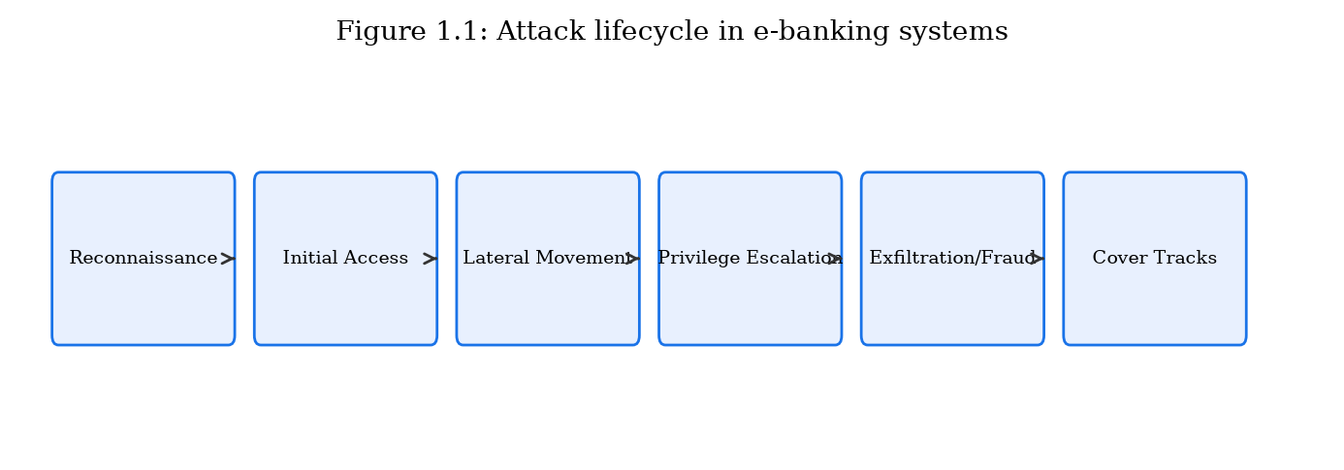
Attack lifecycle flowchart: reconnaissance → initial access → lateral movement → privilege escalation → data exfiltration/fraud → cover tracks (Figure 1.1).

1.1.3 Attack Trends and Statistics
The financial services sector consistently ranks among the top three industries targeted by cyberattacks. The IBM Cost of a Data Breach Report (2024) reports that the average cost of a data breach in the financial sector is $5.9 million, compared to a cross-industry average of $4.45 million. Phishing remains the most common initial access vector, accounting for approximately 41% of breaches in financial services according to the Verizon Data Breach Investigations Report (2024).
The adoption of mobile banking has shifted attack patterns: mobile malware targeting banking applications grew by 32% year-over-year, with trojans such as Anubis, Cerberus, and SharkBot employing overlay attacks to capture credentials and intercept SMS OTPs. Concurrently, API attacks against open-banking endpoints have emerged as a new threat category, with the OWASP API Security Top 10 identifying broken authentication and excessive data exposure as the most prevalent vulnerabilities.
Ransomware groups have increasingly targeted financial institutions, with groups such as LockBit, ALPHV/BlackCat, and Cl0p claiming attacks on banks, insurance companies, and payment processors. The double-extortion model—encrypting data and threatening to publish stolen records—amplifies the pressure on victims to pay.
From a defensive standpoint, understanding attack trends enables prioritization of security investments. The shift from perimeter-focused defenses to zero-trust architectures reflects the recognition that network boundaries have dissolved. In a zero-trust model, every access request—regardless of origin—is authenticated, authorized, and encrypted. The cryptographic schemes proposed in this dissertation align with zero-trust principles by providing device-bound, transaction-scoped authentication (ECC-DTB-AKA) and persistent integrity proofs that survive service-boundary crossings (ECC-HISE).

1.1.4 Regulatory and Standards Landscape
The regulatory environment surrounding e-banking security provides both constraints and guidance for cryptographic system design. The Payment Card Industry Data Security Standard (PCI DSS) v4.0 mandates strong cryptography for cardholder data protection, requiring TLS 1.2 or higher for transmission and AES-256 for storage. The European Union's Revised Payment Services Directive (PSD2) requires strong customer authentication (SCA) for electronic payments, implemented through two of three factors: knowledge (password), possession (device/token), and inherence (biometric).
NIST Special Publication 800-52 Rev. 2 provides guidelines for TLS implementations in government and commercial systems, recommending TLS 1.3 with specific cipher suites. NIST SP 800-57 Part 1 offers key-management guidance, recommending ECC P-256 for protection through 2030 and P-384 for longer-term requirements. ISO/IEC 27001:2022 specifies information security management system requirements applicable to financial institutions globally.
The SWIFT Customer Security Programme (CSP) mandates 32 mandatory and advisory controls for institutions connected to the SWIFT network, including multi-factor authentication for operator sessions, network segmentation, and attestation of security compliance annually. Non-compliance can result in reporting to regulators and potential disconnection from the SWIFT network.
These standards collectively establish minimum baselines but do not prescribe integrated methodologies for binding authentication to key exchange or for hierarchical data-protection envelopes. The gap between compliance and comprehensive security motivates the research contributions of this dissertation.

1.1.5 Detailed Analysis of Selected Attack Vectors
To provide depth beyond the taxonomy presented in Section 1.1.1, this subsection examines three high-impact attack vectors in detail: man-in-the-middle attacks on banking sessions, session hijacking via token theft, and advanced persistent threats (APTs) targeting financial infrastructure.
Man-in-the-middle (MITM) attacks on banking sessions exploit the fact that users often cannot distinguish legitimate bank servers from impersonating proxies. In a typical MITM scenario, the attacker positions a proxy between the client and the bank server. If the client does not validate the server's certificate chain correctly—or if the attacker has compromised a trusted CA or uses a corporate SSL-inspection proxy—the attacker can decrypt, inspect, and modify transaction data in real time. Tools such as mitmproxy and Burp Suite, while designed for legitimate security testing, demonstrate the feasibility of this attack class. Banking trojans such as Zeus and Emotet have historically automated MITM against banking websites by injecting fraudulent transaction fields into otherwise legitimate sessions, redirecting wire transfers to attacker-controlled accounts without altering the confirmation screen displayed to the user.
Session hijacking via token theft represents a distinct but related threat. After successful authentication, the banking application issues a session token (cookie or bearer token) that the client presents with each subsequent request. If an attacker obtains this token—through XSS, malware memory scraping, or network sniffing on unencrypted channels—the attacker can impersonate the victim without knowing their password or MFA code. The OWASP Session Management Cheat Sheet recommends token rotation, binding tokens to client IP addresses, and using HttpOnly/Secure cookie flags, but these mitigations are not universally implemented and do not provide cryptographic binding between the token and the underlying key-exchange material.
Advanced persistent threats (APTs) targeting financial infrastructure operate over extended time periods (weeks to months), maintaining covert access to bank networks while exfiltrating data or preparing fraudulent transactions. APT groups such as Carbanak (also known as FIN7) and Lazarus Group have demonstrated the ability to compromise bank internal networks, learn internal transaction workflows, and execute fraudulent transfers through the same channels used by legitimate operators. APT attacks often begin with spear-phishing emails containing weaponized documents, progress through lateral movement using stolen credentials, and culminate in access to SWIFT terminals or core banking systems. The Bangladesh Bank heist exemplifies an APT-style operation against financial infrastructure.

1.1.6 Impact Assessment Framework
Assessing the impact of attacks on e-banking systems requires a multidimensional framework that goes beyond simple financial loss figures. We adopt a framework with four impact dimensions: financial, operational, reputational, and regulatory.
Financial impact encompasses direct losses (fraudulent transfers, ransom payments), indirect losses (customer compensation, legal fees), and recovery costs (forensic investigation, system restoration). The Ponemon Institute and IBM jointly publish annual cost-of-breach figures; for financial services in 2024, the average total cost was $5.9 million per breach, with an average of 258 days to identify and contain the breach.
Operational impact includes service downtime, degraded performance during attacks, and diversion of IT resources from planned projects to incident response. A DDoS attack against a major bank's online banking portal can prevent millions of customers from accessing services for hours, generating call-center surges and transaction backlogs. The operational resilience requirements of the Bank of England and the European Central Bank mandate maximum tolerable downtime thresholds for critical payment systems.
Reputational impact manifests as customer attrition, negative media coverage, and reduced stock valuation. Studies indicate that publicly traded banks experience an average stock price decline of 5–7% in the week following a major breach announcement, with partial recovery over subsequent months. Customer trust, once eroded, requires sustained investment in transparency and security improvements to rebuild.
Regulatory impact includes fines, consent orders, and increased supervisory scrutiny. The GDPR permits fines up to 4% of global annual revenue for serious data protection violations. The U.S. Office of the Comptroller of the Currency (OCC) and the Federal Reserve have issued consent orders against banks with deficient cybersecurity programs, requiring multi-year remediation plans and independent third-party assessments.

1.2 Authentication and Key Exchange in E-Banking Systems
Authentication and key exchange form the first line of cryptographic defense in e-banking systems. Before any financial transaction can be authorized, the participating parties must establish mutual confidence in each other's identity and agree upon cryptographic keys for protecting subsequent communication. This section reviews the authentication and key-exchange mechanisms currently deployed in client-server and server-server environments of e-banking and e-finance services, analyzes their operational characteristics, and identifies limitations that motivate the scheme proposed in Chapter 2.

1.2.1 Client-Server Authentication Mechanisms
The dominant client-server authentication model in retail e-banking comprises TLS 1.2/1.3 transport layer security combined with application-layer username-password authentication, often supplemented by a second factor (SMS OTP, hardware token, or mobile push notification). In this model, TLS provides server authentication via X.509 certificates and establishes encrypted channels, while the application layer authenticates the user independently.
The TLS 1.3 handshake protocol operates as follows: the client sends a ClientHello message specifying supported cipher suites and a key share (typically ECDHE on curve X25519 or P-256). The server responds with ServerHello, its certificate chain, and a key share. Both parties derive handshake traffic keys and application traffic keys using HKDF. The full handshake requires one round trip (1-RTT); a subsequent resumption using pre-shared keys achieves 0-RTT, though 0-RTT data is vulnerable to replay attacks and is therefore restricted by banking applications.
Application-layer authentication typically follows the TLS handshake. The client submits credentials (username, password hash, or token) over the encrypted channel. The server validates credentials against a stored database, often using bcrypt, scrypt, or Argon2 password hashing. Upon success, the server issues a session token (commonly a JSON Web Token or opaque server-side session identifier) that the client presents with subsequent requests.
Multi-factor authentication (MFA) adds a second verification step. SMS-based OTP remains prevalent despite known vulnerabilities to SIM-swapping and SS7 protocol attacks. Time-based one-time passwords (TOTP) per RFC 6238, implemented by applications such as Google Authenticator, provide stronger security but are susceptible to real-time phishing proxies (e.g., Evilginx) that relay OTPs to the attacker. FIDO2/WebAuthn, based on public-key cryptography with hardware security keys or platform authenticators (biometrics), represents the current state of the art for phishing-resistant MFA.
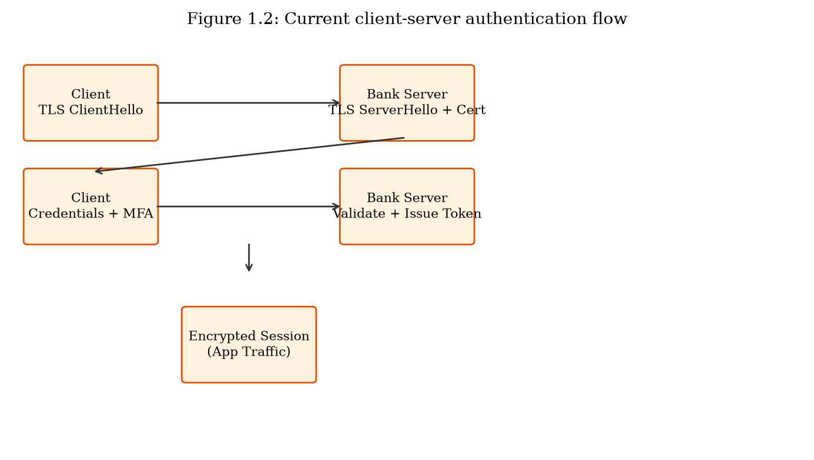
Current client-server authentication flow: TLS handshake → credential submission → MFA challenge → session token issuance (Figure 1.2).

1.2.2 Server-Server Authentication and Key Exchange
Server-server authentication in e-finance encompasses communication between a bank's internal microservices, inter-bank payment networks (SWIFT, ACH, Fedwire, SEPA), card network processors (Visa, Mastercard), and third-party open-banking aggregators. These channels typically employ mutual TLS (mTLS) with client certificates, VPN tunnels, or dedicated leased lines with link-layer encryption.
In the SWIFT network, authentication relies on the SWIFT Alliance Access software and bilateral key exchange (BKE) between institutions. Message authentication uses symmetric keys distributed through SWIFT's Secure Channel protocol. The 2016 Bangladesh Bank heist exposed weaknesses in institutions' local security practices surrounding SWIFT terminal access rather than fundamental flaws in SWIFT's cryptographic protocols, but the incident nonetheless highlighted the importance of end-to-end authentication binding.
Modern microservice architectures within banks increasingly use service mesh platforms (e.g., Istio, Linkerd) that automate mTLS between services. Certificate authorities internal to the bank issue short-lived certificates (typically 24-hour validity) to each service instance. While mTLS provides strong transport security, it does not address application-level authorization, message-level integrity for stored records, or auditability requirements for regulatory compliance.
API-based open-banking connections (under PSD2, Open Banking UK, and similar frameworks) use OAuth 2.0 with PKCE (Proof Key for Code Exchange) for customer consent and access-token issuance. The authorization server authenticates the third-party provider, while the resource server (bank API) validates access tokens. Limitations include token theft via XSS, insufficient scope granularity, and the absence of transaction-level cryptographic binding.
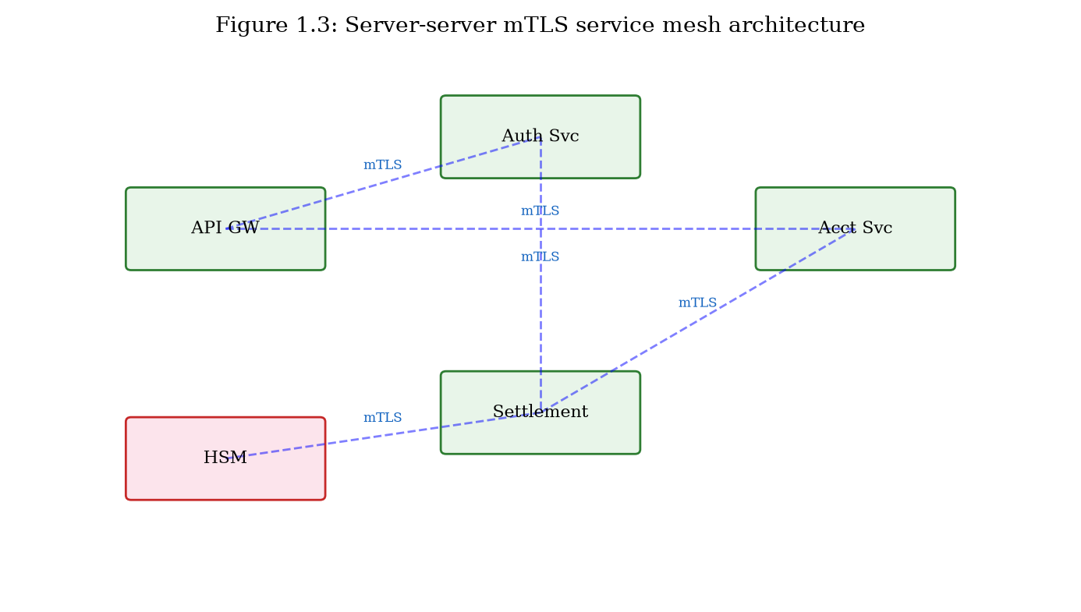
Server-server authentication in a microservice e-finance architecture with mTLS service mesh (Figure 1.3).

1.2.3 Identified Limitations and Drawbacks
Despite the breadth of deployed mechanisms, significant limitations persist in current client-server and server-server authentication and key-exchange practices. These limitations directly motivate the ECC-DTB-AKA scheme proposed in Chapter 2.
Limitation 1 — Decoupled transport and application authentication: TLS authenticates the server (and optionally the client via mTLS) at the transport layer, while user authentication occurs separately at the application layer. This decoupling creates a gap: a valid TLS session does not cryptographically bind the authenticated user identity to the encryption keys. An attacker who compromises a session token can hijack the application session even though the TLS channel remains intact.
Limitation 2 — Absence of device binding in key exchange: Standard TLS ECDHE derives session keys from ephemeral key pairs only, without incorporating device characteristics. If a session token is exfiltrated, it can be replayed from a different device. FIDO2 addresses this for the authentication step but does not integrate device binding into the key-exchange derivation itself.
Limitation 3 — No transaction-level key derivation: Once a session is established, the same application traffic keys protect all transactions within the session. Compromise of session keys exposes all transactions, not merely the current one. Per-transaction key derivation without additional round trips is not supported by TLS or OAuth 2.0.
Limitation 4 — Session token vulnerability: Opaque session tokens and JWTs are bearer credentials—whoever possesses the token is authenticated. Token theft via XSS, malware, or network interception remains a prevalent attack vector. Binding tokens to cryptographic key material established during authenticated key agreement would limit the impact of token compromise.
Limitation 5 — Server-server channels lack message-level security: mTLS protects data in transit between services but does not provide persistent integrity proofs for stored or forwarded messages. If a message is intercepted after TLS termination and before re-encryption, it is vulnerable to tampering.
Limitation 6 — Insufficient forward secrecy in legacy deployments: Although TLS 1.3 mandates forward secrecy, many e-banking systems still support TLS 1.2 with cipher suites that do not use ephemeral Diffie-Hellman (e.g., RSA key transport). Legacy load balancers and API gateways may terminate TLS and re-encrypt with weaker configurations, creating forward-secrecy gaps.
These six limitations collectively demonstrate that current authentication and key-exchange practices in e-banking systems, while adequate for baseline compliance, fail to provide the cryptographic binding of identity, device, and transaction context necessary to resist the attack mechanisms cataloged in Section 1.1. Chapter 2 addresses these limitations through the ECC-DTB-AKA protocol, which integrates mutual authentication, ECDH-based forward secrecy, device fingerprint binding, and on-demand transaction key derivation into a unified three-round handshake.
Limitation | Affected Mechanism | Attack Enabled | Severity
Decoupled auth layers | TLS + app login | Session hijacking | High
No device binding | TLS ECDHE | Credential replay from new device | High
No per-txn key derivation | TLS session keys | Bulk transaction exposure | Medium
Bearer session tokens | JWT / opaque tokens | Token theft (XSS, malware) | High
No message-level integrity | mTLS only | Post-termination tampering | Medium
Legacy TLS configurations | TLS 1.2 RSA suites | Retroactive decryption | Medium
Table 1.2: Limitations of current authentication and key-exchange mechanisms.

1.2.4 Elliptic Curve Cryptography in Financial Authentication
Elliptic curve cryptography has become the preferred public-key primitive for new financial authentication deployments. Understanding its role in current systems is essential context for the novel schemes proposed in Chapters 2 and 3.
An elliptic curve E over a finite field F_p is the set of points (x, y) satisfying the Weierstrass equation y² = x³ + ax + b (mod p), together with a point at infinity forming an abelian group. Cryptographic security relies on the hardness of the elliptic curve discrete logarithm problem (ECDLP): given points P and Q = [k]P, find scalar k. For properly chosen curves with sufficiently large prime subgroups, the best known algorithms require exponential time, providing security proportional to half the bit length of the subgroup order.
In TLS 1.3, the default key-exchange mechanism is ECDHE (Elliptic Curve Diffie-Hellman Ephemeral), using curves X25519 or P-256. The ephemeral nature of ECDHE provides forward secrecy: compromise of the server's long-term private key does not enable decryption of previously recorded sessions. EMV chip cards use ECDSA on curve secp256r1 for offline and online transaction authentication. FIDO2/WebAuthn employs ECDSA or Ed25519 for credential key pairs stored in hardware authenticators.
Despite widespread ECC adoption, current deployments use ECC primarily for individual cryptographic operations (key agreement, signing) rather than as an integrated methodology binding authentication, key exchange, device context, and transaction scope. The ECC-DTB-AKA scheme proposed in Chapter 2 extends ECC key agreement with additional binding inputs (device fingerprint, transaction nonce) in the HKDF derivation, creating a cohesive protocol rather than a stack of independent cryptographic layers.

1.2.5 Comparative Overview of Authentication Protocols
Table 1.4 provides a comparative overview of authentication and key-exchange protocols commonly used in e-banking systems, highlighting properties relevant to the limitations identified in Section 1.2.3.
TLS 1.3 full handshake provides server authentication and forward-secure key agreement in one round trip but does not authenticate the user at the cryptographic layer. OAuth 2.0 with PKCE adds authorization delegation for third-party API access but relies on bearer tokens vulnerable to theft. FIDO2 provides phishing-resistant user authentication but does not integrate with key-exchange derivation. Kerberos with PKINIT (public-key initialization) supports mutual authentication in enterprise environments but is rarely deployed in retail e-banking client-server channels.
None of these protocols simultaneously achieves: (a) mutual authentication at the cryptographic layer, (b) device binding in key derivation, (c) per-transaction key derivation without additional round trips, and (d) three-round handshake efficiency. This gap is the design target for ECC-DTB-AKA.
Protocol | Mutual Auth | Forward Secrecy | Device Bind | Per-Txn Key | Rounds
TLS 1.3 | Server only | Yes | No | No | 1
OAuth 2.0 PKCE | Delegated | Via TLS | No | No | 3+
FIDO2/WebAuthn | User auth | N/A | Partial | No | 2
ECDH + JWT | App layer | Yes | No | No | 2
ECC-DTB-AKA (Ch.2) | Yes | Yes | Yes | Yes | 3
Table 1.4: Comparative overview of authentication protocols for e-banking.

1.2.6 Password-Based Authentication Vulnerabilities
Despite decades of security guidance, password-based authentication remains the default for retail e-banking in most jurisdictions. Understanding its inherent vulnerabilities is essential for motivating cryptographic alternatives.
Human-chosen passwords exhibit highly skewed distributions. Analysis of breached password databases consistently shows that the top 100 passwords account for approximately 17% of all passwords, with '123456', 'password', and 'qwerty' appearing in virtually every corpus. Password complexity rules (requiring uppercase, numbers, symbols) often result in predictable substitutions (P@ssw0rd) that provide minimal additional entropy.
Password hashing algorithms mitigate offline attacks against stolen databases. Bcrypt, scrypt, and Argon2 are designed to be computationally expensive, limiting the rate at which attackers can test guessed passwords. However, weak passwords remain vulnerable even with strong hashing, and credential stuffing attacks bypass hashing entirely by testing leaked credentials from other breaches against banking login portals.
Password reset mechanisms introduce additional attack surfaces. Knowledge-based authentication questions (mother's maiden name, first pet) are often guessable from social media. Email-based reset links can be intercepted if the email account is compromised. SMS-based reset codes inherit SIM-swapping vulnerabilities. These weaknesses reinforce the need for cryptographic authentication mechanisms that do not rely solely on shared secrets memorized by humans.

1.3 Data Encryption, Security, and Integrity in E-Banking
Beyond authentication and key establishment, e-banking systems must protect the confidentiality, integrity, and availability of financial data throughout its lifecycle. This section examines the data encryption, security, and integrity mechanisms currently employed in e-banking and e-finance services, with emphasis on server-server data transfer and storage, and identifies drawbacks that motivate the ECC-HISE scheme proposed in Chapter 3.

1.3.1 Data Encryption Mechanisms
Data-at-rest encryption in banking systems typically employs AES-256 in Galois/Counter Mode (GCM) or XTS mode. Database-level encryption (transparent data encryption, TDE) protects entire tablespaces, while column-level encryption targets sensitive fields (account numbers, social security numbers). Key management is performed by HSMs certified to FIPS 140-2 Level 3 or higher, with key-encryption keys (KEKs) stored in hardware and data-encryption keys (DEKs) wrapped under KEKs.
Data-in-transit encryption relies primarily on TLS as described in Section 1.2. For server-server bulk data transfer (e.g., end-of-day settlement files, regulatory reporting batches), institutions may additionally employ PGP/GPG encryption or proprietary file-encryption tools with pre-shared symmetric keys distributed via out-of-band channels.
Elliptic curve cryptography appears in data-protection contexts primarily through ECIES (Elliptic Curve Integrated Encryption Scheme), which combines ECDH key agreement with a symmetric cipher and MAC. ECIES is standardized in IEEE 1363a and SEC 1, and provides semantic security under chosen-ciphertext attacks when implemented with appropriate KDF and MAC (or authenticated encryption). However, standard ECIES operates at the message level without hierarchical key management or batch audit capabilities required for inter-bank settlement.
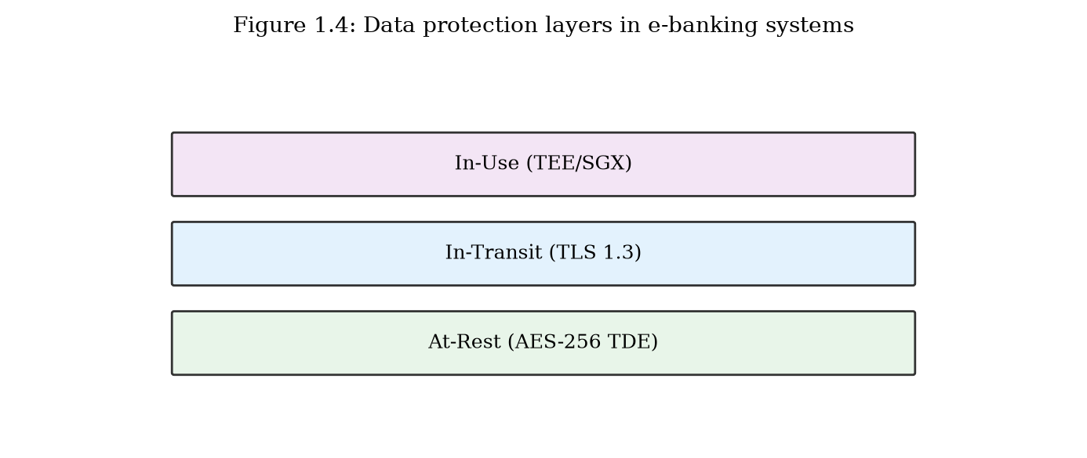
Data protection layers in e-banking: at-rest (TDE), in-transit (TLS), in-use (confidential computing) (Figure 1.4).

1.3.2 Data Integrity and Audit Mechanisms
Integrity protection for individual messages is commonly provided by HMAC-SHA256 or by the authenticated encryption inherent in AES-GCM. Digital signatures using RSA or ECDSA provide non-repudiation for high-value transactions and regulatory submissions. However, per-message signatures do not efficiently support batch verification of large settlement files containing millions of records.
Audit trails in e-banking systems log transaction events, access attempts, and administrative actions to tamper-evident storage. Common implementations include append-only databases, write-once-read-many (WORM) storage, and centralized SIEM platforms. Blockchain and distributed-ledger technologies have been proposed and piloted for settlement audit (e.g., JPMorgan's Onyx, R3 Corda), offering Merkle-tree-based integrity guarantees but introducing latency and scalability trade-offs unsuitable for all use cases.
Hash chains—where each log entry includes the hash of the previous entry—provide lightweight tamper evidence without the overhead of full blockchain consensus. Merkle trees enable efficient verification that a specific record is included in a batch without reprocessing the entire batch, a property essential for regulatory audit of large settlement files.

1.3.3 Identified Limitations and Drawbacks
The following limitations in current data encryption, security, and integrity mechanisms motivate the ECC-HISE scheme proposed in Chapter 3.
Limitation 1 — Flat key management hierarchies: Many institutions use a small number of long-lived symmetric keys for bulk encryption, increasing the blast radius of key compromise. Hierarchical key derivation that scopes keys to business domains and individual batches limits exposure.
Limitation 2 — Disconnected encryption and audit: Encryption and audit logging are typically implemented as independent systems. An encrypted batch file may be stored without a cryptographically linked integrity proof that enables third-party verification of completeness and ordering.
Limitation 3 — Inefficient batch integrity verification: Per-record digital signatures do not scale to settlement batches containing millions of entries. A Merkle-tree-based approach enables O(log n) verification per record while maintaining O(1) batch-level integrity evidence.
Limitation 4 — Static pre-shared keys in server-server channels: Inter-bank file transfer often relies on symmetric keys distributed manually and rotated infrequently (annually or biannually). ECC-based ephemeral key agreement per batch eliminates long-lived shared secrets.
Limitation 5 — Lack of end-to-end integrity across service boundaries: In microservice architectures, a message may be decrypted at each service boundary (TLS termination), processed in plaintext, and re-encrypted. Envelope encryption that persists integrity proofs across service boundaries addresses this gap.
Limitation 6 — Regulatory audit friction: Demonstrating to auditors that no records were added, removed, or reordered in a settlement batch currently requires manual reconciliation or expensive full-batch reprocessing. Cryptographic audit chains reduce audit cost and increase confidence.
These six limitations in data-security mechanisms parallel the authentication gaps identified in Section 1.2, but operate at a different layer of the system stack. While Section 1.2 concerns who is communicating and how keys are established, this section concerns what data is protected, how integrity is maintained, and how compliance can be demonstrated. Chapter 3 addresses these limitations through ECC-HISE, which combines hierarchical ECC key derivation, authenticated envelope encryption, and Merkle-tree audit chains into a cohesive server-server data-protection methodology.
Limitation | Current Practice | Proposed Direction (Ch.3) | Impact
Flat key hierarchy | Few long-lived DEKs | ECC hierarchical derivation | Key compromise scope
Disconnected audit | Separate log systems | Merkle-linked envelopes | Tamper detection
Batch verification cost | Per-record signatures | Merkle tree batch proofs | Scalability
Static PSKs | Annual manual rotation | Ephemeral ECDH per batch | Long-term exposure
Service-boundary gaps | TLS terminate/decrypt | Persistent envelope integrity | Insider tampering
Audit friction | Manual reconciliation | Cryptographic audit chain | Compliance cost
Table 1.3: Limitations of current data security mechanisms and proposed directions.

1.3.4 Key Management in Financial Institutions
Effective data encryption in e-banking depends critically on key management—the generation, distribution, storage, rotation, and destruction of cryptographic keys. Poor key management can render even the strongest encryption algorithms ineffective, as demonstrated by numerous breaches where encryption was deployed but keys were stored alongside encrypted data in accessible locations.
Financial institutions typically employ a tiered key-management architecture. At the top level, master keys are generated within FIPS 140-2 Level 3 (or higher) hardware security modules and never leave the HSM in plaintext form. Key-encryption keys (KEKs) wrap data-encryption keys (DEKs) for distribution to application servers. DEKs encrypt actual customer data and are rotated frequently (daily to monthly) depending on data classification and regulatory requirements.
The ANSI X9.24-3 standard specifies key-management requirements for symmetric keys in financial services, including dual-control procedures for key generation and split-knowledge requirements for critical keys. PCI DSS Requirement 3 mandates protection of stored cardholder data, including key-management procedures for encryption keys. However, these standards focus on symmetric key hierarchies and do not address ECC-based hierarchical derivation for batch envelope encryption with integrated audit chains—the design space targeted by ECC-HISE.

1.3.5 Merkle Trees and Cryptographic Audit Trails
Merkle trees (hash trees) provide an efficient data structure for verifying integrity of large datasets. A Merkle tree is a binary tree in which each leaf node contains the hash of a data block, and each internal node contains the hash of the concatenation of its children. The root hash commits to the entire dataset: any modification to any leaf changes the root hash. A verifier can confirm inclusion of a specific record with O(log n) hash computations given an authentication path (Merkle proof) from the leaf to the root.
In e-banking settlement, Merkle trees enable regulators and counterparties to verify that a specific transaction was included in a batch settlement without reprocessing the entire batch. Combined with digital signatures on the Merkle root, the tree provides both integrity and non-repudiation at the batch level. Bitcoin and other blockchains use Merkle trees in block headers for similar reasons, though blockchain consensus introduces latency unsuitable for real-time settlement. ECC-HISE adopts Merkle trees for audit without requiring distributed consensus, making it applicable to traditional inter-bank settlement workflows.
The integration of Merkle audit chains with ECC-based envelope encryption—rather than treating encryption and audit as separate subsystems—constitutes a key differentiator of the ECC-HISE approach developed in Chapter 3. By including the Merkle root in the signed batch header, any tampering with individual records is detectable through root mismatch, while the hierarchical key structure limits the scope of key compromise to individual batches within specific business domains.

1.3.6 Homomorphic Encryption and Emerging Approaches
While not part of the proposed schemes in this dissertation, emerging cryptographic technologies warrant brief discussion to situate the research within the broader landscape of financial data protection.
Fully homomorphic encryption (FHE) enables computation on encrypted data without decryption, potentially allowing banks to perform fraud detection on encrypted transaction streams. However, FHE remains orders of magnitude slower than plaintext computation and is not yet practical for real-time e-banking workloads. Partial homomorphic schemes (Paillier, ElGamal) support specific operations (addition, multiplication) and have been piloted for privacy-preserving credit scoring.
Confidential computing (Intel SGX, AMD SEV, ARM TrustZone) provides hardware-enforced memory isolation for applications processing sensitive data. Major cloud providers offer confidential virtual machines for financial workloads. These technologies address the 'data in use' protection gap identified in Section 1.3.1 but require trust in hardware manufacturers and are vulnerable to side-channel attacks.
The schemes proposed in this dissertation (ECC-DTB-AKA and ECC-HISE) complement rather than replace these emerging approaches. ECC-DTB-AKA secures the client-server channel; ECC-HISE secures server-server batch data; confidential computing can protect in-memory processing; and post-quantum algorithms will eventually replace specific ECC primitives as standards mature.

1.4 Threat Model, Assumptions, and Research Questions
This section formalizes the threat model, system assumptions, and research questions that guide the design and evaluation of the proposed schemes in Chapters 2 through 5.

1.4.1 Threat Model
We adopt a Dolev-Yao threat model extended with financial-domain adversary capabilities. The adversary A can: (a) eavesdrop on, insert, delete, modify, and replay messages on all network channels; (b) compromise up to N-1 of M server nodes in the settlement network (where M > 2N-1 for quorum systems, but we do not assume quorum); (c) extract session tokens and application data from a compromised client device; (d) perform offline dictionary attacks on captured password hashes (but not on ECDH ephemeral private keys due to computational hardness); (e) submit fraudulent transaction requests using stolen credentials.
The adversary A cannot: (a) break the elliptic curve discrete logarithm problem (ECDLP) or compute discrete logarithms on the chosen curve; (b) break SHA-256, AES-256-GCM, or Ed25519 unforgeability; (c) extract private keys from an HSM (in the prototype, HSM is simulated and this assumption is noted as a limitation); (d) physically access the bank's data center without detection.
Trust assumptions: the bank's certificate authority (CA) is trusted; registered client public keys are distributed securely during account enrollment; the clearing-house master key is generated and stored in an HSM at setup time.
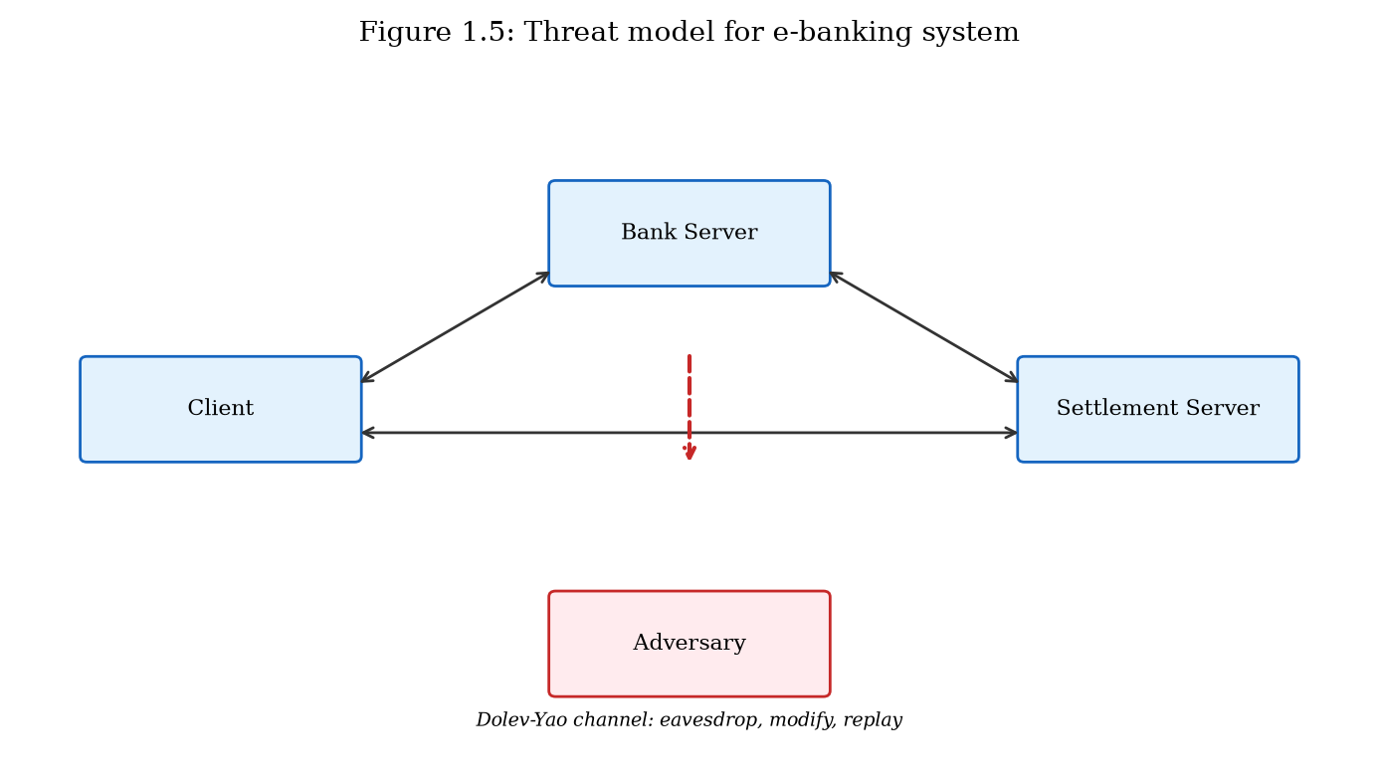
Threat model diagram showing adversary position relative to client, bank server, and inter-bank network (Figure 1.5).

1.4.2 System Assumptions
The e-banking system under consideration comprises: (1) a client application running on a smartphone or desktop with a secure element or trusted execution environment for key storage; (2) a bank application server providing RESTful APIs for account management and transaction authorization; (3) a settlement server participating in inter-bank batch transfer; (4) a clearing-house authority managing the master key hierarchy.
Clients and servers have synchronized clocks within ±5 minutes (for timestamp validation and nonce freshness). Network connectivity is intermittent but eventually available. The elliptic curve used is SECP256R1 (NIST P-256) for ECDH/ECDSA operations and Ed25519 for batch signatures, unless otherwise noted.

1.4.3 Research Questions
RQ1: Can an ECC-based authenticated key agreement protocol that binds session keys to device fingerprints and transaction nonces overcome the authentication limitations identified in Section 1.2 while maintaining or improving communication efficiency?
RQ2: Can a hierarchical ECC-based secure envelope scheme with Merkle audit chains address the data-security limitations identified in Section 1.3 for server-server batch transfer in e-finance systems?
RQ3: How do the proposed schemes compare quantitatively to existing approaches (TLS 1.3, standard ECDH, ECIES, static PSK) in terms of authentication latency, ciphertext overhead, communication round trips, and resistance to attacks cataloged in Section 1.1?
RQ4: Can both schemes be implemented in a unified e-financial service architecture and validated through programmatic testing and benchmark measurement?

1.4.4 Chapter Summary
This chapter has defined and categorized attack mechanisms against e-banking and e-finance systems, presented case studies demonstrating their real-world impact, reviewed current authentication and key-exchange mechanisms with six identified limitations (Section 1.2), reviewed current data encryption and integrity mechanisms with six identified limitations (Section 1.3), and formalized the threat model and research questions guiding this dissertation. The identified limitations provide direct motivation for the two novel ECC-based schemes developed in Chapters 2 and 3, whose prior-work context is further elaborated in Chapter 5.

1.4.5 Security Requirements Derivation
From the threat model (Section 1.4.1) and the identified limitations (Sections 1.2.3 and 1.3.3), we derive the following security requirements that the proposed schemes must satisfy. These requirements serve as evaluation criteria in Chapter 5.
SR1 (Mutual Authentication): Both communicating parties must cryptographically verify each other's identity before any financial data is exchanged. For client-server channels, this means the client verifies the bank server's identity via certificate chain, and the server verifies the client's identity via registered public key signature.
SR2 (Forward Secrecy): Compromise of long-term private keys must not enable decryption of previously recorded sessions. Ephemeral ECDH key pairs must be used for session key establishment.
SR3 (Device Binding): Session keys must be cryptographically bound to the client device, preventing session transfer to unauthorized devices even if session tokens are exfiltrated.
SR4 (Transaction Binding): Individual transactions must be protected by keys derived specifically for that transaction, limiting the impact of single-transaction key compromise.
SR5 (Data Confidentiality): Financial records in server-server batch transfer must be encrypted with semantically secure authenticated encryption.
SR6 (Data Integrity): Any modification to batch records must be detectable through cryptographic verification, with batch-level integrity proofs enabling efficient audit.
SR7 (Non-Repudiation): Batch senders must not be able to deny having sent a batch, achieved through digital signatures on batch headers.
SR8 (Efficiency): Authentication must complete within acceptable latency bounds (target: under 200ms on commodity hardware) with minimal communication overhead.

1.4.6 Relationship to Subsequent Chapters
The security requirements SR1 through SR4 are addressed primarily by the ECC-DTB-AKA protocol developed in Chapter 2. Requirements SR5 through SR7 are addressed by the ECC-HISE scheme developed in Chapter 3. Requirement SR8 is evaluated quantitatively in Chapters 2, 3, and 5 through benchmark measurements of the prototype described in Chapter 4.
Chapter 5 provides the comprehensive prior-work analysis specified in the dissertation requirements: Section 5.2 reviews authentication and key-exchange literature in depth (expanding on the overview in Section 1.2), Section 5.3 reviews data encryption and integrity literature (expanding on Section 1.3), and Section 5.4 synthesizes findings to demonstrate how the proposed schemes address the vulnerabilities cataloged in this chapter.
Readers approaching this dissertation from a practitioner perspective may wish to read Section 1.1 and Sections 1.2.3/1.3.3 first to understand the threat landscape and identified gaps, then proceed to Chapters 2 and 3 for protocol specifications, and Chapter 4 for implementation guidance. Readers with a research orientation may prefer to read Chapter 5's prior-work analysis before the proposed schemes, to situate the contributions within the existing literature.

