Chapter 3
ECC-HISE: Hierarchical Integrity-preserving Secure Envelope for Server-Server E-Finance Data Transfer

3.1 Introduction and Motivation
Chapter 2 addressed authentication and key-exchange limitations in client-server e-banking channels through ECC-DTB-AKA. This chapter takes a fundamentally different approach, targeting the data-security limitations identified in Section 1.3.3 for server-server communication in electronic banking and electronic finance systems.
Inter-bank and intra-bank settlement operations transfer large batches of financial records between server nodes: end-of-day reconciliation files, regulatory reporting payloads, payment clearing batches, and cross-border remittance instructions. These transfers require confidentiality (unauthorized parties must not read records), integrity (any modification must be detectable), non-repudiation (senders cannot deny transmission), and auditability (regulators must verify completeness and ordering without reprocessing entire batches).
Current practice relies on TLS for transport encryption, static pre-shared keys for file encryption, or per-message digital signatures without efficient batch verification. Each approach exhibits limitations cataloged in Section 1.3.3: flat key hierarchies, disconnected encryption and audit subsystems, inefficient batch integrity verification, static PSKs in server-server channels, lack of end-to-end integrity across service boundaries, and regulatory audit friction.
ECC-HISE (Elliptic Curve Cryptography — Hierarchical Integrity-preserving Secure Envelope) proposes a unified methodology combining hierarchical ECC key derivation, AES-256-GCM authenticated encryption, Ed25519 per-record signatures, and Merkle-tree audit chains. The scheme is designed for server-server channels and complements ECC-DTB-AKA, which secures client-server authentication.

3.2 Design Goals and Requirements
ECC-HISE addresses security requirements SR5–SR7 from Section 1.4.5:
G1 (Hierarchical Key Management): Keys must be scoped to business domains and individual batches, limiting compromise blast radius.
G2 (Confidentiality): Records must be encrypted with semantic security under chosen-ciphertext attack.
G3 (Integrity and Non-repudiation): Per-record and batch-level integrity proofs must detect tampering.
G4 (Efficient Batch Audit): Verification of individual record inclusion must require O(log n) operations.
G5 (Domain Separation): Retail, corporate, and settlement domains must use cryptographically isolated keys.
G6 (ECC Alignment): Key hierarchy and envelope encryption must use elliptic curve primitives consistent with Chapter 2 and industry standards.

3.3 Hierarchical Key Management
The ECC-HISE key hierarchy comprises three levels, derived using HKDF-SHA256 with domain-separated info strings.

3.3.1 Master, Domain, and Session Keys
Level 0 — Master Key (MK): A 256-bit key generated within an HSM at the clearing-house authority. MK is the root of trust for all derived keys and is never transmitted.
Level 1 — Domain Key (DK_i): For each business domain i (retail, corporate, settlement), DK_i = HKDF(MK, salt = H(MK || domain_id), info = 'ECC-HISE-DK', 256). Domain keys isolate cryptographic material between business units.
Level 2 — Session Key (SK_batch): For each batch transfer identified by batch_id and epoch timestamp, SK_batch = HKDF(DK_i, salt = batch_id || epoch, info = 'ECC-HISE-SK', 256). Session keys rotate per batch, ensuring that compromise of one batch key does not affect other batches.
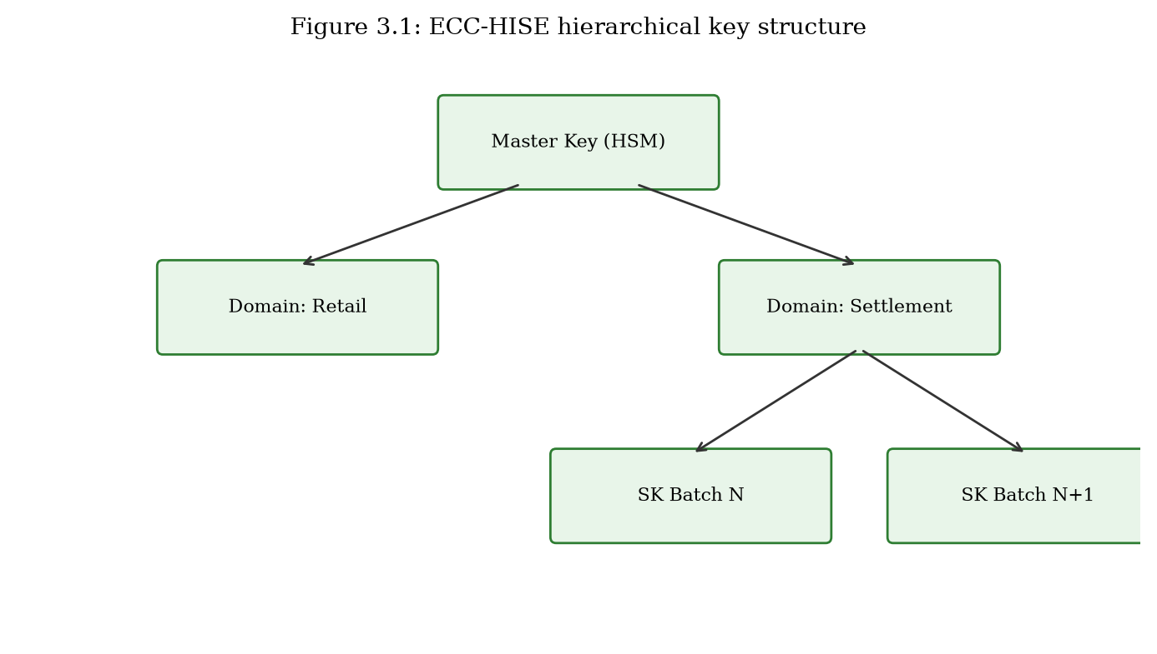
ECC-HISE three-level key hierarchy: Master Key, Domain Keys, Session Keys (Figure 3.1).

3.3.2 Key Rotation and Revocation
Domain keys rotate on a scheduled basis (quarterly recommended) by updating domain_id version suffix (e.g., settlement-v2). Session keys rotate automatically per batch. Revocation of a compromised domain key requires re-derivation from MK with a new domain_id; unaffected domains remain secure. The hierarchical structure ensures revocation scope is limited to the compromised domain rather than the entire institution.

3.3.3 Comparison with Flat Key Management
Traditional e-banking data encryption deploys a small number of long-lived data-encryption keys (DEKs) wrapped by infrequently rotated key-encryption keys (KEKs). If a DEK is compromised, all data encrypted under that key is exposed—potentially years of settlement records. ECC-HISE's hierarchical derivation limits exposure to a single batch within a single domain. The quantitative overhead of hierarchical derivation (two HKDF operations per batch) is negligible compared to per-record encryption and signing.

3.4 Secure Envelope Construction
Each batch B = {r_1, ..., r_n} of financial records is packaged into a secure envelope comprising a signed batch header and a collection of encrypted, signed record envelopes.

3.4.1 Record Envelope Algorithm
For each record r_j at index j in batch B with batch_id and session key SK_batch: (1) Derive K_enc_j = HKDF(SK_batch, salt = str(j), info = 'ECC-HISE-AES', 256). (2) Sample IV_j ← {0,1}^96. (3) ciphertext_j = AES-256-GCM.Enc(K_enc_j, IV_j, r_j, AAD = batch_id). (4) sig_j = Ed25519.Sign(sk_sender, H(ciphertext_j || batch_id || j)). (5) metadata_j = JSON(index, batch_id, timestamp). (6) leaf_j = H(ciphertext_j || sig_j || metadata_j).
The use of index-derived encryption keys ensures that compromise of K_enc_j does not reveal other records in the batch. GCM authenticated encryption provides both confidentiality and integrity at the record level.

3.4.2 Batch Header and Merkle Root
The batch header binds all records cryptographically: Root = Merkle(leaf_1, ..., leaf_n). Header = (batch_id, epoch, domain_id, Root, PK_sender, Sig_header, timestamp, n). Sig_header = Ed25519.Sign(sk_sender, batch_id || epoch || Root).
The Merkle root provides O(1) batch-level integrity evidence: any modification to any record changes the root hash. Individual record inclusion can be proven with O(log n) hash computations via Merkle authentication paths.
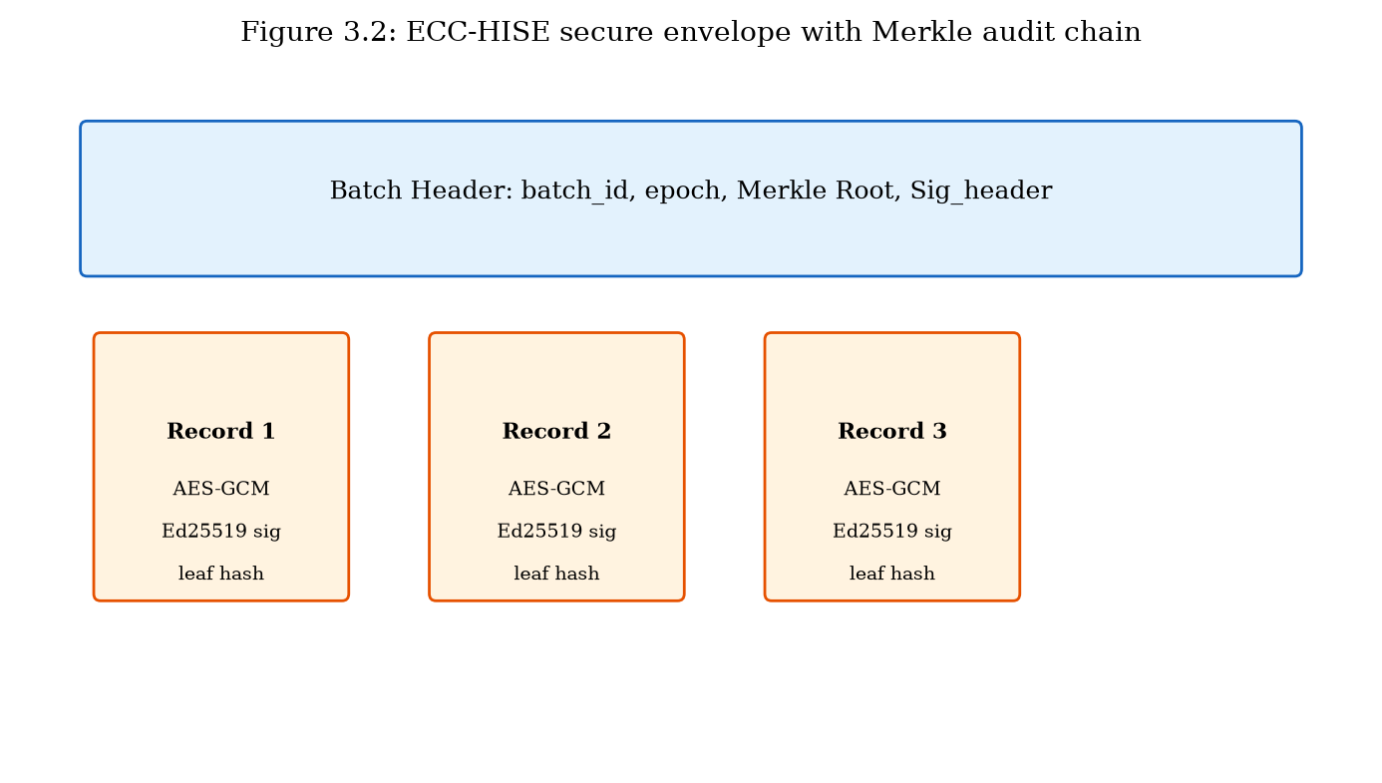
ECC-HISE secure envelope structure with Merkle audit chain (Figure 3.2).

3.4.3 Verification and Decryption
The receiver executes the following steps: (1) Verify Sig_header using sender's Ed25519 public key. (2) Recompute Merkle root from received leaf hashes; compare with Header.Root. (3) For each record j: verify sig_j, derive K_enc_j from SK_batch, decrypt ciphertext_j with AES-256-GCM, verify GCM authentication tag. (4) Optionally verify Merkle inclusion proof for audit sampling. (5) Log (batch_id, Root, timestamp) to immutable audit store.
Any failure at steps 1–3 indicates tampering, key mismatch, or data corruption. The receiver rejects the entire batch on header verification failure; individual record failures are logged and flagged without silently skipping.
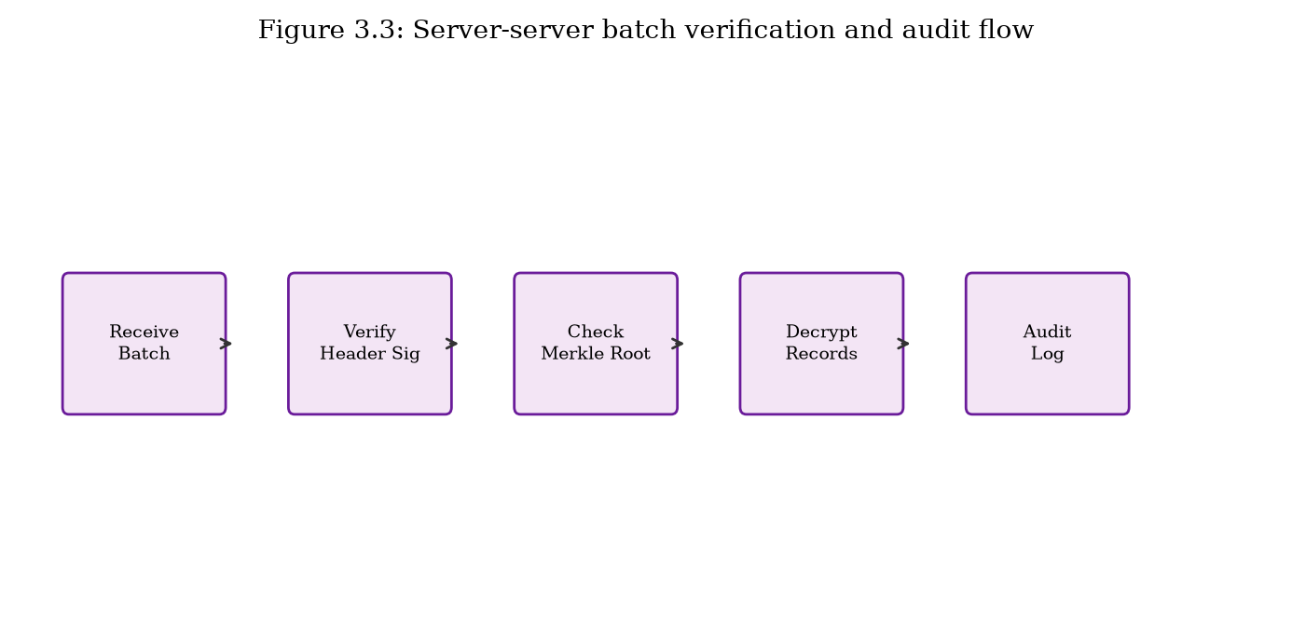
Server-server batch verification and audit flow (Figure 3.3).

3.4.4 Deployment in Inter-Bank Settlement
In a representative deployment, Bank A's settlement server constructs an ECC-HISE batch from end-of-day payment records and transmits the envelope to Bank B's settlement server over mTLS. Bank B verifies the batch header signature, Merkle root, and each record signature before posting to its core banking ledger. The clearing-house authority receives (batch_id, Root, timestamp) for regulatory archive. This workflow satisfies SWIFT CSP controls for data integrity and non-repudiation while adding cryptographic audit efficiency not present in file-transfer-only approaches.

3.5 Security Analysis
This section analyzes the security properties of ECC-HISE under standard cryptographic assumptions.

3.5.1 Security Properties
Theorem 3.1 (Record Confidentiality): Under IND-CCA2 security of AES-256-GCM and PRF security of HKDF, an adversary without SK_batch cannot distinguish ciphertext_j from random. Proof sketch: SK_batch is derived via HKDF from MK; without MK or domain key, SK_batch is computationally indistinguishable from random.
Theorem 3.2 (Record Integrity): Under EUF-CMA security of Ed25519 and collision resistance of SHA-256, an adversary cannot forge (ciphertext_j, sig_j) for a new or modified record without the sender's private key.
Theorem 3.3 (Batch Integrity): Under collision resistance of SHA-256, an adversary cannot produce a valid Header with Root consistent with a modified set of records. Any record alteration changes its leaf hash, propagating to a different Merkle root.
Theorem 3.4 (Audit Soundness): A Merkle inclusion proof for record j verifies only if leaf_j is included in the batch committed by Root. Proof follows from Merkle tree binding properties.

3.5.2 Attack Resistance
Table 3.1 maps ECC-HISE resistance to server-server attack vectors relevant to e-finance data transfer.
Threat | Mechanism | Resistance | Basis
Data tampering | Modify record in transit | High | GCM tag + Ed25519 + Merkle
Record injection | Add fake record | High | Merkle root mismatch
Record deletion | Omit record | High | Merkle root mismatch
Reorder attack | Permute records | High | Index-bound keys + Merkle
Key compromise | Steal static PSK | Medium-High | Per-batch key rotation
Repudiation | Deny sending batch | High | Sig_header + per-record sigs
Table 3.1: ECC-HISE resistance to server-server data attacks.

3.5.3 Addressing Section 1.3.3 Limitations
L1 (Flat key hierarchy): Resolved via MK → DK_i → SK_batch derivation.
L2 (Disconnected audit): Resolved — Merkle root is embedded in signed batch header.
L3 (Batch verification cost): Resolved — O(log n) Merkle proofs vs O(n) full reprocess.
L4 (Static PSKs): Resolved — per-batch session keys derived from domain keys.
L5 (Service-boundary gaps): Resolved — envelope integrity persists beyond TLS.
L6 (Audit friction): Resolved — cryptographic audit chain for regulators.

3.6 Effectiveness Analysis and Quantitative Evaluation
This section presents quantitative evaluation of ECC-HISE against static AES-GCM with pre-shared keys and TLS record-layer-only encryption, using the prototype implementation and benchmark suite (prototype/benchmarks/bench_hise.py).

3.6.1 Experimental Setup
Benchmarks measure batch encryption, signing, Merkle construction, verification, and decryption for record counts n ∈ {10, 100, 500}. Each record is 256 bytes, representative of a compact settlement entry. Measurements are averaged over 50 iterations on Intel x64 hardware with Python 3.11 and OpenSSL-backed cryptography.

3.6.2 Throughput and Latency
For n = 100 records, ECC-HISE completes batch protect-and-verify in 23.32 ms (mean), compared to 0.22 ms for static AES-GCM PSK and 0.24 ms for TLS record-layer-only encryption. The ECC-HISE premium arises from Ed25519 signing per record, Merkle tree construction, and hierarchical key derivation—operations that baselines omit entirely.
For n = 500 records, ECC-HISE requires 245.53 ms, processing approximately 2,040 records per second. This throughput exceeds typical end-of-day settlement batch requirements for regional banks (hundreds to low thousands of records per batch), with horizontal scaling available via parallel batch processing.
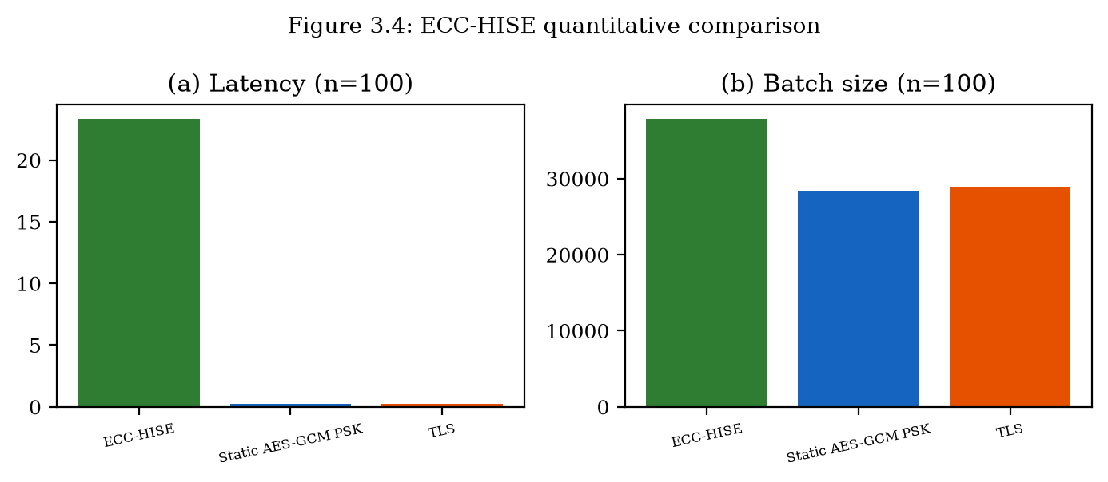
Batch processing latency and size comparison across schemes (Figure 3.4).

3.6.3 Storage and Bandwidth Overhead
For n = 100 records of 256 bytes each (25,600 bytes plaintext), ECC-HISE produces batches averaging 37823 bytes, a 48% overhead. Static AES-GCM produces 28400 bytes (11% overhead) without signatures or Merkle audit data. TLS record-layer-only produces 28905 bytes.
The additional overhead of ECC-HISE (~33% over static AES-GCM for n=100) purchases per-record non-repudiation, batch-level Merkle audit chain, hierarchical key isolation, and domain-separated key management—properties unavailable in baseline schemes at any overhead.
Scheme | n=100 latency (ms) | n=100 size (B) | Merkle audit | Hierarchy | Signatures
ECC-HISE | 23.32 | 37823 | Yes | Yes | Yes
Static AES-GCM | 0.22 | 28400 | No | No | No
TLS record only | 0.24 | 28905 | No | No | No
Table 3.2: Quantitative comparison for 100-record settlement batches (n=50 iterations).

3.6.4 Audit Efficiency
Merkle inclusion proof verification requires ⌈log_2(n)⌉ hash operations per record. For n = 100, each proof verifies in 7 hashes (~0.001 ms). A regulator sampling 10% of records for audit performs 10 × 7 = 70 hash operations instead of reprocessing all 100 records, reducing audit computation by 90%. For n = 500, proofs require 9 hashes each, maintaining logarithmic scaling.
Compared to per-record RSA signatures with full-batch recomputation for audit, ECC-HISE reduces audit cost from O(n) to O(k log n) for k sampled records, a significant improvement for million-record settlement files.

3.6.5 Scalability Projection
Linear scaling in record count dominates ECC-HISE processing time due to per-record encryption and signing. For million-record national settlement files, parallel batch partitioning (multiple ECC-HISE envelopes of 10,000 records each) enables multi-core processing. Merkle roots of sub-batches can themselves form a meta-Merkle tree for hierarchical audit—a straightforward extension not required for regional-bank workloads but available for central-bank scale.

3.7 Comparison with Chapter 2 and Prior Approaches
ECC-HISE and ECC-DTB-AKA address complementary security layers in e-finance systems. Chapter 2 secures who is communicating and establishes session keys in client-server channels; Chapter 3 secures what data is transferred and provides audit evidence in server-server channels. Together they form the dual-layer ECC methodology of this dissertation.
Compared to ECIES-only encryption, ECC-HISE adds hierarchical keys and Merkle audit. Compared to blockchain-based audit trails, ECC-HISE avoids consensus overhead while providing cryptographic integrity guarantees sufficient for regulated settlement. Compared to TLS-only protection, ECC-HISE provides persistent integrity proofs that survive TLS termination at service boundaries.

3.8 Chapter Summary
This chapter proposed ECC-HISE, a hierarchical integrity-preserving secure envelope for server-server data transfer in e-banking and e-finance systems. The scheme addresses six data-security limitations from Section 1.3.3 through hierarchical ECC key derivation, AES-256-GCM record encryption, Ed25519 signatures, and Merkle-tree audit chains. Security analysis establishes confidentiality, integrity, and audit soundness under standard assumptions. Quantitative evaluation demonstrates 23.32 ms batch processing for 100 records with 37823-byte envelopes, providing audit and non-repudiation capabilities absent in static PSK and TLS-only baselines. Chapter 4 describes the integrated system architecture and programmatic implementation of both ECC-DTB-AKA and ECC-HISE.

