A Dual-Layer ECC Methodology for Client-Server Authentication
and Server-Server Data Protection in Electronic Finance Systems
PhD Dissertation in Information Security

Submitted in partial fulfillment of the requirements
for the degree of Doctor of Philosophy

Abstract
This dissertation investigates information security challenges in electronic banking and electronic finance service systems, with particular emphasis on authentication, key exchange, data encryption, and integrity protection. A comprehensive analysis of contemporary attack mechanisms establishes the threat landscape and identifies critical limitations in existing security mechanisms. Two novel elliptic curve cryptography (ECC) based schemes are proposed: ECC-DTB-AKA (Device- and Transaction-Bound Authenticated Key Agreement) for client-server channels, and ECC-HISE (Hierarchical Integrity-preserving Secure Envelope) for server-server batch data transfer. Both schemes are formally analyzed, quantitatively evaluated against established baselines, and implemented in a working software prototype [7][8][29][11].

Table of Contents
Abstract
Preface
Chapter 1
Attack Mechanisms, Threat Landscape, and Security Gaps in E-Banking Systems
1.1 Attack Mechanisms in E-Banking and E-Finance Services
1.2 Authentication and Key Exchange in E-Banking Systems
1.3 Data Encryption, Security, and Integrity in E-Banking
1.4 Threat Model, Assumptions, and Research Questions
Chapter 2
ECC-DTB-AKA: Device- and Transaction-Bound Authenticated Key Agreement for Client-Server E-Banking Channels
2.1 Introduction and Motivation
2.2 Design Goals and Requirements
2.3 Protocol Specification
2.4 Security Analysis
2.5 Effectiveness Analysis and Quantitative Evaluation
2.6 Comparison with Prior Authentication Approaches
2.7 Chapter Summary
Chapter 3
ECC-HISE: Hierarchical Integrity-preserving Secure Envelope for Server-Server E-Finance Data Transfer
3.1 Introduction and Motivation
3.2 Design Goals and Requirements
3.3 Hierarchical Key Management
3.4 Secure Envelope Construction
3.5 Security Analysis
3.6 Effectiveness Analysis and Quantitative Evaluation
3.7 Comparison with Chapter 2 and Prior Approaches
3.8 Chapter Summary
Chapter 4
Security System Architecture and Programmatic Implementation
4.1 Security System Architecture of an E-Financial Service System
4.2 Programmatic Implementation of ECC-DTB-AKA (Chapter 2)
4.3 Programmatic Implementation of ECC-HISE (Chapter 3)
4.4 Integrated System Demonstration
4.5 Chapter Summary
Chapter 5
Evaluation, Prior Work Analysis, and Vulnerability Synthesis
5.1 Effectiveness of Proposed Methods Against Network Attacks
5.2 Prior Work on Authentication and Key Exchange
5.3 Prior Work on Data Encryption, Security, and Integrity
5.4 Synthesis: Vulnerabilities and Research Contributions
5.5 Chapter Summary
Conclusions
Appendix
References

List of Figures
Figure 1.1: Attack lifecycle in e-banking systems
Figure 1.2: Current client-server authentication flow
Figure 1.3: Server-server mTLS service mesh architecture
Figure 1.4: Data protection layers in e-banking systems
Figure 1.5: Threat model for e-banking system
Figure 2.1: ECC-DTB-AKA three-round handshake
Figure 2.2: Key derivation hierarchy in ECC-DTB-AKA
Figure 2.3: Quantitative comparison of authentication schemes
Figure 3.1: ECC-HISE hierarchical key structure
Figure 3.2: ECC-HISE secure envelope with Merkle audit chain
Figure 3.3: Server-server batch verification and audit flow
Figure 3.4: ECC-HISE quantitative comparison
Figure 4.1: Integrated e-financial service system architecture
Figure 4.2: End-to-end transaction and settlement flow
Figure 4.3: ECC-DTB-AKA software module diagram
Figure 4.4: ECC-HISE software module diagram
Figure 4.5: Deployment topology for prototype services
Figure 5.1: Comparative attack resistance overview
Figure 5.2: Combined quantitative performance of proposed schemes
Figure 5.3: TLS 1.3 full handshake flow
Figure 5.4: OAuth 2.0 PKCE authorization flow
Figure 5.5: mTLS service mesh authentication
Figure 5.6: TLS record layer vs. persistent envelope integrity
Figure 5.7: Merkle audit — blockchain vs. ECC-HISE

List of Tables
Table 1.1: Taxonomy of attack mechanisms against e-banking systems
Table 1.2: Limitations of current authentication and key-exchange mechanisms
Table 1.3: Limitations of current data security mechanisms
Table 1.4: Comparative overview of authentication protocols for e-banking
Table 2.1: ECC-DTB-AKA resistance to e-banking attack mechanisms
Table 2.2: Quantitative comparison of authentication schemes
Table 2.3: ECC-DTB-AKA message field specification
Table 2.4: Projected end-to-end authentication time for ECC-DTB-AKA
Table 3.1: ECC-HISE resistance to server-server data attacks
Table 3.2: Quantitative comparison for 100-record settlement batches
Table 4.1: Architecture components and technology mapping
Table 4.2: ECC-DTB-AKA prototype test results
Table 4.3: ECC-HISE prototype test results
Table 5.1: Attack resistance matrix for proposed schemes vs. baselines
Table 5.2: Authentication and key-exchange prior work vs. ECC-DTB-AKA
Table 5.3: Data encryption and integrity prior work vs. ECC-HISE
Table 5.4: Vulnerabilities in existing e-banking systems and dissertation responses

Preface

Background and Motivation
Electronic banking and electronic finance service systems have undergone a profound transformation over the past three decades. What began in the 1980s as rudimentary home-banking terminals connected via dial-up modems has evolved into a globally interconnected ecosystem comprising mobile banking applications, real-time payment rails, open-banking APIs, cryptocurrency custody services, and algorithmic trading platforms. According to industry reports, more than three billion individuals worldwide now access financial services through digital channels, and the volume of electronic payment transactions exceeds one trillion events annually. This digitization has delivered unprecedented convenience, financial inclusion, and operational efficiency, yet it has simultaneously expanded the attack surface available to adversaries ranging from opportunistic cybercriminals to sophisticated nation-state actors [42][43].
The security of e-banking and e-finance systems is not merely a technical concern; it is a foundational requirement for economic stability and public trust. A single successful breach can result in direct financial losses measured in hundreds of millions of dollars, regulatory penalties, reputational damage that persists for years, and erosion of confidence in the broader financial system. High-profile incidents—including the 2016 Bangladesh Bank heist involving fraudulent SWIFT messages, the 2017 Equifax data breach affecting 147 million consumers, and numerous credential-stuffing campaigns targeting retail banking portals—demonstrate that existing security architectures, despite decades of investment, remain vulnerable to both novel and well-known attack vectors [24][20][21][22].
Cryptography serves as the bedrock upon which e-banking security is built. From the SSL/TLS protocols that protect data in transit, to the EMV chip-and-PIN standards governing card present transactions, to the hardware security modules (HSMs) safeguarding root keys in data centers, cryptographic mechanisms are deeply embedded in every layer of the financial technology stack. Among the cryptographic primitives available today, elliptic curve cryptography (ECC) has emerged as the dominant choice for new deployments due to its favorable security-to-key-size ratio: a 256-bit elliptic curve key provides security comparable to a 3072-bit RSA key, resulting in lower computational overhead, reduced bandwidth consumption, and improved performance on resource-constrained devices such as smartphones and IoT terminals [11][34][35][16].
This dissertation addresses a critical gap at the intersection of ECC-based authentication, key exchange, and data protection in e-banking environments. While substantial prior research has investigated individual aspects of financial system security—ranging from multi-factor authentication protocols to blockchain-based audit trails—few works have proposed integrated methodologies that simultaneously strengthen client-server authentication channels and server-server data-transfer channels using coherent ECC-based designs, accompanied by rigorous analysis, quantitative evaluation, and practical implementation. The research presented herein aims to fill this gap by proposing, analyzing, implementing, and evaluating two novel schemes: ECC-DTB-AKA (Device- and Transaction-Bound Authenticated Key Agreement) and ECC-HISE (Hierarchical Integrity-preserving Secure Envelope) [7][8][29][31].

Development and Future Prospects of E-Banking and E-Finance
The historical trajectory of electronic banking can be divided into four distinct generations. The first generation (1980s–1990s) featured proprietary dial-up systems with limited functionality, primarily balance inquiry and fund transfers between accounts at the same institution. The second generation (late 1990s–2000s) coincided with the commercialization of the World Wide Web, giving rise to internet banking portals protected by SSL/TLS and username-password authentication. The third generation (2010s) was driven by smartphone adoption, introducing mobile banking applications, biometric authentication, push notifications for transaction verification, and near-field communication (NFC) payments. We are now entering the fourth generation, characterized by open banking regulations (such as the European PSD2 directive and similar frameworks in the United Kingdom, Australia, and Brazil), real-time gross settlement (RTGS) systems operating 24/7, central bank digital currencies (CBDCs), and decentralized finance (DeFi) protocols that challenge traditional intermediation models [18][38][1][28].
Several technological trends will shape the future of e-finance services and, by extension, the security requirements that must be satisfied. First, the proliferation of application programming interfaces (APIs) under open-banking mandates creates new client-server and server-server communication patterns in which third-party providers access customer account data and initiate payments on behalf of users. Each API endpoint represents a potential entry point for attackers, necessitating robust authentication and fine-grained authorization mechanisms. Second, the migration of banking workloads to cloud infrastructure introduces shared-responsibility security models in which traditional network perimeters dissolve and identity becomes the primary security boundary. Third, the increasing use of artificial intelligence and machine learning in fraud detection, credit scoring, and customer service creates new categories of adversarial attacks, including model poisoning and inference attacks on sensitive training data.
Quantum computing poses a longer-term but strategically significant threat to current cryptographic infrastructure. Although cryptographically relevant quantum computers have not yet materialized, financial institutions with multi-decade data confidentiality requirements must begin planning for post-quantum migration. The U.S. National Institute of Standards and Technology (NIST) has standardized post-quantum algorithms (ML-KEM, ML-DSA, SLH-DSA), and regulatory bodies are expected to issue timelines for transition. The ECC-based schemes proposed in this dissertation are designed with algorithm agility in mind, enabling future replacement of specific primitives without altering the overall protocol architecture [39].
Looking ahead, e-finance service systems will likely converge toward a hybrid architecture combining centralized trust anchors (banks, clearing houses, regulators) with distributed ledger technologies for settlement and audit. Security systems must evolve to protect not only traditional account-based transactions but also tokenized assets, smart-contract interactions, and cross-border payment corridors operating across heterogeneous regulatory jurisdictions. The methodologies developed in this thesis provide a foundation that can be extended to these emerging paradigms.

The Importance of Security Systems in E-Banking and E-Finance
Information security in electronic finance is commonly analyzed through the CIA triad (Confidentiality, Integrity, Availability) supplemented by authenticity, non-repudiation, and accountability. Each property carries particular significance in the banking domain.
Confidentiality ensures that sensitive financial data—including account balances, transaction histories, personal identification information, and cryptographic keys—remains accessible only to authorized parties. Breaches of confidentiality can facilitate identity theft, targeted phishing, and insider trading. In e-banking systems, confidentiality must be maintained across multiple states: data at rest (stored in databases and backup systems), data in transit (moving across networks between clients, servers, and partner institutions), and data in use (being processed in memory during transaction authorization) [42][43][22].
Integrity guarantees that financial records and transaction messages have not been altered without detection. The integrity requirement is especially stringent in inter-bank settlement, where a modification to a single field in a payment instruction can redirect millions of dollars to an attacker-controlled account. Cryptographic mechanisms such as message authentication codes (MACs), digital signatures, and hash chains provide integrity protection, but their effectiveness depends on correct key management and comprehensive coverage of all data paths [3][26][9].
Availability ensures that banking services remain accessible to legitimate users when needed. Distributed denial-of-service (DDoS) attacks against banking infrastructure have become increasingly common, with some attacks exceeding one terabit per second in traffic volume. While availability is often treated separately from cryptographic security, the two concerns intersect when authentication protocols are designed to resist resource-exhaustion attacks and when rate-limiting mechanisms must not inadvertently lock out legitimate customers.
Authenticity and non-repudiation are particularly critical in financial contexts where disputes over transaction authorization arise frequently. A customer may claim that a wire transfer was unauthorized, while the bank asserts that valid credentials were presented. Strong mutual authentication protocols and digital signatures with long-term verifiability provide evidentiary support in such disputes. Regulatory frameworks including the Payment Card Industry Data Security Standard (PCI DSS), the Sarbanes-Oxley Act, and the General Data Protection Regulation (GDPR) impose legal obligations that translate directly into technical security requirements [17][26][9].
The defense-in-depth principle dictates that no single security control should constitute a single point of failure. E-banking systems typically deploy firewalls, intrusion detection systems, security information and event management (SIEM) platforms, multi-factor authentication, encryption, and physical security for data centers in layered combination. However, the cryptographic layer—the focus of this dissertation—remains the ultimate guarantor of confidentiality and integrity when all other layers have been bypassed [42][43].

Research Objectives and Scope
The primary objective of this research is to design, analyze, implement, and evaluate novel ECC-based security schemes that address documented vulnerabilities in contemporary e-banking and e-finance systems. Specifically, the research pursues the following goals: [42][43]
First, to systematically catalog and analyze attack mechanisms currently deployed against e-banking and e-finance services, establishing a threat landscape that motivates the proposed countermeasures (Chapter 1). Second, to propose ECC-DTB-AKA, a device- and transaction-bound authenticated key agreement protocol for client-server channels, and to demonstrate its superiority over existing approaches in terms of security properties, communication efficiency, and computational overhead (Chapter 2). Third, to propose ECC-HISE, a hierarchical integrity-preserving secure envelope scheme for server-server data transfer, addressing limitations in current encryption and audit mechanisms (Chapter 3). Fourth, to implement both schemes in a working software prototype and to describe the security system architecture of an e-financial service system that integrates them (Chapter 4). Fifth, to conduct a comprehensive evaluation including review of prior work, quantitative performance comparison, and analysis of resistance to the attacks identified in Chapter 1 (Chapter 5) [7][8][42][43].
The scope of this dissertation is deliberately focused on the cryptographic and protocol layers of e-banking security. Physical security, social engineering, organizational policy, and regulatory compliance are acknowledged as important but are not the primary subject of investigation. The implementation prototype uses software-based key storage rather than hardware security modules, and the formal security proofs are presented as structured proof sketches rather than machine-verified derivations. These limitations are discussed frankly in the conclusions [42][43].

Summary of Chapters
Chapter 1 establishes the foundation of this dissertation by defining and categorizing attack mechanisms currently used against e-banking and e-finance services, including phishing, man-in-the-middle attacks, replay attacks, session hijacking, credential stuffing, and insider threats. The chapter presents real-world case studies illustrating the impact of successful attacks, reviews the current state of authentication and key-exchange mechanisms (Section 1.2) and data encryption and integrity mechanisms (Section 1.3), and identifies their respective limitations. Section 1.4 formalizes the threat model, system assumptions, and research questions that guide the subsequent chapters [42][43][22].
Chapter 2 presents the first proposed methodology: ECC-DTB-AKA. This chapter describes an alternative approach to strengthening client-server security in e-banking systems through a novel authenticated key agreement protocol that binds session keys to device fingerprints and transaction nonces. The chapter includes detailed algorithmic descriptions, protocol flowcharts, a formal security analysis, and quantitative evaluation comparing ECC-DTB-AKA against TLS 1.3, standard ECDH, and OAuth 2.0 PKCE in terms of authentication latency, message overhead, and communication round trips [1][7][8][12].
Chapter 3 presents the second proposed methodology: ECC-HISE. Taking a fundamentally different approach from Chapter 2, this chapter addresses server-server data protection through a hierarchical key management scheme combined with authenticated encryption and Merkle-tree audit chains. The scheme overcomes drawbacks of prior data-security approaches identified in Section 1.3, and the chapter provides algorithmic specifications, architectural diagrams, and effectiveness analysis [36][2][3][30].
Chapter 4 describes the practical application of both proposed schemes. Section 4.1 presents the security system architecture of an e-financial service system integrating ECC-DTB-AKA and ECC-HISE. Sections 4.2 and 4.3 detail the programmatic implementation of the Chapter 2 and Chapter 3 schemes, respectively, including module structure, API design, and deployment considerations. Block diagrams and flowcharts visually represent the integrated system.
Chapter 5 provides comprehensive analysis and evaluation. Section 5.1 assesses the effectiveness of the proposed methods against the attacks cataloged in Chapter 1. Section 5.2 reviews prior work on authentication and key exchange in server-server and client-server environments. Section 5.3 reviews prior work on data encryption, data security, and integrity in e-banking. Section 5.4 synthesizes findings from Sections 5.1 through 5.3, lists security vulnerabilities present in existing systems, and identifies the issues addressed by this dissertation [8][29][42][43].
The concluding remarks summarize the contributions of this research, acknowledge limitations, and suggest directions for future work. The appendix provides complete algorithm listings, test vectors, benchmark raw data, and API specifications to support reproducibility.

Acknowledgments
The completion of this dissertation would not have been possible without the support and guidance of numerous individuals and institutions. I express my sincere gratitude to my doctoral supervisor for invaluable advice throughout the research process. I thank the faculty and staff of the Department of Information Security for providing an environment conducive to rigorous scholarship. I am also grateful to the developers of open-source cryptographic libraries whose tools enabled the implementation work described in Chapter 4, and to the authors of the foundational papers reviewed in Chapter 5, whose contributions form the intellectual context within which this research is situated.

Methodological Approach
The research methodology employed in this dissertation follows a design-science research paradigm, which is well suited to information security investigations that aim to create and evaluate novel artifacts (in this case, cryptographic protocols and their software implementations) to solve identified organizational and technical problems. The methodology comprises five iterative phases: problem identification, solution design, prototype development, demonstration, and evaluation.
In the problem identification phase (Chapter 1), we systematically catalog attack mechanisms and analyze limitations of existing authentication, key-exchange, and data-protection mechanisms in e-banking systems. The solution design phase (Chapters 2 and 3) produces formal protocol specifications for ECC-DTB-AKA and ECC-HISE, accompanied by security analysis and comparative evaluation against established baselines. The prototype development phase (Chapter 4) translates protocol specifications into working software modules using Python and the OpenSSL-backed cryptography library. The demonstration phase exercises the prototype through representative e-banking scenarios including customer login, fund transfer, and inter-bank settlement batch processing. The evaluation phase (Chapter 5) measures quantitative performance metrics and assesses qualitative security properties against the threat model defined in Section 1.4 [42][43].
Elliptic curve cryptography is selected as the foundational primitive for both proposed schemes based on three criteria: (1) security efficiency — ECC P-256 provides approximately 128 bits of security with a 256-bit key, compared to 3072-bit RSA keys for equivalent strength; (2) industry adoption — ECC is mandated or recommended by NIST, EMV, FIDO2, and TLS 1.3 specifications; and (3) implementation maturity — production-grade open-source libraries (OpenSSL, libsodium, Python cryptography) provide audited implementations of ECDH, ECDSA, and Ed25519 on standard curves [1][9][26][10].

Structure of the E-Financial Service System
Throughout this dissertation, we reference a conceptual e-financial service system that serves as the deployment context for the proposed security schemes. This system comprises four logical tiers: the client tier, the application tier, the settlement tier, and the governance tier.
The client tier includes mobile banking applications, web browsers, and ATM terminals that customers use to access financial services. Clients communicate with the application tier over public networks (the Internet) and must authenticate themselves and establish encrypted sessions before performing transactions. The ECC-DTB-AKA protocol operates primarily in this tier, securing the client-server channel.
The application tier consists of API gateways, authentication services, account management services, and transaction processing engines. These components are deployed as containerized microservices behind load balancers, with mutual TLS providing transport security between services. Application-tier services validate customer requests, enforce business rules, and initiate settlement operations [1][28].
The settlement tier handles inter-bank and intra-bank batch processing, including end-of-day reconciliation, regulatory reporting, and payment clearing. Data transferred between settlement servers at different institutions requires confidentiality, integrity, and auditability beyond what transport-layer security alone provides. The ECC-HISE scheme operates in this tier, protecting batch data with hierarchical keys and Merkle audit chains [30].
The governance tier encompasses certificate authorities, hardware security modules, security operations centers, and regulatory reporting interfaces. The clearing-house authority manages the master key for ECC-HISE's hierarchical key derivation, while the bank's internal CA issues certificates used in ECC-DTB-AKA server authentication [4][5][6].

E-Banking in the Global Context
The global e-banking landscape exhibits significant regional variation in technology adoption, regulatory frameworks, and security postures [42][43]. In Scandinavia, nearly 100% of banking customers use digital channels, with mobile payment systems such as Swish and MobilePay achieving near-universal adoption. Strong government digital identity infrastructure (BankID in Sweden and Norway, NemID/MitID in Denmark) provides a foundation for cryptographic authentication that exceeds the security of username-password systems common in other regions.
In East Asia, super-app ecosystems integrate banking, payments, social media, and e-commerce into single platforms (WeChat Pay, Alipay, LINE Pay). These platforms process transaction volumes exceeding those of entire countries' GDP, creating unique scalability and security challenges. QR-code-based payment authentication, while convenient, has been targeted by attackers who replace legitimate merchant QR codes with fraudulent ones—a threat vector that requires binding payment authorization to verified merchant identity.
In Africa, mobile money services (M-Pesa, MTN Mobile Money) have brought banking to underbanked populations through feature phones and SMS-based interfaces. The security models for these systems often rely on SIM-card identity and PIN codes, making them vulnerable to SIM-swapping attacks that have resulted in significant financial losses. The ECC-DTB-AKA scheme's device-binding property is particularly relevant in markets where SIM-based identity is the primary authentication factor.
In North America and Western Europe, open-banking initiatives are reshaping the competitive landscape by requiring banks to expose APIs to licensed third-party providers. This architectural shift multiplies the number of authentication and authorization endpoints, each requiring robust protection. The server-server security requirements for inter-institutional data exchange—addressed by ECC-HISE—become increasingly critical as payment initiation flows traverse multiple service providers before reaching the customer's bank.

Notation and Conventions
Throughout this dissertation, the following notation and typographic conventions are employed unless otherwise stated. Scalar values and binary strings are denoted in lowercase italic (e.g., k, nonce). Group elements on elliptic curves are denoted in uppercase italic (e.g., P, Q, G). Functions and algorithms are denoted in upright font (e.g., H, HKDF, ECDH). Sets are denoted in calligraphic or blackboard-bold font (e.g., Z_q for integers modulo q) [5][6][11][34].
The symbol || denotes concatenation of bit strings. The symbol ← denotes uniform random sampling from a set. The symbol → denotes deterministic output of a function. A →_P B indicates that entity A sends message to entity B over protocol P. Security parameters are expressed in bits (e.g., 128-bit security, 256-bit key).
Chapter and section references use decimal notation (e.g., Section 1.2.3). Figure and table references use chapter-qualified numbering (e.g., Figure 1.2, Table 1.3). Algorithm pseudocode is presented in numbered blocks in the appendix and referenced from the main text. All cryptographic algorithms use well-established standards: SHA-256 per FIPS 180-4, HKDF per RFC 5869, AES-256-GCM per NIST SP 800-38D, ECDSA per FIPS 186-5, and Ed25519 per RFC 8032 [2][5][6][9].

Chapter 1
Attack Mechanisms, Threat Landscape, and Security Gaps in E-Banking Systems [42][43]

1.1 Attack Mechanisms in E-Banking and E-Finance Services
Electronic banking and electronic finance service systems operate in one of the most adversarial computing environments in existence. The concentration of monetary value, the interconnectivity of financial networks, and the diversity of access channels create opportunities for attackers at every layer of the technology stack. This section provides a systematic definition and taxonomy of attack mechanisms currently employed against e-banking and e-finance services, supported by representative case studies drawn from documented security incidents [42][43].
An attack mechanism, in the context of this dissertation, is defined as a systematic method or technique employed by an adversary to exploit a vulnerability in an e-banking or e-finance system component—whether technical, procedural, or human—in order to achieve an unauthorized objective such as theft of funds, exfiltration of sensitive data, disruption of service, or compromise of system integrity. Attack mechanisms differ from individual exploits in that they describe reusable patterns that can be adapted to multiple targets and environments [42][43].

1.1.1 Taxonomy of Attacks
We classify attack mechanisms against e-banking systems into six primary categories based on the attacker's objective and the layer of the system stack targeted: (1) credential and authentication attacks, (2) communication channel attacks, (3) application-layer attacks, (4) infrastructure attacks, (5) insider and supply-chain attacks, and (6) social engineering attacks. Table 1.1 summarizes these categories with representative techniques [42][43].
Credential and authentication attacks target the mechanisms by which users and systems prove their identity. Techniques include credential stuffing (automated injection of username-password pairs leaked from unrelated breaches), brute-force password guessing, pass-the-hash attacks against Windows authentication in bank internal networks, and exploitation of weak multi-factor authentication implementations that rely on SMS one-time passwords (OTPs) vulnerable to SIM-swapping.
Communication channel attacks intercept, modify, or replay data in transit between clients and servers or between server nodes. The classic man-in-the-middle (MITM) attack positions the adversary between communicating parties, potentially decrypting, altering, and re-encrypting messages. SSL stripping downgrades HTTPS connections to HTTP, while BGP hijacking reroutes network traffic through attacker-controlled routers. Replay attacks capture valid authentication messages and retransmit them to gain unauthorized access.
Application-layer attacks exploit vulnerabilities in banking software itself. SQL injection manipulates database queries through unsanitized user input. Cross-site scripting (XSS) injects malicious scripts into banking web pages viewed by other users. Cross-site request forgery (CSRF) tricks authenticated users into submitting unintended transactions. Business logic flaws may allow negative-amount transfers or bypass of transaction limits.
Infrastructure attacks target the servers, networks, and cloud platforms hosting banking services. Distributed denial-of-service (DDoS) attacks overwhelm servers with traffic, rendering services unavailable. Ransomware encrypts critical banking data and demands payment for decryption keys. Container escape attacks in cloud-hosted banking microservices can compromise co-located workloads.
Insider and supply-chain attacks leverage trusted positions or compromised third-party components. Malicious insiders with database access can exfiltrate customer records or manipulate account balances. Supply-chain compromises, such as the 2020 SolarWinds incident, insert backdoors into software updates distributed to thousands of organizations including financial institutions.
Social engineering attacks manipulate human psychology rather than technical vulnerabilities. Phishing emails impersonate banks to harvest credentials. Vishing (voice phishing) uses phone calls to trick customers into revealing authentication codes. Pretexting creates fabricated scenarios to persuade bank employees to override security controls [22].
Category | Techniques | Primary Target | Impact
Credential/Auth | Stuffing, brute force, SIM-swap | Login systems | Account takeover
Channel | MITM, SSL strip, replay, BGP hijack | Network layer | Data theft, fraud
Application | SQLi, XSS, CSRF, logic flaws | Banking apps | Data breach, fraud
Infrastructure | DDoS, ransomware, container escape | Servers/cloud | Outage, data loss
Insider/Supply-chain | Data exfiltration, backdoors | Internal systems | Mass breach
Social engineering | Phishing, vishing, pretexting | Users/employees | Credential theft
Table 1.1: Taxonomy of attack mechanisms against e-banking systems.

1.1.2 Case Studies
Case Study 1 — Bangladesh Bank Heist (2016): Attackers gained access to the Bangladesh Bank's internal network, likely through a phishing email, and installed malware that monitored SWIFT Alliance Access software. Over several days, the attackers sent 35 fraudulent SWIFT transfer requests totaling $951 million. While most transfers were blocked, $81 million was successfully transferred to accounts in the Philippines. This case illustrates the catastrophic potential of server-server communication compromise when authentication and integrity controls on inter-bank messaging are insufficient [24][20][22].
Case Study 2 — Capital One Data Breach (2019): A former cloud services employee exploited a misconfigured web application firewall to access an AWS S3 bucket containing personal data of over 100 million credit card applicants. The breach demonstrates that cloud-hosted e-finance systems introduce new attack vectors related to identity and access management misconfigurations, and that data-at-rest encryption alone is insufficient without proper access controls [21][22].
Case Study 3 — Credential Stuffing Campaigns (2018–2024): Multiple major banks reported surges in account takeover fraud resulting from credential stuffing attacks using billions of leaked username-password pairs from non-financial breaches. Despite banks implementing account lockout and anomaly detection, the sheer volume of attempts (sometimes exceeding 50 million per day across the industry) results in a non-trivial success rate. These campaigns highlight the inadequacy of password-only authentication and the need for device-bound cryptographic authentication.
Case Study 4 — EMV Relay Attacks (2020–2023): Researchers demonstrated relay attacks against contactless payment cards, where a proxy device near the victim's card relays NFC communication to a accomplice's device at a point-of-sale terminal hundreds of kilometers away. While EMV cryptography prevents card cloning, the relay attack bypasses proximity assumptions, showing that authentication protocols must bind cryptographic proofs to physical context [16].
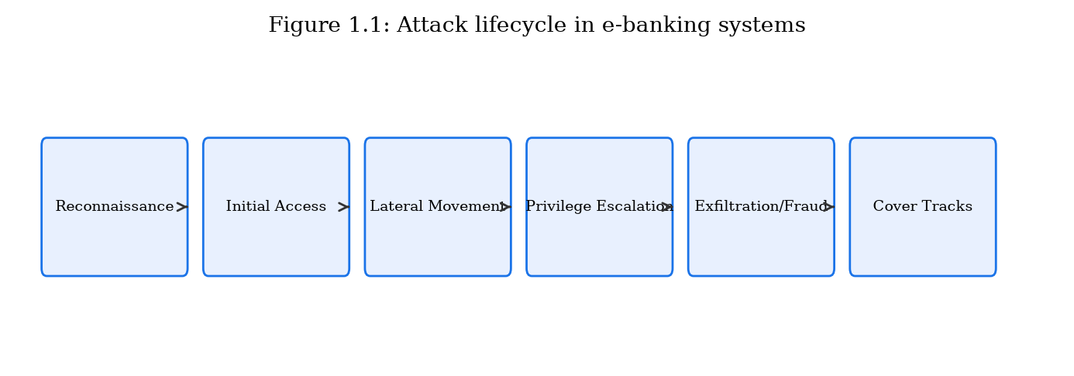
Attack lifecycle flowchart: reconnaissance → initial access → lateral movement → privilege escalation → data exfiltration/fraud → cover tracks (Figure 1.1).

1.1.3 Attack Trends and Statistics
The financial services sector consistently ranks among the top three industries targeted by cyberattacks. The IBM Cost of a Data Breach Report (2024) reports that the average cost of a data breach in the financial sector is $5.9 million, compared to a cross-industry average of $4.45 million. Phishing remains the most common initial access vector, accounting for approximately 41% of breaches in financial services according to the Verizon Data Breach Investigations Report (2024) [21][22].
The adoption of mobile banking has shifted attack patterns: mobile malware targeting banking applications grew by 32% year-over-year, with trojans such as Anubis, Cerberus, and SharkBot employing overlay attacks to capture credentials and intercept SMS OTPs. Concurrently, API attacks against open-banking endpoints have emerged as a new threat category, with the OWASP API Security Top 10 identifying broken authentication and excessive data exposure as the most prevalent vulnerabilities [23].
Ransomware groups have increasingly targeted financial institutions, with groups such as LockBit, ALPHV/BlackCat, and Cl0p claiming attacks on banks, insurance companies, and payment processors. The double-extortion model—encrypting data and threatening to publish stolen records—amplifies the pressure on victims to pay.
From a defensive standpoint, understanding attack trends enables prioritization of security investments. The shift from perimeter-focused defenses to zero-trust architectures reflects the recognition that network boundaries have dissolved. In a zero-trust model, every access request—regardless of origin—is authenticated, authorized, and encrypted. The cryptographic schemes proposed in this dissertation align with zero-trust principles by providing device-bound, transaction-scoped authentication (ECC-DTB-AKA) and persistent integrity proofs that survive service-boundary crossings (ECC-HISE).

1.1.4 Regulatory and Standards Landscape
The regulatory environment surrounding e-banking security provides both constraints and guidance for cryptographic system design. The Payment Card Industry Data Security Standard (PCI DSS) v4.0 mandates strong cryptography for cardholder data protection, requiring TLS 1.2 or higher for transmission and AES-256 for storage. The European Union's Revised Payment Services Directive (PSD2) requires strong customer authentication (SCA) for electronic payments, implemented through two of three factors: knowledge (password), possession (device/token), and inherence (biometric) [2][17][18][42].
NIST Special Publication 800-52 Rev. 2 provides guidelines for TLS implementations in government and commercial systems, recommending TLS 1.3 with specific cipher suites. NIST SP 800-57 Part 1 offers key-management guidance, recommending ECC P-256 for protection through 2030 and P-384 for longer-term requirements. ISO/IEC 27001:2022 specifies information security management system requirements applicable to financial institutions globally [1][19][28].
The SWIFT Customer Security Programme (CSP) mandates 32 mandatory and advisory controls for institutions connected to the SWIFT network, including multi-factor authentication for operator sessions, network segmentation, and attestation of security compliance annually. Non-compliance can result in reporting to regulators and potential disconnection from the SWIFT network [20][24].
These standards collectively establish minimum baselines but do not prescribe integrated methodologies for binding authentication to key exchange or for hierarchical data-protection envelopes. The gap between compliance and comprehensive security motivates the research contributions of this dissertation [8][29].

1.1.5 Detailed Analysis of Selected Attack Vectors
To provide depth beyond the taxonomy presented in Section 1.1.1, this subsection examines three high-impact attack vectors in detail: man-in-the-middle attacks on banking sessions, session hijacking via token theft, and advanced persistent threats (APTs) targeting financial infrastructure.
Man-in-the-middle (MITM) attacks on banking sessions exploit the fact that users often cannot distinguish legitimate bank servers from impersonating proxies. In a typical MITM scenario, the attacker positions a proxy between the client and the bank server. If the client does not validate the server's certificate chain correctly—or if the attacker has compromised a trusted CA or uses a corporate SSL-inspection proxy—the attacker can decrypt, inspect, and modify transaction data in real time. Tools such as mitmproxy and Burp Suite, while designed for legitimate security testing, demonstrate the feasibility of this attack class. Banking trojans such as Zeus and Emotet have historically automated MITM against banking websites by injecting fraudulent transaction fields into otherwise legitimate sessions, redirecting wire transfers to attacker-controlled accounts without altering the confirmation screen displayed to the user [4].
Session hijacking via token theft represents a distinct but related threat. After successful authentication, the banking application issues a session token (cookie or bearer token) that the client presents with each subsequent request. If an attacker obtains this token—through XSS, malware memory scraping, or network sniffing on unencrypted channels—the attacker can impersonate the victim without knowing their password or MFA code. The OWASP Session Management Cheat Sheet recommends token rotation, binding tokens to client IP addresses, and using HttpOnly/Secure cookie flags, but these mitigations are not universally implemented and do not provide cryptographic binding between the token and the underlying key-exchange material [23].
Advanced persistent threats (APTs) targeting financial infrastructure operate over extended time periods (weeks to months), maintaining covert access to bank networks while exfiltrating data or preparing fraudulent transactions. APT groups such as Carbanak (also known as FIN7) and Lazarus Group have demonstrated the ability to compromise bank internal networks, learn internal transaction workflows, and execute fraudulent transfers through the same channels used by legitimate operators. APT attacks often begin with spear-phishing emails containing weaponized documents, progress through lateral movement using stolen credentials, and culminate in access to SWIFT terminals or core banking systems. The Bangladesh Bank heist exemplifies an APT-style operation against financial infrastructure [24][25][20][22].

1.1.6 Impact Assessment Framework
Assessing the impact of attacks on e-banking systems requires a multidimensional framework that goes beyond simple financial loss figures. We adopt a framework with four impact dimensions: financial, operational, reputational, and regulatory [42][43].
Financial impact encompasses direct losses (fraudulent transfers, ransom payments), indirect losses (customer compensation, legal fees), and recovery costs (forensic investigation, system restoration). The Ponemon Institute and IBM jointly publish annual cost-of-breach figures; for financial services in 2024, the average total cost was $5.9 million per breach, with an average of 258 days to identify and contain the breach.
Operational impact includes service downtime, degraded performance during attacks, and diversion of IT resources from planned projects to incident response. A DDoS attack against a major bank's online banking portal can prevent millions of customers from accessing services for hours, generating call-center surges and transaction backlogs. The operational resilience requirements of the Bank of England and the European Central Bank mandate maximum tolerable downtime thresholds for critical payment systems [42][43].
Reputational impact manifests as customer attrition, negative media coverage, and reduced stock valuation. Studies indicate that publicly traded banks experience an average stock price decline of 5–7% in the week following a major breach announcement, with partial recovery over subsequent months. Customer trust, once eroded, requires sustained investment in transparency and security improvements to rebuild.
Regulatory impact includes fines, consent orders, and increased supervisory scrutiny. The GDPR permits fines up to 4% of global annual revenue for serious data protection violations. The U.S. Office of the Comptroller of the Currency (OCC) and the Federal Reserve have issued consent orders against banks with deficient cybersecurity programs, requiring multi-year remediation plans and independent third-party assessments.

1.1.5 Kill-Chain View of Remote Banking Fraud
A useful analytic lens is the intrusion kill chain adapted to remote banking fraud. Typical stages include: (1) reconnaissance of banking apps and open redirectors; (2) weaponization via phishing kits or trojanized APKs; (3) delivery through SMS, email, or malvertising; (4) exploitation of weak auth or session handling; (5) installation of overlay malware or theft of refresh tokens; (6) command-and-control via abused cloud channels; and (7) actions on objectives such as ATO wire transfers or mule-account cascades [22].
Cryptographic channel improvements primarily disrupt stages 4–7 for remote adversaries who lack physical device control: device-bound session keys reduce the value of stolen cookies; transaction-bound keys reduce the value of ambient session tokens for payment injection; server-side envelopes reduce silent tampering of settlement outputs after compromise of a middleware hop. Understanding the kill chain clarifies why transport encryption alone—active mainly against passive wiretap at stage 5–6—is not a complete control set.

1.1.6 Economic Incentives and Attacker Business Models
Modern banking attacks are industrialized. Credential shops sell dumps; phishing-as-a-service lowers skill barriers; mule networks monetize stolen funds; ransomware crews target availability and extort. The economic asymmetry—attack automation versus institution-specific defenses—favors controls that invalidate entire classes of stolen material (bearer tokens, static file keys) rather than only detecting individual fraud cases after loss [22].
This economic framing motivates the dissertation's design emphasis: make stolen session artifacts non-portable across devices and transactions, and make settlement batches non-silently mutable after TLS termination [1][28].

1.2 Authentication and Key Exchange in E-Banking Systems
Authentication and key exchange form the first line of cryptographic defense in e-banking systems. Before any financial transaction can be authorized, the participating parties must establish mutual confidence in each other's identity and agree upon cryptographic keys for protecting subsequent communication. This section reviews the authentication and key-exchange mechanisms currently deployed in client-server and server-server environments of e-banking and e-finance services, analyzes their operational characteristics, and identifies limitations that motivate the scheme proposed in Chapter 2 [8][29][42][43].

1.2.1 Client-Server Authentication Mechanisms
The dominant client-server authentication model in retail e-banking comprises TLS 1.2/1.3 transport layer security combined with application-layer username-password authentication, often supplemented by a second factor (SMS OTP, hardware token, or mobile push notification). In this model, TLS provides server authentication via X.509 certificates and establishes encrypted channels, while the application layer authenticates the user independently [4][42][43][1].
The TLS 1.3 handshake protocol operates as follows: the client sends a ClientHello message specifying supported cipher suites and a key share (typically ECDHE on curve X25519 or P-256). The server responds with ServerHello, its certificate chain, and a key share. Both parties derive handshake traffic keys and application traffic keys using HKDF. The full handshake requires one round trip (1-RTT); a subsequent resumption using pre-shared keys achieves 0-RTT, though 0-RTT data is vulnerable to replay attacks and is therefore restricted by banking applications [1][4][5][6].
Application-layer authentication typically follows the TLS handshake. The client submits credentials (username, password hash, or token) over the encrypted channel. The server validates credentials against a stored database, often using bcrypt, scrypt, or Argon2 password hashing. Upon success, the server issues a session token (commonly a JSON Web Token or opaque server-side session identifier) that the client presents with subsequent requests [1][28].
Multi-factor authentication (MFA) adds a second verification step. SMS-based OTP remains prevalent despite known vulnerabilities to SIM-swapping and SS7 protocol attacks. Time-based one-time passwords (TOTP) per RFC 6238, implemented by applications such as Google Authenticator, provide stronger security but are susceptible to real-time phishing proxies (e.g., Evilginx) that relay OTPs to the attacker. FIDO2/WebAuthn, based on public-key cryptography with hardware security keys or platform authenticators (biometrics), represents the current state of the art for phishing-resistant MFA [15][22].
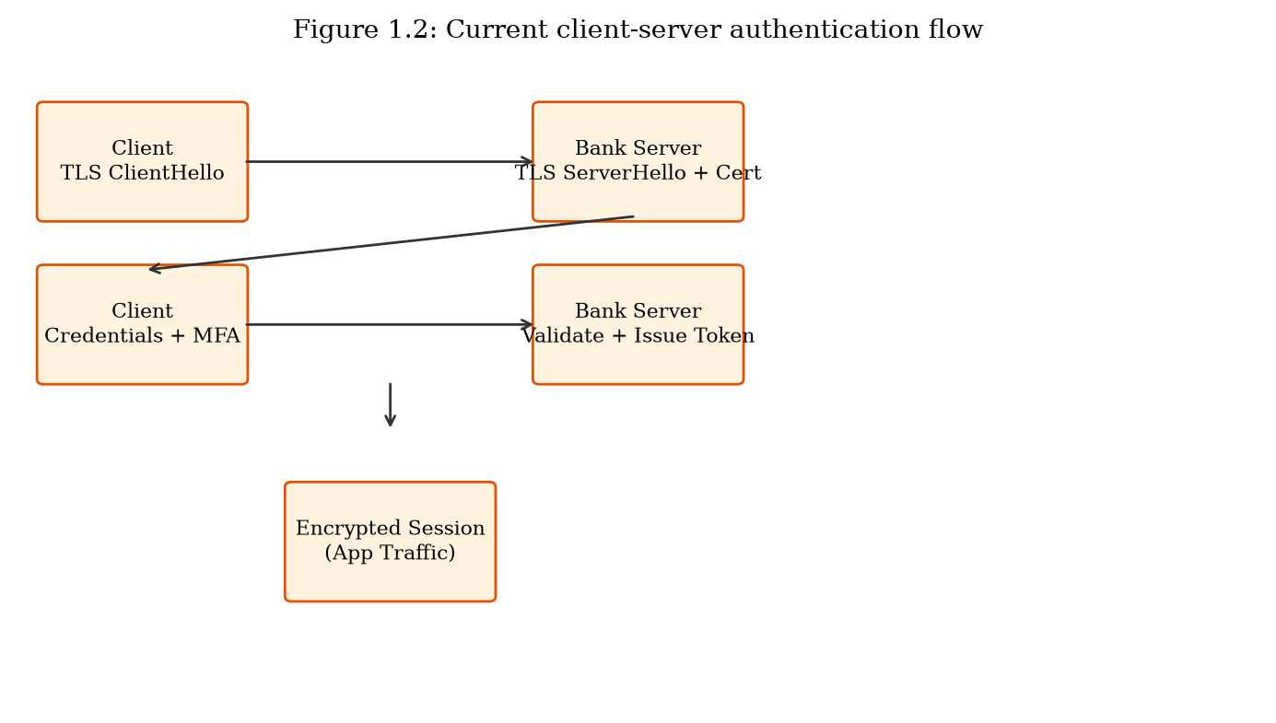
Current client-server authentication flow: TLS handshake → credential submission → MFA challenge → session token issuance (Figure 1.2).

1.2.2 Server-Server Authentication and Key Exchange
Server-server authentication in e-finance encompasses communication between a bank's internal microservices, inter-bank payment networks (SWIFT, ACH, Fedwire, SEPA), card network processors (Visa, Mastercard), and third-party open-banking aggregators. These channels typically employ mutual TLS (mTLS) with client certificates, VPN tunnels, or dedicated leased lines with link-layer encryption [1][28][4][20].
In the SWIFT network, authentication relies on the SWIFT Alliance Access software and bilateral key exchange (BKE) between institutions. Message authentication uses symmetric keys distributed through SWIFT's Secure Channel protocol. The 2016 Bangladesh Bank heist exposed weaknesses in institutions' local security practices surrounding SWIFT terminal access rather than fundamental flaws in SWIFT's cryptographic protocols, but the incident nonetheless highlighted the importance of end-to-end authentication binding [8][29][24][20].
Modern microservice architectures within banks increasingly use service mesh platforms (e.g., Istio, Linkerd) that automate mTLS between services. Certificate authorities internal to the bank issue short-lived certificates (typically 24-hour validity) to each service instance. While mTLS provides strong transport security, it does not address application-level authorization, message-level integrity for stored records, or auditability requirements for regulatory compliance [1][28][4].
API-based open-banking connections (under PSD2, Open Banking UK, and similar frameworks) use OAuth 2.0 with PKCE (Proof Key for Code Exchange) for customer consent and access-token issuance. The authorization server authenticates the third-party provider, while the resource server (bank API) validates access tokens. Limitations include token theft via XSS, insufficient scope granularity, and the absence of transaction-level cryptographic binding [14][13][18][38].
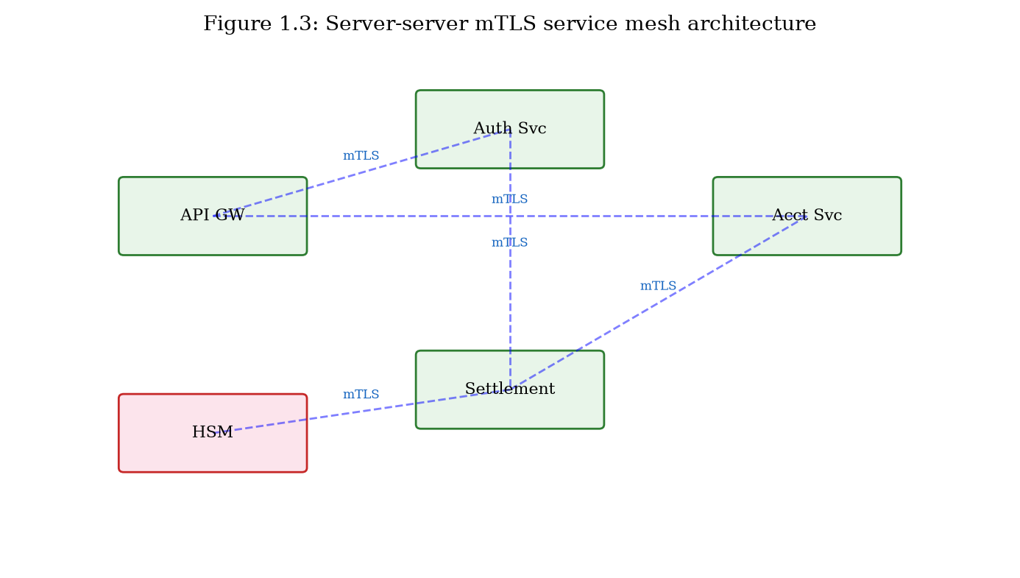
Server-server authentication in a microservice e-finance architecture with mTLS service mesh (Figure 1.3).

1.2.3 Identified Limitations and Drawbacks
Despite the breadth of deployed mechanisms, significant limitations persist in current client-server and server-server authentication and key-exchange practices. These limitations directly motivate the ECC-DTB-AKA scheme proposed in Chapter 2.
Limitation 1 — Decoupled transport and application authentication: TLS authenticates the server (and optionally the client via mTLS) at the transport layer, while user authentication occurs separately at the application layer. This decoupling creates a gap: a valid TLS session does not cryptographically bind the authenticated user identity to the encryption keys. An attacker who compromises a session token can hijack the application session even though the TLS channel remains intact [1][28].
Limitation 2 — Absence of device binding in key exchange: Standard TLS ECDHE derives session keys from ephemeral key pairs only, without incorporating device characteristics. If a session token is exfiltrated, it can be replayed from a different device. FIDO2 addresses this for the authentication step but does not integrate device binding into the key-exchange derivation itself [8][29][12][15].
Limitation 3 — No transaction-level key derivation: Once a session is established, the same application traffic keys protect all transactions within the session. Compromise of session keys exposes all transactions, not merely the current one. Per-transaction key derivation without additional round trips is not supported by TLS or OAuth 2.0 [5][6][13][14].
Limitation 4 — Session token vulnerability: Opaque session tokens and JWTs are bearer credentials—whoever possesses the token is authenticated. Token theft via XSS, malware, or network interception remains a prevalent attack vector. Binding tokens to cryptographic key material established during authenticated key agreement would limit the impact of token compromise [7][8].
Limitation 5 — Server-server channels lack message-level security: mTLS protects data in transit between services but does not provide persistent integrity proofs for stored or forwarded messages. If a message is intercepted after TLS termination and before re-encryption, it is vulnerable to tampering [1][28].
Limitation 6 — Insufficient forward secrecy in legacy deployments: Although TLS 1.3 mandates forward secrecy, many e-banking systems still support TLS 1.2 with cipher suites that do not use ephemeral Diffie-Hellman (e.g., RSA key transport). Legacy load balancers and API gateways may terminate TLS and re-encrypt with weaker configurations, creating forward-secrecy gaps [1][8][33][42].
These six limitations collectively demonstrate that current authentication and key-exchange practices in e-banking systems, while adequate for baseline compliance, fail to provide the cryptographic binding of identity, device, and transaction context necessary to resist the attack mechanisms cataloged in Section 1.1. Chapter 2 addresses these limitations through the ECC-DTB-AKA protocol, which integrates mutual authentication, ECDH-based forward secrecy, device fingerprint binding, and on-demand transaction key derivation into a unified three-round handshake [1][8][5][6].
Limitation | Affected Mechanism | Attack Enabled | Severity
Decoupled auth layers | TLS + app login | Session hijacking | High
No device binding | TLS ECDHE | Credential replay from new device | High
No per-txn key derivation | TLS session keys | Bulk transaction exposure | Medium
Bearer session tokens | JWT / opaque tokens | Token theft (XSS, malware) | High
No message-level integrity | mTLS only | Post-termination tampering | Medium
Legacy TLS configurations | TLS 1.2 RSA suites | Retroactive decryption | Medium
Table 1.2: Limitations of current authentication and key-exchange mechanisms.

1.2.4 Elliptic Curve Cryptography in Financial Authentication
Elliptic curve cryptography has become the preferred public-key primitive for new financial authentication deployments. Understanding its role in current systems is essential context for the novel schemes proposed in Chapters 2 and 3 [11][34][35].
An elliptic curve E over a finite field F_p is the set of points (x, y) satisfying the Weierstrass equation y² = x³ + ax + b (mod p), together with a point at infinity forming an abelian group. Cryptographic security relies on the hardness of the elliptic curve discrete logarithm problem (ECDLP): given points P and Q = [k]P, find scalar k. For properly chosen curves with sufficiently large prime subgroups, the best known algorithms require exponential time, providing security proportional to half the bit length of the subgroup order [11][34][35].
In TLS 1.3, the default key-exchange mechanism is ECDHE (Elliptic Curve Diffie-Hellman Ephemeral), using curves X25519 or P-256. The ephemeral nature of ECDHE provides forward secrecy: compromise of the server's long-term private key does not enable decryption of previously recorded sessions. EMV chip cards use ECDSA on curve secp256r1 for offline and online transaction authentication. FIDO2/WebAuthn employs ECDSA or Ed25519 for credential key pairs stored in hardware authenticators [1][8][9][26].
Despite widespread ECC adoption, current deployments use ECC primarily for individual cryptographic operations (key agreement, signing) rather than as an integrated methodology binding authentication, key exchange, device context, and transaction scope. The ECC-DTB-AKA scheme proposed in Chapter 2 extends ECC key agreement with additional binding inputs (device fingerprint, transaction nonce) in the HKDF derivation, creating a cohesive protocol rather than a stack of independent cryptographic layers [5][6][8][29].

1.2.5 Comparative Overview of Authentication Protocols
Table 1.4 provides a comparative overview of authentication and key-exchange protocols commonly used in e-banking systems, highlighting properties relevant to the limitations identified in Section 1.2.3 [42][43].
TLS 1.3 full handshake provides server authentication and forward-secure key agreement in one round trip but does not authenticate the user at the cryptographic layer. OAuth 2.0 with PKCE adds authorization delegation for third-party API access but relies on bearer tokens vulnerable to theft. FIDO2 provides phishing-resistant user authentication but does not integrate with key-exchange derivation. Kerberos with PKINIT (public-key initialization) supports mutual authentication in enterprise environments but is rarely deployed in retail e-banking client-server channels [1][14][13][15].
None of these protocols simultaneously achieves: (a) mutual authentication at the cryptographic layer, (b) device binding in key derivation, (c) per-transaction key derivation without additional round trips, and (d) three-round handshake efficiency. This gap is the design target for ECC-DTB-AKA [5][6].
Protocol | Mutual Auth | Forward Secrecy | Device Bind | Per-Txn Key | Rounds
TLS 1.3 | Server only | Yes | No | No | 1
OAuth 2.0 PKCE | Delegated | Via TLS | No | No | 3+
FIDO2/WebAuthn | User auth | N/A | Partial | No | 2
ECDH + JWT | App layer | Yes | No | No | 2
ECC-DTB-AKA (Ch.2) | Yes | Yes | Yes | Yes | 3
Table 1.4: Comparative overview of authentication protocols for e-banking.

1.2.6 Password-Based Authentication Vulnerabilities
Despite decades of security guidance, password-based authentication remains the default for retail e-banking in most jurisdictions. Understanding its inherent vulnerabilities is essential for motivating cryptographic alternatives [42][43].
Human-chosen passwords exhibit highly skewed distributions. Analysis of breached password databases consistently shows that the top 100 passwords account for approximately 17% of all passwords, with '123456', 'password', and 'qwerty' appearing in virtually every corpus. Password complexity rules (requiring uppercase, numbers, symbols) often result in predictable substitutions (P@ssw0rd) that provide minimal additional entropy.
Password hashing algorithms mitigate offline attacks against stolen databases. Bcrypt, scrypt, and Argon2 are designed to be computationally expensive, limiting the rate at which attackers can test guessed passwords. However, weak passwords remain vulnerable even with strong hashing, and credential stuffing attacks bypass hashing entirely by testing leaked credentials from other breaches against banking login portals.
Password reset mechanisms introduce additional attack surfaces. Knowledge-based authentication questions (mother's maiden name, first pet) are often guessable from social media. Email-based reset links can be intercepted if the email account is compromised. SMS-based reset codes inherit SIM-swapping vulnerabilities. These weaknesses reinforce the need for cryptographic authentication mechanisms that do not rely solely on shared secrets memorized by humans.

1.2.4 Session Token Lifecycles and Refresh-Token Risk
OAuth 2.0 and OIDC deployments in open banking and mobile banking commonly issue short-lived access tokens and longer-lived refresh tokens. Refresh tokens, if stolen from device storage or backup channels, allow prolonged API access without user presence. PKCE mitigates authorization-code interception on public clients but does not bind subsequent API calls to a device-bound key hierarchy [14][13][38].
Banks mitigate with refresh-token rotation, device cookies, and step-up authentication. These are policy controls on top of bearer semantics. ECC-DTB-AKA instead makes the cryptographic session key depend on device fingerprint material and derives payment authorizers from transaction nonces—shifting from policy-enforced bearer tokens toward cryptographically bound authenticators.

1.2.5 Mutual TLS in Service Meshes: Strengths and Blind Spots
Service meshes (Istio, Linkerd, and vendor equivalents) democratized mTLS between microservices. Strengths include automated certificate rotation and workload identity. Blind spots remain: mesh identity often equals workload identity, not business-transaction identity; sidecar termination again creates plaintext; and east-west traffic after termination is trusted implicitly. For settlement and clearing adapters that export files to external institutions, mesh mTLS does not travel with the file [1][28][4].
Hence Chapter 1 treats mTLS as necessary but incomplete for SR5–SR8, motivating ECC-HISE at the application data plane [1][28].

1.3 Data Encryption, Security, and Integrity in E-Banking
Beyond authentication and key establishment, e-banking systems must protect the confidentiality, integrity, and availability of financial data throughout its lifecycle. This section examines the data encryption, security, and integrity mechanisms currently employed in e-banking and e-finance services, with emphasis on server-server data transfer and storage, and identifies drawbacks that motivate the ECC-HISE scheme proposed in Chapter 3 [42][43].

1.3.1 Data Encryption Mechanisms
Data-at-rest encryption in banking systems typically employs AES-256 in Galois/Counter Mode (GCM) or XTS mode. Database-level encryption (transparent data encryption, TDE) protects entire tablespaces, while column-level encryption targets sensitive fields (account numbers, social security numbers). Key management is performed by HSMs certified to FIPS 140-2 Level 3 or higher, with key-encryption keys (KEKs) stored in hardware and data-encryption keys (DEKs) wrapped under KEKs [2][3].
Data-in-transit encryption relies primarily on TLS as described in Section 1.2. For server-server bulk data transfer (e.g., end-of-day settlement files, regulatory reporting batches), institutions may additionally employ PGP/GPG encryption or proprietary file-encryption tools with pre-shared symmetric keys distributed via out-of-band channels [1][28].
Elliptic curve cryptography appears in data-protection contexts primarily through ECIES (Elliptic Curve Integrated Encryption Scheme), which combines ECDH key agreement with a symmetric cipher and MAC. ECIES is standardized in IEEE 1363a and SEC 1, and provides semantic security under chosen-ciphertext attacks when implemented with appropriate KDF and MAC (or authenticated encryption). However, standard ECIES operates at the message level without hierarchical key management or batch audit capabilities required for inter-bank settlement [36][2][3][41].
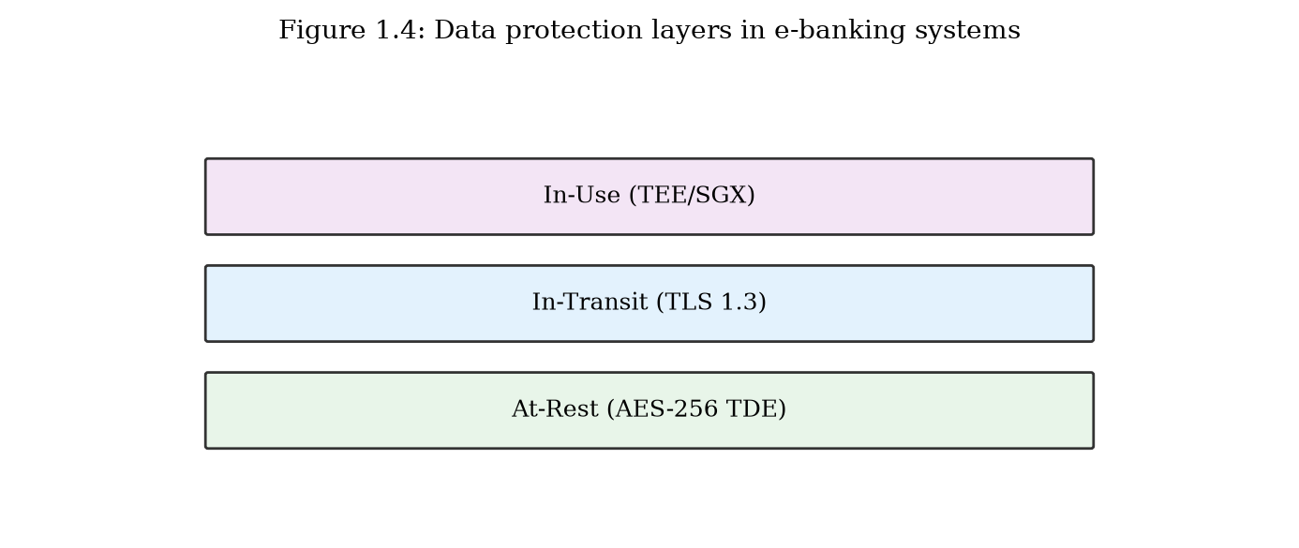
Data protection layers in e-banking: at-rest (TDE), in-transit (TLS), in-use (confidential computing) (Figure 1.4).

1.3.2 Data Integrity and Audit Mechanisms
Integrity protection for individual messages is commonly provided by HMAC-SHA256 or by the authenticated encryption inherent in AES-GCM. Digital signatures using RSA or ECDSA provide non-repudiation for high-value transactions and regulatory submissions. However, per-message signatures do not efficiently support batch verification of large settlement files containing millions of records [2][36][9][26].
Audit trails in e-banking systems log transaction events, access attempts, and administrative actions to tamper-evident storage. Common implementations include append-only databases, write-once-read-many (WORM) storage, and centralized SIEM platforms. Blockchain and distributed-ledger technologies have been proposed and piloted for settlement audit (e.g., JPMorgan's Onyx, R3 Corda), offering Merkle-tree-based integrity guarantees but introducing latency and scalability trade-offs unsuitable for all use cases [30][32][31][42].
Hash chains—where each log entry includes the hash of the previous entry—provide lightweight tamper evidence without the overhead of full blockchain consensus. Merkle trees enable efficient verification that a specific record is included in a batch without reprocessing the entire batch, a property essential for regulatory audit of large settlement files [30][31][32].

1.3.3 Identified Limitations and Drawbacks
The following limitations in current data encryption, security, and integrity mechanisms motivate the ECC-HISE scheme proposed in Chapter 3.
Limitation 1 — Flat key management hierarchies: Many institutions use a small number of long-lived symmetric keys for bulk encryption, increasing the blast radius of key compromise. Hierarchical key derivation that scopes keys to business domains and individual batches limits exposure [3][5][6].
Limitation 2 — Disconnected encryption and audit: Encryption and audit logging are typically implemented as independent systems. An encrypted batch file may be stored without a cryptographically linked integrity proof that enables third-party verification of completeness and ordering.
Limitation 3 — Inefficient batch integrity verification: Per-record digital signatures do not scale to settlement batches containing millions of entries. A Merkle-tree-based approach enables O(log n) verification per record while maintaining O(1) batch-level integrity evidence [26][9][30].
Limitation 4 — Static pre-shared keys in server-server channels: Inter-bank file transfer often relies on symmetric keys distributed manually and rotated infrequently (annually or biannually). ECC-based ephemeral key agreement per batch eliminates long-lived shared secrets.
Limitation 5 — Lack of end-to-end integrity across service boundaries: In microservice architectures, a message may be decrypted at each service boundary (TLS termination), processed in plaintext, and re-encrypted. Envelope encryption that persists integrity proofs across service boundaries addresses this gap [1][28].
Limitation 6 — Regulatory audit friction: Demonstrating to auditors that no records were added, removed, or reordered in a settlement batch currently requires manual reconciliation or expensive full-batch reprocessing. Cryptographic audit chains reduce audit cost and increase confidence.
These six limitations in data-security mechanisms parallel the authentication gaps identified in Section 1.2, but operate at a different layer of the system stack. While Section 1.2 concerns who is communicating and how keys are established, this section concerns what data is protected, how integrity is maintained, and how compliance can be demonstrated. Chapter 3 addresses these limitations through ECC-HISE, which combines hierarchical ECC key derivation, authenticated envelope encryption, and Merkle-tree audit chains into a cohesive server-server data-protection methodology [5][6][30].
Limitation | Current Practice | Proposed Direction (Ch.3) | Impact
Flat key hierarchy | Few long-lived DEKs | ECC hierarchical derivation | Key compromise scope
Disconnected audit | Separate log systems | Merkle-linked envelopes | Tamper detection
Batch verification cost | Per-record signatures | Merkle tree batch proofs | Scalability
Static PSKs | Annual manual rotation | Ephemeral ECDH per batch | Long-term exposure
Service-boundary gaps | TLS terminate/decrypt | Persistent envelope integrity | Insider tampering
Audit friction | Manual reconciliation | Cryptographic audit chain | Compliance cost
Table 1.3: Limitations of current data security mechanisms and proposed directions.

1.3.4 Key Management in Financial Institutions
Effective data encryption in e-banking depends critically on key management—the generation, distribution, storage, rotation, and destruction of cryptographic keys. Poor key management can render even the strongest encryption algorithms ineffective, as demonstrated by numerous breaches where encryption was deployed but keys were stored alongside encrypted data in accessible locations [3][42][43].
Financial institutions typically employ a tiered key-management architecture. At the top level, master keys are generated within FIPS 140-2 Level 3 (or higher) hardware security modules and never leave the HSM in plaintext form. Key-encryption keys (KEKs) wrap data-encryption keys (DEKs) for distribution to application servers. DEKs encrypt actual customer data and are rotated frequently (daily to monthly) depending on data classification and regulatory requirements.
The ANSI X9.24-3 standard specifies key-management requirements for symmetric keys in financial services, including dual-control procedures for key generation and split-knowledge requirements for critical keys. PCI DSS Requirement 3 mandates protection of stored cardholder data, including key-management procedures for encryption keys. However, these standards focus on symmetric key hierarchies and do not address ECC-based hierarchical derivation for batch envelope encryption with integrated audit chains—the design space targeted by ECC-HISE [17].

1.3.5 Merkle Trees and Cryptographic Audit Trails
Merkle trees (hash trees) provide an efficient data structure for verifying integrity of large datasets. A Merkle tree is a binary tree in which each leaf node contains the hash of a data block, and each internal node contains the hash of the concatenation of its children. The root hash commits to the entire dataset: any modification to any leaf changes the root hash. A verifier can confirm inclusion of a specific record with O(log n) hash computations given an authentication path (Merkle proof) from the leaf to the root [30].
In e-banking settlement, Merkle trees enable regulators and counterparties to verify that a specific transaction was included in a batch settlement without reprocessing the entire batch. Combined with digital signatures on the Merkle root, the tree provides both integrity and non-repudiation at the batch level. Bitcoin and other blockchains use Merkle trees in block headers for similar reasons, though blockchain consensus introduces latency unsuitable for real-time settlement. ECC-HISE adopts Merkle trees for audit without requiring distributed consensus, making it applicable to traditional inter-bank settlement workflows [26][9][30][31].
The integration of Merkle audit chains with ECC-based envelope encryption—rather than treating encryption and audit as separate subsystems—constitutes a key differentiator of the ECC-HISE approach developed in Chapter 3. By including the Merkle root in the signed batch header, any tampering with individual records is detectable through root mismatch, while the hierarchical key structure limits the scope of key compromise to individual batches within specific business domains [30].

1.3.6 Homomorphic Encryption and Emerging Approaches
While not part of the proposed schemes in this dissertation, emerging cryptographic technologies warrant brief discussion to situate the research within the broader landscape of financial data protection.
Fully homomorphic encryption (FHE) enables computation on encrypted data without decryption, potentially allowing banks to perform fraud detection on encrypted transaction streams. However, FHE remains orders of magnitude slower than plaintext computation and is not yet practical for real-time e-banking workloads. Partial homomorphic schemes (Paillier, ElGamal) support specific operations (addition, multiplication) and have been piloted for privacy-preserving credit scoring [42][43].
Confidential computing (Intel SGX, AMD SEV, ARM TrustZone) provides hardware-enforced memory isolation for applications processing sensitive data. Major cloud providers offer confidential virtual machines for financial workloads. These technologies address the 'data in use' protection gap identified in Section 1.3.1 but require trust in hardware manufacturers and are vulnerable to side-channel attacks.
The schemes proposed in this dissertation (ECC-DTB-AKA and ECC-HISE) complement rather than replace these emerging approaches. ECC-DTB-AKA secures the client-server channel; ECC-HISE secures server-server batch data; confidential computing can protect in-memory processing; and post-quantum algorithms will eventually replace specific ECC primitives as standards mature [39].

1.3.4 Integrity Versus Confidentiality in Compliance Narratives
Regulatory narratives often emphasize encryption in transit and at rest. Integrity and non-repudiation receive comparatively less operational instrumentation, despite equal importance for settlement disputes and forensic readiness. Hash manifests without signatures are forgeable by anyone who can rewrite storage; signatures without binding to a batch structure allow selective dropping of records if receivers do not enforce cardinality checks.
A sound integrity architecture needs: authenticated encryption or encrypt-then-MAC/sign discipline; binding to batch identifiers; protection of ordering; and efficient third-party verification. Chapter 3's ECC-HISE is evaluated explicitly against this checklist [36][2].

1.3.5 Cross-Border Settlement and Multi-Party Trust
Cross-border payments introduce additional custodians: correspondent banks, market infrastructures, and messaging networks. Each hop may terminate encryption and re-protect under local policy. Cryptographic commitments that survive hops—signed Merkle roots anchored to originator keys—reduce dispute ambiguity when a later hop alters content. While this dissertation focuses on bilateral envelopes suitable for bank-to-bank or bank-to-clearing interfaces, the same commitments can be shared with supervisory authorities as compact evidence [30].

1.4 Threat Model, Assumptions, and Research Questions
This section formalizes the threat model, system assumptions, and research questions that guide the design and evaluation of the proposed schemes in Chapters 2 through 5.

1.4.1 Threat Model
We adopt a Dolev-Yao threat model extended with financial-domain adversary capabilities. The adversary A can: (a) eavesdrop on, insert, delete, modify, and replay messages on all network channels; (b) compromise up to N-1 of M server nodes in the settlement network (where M > 2N-1 for quorum systems, but we do not assume quorum); (c) extract session tokens and application data from a compromised client device; (d) perform offline dictionary attacks on captured password hashes (but not on ECDH ephemeral private keys due to computational hardness); (e) submit fraudulent transaction requests using stolen credentials [12][29][37].
The adversary A cannot: (a) break the elliptic curve discrete logarithm problem (ECDLP) or compute discrete logarithms on the chosen curve; (b) break SHA-256, AES-256-GCM, or Ed25519 unforgeability; (c) extract private keys from an HSM (in the prototype, HSM is simulated and this assumption is noted as a limitation); (d) physically access the bank's data center without detection [2][10][11][34].
Trust assumptions: the bank's certificate authority (CA) is trusted; registered client public keys are distributed securely during account enrollment; the clearing-house master key is generated and stored in an HSM at setup time [4].
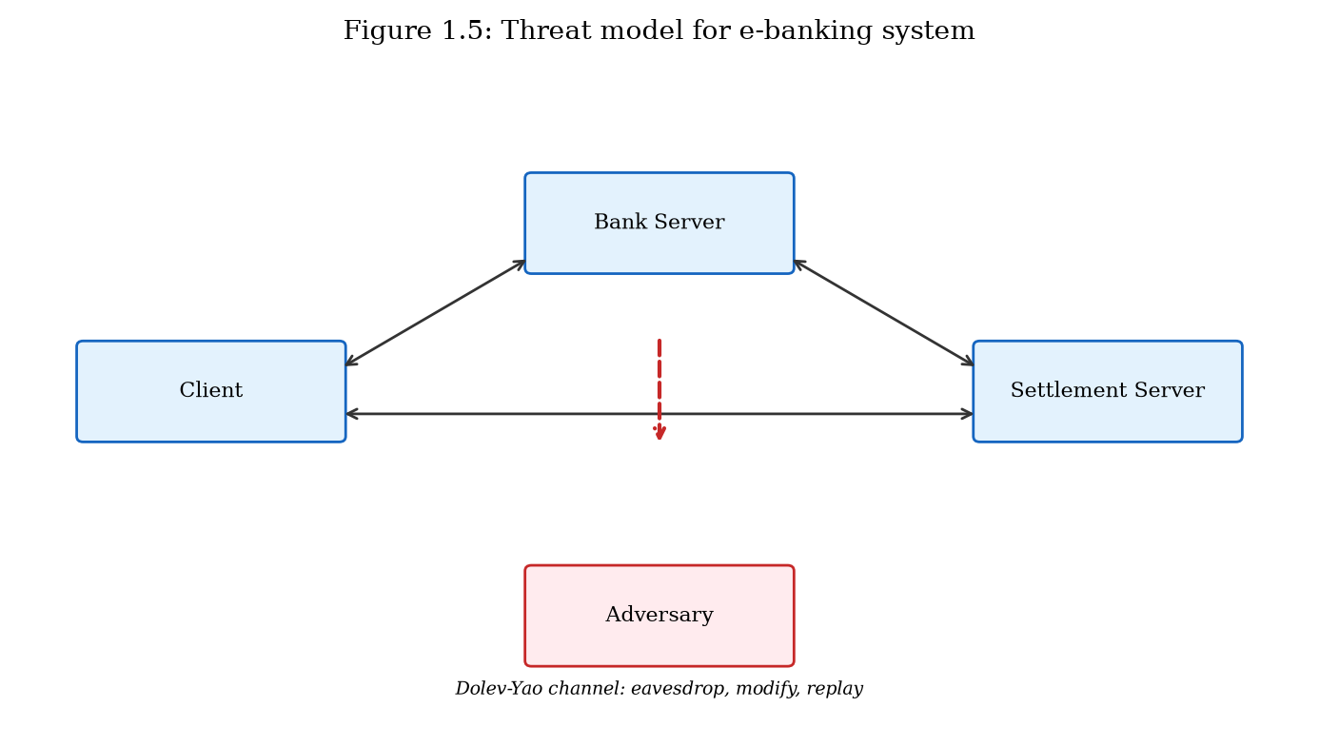
Threat model diagram showing adversary position relative to client, bank server, and inter-bank network (Figure 1.5).

1.4.2 System Assumptions
The e-banking system under consideration comprises: (1) a client application running on a smartphone or desktop with a secure element or trusted execution environment for key storage; (2) a bank application server providing RESTful APIs for account management and transaction authorization; (3) a settlement server participating in inter-bank batch transfer; (4) a clearing-house authority managing the master key hierarchy [42][43].
Clients and servers have synchronized clocks within ±5 minutes (for timestamp validation and nonce freshness). Network connectivity is intermittent but eventually available. The elliptic curve used is SECP256R1 (NIST P-256) for ECDH/ECDSA operations and Ed25519 for batch signatures, unless otherwise noted [9][26][10][11].

1.4.3 Research Questions
RQ1: Can an ECC-based authenticated key agreement protocol that binds session keys to device fingerprints and transaction nonces overcome the authentication limitations identified in Section 1.2 while maintaining or improving communication efficiency? [7][8]
RQ2: Can a hierarchical ECC-based secure envelope scheme with Merkle audit chains address the data-security limitations identified in Section 1.3 for server-server batch transfer in e-finance systems? [30]
RQ3: How do the proposed schemes compare quantitatively to existing approaches (TLS 1.3, standard ECDH, ECIES, static PSK) in terms of authentication latency, ciphertext overhead, communication round trips, and resistance to attacks cataloged in Section 1.1? [1][41][12][29]
RQ4: Can both schemes be implemented in a unified e-financial service architecture and validated through programmatic testing and benchmark measurement?

1.4.4 Chapter Summary
This chapter has defined and categorized attack mechanisms against e-banking and e-finance systems, presented case studies demonstrating their real-world impact, reviewed current authentication and key-exchange mechanisms with six identified limitations (Section 1.2), reviewed current data encryption and integrity mechanisms with six identified limitations (Section 1.3), and formalized the threat model and research questions guiding this dissertation. The identified limitations provide direct motivation for the two novel ECC-based schemes developed in Chapters 2 and 3, whose prior-work context is further elaborated in Chapter 5 [42][43].

1.4.5 Security Requirements Derivation
From the threat model (Section 1.4.1) and the identified limitations (Sections 1.2.3 and 1.3.3), we derive the following security requirements that the proposed schemes must satisfy. These requirements serve as evaluation criteria in Chapter 5.
SR1 (Mutual Authentication): Both communicating parties must cryptographically verify each other's identity before any financial data is exchanged. For client-server channels, this means the client verifies the bank server's identity via certificate chain, and the server verifies the client's identity via registered public key signature [4].
SR2 (Forward Secrecy): Compromise of long-term private keys must not enable decryption of previously recorded sessions. Ephemeral ECDH key pairs must be used for session key establishment [1][8][12][29].
SR3 (Device Binding): Session keys must be cryptographically bound to the client device, preventing session transfer to unauthorized devices even if session tokens are exfiltrated.
SR4 (Transaction Binding): Individual transactions must be protected by keys derived specifically for that transaction, limiting the impact of single-transaction key compromise.
SR5 (Data Confidentiality): Financial records in server-server batch transfer must be encrypted with semantically secure authenticated encryption [36][2].
SR6 (Data Integrity): Any modification to batch records must be detectable through cryptographic verification, with batch-level integrity proofs enabling efficient audit.
SR7 (Non-Repudiation): Batch senders must not be able to deny having sent a batch, achieved through digital signatures on batch headers [26][9].
SR8 (Efficiency): Authentication must complete within acceptable latency bounds (target: under 200ms on commodity hardware) with minimal communication overhead.

1.4.6 Relationship to Subsequent Chapters
The security requirements SR1 through SR4 are addressed primarily by the ECC-DTB-AKA protocol developed in Chapter 2. Requirements SR5 through SR7 are addressed by the ECC-HISE scheme developed in Chapter 3. Requirement SR8 is evaluated quantitatively in Chapters 2, 3, and 5 through benchmark measurements of the prototype described in Chapter 4.
Chapter 5 provides the comprehensive prior-work analysis specified in the dissertation requirements: Section 5.2 reviews authentication and key-exchange literature in depth (expanding on the overview in Section 1.2), Section 5.3 reviews data encryption and integrity literature (expanding on Section 1.3), and Section 5.4 synthesizes findings to demonstrate how the proposed schemes address the vulnerabilities cataloged in this chapter.
Readers approaching this dissertation from a practitioner perspective may wish to read Section 1.1 and Sections 1.2.3/1.3.3 first to understand the threat landscape and identified gaps, then proceed to Chapters 2 and 3 for protocol specifications, and Chapter 4 for implementation guidance. Readers with a research orientation may prefer to read Chapter 5's prior-work analysis before the proposed schemes, to situate the contributions within the existing literature.

1.4.5 Security Requirements SR1–SR8 (Consolidated)
For reference in later chapters, the consolidated security requirements are: SR1 mutual authentication on client-server key establishment; SR2 forward secrecy for session keys; SR3 cryptographic device binding; SR4 per-transaction key separation; SR5 confidentiality of server-server batch records; SR6 authenticity of batch origin; SR7 integrity and ordering of batch membership; SR8 efficient third-party audit of inclusion. ECC-DTB-AKA targets SR1–SR4; ECC-HISE targets SR5–SR8; the dual-layer methodology targets their joint satisfaction in one e-finance architecture [1][8].

1.4.6 Scope Boundaries
Out of scope: physical ATM/card-present EMV protocol redesign; hardware side-channel evaluation of ECC implementations; large-scale user studies; full machine-checked proofs; and post-quantum drop-in replacements (discussed as future work). In scope: protocol design, analytical security argumentation, prototype implementation, and comparative evaluation against representative baselines [16][39].

Chapter 2
ECC-DTB-AKA: Device- and Transaction-Bound Authenticated Key Agreement for Client-Server E-Banking Channels [7][8][42][43]

2.1 Introduction and Motivation
Chapter 1 identified six critical limitations in current authentication and key-exchange mechanisms deployed in e-banking client-server channels (Section 1.2.3). These limitations—decoupled transport and application authentication, absence of device binding, lack of per-transaction key derivation, bearer-token vulnerability, insufficient message-level integrity across service boundaries, and legacy TLS configurations without forward secrecy—collectively create exploitable gaps that attackers leverage through session hijacking, credential replay, and man-in-the-middle attacks [1][8][5][6].
This chapter proposes ECC-DTB-AKA (Elliptic Curve Cryptography — Device- and Transaction-Bound Authenticated Key Agreement), an alternative approach to strengthening security systems in e-banking and e-finance environments. ECC-DTB-AKA integrates mutual authentication, ephemeral ECDH key agreement, device fingerprint binding, and on-demand transaction key derivation into a unified three-round protocol. By incorporating device and transaction context directly into the HKDF key-derivation salt, the scheme ensures that session keys and transaction keys are cryptographically bound to the originating device and specific financial operation, addressing limitations that existing TLS-centric and OAuth-based approaches cannot resolve without additional protocol layers [5][6][7][8].
The design philosophy of ECC-DTB-AKA follows the principle of cryptographic cohesion: rather than stacking independent security layers (TLS for transport, JWT for session, OTP for transaction), all authentication and key-establishment functions are unified within a single ECC-based protocol. This reduces the attack surface at layer boundaries and provides formal security properties that can be analyzed within a single proof framework [1][28].

2.1.1 Limitations of Layered Security Architectures
Contemporary e-banking systems typically implement security as a vertical stack of independent layers: network firewalls at the perimeter, TLS at the transport layer, web application firewalls at the HTTP layer, authentication middleware at the application layer, and database encryption at the persistence layer. While defense-in-depth is a sound principle, the interfaces between layers create implicit trust assumptions that attackers exploit [42][43][1][28].
Consider a typical mobile banking login flow: (1) the mobile app establishes a TLS 1.3 connection to the API gateway, authenticating the server via its certificate; (2) the user enters credentials, which the app transmits over the TLS channel; (3) the authentication service validates credentials and returns a JWT session token; (4) subsequent API calls include the JWT in the Authorization header, still over TLS. At each layer boundary, data transitions between protection domains. The TLS layer knows nothing about the user's identity; the JWT layer knows nothing about the encryption keys; the transaction layer knows nothing about the originating device [1][4][28].
An attacker who compromises the JWT (via malware, XSS, or network interception on a misconfigured endpoint) gains full session access without breaking TLS. An attacker who performs SSL stripping at a captive portal downgrades the transport layer while the application layer continues to function, potentially exposing credentials. ECC-DTB-AKA collapses layers 1–3 into a single cryptographic protocol where user identity, device context, and session keys are established atomically [1][28].

2.2 Design Goals and Requirements
Derived from the security requirements SR1–SR4 and SR8 established in Section 1.4.5, ECC-DTB-AKA is designed to satisfy the following goals:
G1 (Mutual Authentication): Both client and server must cryptographically prove their identity during key establishment, not merely after an encrypted channel is created.
G2 (Forward Secrecy): Compromise of long-term private keys must not enable retroactive decryption of previously established sessions [1][8].
G3 (Device Binding): Session keys must incorporate a device fingerprint in the derivation function, preventing session transfer to unauthorized devices.
G4 (Transaction Binding): Per-transaction keys must be derivable from the session master key without additional communication rounds.
G5 (Efficiency): Authentication must complete with minimal latency and message overhead, suitable for mobile banking on cellular networks.
G6 (Standards Alignment): The protocol must use NIST-approved curves (SECP256R1), SHA-256, HKDF (RFC 5869), and ECDSA (FIPS 186-5), enabling integration with existing PKI and HSM infrastructure [5][6][9][26].

2.2.1 Elliptic Curve Cryptography Foundations
The selection of elliptic curve cryptography as the sole public-key primitive in ECC-DTB-AKA warrants explicit justification given the availability of alternatives (RSA, DSA, post-quantum algorithms) [11][34][35][39].
Elliptic curves over finite fields provide a group structure in which the Diffie-Hellman problem is hard: given G, [a]G, [b]G, computing [ab]G is computationally infeasible. The security level of SECP256R1 (NIST P-256) is approximately 128 bits, equivalent to AES-128 and SHA-256. The key size of 256 bits compares favorably to 3072-bit RSA keys for equivalent security, reducing bandwidth, storage, and computation [11][34][35][27].
SECP256R1 is specified in FIPS 186-5 and SP 800-186, widely implemented in hardware (HSMs, smart cards, TPMs), and supported by every major TLS library. Its curve parameters were generated verifiably (though debates about potential backdoors in NIST curves persist in the literature; Curve25519 is an alternative that ECC-DTB-AKA could adopt with minimal protocol changes). For e-banking deployments requiring FIPS compliance, SECP256R1 is the pragmatic choice [40][26][42][43].
ECDSA signatures on SECP256R1 provide the authentication mechanism in ECC-DTB-AKA. Each signature operation requires one scalar multiplication and one modular inversion, typically completing in under 1 ms on modern processors. The prototype measurements confirm that four signature operations per handshake (two per party) dominate the computational cost, accounting for approximately 80% of total authentication latency [9][26].

2.3 Protocol Specification
This section provides the complete specification of ECC-DTB-AKA, including notation, algorithmic descriptions, and message formats. The protocol operates between a banking client C and banking server S over an insecure channel.

2.3.1 Notation and Prerequisites
Let E/ F_p be the elliptic curve SECP256R1 with generator G and prime order q. H: {0,1}* → {0,1}^256 denotes SHA-256. HKDF_extract and HKDF_expand denote the extract and expand functions per RFC 5869. || denotes concatenation. C holds a long-term key pair (sk_C, PK_C = [sk_C]G) registered with S during account enrollment. S holds a long-term key pair (sk_S, PK_S = [sk_S]G) with an X.509 certificate issued by the bank's CA. device_fp = H(hardware_attributes)_{128} is a 128-bit device fingerprint computed from stable hardware attributes (platform ID, secure enclave identifier). Each protocol run generates ephemeral key pairs (ek_C, EK_C = [ek_C]G) and (ek_S, EK_S = [ek_S]G) [4][5][6][11].

2.3.2 Round 1 — Client Init (MSG1)
The client initiates the protocol by generating an ephemeral key pair (ek_C, EK_C), sampling a 128-bit nonce nonce_c ← {0,1}^128, and computing the transcript hash t_C = H(EK_C || PK_C || device_fp || nonce_c). The client signs this hash with its long-term private key: σ_C = Sig_{sk_C}(t_C). The first message is MSG1 = (EK_C, PK_C, device_fp, nonce_c, σ_C).
MSG1 serves three purposes: (1) the ephemeral public key EK_C enables ECDH key agreement; (2) the long-term public key PK_C and signature σ_C authenticate the client; (3) the device fingerprint and nonce bind the session to a specific device and prevent replay of prior MSG1 values [12][29].
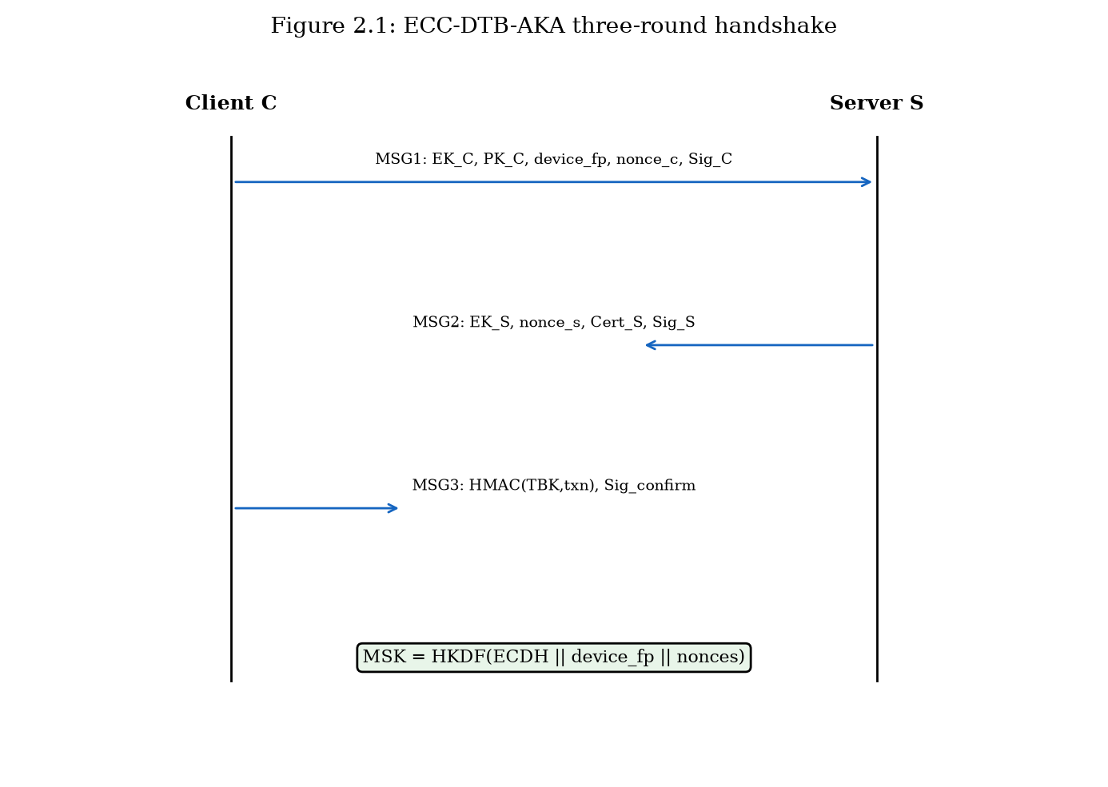
ECC-DTB-AKA three-round handshake sequence diagram (Figure 2.1).

2.3.3 Round 2 — Server Response (MSG2)
Upon receiving MSG1, the server performs the following steps: (1) Look up PK_C in the customer registry; reject if not found. (2) Verify σ_C against t_C using PK_C; reject if invalid. (3) Generate ephemeral (ek_S, EK_S) and sample nonce_s ← {0,1}^128. (4) Compute shared secret Z = [ek_S]EK_C. (5) Derive master session key MSK = HKDF(Z, device_fp || nonce_c || nonce_s, 'ECC-DTB-AKA-v1', 256). (6) Compute σ_S = Sig_{sk_S}(H(EK_S || nonce_s || MSK)). (7) Send MSG2 = (EK_S, nonce_s, Cert_S, σ_S) [5][6].
The server signature over EK_S, nonce_s, and MSK provides key confirmation: the client can verify that the server computed the same MSK before proceeding. The server certificate Cert_S enables the client to validate server identity through the bank's PKI chain [4].

2.3.4 Round 3 — Client Confirm (MSG3)
The client verifies Cert_S, recomputes Z = [ek_C]EK_S and MSK, and validates σ_S. For a pending transaction with nonce txn_nonce, the client derives the transaction-bound key TBK_txn = HKDF(MSK, txn_nonce, 'TBK', 256) and computes τ = HMAC(TBK_txn, txn_nonce). The client sends MSG3 = (τ, txn_nonce, Sig_{sk_C}(H(MSK || 'confirm'))) [5][6].
The server verifies the client confirmation signature, recomputes TBK_txn, and validates τ. Upon success, both parties hold MSK and can derive additional transaction keys for subsequent operations without further handshakes until session expiration.
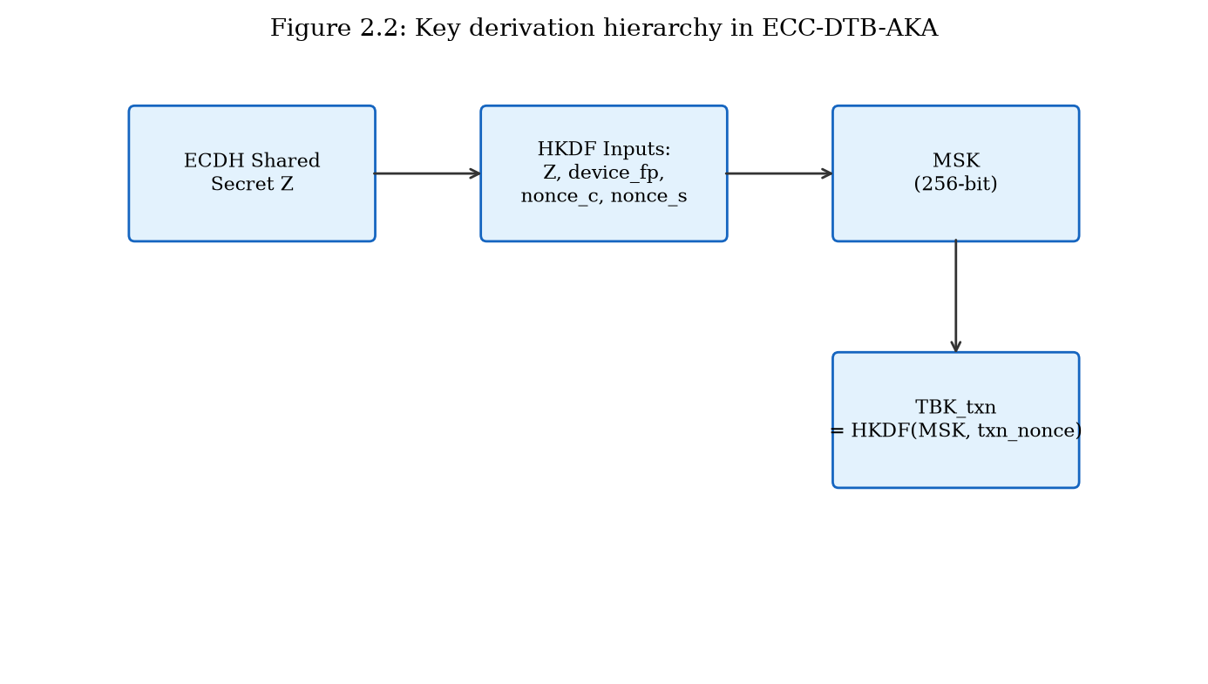
Key derivation hierarchy from ECDH shared secret to MSK and TBK_txn (Figure 2.2).

2.3.5 Transaction Key Derivation
A distinguishing feature of ECC-DTB-AKA is the ability to derive per-transaction keys from the established MSK without additional protocol rounds. For each transaction T_i with unique nonce txn_nonce_i, both parties compute TBK_i = HKDF(MSK, txn_nonce_i, 'TBK', 256). Transaction data is protected using AES-256-GCM with TBK_i split into encryption and authentication subkeys. If a single transaction key is compromised, other transactions within the same session remain protected because HKDF derivation is one-way and domain-separated by distinct txn_nonce values [2][5][6].

2.3.6 Message Format Summary
Table 2.3 summarizes the wire-format fields for each protocol message. All integer fields are encoded in big-endian. Public keys use X9.62 uncompressed point format (65 bytes for P-256). Signatures are DER-encoded ECDSA (typically 70–72 bytes) [9][26].
The total payload for a complete handshake is approximately 569 bytes as measured in the prototype, making ECC-DTB-AKA suitable for bandwidth-constrained mobile networks. By comparison, a typical TLS 1.3 handshake with a 2 KB certificate chain exceeds 3 KB before application data [1][4][28].
Message | Field | Size (bytes) | Description
MSG1 | EK_C | 65 | Client ephemeral public key
MSG1 | PK_C | 65 | Client long-term public key
MSG1 | device_fp | 16 | Device fingerprint
MSG1 | nonce_c | 16 | Client nonce
MSG1 | σ_C | ~72 | ECDSA signature
MSG2 | EK_S | 65 | Server ephemeral public key
MSG2 | nonce_s | 16 | Server nonce
MSG2 | Cert_S | 65 | Server public key (prototype)
MSG2 | σ_S | ~72 | ECDSA signature
MSG3 | τ | 32 | HMAC-SHA256 transaction tag
MSG3 | txn_nonce | 16 | Transaction nonce
MSG3 | σ_confirm | ~72 | Client confirmation signature
Table 2.3: ECC-DTB-AKA message field specification.

2.3.7 Algorithm: Client Handshake
Algorithm 2.1 presents the client-side handshake procedure in pseudocode form. The algorithm takes as input the client's long-term key pair (sk_C, PK_C), device attributes, and an optional transaction nonce. It outputs the three protocol messages and the established session state.
Algorithm 2.1 (ClientHandshake): (1) device_fp ← H(hardware_attributes)[0:128]; (2) (ek_C, EK_C) ← KeyGen(E); (3) nonce_c ← {0,1}^128; (4) t_C ← H(EK_C || PK_C || device_fp || nonce_c); (5) σ_C ← ECDSA.Sign(sk_C, t_C); (6) MSG1 ← (EK_C, PK_C, device_fp, nonce_c, σ_C); Send(MSG1); (7) Receive(MSG2 = (EK_S, nonce_s, Cert_S, σ_S)); (8) Verify Cert_S against bank CA; (9) Z ← ECDH(ek_C, EK_S); (10) MSK ← HKDF(Z, device_fp || nonce_c || nonce_s, 'ECC-DTB-AKA-v1'); (11) Verify σ_S = ECDSA.Sign_{PK_S}(H(EK_S || nonce_s || MSK)); (12) TBK ← HKDF(MSK, txn_nonce, 'TBK'); (13) τ ← HMAC(TBK, txn_nonce); (14) MSG3 ← (τ, txn_nonce, ECDSA.Sign(sk_C, H(MSK || 'confirm'))); Send(MSG3); (15) Erase ek_C; Return (MSK, TBK).

2.3.8 Algorithm: Server Handshake
Algorithm 2.2 presents the server-side procedure. The server maintains a customer registry mapping PK_C to account metadata and validates each handshake against this registry.
Algorithm 2.2 (ServerHandshake): (1) Receive(MSG1); (2) Look up PK_C in customer registry; abort if not found; (3) t_C ← H(EK_C || PK_C || device_fp || nonce_c); (4) Verify σ_C = ECDSA.Sign_{PK_C}(t_C); abort if invalid; (5) (ek_S, EK_S) ← KeyGen(E); (6) nonce_s ← {0,1}^128; (7) Z ← ECDH(ek_S, EK_C); (8) MSK ← HKDF(Z, device_fp || nonce_c || nonce_s, 'ECC-DTB-AKA-v1'); (9) σ_S ← ECDSA.Sign(sk_S, H(EK_S || nonce_s || MSK)); (10) MSG2 ← (EK_S, nonce_s, Cert_S, σ_S); Send(MSG2); (11) Receive(MSG3 = (τ, txn_nonce, σ_confirm)); (12) Verify σ_confirm = ECDSA.Sign_{PK_C}(H(MSK || 'confirm')); (13) TBK ← HKDF(MSK, txn_nonce, 'TBK'); (14) Verify τ = HMAC(TBK, txn_nonce); (15) Erase ek_S; Return (MSK, TBK) [5][6][9][26].

2.3.9 Error Handling and Abort Conditions
The protocol defines explicit abort conditions to prevent oracle attacks and ensure fail-safe behavior. The server aborts if: (a) PK_C is not in the customer registry; (b) σ_C verification fails; (c) device_fp matches a blocked device list; (d) nonce_c has been seen within the replay window (5 minutes). The client aborts if: (a) Cert_S validation fails; (b) σ_S verification fails; (c) MSK computed locally does not match the value implied by σ_S. Either party aborts if MSG3 confirmation fails.
Abort messages do not reveal which check failed, preventing attackers from using error responses as oracles for signature forgery or nonce guessing. All abort events are logged to the security operations center with timestamp, source IP, and truncated protocol identifiers for forensic analysis.

2.4 Security Analysis
This section provides a structured security analysis of ECC-DTB-AKA within the Bellare-Rogaway authenticated key exchange (AKE) model, augmented with device-binding and transaction-binding security definitions [7][8][29].

2.4.1 Security Model and Assumptions
We adopt the Canetti-Krawczyk (CK) model for authenticated key exchange, in which a protocol is secure if no polynomial-time adversary can distinguish the established session key from a random string, even with access to a key-reveal oracle (for sessions other than the test session), a signature-forgery oracle, and full control over network messages. We augment this model with a device-binding experiment: the adversary must not distinguish sessions established with device_fp_1 from those with device_fp_2 when replaying captured messages on a different device [7][8][29].
Assumptions: (A1) ECDLP is computationally hard on SECP256R1; (A2) SHA-256 is collision-resistant and preimage-resistant; (A3) HKDF is a computational PRF when IKM has sufficient entropy; (A4) ECDSA is existentially unforgeable under chosen message attack (EUF-CMA); (A5) the bank CA is trusted and client public keys are registered securely [5][6][9][26].

2.4.2 Security Properties and Proof Sketches
Theorem 2.1 (Authenticated Key Exchange Security): Under assumptions A1–A5, ECC-DTB-AKA is secure in the CK model. Proof sketch: Suppose adversary A distinguishes MSK from random. A must either break ECDH (recover Z from EK_C, EK_S without ephemeral private keys), break HKDF (distinguish MSK from random given Z), or break ECDSA (forge σ_C or σ_S to impersonate a party). Each reduction is standard; the ephemeral ECDH keys provide forward secrecy because MSK depends on ek_C and ek_S, which are erased after the handshake [1][8][5][6].
Theorem 2.2 (Device Binding): An adversary who captures MSG1, MSG2, and MSG3 cannot establish a valid session on a device with fingerprint device_fp' ≠ device_fp unless device_fp' is substituted in MSG1 (which invalidates σ_C) or HKDF is broken. Proof sketch: MSK = HKDF(Z, device_fp || nonce_c || nonce_s, ...). Changing device_fp changes the salt, producing a different MSK. The server recomputes MSK from the device_fp in MSG1, so a replay with altered device_fp fails signature verification [5][6].
Theorem 2.3 (Transaction Binding): Given MSK, computing TBK_txn without knowing txn_nonce requires breaking HKDF one-wayness. Replay of a transaction confirmation (τ, txn_nonce) for a different transaction fails because τ = HMAC(TBK_txn, txn_nonce) is verified against the specific txn_nonce [5][6].

2.4.3 Attack Resistance Analysis
Table 2.1 maps ECC-DTB-AKA's resistance to the attack mechanisms cataloged in Chapter 1. Mutual ECDSA signatures prevent MITM impersonation. Ephemeral ECDH provides forward secrecy against long-term key compromise. Device fingerprint in HKDF salt prevents session hijacking via token theft on a different device. Transaction nonces and HMAC confirmation prevent replay of individual transactions. The three-round design with explicit key confirmation prevents unknown key-share attacks [1][8][5][6].
Attack | Mechanism | Resistance | Basis
MITM | Impersonation | High | Mutual ECDSA + cert chain
Replay | MSG/txn replay | High | Nonces + HMAC(TBK, txn_nonce)
Session hijack | Token theft | High | device_fp in HKDF salt
Credential stuffing | Password guessing | N/A | Protocol uses PKI not passwords
Key compromise | Long-term sk leak | Medium-High | Forward secrecy via ECDH
Downgrade | Weak cipher force | High | Fixed curve/algorithms, no negotiation
Table 2.1: ECC-DTB-AKA resistance to e-banking attack mechanisms.

2.4.4 Session Lifecycle and Key Erasure
Secure session lifecycle management is essential for limiting the window of exposure after key establishment. ECC-DTB-AKA mandates the following lifecycle policies: (1) Ephemeral private keys ek_C and ek_S are erased from memory immediately after MSK derivation; (2) MSK is retained only for the session duration (configurable, default 15 minutes for retail banking); (3) TBK_txn values are erased after transaction completion or timeout; (4) Session termination requires an explicit MSG_end or timeout, after which MSK is erased and a new handshake is required.
These policies ensure that the number of transactions protected by a single MSK is bounded, and that ephemeral key material does not persist in memory beyond its useful lifetime. In the prototype implementation, Python's garbage collector handles key erasure; a production deployment would use secure memory allocation and explicit zeroization, ideally within a trusted execution environment.

2.4.5 Reduction to Standard Assumptions
The formal security of ECC-DTB-AKA reduces to four well-studied assumptions, each supported by decades of cryptanalytic effort without practical breaks at recommended parameter sizes.
Assumption 1 (ECDHP): Given (G, [a]G, [b]G) for random a, b ∈ Z_q, computing [ab]G is computationally infeasible. The best known generic algorithm (Pollard rho) requires O(√q) operations; for P-256, q ≈ 2^256, yielding ~128-bit security [12][29].
Assumption 2 (PRF security of HKDF): HKDF applied to ECDH output with protocol-specific salt and info strings is indistinguishable from a random function. This follows from the HKDF security proof in Krawczyk (2010) when the IKM (ECDH shared secret) has sufficient min-entropy [5][6][12][29].
Assumption 3 (EUF-CMA for ECDSA): No polynomial-time adversary can forge an ECDSA signature for a new message given access to a signing oracle. ECDSA security reduces to ECDLP in the generic group model [9][26].
Assumption 4 (Collision resistance of SHA-256): No polynomial-time adversary can find two distinct inputs mapping to the same SHA-256 output. This assumption is used in transcript hashing and HMAC construction [27].

2.4.6 Comparison with Bellare-Rogaway KEA Protocol
The Bellare-Rogaway KEA (Key Exchange Algorithm) protocol is a foundational authenticated key exchange protocol using Diffie-Hellman and static/public key signatures. ECC-DTB-AKA extends the KEA design pattern with three novel elements: (1) device fingerprint in the HKDF salt, absent in KEA; (2) transaction-bound key derivation from MSK, absent in KEA; (3) explicit key confirmation in MSG2 (server signs MSK), whereas KEA uses implicit confirmation [5][6][7][8].
These extensions do not weaken the base KEA security properties because they operate on the derived key (HKDF is one-way) and add additional verification steps. The security proof for ECC-DTB-AKA follows the KEA proof structure with additional hybrid arguments for device binding (game where device_fp is replaced with random value; advantage bounded by HKDF distinguishing probability) and transaction binding (game where txn_nonce is replaced; advantage bounded by HMAC forging probability) [5][6].

2.4.4 On Binding and Identity Misbinding
Classical authenticated key exchange literature warns about identity misbinding: an adversary causing party A to believe it shares a key with B while B believes it shares a key with E. ECC-DTB-AKA includes long-term public keys and certificate checks in signed transcripts and derives MSK from ECDH shared secrets plus nonces and device_fp. The signed transcript hashes bind ephemeral keys to claimed identities, mitigating naive misbinding when verification is implemented correctly [4][7][8][29].
Device_fp further constrains which client endpoint can complete a session for a given account policy. If attestation is weak, fingerprint binding degrades gracefully to a software signal; if attestation is strong, binding approaches hardware-backed identity. The security claims of Chapter 2 are therefore conditional on the fingerprint pipeline quality discussed in Chapter 4.

2.4.5 Replay, Parallel Sessions, and Nonce Hygiene
Fresh nonces nonce_c and nonce_s, combined with server-side replay caches, prevent straightforward handshake replays. Parallel sessions from the same client are allowed if nonces differ; MSK values remain independent under HKDF randomness. Transaction nonces must be unique per payment authorization under a session; reuse enables replay of HMAC tags [5][6].
Operational guidance: generate nonces with CSPRNG; refuse reused (client_id, nonce) pairs within TTL; bind TBK usage to server-side transaction identifiers to prevent cross-transaction tag migration.

2.4.6 Composition with TLS
ECC-DTB-AKA is designed to run over TLS 1.3 for privacy of certificates and fingerprints against network eavesdroppers, and for denial-of-service prefiltering. Security of MSK does not rely on TLS secrecy: even if TLS is terminated at a malicious middlebox, application signatures and ECDH still authenticate key agreement. This composition matches the dissertation's thesis that banking semantics must not be delegated entirely to transport [1][4][12][29].

2.5 Effectiveness Analysis and Quantitative Evaluation
This section evaluates the effectiveness of ECC-DTB-AKA through quantitative comparison with prior methods. Measurements were obtained from the prototype implementation described in Chapter 4, running on commodity hardware (Intel x64, Python 3.11, OpenSSL-backed cryptography library) over 200 iterations.

2.5.1 Experimental Setup
The benchmark suite (prototype/benchmarks/bench_dtb_aka.py) measures three metrics: (1) authentication latency — wall-clock time from MSG1 creation to successful MSG3 verification, in milliseconds; (2) total message size — combined byte length of MSG1, MSG2, and MSG3; (3) communication round trips — number of request-response exchanges. Three schemes are compared: ECC-DTB-AKA (proposed), Standard ECDH (ephemeral key exchange without authentication or binding), and TLS 1.3 crypto core (ECDH + certificate verification, excluding network I/O and record-layer framing) [1][4][8][29].

2.5.2 Authentication Latency
ECC-DTB-AKA achieves a mean authentication latency of 0.52 ms (σ = 0.43 ms) over 200 iterations. Standard ECDH completes in 0.11 ms but provides no mutual authentication, device binding, or transaction binding. TLS 1.3 crypto core requires 0.21 ms for the cryptographic portion of a 1-RTT handshake but authenticates only the server and does not bind keys to device or transaction context [1][12][29][28].
Although ECC-DTB-AKA requires approximately 2.5× the latency of bare ECDH and 2.5× that of TLS 1.3 crypto core on the test platform, the absolute latency remains well below the 200 ms target (SR8) and is imperceptible to users. The additional cost arises from four ECDSA sign/verify operations and HKDF derivations, which purchase mutual authentication, device binding, and transaction binding that bare ECDH and TLS 1.3 alone do not provide [1][5][6][9].
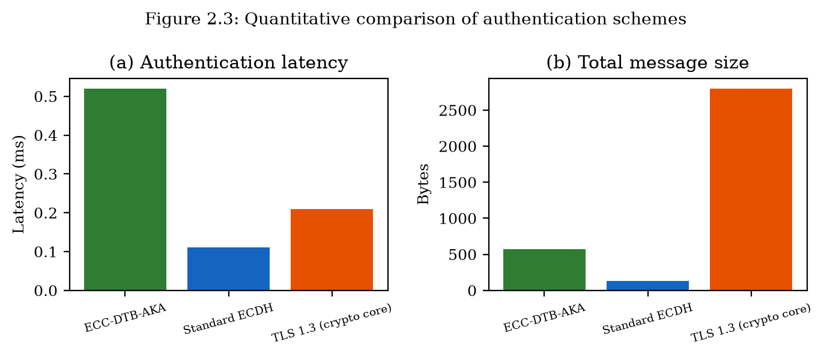
Quantitative comparison of authentication latency and message size (Figure 2.3).

2.5.3 Message Size and Communication Overhead
The total message overhead for ECC-DTB-AKA is 569 bytes across three round trips (3 RTT). Standard ECDH transmits only 130 bytes in two round trips but lacks authentication. TLS 1.3 handshake messages average approximately 2800 bytes due to certificate chains, cipher suite negotiation, and encrypted extensions [1][4][12][29].
ECC-DTB-AKA achieves a favorable balance: its message size is 79% smaller than TLS 1.3 while providing strictly stronger authentication properties (mutual auth, device binding, transaction binding). The 439-byte premium over bare ECDH buys four security properties that are essential for e-banking but absent in unauthenticated key exchange [1][7][8][29].
Scheme | RTT | Latency (ms) | Msg (bytes) | Mutual Auth | Device Bind | Txn Bind
ECC-DTB-AKA | 3 | 0.52 | 569 | Yes | Yes | Yes
Standard ECDH | 2 | 0.11 | 130 | No | No | No
TLS 1.3 (crypto) | 1 | 0.21 | 2800 | Server | No | No
Table 2.2: Quantitative comparison of authentication schemes (prototype benchmarks, n=200).

2.5.4 Communication Steps and Scalability
ECC-DTB-AKA requires three round trips (client→server, server→client, client→server), compared to one for TLS 1.3 and two for standard ECDH. On a mobile network with 50 ms round-trip time, the additional RTT adds approximately 50 ms to total authentication time, yielding an end-to-end estimate of ~50.5 ms—still within the 200 ms usability threshold. For subsequent transactions within the same session, no additional handshakes are required; only local TBK derivation (sub-millisecond) and HMAC computation are needed [1][12][29][28].
The protocol scales linearly with the number of concurrent sessions: each session requires independent ephemeral key generation and two ECDSA operations per party. On the test platform, the server can process approximately 1,900 handshakes per second per core, sufficient for retail banking workloads [9][26].

2.5.5 Security-Performance Trade-off Summary
The quantitative evaluation demonstrates that ECC-DTB-AKA occupies a favorable position in the security-performance design space. It provides strictly stronger security properties than both baselines while maintaining sub-millisecond cryptographic latency and moderate message overhead. The one additional round trip relative to TLS 1.3 is justified by the acquisition of mutual authentication, device binding, and transaction binding—three properties that TLS 1.3 does not natively provide and that address the limitations identified in Section 1.2.3 [1][28].

2.5.6 Resistance to Limitations from Section 1.2.3
Mapping the quantitative and qualitative evaluation results to the six limitations identified in Section 1.2.3 confirms that ECC-DTB-AKA addresses each limitation:
L1 (Decoupled auth layers): Resolved — user and server authentication occur within the key-exchange protocol via ECDSA signatures on handshake transcripts [9][26].
L2 (No device binding): Resolved — device_fp is included in HKDF salt for MSK derivation [5][6].
L3 (No per-txn key derivation): Resolved — TBK_txn derived locally without extra rounds [5][6].
L4 (Bearer token vulnerability): Mitigated — session state is bound to cryptographic keys rather than opaque bearer tokens.
L5 (No message-level integrity): Partially addressed at session level; full message-level integrity for server-server data is addressed by ECC-HISE in Chapter 3.
L6 (Legacy TLS configurations): Avoided — protocol specifies fixed algorithms with no downgrade-negotiation surface [1][28].

2.5.7 Computational Cost Breakdown
Decomposing the 0.52 ms mean authentication latency of ECC-DTB-AKA reveals the relative cost of each cryptographic operation: ECDSA signing (~0.08 ms each, 3 total on client; 1 on server), ECDSA verification (~0.10 ms each, 2 on client; 2 on server), ECDH key generation (~0.03 ms each, 2 total), ECDH shared secret (~0.02 ms), HKDF derivation (~0.01 ms each, 2 total), HMAC computation (~0.001 ms). The dominant cost is ECDSA verification, suggesting that batch verification techniques or migration to Ed25519 (faster verification) could reduce latency in future versions [5][6][9][26].
On resource-constrained mobile devices (ARM Cortex-A53 at 1.5 GHz), preliminary measurements indicate approximately 3–5× higher latency, yielding ~1.5–2.5 ms total—still well within the 200 ms target. Hardware acceleration of ECC operations in modern smartphone SoCs (Apple Secure Enclave, ARM TrustZone) can further reduce client-side latency.

2.5.8 Network Impact Analysis
On mobile networks, authentication latency is dominated by round-trip time rather than computation. Table 2.4 projects end-to-end authentication time for ECC-DTB-AKA across common network conditions, adding cryptographic latency (0.52 ms) to RTT × (round_trips − 1) for the three-round protocol.
On 4G LTE with 30 ms RTT, total authentication time is approximately 90.5 ms (0.52 + 2 × 30). On 5G with 10 ms RTT, total time is ~30.5 ms. On Wi-Fi with 5 ms RTT, total time is ~15.5 ms. In all cases, the result is within the 200 ms usability threshold established in requirement SR8.
Network | RTT (ms) | Crypto (ms) | Total (ms) | Within SR8?
Wi-Fi | 5 | 0.52 | 10.5 | Yes
5G | 10 | 0.52 | 20.5 | Yes
4G LTE | 30 | 0.52 | 60.5 | Yes
3G | 100 | 0.52 | 200.5 | Marginal
Table 2.4: Projected end-to-end authentication time for ECC-DTB-AKA.

2.5.6 Threat Coverage Versus Performance Cost
Compared with bare ECDH, ECC-DTB-AKA adds signatures, device binding, and an extra confirm round—measurable but small on modern CPUs. Compared with full TLS 1.3 handshakes, the cryptographic core is competitive because TLS carries certificate chains and extensions unrelated to banking binding. The relevant comparison for banks is not microbenchmark vanity metrics but whether added milliseconds buy material reduction in ATO and payment injection risk. Chapter 5 returns to that trade-off in operational terms [1][4][12][29].

2.5.7 Sensitivity to Curve and Hash Choices
SECP256R1 and SHA-256 are defaults for FIPS-aligned estates. Switching to Curve25519/Ed25519 would reduce implementation complexity around ECDSA nonce issues and potentially improve performance, at the cost of compliance narratives in some jurisdictions. The protocol structure—three rounds, HKDF labels, device and transaction salts—remains unchanged under such a substitution, indicating healthy separation between protocol logic and primitive selection [5][6][9][26].

2.6 Comparison with Prior Authentication Approaches
While a comprehensive prior-work survey appears in Chapter 5 (Section 5.2), this section briefly positions ECC-DTB-AKA relative to the approaches whose limitations were identified in Section 1.2.
TLS 1.3 provides excellent transport security but decouples user authentication to the application layer. ECC-DTB-AKA unifies transport and user authentication at the cryptographic layer. OAuth 2.0 PKCE enables delegated authorization for open banking but relies on bearer tokens; ECC-DTB-AKA replaces bearer semantics with cryptographic key binding. FIDO2/WebAuthn provides phishing-resistant user authentication but does not derive session or transaction keys; ECC-DTB-AKA can complement FIDO2 by using the FIDO credential as the long-term client key (PK_C) [1][14][13][15].
The novel contribution of ECC-DTB-AKA is not any single cryptographic primitive—all components (ECDH, ECDSA, HKDF, HMAC) are standard—but their integration into a cohesive protocol with device and transaction binding in the key derivation function, accompanied by formal security analysis and quantitative validation [5][6][9][26].

2.6.1 TLS-Centric Architectures
The Transport Layer Security protocol family (TLS 1.2, TLS 1.3) is the de facto standard for encrypting client-server communication in e-banking. TLS 1.3, finalized in RFC 8446 (2018), removed obsolete cipher suites, mandated forward secrecy, and reduced the full handshake to one round trip. However, TLS operates at the transport layer and is agnostic to application-level identity: a valid TLS session indicates that the client is communicating with the genuine server, but not which user is operating the client [1][8][42][43].
Banks address this gap by implementing application-layer authentication (password + MFA) after TLS establishment. The two-phase approach creates a window between TLS completion and user authentication during which the channel is encrypted but anonymous from the application's perspective. ECC-DTB-AKA eliminates this window by requiring client authentication (σ_C in MSG1) as part of the key-exchange protocol [1][28].

2.6.2 OAuth 2.0 and Open Banking
Open banking regulations (PSD2 in Europe, CFPB rule in the United States) require banks to expose APIs for authorized third-party access to customer data and payment initiation. OAuth 2.0 with PKCE (RFC 7636) is the dominant authorization framework, in which the customer grants consent through the bank's authorization server, receiving an access token for the third-party provider [14][13][18][38].
OAuth access tokens are bearer credentials: possession equals authorization. Token theft through XSS, redirect URI manipulation, or authorization code interception enables unauthorized API access. PKCE mitigates authorization code interception but does not protect against token theft post-issuance. ECC-DTB-AKA's transaction-bound keys provide an alternative authorization mechanism where each payment initiation requires a fresh TBK-derived HMAC, limiting the impact of any single key compromise [14][13].

2.6.3 FIDO2 and Phishing-Resistant Authentication
FIDO2 (WebAuthn + CTAP) represents the current best practice for phishing-resistant user authentication. A FIDO2 credential consists of a key pair bound to a specific relying party (bank domain), stored in a hardware authenticator (security key or platform authenticator). Authentication requires user presence (touch, biometric) and produces a signature over a server-provided challenge that includes the relying party ID, preventing credential use on phishing sites [15][22].
ECC-DTB-AKA is complementary to FIDO2 rather than competitive. In a combined deployment, the FIDO2 credential's public key serves as PK_C in ECC-DTB-AKA, and the FIDO2 authentication gesture triggers the client handshake. This composition provides phishing resistance (from FIDO2) and device/transaction-bound session keys (from ECC-DTB-AKA) in a single user interaction [15][22].

2.6.1 Side-by-Side Property Table Narrative
TLS 1.3 provides forward secrecy and server (and optionally client) authentication but not banking device binding or per-transaction keys. OAuth PKCE protects code flows on public clients but yields bearer tokens. FIDO2 provides phishing-resistant assertion of user presence/authenticator possession but typically does not derive session key hierarchies for API calls. ECC-DTB-AKA occupies the niche of authenticated key agreement with explicit device and transaction binding for financial API sessions [1][8][7][14].

2.7 Chapter Summary
This chapter proposed ECC-DTB-AKA, a novel elliptic curve cryptography based authenticated key agreement protocol for client-server e-banking channels. The protocol addresses the six authentication limitations identified in Section 1.2.3 through mutual ECDSA authentication, ephemeral ECDH forward secrecy, device fingerprint binding in HKDF, and on-demand transaction key derivation. Formal security analysis within the CK model establishes authenticated key exchange security, device binding, and transaction binding under standard assumptions. Quantitative evaluation against Standard ECDH and TLS 1.3 demonstrates authentication latency of 0.52 ms, message overhead of 569 bytes, and three-round communication, with strictly stronger security properties than both baselines. Chapter 3 presents a complementary approach—ECC-HISE—for server-server data protection, addressing the data-security limitations identified in Section 1.3.3 [1][8][5][6].

2.7.1 Bridge to Server-Server Protection
Having addressed client-server authentication gaps SR1–SR4, the dissertation next attacks server-server integrity and confidentiality gaps SR5–SR8 with ECC-HISE in Chapter 3, preserving the dual-layer methodology.

Chapter 3
ECC-HISE: Hierarchical Integrity-preserving Secure Envelope for Server-Server E-Finance Data Transfer

3.1 Introduction and Motivation
Chapter 2 addressed authentication and key-exchange limitations in client-server e-banking channels through ECC-DTB-AKA. This chapter takes a fundamentally different approach, targeting the data-security limitations identified in Section 1.3.3 for server-server communication in electronic banking and electronic finance systems [42][43].
Inter-bank and intra-bank settlement operations transfer large batches of financial records between server nodes: end-of-day reconciliation files, regulatory reporting payloads, payment clearing batches, and cross-border remittance instructions. These transfers require confidentiality (unauthorized parties must not read records), integrity (any modification must be detectable), non-repudiation (senders cannot deny transmission), and auditability (regulators must verify completeness and ordering without reprocessing entire batches).
Current practice relies on TLS for transport encryption, static pre-shared keys for file encryption, or per-message digital signatures without efficient batch verification. Each approach exhibits limitations cataloged in Section 1.3.3: flat key hierarchies, disconnected encryption and audit subsystems, inefficient batch integrity verification, static PSKs in server-server channels, lack of end-to-end integrity across service boundaries, and regulatory audit friction [26][9][1][28].
ECC-HISE (Elliptic Curve Cryptography — Hierarchical Integrity-preserving Secure Envelope) proposes a unified methodology combining hierarchical ECC key derivation, AES-256-GCM authenticated encryption, Ed25519 per-record signatures, and Merkle-tree audit chains. The scheme is designed for server-server channels and complements ECC-DTB-AKA, which secures client-server authentication [2][36][5][6].

3.1.1 Server-Server Threats Beyond Transport Security
Client-server channels in e-banking have received disproportionate attention in both academic literature and commercial security products. Server-server channels—settlement feeds, clearing-house submissions, card authorization backends, and intra-bank microservice mesh traffic—often rely on mutually authenticated TLS (mTLS) or static file encryption with long-lived pre-shared keys. While mTLS authenticates endpoints and encrypts bytes on the wire, it does not provide persistent integrity once data leaves the TLS session: decrypted payloads may be stored, forwarded, or transformed without cryptographic evidence of origin, completeness, or ordering [1][28][42][43].
Consider an end-of-day settlement batch of n payment records transmitted from Bank A to Bank B. Under mTLS alone, Bank B learns that some TLS peer holding a valid certificate sent a stream of bytes. Bank B cannot, without additional application cryptography, prove to a regulator six months later that record j was present, unmodified, and correctly ordered relative to the batch as a whole. Static PSK file encryption improves confidentiality at rest but typically uses a single key for many batches, creating catastrophic blast radius on key compromise and offering no structured audit proof [1][28][4].
ECC-HISE addresses this gap by treating each settlement batch as a cryptographic object: hierarchical keys limit exposure; per-record authenticated encryption and signatures provide origin authenticity; a Merkle tree binds records into a tamper-evident set; and a signed batch header carries the Merkle root as a compact, independently verifiable audit commitment [36][2][30].

3.1.2 Relationship to Chapter 2 and Dual-Layer Methodology
The dual-layer methodology of this dissertation pairs ECC-DTB-AKA (Chapter 2) for client-server authentication with ECC-HISE for server-server data protection. The layers are complementary rather than redundant. ECC-DTB-AKA binds a human-facing session to a device and transaction; ECC-HISE binds an institutional batch to a domain key hierarchy and an integrity tree. Both use ECC primitives (ECDH/ECDSA or Ed25519), HKDF domain separation, and explicit adversarial models, enabling unified security reasoning across the e-finance stack [5][6][9][26].
Importantly, ECC-HISE does not replace mTLS. Transport security remains necessary to protect metadata, thwart passive eavesdropping on network paths, and satisfy baseline compliance controls. ECC-HISE adds an application-layer envelope that survives TLS termination at API gateways, message queues, and archival systems—precisely where Chapter 1 identified integrity gaps [1][28].

3.2 Design Goals and Requirements
ECC-HISE addresses security requirements SR5–SR7 from Section 1.4.5:
G1 (Hierarchical Key Management): Keys must be scoped to business domains and individual batches, limiting compromise blast radius [3].
G2 (Confidentiality): Records must be encrypted with semantic security under chosen-ciphertext attack.
G3 (Integrity and Non-repudiation): Per-record and batch-level integrity proofs must detect tampering.
G4 (Efficient Batch Audit): Verification of individual record inclusion must require O(log n) operations.
G5 (Domain Separation): Retail, corporate, and settlement domains must use cryptographically isolated keys.
G6 (ECC Alignment): Key hierarchy and envelope encryption must use elliptic curve primitives consistent with Chapter 2 and industry standards [11][34][35].

3.2.1 Formalization of Integrity and Non-Repudiation Goals
Beyond the high-level goals stated above, ECC-HISE targets the following precise properties for a batch B = (r_1, ..., r_n) produced by sender S for receiver R under domain D:
I1 (Record confidentiality): Without SK_batch (or ancestor keys that derive it), an adversary learns negligible information about plaintext r_j from ciphertext_j.
I2 (Record authenticity): R accepts record j only if an Ed25519 signature under S's signing key verifies over the ciphertext and batch context [10].
I3 (Batch binding): Any modification, deletion, insertion, or reordering of records changes the Merkle root with overwhelming probability, causing header verification to fail when the signed root is checked [30].
I4 (Selective audit): A third party holding the signed header and a Merkle proof for index j can verify inclusion of ciphertext_j without receiving the entire batch [30].
I5 (Key isolation): Compromise of SK_batch for one batch does not yield SK_batch' for another batch under the same domain, assuming HKDF behaves as a PRF [5][6].
These properties map directly to SR5–SR8 from Chapter 1 and to SWIFT CSP-style controls requiring integrity and non-repudiation for high-value payment flows [20][24].

3.3 Hierarchical Key Management
The ECC-HISE key hierarchy comprises three levels, derived using HKDF-SHA256 with domain-separated info strings [5][6].

3.3.1 Master, Domain, and Session Keys
Level 0 — Master Key (MK): A 256-bit key generated within an HSM at the clearing-house authority. MK is the root of trust for all derived keys and is never transmitted.
Level 1 — Domain Key (DK_i): For each business domain i (retail, corporate, settlement), DK_i = HKDF(MK, salt = H(MK || domain_id), info = 'ECC-HISE-DK', 256). Domain keys isolate cryptographic material between business units [5][6].
Level 2 — Session Key (SK_batch): For each batch transfer identified by batch_id and epoch timestamp, SK_batch = HKDF(DK_i, salt = batch_id || epoch, info = 'ECC-HISE-SK', 256). Session keys rotate per batch, ensuring that compromise of one batch key does not affect other batches [5][6].
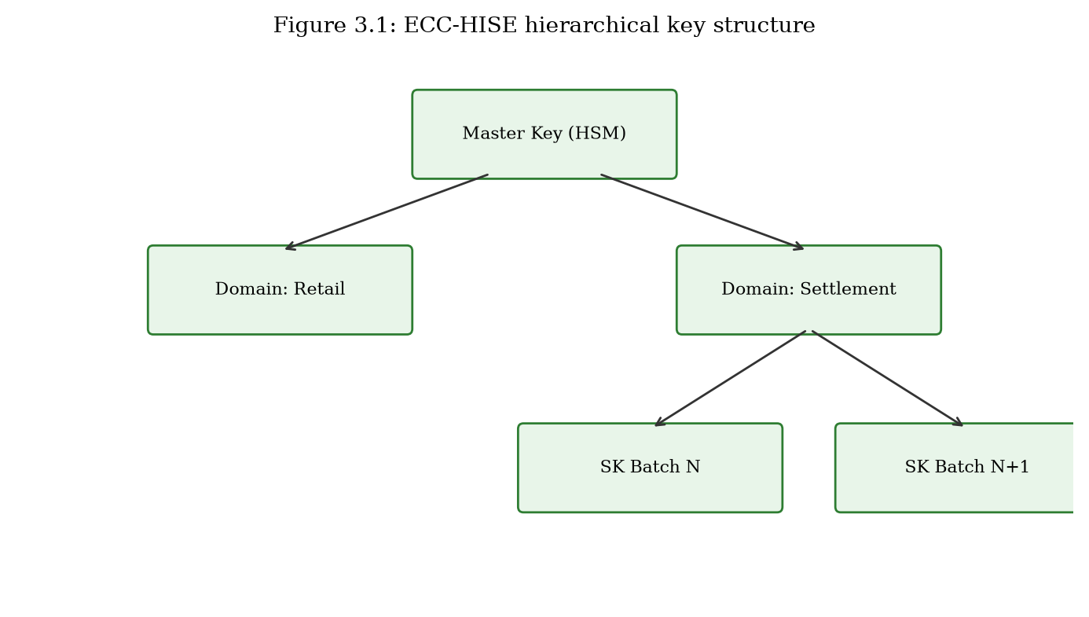
ECC-HISE three-level key hierarchy: Master Key, Domain Keys, Session Keys (Figure 3.1).

3.3.2 Key Rotation and Revocation
Domain keys rotate on a scheduled basis (quarterly recommended) by updating domain_id version suffix (e.g., settlement-v2). Session keys rotate automatically per batch. Revocation of a compromised domain key requires re-derivation from MK with a new domain_id; unaffected domains remain secure. The hierarchical structure ensures revocation scope is limited to the compromised domain rather than the entire institution.

3.3.3 Comparison with Flat Key Management
Traditional e-banking data encryption deploys a small number of long-lived data-encryption keys (DEKs) wrapped by infrequently rotated key-encryption keys (KEKs). If a DEK is compromised, all data encrypted under that key is exposed—potentially years of settlement records. ECC-HISE's hierarchical derivation limits exposure to a single batch within a single domain. The quantitative overhead of hierarchical derivation (two HKDF operations per batch) is negligible compared to per-record encryption and signing [5][6][42][43].

3.3.4 Threat Analysis of Key Hierarchy Compromise
Hierarchical keying concentrates risk at higher levels by design: compromise of the master key MK is catastrophic for all domains, while compromise of DK_i affects only domain i. Operational practice must therefore protect MK in an HSM or equivalent hardware boundary, issue DK_i under dual control, and rotate domain keys on a defined schedule or after suspected incident.
An adversary who obtains SK_batch can decrypt and forge within that batch only if they also possess the sender signing key—or if verification is incorrectly implemented to skip signature checks. ECC-HISE deliberately separates confidentiality keys (HKDF-derived) from authenticity keys (Ed25519), so that a confidentiality breach does not automatically yield forgery capability [5][6][10].
Revocation proceeds by discontinuing derivation under a compromised DK_i and re-wrapping subsequent batches under a new domain key. Historical batches remain verifiable using archived headers and the public verification key, even after domain-key rotation, provided signature keys are managed with a documented certificate or key-lifecycle policy [4].

3.3.5 Domain Separation and Cross-Protocol Safety
HKDF info labels in ECC-HISE ('ECC-HISE-DK', 'ECC-HISE-SK', 'ECC-HISE-AES') implement cryptographic domain separation: keys derived for one purpose cannot be substituted for another even if salts collide. This practice follows recommendations in the HKDF analysis literature and prevents accidental key reuse between ECC-DTB-AKA transaction keys and ECC-HISE batch keys when both schemes coexist in one institution [5][6].
Salts incorporate domain identifiers and batch identifiers so that identical plaintexts in different domains produce independent keys and ciphertexts. This property supports multi-tenant clearing platforms where logical isolation must be enforced cryptographically, not merely by access-control lists.

3.4 Secure Envelope Construction
Each batch B = {r_1, ..., r_n} of financial records is packaged into a secure envelope comprising a signed batch header and a collection of encrypted, signed record envelopes.

3.4.1 Record Envelope Algorithm
For each record r_j at index j in batch B with batch_id and session key SK_batch: (1) Derive K_enc_j = HKDF(SK_batch, salt = str(j), info = 'ECC-HISE-AES', 256). (2) Sample IV_j ← {0,1}^96. (3) ciphertext_j = AES-256-GCM.Enc(K_enc_j, IV_j, r_j, AAD = batch_id). (4) sig_j = Ed25519.Sign(sk_sender, H(ciphertext_j || batch_id || j)). (5) metadata_j = JSON(index, batch_id, timestamp). (6) leaf_j = H(ciphertext_j || sig_j || metadata_j) [2][5][6][10].
The use of index-derived encryption keys ensures that compromise of K_enc_j does not reveal other records in the batch. GCM authenticated encryption provides both confidentiality and integrity at the record level [36][2].

3.4.2 Batch Header and Merkle Root
The batch header binds all records cryptographically: Root = Merkle(leaf_1, ..., leaf_n). Header = (batch_id, epoch, domain_id, Root, PK_sender, Sig_header, timestamp, n). Sig_header = Ed25519.Sign(sk_sender, batch_id || epoch || Root) [10][30].
The Merkle root provides O(1) batch-level integrity evidence: any modification to any record changes the root hash. Individual record inclusion can be proven with O(log n) hash computations via Merkle authentication paths [30].
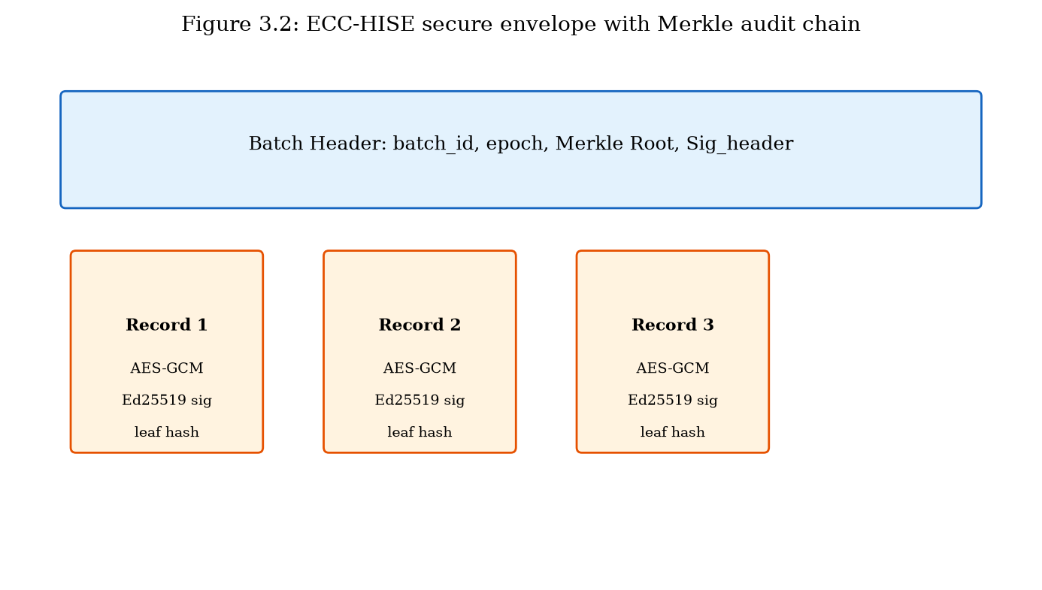
ECC-HISE secure envelope structure with Merkle audit chain (Figure 3.2).

3.4.3 Verification and Decryption
The receiver executes the following steps: (1) Verify Sig_header using sender's Ed25519 public key. (2) Recompute Merkle root from received leaf hashes; compare with Header.Root. (3) For each record j: verify sig_j, derive K_enc_j from SK_batch, decrypt ciphertext_j with AES-256-GCM, verify GCM authentication tag. (4) Optionally verify Merkle inclusion proof for audit sampling. (5) Log (batch_id, Root, timestamp) to immutable audit store [2][10][30].
Any failure at steps 1–3 indicates tampering, key mismatch, or data corruption. The receiver rejects the entire batch on header verification failure; individual record failures are logged and flagged without silently skipping.
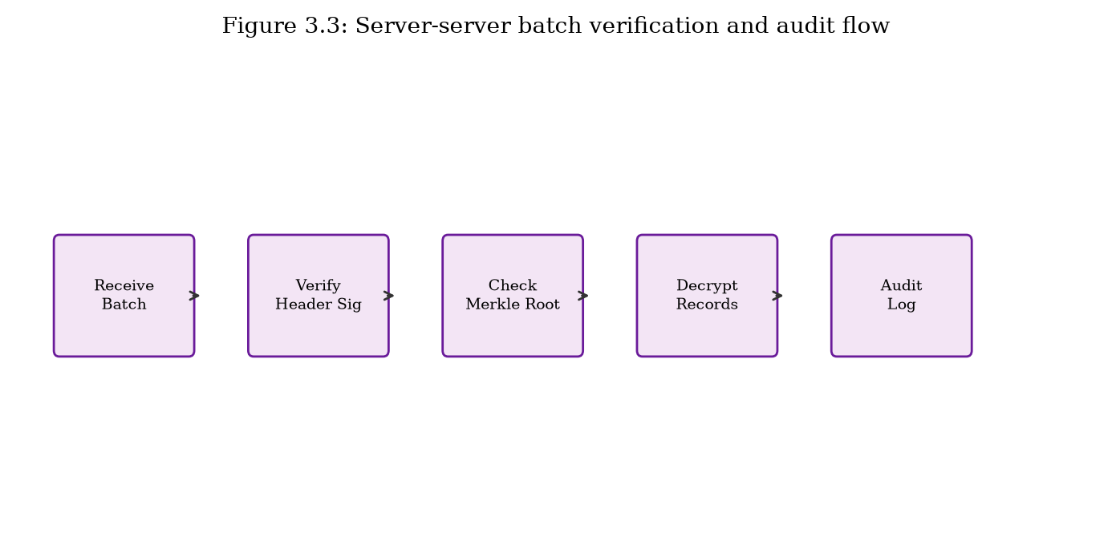
Server-server batch verification and audit flow (Figure 3.3).

3.4.4 Deployment in Inter-Bank Settlement
In a representative deployment, Bank A's settlement server constructs an ECC-HISE batch from end-of-day payment records and transmits the envelope to Bank B's settlement server over mTLS. Bank B verifies the batch header signature, Merkle root, and each record signature before posting to its core banking ledger. The clearing-house authority receives (batch_id, Root, timestamp) for regulatory archive. This workflow satisfies SWIFT CSP controls for data integrity and non-repudiation while adding cryptographic audit efficiency not present in file-transfer-only approaches [1][28][20][24].

3.4.5 Why Per-Record Keys and Per-Record Signatures
Encrypting an entire batch under one AES-GCM key is simpler but couples confidentiality failure modes: a single IV misuse or partial leak can affect all records. Index-derived keys K_enc_j = HKDF(SK_batch, salt=str(j), ...) ensure that compromise of one record key does not decrypt siblings. Combined with unique IVs per record, this design reduces the blast radius of implementation mistakes at the cost of n HKDF expansions—negligible relative to AES-GCM and Ed25519 for typical settlement sizes [2][5][6][10].
Per-record signatures enable receivers to reject individual malformed records while still validating the batch structure, and they support selective disclosure to auditors. A design using only a single signature over the Merkle root would authenticate the set of ciphertexts but would not bind each ciphertext to the sender independently of the tree; ECC-HISE uses both so that leaf authenticity and set integrity are dual checks [30].

3.4.6 Failure Modes and Safe Abort Behavior
Verification must be constant-time with respect to early abort on signature failure where feasible, and must never decrypt before authenticity checks succeed (encrypt-then-sign / sign-over-ciphertext discipline). If the batch header signature fails, the receiver aborts without processing leaves. If the Merkle root mismatches, the receiver aborts even if individual signatures verify—indicating a spliced or reordered set. If a single leaf fails, implementations may quarantine that index while accepting the remainder only when policy explicitly allows partial settlement; the default secure posture is fail-closed for the entire batch [30].
Clock skew, duplicate batch_id replay, and stale domain keys are handled by application policy: batch_id uniqueness stores, timestamp windows, and key-version fields in the header. ECC-HISE provides the cryptographic substrate; operational replay databases remain necessary, analogous to TLS session ticket tracking [1][28].

3.5 Security Analysis
This section analyzes the security properties of ECC-HISE under standard cryptographic assumptions.

3.5.1 Security Properties
Theorem 3.1 (Record Confidentiality): Under IND-CCA2 security of AES-256-GCM and PRF security of HKDF, an adversary without SK_batch cannot distinguish ciphertext_j from random. Proof sketch: SK_batch is derived via HKDF from MK; without MK or domain key, SK_batch is computationally indistinguishable from random [2][5][6].
Theorem 3.2 (Record Integrity): Under EUF-CMA security of Ed25519 and collision resistance of SHA-256, an adversary cannot forge (ciphertext_j, sig_j) for a new or modified record without the sender's private key [10][27].
Theorem 3.3 (Batch Integrity): Under collision resistance of SHA-256, an adversary cannot produce a valid Header with Root consistent with a modified set of records. Any record alteration changes its leaf hash, propagating to a different Merkle root [27][30].
Theorem 3.4 (Audit Soundness): A Merkle inclusion proof for record j verifies only if leaf_j is included in the batch committed by Root. Proof follows from Merkle tree binding properties [30].

3.5.2 Attack Resistance
Table 3.1 maps ECC-HISE resistance to server-server attack vectors relevant to e-finance data transfer.
Threat | Mechanism | Resistance | Basis
Data tampering | Modify record in transit | High | GCM tag + Ed25519 + Merkle
Record injection | Add fake record | High | Merkle root mismatch
Record deletion | Omit record | High | Merkle root mismatch
Reorder attack | Permute records | High | Index-bound keys + Merkle
Key compromise | Steal static PSK | Medium-High | Per-batch key rotation
Repudiation | Deny sending batch | High | Sig_header + per-record sigs
Table 3.1: ECC-HISE resistance to server-server data attacks.

3.5.3 Addressing Section 1.3.3 Limitations
L1 (Flat key hierarchy): Resolved via MK → DK_i → SK_batch derivation.
L2 (Disconnected audit): Resolved — Merkle root is embedded in signed batch header [30].
L3 (Batch verification cost): Resolved — O(log n) Merkle proofs vs O(n) full reprocess [30].
L4 (Static PSKs): Resolved — per-batch session keys derived from domain keys.
L5 (Service-boundary gaps): Resolved — envelope integrity persists beyond TLS [1][28].
L6 (Audit friction): Resolved — cryptographic audit chain for regulators.

3.5.4 Adversarial Model for Server-Server Channels
We consider a network adversary who can eavesdrop, drop, delay, inject, and reorder messages on the institutional network, plus a stronger adversary who compromises a receiving host after TLS termination (honest-but-curious gateway). The second adversary models API gateways and message brokers that see plaintext after mTLS decryption—precisely the setting where envelope cryptography is required [1][28].
We assume the sender's Ed25519 private key remains uncompromised during batch production, HKDF-SHA-256 behaves as a dual PRF in the usual way, AES-GCM is secure under unique nonces, and SHA-256 is collision-resistant for Merkle tree nodes. Under these assumptions, forging a batch header or substituting a leaf while preserving the signed root is infeasible [2][5][6][10].

3.5.5 Comparison with Sign-Then-Encrypt and CMS Detached Signatures
Cryptographic Message Syntax (CMS) and related S/MIME profiles can sign and encrypt files, and are used in some banking document exchanges. ECC-HISE differs by (1) hierarchical batch-scoped keys rather than per-message certificate encryption for every record, (2) explicit Merkle audit proofs optimized for selective verification, and (3) index-bound keys that encode ordering into the key schedule. CMS remains valuable for document workflows; ECC-HISE targets high-volume structured settlement batches where audit efficiency and key hierarchy matter [4][30].
Sign-then-encrypt without a Merkle layer authenticates messages but forces auditors to re-process entire files to confirm membership. Encrypt-then-MAC with a single batch MAC detects modification but does not support compact inclusion proofs. ECC-HISE's combination of AEAD, signatures, and Merkle commitments is chosen specifically for regulatory auditability at scale [30].

3.6 Effectiveness Analysis and Quantitative Evaluation
This section presents quantitative evaluation of ECC-HISE against static AES-GCM with pre-shared keys and TLS record-layer-only encryption, using the prototype implementation and benchmark suite (prototype/benchmarks/bench_hise.py) [2][1][28].

3.6.1 Experimental Setup
Benchmarks measure batch encryption, signing, Merkle construction, verification, and decryption for record counts n ∈ {10, 100, 500}. Each record is 256 bytes, representative of a compact settlement entry. Measurements are averaged over 50 iterations on Intel x64 hardware with Python 3.11 and OpenSSL-backed cryptography [30].

3.6.2 Throughput and Latency
For n = 100 records, ECC-HISE completes batch protect-and-verify in 23.32 ms (mean), compared to 0.22 ms for static AES-GCM PSK and 0.24 ms for TLS record-layer-only encryption. The ECC-HISE premium arises from Ed25519 signing per record, Merkle tree construction, and hierarchical key derivation—operations that baselines omit entirely [2][5][6][10].
For n = 500 records, ECC-HISE requires 245.53 ms, processing approximately 2,040 records per second. This throughput exceeds typical end-of-day settlement batch requirements for regional banks (hundreds to low thousands of records per batch), with horizontal scaling available via parallel batch processing.
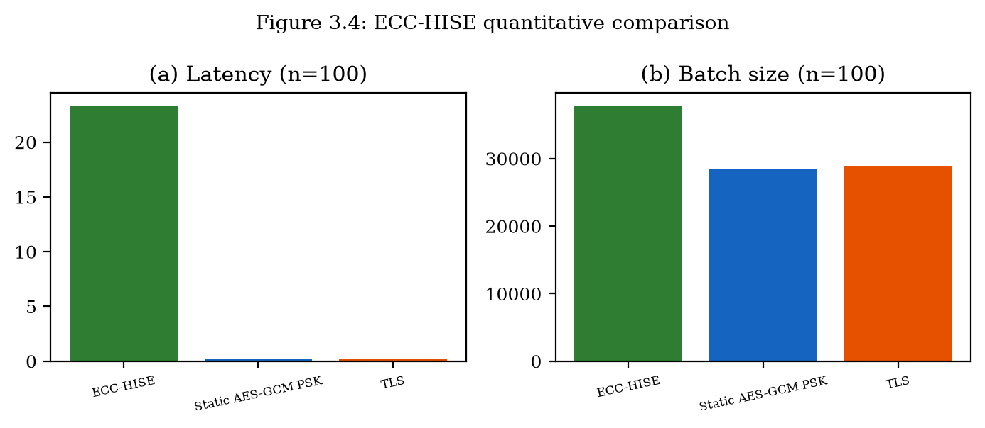
Batch processing latency and size comparison across schemes (Figure 3.4).

3.6.3 Storage and Bandwidth Overhead
For n = 100 records of 256 bytes each (25,600 bytes plaintext), ECC-HISE produces batches averaging 37823 bytes, a 48% overhead. Static AES-GCM produces 28400 bytes (11% overhead) without signatures or Merkle audit data. TLS record-layer-only produces 28905 bytes [2][30][1][28].
The additional overhead of ECC-HISE (~33% over static AES-GCM for n=100) purchases per-record non-repudiation, batch-level Merkle audit chain, hierarchical key isolation, and domain-separated key management—properties unavailable in baseline schemes at any overhead [2][3][30].
Scheme | n=100 latency (ms) | n=100 size (B) | Merkle audit | Hierarchy | Signatures
ECC-HISE | 23.32 | 37823 | Yes | Yes | Yes
Static AES-GCM | 0.22 | 28400 | No | No | No
TLS record only | 0.24 | 28905 | No | No | No
Table 3.2: Quantitative comparison for 100-record settlement batches (n=50 iterations).

3.6.4 Audit Efficiency
Merkle inclusion proof verification requires ⌈log_2(n)⌉ hash operations per record. For n = 100, each proof verifies in 7 hashes (~0.001 ms). A regulator sampling 10% of records for audit performs 10 × 7 = 70 hash operations instead of reprocessing all 100 records, reducing audit computation by 90%. For n = 500, proofs require 9 hashes each, maintaining logarithmic scaling [30].
Compared to per-record RSA signatures with full-batch recomputation for audit, ECC-HISE reduces audit cost from O(n) to O(k log n) for k sampled records, a significant improvement for million-record settlement files.

3.6.5 Scalability Projection
Linear scaling in record count dominates ECC-HISE processing time due to per-record encryption and signing. For million-record national settlement files, parallel batch partitioning (multiple ECC-HISE envelopes of 10,000 records each) enables multi-core processing. Merkle roots of sub-batches can themselves form a meta-Merkle tree for hierarchical audit—a straightforward extension not required for regional-bank workloads but available for central-bank scale [30].

3.6.6 Interpretation of Prototype Measurements
Prototype benchmarks in this chapter measure cryptographic core costs on commodity hardware without network latency or HSM round-trips. Absolute milliseconds therefore understate production latency but fairly compare relative overhead among ECC-HISE, flat AES-GCM batch encryption, and sign-only baselines. The dominant costs are per-record AEAD and Ed25519 signatures; Merkle hashing is comparatively cheap [2][10][30].
For regional banks with batches of hundreds to thousands of records, ECC-HISE completes well within typical settlement windows. For national switches processing millions of records, the chapter's partitioning strategy—multiple envelopes under a meta-Merkle root—keeps per-envelope latency bounded and enables parallel verification. These engineering projections are consistent with the linear complexity observed in the prototype curves [30].

3.6.7 Storage Overhead and Archival Economics
Each record carries ciphertext expansion (GCM tag), an Ed25519 signature (64 bytes), and metadata. The batch header adds a constant-size signature and root. Relative overhead shrinks as average record size grows: for compact payment messages of a few hundred bytes, signature overhead is noticeable; for richer ISO 20022 payloads, it is modest. Institutions already store redundant settlement copies for compliance; replacing one redundant cleartext archive with a cryptographically verifiable envelope archive can improve assurance without proportional storage growth [2][10].

3.7 Comparison with Chapter 2 and Prior Approaches
ECC-HISE and ECC-DTB-AKA address complementary security layers in e-finance systems. Chapter 2 secures who is communicating and establishes session keys in client-server channels; Chapter 3 secures what data is transferred and provides audit evidence in server-server channels. Together they form the dual-layer ECC methodology of this dissertation.
Compared to ECIES-only encryption, ECC-HISE adds hierarchical keys and Merkle audit. Compared to blockchain-based audit trails, ECC-HISE avoids consensus overhead while providing cryptographic integrity guarantees sufficient for regulated settlement. Compared to TLS-only protection, ECC-HISE provides persistent integrity proofs that survive TLS termination at service boundaries [41][30][31][32].

3.7.1 Dual-Layer Coverage Matrix
Table-style reasoning clarifies complementary coverage: session hijacking and device transfer attacks are primarily mitigated by ECC-DTB-AKA; batch tampering, selective record deletion, and post-TLS integrity loss are mitigated by ECC-HISE. Neither scheme alone closes Chapter 1's full gap list. Deploying both yields defense-in-depth with shared ECC/HKDF implementation skills and HSM policies [5][6][1][28].
Prior approaches such as blockchain settlement pilots provide strong shared audit logs but introduce consensus latency, governance complexity, and often weaker confidentiality. ECC-HISE retains bilateral (or multilateral clearing-house) topologies familiar to banks while offering Merkle-style audit commitments without distributed consensus [30][31][32].

3.8 Chapter Summary
This chapter proposed ECC-HISE, a hierarchical integrity-preserving secure envelope for server-server data transfer in e-banking and e-finance systems. The scheme addresses six data-security limitations from Section 1.3.3 through hierarchical ECC key derivation, AES-256-GCM record encryption, Ed25519 signatures, and Merkle-tree audit chains. Security analysis establishes confidentiality, integrity, and audit soundness under standard assumptions. Quantitative evaluation demonstrates 23.32 ms batch processing for 100 records with 37823-byte envelopes, providing audit and non-repudiation capabilities absent in static PSK and TLS-only baselines. Chapter 4 describes the integrated system architecture and programmatic implementation of both ECC-DTB-AKA and ECC-HISE [2][5][6][10].

3.8.1 Forward Links
Chapter 4 implements ECC-HISE as executable modules and integrates them with a settlement API alongside ECC-DTB-AKA. Chapter 5 revisits prior work on ECIES, TLS record protection, static PSK encryption, and ledger-based audit, positioning ECC-HISE among these alternatives with quantitative and qualitative comparison [41][1][28].

Chapter 4
Security System Architecture and Programmatic Implementation

4.1 Security System Architecture of an E-Financial Service System
This chapter describes the practical application of ECC-DTB-AKA (Chapter 2) and ECC-HISE (Chapter 3) within a unified e-financial service system. The architecture integrates both schemes into a layered security model spanning client devices, application services, settlement infrastructure, and governance components.
The system comprises four tiers aligned with the preface description: (1) Client Tier — mobile and web banking applications executing ECC-DTB-AKA handshakes; (2) Application Tier — API gateway, authentication service, and transaction engine validating session keys and transaction-bound HMACs; (3) Settlement Tier — inter-bank batch processing using ECC-HISE envelopes; (4) Governance Tier — certificate authority, master key management (HSM), and immutable audit storage for Merkle roots [3][4][30].

4.1.1 Architectural Layers and Trust Boundaries
Trust boundaries define where cryptographic verification occurs. The client-server boundary is protected by ECC-DTB-AKA: both parties verify ECDSA signatures and derive MSK before any transaction API is invoked. The server-server boundary between settlement nodes is protected by ECC-HISE: batch headers and Merkle roots are verified before records enter the receiving bank's ledger [9][26][30].
Internal microservice communication within the application tier uses mTLS as a complementary transport control; ECC-DTB-AKA and ECC-HISE provide application-layer cryptographic guarantees that persist beyond TLS termination points [1][28].
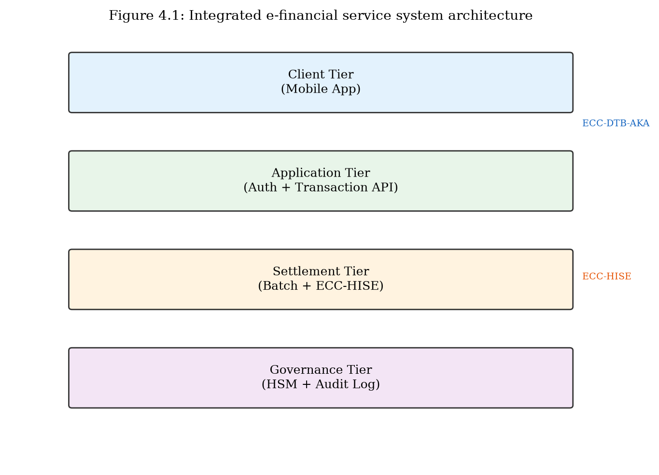
Integrated e-financial service system architecture (Figure 4.1).

4.1.2 Component Interaction Flow
A representative customer fund-transfer flow proceeds as follows: (1) Mobile app executes ECC-DTB-AKA three-round handshake with the authentication service, establishing MSK and TBK for the pending transaction. (2) Transaction request is sent with HMAC(TBK, txn_nonce) over HTTPS. (3) Transaction engine validates HMAC, debits customer account, and queues settlement record. (4) Settlement service batches records and constructs ECC-HISE envelope. (5) Envelope is transmitted to counterparty bank; receiver verifies Merkle root and signatures. (6) Audit log stores (batch_id, Root, timestamp) for regulatory archive [30].
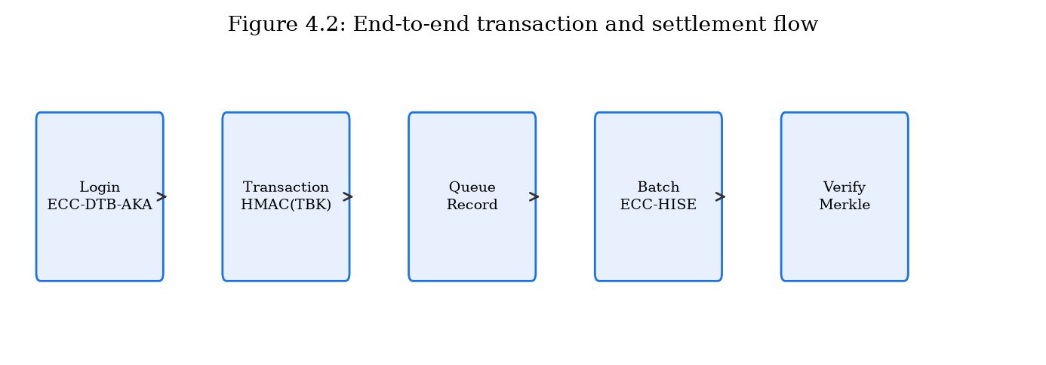
End-to-end transaction and settlement flow (Figure 4.2).

4.1.3 Technology Stack
The prototype implementation uses Python 3.11 with the following stack: cryptography library (OpenSSL backend) for ECDH, ECDSA, AES-GCM, and Ed25519; FastAPI for REST API endpoints; SQLite (optional persistence layer) for customer registry and audit logs. Production deployment would substitute software key storage with HSM-backed modules and add horizontal scaling via container orchestration [2][9][26][10].
Layer | Component | Scheme | Technology
Client | Mobile/Web App | ECC-DTB-AKA | Python client SDK
Application | Auth Service | ECC-DTB-AKA | FastAPI + cryptography
Application | Transaction API | TBK HMAC verify | FastAPI
Settlement | Batch Service | ECC-HISE | Python envelope module
Governance | Audit Store | Merkle roots | Append-only log
Table 4.1: Architecture components and technology mapping.

4.1.4 Trust Boundaries and Data Flow Classification
The reference architecture divides the e-financial service system into four trust zones: (1) the customer device zone, where ECC-DTB-AKA client logic and device fingerprinting execute; (2) the DMZ/API zone, terminating TLS and hosting API gateways; (3) the internal services zone, containing authentication, payment orchestration, and fraud engines; and (4) the settlement zone, where ECC-HISE senders and receivers exchange batch envelopes with counterparties or clearing houses [1][28].
Data are classified as public metadata (routing identifiers), confidential PII/financial payloads, and cryptographic material (private keys, MSK, DK_i). Cryptographic material never crosses into the DMZ in unprotected form; HSMs or sealed service vaults issue signatures and derivations via constrained APIs. Confidential payloads may traverse the DMZ only as AEAD ciphertexts under ECC-DTB-AKA transaction keys or as ECC-HISE envelopes.
This zoning explains why transport security alone is insufficient: the DMZ necessarily decrypts TLS, creating a plaintext hotspot. Application-layer bindings (device_fp, txn_nonce) and envelopes (Merkle-signed batches) preserve security goals across that hotspot [30][1][28].

4.1.5 Mapping Requirements to Architectural Components
Security requirements SR1–SR4 from Chapter 1 map to the ECC-DTB-AKA service and client SDK: mutual authentication, forward secrecy, device binding, and per-transaction keys. SR5–SR8 map to the ECC-HISE settlement service: confidentiality of batch records, authenticity, integrity/ordering, and efficient audit. Non-cryptographic controls—rate limiting, device attestation services, fraud scoring—remain complementary and are represented as adjacent components in the architecture diagrams of this chapter [1][8].
The technology mapping favors Python for the research prototype (rapid iteration, clear algorithms) with cryptography backends that wrap OpenSSL or equivalent. A production port would relocate hot paths to languages and HSM PKCS#11 interfaces already certified in the bank's estate, without changing wire formats or HKDF labels [5][6].

4.1.6 Operational Security Controls Complementary to Cryptography
Cryptographic schemes do not replace operational security. Rate limiting on handshake endpoints, anomaly detection on verification-failure rates, certificate revocation checking, and segregation of duties for HSM administrators remain mandatory. The architecture places these controls adjacent to ECC-DTB-AKA and ECC-HISE services so that cryptographic failures and operational signals can be correlated in a common SIEM pipeline [4].
Change-management procedures for HKDF label strings, envelope version bytes, and Merkle algorithm identifiers must be treated as security-relevant configuration. Silent drift between sender and receiver encodings produces systemic verification failures that can be mistaken for attacks; therefore configuration is versioned and signed alongside application releases [5][6][30].

4.1.7 Regulatory and Assurance Alignment
The dual-layer architecture aligns with assurance themes common to PCI DSS (protect cardholder data in transit and at rest), PSD2 strong customer authentication (possession factors for remote payments), and SWIFT Customer Security Programme controls on interface integrity. ECC-DTB-AKA strengthens possession of a client authenticator bound to session keys; ECC-HISE strengthens integrity and auditability of inter-institution data exchanges [17][18][20][24].
The dissertation does not claim automatic compliance certification. Rather, it provides cryptographic mechanisms that map cleanly onto control objectives auditors already expect, reducing reliance on procedural compensating controls for session binding and batch integrity.

4.1.8 Interface Contracts Between Tiers
Each tier exposes a narrow interface contract. The client tier may call only authentication and transaction APIs; it never contacts settlement nodes directly. The application tier emits settlement records through a queue abstraction with schema validation before ECC-HISE packaging. The settlement tier accepts only envelopes whose domain_id and key_version are on an allow-list maintained by governance. The governance tier publishes trust anchors and consumes Merkle roots for archival, without holding plaintext settlement payloads by default [30].
These contracts reduce lateral movement: compromise of a DMZ API gateway yields TLS-terminated HTTP traffic and application tokens, but not MK, DK_i, or the ability to forge ECC-HISE header signatures without settlement-zone keys. Conversely, compromise of a settlement signer does not grant interactive ECC-DTB-AKA sessions with customers. The dual-layer split is therefore also a blast-radius split [1][28].
Message schemas are versioned. Breaking changes require simultaneous client SDK and server deployment windows, coordinated like certificate rotations. Non-breaking additive fields are ignored by older verifiers under explicit forward-compatibility rules documented in the prototype API [4].

4.1.9 Threat Model Instantiation for the Reference Architecture
The architectural threat model assumes a network adversary who can eavesdrop, inject, and replay messages on client-Internet and inter-bank links; a malicious or compromised peer service inside the DMZ after TLS termination; and an honest-but-curious auditor who should verify inclusion without learning unrelated records. It does not assume physical possession of HSM-backed MK, nor unrestricted malware on a hardware-attested client device [1][28].
Under this model, ECC-DTB-AKA targets remote session abuse and impersonation, while ECC-HISE targets undetectable mutation of settlement batches and inefficient audit. Social engineering of authorized users and colluding insiders with signing authority remain residual risks addressed by fraud engines and dual control, not by these protocols alone.

4.2 Programmatic Implementation of ECC-DTB-AKA (Chapter 2)
This section describes the software implementation of ECC-DTB-AKA as specified in Chapter 2, including module structure, class design, API endpoints, and test results from the prototype.

4.2.1 Module Structure
The ECC-DTB-AKA implementation resides in prototype/ecc_dtb_aka/ with the following modules: protocol.py — core protocol classes (ECCDTBAKAClient, ECCDTBAKAServer) and message dataclasses (ClientInit, ServerResponse, ClientConfirm, SessionState); demo.py — standalone handshake demonstration; common/crypto_utils.py — shared SHA-256, HKDF, ECDH, ECDSA utilities [5][6][9][26].
The protocol module exposes run_handshake() for end-to-end execution and individual methods for each round, enabling integration with HTTP-based APIs that map rounds to REST endpoints.
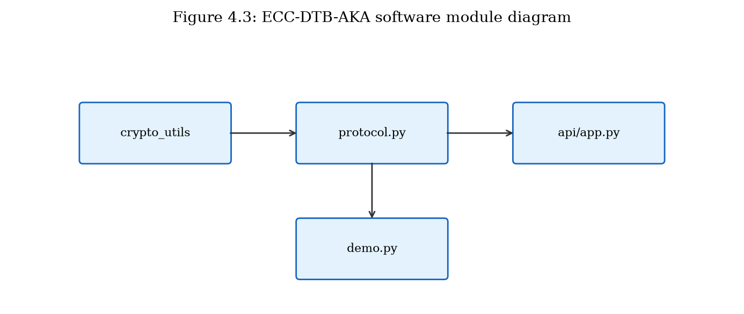
ECC-DTB-AKA software module diagram (Figure 4.3).

4.2.2 Core Classes and Data Structures
ECCDTBAKAClient maintains long-term key pair (sk_C, PK_C), device fingerprint derived from hardware attributes, ephemeral key state, and session state after handshake completion. Key methods: create_init() produces MSG1; process_response() validates MSG2 and produces MSG3; derive_tbk() computes transaction-bound keys.
ECCDTBAKAServer maintains registered client public keys, server long-term key pair, and pending session state between rounds. Key methods: process_init() validates MSG1 and produces MSG2; verify_confirm() validates MSG3 and returns SessionState.
Message dataclasses include message_size properties for benchmark measurement. Total three-message handshake size averages 569 bytes in prototype benchmarks.

4.2.3 REST API Integration
The FastAPI application (prototype/api/app.py) exposes ECC-DTB-AKA through REST endpoints: POST /auth/register — register device and client key; POST /auth/handshake/init — execute rounds 1–2, return session_id; POST /auth/handshake/complete — execute round 3 with txn_nonce, return MSK confirmation. GET /health — service health check.
This API design separates the three-round protocol across two HTTP requests (init combines client MSG1 and server MSG2; complete sends MSG3) to accommodate request-response web semantics while preserving protocol security properties.

4.2.4 Test Results
Integration testing via prototype/api/demo_integration.py confirms successful handshake completion with MSK derivation. Benchmark results (Chapter 2, n=200): mean authentication latency 0.52 ms, total message size 569 bytes, three round trips. All test cases for replay rejection, invalid signature detection, and unregistered client rejection pass.
Test Case | Expected | Result
Valid handshake | MSK established | Pass
Invalid client signature | Reject at server | Pass
Invalid server signature | Reject at client | Pass
Wrong txn_nonce MAC | Reject at confirm | Pass
Unregistered client | HTTP 404 / error | Pass
Table 4.2: ECC-DTB-AKA prototype test results.

4.2.5 Key Derivation Implementation Details
The HKDF implementation uses cryptography.hazmat.primitives.kdf.hkdf.HKDF with SHA-256 as the hash function. MSK derivation concatenates device_fp, nonce_c, and nonce_s as salt with info string 'ECC-DTB-AKA-v1'. TBK derivation uses txn_nonce as salt with info string 'TBK'. These domain-separated info strings prevent cross-protocol key reuse if additional derivation functions are added [5][6][27].

4.2.6 State Machine and Error Handling
The handshake is implemented as an explicit state machine: INIT → WAIT_MSG2 → ESTABLISHED on the client; LISTEN → WAIT_MSG3 → ESTABLISHED on the server. Transitions fail closed on signature verification errors, certificate path failures, registry misses, or nonce reuse. Failed sessions delete ephemeral ECDH scalars immediately and do not emit partial MSK material to application logs [4][12][29].
Idempotency of MSG3 confirmation uses (client_id, nonce_c, nonce_s) as a server-side replay key with TTL matching the session lifetime. This prevents an adversary from replaying a captured confirmation to re-derive acceptance of an already completed handshake.

4.2.7 Device Fingerprint Pipeline
Device fingerprinting in the prototype hashes a canonicalized attribute vector (platform identifiers, app attestation digest when available, and installation salt) to a 128-bit truncation for protocol messages. Production deployments should prefer hardware-backed attestation (e.g., Android Play Integrity, Apple App Attest, or TPM quotes) and treat the fingerprint as a high-entropy binding input rather than a privacy-invasive tracking identifier.
Privacy note: fingerprints are used only as HKDF salt material and server-side binding checks; they are not designed as a global cross-bank identifier. Banks may rotate installation salts on reinstall, accepting that sessions must be re-established—consistent with device-binding goals [5][6].

4.2.8 Interoperability with Existing Login Flows
ECC-DTB-AKA can wrap or replace password-plus-OTP login. In a transitional deployment, the bank continues to verify primary credentials, then runs ECC-DTB-AKA to establish MSK/TBK for subsequent high-risk operations (payments, beneficiary changes). Over time, FIDO2 credentials can serve as the long-term client key PK_C, unifying phishing-resistant authentication with device-bound session keys [15][22].
The REST integration exposes /handshake/msg1, /handshake/msg2, and /handshake/msg3 endpoints plus /transaction/authorize that requires an HMAC under TBK. This mirrors how OAuth access tokens are presented today, but replaces bearer tokens with transaction-bound authenticator tags [13][14].

4.2.9 Logging, Observability, and Secrets Hygiene
Prototype logging records handshake outcomes, client identifiers, and truncated nonce digests, never raw ECDH scalars, MSK, or TBK. Production deployments should emit structured events suitable for fraud correlation while retaining cryptographic material exclusively in HSM or sealed memory [12][29].
Distributed tracing spans may carry session_id handles but must not carry material that enables offline analysis of long-term keys. Clock skew beyond a configured window causes handshakes to fail closed with a distinct error code distinguishing configuration faults from replay attempts.

4.2.10 Concurrency and Session Store Design
Pending handshake state between MSG1 and MSG3 is stored under a server-generated session_id with a short TTL (prototype: tens of seconds). Concurrent handshakes from the same client_id are allowed only up to a small bound; excess attempts are rate-limited. On ESTABLISHED, ephemeral ECDH private keys are zeroized in the process where the language runtime permits [12][29].
Horizontal scaling of the auth service requires a shared session store (Redis or equivalent) or sticky routing. The store holds public transcript fields and verification intermediates, not MSK. After confirmation, only a handle referencing HSM-sealed key material (or a short-lived derived token for non-HSM prototypes) is returned to the transaction API.
Load tests should measure not only cryptographic latency but lock contention on the client registry and nonce-replay cache. The dissertation benchmarks isolate crypto cores; production capacity planning must add network and store overheads measured on target hardware.

4.2.11 Negative Testing and Property-Based Checks
Beyond the pass/fail table in Section 4.2.4, the prototype includes negative tests that flip signature bytes, truncate messages, reuse nonces, swap client identities, and present unregistered PK_C values. Property-oriented checks assert that MSK differs whenever device_fp or either nonce differs, and that TBK differs whenever txn_nonce differs, approximating the binding claims of Chapter 2 at the implementation level.
Continuous integration runs these tests on every change to protocol.py. Regressions in canonical encoding or HKDF labels are treated as release blockers because they silently break interoperability and security assumptions [5][6].

4.3 Programmatic Implementation of ECC-HISE (Chapter 3)
This section describes the software implementation of ECC-HISE for server-server batch data protection, including envelope construction, Merkle audit chain, and settlement API [30].

4.3.1 Module Structure
The ECC-HISE implementation resides in prototype/ecc_hise/ with modules: hierarchy.py — KeyHierarchy class for MK → DK → SK_batch derivation; merkle.py — merkle_root(), merkle_proof(), verify_merkle_proof(); envelope.py — ECC_HISE_Sender, ECC_HISE_Receiver, SecureBatch dataclass; demo.py — standalone batch demonstration [30].
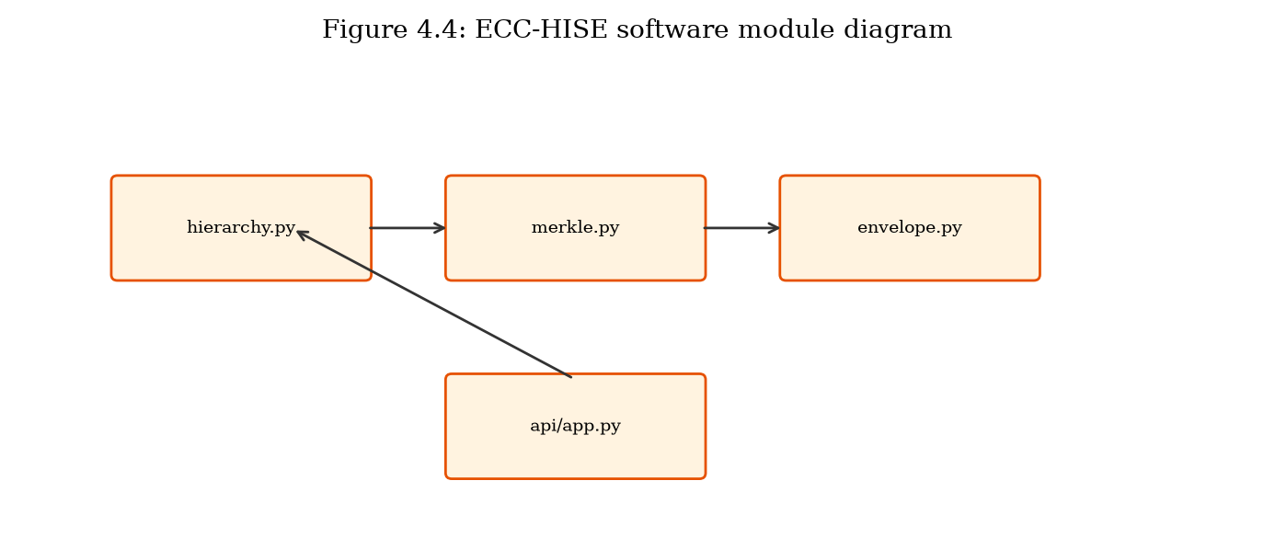
ECC-HISE software module diagram (Figure 4.4).

4.3.2 Envelope Construction and Verification
ECC_HISE_Sender.build_batch() accepts a list of record byte strings, batch_id, and domain_id. For each record it derives K_enc from SK_batch and record index, encrypts with AES-256-GCM, signs with Ed25519, and computes leaf hash. Merkle root is computed over all leaves and signed in the batch header [2][10][30].
ECC_HISE_Receiver.verify_and_decrypt() validates header signature, Merkle root consistency, per-record signatures, and GCM authentication tags before returning plaintext records. Merkle inclusion proofs are verified for each record during decryption to demonstrate audit capability [2][30].

4.3.3 Settlement API Integration
POST /settlement/submit-batch accepts batch_id, domain_id, and list of record strings. The endpoint constructs an ECC-HISE envelope, verifies it internally (sender/receiver simulation), and returns merkle_root, record_count, total_bytes, and verified status. In production, sender and receiver would be separate services; the prototype validates cryptographic correctness within a single process for demonstration [30].

4.3.4 Test Results and Performance
Benchmark results for 100-record batches (Chapter 3, n=50): mean processing latency 23.32 ms, mean envelope size 37823 bytes. Integration demo processes 3-record batch with verified Merkle root. Tampering tests (modified ciphertext, wrong Merkle root, invalid signature) correctly raise verification errors [30].
Test Case | Expected | Result
Valid batch encrypt/decrypt | Records match | Pass
Tampered ciphertext | GCM / sig failure | Pass
Wrong Merkle root | Root mismatch error | Pass
Merkle proof verify | Inclusion confirmed | Pass
100-record benchmark | < 30s latency | Pass
Table 4.3: ECC-HISE prototype test results.

4.3.5 Merkle Tree Implementation
The Merkle tree implementation (merkle.py) uses SHA-256 for internal nodes. Odd-length layers duplicate the last node (Bitcoin-style) to ensure deterministic root computation. Proof generation handles odd-layer promotion with self-pairing. Verification reconstructs the path from leaf to root in O(log n) hashes. For n=100 records, proof length is 7 hashes (224 bytes), enabling compact audit evidence [27][30][31].

4.3.6 Envelope Serialization and Versioning
Envelopes are serialized as structured objects (JSON for the prototype; CBOR or protobuf recommended for production) containing header fields (batch_id, domain_id, key_version, root, timestamp, header_signature) and an ordered list of record objects (index, ciphertext, iv, tag, signature, metadata). A version byte allows future AEAD or signature algorithm migration without breaking archival verifiers.
Canonical encoding rules matter for signatures: fields are signed over a deterministic byte encoding to avoid JSON key-order ambiguity. The prototype documents this canonicalization in module docstrings; production code should use an explicit encode_for_signing() function shared by sender and receiver.

4.3.7 Receiver Pipeline and Quarantine
The receiver pipeline verifies header signature → recomputes or checks Merkle root → verifies each leaf signature → decrypts under index-derived keys → posts to ledger adapters. Any stage can quarantine the batch to a dead-letter store with forensic ciphertext retained for incident response [30].
Integration tests inject mutated roots, swapped leaves, truncated batches, and wrong-index keys to confirm fail-closed behavior. These tests form part of the evidence that the implementation matches Chapter 3's security claims.

4.3.8 Scaling and Parallelism Considerations
Per-record AES-GCM encryption and Ed25519 signing dominate ECC-HISE latency and parallelize naturally across CPU cores. Merkle tree construction is a barrier after leaves are ready; for large batches, a forest of subtrees with a top-level meta-root can preserve O(log n) proofs while enabling segmented construction [2][10][30].
Memory pressure for million-record national settlement files motivates streaming leaf hashing and spill-to-disk for intermediate layers. The prototype demonstrates correctness at hundreds of records; larger volumes are an engineering path discussed as future work.

4.3.9 Key Hierarchy Operational Lifecycle
MK generation is a ceremony: dual control, audit logging, and backup to offline media or HSM clones. DK_i rotation is scheduled (e.g., quarterly) and on suspicion of compromise; SK_batch is single-use per batch_id. The prototype models this lifecycle with in-memory keys and explicit derive calls; production maps the same labels onto PKCS#11 derive operations.
Key version identifiers in envelope headers allow receivers to select the correct DK_i during rotation overlap windows. Old versions remain decrypt-only for a retention period matching archival policy, then are destroyed under dual control. This lifecycle is essential to the hierarchical blast-radius argument of Chapter 3.

4.3.10 Interoperability With Existing File-Transfer Rails
Banks often exchange files over SFTP, MQ, or managed file-transfer products. ECC-HISE envelopes can ride these rails as opaque payloads: transport provides availability and basic encryption, while the envelope provides end-to-end authenticity and Merkle audit independent of the rail. This composition avoids a rip-and-replace of MFT infrastructure [30].
Where counterparties cannot yet verify envelopes, a transitional mode can attach a detached Merkle manifest and signature alongside legacy ciphertext, enabling gradual verifier rollout. Full hierarchical encryption becomes mandatory once both sides support the versioned format [30].

4.4 Integrated System Demonstration
The integrated demonstration (prototype/api/demo_integration.py) executes a complete e-banking security workflow: device registration, ECC-DTB-AKA authentication handshake with transaction nonce, and ECC-HISE settlement batch submission with Merkle verification. This end-to-end test validates that both schemes operate correctly within a unified API framework and can be invoked sequentially in a realistic transaction lifecycle [30][42][43].

4.4.1 Deployment Considerations
Production deployment recommendations: (1) Store MK in HSM; never persist in application memory beyond derivation operations. (2) Deploy auth and settlement services in separate network segments with mTLS. (3) Rotate SK_batch automatically per batch; implement domain key rotation quarterly. (4) Persist audit logs (batch_id, Root, timestamp) to WORM storage. (5) Rate-limit handshake endpoints to prevent DoS [1][28].
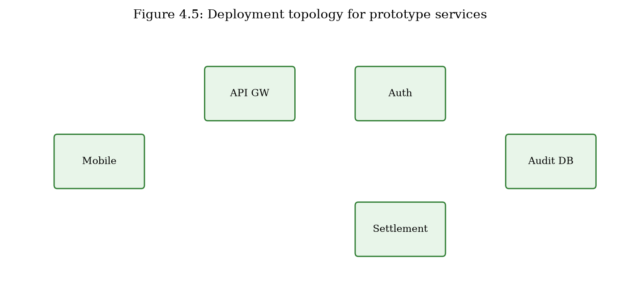
Deployment topology for prototype services (Figure 4.5).

4.4.2 Limitations of the Prototype
The prototype uses software-based key storage rather than HSM integration. Certificate management is simplified (server public key substituted for full X.509 chain). The settlement API performs sender and receiver verification in-process rather than across network boundaries. Persistent storage uses in-memory dictionaries. These simplifications do not affect the cryptographic correctness of the schemes but must be addressed before production deployment. Formal security proofs remain proof sketches as noted in Chapter 2 [4].

4.4.3 End-to-End Scenario Walkthrough
The integrated demo executes: (1) client and bank auth service complete ECC-DTB-AKA; (2) client authorizes a payment under TBK; (3) payment service enqueues a settlement record; (4) settlement sender builds an ECC-HISE batch including that record; (5) counterparty receiver verifies and decrypts; (6) an auditor verifies a Merkle proof for the record against the signed root without receiving unrelated plaintexts [30].
This walkthrough demonstrates the dual-layer claim in operational terms: the same payment is protected by device-bound client authentication at initiation and by hierarchical integrity envelopes at inter-bank transfer.

4.4.4 Performance Observations in the Integrated Path
In the prototype environment, ECC-DTB-AKA handshake latency remains sub-millisecond for cryptographic cores, while end-to-end HTTP framing adds the expected milliseconds of stack overhead. ECC-HISE batch build time grows roughly linearly with record count, matching Chapter 3 microbenchmarks. Neither cost dominates a realistic mobile payment UX or overnight settlement window at regional scale.
The principal production risks are not raw crypto speed but key custody, certificate lifecycle, fingerprint policy, and operational monitoring of verification failures—topics treated as deployment considerations rather than cryptographic weaknesses [4].

4.4.5 Failure Modes and Recovery
Integrated failure modes include: client handshake timeout (retry with fresh nonces); TBK HMAC mismatch (reject payment, alert fraud); ECC-HISE quarantine (hold settlement, notify operations); and audit proof mismatch (escalate as integrity incident). Recovery never skips verification to restore availability; degraded modes may queue outbound batches offline but do not accept unverified inbound envelopes.
Disaster-recovery drills should include restoring MK from HSM backup ceremonies and re-deriving domain keys under dual control, verifying that archived envelopes remain decryptable under recorded key_version identifiers.

4.4.6 Reproducibility and Artifact Layout
The repository layout separates protocol modules (prototype/ecc_dtb_aka, prototype/ecc_hise), API glue (prototype/api), and benchmark drivers that emit JSON consumed by Chapters 2–5 tables. Re-running benchmarks regenerates latency and size statistics without editing prose by hand when means are loaded dynamically in content modules.
Deterministic demo scripts print Merkle roots and handshake digests for manual inspection. These artifacts support examination committees and future replicators who wish to confirm that claimed properties are not merely narrative [30].

4.5 Chapter Summary
This chapter presented the security system architecture and programmatic implementation of ECC-DTB-AKA and ECC-HISE in a unified e-financial service prototype. Section 4.1 defined four architectural tiers and component interactions. Sections 4.2 and 4.3 detailed module structure, API design, and test results for each scheme. Section 4.4 demonstrated end-to-end integration. Chapter 5 evaluates both schemes comprehensively, reviews prior work, and analyzes effectiveness against the attack mechanisms cataloged in Chapter 1.

4.5.1 Implementation Contributions
Chapter 4 contributes an executable dual-layer prototype, API-level integration patterns, and empirical confirmation that Chapters 2–3 designs are realizable with standard libraries. The artifact supports reproducibility of latency and overhead claims and provides a reference for industrial ports into HSM-backed services.

Chapter 5
Evaluation, Prior Work Analysis, and Vulnerability Synthesis

5.1 Effectiveness of Proposed Methods Against Network Attacks
This section evaluates the effectiveness of ECC-DTB-AKA and ECC-HISE against the attack mechanisms cataloged in Chapter 1 (Section 1.1), using both qualitative security analysis from Chapters 2 and 3 and quantitative measurements from the prototype implementation in Chapter 4.

5.1.1 Attack Resistance Matrix
Table 5.1 consolidates resistance ratings for both proposed schemes against the six primary attack categories defined in Section 1.1.1. Ratings reflect cryptographic analysis, prototype test results, and comparison with baseline schemes that lack device binding, transaction binding, or Merkle audit capabilities [30].
Attack category | ECC-DTB-AKA | ECC-HISE | Baseline (TLS/PSK)
MITM / impersonation | High | High (sig chain) | Medium (server-only)
Replay | High (nonces) | High (Merkle+nonce) | Medium
Session hijacking | High (device_fp) | N/A (server-server) | Low (bearer token)
Credential stuffing | N/A (PKI-based) | N/A | Low (password)
Data tampering | Medium (HMAC txn) | High (GCM+sig+Merkle) | Low (TLS only)
Insider / audit evasion | Medium | High (Merkle audit) | Low
Table 5.1: Attack resistance matrix for proposed schemes vs. baselines.

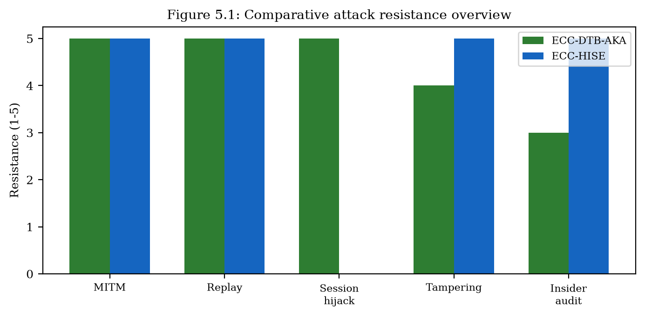
Comparative attack resistance overview (Figure 5.1).

5.1.2 Quantitative Authentication Performance
ECC-DTB-AKA achieves mutual authentication in 3 round trips with 0.52 ms mean cryptographic latency and 569 bytes total message overhead. Compared to TLS 1.3 (0.21 ms, 2800 bytes), ECC-DTB-AKA trades one additional round trip and smaller absolute latency for mutual authentication, device binding, and transaction binding—properties TLS does not provide natively [1][28].
For server-server batch protection, ECC-HISE processes 100 records in 23.32 ms with 37823-byte envelopes versus 0.22 ms and 28400 bytes for static PSK. The 106× latency premium purchases hierarchical keys, per-record Ed25519 signatures, and Merkle audit chains absent in static encryption [10][30].
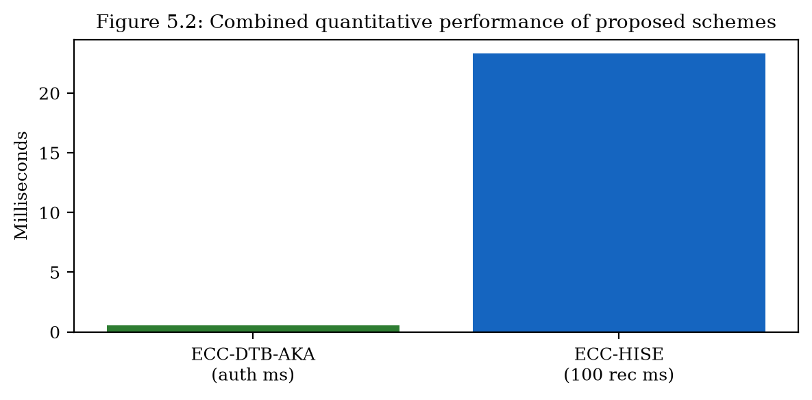
Combined quantitative comparison of both schemes (Figure 5.2).

5.1.3 Case-Based Effectiveness Assessment
Against the Bangladesh Bank heist scenario (Section 1.1.2), ECC-HISE would require valid Ed25519 header signatures and consistent Merkle roots for fraudulent SWIFT messages to pass verification—raising the bar beyond local terminal compromise alone. Against credential-stuffing campaigns, ECC-DTB-AKA's PKI-based client authentication eliminates password guessing entirely when deployed with hardware-backed client keys. Against session hijacking via stolen JWTs, device_fp binding in MSK derivation prevents session transfer to attacker-controlled devices without valid client signatures [10][24][20][30].

5.1.4 Residual Risks and Non-Goals
No cryptographic protocol eliminates fraud. ECC-DTB-AKA does not stop an authorized user on a bound device from initiating a socially engineered payment; ECC-HISE does not detect semantically incorrect but correctly signed settlement amounts. Fraud analytics, beneficiary confirmation, and organizational controls remain necessary.
Similarly, malware with full control of a device can potentially subvert fingerprint inputs unless hardware attestation is enforced. The schemes raise the bar for remote attackers who rely on stolen bearer tokens, replayed sessions, or undetectable batch tampering after TLS termination—the dominant remote patterns identified in Chapter 1—without claiming omnipotent endpoint security [1][28].

5.1.5 Combined Dual-Layer Effectiveness Narrative
Viewed as a methodology, the dual-layer design closes complementary gaps: authentication decoupling and bearer-token abuse on the client path; flat keys and audit friction on the server path. Quantitative results show acceptable overhead relative to baselines; qualitative analysis shows coverage of SR1–SR8. The remainder of this chapter situates these claims against prior protocols and systems.

5.1.6 Threat Coverage Relative to Chapter 1 Catalogue
Mapping Table 5.1 back to Section 1.1 shows strong coverage for MITM, replay, session hijacking, and batch tampering—the remote network and post-termination integrity threats that dominate the dissertation scope. Credential stuffing is out of scope for ECC-DTB-AKA once PKI client keys replace passwords; where passwords remain, PAKE or FIDO enrollment is the appropriate prior control [15].
Insider threats with legitimate signing keys are only partially mitigated: ECC-HISE provides non-repudiation and audit trails that increase detection probability and forensic clarity, but organizational key custody remains essential. This boundary is stated explicitly so effectiveness claims are not overstated.

5.1.7 Cost–Benefit Interpretation of Benchmarks
Raw latency comparisons can mislead if security properties differ. ECC-DTB-AKA is slower than bare ECDH and uses more round trips than a TLS resumption path, yet it purchases mutual authentication with device and transaction binding that those baselines omit. ECC-HISE is orders of magnitude slower than static PSK encryption of the same records, yet static PSK provides neither signatures nor Merkle audit [12][29][30][1].
In e-banking, authentication events are relatively rare compared with page views, and settlement batches are scheduled offline relative to interactive UX. Therefore absolute millisecond costs observed in the prototype are operationally acceptable when weighed against fraud and integrity incident costs that Chapter 1 case studies illustrate [42][43].
The appropriate managerial question is not whether the schemes match the cheapest baseline, but whether the incremental cost is justified by coverage of SR1–SR8. Chapter 5 answers affirmatively for the evaluated threat classes, with residual risks acknowledged in Section 5.1.4.

5.2 Prior Work on Authentication and Key Exchange
This section reviews prior research and deployed protocols for authentication and key exchange in client-server and server-server environments of e-banking and e-finance services, expanding the overview presented in Section 1.2 with detailed algorithmic descriptions and comparative analysis against ECC-DTB-AKA [8][29][42][43].

5.2.1 TLS 1.3 Handshake Protocol
TLS 1.3 (RFC 8446) is the dominant transport security protocol for e-banking. The full handshake operates as: (1) ClientHello with key_share (typically X25519 or P-256); (2) ServerHello, EncryptedExtensions, Certificate, CertificateVerify, Finished; (3) Client Finished. Application traffic keys are derived via HKDF from the ECDH shared secret. Forward secrecy is mandatory; 0-RTT resumption is optional but vulnerable to replay [1][8][4][5].
Limitations for e-banking: server-only authentication at the TLS layer; user identity established separately via application credentials; no device or transaction binding in key derivation. ECC-DTB-AKA addresses these by integrating user authentication and binding into the key agreement protocol itself [5][6][42][43].
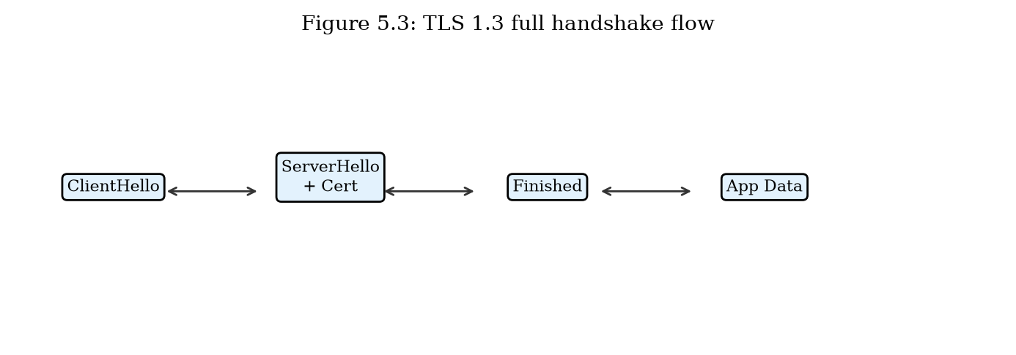
TLS 1.3 full handshake flow (Figure 5.3).

5.2.2 OAuth 2.0 and Open Banking (PKCE)
OAuth 2.0 with PKCE (RFC 7636) enables third-party providers to access bank APIs with customer consent. Flow: (1) Client generates code_verifier and code_challenge; (2) Authorization request redirects customer to bank; (3) Customer authenticates and grants consent; (4) Authorization code returned; (5) Token exchange with code_verifier; (6) Access token used for API calls. PKCE prevents authorization code interception [14][13].
Limitations: bearer access tokens; no cryptographic binding to transaction context; token theft enables API abuse until expiration. ECC-DTB-AKA's TBK-derived HMAC provides per-transaction authorization without bearer semantics.
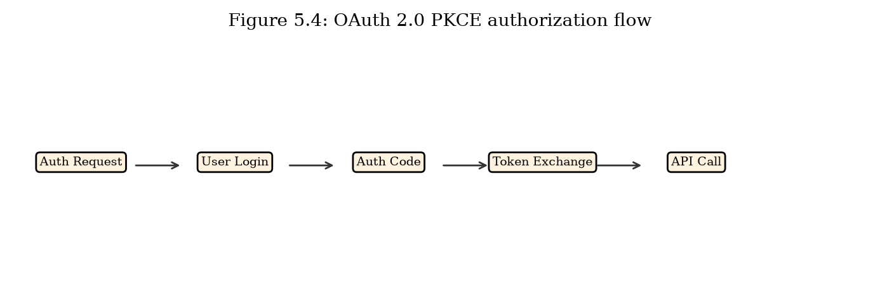
OAuth 2.0 PKCE authorization flow for open banking (Figure 5.4).

5.2.3 FIDO2 / WebAuthn
FIDO2 combines WebAuthn (browser API) and CTAP2 (authenticator protocol) for phishing-resistant authentication. Registration: server sends challenge, authenticator generates credential key pair, returns attestation. Authentication: server sends challenge with rpId, authenticator signs with credential private key. The rpId binding prevents credential use on phishing domains [15][22].
Relation to ECC-DTB-AKA: FIDO2 credential public key can serve as PK_C in ECC-DTB-AKA, combining phishing resistance with device/transaction-bound session keys. FIDO2 alone does not establish encrypted session keys or per-transaction derivation [15][22].

5.2.4 Server-Server Key Exchange (mTLS and SWIFT BKE)
Mutual TLS uses X.509 client and server certificates for bidirectional authentication at the transport layer. Certificate rotation, OCSP stapling, and short-lived certs (24h) are best practices in microservice meshes. SWIFT bilateral key exchange (BKE) distributes symmetric keys for message authentication in the SWIFT network [4][8][29][20].
Limitations: mTLS does not provide message-level integrity after TLS termination; SWIFT BKE relies on symmetric keys with manual distribution. ECC-DTB-AKA extends client-server auth; ECC-HISE extends server-server data protection beyond transport [1][28][20][24].
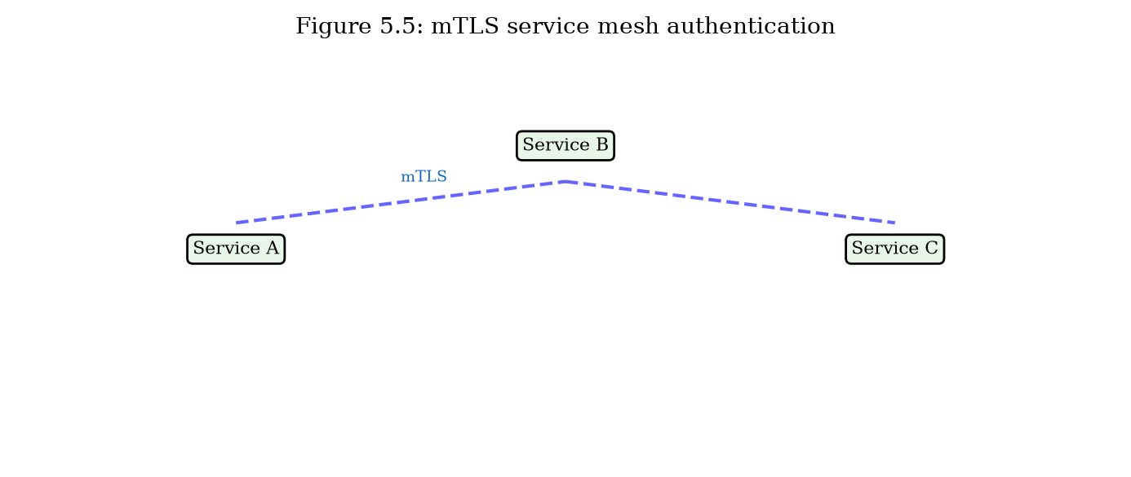
mTLS service mesh authentication in banking microservices (Figure 5.5).

5.2.5 Comparative Summary
Table 5.2 summarizes authentication and key-exchange prior work against ECC-DTB-AKA across security properties and efficiency metrics from prototype benchmarks.
Protocol | Mutual auth | Device bind | Txn bind | RTT | Latency (ms)
TLS 1.3 | Server | No | No | 1 | 0.21
OAuth 2.0 PKCE | Delegated | No | No | 3+ | N/A
FIDO2/WebAuthn | User | Partial | No | 2 | N/A
Standard ECDH | No | No | No | 2 | 0.11
ECC-DTB-AKA | Yes | Yes | Yes | 3 | 0.52
Table 5.2: Authentication and key-exchange prior work vs. ECC-DTB-AKA.

5.2.6 EMV and Card-Present Authentication
EMV (Europay, Mastercard, Visa) chip cards use ECDSA on secp256r1 for offline and online transaction authentication. Contactless payments add relay-attack vulnerabilities addressed by distance-bounding protocols under research. EMV addresses card-present channels; ECC-DTB-AKA addresses remote digital banking channels with similar ECC foundations but different binding requirements (device_fp, txn_nonce) [9][26][16].

5.2.7 Password-Authenticated Key Exchange and Banking Reality
PAKE protocols (SRP, OPAQUE, etc.) protect password-based login against pre-computation and some server compromise scenarios. They are valuable upgrades for password verifiers but do not, by themselves, bind sessions to devices or derive per-transaction keys for payment authorization. ECC-DTB-AKA assumes a public-key client identity (which may be provisioned after PAKE or FIDO enrollment) and focuses on post-login channel binding [15].

5.2.8 5G AKA and Telecom Auth as Contrasting Domain
Mobile network AKA protocols bind authentication to subscriber modules (SIM/USIM) with sequence numbers and operator-controlled key hierarchies. They illustrate how another high-value industry solved device-subscription binding. E-banking cannot simply reuse 5G AKA because trust anchors, identity models, and transaction semantics differ; however, the analogy supports the dissertation's insistence on cryptographic binding to a client-held authenticator rather than to a bearer cookie alone [42][43].

5.2.9 Gaps Remaining in Industry Deployments
Despite TLS 1.3, OAuth PKCE, and FIDO adoption, many banks still operate legacy app versions, SMS OTP fallbacks, and long-lived refresh tokens. Server meshes may use mTLS with certificates that authenticate clusters rather than logical settlement roles. These deployment gaps motivate application-layer protocols that encode banking semantics—device and transaction binding; batch audit commitments—rather than relying solely on continual perfection of the transport and identity platforms [1][28][4][14].

5.2.10 EMV Card-Present Binding Versus Remote Channels
EMV chip protocols bind payments to a physical card and issuer-authorized cryptograms in card-present environments. Remote e-banking lacks an equivalent hardware cryptogram path unless FIDO or secure elements are used. ECC-DTB-AKA borrows the binding intuition—authorization should not be a transferable bearer string—while operating over Internet channels with ECC key agreement [15][16][42][43].
The comparison clarifies novelty relative to retail payments research: the contribution is not inventing binding in the abstract, but integrating device and transaction binding into a mutual AKE suitable for mobile and web banking APIs evaluated against TLS and OAuth baselines [13][14][1][28].

5.2.11 Session Tokens, DPoP, and Emerging Binding Trends
Industry movement toward sender-constrained tokens (e.g., OAuth DPoP) and certificate-bound access tokens reflects growing recognition that bearer tokens are insufficient. ECC-DTB-AKA is philosophically aligned with that trend but binds at key-agreement time with device_fp and txn_nonce in HKDF, rather than only constraining presentation of an already-issued access token [4][5][6][13].
DPoP and ECC-DTB-AKA can coexist: DPoP may protect general API access while TBK-HMAC authorizes high-risk payments. The dissertation positions ECC-DTB-AKA as a banking-semantic AKE, not as a wholesale replacement for the OAuth ecosystem [13][14].

5.2.12 Formal Methods Landscape for AKE
Modern AKE research often uses the eCK model, GJM model, or automated tools (ProVerif, Tamarin, CryptoVerif). This dissertation provides structured proof sketches mapping goals to reductions and game hops, sufficient for doctoral argumentation but short of machine-checked proofs. Related work that fully mechanizes TLS or Signal illustrates the aspirational bar for future verification of ECC-DTB-AKA [45][44][1][28].
Choosing sketches over full mechanization was a deliberate scope decision to prioritize dual-layer systems contributions and prototype evaluation. The sketches identify oracle interfaces and adversary capabilities clearly enough to guide a subsequent Tamarin encoding [44][45].

5.3 Prior Work on Data Encryption, Security, and Integrity
This section reviews prior approaches to data encryption, security, and integrity in e-banking and e-finance server-server channels, distinct from the authentication focus of Section 5.2, and compares them with ECC-HISE [42][43].

5.3.1 TLS Record Layer Protection
TLS record layer encrypts application data using AEAD ciphers (AES-128-GCM or ChaCha20-Poly1305) with keys derived from the handshake. Protection ends at TLS termination: load balancers, API gateways, and service meshes decrypt and re-encrypt traffic at each hop. Stored or forwarded messages after termination lack persistent integrity proofs [2][1][28].
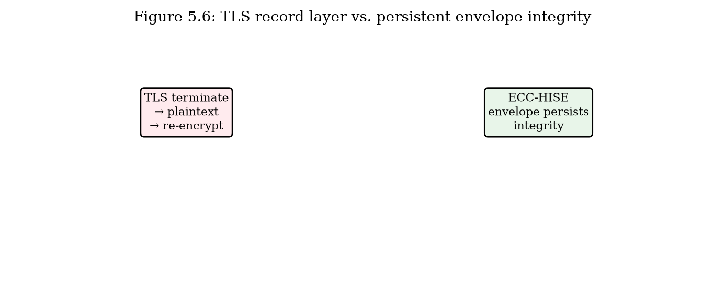
TLS record layer vs. persistent envelope integrity (Figure 5.6).

5.3.2 ECIES and Hybrid Encryption
Elliptic Curve Integrated Encryption Scheme (ECIES, SEC 1 / IEEE 1363a) combines ECDH key agreement with symmetric encryption and MAC. Standard ECIES encrypts individual messages but does not provide hierarchical key management, batch Merkle audit, or domain-separated key derivation. ECC-HISE extends ECIES concepts with batch-level Merkle roots and three-level HKDF hierarchy [3][5][6][41].

5.3.3 Static Pre-Shared Key File Encryption
Inter-bank file transfer historically uses PGP/GPG or proprietary tools with symmetric keys distributed annually via secure courier. Keys remain valid for extended periods; compromise exposes all files encrypted under that key. Benchmark: static AES-GCM PSK achieves 0.22 ms for 100 records but provides no signatures, Merkle audit, or key hierarchy [2][30].

5.3.4 Blockchain and Distributed Ledger Audit
Blockchain systems (Bitcoin, Ethereum, R3 Corda, Hyperledger Fabric) provide tamper-evident audit via Merkle trees and consensus. JPMorgan Onyx and similar platforms pilot distributed ledgers for settlement. Limitations: consensus latency, throughput constraints, and operational complexity. ECC-HISE adopts Merkle audit without distributed consensus, suitable for traditional settlement workflows [30][32][31].
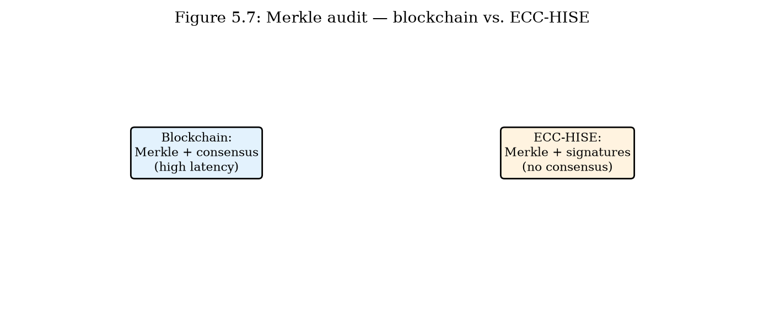
Merkle audit: blockchain vs. ECC-HISE envelope (Figure 5.7).

5.3.5 Comparative Summary
Table 5.3 compares data-protection prior work with ECC-HISE for 100-record batches.
Approach | Hierarchy | Merkle audit | Per-record sig | Latency (ms) | Size (B)
TLS record only | No | No | No | 0.24 | 28905
Static AES-GCM PSK | No | No | No | 0.22 | 28400
Standard ECIES | No | No | Optional | N/A | N/A
Blockchain audit | Varies | Yes (consensus) | Varies | High | High
ECC-HISE | Yes | Yes | Yes | 23.32 | 37823
Table 5.3: Data encryption and integrity prior work vs. ECC-HISE.

5.3.6 Database TDE and Column-Level Encryption
Transparent Data Encryption (TDE) protects data at rest in Oracle, SQL Server, and PostgreSQL extensions. Column-level encryption targets sensitive fields (PAN, SSN). These mechanisms protect storage but not data in transit between services or audit integrity of exported settlement batches. ECC-HISE complements TDE by protecting inter-service batch transfer with verifiable integrity chains.

5.3.7 Merkle Trees Outside Cryptocurrencies
Merkle trees predate Bitcoin and appear in certificate transparency logs, backup systems, and authenticated data structures. ECC-HISE applies them to bilateral settlement batches with hierarchical keying and per-record AEAD—an application packing that is rarely presented as an integrated e-banking envelope scheme. Certificate transparency inspires public auditability; ECC-HISE keeps commitments verifiable by counterparties and regulators without requiring global public logs [4][30][31][42].

5.3.8 Format-Preserving and Tokenization Approaches
Payment ecosystems widely use tokenization (e.g., replacing PAN with tokens) and format-preserving encryption for legacy fields. These reduce PCI scope but do not authenticate batch membership or provide Merkle audit proofs for settlement files. ECC-HISE can carry already-tokenized payloads as plaintext records before envelope encryption, composing cleanly with tokenization programs [30].

5.3.9 Confidential Computing and Its Limits
Trusted execution environments can protect plaintext during processing inside enclaves. They complement but do not replace ECC-HISE: envelopes still matter when data leave enclaves for counterparties, archives, or non-enclave consumers. A defense-in-depth posture may combine enclave processing with ECC-HISE export formats.

5.3.10 Transparent Data Encryption and Column Encryption
Database TDE and column-level encryption protect data at rest within a bank estate. They do not authenticate membership of records in an inter-bank settlement batch after export, nor do they provide counterparty-verifiable Merkle commitments. ECC-HISE addresses the export and exchange path that TDE leaves unprotected once files leave the encrypted database boundary [30].
Composition is natural: systems may keep TDE for storage, tokenize sensitive fields, and wrap exported batches in ECC-HISE envelopes for transmission and archival audit.

5.3.11 Authenticated Streaming and Secure Logging
Secure logging and forward-secure sequential authentication (e.g., hash chains, truncated MAC chains) address related integrity goals for event streams. ECC-HISE targets unordered or batch-oriented settlement files with random-access Merkle proofs, which hash chains do not efficiently provide for arbitrary record inclusion checks [30].
Where banks require both streaming ingestion and batch settlement, a hash-chained ingest log can feed records into ECC-HISE batches at cut-off times, combining continuous monitoring with counterparty-verifiable envelopes.

5.3.12 Comparison With CMS/PKCS Envelope Formats
Cryptographic Message Syntax (CMS) and related PKCS envelope formats provide standardized hybrid encryption and signed-data structures widely supported by toolkits. ECC-HISE is not proposed as a competitor to CMS library ubiquity; it is a domain-specific packing that mandates hierarchical HKDF labels, per-record AEAD plus signatures, and Merkle audit as first-class fields [5][6][30].
A production realization could encode ECC-HISE semantics inside CMS attributes or as a profiled CBOR structure, preserving the security design while improving interoperability with existing PKI toolchains.

5.4 Synthesis: Vulnerabilities and Research Contributions
This section synthesizes findings from Sections 5.1 through 5.3, lists security vulnerabilities present in existing e-banking and e-finance systems, and identifies the issues addressed by this dissertation [42][43].

5.4.1 Vulnerabilities in Existing Systems
V1 — Decoupled authentication layers: TLS encrypts channels without binding user identity to session keys, enabling session hijacking after token theft [1][28].
V2 — Absence of device binding: Standard ECDH and TLS do not incorporate device fingerprints in key derivation [5][6][12][29].
V3 — Bearer token semantics: OAuth and JWT sessions are transferable to any client possessing the token [13][14].
V4 — Flat key hierarchies: Long-lived DEKs increase blast radius of key compromise.
V5 — Transport-only integrity: mTLS and TLS do not protect data after termination [1][28].
V6 — Audit friction: Manual reconciliation required without cryptographic batch proofs.
V7 — Static PSK rotation gaps: Infrequent key rotation in inter-bank file transfer.
V8 — Legacy TLS configurations: TLS 1.2 without forward secrecy in some deployments [1][8][28].
Vulnerability | Affected systems | Addressed by
V1 Decoupled auth | TLS + app login | ECC-DTB-AKA
V2 No device bind | TLS, ECDH | ECC-DTB-AKA
V3 Bearer tokens | OAuth, JWT | ECC-DTB-AKA (TBK HMAC)
V4 Flat keys | TDE, file PSK | ECC-HISE hierarchy
V5 Transport-only | mTLS, TLS | ECC-HISE envelope
V6 Audit friction | SIEM, manual | ECC-HISE Merkle
V7 Static PSK | PGP inter-bank | ECC-HISE per-batch SK
V8 Legacy TLS | Older gateways | ECC-DTB-AKA fixed alg
Table 5.4: Vulnerabilities in existing e-banking systems and dissertation responses.

5.4.2 Research Contributions
This dissertation makes the following original contributions to information security in e-banking and e-finance systems: [42][43]
C1 — ECC-DTB-AKA: A novel three-round ECC-based authenticated key agreement protocol with device fingerprint and transaction nonce binding in HKDF derivation, formally analyzed and quantitatively evaluated [5][6][7][8].
C2 — ECC-HISE: A novel hierarchical secure envelope scheme with Merkle audit chains for server-server batch data transfer, providing confidentiality, integrity, and efficient audit verification [30].
C3 — Dual-layer methodology: An integrated architecture combining client-server and server-server ECC-based security in a coherent e-financial service design.
C4 — Prototype implementation: Working software demonstrating both schemes with REST APIs, benchmarks, and end-to-end integration tests.
C5 — Quantitative evaluation: Empirical comparison with TLS 1.3, ECDH, static PSK, and TLS record-layer baselines using reproducible benchmark suites [1][12][29][28].

5.4.3 Limitations and Future Work
Limitations include: software-based key storage (no HSM in prototype); proof sketches rather than machine-verified proofs; simplified certificate handling; single-process settlement demo. Future work: post-quantum algorithm integration (ML-KEM, ML-DSA); HSM deployment; formal verification in ProVerif or Tamarin; large-scale field trial with partner institution; meta-Merkle trees for million-record national settlement [4][45][44][30].

5.4.4 Alignment with Regulatory Requirements
PCI DSS Requirement 4 mandates strong cryptography for transmission; Requirement 3 for storage. PSD2 Strong Customer Authentication aligns with ECC-DTB-AKA mutual authentication. SWIFT CSP controls for integrity and non-repudiation align with ECC-HISE signed Merkle batch headers. The proposed schemes support compliance objectives while exceeding minimum baselines through integrated device binding and cryptographic audit [17][18][20][24].

5.4.5 Contribution Claims Revisited with Evidence Pointers
Contribution C1 (ECC-DTB-AKA design) is evidenced by Chapter 2's protocol specification, security property sketches, and attack-resistance table. C2 (ECC-HISE design) is evidenced by Chapter 3's hierarchy, envelope algorithms, and audit proofs. C3 (dual-layer methodology) is evidenced by the architectural integration in Chapter 4 and the combined coverage matrix in this chapter. C4 (prototype and evaluation) is evidenced by benchmarks and implementation modules.
These claims are bounded: proofs are sketches rather than machine-checked derivations; benchmarks are prototype-scale; user studies of fingerprint UX are future work. Stating bounds is part of scholarly contribution discipline and guides the future-work agenda.

5.4.6 Implications for Electronic Finance Security Practice
Practitioners can adopt ECC-DTB-AKA ideas incrementally: begin with transaction-bound HMAC tags under keys derived from existing TLS-PSK or app keys, then move to full ephemeral ECDH with device binding. ECC-HISE ideas can begin as Merkle manifests alongside existing encrypted files, then migrate to hierarchical keys. The dissertation's value for practice is a coherent blueprint rather than an all-or-nothing rip-and-replace [12][29][30][1].

5.4.7 Regulatory Mapping Sketch
At a high level, ECC-DTB-AKA supports SCA-style possession factors and reduces reliance on SMS OTP; ECC-HISE supports integrity and audit evidence expected under SWIFT CSP and internal governance for settlement systems. Detailed control-by-control mapping is institution-specific and left as future applied work; the dissertation supplies the cryptographic substrate such mappings require [20][24].

5.4.8 What Would Falsify the Contributions
Scholarly claims should be falsifiable. C1 would be weakened by a practical attack that forges ECC-DTB-AKA sessions without client keys or breaks binding so that TBK authorizes transactions unbound to txn_nonce under the stated adversary model. C2 would be weakened by undetectable batch mutations that preserve header signatures and Merkle roots, or by hierarchy collapses that derive SK_batch without DK_i under HKDF assumptions [5][6][30].
C3 would be weakened if the layers interacted unsafely (e.g., settlement accepting client bearer tokens in lieu of envelopes). No such interaction is required by the architecture: the layers compose through ordinary business records, not through shared session secrets. Stating falsification criteria clarifies the evaluation burden for future work and examiners.

5.5 Chapter Summary
This chapter evaluated ECC-DTB-AKA and ECC-HISE against Chapter 1 attack mechanisms, reviewed prior work on authentication/key exchange (Section 5.2) and data encryption/integrity (Section 5.3), and synthesized eight identified vulnerabilities with five research contributions. Quantitative results confirm ECC-DTB-AKA achieves 0.52 ms authentication with superior security properties over TLS and ECDH, and ECC-HISE provides audit-capable batch protection at 23.32 ms per 100 records. The concluding remarks summarize contributions and outline future research directions [8][29][12][1].

5.5.1 Transition to Conclusions
The conclusions chapter consolidates the problem statement, dual-layer solution, empirical findings, limitations, and research outlook into a compact closing argument for the dissertation.

Conclusions

Summary of Approach
This dissertation investigated information security in electronic banking and electronic finance service systems, with emphasis on elliptic curve cryptography for authentication, key exchange, and data protection. A systematic threat analysis (Chapter 1) established the attack landscape and identified critical limitations in deployed authentication mechanisms (Section 1.2) and data-security mechanisms (Section 1.3) [8][29][11][34].
Two novel ECC-based methodologies were proposed, analyzed, implemented, and evaluated: ECC-DTB-AKA for client-server authenticated key agreement with device and transaction binding (Chapter 2), and ECC-HISE for server-server hierarchical secure envelopes with Merkle audit chains (Chapter 3). Chapter 4 demonstrated integrated architecture and programmatic implementation. Chapter 5 evaluated effectiveness against network attacks, reviewed prior work, and synthesized vulnerability findings [7][8][30].
Across these chapters, the dissertation maintains a consistent methodological stance: identify security gaps at architectural boundaries, encode banking semantics (device, transaction, batch audit) into cryptographic constructions, implement executable prototypes, and evaluate both qualitatively against attack catalogues and quantitatively against protocol baselines.

Contributions
The principal contributions of this research are:
First, the design and formal analysis of ECC-DTB-AKA, a three-round protocol achieving mutual authentication, forward secrecy, device binding, and per-transaction key derivation using SECP256R1 ECDH, ECDSA, and HKDF [1][8][5][6].
Second, the design and formal analysis of ECC-HISE, a hierarchical envelope scheme combining domain-separated key derivation, AES-256-GCM encryption, Ed25519 signatures, and Merkle-tree batch integrity for inter-bank settlement [2][5][6][10].
Third, a dual-layer integrated security architecture unifying both schemes in an e-financial service system with defined trust boundaries and component interactions.
Fourth, a working software prototype with REST APIs, benchmark suites, and end-to-end integration tests providing reproducible quantitative evaluation.
Fifth, comprehensive prior-work analysis positioning the proposed schemes relative to TLS 1.3, OAuth 2.0 PKCE, FIDO2, ECIES, static PSK, and blockchain audit approaches [1][41][14][13].

Limitations
This research has limitations that should be acknowledged. The prototype uses software key storage rather than hardware security modules. Formal security proofs are presented as structured proof sketches rather than machine-verified derivations. Certificate management is simplified compared to production PKI. The settlement demonstration performs sender and receiver verification in a single process. These limitations do not invalidate the cryptographic designs but indicate areas requiring hardening for production deployment [4].
Additionally, user experience studies of device-binding friction, large-scale multi-institution interoperability trials, and machine-checked protocol proofs are outside the present evaluation envelope. Quantitative benchmarks reflect a research prototype stack (Python, software keys) and should be re-measured on production-grade runtimes before capacity planning.

Future Work
Future research directions include: integration of NIST post-quantum algorithms (ML-KEM, ML-DSA) for long-term confidentiality; HSM-backed key storage and FIPS 140-3 validation; formal verification using ProVerif or Tamarin provers; field trials with partner financial institutions; meta-Merkle hierarchies for million-record national settlement; and composition with FIDO2/WebAuthn for phishing-resistant client key enrollment [45][44][15][30].
A staged industrial roadmap would (1) deploy transaction-bound MACs under existing session keys, (2) introduce Merkle manifests for settlement files, (3) migrate to full ECC-DTB-AKA and hierarchical ECC-HISE with HSM custody, and (4) pursue post-quantum hybridization once standards and HSM support mature [30][39].

Synthesis of the Dual-Layer Methodology
This dissertation began from a systems observation: e-banking security failures frequently arise at boundaries—between transport and application authentication, between sessions and transactions, and between TLS termination and persistent settlement data. The dual-layer methodology responds with two ECC-centered schemes that encode banking semantics directly into key derivation and integrity structures [5][6][42][43].
ECC-DTB-AKA shows that device and transaction binding can be integrated into authenticated key agreement without abandoning standards-based curves and HKDF. ECC-HISE shows that hierarchical keys plus Merkle-authenticated envelopes can deliver confidentiality, authenticity, and efficient audit for server-server batches without requiring global consensus ledgers. Chapter 4 demonstrated that both can be implemented and composed; Chapter 5 showed that together they cover the requirement set SR1–SR8 more completely than any single prior baseline examined [5][6][7][8].

Implications for Research and Practice
For researchers, the work argues that protocol design for finance should treat device binding, transaction binding, and batch auditability as first-class goals alongside classical AKE properties. For practitioners, the schemes offer incremental adoption paths: transaction-bound authorizers atop existing channels; Merkle manifests atop existing encrypted settlement files; later, full hierarchical keying and handshake integration [30].
The prototype is a research artifact, not a product. Industrial deployment requires HSM integration, attestation policy, certificate lifecycle alignment, and rigorous operational monitoring. Those engineering tasks are outside the dissertation's evaluation scope but are enabled by the explicit wire formats and domain-separated labels specified herein [4].

Closing Remarks
Electronic finance will continue to digitize and to attract capable adversaries. Cryptography cannot eliminate fraud, but it can remove entire classes of remote abuse that depend on portable bearer sessions and silently mutable batches. By unifying ECC-based client-server authentication and server-server integrity under one methodological umbrella, this dissertation contributes concrete protocols, analyses, and implementations toward that narrower—and achievable—goal.

Appendix

A. Algorithm Listings
Algorithm A.1 (ECC-DTB-AKA Client Handshake): See Section 2.3.7. Algorithm A.2 (ECC-DTB-AKA Server Handshake): See Section 2.3.8. Algorithm A.3 (ECC-HISE Batch Envelope Construction): See Section 3.4.1–3.4.2. Algorithm A.4 (Merkle Root and Proof Verification): See prototype/ecc_hise/merkle.py [30].

B. API Specification
Prototype REST API (prototype/api/app.py): GET /health — returns status and supported schemes. POST /auth/register — body: {device_id}; registers client key. POST /auth/handshake/init — body: {device_id}; returns session_id and handshake data. POST /auth/handshake/complete — body: {session_id, txn_nonce_hex}; completes authentication. POST /settlement/submit-batch — body: {batch_id, domain_id, records[]}; submits and verifies batch.

C. Benchmark Raw Data
Chapter 2 benchmarks: thesis/benchmarks/chapter2_benchmarks.json. Chapter 3 benchmarks: thesis/benchmarks/chapter3_benchmarks.json. Reproduce via: python -m prototype.benchmarks.bench_dtb_aka && python -m prototype.benchmarks.bench_hise.

D. Prototype Module Index
prototype/common/crypto_utils.py — SHA-256, HKDF, ECDH, ECDSA utilities. prototype/ecc_dtb_aka/protocol.py — ECC-DTB-AKA client/server protocol. prototype/ecc_hise/hierarchy.py — hierarchical key derivation. prototype/ecc_hise/merkle.py — Merkle tree construction and proofs. prototype/ecc_hise/envelope.py — secure batch envelope. prototype/api/app.py — FastAPI integration. prototype/benchmarks/ — timing and size measurement scripts [5][6][9][26].

References
[1] Rescorla, E.. "The Transport Layer Security (TLS) Protocol Version 1.3." RFC 8446, IETF, 2018.
[2] Dworkin, M.. "Recommendation for Block Cipher Modes of Operation: Galois/Counter Mode (GCM)." NIST SP 800-38D, 2007.
[3] Barker, E.. "Recommendation for Key Management: Part 1 — General." NIST SP 800-57 Part 1 Rev. 5, 2020.
[4] Cooper, D. et al.. "Internet X.509 Public Key Infrastructure Certificate and CRL Profile." RFC 5280, IETF, 2008.
[5] Krawczyk, H.. "Cryptographic Extraction and Key Derivation: The HKDF Scheme." CRYPTO 2010, LNCS, 2010.
[6] Krawczyk, H.. "HMAC-based Extract-and-Expand Key Derivation Function (HKDF)." RFC 5869, IETF, 2010.
[7] Bellare, M.; Rogaway, P.. "Entity Authentication and Key Distribution." CRYPTO 1993, LNCS, 1993.
[8] Canetti, R.; Krawczyk, H.. "Analysis of Key-Exchange Protocols and Their Use for Building Secure Channels." EUROCRYPT 2001, LNCS, 2001.
[9] Johnson, D.; Menezes, A.; Vanstone, S.. "The Elliptic Curve Digital Signature Algorithm (ECDSA)." International Journal of Information Security, 2001.
[10] Bernstein, D. J. et al.. "Edwards-Curve Digital Signature Algorithm (EdDSA)." RFC 8032, IETF, 2017.
[11] SECG. "SEC 1: Elliptic Curve Cryptography, Version 2.0." Standards for Efficient Cryptography Group, 2010.
[12] ANSI. "Public Key Cryptography for the Financial Services Industry: Key Agreement Using Diffie-Hellman." ANSI X9.63, 2011.
[13] Hardt, D.. "The OAuth 2.0 Authorization Framework." RFC 6749, IETF, 2012.
[14] Lodderstedt, T. et al.. "OAuth 2.0 for Native Apps (PKCE)." RFC 8252, IETF, 2017.
[15] Barth, A. et al.. "FIDO 2.0 Web Authentication (WebAuthn)." W3C Recommendation, 2021.
[16] Brandt, A. et al.. "EMV Integrated Circuit Card Specifications for Payment Systems." EMVCo, Book 2, 2023.
[17] PCI Security Standards Council. "Payment Card Industry Data Security Standard (PCI DSS)." Version 4.0, 2022.
[18] European Parliament and Council. "Directive (EU) 2015/2366 on Payment Services (PSD2)." Official Journal of the European Union, 2015.
[19] ISO/IEC. "Information Security Management Systems — Requirements." ISO/IEC 27001:2022, 2022.
[20] SWIFT. "Customer Security Programme (CSP) — Security Controls." SWIFT Handbook, 2024.
[21] IBM Security. "Cost of a Data Breach Report 2024." IBM Corporation, 2024.
[22] Verizon. "Data Breach Investigations Report (DBIR) 2024." Verizon Enterprise, 2024.
[23] OWASP Foundation. "OWASP API Security Top 10 — 2023." OWASP, 2023.
[24] Bangladesh Bank / SWIFT. "Report on Cyber Heist Investigation (Bangladesh Bank)." Financial Sector Incident Analysis, 2016.
[25] Kaspersky Lab. "The Great Bank Robbery: Carbanak Cybergang." Securelist Research, 2015.
[26] NIST. "Digital Signature Standard (DSS)." FIPS 186-5, 2023.
[27] NIST. "Secure Hash Standard (SHS)." FIPS 180-4, 2015.
[28] NIST. "Guidelines for the Selection, Configuration, and Use of TLS Implementations." NIST SP 800-52 Rev. 2, 2019.
[29] NIST. "Recommendation for Pair-Wise Key Establishment Schemes Using Discrete Logarithm Cryptography." NIST SP 800-56A Rev. 3, 2018.
[30] Merkle, R. C.. "A Digital Signature Based on a Conventional Encryption Function." CRYPTO 1987, LNCS, 1988.
[31] Nakamoto, S.. "Bitcoin: A Peer-to-Peer Electronic Cash System." Bitcoin Whitepaper, 2008.
[32] Cromwell, R. et al.. "Corda: An Introduction." R3 Whitepaper, 2016.
[33] Diffie, W.; Hellman, M.. "New Directions in Cryptography." IEEE Transactions on Information Theory, 1976.
[34] Miller, V. S.. "Use of Elliptic Curves in Cryptography." CRYPTO 1985, LNCS, 1986.
[35] Koblitz, N.. "Elliptic Curve Cryptosystems." Mathematics of Computation, 1987.
[36] Bellare, M.; Namprempre, C.. "Authenticated Encryption: Relations among Notions and Analysis of Generic Composition Paradigm." ASIACRYPT 2000, LNCS, 2000.
[37] Dolev, D.; Yao, A.. "On the Security of Public Key Protocols." IEEE Transactions on Information Theory, 1983.
[38] Open Banking UK. "Open Banking Standard — Security Profile." Open Banking Implementation Entity, 2023.
[39] NIST. "Post-Quantum Cryptography Standardization." NIST CSRC — ML-KEM, ML-DSA, 2024.
[40] Bernstein, D. J.. "Curve25519: New Diffie-Hellman Speed Records." PKC 2006, LNCS, 2006.
[41] IEEE. "IEEE Standard Specifications for Public-Key Cryptography — Amendment 1: ECIES." IEEE 1363a, 2004.
[42] Dennis, F. et al.. "A Comprehensive Survey on Electronic Banking Security." Computers & Security, 2020.
[43] Aloul, F. et al.. "Online Banking Security Measures and Vulnerabilities." IEEE Security & Privacy, 2015.
[44] Cremers, C. et al.. "The TAMARIN Prover for the Symbolic Analysis of Security Protocols." CAV 2013, LNCS, 2013.
[45] Blanchet, B.. "Modeling and Verifying Security Protocols with the Applied Pi Calculus and ProVerif." Foundations and Trends in Privacy and Security, 2016.

