Bug-01: The system accepts a negative number

Description: The application accepted a negative number, and after clicking on the “Start” button countdown started.

Steps of reproduction:

1. Navigate to <https://e.ggtimer.com/>
2. Add the negative number “-1” in the text box
3. Click on the “Start” button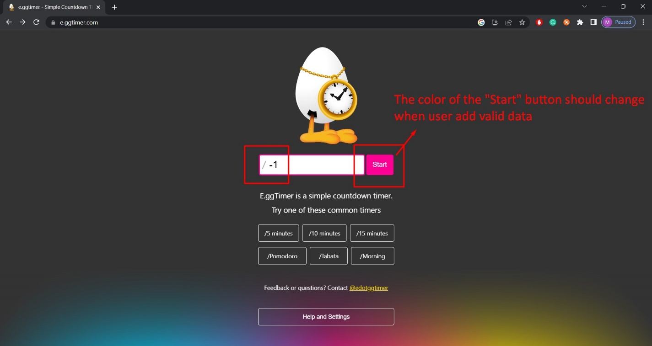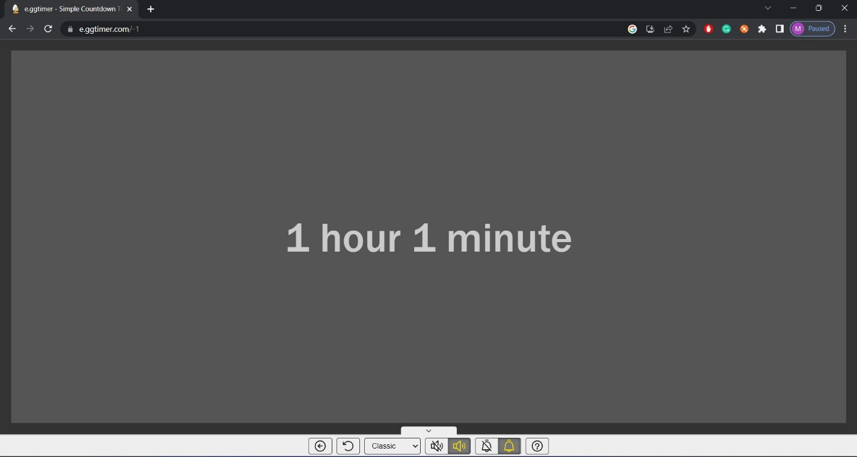

Bug-02: The countdown doesn't start with every 10-digit combination

Description: The system accepts the 10-digit number, but when the combinations of the numbers are “0000000000” and “1111111111” the countdown doesn't start, and there is no error message. The countdown start’s with every other 10-digit combination.

Steps of reproduction:

1. Navigate to <https://e.ggtimer.com/>
2. Add the 10-digit number “000000000” or “11111111111” in the text box
3. Click on the “Start” button

Bug-03: System accept “0”

Description: After entering "0" and clicking the "Start" button, the system starts counting down and a beep alarm is heard immediately.

Steps of reproduction:

1. Navigate to <https://e.ggtimer.com/>
2. Add the “0” in the text box
3. Click on the “Start” button

Bug-04: System accept a date from the past

Description: The countdown has begun after entering the date from the past “01.01.2022” and clicking the "Start" button.

Steps of reproduction:

1. Navigate to <https://e.ggtimer.com/>
2. Add “2022/01/01 in the text box
3. Click on the “Start” button

