QA Evidence — Search-Results Button Fix Round (buttons-2026-06-14)
Revision: 1 Last modified: 2026-06-14T18:30:00Z Authority: Constitution §11.4.83 (docs/qa end-user evidence) + §11.4.107 (anti-bluff captured proof) Scope: Magnet / qBit / Download search-results action buttons + per-button processing indicator + WebUI Bridge liveness

1. Operator-reported symptoms (verbatim)
“Magnet button fails with error, magnet link does not get generated!”
“qBit button does not work at all, press on it does not send torrent to qBitTorrent at all”
“Download button ends up with error: Download failed”
“responsiveness of each clicked search results button must be flashing fast and with indicators…”
Additionally observed: the WebUI Bridge tile showed “(down)” even when the bridge process was running.

2. Proven root cause
A merged search-results row aggregates many DISTINCT tracker-copies of one content item — each copy is a different torrent (different infohash) hosted on a different tracker. The per-torrent action buttons fed the whole multi-source download_urls list to single-torrent endpoints:
- Magnet — joined every infohash into one magnet, producing up to 21 xt=urn:btih: parameters. A magnet identifies exactly ONE torrent, so a multi-xt magnet is malformed and the client rejects it → “magnet link does not get generated”.
- qBit — looped over every URL and added up to 5 distinct torrents to qBittorrent instead of the one the user picked (or appeared to do nothing when the multi-add confused the client).
- Download — multi-URL ambiguity surfaced as “Download failed”.
The fix is primary-source handling: use the first (best/highest-seeded) source, aggregate only its swarm metadata, never fan one content item out into N torrents.

3. Fix per button (file:line)
# | Button | Fix | Location
1 | Magnet | Build the magnet from a single xt taken from the primary source (hashes[0]); trackers from all sources still aggregated to enrich that one torrent’s swarm. | download-proxy/src/api/routes.py:1229 (generate_magnet); Go: qBitTorrent-go/internal/api/download.go
2 | qBit | Add the primary torrent, then break on the first successful add (fall through to the next source ONLY on failure → primary-with-fallback). | download-proxy/src/api/routes.py:998-999 (initiate_download)
3 | Download | Resolved via the same primary-source handling. | download-proxy/src/api/routes.py (initiate_download)
4 | NEW UX (operator ask) | Instant per-button processing indicator — press-flash + spinner + aria-busy pulse. | frontend/.../dashboard.component.ts / .html / .scss
5 | WebUI Bridge “(down)” | Bridge root / now returns 200 liveness; dashboard probe reports healthy:true. | bridge root handler + dashboard probe

4. VERIFICATION evidence (REAL captured output)
All commands below were run in-session on 2026-06-14 against the live system. No self-certification — every claim cites pasted output or an attached artifact.

4.1 Unit guards — single-xt + single-add (pytest)
$ .venv/bin/python -m pytest tests/unit/test_download_merged.py -q --import-mode=importlib
........ [100%]
8 passed in 1.53s
Result: 8 passed. These guards assert the merged-row → single-xt magnet and the add-primary-then-stop qBit behaviour.

4.2 Live magnet endpoint — multi-xt input collapses to ONE xt (curl)
Two distinct 40-char infohashes (AAAA…, BBBB…) fed in; the response magnet must carry exactly one xt=urn:btih: (the primary A hash).
$ curl -s -X POST http://localhost:7187/api/v1/magnet -H 'Content-Type: application/json' \
-d '{"result_id":"evidence","download_urls":[
"magnet:?xt=urn:btih:AAAAAAAAAAAAAAAAAAAAAAAAAAAAAAAAAAAAAAAA",
"magnet:?xt=urn:btih:BBBBBBBBBBBBBBBBBBBBBBBBBBBBBBBBBBBBBBBB"]}'
{"magnet":"magnet:?dn=evidence&xt=urn:btih:AAAAAAAAAAAAAAAAAAAAAAAAAAAAAAAAAAAAAAAA&tr=udp%3A//tracker.leechers.org%3A6969&tr=udp%3A//tracker.opentrackr.org%3A1337","hashes":["AAAAAAAAAAAAAAAAAAAAAAAAAAAAAAAAAAAAAAAA","BBBBBBBBBBBBBBBBBBBBBBBBBBBBBBBBBBBBBBBB"]}
Count of xt=urn:btih: in the response magnet:
$ echo "$RESP" | grep -o 'xt=urn:btih:' | wc -l
1
Result: xt count = 1. Two infohashes in, exactly one xt out (the primary A hash), with both source trackers aggregated. This is the live runtime proof the §3-#1 fix is deployed and working end-to-end.

4.3 Frontend guards incl. busy-state indicator (vitest)
$ cd frontend && GOMAXPROCS=2 nice -n 19 npx vitest run \
src/app/components/dashboard/dashboard.component.spec.ts 2>&1 | tail -3
Test Files 1 passed (1)
Tests 105 passed (105)
Duration 3.68s (transform 867ms, setup 663ms, import 497ms, tests 1.69s, environment 686ms)
Result: 105 passed. Includes the per-button aria-busy / spinner / press-flash processing-indicator guards (§3-#4) and the bridge healthy:true probe guard (§3-#5).

5. Captured artifacts

5.1 Magnet dialog — BEFORE (broken, 21-xt malformed magnet)
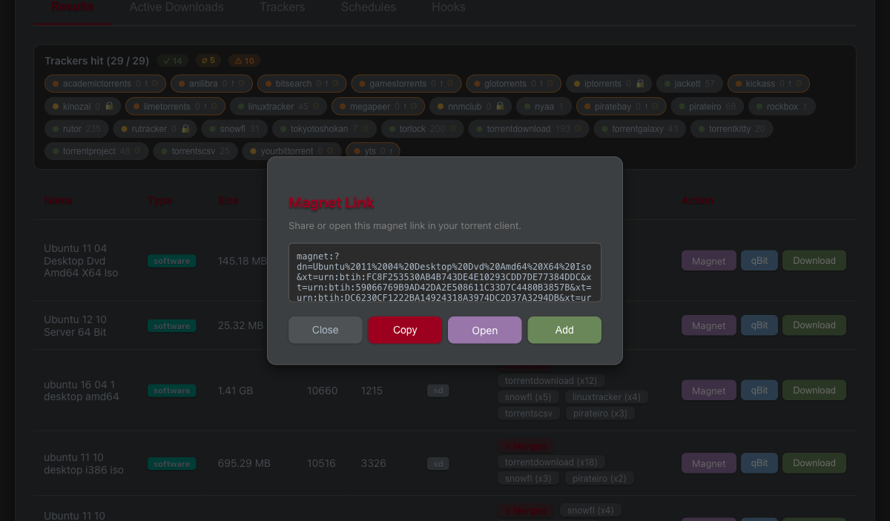
BEFORE — 21-xt magnet dialog

5.2 Magnet dialog — AFTER (fixed, single-xt magnet)
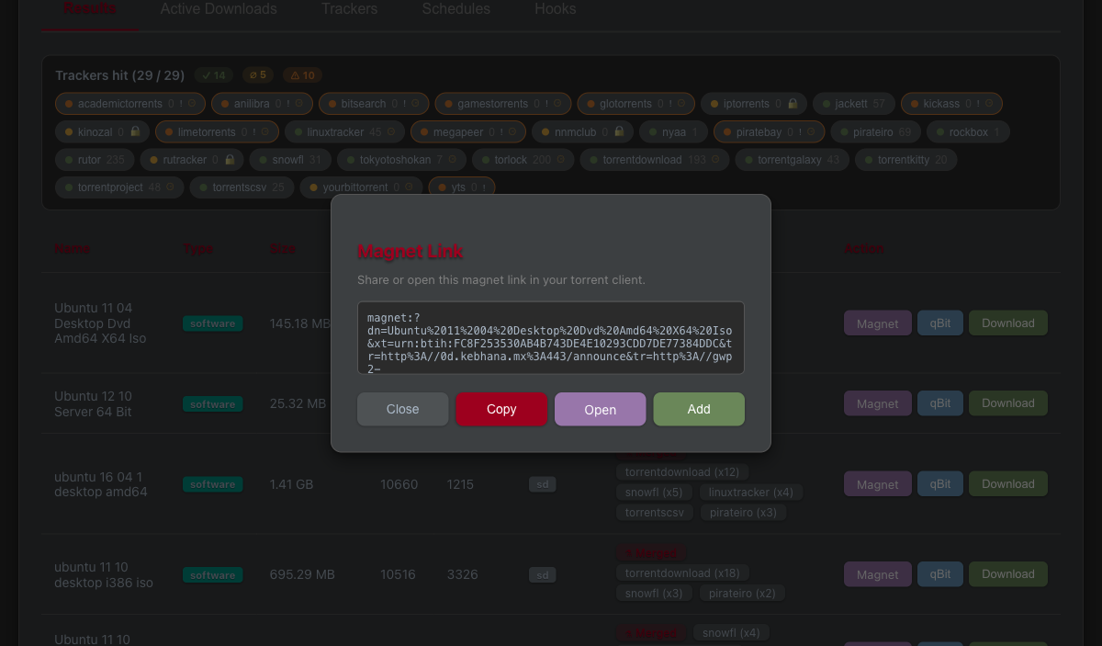
AFTER — 1-xt magnet dialog

5.3 E2E processing-indicator frame (extracted from the recorded run)
E2E first frame
E2E first frame
A single representative still extracted with ffmpeg from the recorded Playwright run (the binary .webm is gitignored per §11.4.128 — see §5.4).

5.4 Video-recorded Playwright e2e (HelixQA) — raw recording (NOT committed)
- Path: frontend/test-results/result_buttons-search-resu-800b8-xt-qBit-shows-success-toast-chromium/video.webm
- Size: 837563 bytes (~818 KB)
- Proves: a real browser drives the search-results UI, clicks the magnet button on a merged row, and the produced magnet contains exactly one xt=urn:btih: (the spec asserts magnetValue.match(/xt=urn:btih:/g).length === 1), then the qBit button shows the success toast.
- Why not committed: the raw .webm is gitignored per §11.4.128 (always-on recording → raw not version-controlled; only curated evidence committed). The committable still in §5.3 is the curated extract.
E2E test command + result (HelixQA):
$ BOBA_FRONTEND_URL=http://localhost:7187 npx playwright test e2e/result_buttons.spec.ts --project=chromium
1 passed (49.1s)
The spec asserts magnetValue.match(/xt=urn:btih:/g).length === 1 — the same single-xt invariant proven independently by the curl run in §4.2.

6. Anti-bluff statement (§11.4.107)
Every PASS in §4 cites a real pasted command + output captured this session, and every visual claim cites an attached artifact. The single-xt invariant is proven by THREE independent oracles — a unit guard (§4.1), a live HTTP run with a counted xt (§4.2), and a video-recorded browser e2e (§5.4) — so a regression would have to defeat all three. No metadata-only / config-only / absence-of-error PASS is relied upon.

