Advanced Driver Assistance Systems -
Past, Present and Future
Adnan Shaout, Dominic Colella, S. Awad
The University of Michigan Dearborn
The Electrical and Computer Engineering Department
Dearborn, Michigan

Abstract-Every year, automobile manufactures spend millions in funding development of cutting edge technologies to keep drivers safe and accident free while operating their vehicles. These technologies are known in the industry as Advanced Driver Assistance Systems and each one is controlled by complex real-time embedded systems. This paper will present the state of the art for Advanced Driver Assistance Systems and will give detailed overviews of past, present and future designs of each variant. Each overview will focus on the design of the actual real-time embedded system involved.

Key words- advanced driver assistance, adaptive cruise control, automated parking assistance, blind-spot information, drowsiness detection, electronic control unit (ECU), lane departure warning, pre-crash warning, human machine interface (HMI).
- Introduction
Automobile accidents account for 33,963 accidental deaths in the United States every year and these values are expected to rise by 65% over the next 20 years [50]. The National Highway Traffic Safety Association was formed in 1970 to, among other things, regulate and enforce safety standards placed on automobile manufactures. Since then manufactures have been competing to offer their customers the latest in cutting edge systems that will assist drivers in safe, accident free driving and parking. Most of the first, modern embedded systems were created at MIT and used by NASA in the late 1960s on the Apollo Space Program [27].

Embedded Systems in automobiles
Since the first use in the space program, embedded systems research has experienced rapid growth and development to the point that virtually every new car produced today has at least a few electronic control units (ECUs) on board. Since Driver Assistance systems directly impact safety and accident avoidance these systems are classified as real-time systems. Driver assistance ECUs need to be able to take inputs from various vehicle systems as well as the driver’s input and produces scheduled outputs in real time without missing deadlines. Failure to do so can result in vehicle accidents.
These systems are responsible for receiving multiple inputs and producing multiple, scheduled outputs and thus they are called multitasking. There are many strategies to how to schedule these tasks but hard real-time systems often use what is called preemptive priority scheduling. A shortened description of this strategy is that interrupts are used to suspend lower priority tasks when higher priorities need computing resources. Once the higher priority task is completed the previous task will commence. This allows the hard real-time system to meet all deadlines through meaningful prioritization of tasks. In terms of automobiles this can be the difference between a collision avoidance alarm going off and applying braking measures at the correct time or not.

- Advanced Driver Assistance Systems
There are various types of driver assistance systems, each working to provide a different feature to the user. Some systems are critical to the safety of the driver while others may be an added convenience to help the driver avoid minor accidents.
- Cruise Control
Inventions that would automatically control the speed of a motor vehicle have been around since the early 1900s and operated by the use of a mechanical device called a centrifugal governor. Electronic cruise control was first developed in the late 1960s but wasn’t put into mass production for automobiles until the mid-80s [43].
The first real-time embedded system designed for cruise control applications was developed by Kazumasa Nakamura as seen in figures 1 and 2 [37]. The system used a Fujitsu MB8842 Series 4-bit single-chip microprocessor with 2KB of ROM and 64B of RAM. The ECU utilizes a priority scheduling algorithm to assign resource time to on board tasks along with the inputs: speed signal from engine, “Cancel”, “Coast”, “Resume” and “Set” hard switches. Speed is set when the user depresses the “Set” switch and the ECU uses an analog to digital (A-D) converter to convert the speed signal into a value and saves that value to RAM to be used as the constant-speed reference. 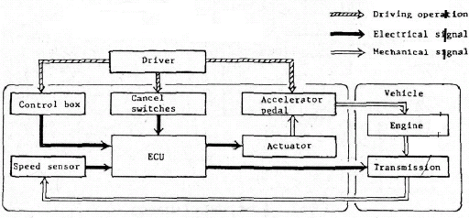
Figure 1. Embedded Cruise Control System [37]
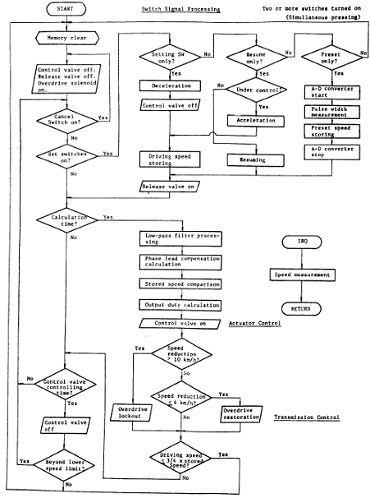
Figure 2. Flow Chart of ECU Signal Processing [37]
Cruise control offers several benefits to vehicle operators. The first is the reduction in driver fatigue by allowing the driver to rest their foot while on long drives. The next benefit is the added fuel economy cruise control offers. Fuel economy is increased due to the vehicle driving at constant speed controlled by the cruise control module.
- Adaptive Cruise Control
The next developments led to adaptive cruise control systems. With adaptive cruise control the vehicle utilizes a forward looking sensor to scan the area in front of the vehicle. When engaged, the system will operate as a standard cruise control system but will react to any vehicles coming into range of the sensors. The system will react by matching speed of the vehicle in the sensor’s range and apply braking and reduce acceleration to follow the vehicle at a user prescribed time-gap or distance. The complexity of adaptive cruise control increases compared to its predecessor due to the inclusion of inputs for the forward looking sensor and additional outputs to control braking [30]. Table 1 shows Auto Manufacturer’s Release of ACC and Sensor Type [3, 4, 11, and 30]

Manufacturer | Sensor Type | Model Year Offered
Chrysler | Laser | 2006
Ford | Radar | 2009
GM | Radar | 2004
Jaguar | Radar | 1999
Lexus | Laser | 2001
Mercedes | Radar | 2001
Saab | Radar | 2002
Toyota | Laser | 1998
Volvo | Radar | 2002
Table 1. Auto Manufacturer’s Release of ACC and Sensor
Early on the debate over sensor types used in adaptive cruise applications was between laser and radar based sensors. Laser sensors are attractive because they offer a low-cost option while being easy to package due to small size. The drawback to laser sensors is their inaccuracy in adverse weather conditions and laser beams getting blocked by dirt build up on sensor lenses. Radar sensors offer a farther range but are more expensive and harder to package. A radar sensor can be 14 x 7 x 10 cm where as laser sensors can be a quarter of that size [30].
One of the first developments in the technology was by Bjornberg [22]. In his paper he designs a 4 part system: 1) forward looking radar sensor to detect the preceding car, 2) microcontroller to I/O handling and signal processing, 3) HMI-unit to present information to driver and take control inputs, and 4) output to actuators to control acceleration and braking. Figure 3 shows the system environment.
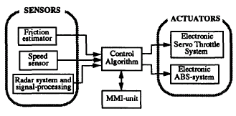
Figure 3. System Environment [1]
The main goal of Bjornberg’s design is to safely follow the preceding vehicle at the user prescribed distance gap. Additionally, the controller needs to maintain occupant comfort by applying smooth adjustments to acceleration and braking to reduce jerking motions of the vehicle. The controller also needs to aid in fuel conservation by maintaining a constant speed and reducing the time spend making adjustments to throttle actuators. These goals stress the real-time system by making constant demands of CPU resources for adjustments calculations based on speed and radar inputs. The speed control algorithm is computed from the difference between the actual speed and the driver’s requested speed multiplied by a constant. This output is limited by an upper and lower value to control driver comfort by reducing large increases or decreases in acceleration which would produce a jerking motion of the vehicle. The distance control algorithm combines the vehicle speed input along with the speed of and distance to the preceding vehicle. These inputs are combined with the driver’s input of distance gap to produce a distance control output. The two outputs of the speed and distance algorithms are combined and filter to produce output signals to the braking and throttle actuators. Systems designed as above were first produced in the late 1990s in Toyota’s Lexus luxury sedans. Other manufactures also introduced systems later that were either based on radar or laser based forward-looking sensors and controlled speed reduction either though braking or drastically reducing acceleration.
Future developments in this technology are leading to more advanced controllers that can allow for a smoother ride, faster reaction times and the ability to bring the vehicle to a full stop based on feedback from preceding vehicle distance. In a 2003 journal article by Lh Cai, A. B. Rad, W. L. Chan and M. L. Ho a system is designed based on a Neural-Fuzzy controller [34]. The basic concept of the system is similar to Bjornberg’s in that the two main goals are matching of the preceding vehicle speed and maintaining a safe follow distance. The system uses a fuzzy controller with three inputs: distance to and velocity of preceding vehicle and acceleration of your vehicle. The output of the fuzzy controller is the change in throttle actuator control. The use of fuzzy logic in this design allows for dynamic predictions of the host vehicle’s accelerations and allows for smoother responses in throttle control.
A 2005 IEEE article by Anouck Girard, Stephen Spry, and J. Karl Hedrick proposes an adaptive cruise control system paired with the ability to wireless communicate with the host vehicle [26]. This will allow for more accurate following of vehicles and response time based host vehicle information directly sent to your vehicle wireless over the wireless connection. The controller in this case must operate in three different modes: cruise, adaptive cruise, and cooperative adaptive cruise control. While in cooperative mode the controller must take inputs from speed and radar sensors as well as driver HMI and also take inputs from the preceding vehicles data sent wirelessly. These inputs are all combined in to the acceleration/braking algorithms to produce outputs to designated actuators for control.
A 2010 IEEE article by students from Gudlavalleru Engineering College in India have developed a combined system that controls adaptive cruise control elements as well engine management systems for a more integrated vehicle control system [48]. The adaptive cruise system uses an infrared sensor to detect vehicles in a 120m area in front of the vehicle. The controller takes the sensor input and combines it with speed and user inputs to output typical adaptive cruise elements. This system will integrate itself with the engine management controller by providing data to reduce or increase fuel injection rates to control throttle outputs in a more direct manner. A system like this takes in both adaptive cruise sensor data as well as engine sensor data to produce outputs that will increase occupant safety as well as engine performance.
Adaptive cruise control systems all have similar offers to drivers by detecting vehicles in their paths. These systems will increase safety of cruise control use by detecting vehicles ahead and applying braking to slow the vehicle. Systems like this seem to aid in vehicle safety by making up for the inattentiveness that comes from long periods of cruise control use.
- Precrash Systems
Systems that can detect and alert the driver to imminent accidents are known as precrash systems. These systems can use radar or laser sensors oriented in a forward looking manner as well as video cameras to detect vehicles and alert the driver in a number of ways and even prepare them for the crash by precharging the brakes, adjusting the seats for added support, or tensioning the seatbelts. The systems first appeared in the mid 2000s by Toyota and Honda and incorporated forward looking sensors that would detect imminent collisions and tension the seatbelts and charge the brakes. By the late 2000s similar systems had been adopted by the remaining manufacturers such as Ford, Mercedes and BMW. These systems often piggy back off the sensor data provided by adaptive cruise control systems but have an increase number of outputs and their embedded systems need to be much more diligent in their event handling.

Manufacturer | Sensor Type | Model Year Offered
Audi | Radar/Video | 2011
Ford | Radar | 2009
Honda | Radar | 2003
Mercedes | Radar | 2002
Toyota | Radar | 2003
Volkswagen | Radar/Video | 2011
Volvo | Radar/Video | 2007
Table 2. Precrash System Sensor Type of Year Offered [1] [6] [7] [12] [14] [16] [32]
The varying manufacturers of these systems also offer differing feedback to the drivers when crashes are imminent. Audi’s Pre-Sense Plus System has four phases of operation: 1) provide visual and audible warnings and roll windows up, 2) apply light braking to gain driver attention, 3) apply high degree of automatic braking, 4) decelerates vehicle and applies full braking power[32]. Ford’s Collision Warning with Brake Support queues visual and audible alarms as well as precharges the brakes to increase the driver’s braking performance [6]. Honda’s Collision Braking Mitigation System has three phases: 1) audible and visual warnings, 2) pretension the seatbelt for the driver, 3) increased seatbelt tensioning and automatic braking [7]. Mercedes offers their Pre-Safe system which applies 40% partial braking and also alerts the driver of the incident [12]. Toyota’s Pre-Collision System offers similar features with seatbelt pretensioning and partial brake application [14]. Volkswagen’s Front Assist also offers automatic braking as well as seatbelt pretensioning [16]. Volvo’s Collision Warning with Auto Brake offers audible and visual warnings, seatbelt pretensioning, and automatic braking [1].
Manufacturer | System Name | Precrash System Response
Audi | Pre-Sense Plus | 1) provide visual and audible warnings and roll windows up, 2) apply light braking to gain driver attention, 3) apply higher degree of automatic braking, 4) decelerate vehicle and apply braking power
Ford | Collision Warning with Brake Support | Visual and audible alarms, precharge the brakes to increase the driver’s braking performance
Honda | Collision Braking Mitigation System | 1) audible and visual warnings, 2) pretension the seatbelt for the driver, 3) increased seatbelt tensioning and automatic braking
Mercedes | Pre-Safe | 40% partial braking and alert the driver of the incident
Toyota | Pre-Collision System | Seatbelt pretensioning and partial brake application
Volkswagen | Front Assist | Seatbelt pretensioning and partial brake application
Volvo | Collision Warning with Auto Brake | Seatbelt pretensioning and partial brake application
Table 3. Precrash Systems and Associated Responses [1] [6] [7] [12] [14] [16] [32]
A 2002 paper written by a group from the National Technical Institute of Athens proposes a system that incorporates both radar based sensors as well as an infrared cameras to detect obstacles in the vehicle’s path [18]. The system’s architecture is divided into several software modules that control sensor data, data processing, threat assessment and outputs to vehicle interface.
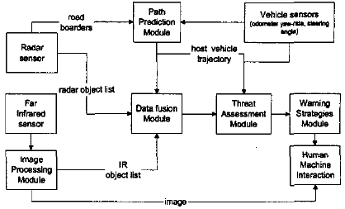
Figure 4. Precrash System Dataflow [18]
Camera and radar sensor data are organized into object lists that are then used by the data fusion module. The data fusion module takes the sensor data and creates tracking data for each obstruction and assigns priorities into lists that are then used by the threat assessment module which polls each threat tracked by the data fusion module. Once a threat determined to be associated with an impeding collision data is sent to the user interface to notify the driver to take precautions to avoid the collision.
In a 2003 IEEE paper by a group from the Chemnitz, University of Technology in Germany a more standard version of precrash system is proposed [42]. The system incorporates 4 sensors that are in a forward-looking orientation that have a 140 degree field of view. The sensors input their data to microcontroller called a Radar Decision Unit that uses real-time LynxOS as its operating system. The RDU’s output is the position of objects in sensor range based on information from the 4 sensors as well as vehicle information read from the existing vehicle Controller Area Network (CAN) bus. Each radar sends data to the RDU on its own input channel and the data is read in a FIFO format. RDU needs to prioritize which objects are collision critical based on relative position and velocity and then once the object enters a critical zone the system warns the driver of the crash relevant situation. As the RDU can track multiple objects in range of the sensors the RDU must make classifications on each tracked object and discerns which can be dismissed.
A 2004 paper by students at the National Chiao Tung University in Taiwan discusses a CAN based system that incorporates a collection of laser and radar sensors that monitor collision from all angles [19]. The controller in this design incorporates two subsystems: 1) laser sensor based to monitor front-end collisions and 2) radar sensor on each side to monitor side collisions. The embedded system will take receive input from all sensors appropriately and assign a threat index to each tracked object on any of the sensors. The threat index will be computed from vehicle speed, tracked object speed and distance to tracked object. Once the thread index passes a midrange limit an LED will blink implying an object is getting close to that side, if the threat index increases past an upper limit an LED will light solid implying immediate thread of collision. The embedded system here must take inputs from each sensor as equal prioritized interrupts to the system as well as equate the sensor data to threat index in equal priority. The highest priorities in the scheduling hierarchy will be for the mid-range alarm and for the upper threat index limit alarm which would hold highest priority for task interrupts.
The most complex system discussed so far has been by a group from the Wuhan University of Technology in China [41]. The system incorporates a rear-view mirror mounted video camera that is forward facing for object detection. The system is powered by a Texas Instruments Davinci Series TMS320DM6437 and was chosen for its automotive grade robustness and automotive vision systems functionality. The core can operate at a frequency of 600MHz and has a peak speed of 4800 MIPS which is helpful for processing of digital video signals. The chip also uses an enhanced Direct Memory Access controller with 64-channels to support complex data transmissions without taxing the CPU with I/O handling. Three sensor types were reviewed for this application: a laser sensor, infrared sensor and video camera. The video camera can detect color, outline, and type information on obstacles without the drawbacks of the other two and is thus the chosen sensor. The system communicates with the CAN network of the vehicle using an on-chip peripheral called a high-eng CAN controller (HECC) which will transmit control signals for sounding collision alarms and actuators for throttle and braking.

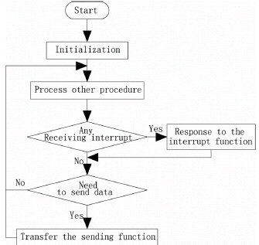
Figure 5. Flow of Communication Through HECC [41]
The TMS320 processes video signal from the camera along with vehicle speed data from the CAN bus to analyze and detect threats of collision. When the threat level reaches a mid-range limit it will sound an alarm. If the threat level is high enough the control for the braking and/or throttle actuators need to be signaled to aid in stopping the vehicle.

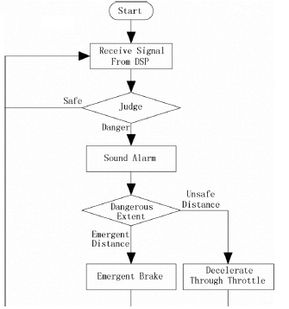
Figure 6. Control Flow of Precrash System [41]
- Blind Spot Information Systems
Blind spots are the areas around a vehicle where the driver cannot detect an object using their mirrors and must turn their heads away from the road. These areas are usually over the right and left shoulders of the driver and are out of range of the side- and rear-view mirrors. The system was first introduced by Volvo in their S80 sedan and has since been introduced in its parent company, Ford, products. Production versions offered today typically use radar based sensors but future researched technologies offer systems based on vision systems and advanced radar arrays. The 2011 Infiniti M product will be the first commercially offered vehicle to assist in steering the vehicle out of the lane if an object is detected in the blind spot [5]. Most of the systems offered on the market today, aside from the Infiniti reference above, offer similar blind spot systems that alert the driver of an object though illuminating LEDs on or near each side-view mirror [2].
An IEEE paper written by a group at the Automotive Research & Testing Center in Taiwan proposes a method to detect objects in vehicle blind spots using cameras [23]. The system designed here is divided into three units: input unit, processing unit, and output unit.

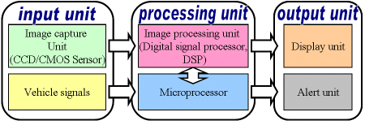
Figure 7. 3-Unit Design of Blind Spot System [23]
The input unit will handle receiving of the image data from a Charge-Coupled Device (CCD)/ Complementary Metal-Oxide-Semiconductor (CMOS) camera as well as steering wheel angle and speed sensor data from the vehicle’s CAN network. The processing unit is comprised of a digital signal processor and microprocessor to handle the inputs. The image data will use a theory called image entropy estimation to convert the data into a one dimensional (1-D) distance to object value. The resulting flow of information through the processing unit is show below.

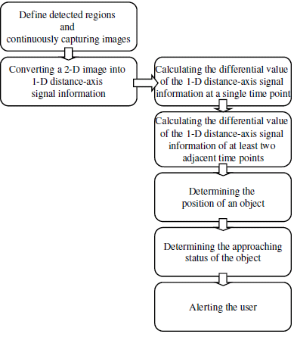
Figure 8. Data Flow of Processing Unit [23]
Once the determined approaching status of an object has been deemed a threat an alert to the user is made through the output unit. The output unit includes a display showing a view of the camera as well as a unit to alert the driver by means of an audible and visual alarm. The complexity of a system like this makes it too expensive for use on common consumer vehicles but the technologies employed here allow for faster reaction times and less chances for false positive results for the driver.
A paper by Uvais Qidwai, a Computer Science & Engineering Department student at Qatar University, uses an advanced four sensor array along with a complex fuzzy logic controller to determine objects in blind spots [40]. Typical systems offered today employ two sensors mounted in the rear wheel wells where this system uses a side-view mirror as well as bumper sensors on the right and left sides of the vehicle. The mirror mounted sensors are S1 and S2 while the bumper mounted sensors are B1 and B2. The system uses a BASIC Stamp embedded microcontroller manufactured by Parallax, Inc which allows for software to be written in the BASIC programming language.

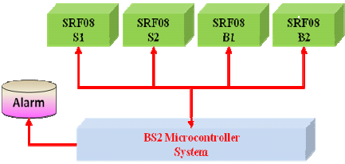
Figure 9. System Architecture [40]
When the inputs are read into the microcontroller by using a polling technique where all the sensors are assigned a unique address in memory and are accessed over the inter-integrated (I²C) circuit bus. The data is read sequentially and sent to the Fuzzy Interface System (FIS) to determine if an object is detected. Object detection is done by the FIS through assigning a degree of membership to sensor data within a set of possibilities. This stratifies the yes/no decision of object detection and increases accuracy of the system. The FIS will employ a look-up table based on sets of rules to decide when the detection of an object should signal the alarm to the user.
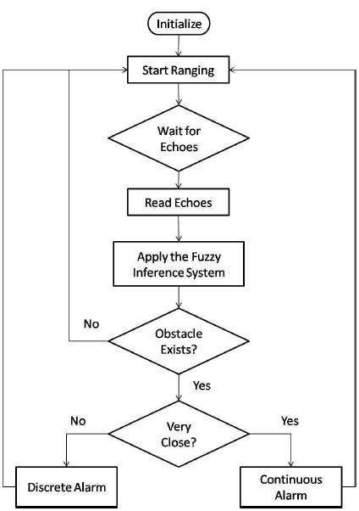

Figure 10. Fuzzy System Flow Chart [40]
- Lane Departure Warning System
Systems that monitor unintended lane changes by drivers were first implemented as aftermarket systems for semi-truck drivers but were adopted by the consumer vehicle community in 2001 with Nissans Lane Keeping Support system [46]. Systems like these are onboard embedded systems that monitor if the vehicle is leaving the current lane without use of a turn signal to detect drowsy or careless drivers to help prevent accidents. Lane departure systems can either alert the driver if a lane change is detected without the use of a turn signal or go a step past alerting the driver and take steps to control vehicle steering to stay in the current lane. Driver alerts usually come in the form of audible or visual and can even go as far as vibrating the steering wheel to act as a simulated highway rumble strip. Lane departure system slowly grew more common over the 2000s to currently being included on luxury models from most automotive manufacturers. These systems can be temporarily deactivated when the turn signal is engaged or permanently deactivated using some form of HMI. Products like this are constantly being redesigned to produce cheaper systems while the embedded systems that drive them are increasing in complexity and ingenuity.
Manufacturer | Model Year Offered
Audi | 2007
BMW | 2007
Ford | 2010
GM | 2008
Honda | 2003
Kia | 2010
Mercedes | 2009
Nissan | 2001
Toyota | 2002
Table 4. LDWS Offerings Timeline [8][9][15][17] [28][36][46][47]
The system offered by Audi is called Lane Assist and features a forward looking camera and emits a warning chime from the instrument cluster when lane departure is detected [15]. BMW’s system, called Lane Departure Warning, vibrates the steering wheel when unintended lane departures occur [36]. Ford’s Lane Departure Warning System uses a forward looking camera and also sounds chimes and directs the driver to steer the vehicle back in the lane [47]. Lane Departure Warning offered by General Motors uses chimes and a warning LED on the instrument cluster [8]. Honda’s Lane Keep Assist System uses a windshield mounted camera to detect unintended lane changes and provides 80% of steering torque to aid the driver in returning to their lane [7]. KIA’s Lane Departure Warning system offers similar output in the form of audible chimes and a visual telltale on the instrument panel [28]. Mercedes’ system, Lane Keeping Assist, vibrates the steering wheel [9]. Nissan offers Lane Keeping Support which uses a camera system to detect lane changes and sound a warning alarm when detected [46]. Toyota’s Lane Monitoring System uses a camera for lane departure detections and will counter steer the vehicle if needed [17]. These systems offer two different forms of feedback to the driver: visual/audio and steering wheel vibration or counter steering actions. While the counter steering actions would seem to be safest they are also the most invasive and could possible interfere with normal operation if the vehicle suffers some failure. The systems that warn the driver seem overall to be very safe while also very reliable; this combination would make them more attractive to vehicle buyers in this author’s opinion.

OEM | System Name | Lane Departure Warning System Response | Invasive Level
Audi | Lane Assist | Systems emits a warning chime when lane departure detected | Low level, driver still fully controls vehicle
BMW | Lane Departure Warning | Vibrates steering wheel to simulate rumble strip to notify driver of lane departure | Moderately invasive but driver still in full control
Ford | Lane Departure Warning System | Sounds chimes and uses visual feedback to direct driver back into lane | Low level, driver still fully controls vehicle
GM | Lane Departure Warning | Sounds chimes and uses visual feedback to direct driver back into lane | Low level, driver still fully controls vehicle
Honda | Lane Keep Assist System | Provides 80% torque on power steering to guide vehicle back into lane | Highly invasive, system has high level of control over vehicle
Kia | Lane Departure Warning | Sounds chimes and uses visual feedback to direct driver back into lane | Low level, driver still fully controls vehicle
Mercedes | Lane Keeping Assist | Vibrates steering wheel to simulate rumble strip to notify driver of lane departure | Moderately invasive but driver still in full control
Nissan | Lane Keeping Support | Systems emits a warning chime when lane departure detected | Low level, driver still fully controls vehicle
Toyota | Lane Monitoring System | Provides minor steering torque to guide vehicle back into lane | Highly invasive, system has high level of control over vehicle
Table 5. Overview of LDWSs [8][9][15][17] [28][36][46][47]
A 2006 paper by Pei-Yung Hsiao and Chun-Wei Yeh of the Chang Gung University in Taiwan speaks about a portable system that runs off two embedded modules and uses a CMOS image sensor for input [38]. The first processor is an ARM based processor that is used for computation of image data coming in from a reconfigurable Field Programmable Gate Array (FPGA) used to handle I/O. The two modules communicate over an Advanced Microcontroller Bus Architecture (AMBA) High-performance Bus (AHB).

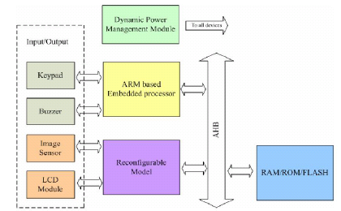
Figure 11. LDWS Architecture [48]
The ARM processors refines the camera image in a five step process: 1) Image Preprocessing-smoothing an image and reducing noise, 2) Peak and Edge Finding-determining the straight and continuous edges of road lane markers, 3) Edge Connection-Creating lines from edges and peaks found in previous process, 4) Line Segment Combination-combining line segments to form lane boundaries, 5) Lane Boundary Selection-longest line segments selected as master lane boundary. Lane boundaries are monitored through an algorithm based off 10 continuous camera frames. Once a departure is detected an alarm is sounded through a buzzer and displayed on an LCD Module.
A 2009 IEEE paper by Stephen P. Tseng, YungSheng Liao, Chih Hsie Yeh, and LiKung Huang presents a more complex system based on a digital signal processor [45]. The real-time system is based on a dual core ADIBlackfin 561 DSP processor and the two cores are labeled as A and B. Core A will control inputs, image processing and lane departure recognition while Core B will handle outputs and other vehicle information processing.
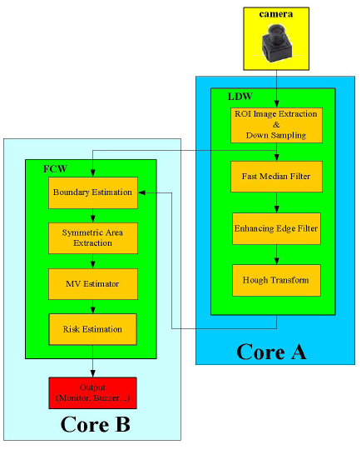
Figure 12. LDWS Processor Division [45]
The system utilizes inputs from a windshield mounted video camera that is continuously capturing images which will be processed digitally and input into the DSP. The images are processed by the DSP to determine lane markers on the road and distance between the vehicle and the markers. The system will determine lane departure through the driver’s inputs of braking, speed and turn signal use and, if needed, will warn the driver visually/audibly while also engaging the turn signals to warn other drivers of the possible lane departure.
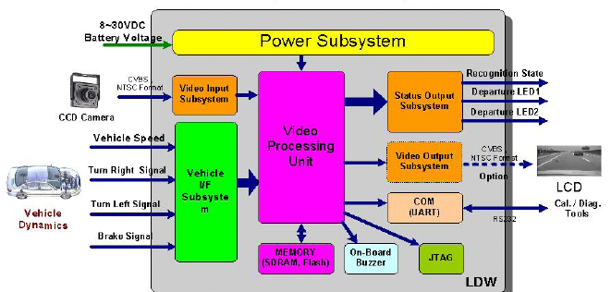
Figure 13. LDWS I/O Block Diagram [45]
User of a powerful dual core processor and advanced digital signal processing enable a system like this have fast, real-time computing efficiency while also accurately detecting lane departure through various lighting and weather conditions.
- Autonomous Parking Assistance Systems
Vehicle systems that can aid the driver in maneuvering the vehicle into parking spaces were first developed in the mid 1990s but haven’t been put into mass production until 2003 with the Toyota Prius. Later companies like BMW, Mercedes and Ford followed suit with similar systems in the late 2000s. The typical system uses a vehicle surrounding radar array to find parallel, diagonal, or perpendicular parking spots. The systems will take control of the power steering system to direct the vehicle in to the vacant spot while the driver controls acceleration and braking. Direction is given to the user through some form of HMI. While today’s system are controlled by on-board microcontrollers and only use CAN data inputs of vehicle position from radar sensors future systems could use GPS inputs and communicate with parking lot management systems via wireless fidelity.
An IEEE paper written by Massaki Wada, Kang Sup Yoon, and Hideki Hashimoto illustrates a complex system that uses multiple sensor inputs and data from outside vehicle sources transmitted wirelessly [49]. The system is composed of three different microcontrollers: 1) the path/parking system PC, 2) a parking administration PC that is monitors the parking lot itself, 3) the HMI PC that will transmit data to the vehicle’s driver. The three systems communicate over an in car Ethernet network with the Parking Administration PC sending data wirelessly over a Local Area Network (LAN).
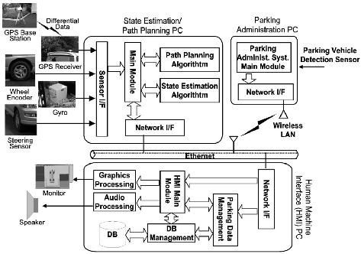
Figure 14. Advanced Parking Assistance System [49]
- Drowsiness Detection System
Sleep-related vehicle accidents account for a large portion of road accidents annually. Systems that can detect a driver’s patterns and respond through various means can help aid in reduction of these cases. The first drowsiness detection system was developed by Toyota for its Lexus products in 2006 and used a camera placed on the steering column to detect eye movements of the driver [10]. The camera is a Charge Couple Device (CCD) that can detect movements using infrared LEDs. Later companies like Mercedes offered Attention Assist in 2009 and Ford with Driver Alert in 2010 [13][33]. These systems all base their inputs off tracking of driver head or eye patterns. Future systems will be able to detect all facial movements or even biomedical signals from the brain to determine the state of the driver .
Toyota’s Driver Attention Monitor for its Lexus line uses LED sensors to monitor eye movements to detect driver attention [10]. When drowsiness is detected the system will use audible and visual warning alarms, if the driver still doesn’t respond the system will apply braking and sound another alarm. Ford’s Driver Alert uses cameras and radar sensors mounted on the car to detect erratic vehicle movements, not using the system to monitor the driver as Lexus does[33]. If the system detects the driver’s inattentiveness it will use an audible and visual warning to alert the driver. Volkswagen’s Driver Alert Control tracks the driver’s eye movements and uses a visual and audible warning to alert the driver[13]. Mercedes Attention Assist system uses sensor data from steering angle, braking, acceleration, and time of day to detect the driver’s alertness and will alert them through visual and audible warnings [20]. Volvo’s Driver Alert Control works similar to Ford’s in that it uses vehicle sensor data to determine the driver’s alertness and warns them using visual and audible alarms[35]. While all these systems seem to offer the same results the Toyota/Lexus system seems to be the most invasive. The Toyota/Lexus system provides braking if a driver is determined to be driver but a system like this seems to be too obtrusive on the driver’s control of the vehicle. The best options seem to offer visual/audible feedback that the driver can react too without interfering with their control of the car.
OEM | Sensor Type | Response
Ford | Based on Vehicle Sensor Data | Visual/Audible Alert
Lexus | LED sensor to monitor eye movements | Phase 1) Visual/Audible Alert  Phase 2) Vehicle Braking
Mercedes | Based on Vehicle Sensor Data | Visual/Audible Alert
VW | LED sensor to monitor eye movements | Visual/Audible Alert
Volvo | Based on Vehicle Sensor Data | Visual/Audible Alert
Table 6. Drowsy Detections System Overviews [10][13][20][33][35]
In a paper 2007 by Tianyi Hong and Huabiao Qin from the South China University of Technology bases its detection algorithm on the biomedical concept of PERCLOS or PERcentage of eye CLOSure [44]. The system uses an advanced algorithm to track the face closely to reduce the occurrence of inaccurate PERCLOS detection.

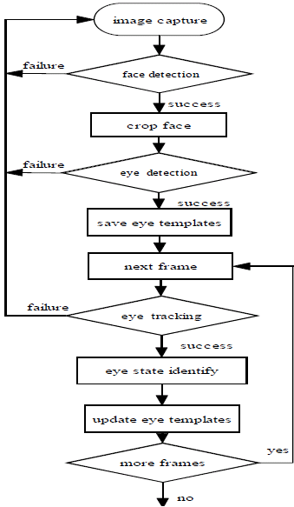
Figure 15. Drowsiness Detection System Flowchart [44]
A 2008 paper by a group of IEEE members illustrates a system based on a biomedical signal monitor that is connected wirelessly to an embedded system to monitor the brain for drowsiness [24]. The system incorporates a brain wave sensor built into a hat that would transmit data to the system. The embedded system is based off a dual core Texas Instruments platform with one core being an ARM925 processor and the other a TMS320C55x DSP processor. The DSP will handle the biomedical data from the sensors and the ARM processor will handle I/O.
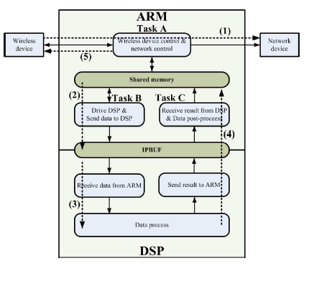
Figure 16. Drowsiness Detection Dual Core Design [24]
The dual cores communicate using an Interprocessor Buffer (IPBUF). The ARM processor uses an embedded multitask scheduling mechanism to manage I/O handling of signals to and from the DSP.
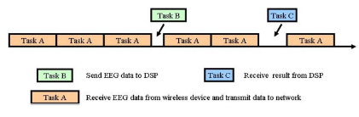
Figure 17. Diagram of Multitask Scheduling in ARM Core [24]
Once the DSP signals the ARM core to alert the driver a signal is sent to the warning device. The warning device incorporates a high frequency audio signal.
- Conclusion
Automotive safety systems have become a major target for real-time embedded system technology. The use of efficient scheduling algorithms and powerful but compact processors has allowed these miniature systems to offer powerful benefits to the vehicle operators. Future systems in development are heading towards autonomous driving vehicles and highway networks of driverless smart vehicles all safely heading toward their destinations.
References
- "Adaptive Cruise Control and Distance Alert - to help the driver keep a proper distance to the vehicle in front," Internet: http://www.zercustoms.com/news/Volvo-Collision-Warning-with-Auto-Brake.html, Aug. 28, 2007.
- "Blind Spot Detection Systems in 25% of cars by 2016,” Internet: http://www.abiresearch.com/press/3637-Blind+Spot+Detection+Systems+In+25%25+of+New+Cars+by+2016; Mar. 15, 2011.
- "Chrysler 300 Cars Equipped with Hella's Adaptive Cruise Control," Internet: http://www.theautochannel.com/news/2006/11/14/028570.html, Nav. 14, 2006.
- "Delphi's Adaptive Cruise Control Technology Featured on Cadillac XLR," Internet: http://www.theautochannel.com/news/2003/06/23/163587.html, June 23, 2004.
- "First Drive: 2011 Infiniti M Protoype,” Internet: http://www.motortrend.com/roadtests/sedans/112_1001_2011_infiniti_m_prototype_drive/driving_impressions.html; Oct. 1, 2011.
- "Ford's Latest Safety Brakethrough - Collision Warning with Brake Support," Internet: http://media.ford.com/article_display.cfm?article_id=29188, Aug. 6, 2009.
- "Honda Announces a Full Model Change for the Inspire," Internet: http://world.honda.com/news/2003/4030618_2.html, June 18, 2003.
- "Lane Departure Warning," Internet: http://www.mobileye.com/node/58, June 13, 2007.
- "Lane Keeping Assist: Steering Wheel vibrates to warn the driver if the car leaves its lane unintentionally," Internet: http://media.daimler.com/dcmedia/0-921-614216-1-1147529-1-0-0-0-0-0-11702-0-0-1-0-0-0-0-0.html, Nav. 12, 2008.
- "LS460 achieves a first in preventative safety," Internet: http://www.newcarnet.co.uk/Lexus_news.html?id=5787, Aug. 30, 2006.
- "New Safety Features From Ford: Collision Warning, Adaptive Cruise Control and BLIS", Internet: http://www.inautonews.com/new-safety-features-from-ford-collision-warning-adaptive-cruise-control-and-blis, October 6, 2008.
- "New S-Class to Debut PRE-SAFE Radar," Internet: http://www.worldcarfans.com/10506168932/new-s-class-to-debut-pre-safe-radar; June 20, 2005.
- "Paris: New VW Passat loaded with ADAS including fatigue detection,” Internet: http://telematicsnews.info/2010/09/29/vw-new-vw-passat-loaded-with-adas_s1293/, Sept. 27, 2010.
- "Safety matters: advanced crash avoidance technology finds its way into production vehicles in Japan". Internet: http://findarticles.com/p/articles/mi_m3012/is_8_184/ai_n6173980/pg_2/?tag=mantle_skin;content, July, 2004.
- "The Audi Q7 4.2 TDI," Internet: http://www.audiworld.com/news/07/audi-q7-42-tdi/content.shtml, March 1, 2007.
- "To The Point: The New Toureg Volkswagen SUV is one of the safest automobiles of all time," Internet: https://www.volkswagen-media-services.com/medias_publish/ms/content/en/pressemitteilungen/2010/03/04/to_the_point__the.standard.gid-oeffentlichkeit.html, Mar. 4, 2010.
- "Toyota Cardina," Internet: http://www.japanvehicles.com/newcars/toyota/Caldina/main.htm, Feb. 2001.
- Amditis, A.; Polychronopoulos, A.; Karaseitanidis, I.; Katsoulis, G.; Bekiaris, E.; , "Multiple sensor collision avoidance system for automotive applications using an IMM approach for obstacle tracking," Information Fusion, 2002. Proceedings of the Fifth International Conference on, vol.2, no., pp. 812- 817 vol.2, 2002.
- An-Ping Wang; Jie-Cheng Chen; Pao-Lo Hsu; , "Intelligent CAN-based automotive collision avoidance warning system," Networking, Sensing and Control, 2004 IEEE International Conference on , vol.1, no., pp. 146- 151 Vol.1, 21-23 March 2004.
- Begun, Daniel A.; "Mercedes Implements a Drowsy Driver Alert System," Internet: http://hothardware.com/News/Mercedes-Implements-a-Drowsy-Driver-Alert-System/, December 26, 2008.
- Bing-Fei Wu; Chao-Jung Chen; Chih-Chung Kao; Chia-Wei Chang; Shen-Ting Chiu; , "Embedded weather adaptive lane and vehicle detection system," Industrial Electronics, 2008. ISIE 2008. IEEE International Symposium on, vol., no., pp.1255-1260, June 30 2008-July 2 2008.
- Bjornberg, A.; , "Autonomous intelligent cruise control," Vehicular Technology Conference, 1994 IEEE 44th , vol., no., pp.429-433 vol.1, 8-10 Jun 1994.
- Chen, C.T.; Chen, Y.S.; "Real-time approaching vehicle detection in blind-spot area," Intelligent Transportation Systems, 2009. ITSC '09. 12th International IEEE Conference on, vol., no., pp.1-6, 4-7 Oct. 2009.
- Chin-Teng Lin; Yu-Chieh Chen; Teng-Yi Huang; Tien-Ting Chiu; Li-Wei Ko; Sheng-Fu Liang; Hung-Yi Hsieh; Shang-Hwa Hsu; Jeng-Ren Duann; , "Development of Wireless Brain Computer Interface With Embedded Multitask Scheduling and its Application on Real-Time Driver's Drowsiness Detection and Warning," Biomedical Engineering, IEEE Transactions on , vol.55, no.5, pp.1582-1591, May 2008.
- Clanton, J.M.; Bevly, D.M.; Hodel, A.S.; "A Low-Cost Solution for an Integrated Multisensor Lane Departure Warning System," Intelligent Transportation Systems, IEEE Transactions on, vol.10, no.1, pp.47-59, March 2009.
- Girard, A.P.; Spry, S.; Hedrick, J.K.; "Intelligent cruise control applications: real-time embedded hybrid control software," Robotics & Automation Magazine, IEEE, vol.12, no.1, pp. 22- 28, March 2005.
- Hall, Eldon C.; "Integrated Circuits of the Apollo Guidance Computer," Internet: http://klabs.org/history/history_docs/integrated_circuits/ic4-po.pdf, Jan. 15, 2009.
- Han, Il-woong; "Safe Driving and Parking with Cadenza!" "Internet: http://kia-buzz.com/?p=4040, Feb. 19, 2010.
- Jing-Fu Liu; Jui-Hung Wu; Yi-Feng Su; "Development of an Interactive Lane Keeping Control System for Vehicle," Vehicle Power and Propulsion Conference, 2007. VPPC 2007. IEEE, vol., no., pp.702-706, 9-12 Sept. 2007.
- Jones, Willie D.; "Keeping Cars From Crashing," IEEE Spectrum, pp 40-45, September 2001.
- Kaszubiak, J.; Tornow, M.; Kuhn, R.W.; Michaelis, B.; Knoeppel, C.; , "Real-time vehicle and lane detection with embedded hardware," Intelligent Vehicles Symposium, 2005. Proceedings. IEEE , vol., no., pp. 619- 624, 6-8 June 2005.
- Kraus, Stephan;, "Extensive safety in the new Audi A8 Bosch predictive emergency braking system goes into series production," Internet: http://www.bosch-presse.de/presseforum/details.htm?txtID=4570&locale=en, April 2010.
- Lauron, Grace;, "Ford Keeps Drivers Alert and Away from Danger," Internet: http://www.automotive-fleet.com/Channel/Safety-Accident-Management/Article/Story/2007/10/Ford-Keeps-Drivers-Alert-and-Away-from-Danger.aspx?interstitial=1, October, 2007.
- Lin Cai; Rad, A.B.; Chan, W.L.; Ho, M.L.; , "A neural-fuzzy controller for intelligent cruise control of vehicle in highways," Intelligent Transportation Systems, 2003. Proceedings. 2003 IEEE , vol.2, no., pp. 1389- 1393 vol.2, 12-15 Oct. 2003.
- Lombardi, Candace;, "High-tech for Volvo S80, V70, XC70," Internet: http://news.cnet.com/8301-10784_3-9767488-7.html, Aug. 28, 2007.
- Massy, Kevin;, "Good Vibrations for New BMW Drivers," Internet: http://news.cnet.com/8301-17938_105-9693601-1.html, March 5, 2007.
- Nakamura, Kazumasa; Ochiai, Takeshi; Tanigawa, Kou; , "Application of Microprocessor to Cruise-Control System," Industrial Electronics, IEEE Transactions on , vol.IE-30, no.2, pp.108-113, May 1983.
- Pei-Yung Hsiao; Chun-Wei Yeh; , "A Portable Real-Time Lane Departure Warning System based on Embedded Calculating Technique," Vehicular Technology Conference, 2006. VTC 2006-Spring. IEEE 63rd , vol.6, no., pp.2982-2986, 7-10 May 2006.
- Pei-Yung Hsiao; Chun-Wei Yeh; Shih-Shinh Huang; Li-Chen Fu; , "A Portable Vision-Based Real-Time Lane Departure Warning System: Day and Night," Vehicular Technology, IEEE Transactions on , vol.58, no.4, pp.2089-2094, May 2009.
- Qidwai, U.; , "Fuzzy Blind-Spot scanner for automobiles," Industrial Electronics & Applications, 2009. ISIEA 2009. IEEE Symposium on , vol.2, no., pp.758-763, 4-6 Oct. 2009.
- Shan Zhu; Honghui Zhu; Mi Zhou; , "A design of vehicle collision avoidance system based on DSP," Mechatronics and Automation, 2009. ICMA 2009. International Conference on , vol., no., pp.530-534, 9-12 Aug. 2009.
- Skutek, M.; Mekhaiel, M.; Wanielik, G.; , "A precrash system based on radar for automotive applications," Intelligent Vehicles Symposium, 2003. Proceedings. IEEE , vol., no., pp. 37- 41, 9-11 June 2003.
- Tatum, Malcom;, "What is cruise control?," Internet: http://www.wisegeek.com/what-is-cruise-control.htm, June, 2003.
- Tianyi Hong; Huabiao Qin; , "Drivers drowsiness detection in embedded system," Vehicular Electronics and Safety, 2007. ICVES. IEEE International Conference on , vol., no., pp.1-5, 13-15 Dec. 2007.
- Tseng, S.P.; Yung-Sheng Liao; Chih-Hsie Yeh; Li-Kung Huang; , "A DSP-based lane recognition method for the lane departure warning system of smart vehicles," Networking, Sensing and Control, 2009. ICNSC '09. International Conference on , vol., no., pp.823-828, 26-29 March 2009.
- Tsuda, Hiroshi;, "Nissan Demos New Lane Keeping Products," Internet: http://ivsource.net/archivep/2001/feb/010212_nissandemo.html, Feb. 12, 2001.
- Van Dan Elzen, Christopher;, "Ford Selects Iteris for Lane Departure Warning Systems," Sep. 30, 2000.
- Vijay, E.V.; Rama Rao, C.V.; Kumar, E.V.; Swamy, G.N.; , "Electronic control unit for an adaptive cruise control system & engine management system in a vehicle using electronic fuel injection," Emerging Trends in Robotics and Communication Technologies (INTERACT), 2010 International Conference on , vol., no., pp.143-146, 3-5 Dec. 2010.
- Wada, M.; Yoon, K.; Hashimoto, H.; Matsuda, S.; Masuda, H.; , "Development of advanced parking assistance system," Intelligent Transportation Systems, 1999. Proceedings. 1999 IEEE/IEEJ/JSAI International Conference on , vol., no., pp.716-721, 1999.
- Wagstaff, Keith; ,"Experiemnt Will Implement Talking Cars in 6 Cities to Fight Car Deaths," Internet: http://utopianist.com/2011/05/experiment-will-implement-talking-cars-in-6-cities-to-fight-car-deaths/, May 19, 2011.

