C-Registration System
C2 Iteration Plan

Version 1.0
Revision History
Date | Version | Description | Author
22/March/1999 | 1.0 | Initial Plan for Construction Phase – 2nd Iteration | Rick Bell

Table of Contents
1. Objectives 4
2. Scope 4
3. References 4
4. Plan 4
4.1 Iteration Activities 5
4.2 Iteration Schedule 5
4.3 Iteration Deliverables 5
5. Resources 6
5.1 Staffing Resources 6
5.2 Financial Resources 6
5.3 Equipment & Facilities Resources 7
6. Use Cases 7
7. Evaluation Criteria 8

C2 Iteration Plan

Objectives
This Iteration Plan describes the detailed plans for the second iteration (C2) of the Construction Phase of the C-Registration System Project.
The first iteration (C1) of the Construction Phase developed the Beta software for Release 1 (R1.0). The second iteration (C2) of the Construction Phase will implement the remaining components for Release 1 and will fix the defects discovered in the Beta Release. The final output of this iteration will be the R1.0 software.

Scope
This C2 Iteration Plan applies to the C-Registration System project being developed by Wylie College Information Systems for Wylie College. This document will be used by the Project Manager and by the project team.

References
Applicable references are:
- Vision Document for the C-Registration System, WyIT387, V1.0, Wylie College IT.
- Stakeholder Requests Document for the C-Registration System, WyIT389, V1.0, 1998, Wylie College IT.
- Glossary for the C-Registration System, WyIT406, V1.0, 1998, Wylie College IT.
- C-Registration Construction Phase Schedule, V1.0, 1999, Wylie College IT.
- Project Plan for the C-Registration System, WyIT418, V2.0, 1999, Wylie College IT.
- C2 Test Plan for the C-Registration System, WyIT501, V1.0, 1999, Wylie College IT.
- Supplementary Specification for the C-Registration System, WyIT400, V1.0, 1999, Wylie College IT.

Plan
The second iteration (C2) of the Construction Phase will address all defect logs and user feedback received from the Beta Release. C2 will also implement remaining use cases, classes, and components that did not make it into the Beta Release. C2 will result in fully operational software for Release 1 (R1.0).
The duration of the second iteration (C2) is approximately one month.
The primary use cases that form Release 1.0 are:
- Logon
- Close Registration
- Register for Courses
- Interface to Course Catalog Database
- Interface to Finance System
- Maintain Student Information
- Maintain Professor Information

Iteration Activities
The following table illustrates the high level activities for C2 with their planned start and end dates.
Activity | Start Date | End Date
Analysis and Design (Remaining R1 use cases & defects) | April 16, 1999 | April 26, 1999
Implementation (R1 & Beta defects) | April 16, 1999 | May 6, 1999
Test (R1 & Beta defects) | April 16, 1999 | May 12, 1999
Environment | April 13, 1999 | May 14, 1999
Management | April 13, 1999 | May 14, 1999

Iteration Schedule
The detailed schedule showing all tasks and the assigned responsibilities is contained in the following schedule [4]:
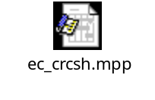

Iteration Deliverables
The following deliverables will be generated and reviewed during the second iteration (C2) of the Construction Phase:
Process | Deliverable | Responsible Owner
Design Set | Analysis Model (update)  Design Model (update)  Software Architecture Document (update) | Sue Gamble  Beth MacDonald  Steve Johnson
Implementation Set | Integration Build Plan  R1.0 Software Baseline  Test Drivers, Stubs, Data, & Scripts  Test Procedures  Test Evaluation Report | Kerry Stone  Phil Johnson  Simon Jones  Carol Smith  Carol Smith
Management Set | C2 Iteration Plan  Project Plan (update)  Project Schedule (update)  Project Risk List (update)  Status Assessment  Iteration Assessment  Test Plan | Rick Bell  Rick Bell  Rick Bell  Rick Bell  Rick Bell  Rick Bell  Kerry Stone

Resources

Staffing Resources
At this stage in the project, the Business Modeling Group and some of the Systems Engineering group have been released from the project. They remain available to provide minimal phone support.
The staffing requirements for the C2 Iteration of the Construction Phase are:
Project Management
Project Management Rick Bell
Systems Engineering
Architect Steve Johnson
Software Engineering
Software Engineering Manager Diane Ng
Process Engineer (CM) Simon Jones
Developer Beth MacDonald
Developer Gavin Hansen
Developer/Designer Phil Johnson
Developer Adrian Harmsen
Test
Test Manager Kerry Stone
System Tester Carol Smith
Test Designer Sophie King

The project organization chart and the staffing requirements for the full project are contained within the Project Plan [5].

Financial Resources
The following table shows the budget for the C2 Iteration of the Construction Phase.
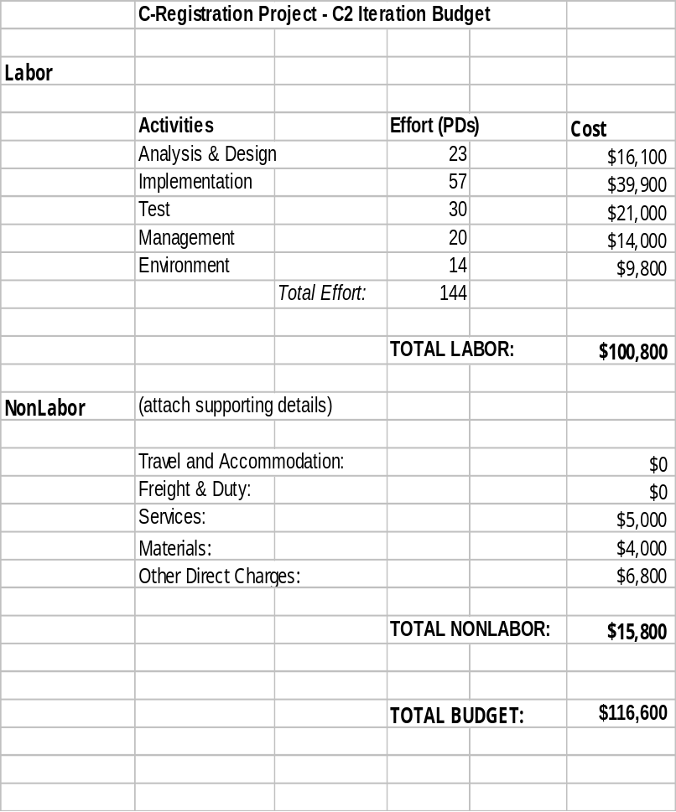

Equipment & Facilities Resources
The C2 Iteration requires the following computer equipment:
- 18 PCs (Windows 95 , MS Office, Rational Rose, Requisite Pro)
- 20 Monitors
- 3 Printers (2 Laser, 1 Color)
- Access to the Wylie College Server.
This equipment is already in place at Wylie College Information Systems. Equipment required exclusively for Test will be detailed in the Test Plan.
Office space needs to be setup for the 2 new hires.

Use Cases
No new use cases will be developed for the C2 Iteration as the previous iteration (C1) to produce the Beta brought in the remaining Release 1.0 use cases. However, the following existing use cases require extensive rework:
- Close Registration
- Interface to Course Catalog Database
- Interface to Finance System

Evaluation Criteria
The primary goal of the C2 Iteration of the Construction Phase is to complete the software baseline for Release 1 (R1.0). The R1.0 baseline must be available for the Deployment Team no later than May 20th, 1999.
In addition, the following criteria must be met prior to completion of the C2 Iteration:
- All critical, high, and medium priority defects discovered in the Beta Release (from C1 Iteration) must be resolved.
- All user feedback from the Beta Release must be evaluated. All feedback classified as “major” must be resolved.
- All use cases and requirements targeted for Release 1 must be implemented and tested.
- All timing, performance, and quality requirements, as specified in the Supplementary Specification [7], must be met.
- The Tests, as defined in the Test Plan [6], must be executed.
- All test results must be reviewed.
- The senior management team and the Wylie College representative must approve the release of the R1.0 software baseline.

