C-Registration System
Preliminary Iteration Plan

Version 1.1
Revision History
Date | Version | Description | Author
18/Jan/1999 | 1.0 | Initial Release | Rick Bell
22/Jan/1999 | 1.1 | Revised the high level schedule.  Adjusted the budget. | Rick Bell

Table of Contents
1. Objectives 4
2. Scope 4
3. References 4
4. Plan 4
4.1 Iteration Activities 4
4.2 Iteration Schedule 4
4.3 Iteration Deliverables 5
5. Resources 5
5.1 Staffing Resources 5
5.2 Financial Resources 6
5.3 Equipment & Facilities Resources 7
6. Use Cases 7
7. Evaluation Criteria 8

Preliminary Iteration Plan

Objectives
This Iteration Plan describes the detailed plans for the Preliminary Iteration of the C-Registration System Project. During this iteration, the requirements of the system will be defined and the high level plan for execution of the full project will be developed. This first iteration will conduct a thorough analysis on the business case for the system and will result in a decision on whether the project will proceed.

Scope
The Preliminary Iteration Plan applies to the C-Registration System project being developed by Wylie College Information Systems for Wylie College. This document will be used by the Project Manager and by the project team.

References
Applicable references are:
- Vision Document for the C-Registration System, WyIT387, V1.0, Wylie College IT.
- Stakeholder Requests Document for the C-Registration System, WyIT389, V1.0, 1998, Wylie College IT.
- Glossary for the C-Registration System, WyIT406, V1.0, 1998, Wylie College IT.
- C-Registration System Inception Phase Schedule, V1.0, 1999, Wylie College IT.
- Project Plan for the C-Registration System, WyIT418, V1.0, 1999, Wylie College IT.

Plan
The Preliminary Iteration will develop the product requirements and establish the business case for the C-Registration System. The major use cases will be developed as well as the high level Project Plan. At the end of this iteration, Wylie College will decide whether to fund and proceed with the project based upon the business case.

Iteration Activities
The following table illustrates the high level activities with their planned start and end dates.
Activity | Start Date | End Date
Business Modeling | Dec 1, 1998 | Dec 22, 1998
Requirements Definition | Dec 1, 1998 | Jan 19, 1999
Configuration Management Setup | Dec 1, 1998 | Jan 14, 1999
Management | Dec 1, 1998 | Jan 19, 1999

Iteration Schedule
The detailed schedule showing all tasks and the assigned responsibilities is contained in the following schedule:
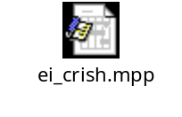

Iteration Deliverables
The following deliverables or artifacts will be generated and reviewed during the Preliminary Iteration:
Artifact Set | Deliverable | Responsible Owner
Business Modeling Set | Glossary  Business Use Case Model  Supplementary Business Spec.  Business Use Case Realization | Bob Collings  Yee Chung  Bob Collings  Yee Chung
Requirements Set | Vision Document  Stakeholder Requests Document  Use Case Specifications  Supplementary Specification  Requirements Attributes Document  Use Case Model (and Model Survey) | Sue Gamble  Bob King  Sue Gamble  Sue Gamble  Sue Gamble  Sue Gamble
Management Set | Preliminary Iteration Plan  Project Plan  Project Schedule  Project Risk List  Measurement Plan  Business Case Document  Status Assessment  Preliminary Iteration Assessment  Configuration Management Plan | Rick Bell  Rick Bell  Rick Bell  Rick Bell  Rick Bell  Rick Bell  Rick Bell & Carol Ming  Rick Bell & Carol Ming  Simon Jones
Standards and Guidelines | Requirements Attributes Guidelines  Configuration Management Environment | Simon Jones  Simon Jones

Resources

Staffing Resources
The staffing requirements for the Preliminary Iteration are:
Project Management
Project Management Rick Bell
Business Modeling Group
Business Modeling Manager Bob King
Business-Process Analysts Bill Collings, Glen Fox
Business Designer Yee Chung
Business-Model Reviewer Abu Zony
Systems Engineering
Systems Engineering Manager Carol Ming
Systems Analysts Sue Gamble, <TBD>
Architect Steve Johnson
Software Engineering
Process Engineer (CM) Simon Jones
The project organization chart and the staffing requirements for the full project will be contained within the Project Plan [5].

Financial Resources
The following table shows the budget for the Preliminary Iteration. Wylie College has secured $150,000 in funds for this first iteration.
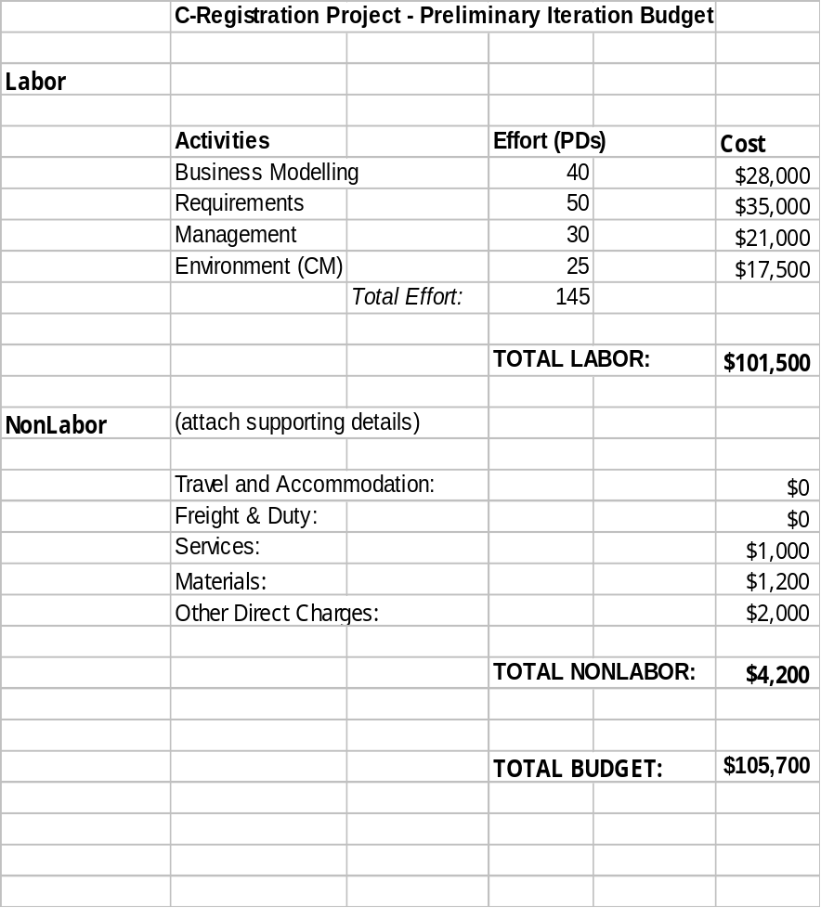

Equipment & Facilities Resources
The Inception Phase requires the following computer equipment, which has already been acquired by the Information Systems department:
- 4 PCs (Windows 95 , MS Office, Rational Rose, Requisite Pro)
- 6 Monitors
- 1 Printer
- Access to the Wylie College Server.
The Wylie College Information Systems department has sufficient office space and furniture to meet the needs of this iteration.

Use Cases
During the Preliminary Iteration, all significant use cases and actors will be identified. The basic flows and key alternative flows of each use case will be determined and documented in the Use Case Specifications. The design and implementation of use cases will begin in the next iteration.

Evaluation Criteria
The primary goal of the Preliminary Iteration is to define the system to the level of detail required to make a sound business judgement on the viability of the project from a business prospective. At the completion of the iteration, a review of the Business Case will arrive at a Go / No Go decision for the project.
Each deliverable developed during the iteration will be peer reviewed and subject to approval from the team.

