C-Registration System
Project Plan

Version 1.0
Revision History
Date | Version | Description | Author
15/Jan/99 | 1.0 | Initial version | Rick Bell

Table of Contents
1. Objectives 4
2. Scope 4
3. References 4
4. Phase Plan 4
5. Schedules 5
6. Objectives of Each Iteration 6
7. Releases 7
8. Resource plan 8
8.1 Organizational Structure 8
8.2 Staffing Plan 8
8.3 Training Plan 9
9. Cost 9

Project Plan

Objectives
The objective of this Project Plan is to define the development activities in terms of the phases and iterations required for implementing a computerized class registration system for Wylie College.

Scope
This Project Plan describes the overall plan to be used by Wylie College Information Systems for developing the C-Registration System for Wylie College. The details of the individual iterations will be described in the Iteration Plans.
The plans as outlined in this document are based upon the product requirements as defined in the Vision Document [1].

References
Applicable references are:
- Vision Document for the C-Registration System, WyIT387, V1.0, Wylie College IT.
- System Business Case for the C-Registration System, WyIT388, DRAFT, 1998, Wylie College IT.
- Stakeholder Requests Document for the C-Registration System, WyIT389, V1.0, 1998, Wylie College IT.
- Glossary for the C-Registration System, WyIT406, V1.0, 1998, Wylie College IT.
- C-Registration High Level Project Schedule, V1.0, 1999, Wylie College IT.

Phase Plan
The development of the C-Registration System will be conducted using a phased approach where multiple iterations occur within a phase. The phases and the relative timeline is shown in the table below:

Phase | No. of Iterations | Start | End
Inception Phase | 1 | Week 1 | Week 8
Elaboration Phase | 1 | Week 8 | Week 15
Construction Phase | 3 | Week 15 | Week 31
Transition Phase | 2 | Week 25 | Week 32

Table 4.1 describes each phase and the major milestone that marks the completion of the phase.

Phase | Description | Milestone
Inception Phase | The Inception Phase will develop the product requirements and establish the business case for the C-Registration System. The major use cases will be developed as well as the high level Project Plan. At the end of the Inception Phase Wylie College will decide whether to fund and proceed with the project based upon the business case. | Business Case Review Milestone at the end of the phase marks the Go/No Go decision for the project.
Elaboration Phase | The Elaboration Phase will analyze the requirements and will develop the architectural prototype. At the completion of the Elaboration Phase all use cases selected for Release 1.0 will have completed analysis and design. In addition, the high risk use cases for Release 2.0 will have been analyzed and designed. The architectural prototype will test the feasibility and performance of the architecture that is required for Release 1.0. | The Architectural Prototype Milestone marks the end of the Elaboration Phase. This prototype signifies verification of the major architectural components that comprise the R1.0 Release.
Construction Phase | During the Construction Phase, remaining use cases will be analyzed and designed. The Beta version for Release 1.0 will be developed and distributed for evaluation. The implementation and test activities to support the R1.0 and R2.0 releases will be completed. | The R2.0 Operational Capability Milestone marks the end of the Construction Phase. Release 2.0 software is ready for packaging.
Transition Phase | The Transition Phase will prepare the R1.0 and R2.0 releases for distribution. It provides the required support to ensure a smooth installation including user training. | The R2.0 Release Milestone marks the end of the Transition Phase. At this point all capabilities, as defined in the Vision Document [1], are installed and available for the users.

Table 4.1 Project Phases and Major Milestones

Each phase is split into development iterations as described in Section 6.0.
The Gantt Chart shown in Section 5 illustrates the high-level project schedule showing phases, iterations, and major milestones. The project duration is expected to be 7-8 months.

Schedules
The high level schedule showing project phases, iterations, and milestones is contained in the C-Registration High Level Project Schedule [5] as shown below.
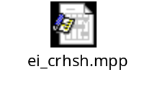

Objectives of Each Iteration
Each phase consists of development iterations in which a subset of the system is developed. In general, these iterations:
- Reduce technical risk;
- Provide early versions of a working system;
- Allow maximum flexibility in planning features for each release; and
- Enable scope changes to be handled effectively within an iteration cycle.
The following table describes the iterations along with associated milestones and addressed risks.
Phase | Iteration | Description | Associated Milestones | Risks Addressed
Inception Phase | Preliminary Iteration | Defines business model, product requirements, project plan, and business case. | Business Case Review | Clarifies user requirements up front.  Develops realistic project plans and scope.  Determines feasibility of project from a business point of view.
Elaboration Phase | E1 Iteration – Develop Architectural Prototype | Completes analysis & design for all R1 use cases. Develops the architectural prototype for R1.  Complete Analysis and Design for all high risk R2 use cases. | Architectural Prototype | Architectural issues clarified.  Technical risks mitigated.  Early prototype for user review.
Construction Phase | C1 Iteration – Develop R1 Beta | Implement and test R1 use cases to provide the R1 Beta Version. | R1 Beta | All key features from a user and architectural prospective implemented in the Beta.  User feedback prior to release of R1.
 | C2 Iteration – Develop R1 Release | Implement and test remaining R1 use cases, fix defects from Beta, and incorporate feedback from Beta.  Develops the R1 system. | R1 Software | R1 fully reviewed by user community.  Product quality should be high.  Defects minimized.  Cost of quality reduced.
 | C3 Iteration – Develop R2 Release | design, implement, and test R2 use cases.  Incorporate enhancements and defects from R1.  Develops the R2 system. | R2 Software | Quick release of R2 addresses customer satisfaction.  All key functionality provided in System by R2 Release.
Transition phase | T1 Iteration – R1 Release | Package, distribute, and install R1 Release. | R1 Released | Two-stage release minimizes defects.  Two-stage release provides easier transition for users.
 | T2 Iteration – R2 Release | Package, distribute, and install R2 Release. | R2 Released | Two-stage release minimizes defects.  Two-stage release provides easier transition for users.

Releases
This project plan addresses the first 2 releases of the C-Registration System. Key features as defined in the Vision Document [1] are targeted for the first 2 releases. All features critical to student registration are planned for the first release (R1.0).
The planned content of the releases is expected to change as the project progresses. This may be due to a number of business and technical factors. To accommodate the changes, Requisite Pro will be used to manage the product requirements and to keep track of release content. In particular, benefit, effort, and risk attributes are used to determine priority of product requirements and thus the target release.
It is anticipated that the C-Registration System will be released for general use at Wylie College through 2-4 main releases.
Release 1 must contain as a minimum the basic functionality as listed below:
- Logon
- Register for courses
- Interface to Course Catalog Database
- Maintain Student Information
- Maintain Professor Information
Release 2 should include:
- Submit Student Grades
- View Grades
- Select courses to teach
The functionality for Release 3 has not yet been determined. It is anticipated that this release will contain enhancements to the existing functionality.
Future replacement of the legacy Billing System and Course Database System is targeted for Release 4 in Year 2005.
In addition, a Beta Release will precede the R1.0 Product Release.

Resource plan

Organizational Structure
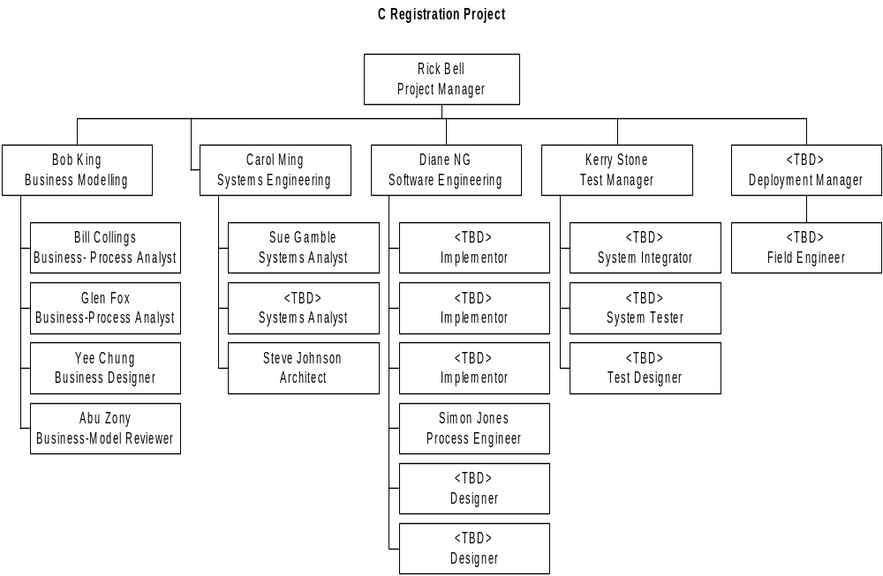The project organization is as shown in the chart below.

Staffing Plan
The IT employees identified in the Organizational Chart in Section 8.1 are allocated to the project. Additional resources will not staffed until the business case is reviewed at the end of the Inception Phase and a Go/No Go decision is made on the project.
The Wylie College IT department has insufficient Developers and Designers to meet the project needs. The Wylie College Recruiting Office is prepared to recruit 2 Developers with C++ experience and 2 Designers with OO and C++ experience.

Training Plan
Training on the following skills will be conducted for the project team prior to the commencement of design activities:
- Object Oriented Analysis and Design
- Introduction to the Rational Unified Process
- Advanced C++ Features

Cost
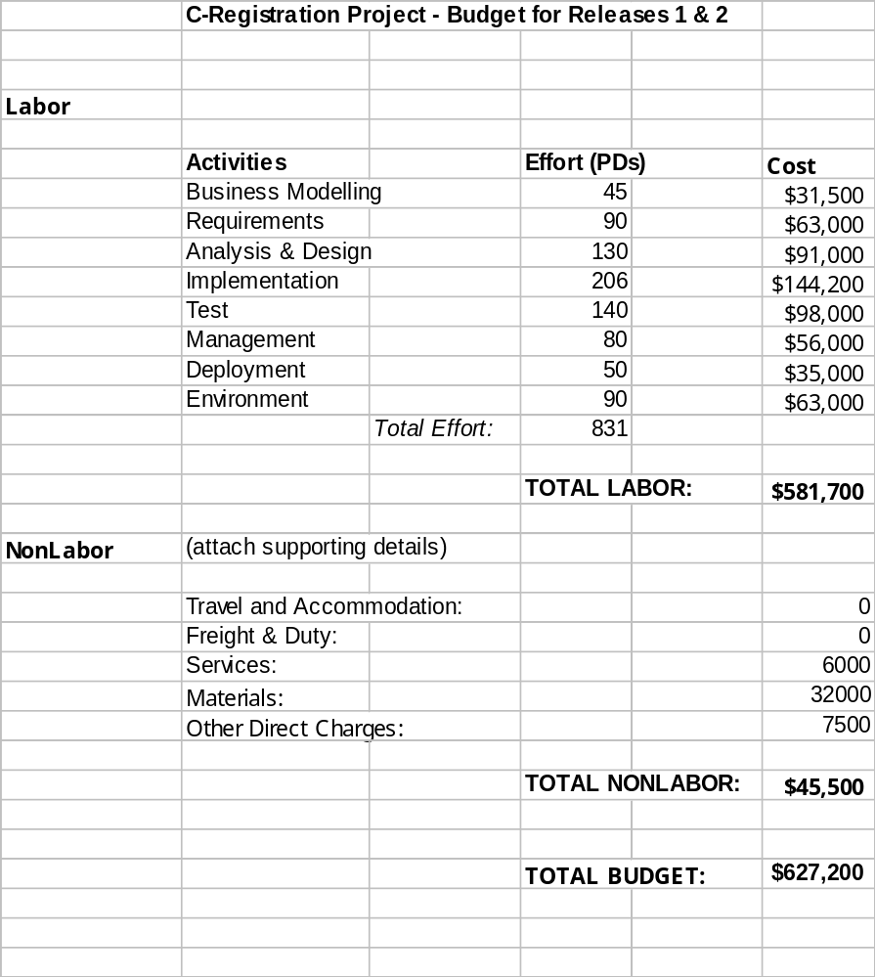The project’s budget as based upon the initial estimates is as shown in the Excel spreadsheet below:

