C-Registration System
T1 & T2 Iteration Plan

Version 1.0
Revision History
Date | Version | Description | Author
May 15/1999 | 1.0 | Initial Plan for 2 iterations of the Transition Phase: T1 and T2. | Rick Bell

Table of Contents
1. Objectives 4
2. Scope 4
3. References 4
4. Plan 4
4.1 Iteration Activities 5
4.2 Iteration Schedule 5
4.3 Iteration Deliverables 5
5. Resources 6
5.1 Staffing Resources 6
5.2 Financial Resources 6
5.3 Equipment & Facilities Resources 7
6. Use Cases 7
7. Evaluation Criteria 8

T1 & T2 Iteration Plan

Objectives
This Iteration Plan describes the detailed plans for the first two iterations of the Transition Phase.
The first iteration (T1) of the Transition Phase packages and installs the R1.0 version of the C-Registration System. This release contains all key functionality for course registration with the exception of submission and viewing of student marks.
The second iteration (T2) of the Transition Phase packages and installs the R2.0 version. This release contains all key functionality as defined in the Vision Document [1].

Scope
This Iteration Plan applies to the C-Registration System project being developed by Wylie College Information Systems for Wylie College. This document will be used by the Project Manager, Deployment Manager, and by the project team.

References
Applicable references are:
- Vision Document for the C-Registration System, WyIT387, V1.0, Wylie College IT.
- Stakeholder Requests Document for the C-Registration System, WyIT389, V1.0, 1998, Wylie College IT.
- Glossary for the C-Registration System, WyIT406, V1.0, 1998, Wylie College IT.
- Project Plan for the C-Registration System, WyIT418, V2.0, 1999, Wylie College IT.
- C-Registration Schedule for the Transition Phase, V1.0, Wylie College IT.

Plan
The first iteration (T1) will commence when the R1.0 software baseline is available from the development team. The software will be packaged and the distribution media created. The Transition team will create the User Manual and will install the software on the Wylie College Server and selected client PCs on campus. The Transition Team is responsible for conducting the User Acceptance Tests and obtaining signoff from the Wylie College representative.
In addition, the client software will be setup on an FTP site so that any client P.C. with a valid ID and Internet access may download the client portion to their P.C.
The transition team provides training and support to the Wylie College Registrar and administration staff following installation of the software.
The second iteration (T2) will commence when the R2.0 software baseline is available from the development team. The activities for preparing the R2.0 Release are the same as defined above for R1.0, with the exception that R2.0 must convert and import the R1.0 data.
The primary use cases that form Release 1.0 are:
- Logon
- Close Registration
- Register for Courses
- Interface to Course Catalog Database
- Interface to Finance System
- Maintain Student Information
- Maintain Professor Information
The primary use cases that form Release 2.0 are:
- Submit Student Grades
- View Grades
- Select Courses to Teach

Iteration Activities
The following table illustrates the high level activities for T1 and T2 iterations with their planned start and end dates.
Activity | Start Date | End Date
T1 Iteration – Release 1.0
Produce Software | May 27, 1999 | June 1, 1999
Package & Distribute Release | June 2, 1999 | June 7, 1999
Acceptance Test | June 10, 1999 | June 11, 1999
T2 Iteration – Release 2.0
Produce Software | June 30, 1999 | July 2, 1999
Package & Distribute Release | July 5, 1999 | July 8, 1999
Migrate R1.0 Data | June 30, 1999 | July 20, 1999
Acceptance Test | July 13, 1999 | July 14, 1999

Iteration Schedule
The detailed schedule showing all tasks and the assigned responsibilities is contained in the following Microsoft Project schedule [5]:
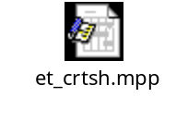

Iteration Deliverables
The following deliverables will be generated and reviewed during the T1 & T2 Iterations:
Iteration | Deliverable | Responsible Owner
T1 | Installation Scripts  User Manual  Configuration Data  Software Installation Media  Release Notes  User Training Materials  Acceptance Test Signoff | P. Armstrong  G. Mandu  P. Armstrong  P. Armstrong  G. Mandu  G. Mandu  K. Stone / R. Bell
T2 | Installation Scripts  User Manual  Configuration Data  Data Migration Utility Program  Software Installation Media  Release Notes  User Training Materials  Acceptance Test Signoff | P. Armstrong  G. Mandu  P. Armstrong  B. MacDonald  P. Armstrong  G. Mandu  G. Mandu  K. Stone / R. Bell

Resources

Staffing Resources
During the T1 & T2 Iterations the staffing requirements are:
Project Management
Project Management Rick Bell
Deployment Management Greg Mandu
Software Engineering
Developer Beth MacDonald
Test
Test Manager Kerry Stone
Deployment
Field Engineer Phil Armstrong

The project organization chart and the staffing requirements for the full project are contained within the Project Plan [4].

Financial Resources
The following table shows the budget for the T1 & T2 Iterations.
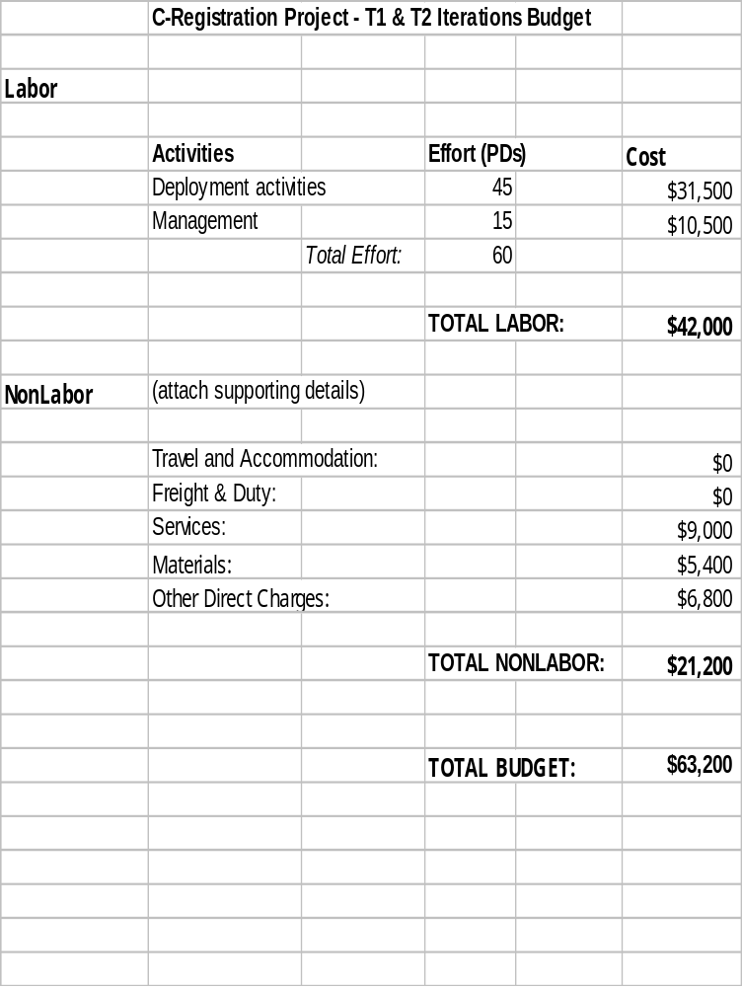

Equipment & Facilities Resources
The T1 & T2 Iterations require no additional equipment or facilities beyond those items already identified and obtained for the Construction Phase.
The existing Wylie College web site will be used for user support and downloading the client software.
The printing of the User Manuals will be contracted to the Wylie College Print Shop.

Use Cases
The T1 & T2 Iterations do not include the development of any use cases.
The primary use cases that form Release 1.0 are:
- Logon
- Close Registration
- Register for Courses
- Interface to Course Catalog Database
- Interface to Finance System
- Maintain Student Information
- Maintain Professor Information
The primary use cases that form Release 2.0 are:
- Submit Student Grades
- View Grades
- Select Courses to Teach

Evaluation Criteria
The primary goal of the T1 and T2 Iterations is to install R1.0 and R2.0 and obtain user acceptance of the software.
In addition, the following criteria must be met prior to completion of the T1 and T2 Iterations:
- The R1.0 and R2.0 releases must not contain any critical or high priority defects.
- R2.0 must be installed and operational 3 weeks prior to the start of student registration for the Fall Semester.
- R1.0 and R2.0 must pass user acceptance and must be formally signed off by the Wylie College representative.
- User training must be completed.
- Web site must be established for product support.
- User Manuals must be printed and available either through the IT department or the Wylie College Book Store.
- The process and resources to provide ongoing user support must be established.

