Foreword
This portfolio started as an attempt to capture my journey from absolute uncertainty to a solid grasp og Generalised Linear Models. My aim is to document not just the concepts, but the problems I encountered, questions I asked, nd how I approached answering them.
Traditional note taking usually amounts t writing down vague, cognitively disconnected concepts that teach the how without ever establishing the why. This portfolio takes the opposite approach : It moves slowly through the why before arriving at the how.
TO ensure this I settled on a study technique I call ECRA which breaks studying into four distinct phases: Exploration, cognition, reflection and application. Each chapter uses this stricture the exploration phase is the informal, begineer’s first contact with a concept( a video, a search) to build intuition; Cognition is where things get formal, with definintions and derivations; Reflection is where I step back and interrogate what actually landed and what didn’t; and application is where the concepts get used, tested, or simulated.
I have not approached this portfolio like a textbook even thought it covers essentialy all the mathematics needed for a first course in GLMs.. Instead the structure follows the shape of the problem its elf: try something, wathc it fail, ask why it failed, then build the solution that addresses that specific failure. Each chapter Is a pathway from problem to solution rather than a definintion waiting to be memorised.
By the end of this portfolio a reader should understand why we speak about generalised linear models at all, all the mathematics underlying them, how to fit a glm with some code in R, variable importance and so on.
Without further ado lets dive into the world of glms

Attached below are the class test written throughout the semester
From Class test 1 to 4
Class test 1
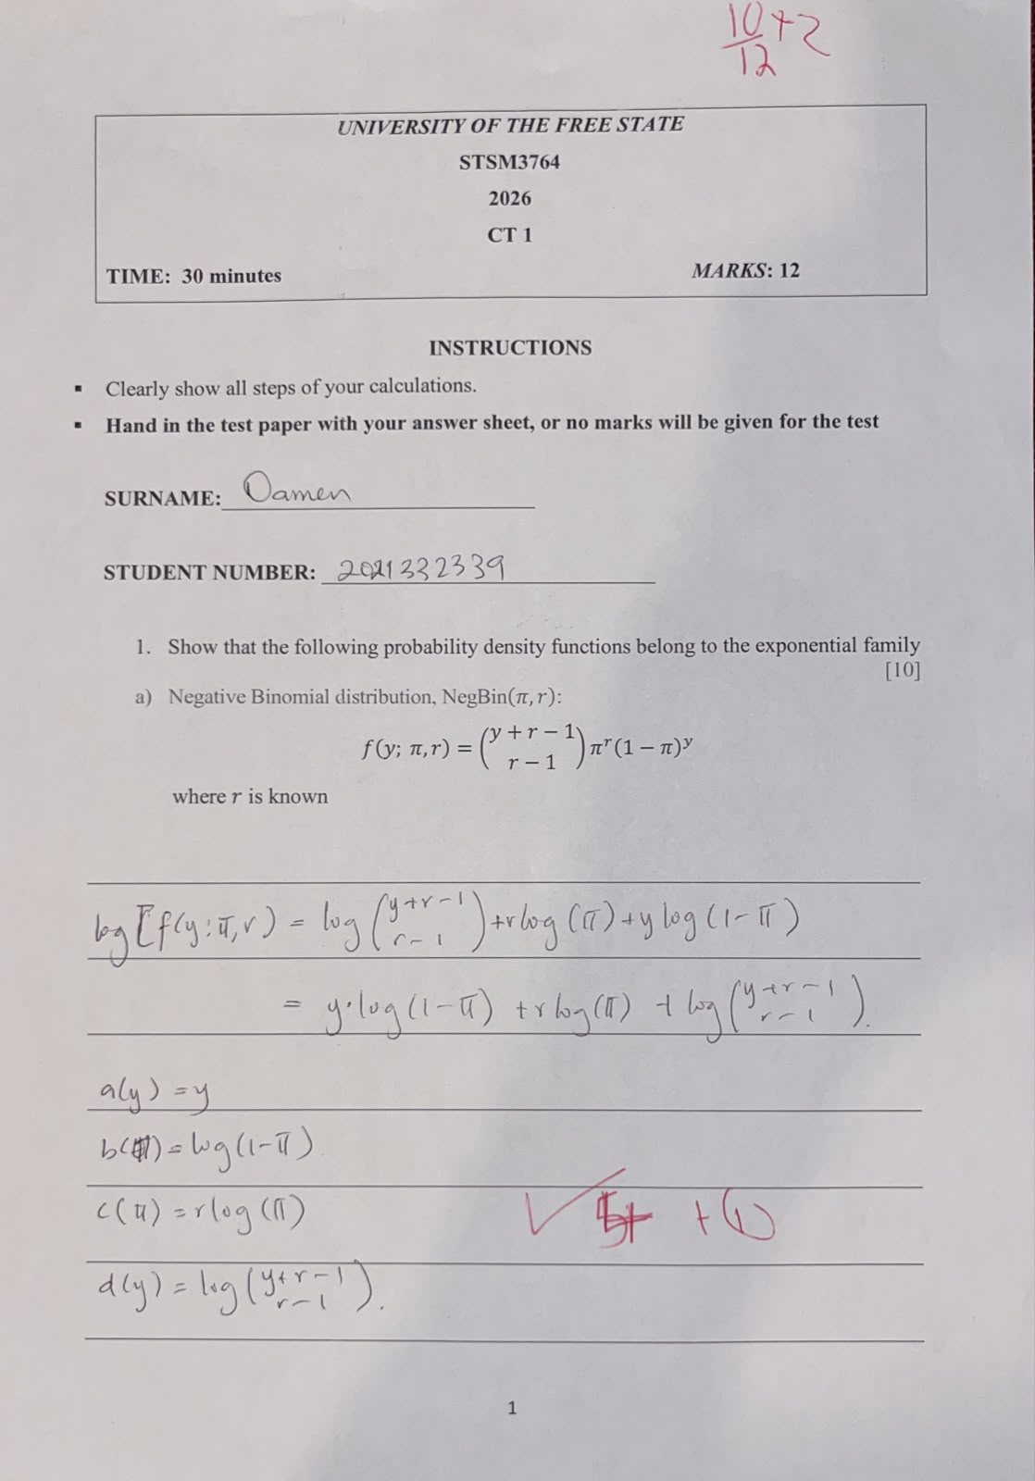

Class 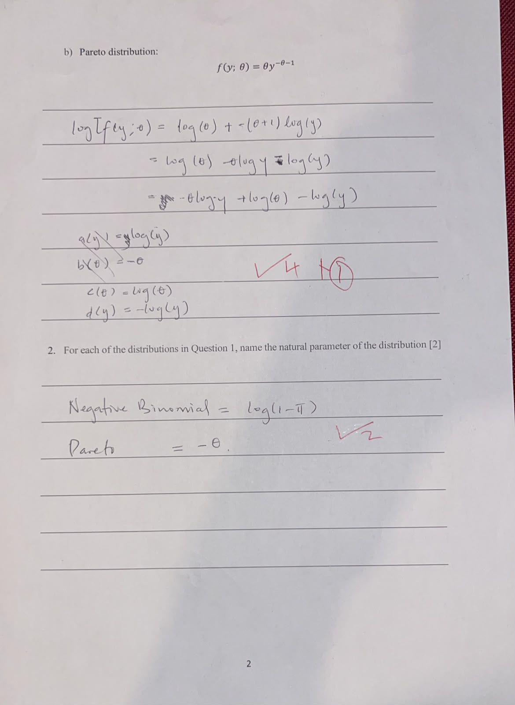
Class test 2
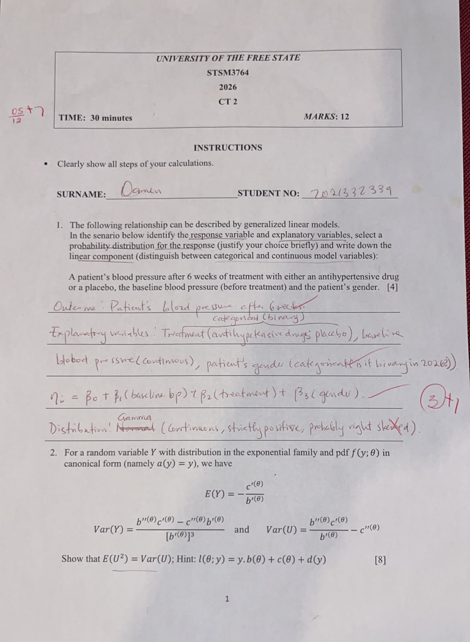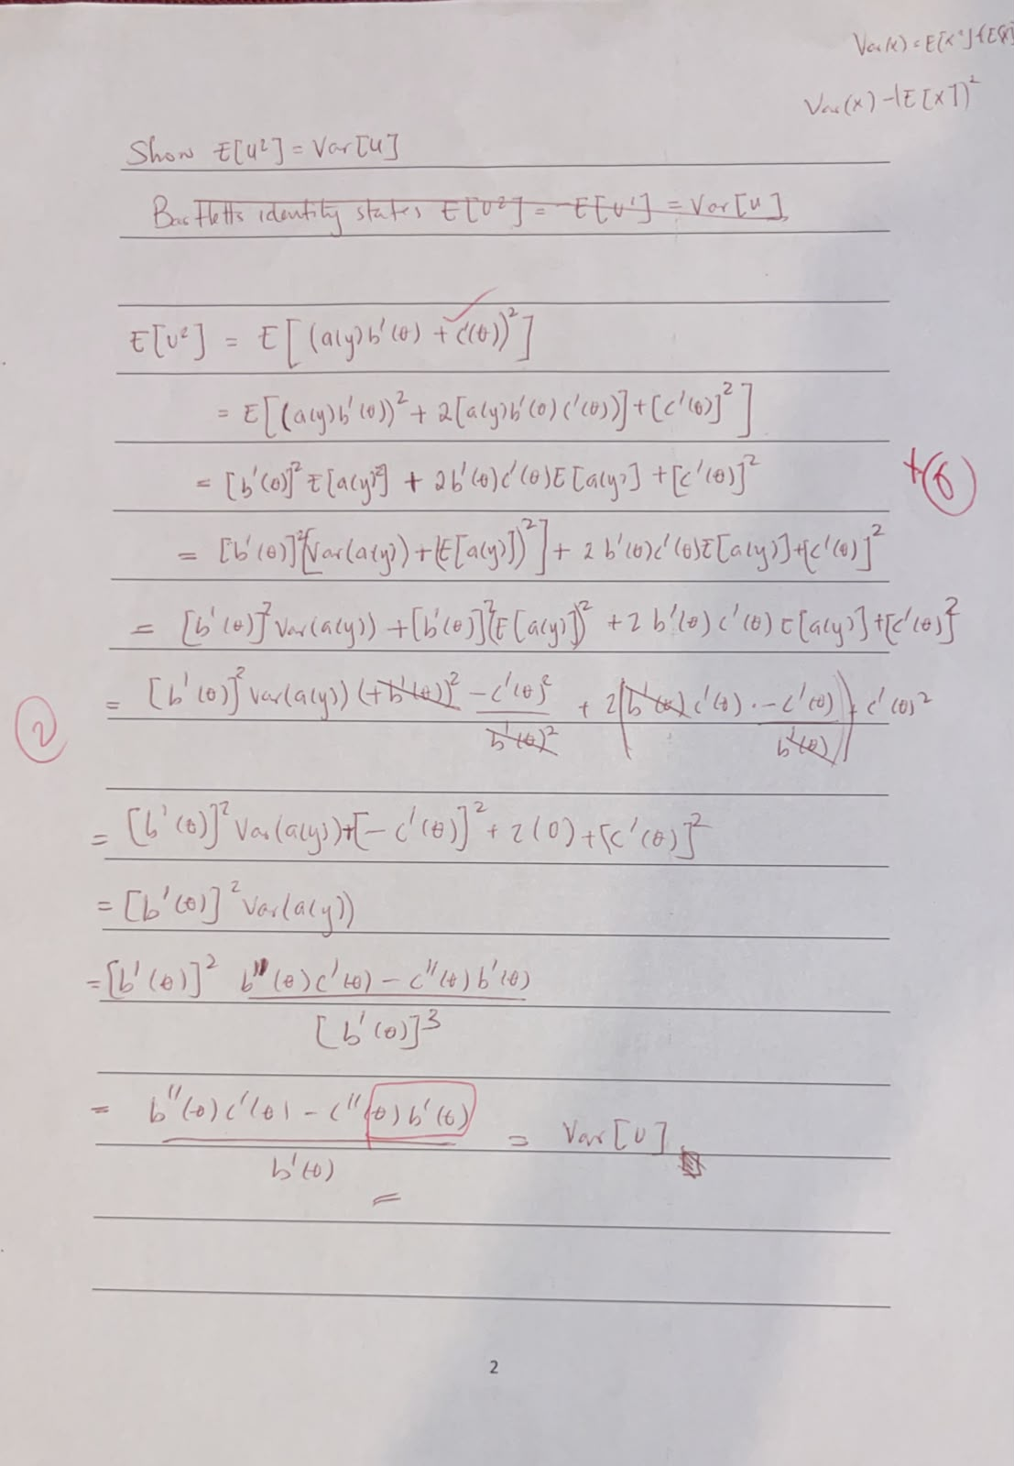
Class test 3
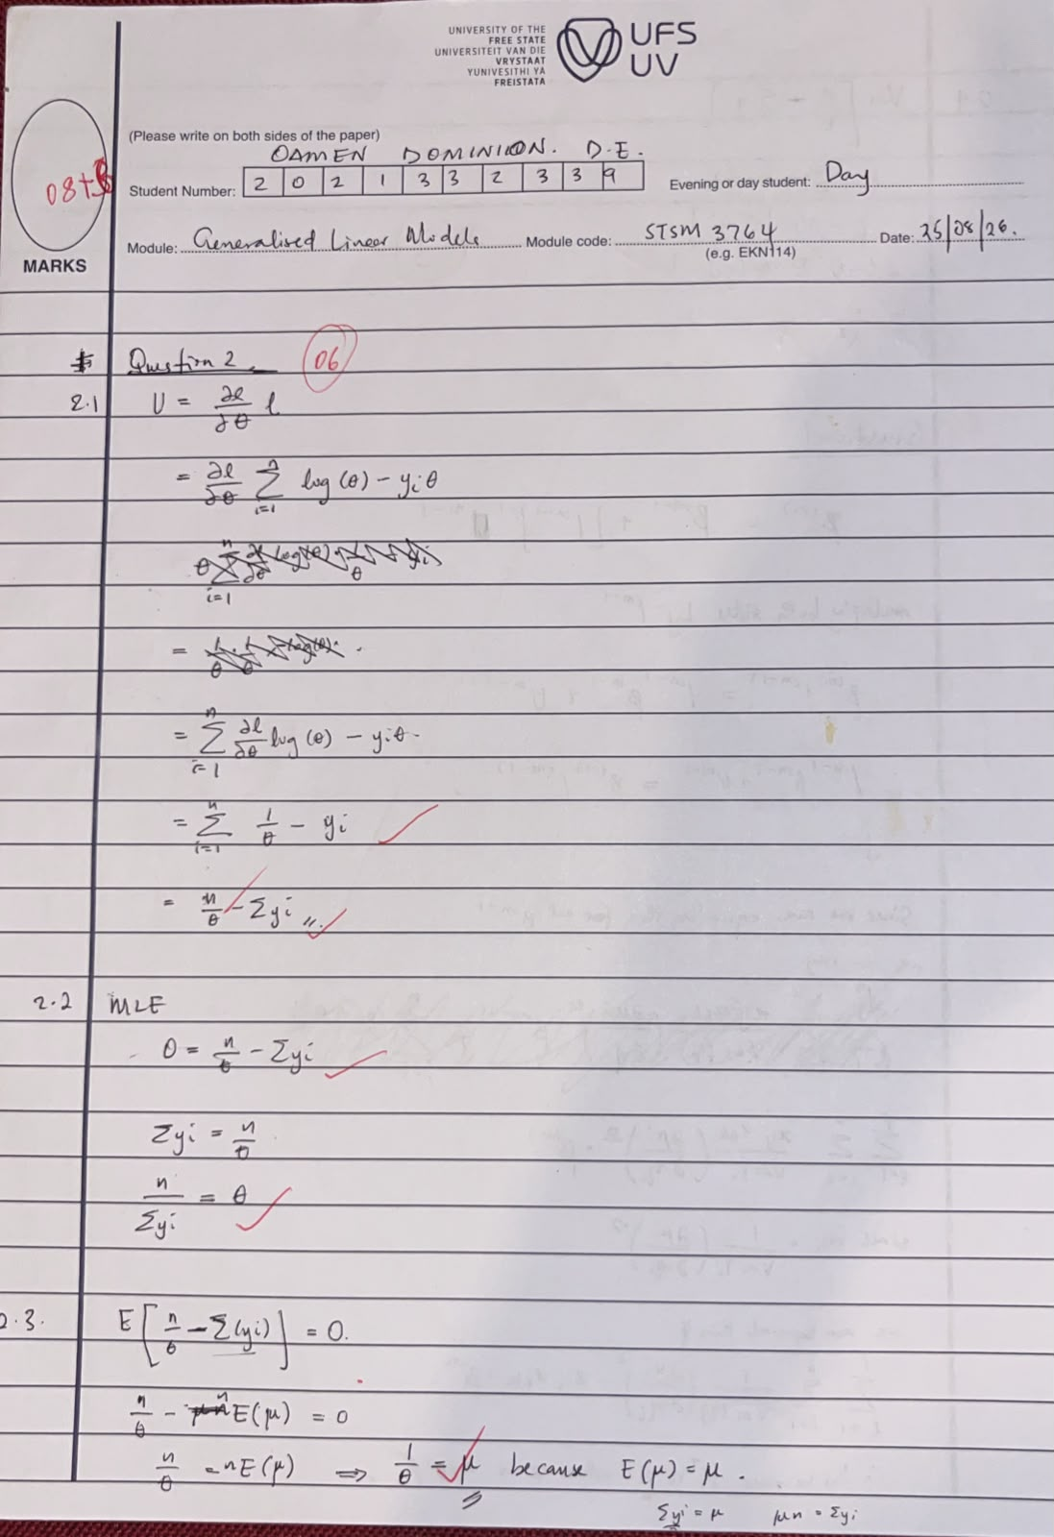
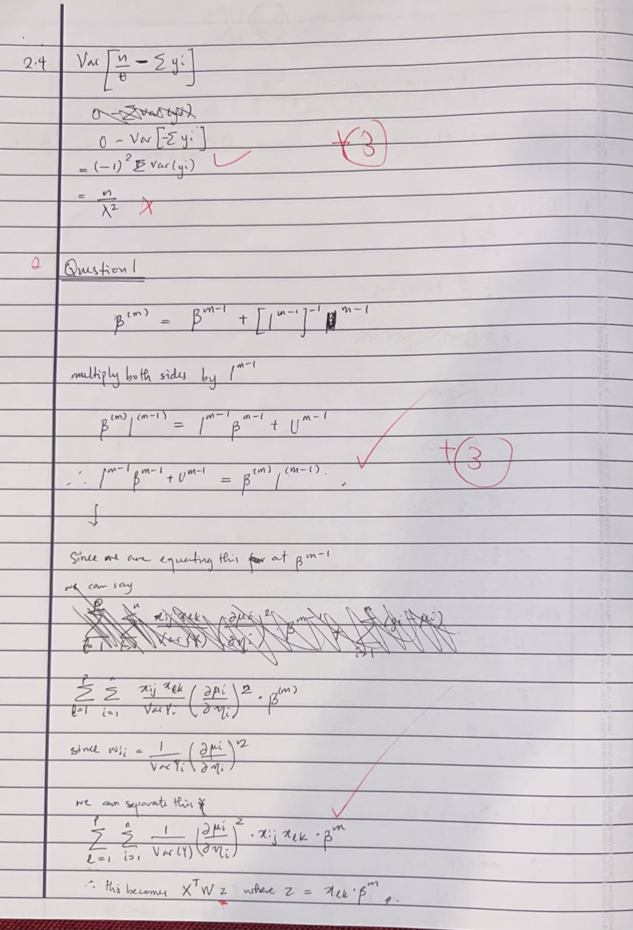
Class test 4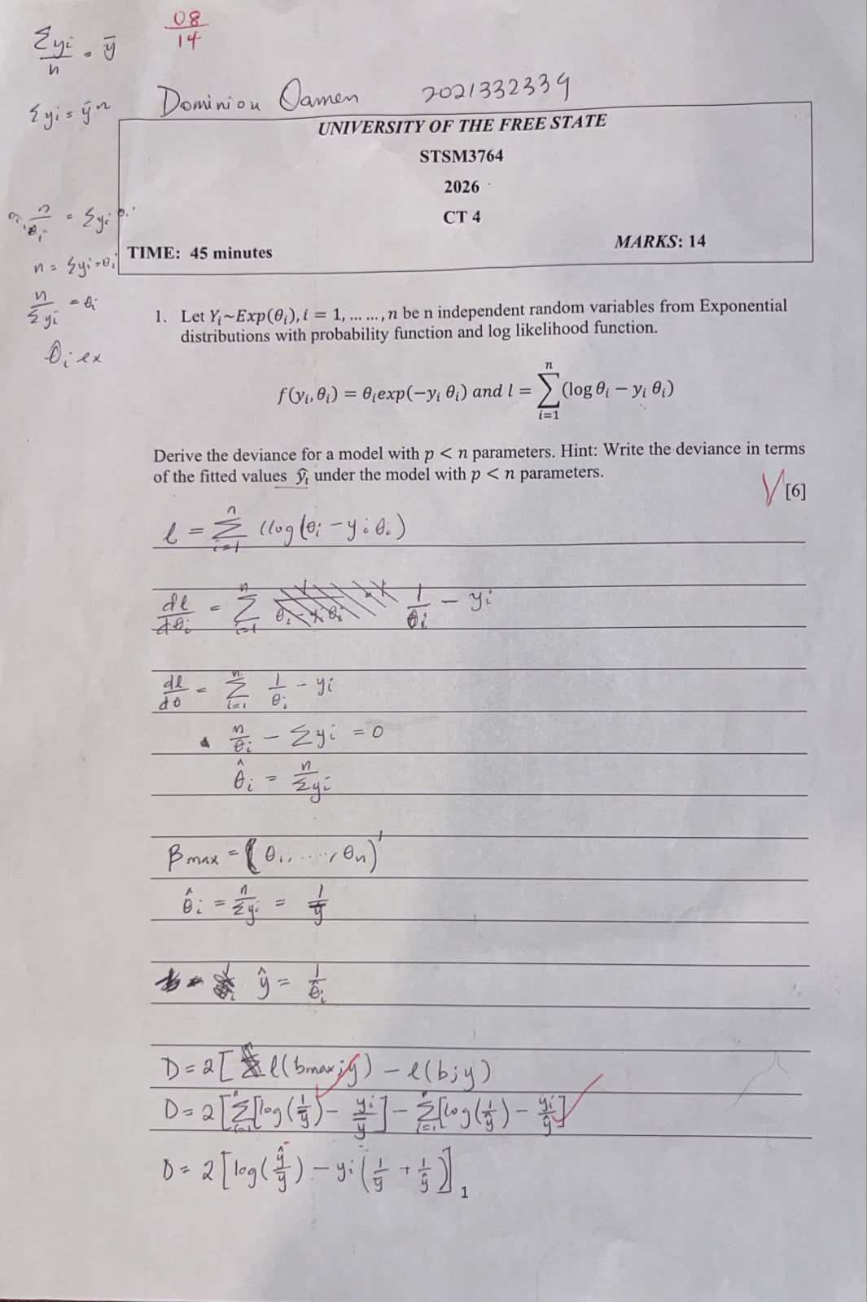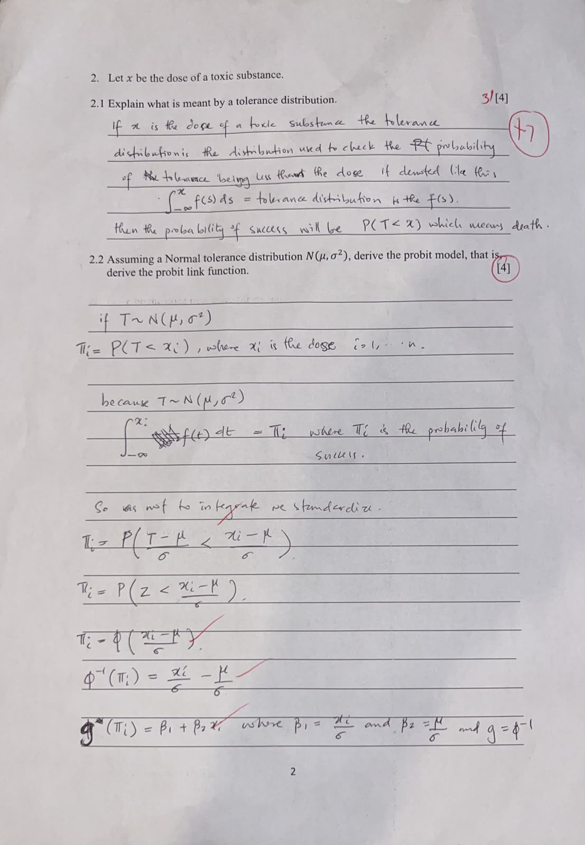
Changes to be implemented
Remove Model evaluation
Take deviance back to chapter 5 it shouldn’t be a part of chapter 7.
Update the foreword
Add the class tests to the appendix
Add a note on the sampling distribution of the sampling statistic
Delete the Fisher panel place holder
Remove model evaluation move deviance back to where it was
And do an MLE example on R showing how we derive MLEs blah bblah blah

