
Průvodce programem Impress

Chapter 9
Slide Shows and Photo Albums

testovací Zdeněk Autorská práva
This document is Copyright © 2021 by the LibreOffice Documentation Team. testovací Zdeněk testovací Zdeněk Přispěvatelé jsou uvedeni níže. Dokument je možné šířit nebo upravovat za podmínek licence GNU General Public License (http://www.gnu.org/licenses/gpl.html) verze 3 nebo novější nebo za podmínek Commons Attribution License (http://creativecommons.org/licenses/by/4.0/) verze 4.0 nebo novější.
testovací Zdeněk testovací Zdeněk námky uvedené v této příručce patří jejich vlastníkům.

testovací Zdeněk Přispěvatelé
K tomuto vydání.
Peter Schofield | Samantha Hamilton
Do předchozích vydání.
Elliot Turner | testovací Zdeněk testovací Zdeněk testovací Zdeněk testovací Zdeněk testovací Zdeněk testovací Zdeněk er | Peter Schofield

testovací Zdeněk Zpětná vazba
testovací Zdentestovací Zdeněk ěk Připomínky a náměty k tomuto dokumentu posílejte v angličtině dokumentačnímu týmu na adresu: documentation@global.libreoffice.org.
- testovací Zdeněk testovací Zdeněk testovací Zdeněk testovací Zdeněk
Vše, co do e-mailové konference pošlete, včetně e-mailové adresy a dalších osobních informací uvedených ve zprávě, bude veřejně viditelné bez možnosti smazání.

verze...verze...Datum vydání a verze programu
Published February 2021. Kniha je určena pro LibreOffice 7.0.

testovací Zdeněk Používání LibreOffice na systému macOS
testovací Zdeněk Některé klávesové zkratky a položky nabídek jsou v systému macOS jiné než v systémech Windows a Linux. testovací Zdeněk V následující tabulce jsou uvedeny nejdůležitější rozdíly, které se týkají informací v tomto dokumentu. testovací Zdeněk Podrobný seznam najdete v nápovědě aplikace.
testovací Zdeněk Windows nebo Linux | testovací Zdeněk Ekvivalent pro macOS | testovací Zdeněk Akce
testovací Zdeněk Nástroje > Možnosti…  testovací Zdeněk výběr nabídky | testovací Zdeněk LibreOffice > Předvolby | testovací Zdeněk Otevřou se možnosti nastavení
testovací Zdeněk Klepnutí pravým tlačítkem | Control + klepnutí ntestovací Zdeněk ebo klepnutí pravým tlačítkem v závislosti na nastavení počítače | testovací Zdeněk Otevře se místní nabídka
testovací Zdeněk Ctrl (Control) | ⌘ (Command) | testovací Zdeněk Používá se také s dalšími klávesami
testovací Zdeněk F11 | testovací Zdeněk ⌘ + T | testovací Zdeněk Otevřete balíček Styly v postranním panelu

testovací Zdeněk Obsah
testovací Zdeněk Autorská práva 2
testovací Zdeněk Přispěvatelé 2
testovací Zdeněk Zpětná vazba 2
verze...verze...Datum vydání a verze programu 2
testovací Zdeněk Používání LibreOffice na systému macOS 2
Úvod 4
Creating slide shows 4
Basic settings 4
Slide Show options 4
Skrývání snímků testovací Zdeněk 6
Skrývání snímků testovací Zdeněk 6
Showing hidden slides testovací Zdeněk 6
Custom slide show 7
Creating custom slide show 7
Editing custom slide show testovací Zdeněk testovací Zdeněk 8
Copying custom slide show testovací Zdeněk testovací Zdeněk 8
Deleting custom slide show testovací Zdeněk testovací Zdeněk 9
Using slide transitions testovací Zdeněk testovací Zdeněk 9
Adding transitions testovací Zdeněk testovací Zdeněk 9
Removing transitions testovací Zdeněk testovací Zdeněk testovací Zdeněk 10
Playing music testovací Zdeněk testovací Zdeněk testovací Zdeněk 10
Animace testovací Zdeněk testovací Zdeněk 11
Applying animation testovací Zdeněk testovací Zdeněk 11
Changing animation testovací Zdeněk 13
Removing animation testovací Zdeněk 13
Additional animation options testovací Zdeněk 13
Effect options testovací Zdeněk testovací Zdeněk testovací Zdeněk 14
Timing options testovací Zdeněk testovací Zdeněk 15
Text animation options testovací Zdeněk testovací Zdeněk 15
Animation example testovací Zdeněk testovací Zdeněk 16
Using interactions testovací Zdeněk testovací Zdeněk testovací Zdeněk 17
Slide shows testovací Zdeněk testovací Zdeněk 18
Spuštění prezentace testovací Zdeněk testovací Zdeněk 18
Context menu navigation and options testovací Zdeněk testovací Zdeněk 18
Automatic slide show repeat testovací Zdeněk testovací Zdeněk 19
Slide show timing testovací Zdeněk testovací Zdeněk 19
Default timing testovací Zdeněk testovací Zdeněk 19
Variable timing testovací Zdeněk testovací Zdeněk 19
Presenter Console 20
Photo albums 21

Úvod
LibreOffice Impress gives you the tools to organize and display a slide show, including:
- Which slides to show and in what sequence.
- Whether to run the show automatically or manually.
- Transitions between slides.
- Animations on individual slides.
- Interactions: what happens when you click a button or link.
- A presenter console.

Creating slide shows

Basic settings
Most tasks associated with putting together a slide show are best done in Slide Sorter view where all of your slides in the presentation appear in the workspace.
- Open the Slide Sorter view (Figure 1) using one of the following methods:
- Go to View > Slide Sorter on the main menu bar.
- Click the Slide Sorter tab at the top of the Workspace pane.
- Go to Slide Show > Slide Show Settings on the main menu bar to open the Slide Show Settings dialog (Figure 2).
- Select the options you want to use for your slide show.
- Click OK to save your changes and close the Slide Show Settings dialog.

Slide Show options
- Range – select which slides to include in the slide show.
- All slides – includes all slides except for those slides marked Hidden (see “Hiding slides” on page 6). Slides are shown in the sequence they occur in the file. To change the sequence, either rearrange the slides in the slide sorter or select the custom slide show option.
- From – starts the show at the slide selected from the drop down list. For example, you might have several slides at the beginning that describe you and your company, but when you present this show to your work colleagues, you may want to skip that introduction.
- Custom slide show – shows the slides in a different sequence that you have previously set up. This setting is not available until you have set up a custom slide show (see “Custom slide show” on page 7). You can set up as many different custom shows as you wish from one set of slides and they will appear in the drop-down list for this option.
- Presentation Mode – select how the slides will be displayed.
- Full screen – shows the slides full screen without the LibreOffice program controls visible and exits the show after the last slide.
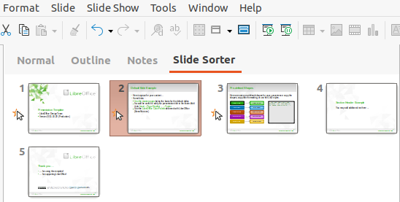Figure 1: Slide Sorter view
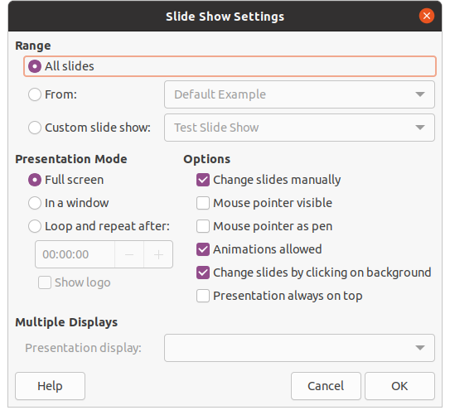Figure 2: Slide Show Settings dialog
- In a window – runs the slide show in the Impress window and exits the show after the last slide.
- Loop and repeat after – restarts the slide show after the last slide has displayed and after the specified length of time delay. A pause slide is displayed between the last slide and the start slide. Press the Esc key at any time to stop the show. If zero is entered as time delay, the show restarts immediately without showing a pause slide.
- Show logo – shows the LibreOffice logo on the pause slide when Loop and repeat after option is selected.
- Options – determine how the slide show runs as a presentation.
- Change slides manually – prevents slides from changing automatically even if an automatic transition has been set up.
- Mouse pointer visible – shows the mouse pointer during a slide show. If you do not have a laser pointer or other device to highlight items of interest during the show, this can be useful.
- Mouse pointer as pen – enables you to write or draw on slides during the presentation. Anything you write with the pen is not saved when you exit the slide show. The color of the pen cannot be changed.
- Animations allowed – displays all frames of animated GIF files during the slide show. If this option is not selected, only the first frame of an animated GIF file is displayed. This has nothing to do with the slide animations described in “Animations” on page 11.
- Change slides by clicking on background – advances to the next slide when you click on the background of a slide. You can also press the spacebar on the keyboard to advance to the next slide.
- Presentation always on top – prevents any other program window from appearing on top of the presentation.
- Multiple Displays – determines how the slide show is displayed.
- Presentation display – select from the drop down list which display to use for full screen slide show mode. Only available if the computer being used for the slide show is connected to more than one monitor.
- testovací Zdeněk testovací Zdeněk testovací Zdeněk testovací Zdeněk
The multiple displays setting is not an option saved with the presentation file, but is instead saved as a local setting in the user configuration for the computer. This means that if you open the presentation on a different computer, the local settings for that computer are applied.

Skrývání snímků
You may not want to show all of the slides in a particular slide show. You can either hide some of the slides or set up a custom slide show to suit your requirements. For example, you may have draft slides that you do not want to show until they are finished, or you may have some slides that contain information for yourself, but not your audience.

Skrývání snímků
- In the Slides pane, or Slide Sorter view in the Workspace, select the slides that you want to hide.
- Hide selected slides using one of the following methods:
- Click on Hide Slide in the Slide View toolbar (Figure 3).
- Right-click on the selected slide and select Hide Slide from the context menu.
- Go to Slide > Hide Slide on the main menu bar.
The selected slide is now displayed grayed out to indicate that it is hidden (Figure 4). The slide is not deleted and remains in the presentation file.

Showing hidden slides
- In the Slides pane, or Slide Sorter view in the Workspace, select the hidden slides that you want to show.
- Show the selected slides using one of the following methods. Show Slide is only active when there hidden slides are selected in your presentation.
- Click on Show Slide in the Slide View toolbar.
- Right-click on the selected slide and select Show Slide from the context menu.
- Go to Slide > Show Slide on the main menu bar.
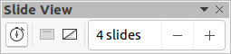Figure 3: Slide View toolbar
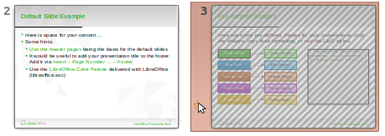Figure 4: Slide 3 hidden
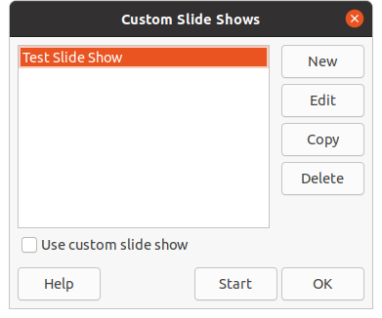Figure 5: Custom Slide Shows dialog

Custom slide show
To show the slides in a different order, you can either rearrange them in the Slides pane or Slide Sorter view in the Workspace, or set up a custom slide show.
You can define as many custom slide shows as you require from one set of slides. In a custom slide show, you can select which slides to include as well as the order in which they are shown. Any hidden slides will not appear in a custom slide show.

Creating custom slide show
- Go to Slide Show > Custom Slide Show on the main menu bar to open the Custom Slide Shows dialog (Figure 5).
- Click on New and the Define Custom Slide Show dialog opens (Figure 6).
- Type a name for the new custom slide show in the Name text box.
- In the Existing slides list, select the slides to include in the show.
- Click the >> button to include the slides in the Selected slides list. You can select and include several slides at the same time. Hold down the Shift key and click the first and last slide in a group to select that group, or hold down the Ctrl key and click on individual slides to select them.
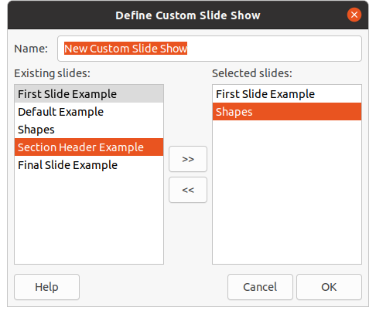Figure 6: Define Custom Slide Show dialog
- If required, rearrange the slide order in the Selected slides list. Click on a slide name and drag it to a new position in the list, then release the mouse button.
- Click OK to save the custom slide show and return to the Custom Slide Shows dialog.
- To activate a custom show, select it in the list in the Custom Slide Shows dialog and then select the Use custom slide show option.
- Click Start to test the custom slide show or click OK to close the Custom Slide Shows dialog.

Editing custom slide show
- Go to Slide Show > Custom Slide Show on the main menu bar to open the Custom Slide Shows dialog.
- Select the name of the custom slide show you want to edit and click on Edit and the Define Custom Slide Show dialog opens.
- Add slides, remove slides, change the slide order, or change the name of the custom slide show in the Define Custom Slide Show dialog.
- Click OK to save the custom slide show and return to the Custom Slide Shows dialog.
- Click OK to close the Custom Slide Shows dialog.

Copying custom slide show
- Go to Slide Show > Custom Slide Show on the main menu bar to open the Custom Slide Shows dialog.
- Select the title of the custom slide show you want to copy and click on Copy. The name of the selected custom slide show is repeated with the word (Copy 1) added to the name.
- Select the name of the copied custom slide show and click on Edit and the Define Custom Slide Show dialog opens.
- Change the name of the copied custom slide show in the Define Custom Slide Show dialog.
- Click OK to save the copied custom slide show and return to the Custom Slide Shows dialog.
- Click OK to close the Custom Slide Shows dialog.

Deleting custom slide show
- Go to Slide Show > Custom Slide Show on the main menu bar to open the Custom Slide Shows dialog.
- Select the name of the custom slide show you want to delete and click on Delete. Deletion is immediate and no confirmation message appears.
- Click OK to close the Custom Slide Shows dialog.

Using slide transitions
Slide transitions are effects and/or sounds that take place between slides when slides change in a slide show. Transitions can add a professional look to a slide show, smoothing the change over between slides.

Adding transitions
- Click on Slide Transition in the Sidebar to open the Slide Transition deck (Figure 7).
- Open the presentation file where you want to add slide transitions.
- In the Slides Pane or Slide Sorter view in the Workspace, select the slides where you want to apply slide transitions.
- Click on a transition from the displayed list to apply it to the selected slide.
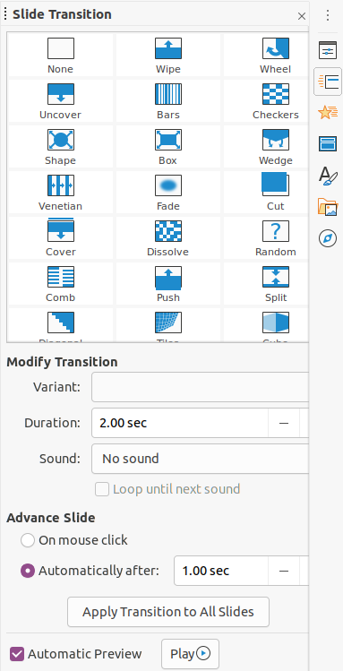Figure 7: Slide Transition deck on Sidebar
- To apply the same transition to all slides in the presentation, click on Apply Transition to All Slides at the bottom of the Slides Transition deck.
- To check how the transition looks, click on Play at the bottom of the Slides Transition deck. Alternatively, to automatically preview how the transition looks when it is applied, select Automatic Preview at the bottom of the Slides Transition deck.
- In the Modify Transition section, select from the available options as follows:
- Variant – select an option from the drop list. The available options change according to the transition that has been selected.
- Duration – enter a time for how long the transition lasts.
- Sound – select a sound from the drop down list that is played when the transition activates. If a sound is selected, the Loop until next sound option becomes active. Select this option to play the sound repeatedly until another sound starts. If there are no subsequent sounds in your slide show, the selected sound will play continuously for the remainder of the show. Sounds can be played when None is selected for the transition effect.
- In the Advance Slide section, select one of the two following options on how the slides change in a presentation. Only one option can be selected as follows:
- On mouse click – each time the mouse is clicked, the presentation advances to the next slide.
- Automatically after – enter a time in box to elapse before the next slide in the presentation advances into view.
- testovací Zdeněk Tip
A single type of transition can be applied to all the slides in the slide show or a different transition to any or every single slide in the slide show. While using many different transitions may be fun to do, it may not give your slide show a professional appearance.

Removing transitions
- Click on Slide Transition in the Sidebar to open the Slide Transition deck.
- Select the slides where you want to remove the transitions.
- Select None at the top of the Slide Transition deck in the Sidebar.
- testovací Zdeněk testovací Zdeněk testovací Zdeněk testovací Zdeněk
Slides with transitions are indicated by a star in the bottom left corner of the slide when viewed in the Slides Pane or the Slide Sorter view in the Workspace.

Playing music
You can play music during a slide show instead of a sound as a transition effect. When using music in a slide show, make sure you not infringing any musical copyright or licensing for the music.
- Click on Slide Transition in the Sidebar to open the Slide Transition deck.
- Open the presentation file where you want to add slide transitions.
- In the Slides Pane or Slide Sorter view in the Workspace, select the slide where you want to add music.
- In the Modify Transition section, select Other sound from the Sound drop-down list.
- In the file browser window that opens, navigate to where the music file is located.
- Select the music file you want to use and click on Play to check if the music file is suitable.
- If the music is suitable, click Open to add the music to the selected slide and close the file browser window.
- To play a music file continuously in the slide show, select the option Loop until next sound. The music file restarts once it is finished until the next music file that is inserted in the slide show.
- testovací Zdeněk testovací Zdeněk testovací Zdeněk testovací Zdeněk
Do not select the Apply Transition to All Slides option, otherwise the selected music file restarts at every slide.
- testovací Zdeněk testovací Zdeněk testovací Zdeněk testovací Zdeněk
The music file is linked to a slide show rather than embedded. If you plan to display the slide show on a different computer, remember that you also have to make the music file available on the computer where the slide show will be played and establish the link to the music file before starting the slide show.

Animace
Slide animations are similar to transitions, but they are applied to individual elements in a single slide, such as title, chart, shape, or individual bullet point. Animations can make a presentation more lively and memorable. However, as with transitions, heavy use of animations can be fun, but distracting and even annoying for an audience expecting a professional presentation.
Animations are best applied using Normal view in the Workspace so that you can easily select individual objects on a single slide.
- testovací Zdeněk testovací Zdeněk testovací Zdeněk testovací Zdeněk
At present it is not possible to apply animations to elements in master slides. This means that if you want to display the items in a text box one by one and use the same animation on more than one slide, you need to apply the effects to each slide. Alternatively you can copy the animated element from one slide to another.

Applying animation
On a slide, an element such as a graphic or an entire text box has selection handles around it when selected. If you select only a portion of the text in a text box, you may not see any selection handles.
- Go to View > Normal on the main menu bar to open Normal view in the Workspace.
- Select the slide and element you want to animate.
- On the Sidebar, select Animation to open the Animation deck (Figure 8).
- Click on Add Effect (+ plus sign) to open the animation options on the Animation deck.
- Select an animation category from the Category drop down list.
- Select an animation effect from the available options in the Effect list.
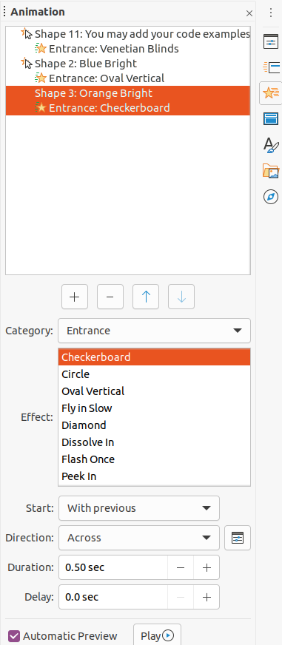Figure 8: Animation deck on Sidebar
- Select how the animation starts from the Start drop down list.
- Select the direction of the animation from the Direction drop down list.
- Enter a time for the duration of the animation in the Duration box.
- Enter a time for the delay of when the animation starts in the Delay box.
- If you require more animation options, see “Additional animation options” on page 13 for more information.
- If required, select Automatic Preview so you can automatically check how the animation looks when applied to a slide element.
- Click on Play to check how the animation looks when applied to a slide element.
- testovací Zdeněk testovací Zdeněk testovací Zdeněk testovací Zdeněk
The options available for an animation depend on the Category and Effect that have been selected for an animation.

Changing animation
- Go to View > Normal on the main menu bar to open Normal view in the Workspace.
- On the Sidebar, select Animation to open the Animation deck.
- Select the slide and the slide element where you want to change the animation effect in the Animation box.
- Using the procedure in “Applying animation” on page 11, select a new animation effect for the selected element.
- Click on Play to check how the animation looks when applied to a slide element.

Removing animation
- Go to View > Normal on the main menu bar to open Normal view in the Workspace.
- Select the slide and the animated element you want to remove.
- On the Sidebar, select Animation to open the Animation deck.
- Click on Remove Effect to remove the animation from the selected element.

Additional animation options
Some animations have additional options that you can set or change. That actual options that are available depend on the animation selected.
- Go to View > Normal on the main menu bar to open Normal view in the Workspace.
- On the Sidebar, select Animation to open the Animation deck.
- Select the slide and element where you want to apply additional animation options.
- Click on Options to the right of the Direction drop down list to open the Effect Options dialog (Figure 9).
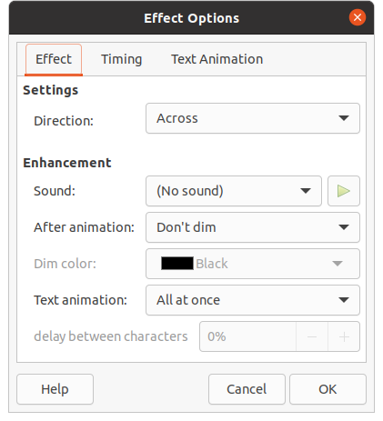Figure 9: Effect Options dialog - Effect page
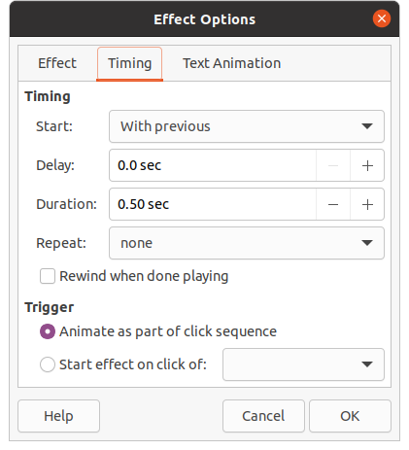Figure 10: Effect Option dialog - Timing page
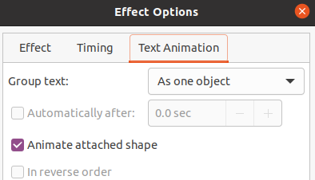Figure 11: Effect Options dialog - Text Animation page
- Click on a tab to open the options for the type of effect options you want to change and use.
- Effect – specifies the settings and enhancements of the selected animation (Figure 9).
- Timing – specifies the timing for the selected animation effect (Figure 10).
- Text Animation – specifies how text is animated for the selected animation (Figure 11).
- Click OK to save your changes and close the Effect Options dialog.

Effect options
Specifies the settings and enhancements for the selected animation using the Effect page in the Effect Options dialog (Figure 9).
- Direction – specifies the direction for the effect.
- Sound – select a sound from the drop down list or select one of the special entries as follows:
- (No sound) – no sound is played during animation of the effect.
- (Stop previous sound) – the sound of the previous effect is stopped as soon as the current effect runs.
- Other sound – displays a file open dialog to select a sound or music file.
- After animation – select what happens after animation.
- Don't dim – no after-effect runs.
- Dim with color – after the animation a dim color fills the shape.
- Hide after animation – hides the shape after the animation ends.
- Hide on next animation – hides the shape on the next animation.
- Dim color – select the dim color. Only available if Dim with color has been selected.
- Text animation – select the animation mode for the text of the current shape:
- All at once – animates the text all at once.
- Word by word – animates the text word by word.
- Letter by letter – animates the text letter by letter.
- Delay between characters – specifies the percentage of delay between animations if Word by word or Letter by letter has been selected for Text animation.

Timing options
Specifies the timing for the selected animation using the Timing page in the Effect Options dialog (Figure 10).
- Start – displays the start property of the selected animation effect.
- On click – the animation stops at this effect until the next mouse click.
- With previous – the animation runs immediately.
- After previous – the animation runs as soon as the previous animation ends.
- Delay – specifies an additional delay in seconds until the effect starts.
- Speed – specifies the duration of the effect in seconds.
- Repeat – specifies when and how to repeat the current effect. Enter the number of repeats, or select from the list:
- none – the effect is not repeated.
- Until next click – the animation is repeated until the next mouse click.
- Until end of slide – the animation repeats as long as the slide is displayed.
- Rewind when done playing – the animated shape returns to its starting state after the animation ends.
- Animate as part of click sequence – allows the animation start in a normal click sequence.
- Start effect on click of – allows the animation start when a specified shape is clicked. Select the shape by its name from the drop down list.

Text animation options
Specifies the text animation settings for the selected animation using the Text Animation page in the Effect Options dialog (Figure 11).
- Group text – specifies how multiple paragraphs are animated:
- As one object – all paragraphs are animated as one object.
- All paragraphs at once – all paragraphs are animated at once, but paragraphs can have different effects.
- By 1st level paragraphs – the first level paragraphs, including sub-level paragraphs, are animated one after another.
- Automatically after – if By 1st level paragraphs is selected for Group text, the paragraphs are animated one after the other. Enter an additional delay in seconds to animate subsequent paragraphs.
- Animate attached shape – deselect this box to animate only the text, not the shape.
- In reverse order – animates the paragraphs in reverse order.

Animation example
Creating animations on a slide takes practice to achieve the animation effect you want. The following steps explains how to setup the animation shown in Figure 12 as a simple example of multiple animations that you can create. The example slide is taken from a LibreOffice presentation. It would be very easy for you to create a similar slide and recreate this example.
- Go to View > Normal on the main menu bar to open Normal view in the Workspace.
- Select a slide that you want to animate.
- On the Sidebar, select Animation to open the Animation deck.
- Select two elements on the slide, then click on Add Effect (+ plus sign) to open the animation options on the Animation deck. The selected elements appear on the Animation deck.
- Select the first element (Shape 1: Green Bright) and select Entrance from the Category drop down list.
- Select the following options for the animation:
- Effect – Venetian Blinds
- Start – On click
- Direction – Vertical
- Duration – 0.50 sec
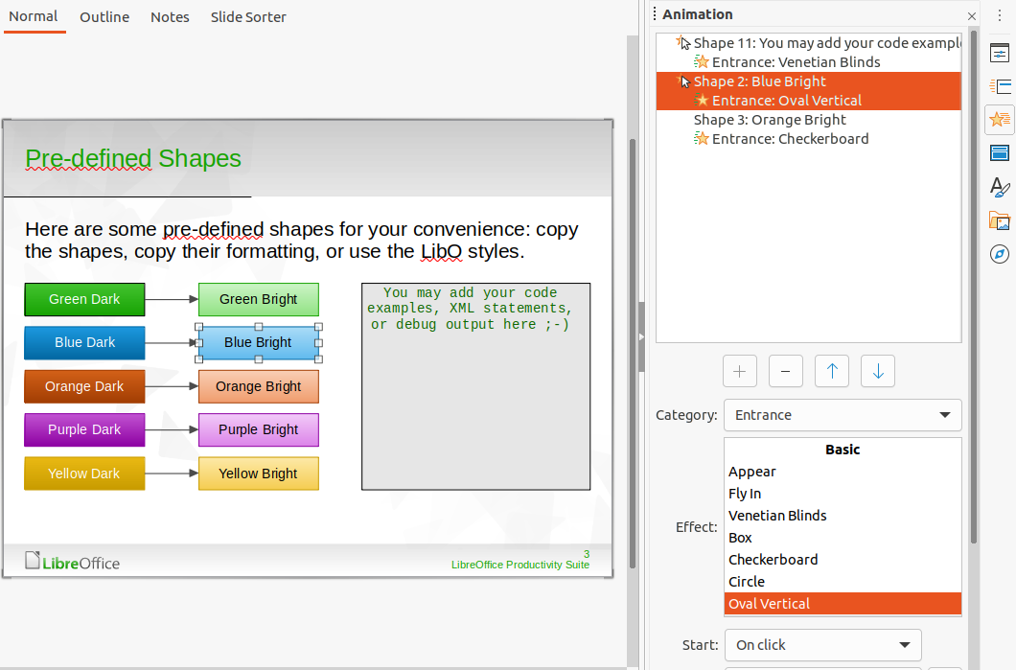Figure 12: Animation example
- Select the second element (Shape 3: Blue Bright) and select Motion Paths from the Category drop down list.
- Select the following options for the animation:
- Effect – 5 Point Star
- Start – After previous
- Duration – 10.00 sec
- Go to Slide Show > Rehearse Timings on the main menu bar and check the animation of these two objects.

Using interactions
Interactions are where objects on a slide are used to create an event when it is clicked with the mouse cursor. These objects with interactions can be buttons, images, or text objects.
- Go to View > Normal on the main menu bar to open Normal view in the Workspace.
- Select a slide where you want to add an interaction to an object on the slide.
- Select the object, then use one of the following methods to open the Interaction dialog (Figure 13).
- Right-click on the object and select Interaction from the context menu.
- Go to Format > Interaction on the main menu bar.
- Select an interaction from the Action at mouse click drop-down list. The options available in this dialog depend on the interaction that has been selected.
- Click OK to save your changes and close the Interaction dialog.
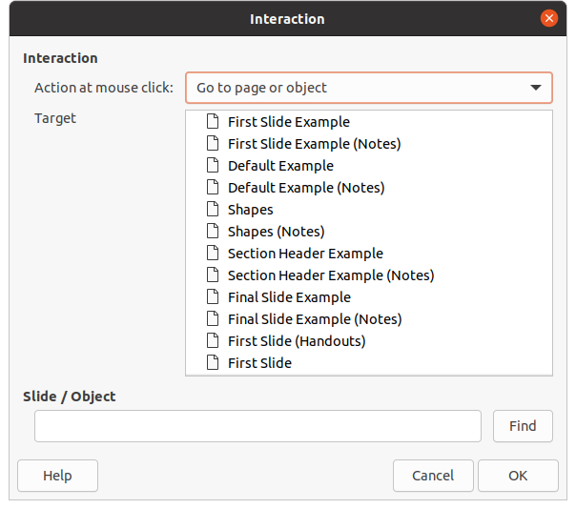Figure 13: Interaction dialog

Slide shows

Spuštění prezentace
- Open your presentation and start the slide show using one of the following methods:
- Use the keyboard shortcut F5 to start from the first slide or Shift+F5 to start from the current slide.
- Go to Slide Show > Start from First Slide or Start from Current Slide on the main menu bar.
- Click on Start from First Slide on the Slide Sorter toolbar.
- If the slide transition is set to Automatically after x sec, the slide show starts and runs after the set time has elapsed.
- If the slide transition is set to On mouse click, use one of the following methods to advance the slides:
- Click the left mouse button.
- Press the down arrow key.
- Press the right arrow key.
- Press the page down key.
- Press the spacebar.
- To navigate backwards through a slide show one slide at a time, use one of the following methods:
- Press the up arrow key.
- Press the left arrow key.
- Press the page up key.
- During a slide show, more navigation options are available when you right click on a slide and use the options available in the context menu.
- When the last slide has displayed, the message Click to exit presentation... is displayed on screen. Press the Esc key or click the left mouse button to exit the slide show.
- To exit the slide show and return to the Impress workspace at any time, press the Esc key during the slide show.
- testovací Zdeněk testovací Zdeněk testovací Zdeněk testovací Zdeněk
During the slide show, any animations on a slide are run in the specified order as the slide is displayed.

Context menu navigation and options
If the slide show consists of more than one slide, right-clicking on the screen opens a context menu displaying navigation options. These navigation options are as follows:
- Next – moves to the next slide in the slide show.
- Previous – moves to the previous slide in the slide show.
- Go to Slide – displays a sub-context menu allowing selection and navigation to any slide in the slide show. The list of slides shows the need of naming slides in a slide show rather than using the default slide names of Slide 1, Slide 2, and so on. Naming slides makes it easier to identify the required slide.
- Mouse pointer as Pen – allows you to use the cursor as a pen and draw on a slide to emphasize or explain a point.
- Pen Width – opens a sub-context menu providing options to set the width of any lines drawn on a slide when using the cursor as a pen.
- Change pen Color – opens a dialog allowing you to change the line color when using the cursor as a pen.
- Erase all ink on Slide – deletes all lines drawn after you have finished using the cursor as a pen.
- Screen – opens a sub-context menu with a black or white color choice. This is useful if you want to pause the slide show for a break or to demonstrate something else.
- End Show – ends the presentation and returns you to the Impress workspace. This is the same effect as pressing the Esc key.

Automatic slide show repeat
- Go to Slide Show > Slide Show Settings on the main menu bar to open the Slide Show Settings dialog (Figure 2 on page 5)
- In Presentation Mode, select the option Loop and repeat after and a time delay in the box of when you want the slide show to start again.
- If necessary, select Show logo if you want the LibreOffice logo to be displayed during the pause between slide shows.
- Click OK to save the settings and close the Slide Show Settings dialog.

Slide show timing

Default timing
- Click on Slide Transition in the Sidebar to open the Slide Transition deck (Figure 7 on page 9).
- Select None at the top of the Slide Transition deck in the Sidebar as the transition effect.
- Select the option Automatically after in Advance Slide and set a time in the box.
- Click on Apply Transition to All Slides to set the default timing of the slide show.
- Go to Slide Show > Start from First Slide on the main menu bar to check how the presentation runs.
- If necessary, adjust the default timing until you are satisfied on how the slide show runs.

Variable timing
- Select Slide Show > Rehearse Timings on the main menu bar. The slide show starts in full-screen mode and a timer appears in the lower left corner of the display.
- When you want to advance to the next slide, click on the timer to set the time duration for the displayed slide and advance to the next slide. To keep the default time duration for a slide, click the slide and not the timer.
- Continue until the time duration is set for all slides in the slide show. Impress records the time duration set for each slide.
- To exit from rehearsal timing of the slide show, press the Esc key, or click on the slide.

Obrazovka přednášejícího
Normally, LibreOffice Impress already includes the Presenter Console when LibreOffice is installed on your computer. If the Presenter Console is not included, the extension can be downloaded from the LibreOffice website and installed on your computer. For more information, see Chapter 11, Setting up and Customizing Impress.
The Presenter Console provides extra control over slide shows when using dual displays, such as a laptop for yourself and large display or projector for your audience. The view you see on your computer display includes the current slide that can be seen by the audience, the next slide in your presentation, any slide notes, and a presentation timer.
- testovací Zdeněk testovací Zdeněk testovací Zdeněk testovací Zdeněk
The Presenter Console only works with operating systems that support two displays. When two displays are being used, one display can be a laptop.
The Presenter Console provides the following views to assist you when making a presentation:
- Default view – displays the current slide, including any effects and the next slide in the presentation (Figure 14). Click on the Previous and Next arrows to navigate through a presentation.
- Notes view – click on Notes to switch to display any notes that accompany each slide in the presentation (Figure 15). Click on Notes again to return to the default view.
- Slides view – click on Slides to switch to display the slide thumbnails that are being used for the presentation (Figure 16). Click on Slides again to return to the default view.
- Exchange – click on this icon to switch the Presentation Console between displays.
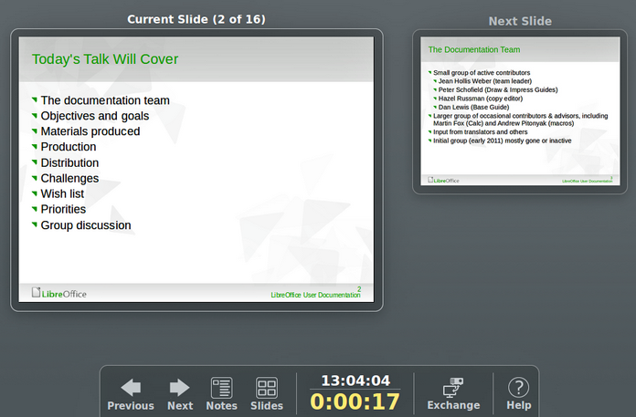Figure 14: Presenter Console – Default view
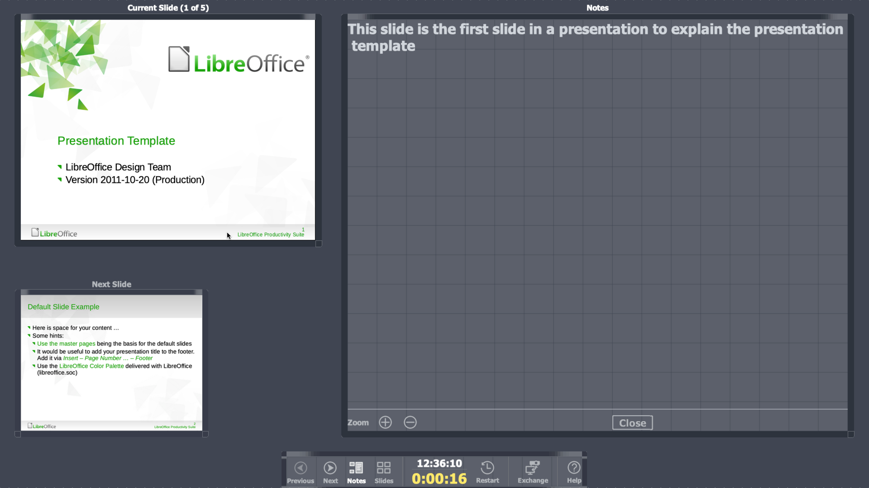Figure 15: Presenter Console - Notes view
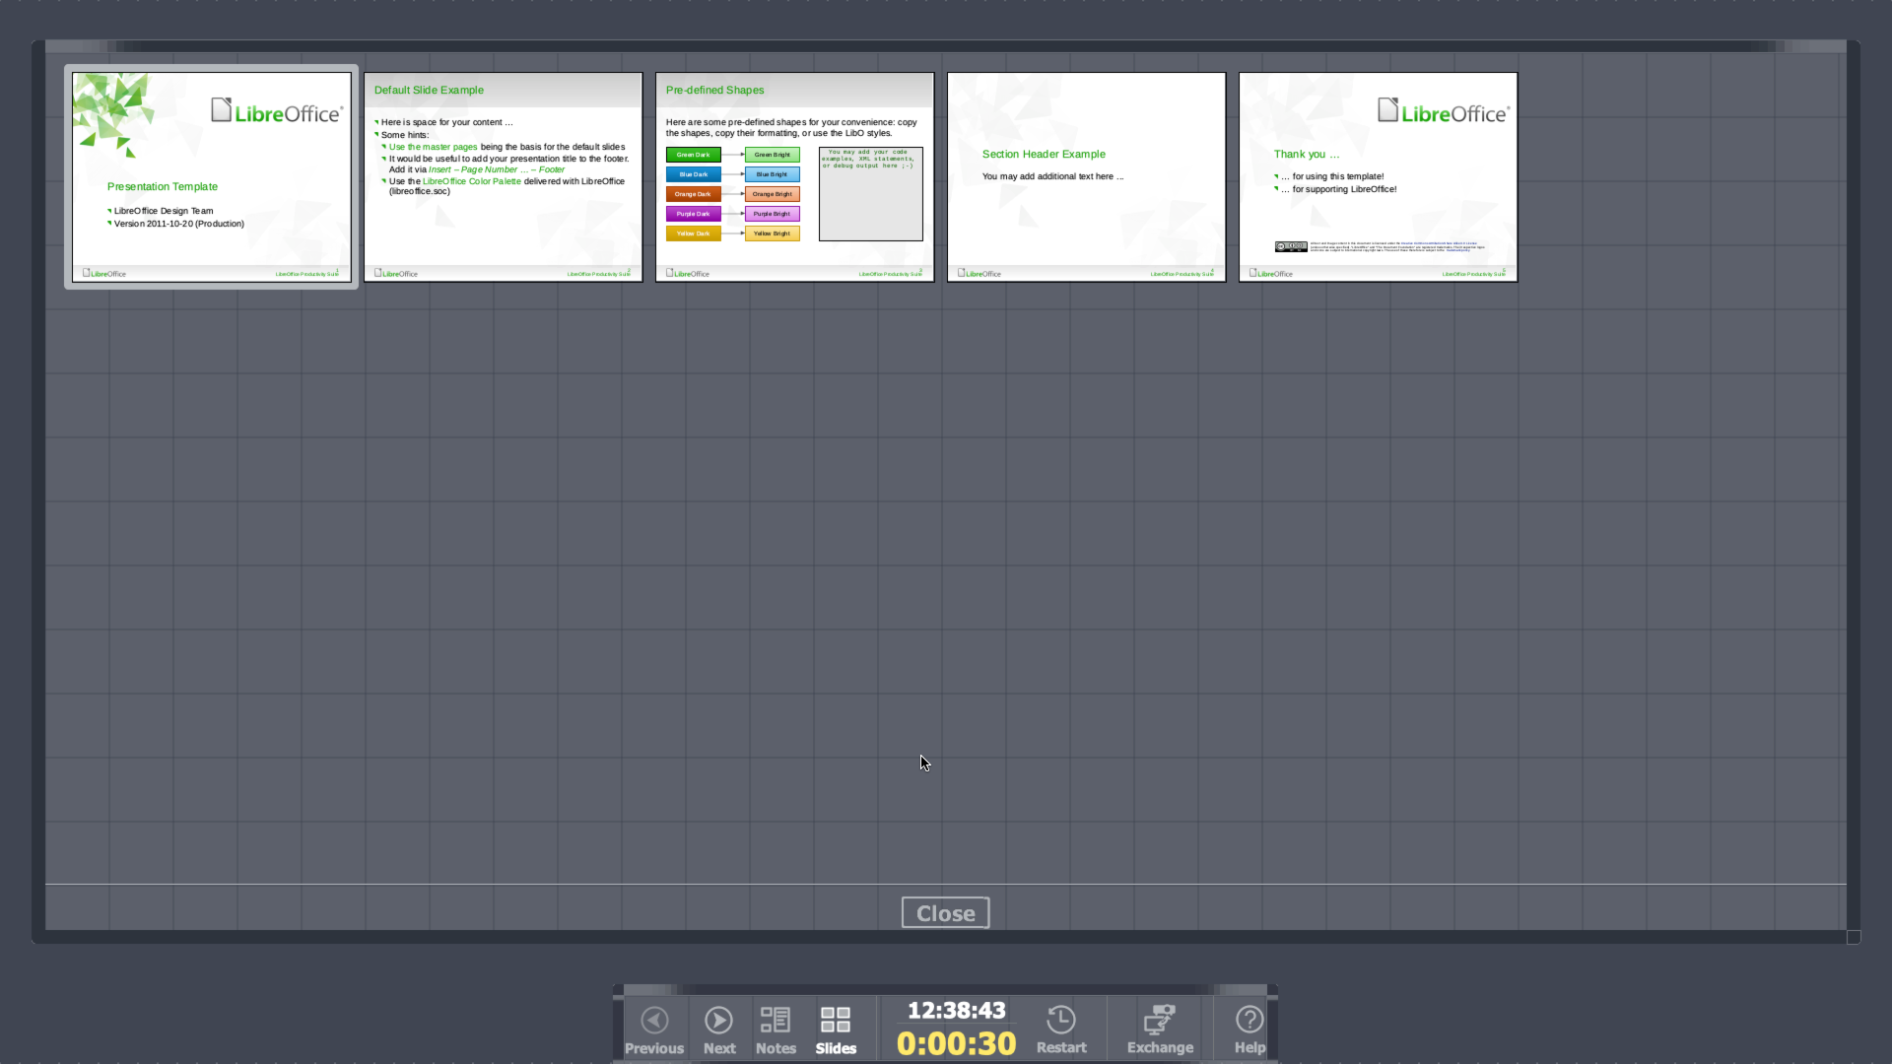Figure 16: Presenter Console - Slides view

Photo albums
Impress může vytvořit fotoalbum ze sady obrázků, obvykle s jednou fotografií na snímek. This photo album can be a slide show or multimedia show with graphics and images or your latest vacation pictures.
- Create a new presentation or open an existing presentation.
- Select the slide that is going to precede the photo album. In a new presentation, this will be the first slide.
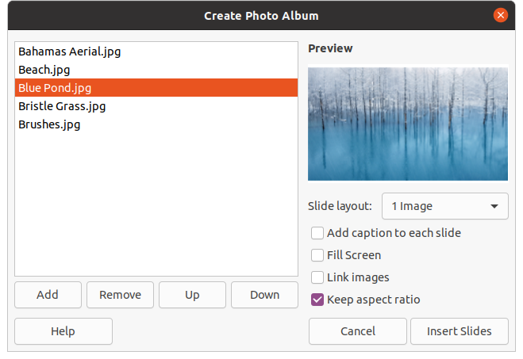Figure 17: Create Photo Album dialog
- Go to Insert > Media > Photo Album on the main menu bar to open the Create Photo Album dialog (Figure 17).
- Click on Add to open a file browser.
- Navigate to the folder where your pictures or photos are located.
- Select the pictures or photos you want to use and click on Open. This closes the file browser and the selected files appear in the Create Photo Album dialog.
- Select the number of images per slide in the Slide layout: drop-down list.
- If required, select Add caption to each slide. This inserts a text box on each slide allowing you to add a caption to the images.
- If required and there is only one image per slide, select Fill Screen for each image to fill the entire slide.
- Create the required sequence of photos or pictures by moving image files up or down in the list of images.
- When the sequence of images is ready, click Insert Slides to create the number of slides required for your photo album. Impress creates a presentation with as many slides that are required to contain your images. The sequence can be changed later, as you can with any slides.
- If required, you can copy and paste images between slides as you can with any other elements that can be placed on a slide.
- If required, you can setup your photo album and run it as a slide show. See “Creating slide shows” on page 4 and “Slide shows” on page 18.

