**Lab Test – 2 (6%)**

**COMP 3123 Full Stack Development – II**

**Submission: Week 13 – Thursday, 3rd Dec 2020 09:00 PM**

**PART - I**

**Setup Requirements**

1. Open given **Spring_Boot_Employee_Management_System** application on **Intellij IDE**
2. To run the application run **SpringbootBackendApplication** class file containing main() method. *(For successful execution you need to start MySQL and setup database. Follow below given steps 3, 4, 5)*
3. Install MySQL on your machine and remember username and password of MySQL

<https://dev.mysql.com/downloads/installer/>

1. Create database name **studentid_ems** on MySQL

*Note: You don't have to create any tables inside database name studentid_ems*

1. Open **resources/application.properties** file and do following changes
   1. Update **line#1** spring.datasource.url property replace your own database name like studentid_ems
   2. Update **line#2** and **#3** change your MySQL username and password with your own MySQL username and password
2. Following are five REST APIs (Controller handler methods), we will develop for Employee resource.

1. Import given Postman API file to your installed postman to refer/test the REST API.

Here we are using <http://localhost:9090> base URL to call all the endpoints after running the sprint boot application.

**For example**

**PART – II**

1. Create reactJS application name **studentID_lab_assignment_2** to perform CRUD operation. Consume REST API exposed by Spring-Boot-Application
2. List employees screen

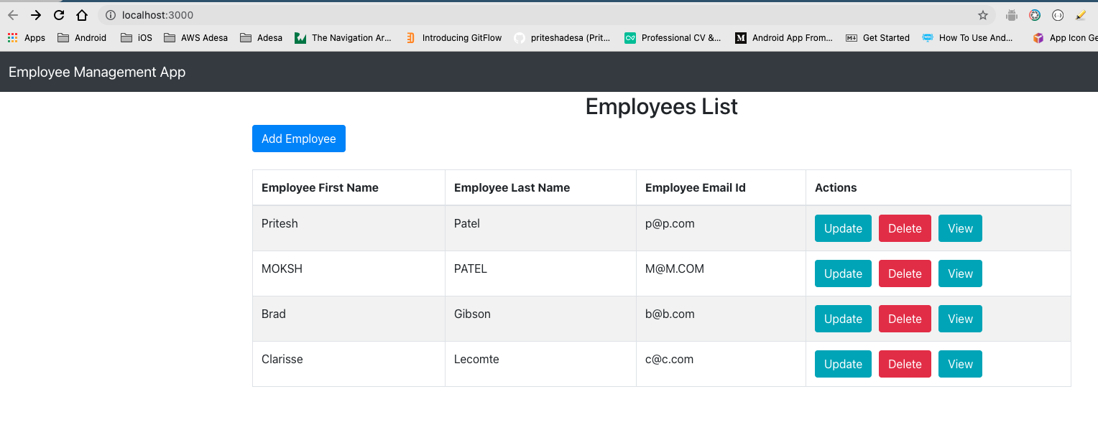

1. Add new employee

1. View Employee details when you click on View button

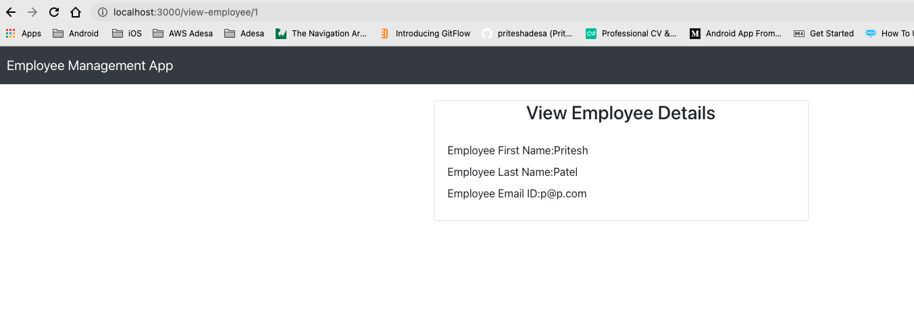

1. Update employee information when you click Update button

1. Delete employee record when you press delete button

*Think of your own UI design. Make use of reactJS concepts like states, props, react-bootstrap, axios, react-routes, class component, function components.*

**Submission**

Upload ZIP file of your reactJS application, spring boot application, screenshot showing data from your MySQL database and screenshot of all your CRUD operation screens.

**If you have any question, then email at** [**Pritesh.patel2@georgebrown.ca**](mailto:Pritesh.patel2@georgebrown.ca) **or use SLACK**

**References**

**ReactJS + Spring Boot CRUD Full Stack Architecture**

**Application Structure and file names**

