ACTIVE SHARED OBJECT/MAIL BOX

WITH

CENTRAL SERVER

(formalized description)

1. **General concepts**

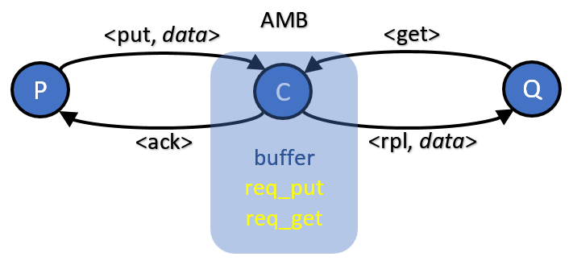

Fig. 1. System Communications Structure

1. **Central Server Pseudocode**

**C::**

**{ПРЕДПОЛОЖЕНИЯ}**

**…**

**{СИСТЕМНИ КОНСТАНТИ}**

String MSG_PUT // put message type

String MSG_ACK // ack message type

String MSG_GET // get message type

String MSG_RPL // rpl message type

Int MAX_BUFFER_SIZE

**{СЪОБЩЕНИЯ}**

<put, data>

<ack>

<get>

<rpl, data>

**{МНОЖЕСТВО СЪСТОЯНИЯ }**

**<State> := {ME_INIT, ME_FREE, … }**

**{ВЪТРЕШНИ ПРОМЕНЛИВИ}**

Queue qBuffer // data buffer

Req reqPut; // pending put request

Req reqGet; // pending get request

**{СЪБИТИЯ}**

**OnInit:**

qBuffer.clear()

reqPut := false

reqGet := false

**OnReceiptOf <put, data> from P:**

qBuffer.insert(data)

**If** reqGet = true

reqGet := false

data := qBuffer.remove()

Send<rpl, data> to Q

**EndIf**

**EndIf**

**If** qBuffer.size() < MAX_BUFFER_SIZE

Send<ack> to P

**Else**

reqPut := true

**EndIf**

**OnReceiptOf <get> from Q:**

**If** qBuffer.size() != 0

data := qBuffer.remove()

Send<rpl, data> to Q

**If** reqPut = true

reqPut := false

Send<ack> to P

**EndIf**

**Else**

reqGet := true

**EndIf**