**Standalone Temperature & Humidity Detector**

***Milad Sabouri***

**Illinois Institute of Technology**

**Embedded Systems – Spring 2018**

# Introduction

In this project I developed an electronic working prototype that covers *Data Collection*, *Data Transmission*, and *Data Presentation* phases. The micro-controller board which is used in this project is **Ardino-UNO**. In Data Transmission phase, **DHT22** sensor is used. It is a basic, low-cost digital temperature and humidity sensor. In Data Transmission phase, both **Arduino Ethernet Shield** and **Adafruit BLUEFRUIT LE UART** are used to transmit data with network cable and Bluetooth respectively. In Data Presentation phase, I have used web server to present the data which are transmitted with network cable. Also, I have used android application to present the data that are transmitted via Bluetooth. Moreover, I have used **0.54”14-segment LED HT16K33** to present the temperature.

# Functional Working Process

The functionality of this project is detecting the temperature of the environment based on Celsius degree. It has an option that users can convert the Celsius to Fahrenheit easily with just pressing one push button. Also, this project detects the humidity. The data which is collected by the sensor are transmitted to web server and smart phone with using the network cable and Bluetooth technology. Webserver, smart phone application, and LED are three ways to present the data.

# Electrical Working Process

The heart part of this project is DHT22 sensor. This sensor can detect the temperature and humidity. The temperature is based on Celsius degree. This sensor has four pins. Two pins for power and ground. The third pin is unused in this project. The forth pin is data pin and connected to digital pin 6

This project has three ways for data presentation. One of this way is LED. The model of this LED is 0.54”14-segment LED HT16K33. This component has 5 pins. The first two pins are power pins which are connected to 5 volts pin on the ethernet shield Arduino board. The third pin is ground and connected to ground pin of the board. The forth and fifth pins are data pins which are connected to A4 and A5 analog pins in the board respectively.

One of the key component of this project is Bluetooth chip. I used Adafruit BLUEFRUIT LE UART. Obviously, it has 2 pins for power and ground. Also, it has 4 pins for data which are connected to digital pins 5, 8, 9, 11.

The other component which is used in this project is a push button. The default degree for temperature is Celsius. If we press the push button the temperature whish is shown by LED converted to Fahrenheit degree. I connected this push button to analog pin in the board. The reason is the restriction of digital pins. In other words, because most of the digital pins have been occupied by other components in this project, I used analog pin for push button. When the user presses the button the value of the analog pin is going to zero, so in this case the program can detect the pressing and convert Celsius to Fahrenheit.

# Comparative Technical and Cost Analysis

|  |  |
| --- | --- |
| Component | Cost |
| Arduino Uno | $22.00 |
| DHT22 | $9.95 |
| 0.54”14-segment LED HT16K33 | $13.95 |
| Adafruit BLUEFRUIT LE UART | $17.50 |
| Ethernet Shield | ~ $10.00 |
| TOTAL | **~ $73.40** |

According to above table the total price for building this prototype is around 73.40. However, with searching on the market place we can find some devices with more than this price, also there are some other devices which are cheaper than it.

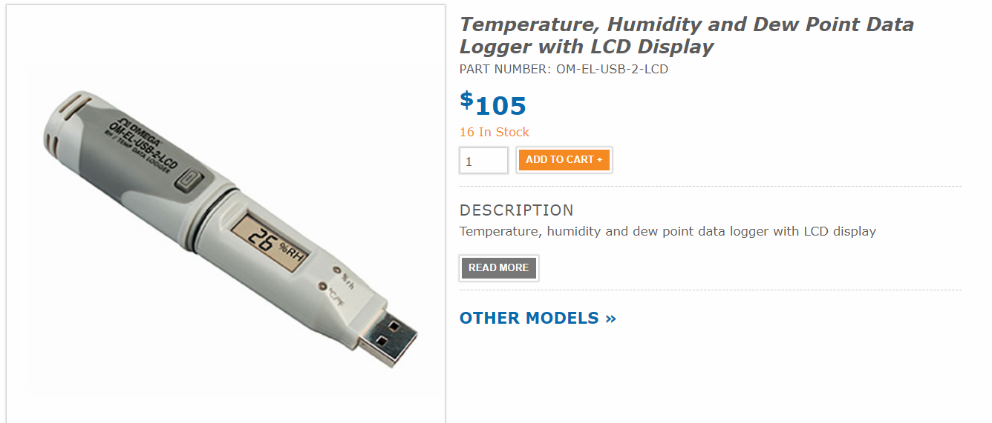

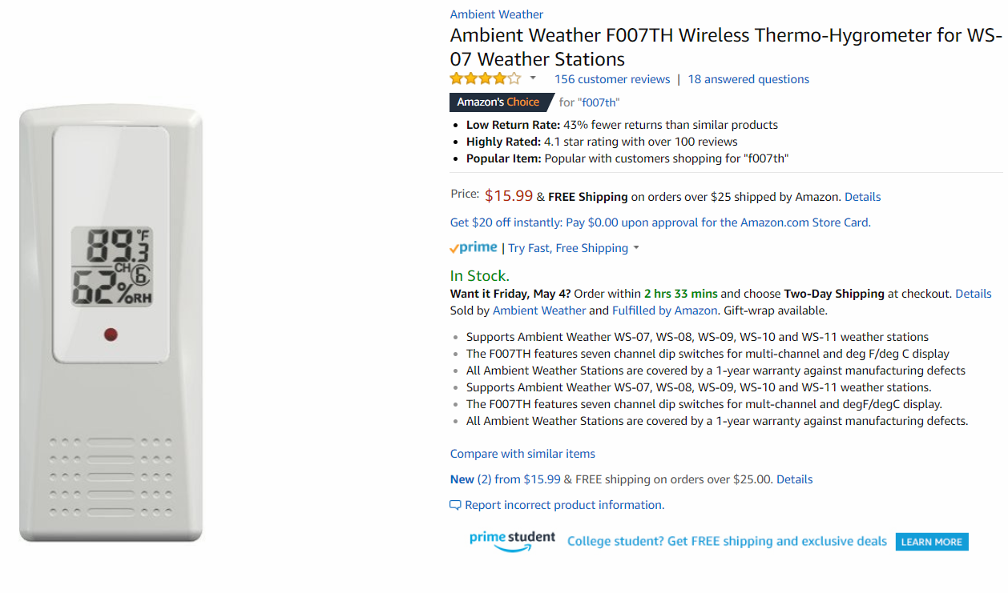

# Diagram

